ADVANCED HYBRID SOLAR THERMOELECTRIC GENERATOR THEORETICAL ANALYSES

Udham singh¹, Raja somadder², Rone^{3,} Akhilesh Pati Tiwari⁴
¹ Udham Singh Author FCEM College
² Raja Somadder Author FCEM College
³Rone Assistant Professor FCEM College
⁴ Akhilesh Pati Tiwari Assistant Professor FCEM College

---------------------------------------------------------------------***---------------------------------------------------------------------
Abstract - Due to the fact that much of the world’s best solar resources are inversely correlated with population centers, significant motivation exists for developing the technology, which can deliver reliable and autonomous conversion of sunlight into electricity. Thermoelectric generators (TEG) are gaining incremental ground in this area due to its extensive use in solar thermal application as power generators, known as solar thermoelectric generators (STEG).
STEG systems are gaining significant interest in both, concentrated and non-concentrated systems and have been employed in hybrid configurations with the solar thermal and photovoltaic systems. In this dissertation, mainly studies of Hybrid Solar Thermoelectric Generators (HSTEG) configuration are presented. HSTEG systems are much less studied both experimentally and theoretically, despite their clear technoeconomic advantages. There is a scope for significant improvement in the performance (efficiency) and a need for detailed performance analysis to understand the fundamentals of the energy transfer process. HSTEG systems (conventional) reported till date, initially the solar energy is utilized by the TEG for generating electricity and then transferred to other low temperature thermal cycles (heating or cooling). As an alternative one can design an advanced HSTEG system, in such way to first utilize the solar energy in the heat transfer fluid (HTF), which can run high temperature thermal cycle for heating or cooling or power generation)
and then generate electricity by using TEG. Further, there is no advanced HSTEG system is available in the literature, which could deliver high temperature heat output from the hot side of the HSTEG system.

Key Words: optics, photonics, light, lasers, stencils, journals

1.INTRODUCTION
Average worldwide electrical power utilization in 2020 was calculated at 17.4 terawatts, but it is anticipated to become more than double and triple by 2050 and 2100, respectively [1].
At their present consumption rate, economically extractable fossil fuel resources will be heavily depleted within these spans times (mainly if we realize their impact on the environment). Hence, globally countries are shifting towards renewable and sustainable energy resources to generate electricity to meet their future energy demand. Solar-derived electricity embodies a vast, basically untapped renewable energy reserve, which can be harvested either via photovoltaic or thermal routes [2]. In this dissertation, one thermal route is presented in particular, Hybrid Solar Thermoelectric Generators (HSTEG), which has recently been garnering research attention due to enhancements in thermoelectric materials properties as well as in HSTEG system design.
Eventually, a new class of efficient, cost effective solar to electricity conversion systems could be possible, if these improvements are sustained [1].

1.2. SOLAR-TO-ELECTRICITY CONVERSION TECHNOLOGY
The average solar radiation received on earth is about 162,000 TW, whereas only a vanishingly small portion of this power are used for electricity generation [3]. Solar photovoltaic cells (PV) convert some of the solar spectrum directly into electricity [4], while concentrated
solar thermal (CST) technologies first convert incident solar energy to heat and then (usually) use this heat to boil a working fluid which drives a Rankine cycle [5]. Various PV cells and CST system are compared in Table 1.1 with respect to their operational temperature, concentration ratio (CR = Area of the collector/Area of the receiver), and maximum efficiency. Laboratory
scale PV modules have reached a maximum efficiency of about ~29% and amaximum efficiency of about 46% was attained for concentrated photovoltaic (CPV) cell [6, 7]. However, commercially available solar PV modules, have efficiencies between 10- 24% [8]. Commercially, large-scale CST projects have proven to be more efficient than PV cells [9]. Solar thermal technologies use a structure (a collector) to receive and absorb solar thermal radiation; these collectors can be broadly classified into two types, non-concentrating and concentrating. Collectors, which do not concentrate sunlight, can be stationary and do not require tracking mechanisms. For most solar thermal electricity generation systems, however, concentration (and thus tracking) is required which adds to the system’s capital cost. Another key component of the collector is the receiver – a heat exchanger that absorbs sunlight and transfers this energy as heat to a fluid passing through it [10, 11]. Non-concentrating collectors are limited to a temperature range from ambient to 240 °C, while, depending on the CR, concentrating collectors (CST) can operate up to 1500 °C [12].

1.3. Solar thermoelectric generator
Figure 1.1 Thermoelectric generator deployed in different solar thermal system Electrical power generation with the help of thermoelectric materials using solar thermal technologies was known since 19th century [18, 19]. A typical STEG system uses a collector, a thermoelectric generator (TEG), and a heat sink. Incident solar flux on the thermoelectric generator can be varied with several collector options such as evacuated flat plate; parabolic troughs; Fresnel lenses; and parabolic dishes (as shown in Figure 1.1). Heat sink are used a cooling system to dissipate heat from the cold side of the TEG. Recently, instead of using heat sinks, the rejected heat from the cold side of the TEG has been utilized in heating/absorption cooling applications or even for secondary power generation cycles (increasing the overall efficiency of the system), and these modified systems are called as hybrid systems [1]. A thermoelectric device consists of both n- and p- type semiconducting materials connected electrically in series and thermally in parallel [20]. Thermoelectric generators (TEG) utilize the Seebeck effect, which generates voltage when one side of the TEG is maintained at a higher temperature compared to the other side, due to the random thermal motion of charge carriers, which cause current to flow when the circuit is closed [21]. As such, thermoelectrics represent reliable solid-state devices that convert heat directly into electricity and vice versa [22, 23]. They are widely used in refrigerators, space applications, remote sensing, electronics cooling, the automobile industry, and have good potential for solar thermal power generation [24, 25]. The efficiency of a thermoelectric device depends on the materials used. The most important material properties can be lumped into a dimensionless figure of merit (zT) – defined as,zT = (S2 σ /κ)T where S, σ, k and T are the Seebeck coefficient, electrical conductivity, thermal conductivity and absolute temperature respectively [2]. The numerator, S2 σ , constitutes to the electrical properties of the materials and is known widely as thermoelectric power factor [26].
1.4. Experimental setup and methodology of the Single TEG And The Conventional HSTEG System
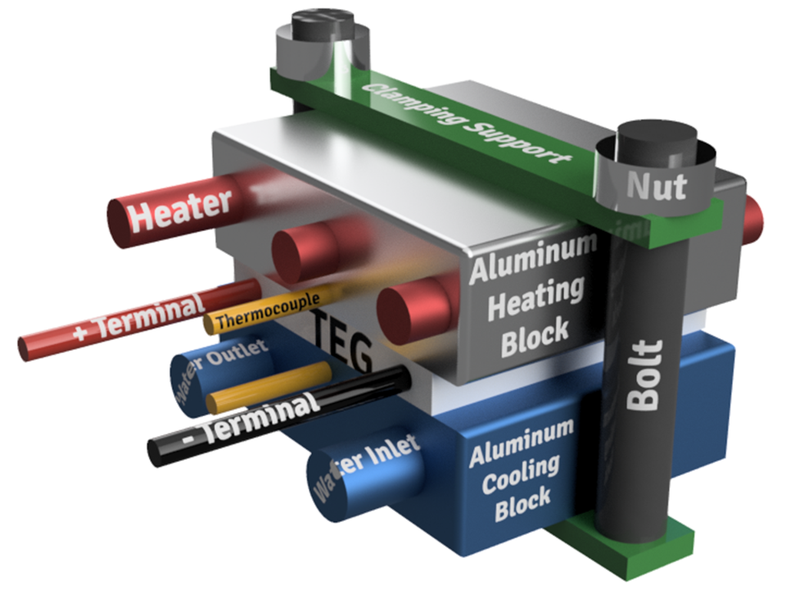
Figure 1.1. Schematics of the experimental setup used for the performance analysis of the single
TEG module
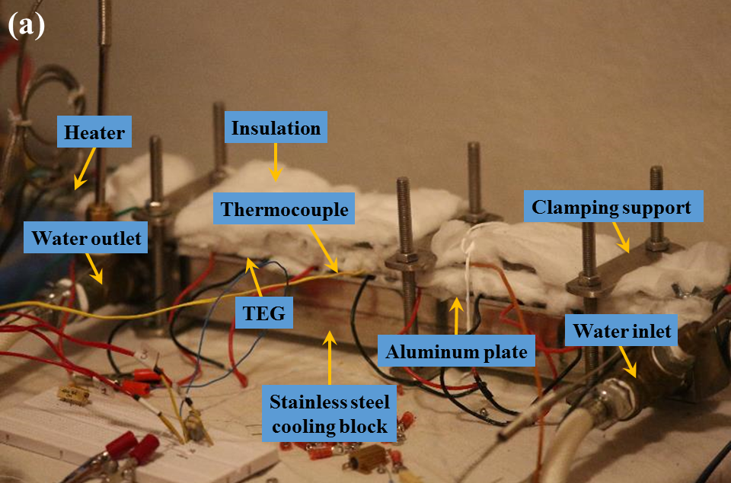

Figure 1.2 (a) Laboratory scale conventional HSTEG system that is used for the experimental analysis (Insulation on the bottom part is removed just for taking this picture)

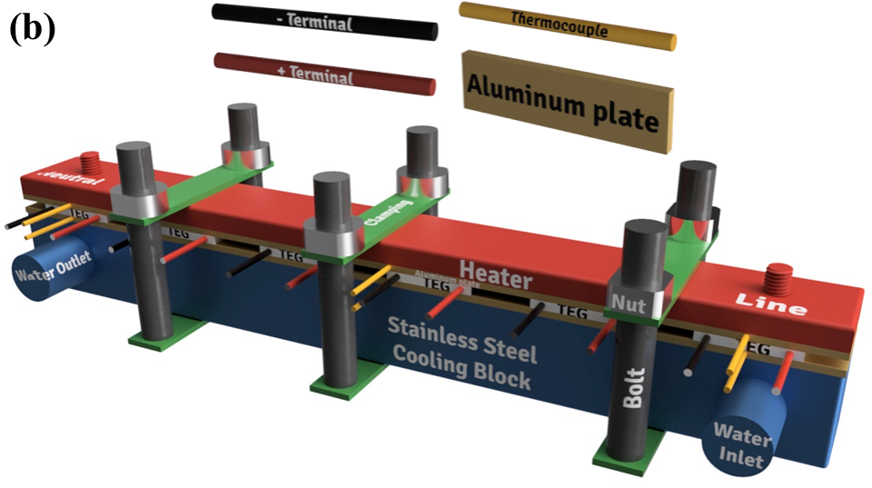

Figure 1.3 (b) Schematics of the laboratory based conventional HSTEG system
Figure 1.1, shows the schematics of the experimental setup, which is used for measuring the open-circuit voltage, current, power and electrical efficiency of a single TEG module. The parameters of the commercially available TEG module (Everredtronics – Model# TEG1–27– 1.4–1.0, see Appendix IV) that used in this experiment are given in Table 1.1 [17]. The TEG
module is sandwiched between the aluminum heating and cooling blocks (dimension: 40 mm, 50 mm and 15 mm). Three cartridge heaters (50 W each, diameter – 6.5 mm and length – 50 mm), which are connected in series, are inserted within the heating block and the input to the heater is varied using a Variac. Two K–type thermocouples are also inserted within the aluminum blocks for measuring the temperature of the hot side and cold side surfaces of the TEG as shown in the
Figure 1.1. The inlet water temperature of the cooling block is maintained at about 18 °C with a mass flow rate of 0.07 kg/s. Two Envada universal data loggers (Model: EN6000B6-23, 8 channels) are used for measuring (the voltage and current) from the TEG module and the temperature signal from the thermocouple. The maximum power point measurement system (MPPM) is
developed with a voltage source (NI-9263) and an universal data logger (Envada) as similar to that used by Crisostomo et al. [18] for measuring the maximum power output of the TEG module at a matched load condition. Table 1.1 Parameters of the commercial TEG module used in the experiments (Everredtronics –
Model# TEG1–27–1.4–1.0)
Below-mentioned specifications are based on that the hot side temperature is at 160℃ and cold side at 50℃
Parameters Specification Dimensions (mm) 40×40
Material Bi2Te3 Number of p and n legs pair 127
Open-circuit Voltage 6.4
Matched load 1.8
Matched output Voltage (V) 3.2
Matched output Power (W) 5.2
Figure of merit of the module - ZTM 0.4
The heat flux applied to our design is in line with commercial parabolic trough collectors e.g. Luz, Euro trough, and Ultimate Trough designs in order to simulate real commercial operation. The theoretical results in terms of power output (PTEG-Theory), electrical efficiency (ηElec-Theory) and thermal efficiency (ηTh-Theory) are compared with experimental results for the heater input power/solar irradiance of ~9–24 kW/m2.The inlet water temperature of the cold side block is maintained at about 26 °C with a mass flow rate of 0.19 kg/s, while the inlet water temperature of the hot side block varied from 30–90 °C, with mass flow rate of 0.15 kg/s. Two Envada universal data loggers (Model: EN6000B6-23, 8 channels) are used for measuring the (voltage and current) from the TEG module and the temperature signal from the thermocouple. The MPPM and data logging configurations are used as similar to the single TEG module measurement the time dependent open-circuit voltage (OCV) for the laboratory
scale advanced HSTEG system. The OCV is plotted with the time up to 1220 seconds while the heater power input is kept constant at 250 W, corresponding to solar irradiance of 15.6 kW/m2 . The heat flux applied to our design is in line with commercial parabolic trough collectors, which vary between ~9–24 kW/m2 . It can be seen that the OCV values are saturated almost from the
beginning, because the circulation bath was able to maintain the hot side tube inlet fluid temperature, THfi constantly at the set temperature the open-circuit voltage
(OCV) and the average temperature difference between the hot and cold side tube, ΔT plotted as a function of THfi for the laboratory scale advanced HSTEG system. It can be observed, that both the OCV and ΔT, varies linearly with THfi. OCV achieved by the laboratory scale advanced HSTEG system, for THfi of 40, 50, 60, 70, 80 and 90 °C, is about 0.8, 1.5, 2.2, 3, 3.8 and 4.58 V, respectively, corresponding to ΔT of 13.6, 22.8, 31.6, 40.9, 50.7 and 60.1 °C, respectively
1.6. Summary
A detailed experimental analysis showed that the maximum power output and electrical efficiency achieved by the single TEG module is around 3 W and 2.7%, respectively for a temperature difference (ΔT) of about 198 °C with a heater input power of about 112 W. The conventional HSTEG is capable of producing a maximum electrical power output of 4.7 W, an
electrical efficiency of 1.2% and thermal efficiency of 61% for an average temperature difference (ΔTavg) of 92 °C across the TEG modules with a heater power input of 382 W. Laboratory scaled advanced HSTEG system was able to achieve a maximum electrical power of about 197 mW with corresponding electrical and thermal efficiency of about 0.1% and 63.5% for the hot side tube inlet temperature of 90 °C. Though, the electrical efficiency of the laboratorybased advanced HSTEG system is very low, but, it could be improved by enhancing the ΔTavg and using TEG module with ZT higher than 1. Moreover, the proposed advanced HSTEG system opens up a huge potential for the generation of both heat and electricity in an efficient manner with high temperature heat output from the hot side of the HSTEG system. The relative error for both the power output and electrical efficiency varies between 1– 10% for the conventional HSTEG system and 3–6% for the advanced HSTEG system, respectively, but this could be improved by relaxing the fixed ZTM assumption used here – a value, which in reality is sensitive to temperature change. The relative error for the thermal efficiency is falls within 2% and 6% for the conventional and advanced HSTEG system, respectively. Investigation shows that the theoretical results are in good agreement with the experimental results and that the relative error could be further reduced by, using improved empirical data. This experimental/theoretical analysis serves as a fundamental basis to understand the complex energy transfer processes in HSTEG systems.
- Conclusions
Theoretical and experimental investigation of novel (advanced) and conventional (with/without vacuum enclosure) HSTEG systems are presented in this dissertation. Wellformulated theoretical models of conventional and advanced HSTEG system are established to estimate the heat loss, power generated from the TEG, thermal efficiency and electrical efficiency. These theoretical models enable us to evaluate the performance by analyzing important parameters such as the geometric solar concentration ratio (CR), solar insolation, figure of merit (ZT) of the TEG module, hot side tube inlet fluid temperature (THfi), cold side tube inlet fluid temperature (TCfi), mass flow rate (ṁ) and wind speed (Ws). Laboratory scale experimental setups of conventional and advanced HSTEG systems are developed and used for measuring the open-circuit voltage, current, power, electrical efficiency and thermal efficiency. Experimental setup consists of the six TEG modules connected in series, these TEG module are sandwiched between the aluminum plates. This arrangement is then sandwiched between (the strip heater and stainless steel cooling block) and (stainless steel block (hot and cold side) and the strip heater) for the conventional and advanced HSTEG systems respectively. Aluminum plates are used in order to measure the average surface temperature across the TEG module using six thermocouples. In addition to the clamping support, thermal interface material (heat sink paste or graphite sheet) is used to reduce the thermal contact resistance between the surfaces. Refrigerated/heating circulation bath is used for maintaining the inlet hot side fluid temperature at a constant level for the advanced HSTEG system. Finally,
thick glass wool insulation is used to reduce the heat loss from the system. Two Envada universal data loggers are used for measuring (the voltage and current) from the TEG module and the temperature signal from the thermocouple. Maximum power point measurement system (MPPM) is developed for measuring the maximum power output of the TEG module at a matched load condition.

  - Conventional HSTEG system
• Theoretical analyses show that the maximum TEG electrical and thermal efficiency that could be achieved by the V–HSTEG and B–HSTEG systems is about (5.6 and 70.3%) and (5.7and 69.8%), respectively (for CR = 25 and 55, THfi = 20 °C, and varying ZT).
• Maximum TEG electrical and thermal efficiency that could be achieved by the conventional HSTEG system is about 11.6 and 65.4%, respectively (for CR = 135, THfi = 20 °C, and ZT = 1).
• Experimental analysis shows that the maximum power output and electrical efficiency
achieved by the single TEG module is around 3 W and 2.7%, respectively for ΔT
(temperature difference across the TEG module) of about 198 °C with a heater input power of about 112 W.
• Laboratory scale conventional HSTEG is capable of producing a maximum electrical power output of 4.7 W, an electrical efficiency of 1.2% and thermal efficiency of 61% for an average temperature difference (ΔTavg) of 92 °C across the TEG modules with a heater power input of 382 W.
• Comparative analysis between the theoretical and experimental values shows that the relative error for both the power output and electrical efficiency varies between 1–10% and it falls within 2% for the thermal efficiency.

  - Advanced HSTEG system
• Maximum TEG electrical and thermal efficiency that could be achieved by the SC-PTTR system is about 5.4% and 62.7%, respectively (ZT = 1, THfi = 300 °C, TCfi = 27 °C) for an optical efficiency of about 75%. However, the maximum TEG electrical and thermalefficiency could be as high as 5.9% and 69% %, respectively (ZT = 1, THfi = 300 °C, TCfi
= 27 °C) for an optical efficiency of 81%.
• Laboratory scaled advanced HSTEG system was able to achieve a maximum electrical
power of about 197 mW with corresponding electrical and thermal efficiency of about 0.1% and 63.5% for the hot side tube inlet temperature of 90 °C. Though, the electrical efficiency of the laboratory based advanced HSTEG system is very low, but, it could be improved by enhancing the ΔTavg and using TEG module with ZT higher than 1.
• Comparative analysis between the theoretical and experimental values shows that the relative error for both the power output and electrical efficiency varies between 3–6% and it falls within 6% for the thermal efficiency.
In summary, comparative analysis between the theoretical and experimental shows that the results are in good agreement and that the relative error could be further reduced by, using improved empirical data. Thus experimental/theoretical analysis reported in this thesis serves as a fundamental basis to understand the complex energy transfer processes of HSTEG systems. Moreover, the proposed advanced HSTEG system opens up a huge potential for the generation of both heat and electricity in an efficient manner with high temperature heat output from the hot side of the HSTEG system.

- Future work
• In an experimental setup using electrical heaters to simulate the equivalent solar energy, is a wide spread practice, however, primarily it would be useful in understanding the steady state response for a certain input. Hence, author proposes that a prototype could be
built with a solar concentrator to study real time (transient) response of the system in detail.
• Author propose that the performance of the advanced HSTEG systems could be analyzed using a vacuum enclosure, since it would help in understanding the heat transfer from the hot side tube to cold side tube.
• Semi-cylindrical Parabolic Trough Thermoelectric Receiver (the tri-segmented geometry), in which the thermoelectric generator module is sandwiched between two semi-cylindrical tubes, possess an inherent advantage providing high and low temperature heat output from the hot side and cold side, respectively. Author proposes that investigation could be made in analysing the amount electrical energy output that could be converted using the high temperature output from the hot side in a solar thermal power plant. Further, a very ambitious study could be made in using the low temperature heat out from cold side tube in a solar vapour absorption air conditioning system; it is worthy to mention here that the complexity of the system increases tremendously.
• Computational Fluid Dynamics (CFD) software can be utilized to analyse the performance of the HSTEG system more vigorous via 3D modelling.
• Economic analysis of the advanced HSTEG system could be carried out to estimate the cost efficiency of the system in comparison with other solar power and process heating systems

- Reference

[1] P. Sundarraj, D. Maity, S.S. Roy, R.A. Taylor. Recent advances in thermoelectric materials and solar thermoelectric generators - a critical review. RSC Adv. 4 (2014) 46860-74.

- D. Kraemer, B. Poudel, H.-P. Feng, J.C. Caylor, B. Yu, X. Yan, et al. High-performance flatpanel solar thermoelectric generators with high thermal concentration. Nat Mater. 10 (2011) 532- 8.

[3] A. Mojiri, R. Taylor, E. Thomsen, G. Rosengarten. Spectral beam splitting for efficient conversion of solar energy—A review. Renew Sust Energ Rev. 28 (2013) 654-63.

[4] B. Parida, S. Iniyan, R. Goic. A review of solar photovoltaic technologies. Renew Sust Energ Rev. 15 (2011) 1625-36.

[5] H.L. Zhang, J. Baeyens, J. Degrève, G. Cacères. Concentrated solar power plants: Review and design methodology. Renew Sust Energ Rev. 22 (2013) 466-81.

[6] M.A. Green, K. Emery, Y. Hishikawa, W. Warta, E.D. Dunlop. Solar cell efficiency tables (version 43). Progr Photovoltaics: Res Appl. 22 (2014) 1-9.

[7] M.A. Green, K. Emery, Y. Hishikawa, W. Warta, E.D. Dunlop, D.H. Levi, et al. Solar cell efficiency tables (version 49). Progress in Photovoltaics: Research and Applications. 25 (2017) 3-13.

[8] Renewable Energy Technologies - Cost analysis series (PV) Int Energy Agency. (2012; available at http://www.irena.org).

[9] S. Kuravi, J. Trahan, D.Y. Goswami, M.M. Rahman, E.K. Stefanakos. Thermal energy storage technologies and systems for concentrating solar power plants. Progr Energy Combust Sci. 39 (2013) 285-319.

[10] D.Y. Goswami, F. Kreith, J.F. Kreider. Principles of solar engineering. CRC PressI Llc2000.

[11] J. Mariyappan, D. Anderson. Solar Thermal thematic review SolarPACES Annual Report. (2001).

- S.A. Kalogirou. Solar thermal collectors and applications. Progr Energy Combust Sci. 30 (2004) .

- M. Xie, D.M. Gruen. Potential Impact of ZT= 4 Thermoelectric Materials on Solar Thermal Energy Conversion Technologies†. J Phys Chem B. 114 (2010) 14339-42. 126

- W.T. Xie, Y.J. Dai, R.Z. Wang, K. Sumathy. Concentrated solar energy applications using Fresnel lenses: A review. Renew Sust Energ Rev. 15 (2011) 2588-606.

- A. Fernández-García, E. Zarza, L. Valenzuela, M. Pérez. Parabolic-trough solar collectors and their applications. Renew Sust Energ Rev. 14 (2010)

- M.H. Ahmadi, A.H. Mohammadi, S. Dehghani, M.A. Barranco-Jiménez. Multi-objective
thermodynamic-based optimization of output power of Solar Dish-Stirling engine by
implementing an evolutionary algorithm. Energy Convers Manage. 75 (2013) 438-45.
[17] S.H. Alawaji. Evaluation of solar energy research and its applications in Saudi Arabia — 20
years of experience. Renew Sust Energ Rev. 5 (2001) 59-77.
[18] E. Weston. Apparatus for Utilizing Solar Radiant Energy. United States Patent US389124
A1888 Sep 4.
[19] L. Weinstein, K. McEnaney, G. Chen. Modeling of thin-film solar thermoelectric
generators. J Appl Phys. 113 (2013) 164504.
[20] H. Xi, L. Luo, G. Fraisse. Development and applications of solar-based thermoelectric
technologies. Renew Sust Energ Rev. 11 (2007) 923-36.

