Automated System for Waste Segmentation and Disposal
Amal Khan P¹, Anagha B², Shadiya Farhana V P³, Sudhina S⁴ & Ms. Ajeena A⁵
^{1,2,3&4}UG Students, Department of Electronics and Communication Engineering, Jawaharlal College of Engineering and Technology, Ottapalam, Kerala, India
⁵Assistant Professor, Department of Electronics and Communication Engineering, Jawaharlal College of Engineering and Technology, Ottapalam, Kerala, India

---------------------------------------------------------------------***---------------------------------------------------------------------

Abstract - This paper provides a brief an overview of the expanding waste management issue and the necessity of effective waste separation and disposal systems is given in this paper. This demonstrates the difficulties with conventional waste management techniques and the significance of appropriate waste segregation in reducing environmental effect. The effective separation of garbage into three categories—dry, metallic, and wet—is the specific goal of this endeavour. The system uses three important sensors—a moisture sensor, a metallic sensor, and an infrared (IR) sensor—to do this. Every sensor is essential to the detection of the waste that it is designed to detect. The system facilitates proper disposal by automatically opening the corresponding bin when garbage is detected. The integration of the Blink software, which enables easy control of trash separation and disposal using an Android phone, is one noteworthy aspect of this project.

Key Words: IR Sensor, Moisture sensor, Metallic Sensor, Blink App

1.INTRODUCTION
Currently, one of the biggest challenges facing large cities worldwide is successfully managing their trash without causing the city to become dirty. In today's trash management systems, a big number of workers are assigned to regularly visit a specific number of dumpsters on a daily basis. This results in a highly messy and inefficient system where some dumpsters may not even be halfway filled while others will be overflowing. This is due to fluctuations in the city's population density or some other random element, which makes it hard to pinpoint which area requires emergency care. Here, a waste management system is presented. Each dumpster has an embedded monitoring system that alerts the appropriate person when the dumpster is full.Wet and dry garbage can also be separated into two different containers using this approach. The waste management issue is effectively solved by this system[1].
In the modern world, waste disposal is a major source for concern. The way that a large quantity of created waste is disposed of has had a negative impact on the environment. This strategy has an impact on plant, animal, and human health. Hazardous chemicals are produced by the destructive waste disposal approach, contaminating both surface and groundwater. It may produce disease vectors, which disseminate dangerous illnesses. In addition to being an inefficient use of land resources, this diminishes the aesthetic value of the surrounding landscape. Waste cannot be considered economically valuable unless it is recycled entirely[6]. Technological developments have also made it possible to process the garbage and turn it into productive organisations like garbage to Energy, which uses the waste to produce synthetic gas, or syngas, which is a mixture of hydrogen and carbon monoxide. After that, the gas is burned to create steam and power; waste to fuel, from which the waste can be made into biofuels. Waste has a better chance of recovery and can thus be recycled and reused when it is divided into fundamental streams like wet, dry, and metallic. The moist waste portion is frequently turned into methane gas, compost, or both.Biogas can be utilised as a source of energy, and compost can take the place of chemical fertilisers. It is possible to recycle or reuse the metallic waste [2].
Global material consumption and the amount of material waste per person have increased dramatically, endangering the attainment of Sustainable Development Goal 12 of the Sustainable Development Goals of the United Nations. In order to prevent the overuse of resources or the degradation of environmental resources, immediate action is required. This action should include policies that increase resource efficiency, cut waste, and integrate sustainable practices into all spheres of the economy. Global material consumption increased to 92.1 billion tonnes in 2017 from 87 billion in 2015 and a 254 per cent increase in % rise from 27 billion in 1970, and since 2000, the pace of extraction has been growing annually. This is a reflection of the decades-long rise in demand for natural resources, which has placed an excessive load on environmental resources. In the absence of swift and coordinated political measures, it is predicted that the amount of resources extracted worldwide may increase to 190 billion tonnes by 2060 [3].

2. Existing System
The effective separation of garbage into three categories—wet, metallic, and dry—is the particular focus of this study. The system uses three important sensors—a moisture sensor, a metallic sensor, and an infrared (IR) sensor—to do this. Every sensor is essential for identifying the waste that it is meant to detect. The technology opens the appropriate container immediately when garbage is detected, making proper disposal easier. The incorporation of the Blink software, which enables easy control of trash separation and disposal using an Android phone, is one noteworthy aspect of this project. This function offers flexibility and convenience of use by allowing customers to manage garbage from any location. Multiple advantages can be attained by putting this automated system into place[4].

3. Proposed System
With this suggested system, you may monitor several waste parameters and determine the type of garbage by utilising sensors such as moisture, infrared, and metal sensors. You can find any metallic waste in the trash by using the metallic sensor. A buzzer will sound to alert the public and authorities if the amount of metallic waste reaches its maximum. In addition to serving as a reminder when the bins are full, the IR sensor can assist in the detection of dry trash and plastic waste. The moisture sensor can also identify and direct various types of wet garbage to the proper bin[7]. The fact that this project uses the Java programming language and Firebase database to develop the Blink app, which enables for remote waste level monitoring, is impressive. You may have control and convenience with this feature, no matter where you are in the globe. Through the use of cutting-edge sensor technology and automated waste segregation, this system has the ability to enhance waste management procedures, lower health hazards, and create a cleaner, healthier environment.

4. Hardware
4.1 ARDUINO MEGA
Strong microcontroller boards like the Arduino Mega are essential components for many embedded systems and electronics applications. The ATmega2560 microcontroller, with its astounding range of features and capabilities, is at its core. With sixteen analogue inputs and fifty-four digital input/output pins—of which fifteen can be utilised as PWM outputs—the Mega provides a vast array of options for both creative expression and practical adaptability. Its large memory capacity allows for complicated algorithms, data storage, and multitasking. It has 256 KB of flash memory for programme storage and 8 KB of SRAM.The Mega's versatility is further enhanced by its compatibility with a large variety of sensors, actuators, and communication modules, which allow for easy integration into projects ranging from industrial control systems to robotics and home automation, among other things.

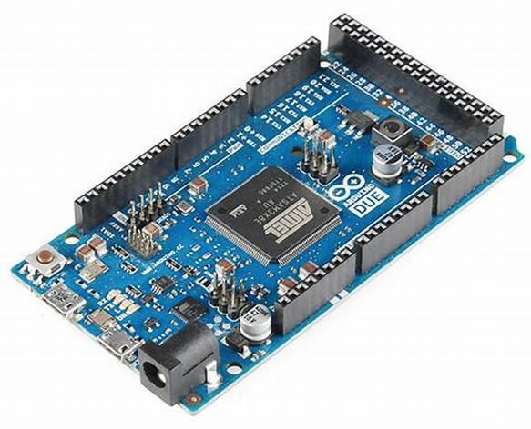
Fig 1: Arduino Mega

4.2 IR SENSOR
A device that picks up infrared radiation generated by objects is called an infrared (IR) sensor. It functions on the premise that heat energy is emitted by all objects above absolute zero in the form of infrared radiation. Usually, these sensors are made up of an IR emitter and a receiver. Infrared radiation is emitted by the emitter, reflects off of things, and is subsequently detected by the receiver. The radiation is collected and transformed by the receiver into an electrical signal that can be used for analysis to detect changes in temperature or the presence or absence of things.
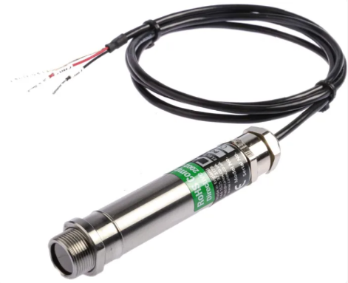
Fig 2: IR Sensor
4.3 INDUCTIVE PROXIMITY SENSOR
Without making physical contact, an inductive proximity sensor may identify whether or not metallic items are present. It works using the electromagnetic induction concept. Usually, these sensors are made up of a coil, a detection circuit, and an oscillator circuit. An electromagnetic field with a high frequency is produced around the coil by the oscillator. The electromagnetic field is disrupted and the coil's impedance changes when a metallic object reaches the sensor's sensing range. The detection circuit notices this change and subsequently generates an output signal that indicates the object's presence. Industrial automation uses inductive proximity sensors extensively for purposes like location sensing, object detection, and speed monitoring.
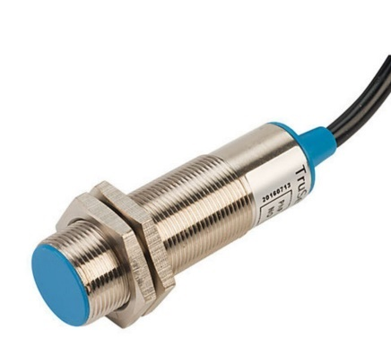
Fig 3: Inductive Proximity Sensor

4.4 MOISTURE SENSOR
A moisture sensor is a tool used to gauge the amount of water or moisture present in a certain material or environment. It is frequently employed in many different fields, including gardening, building maintenance, and agriculture. The sensor determines whether moisture is present or absent and outputs information or feedback for tracking or management. For instance, in gardening, a moisture sensor can assist in determining when plants require watering in order to promote healthy growth and resource conservation. A moisture sensor is a tiny device that indicates the relative moisture content of an object. It functions something like a little detective and can detect the amount of moisture or water in materials like soil and air. This can be quite beneficial in a variety of circumstances. If you enjoy gardening, for instance, a moisture sensor can tell you when to water your plants. It's a useful tool that aids in maintaining equilibrium and ensuring that everyone is content and healthy!

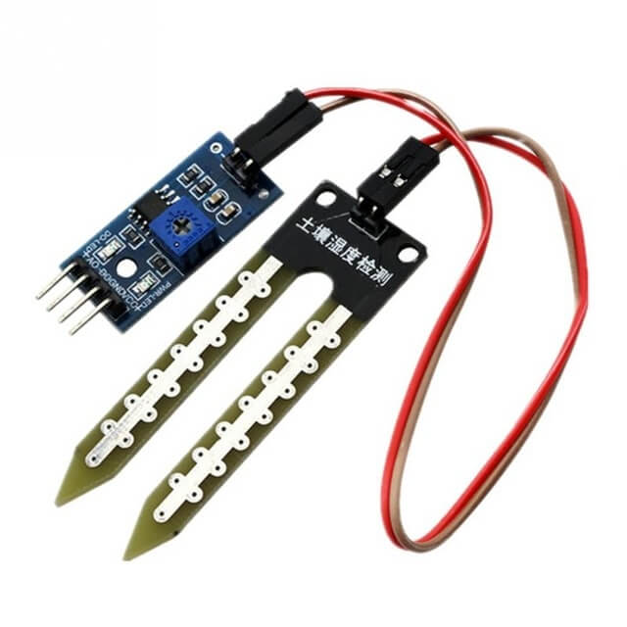
Fig 4: Moisture Sensor

4.5 NODE MCU
Combining the ease of Lua programming with the power and versatility of the ESP8266 Wi-Fi module, the NodeMCU is an open-source development board. It is based on the ESP-12E module and has an integrated USB-to-serial converter that facilitates code uploading and programming. The NodeMCU board has GPIO ports for sensor and actuator interface, inbuilt Wi-Fi connectivity, and support for many communication protocols like MQTT, HTTP, and TCP/IP, making it an affordable option for Internet of Things (IoT) projects. It may be programmed in either the Arduino IDE or the Lua programming language, allowing developers to work in whatever environment suits them best.

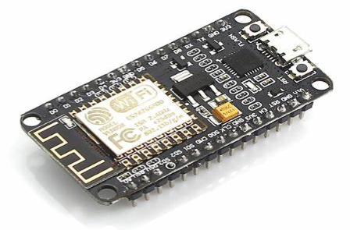
Fig 5: Node MCU

4.6 LCD DISPLAY
Technology known as LCD (Liquid Crystal Display) has completely changed how information is shown and used in a variety of electronic gadgets. An LCD display is composed of a panel of many small liquid crystal cells positioned between two glass substrates and two polarising filters. Depending on the electric charge given to them, these cells have the ability to either block or permit light to pass through. This characteristic allows the display to selectively alter the flow of light to form text and images. Compared to conventional CRT displays, LCD displays provide a number of benefits, such as sharp image clarity, high resolution, and low power usage. They are extensively utilised in many gadgets, including digital cameras, cell phones, computer monitors, and televisions.
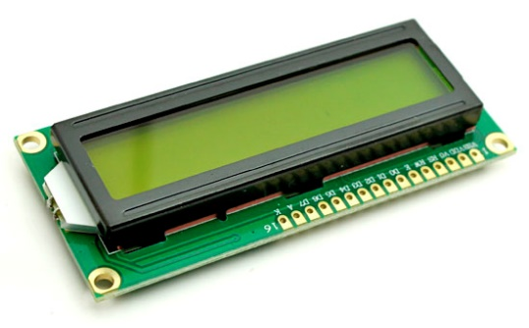
Fig 6: LCD Display
4.7 SERVO MOTOR

A servo motor is like a super precise rotary actuator that helps control the angle of rotation. It's made up of a motor and a position feedback sensor, usually a potentiometer. Servo motors are used in lots of cool applications that need really accurate motion control, like robotics, remote-controlled vehicles, industrial automation, and model aircraft. One of the coolest things about servo motors is that they can move to a specific position based on the feedback they get from the sensor. This means they're great for precise positioning and movement. They're also known for having a lot of torque, which means they can exert a lot of force even at low speeds. You can control servo motors using different methods, like pulse-width modulation (PWM) signals, analog voltage signals, or digital signals from microcontrollers or computers.
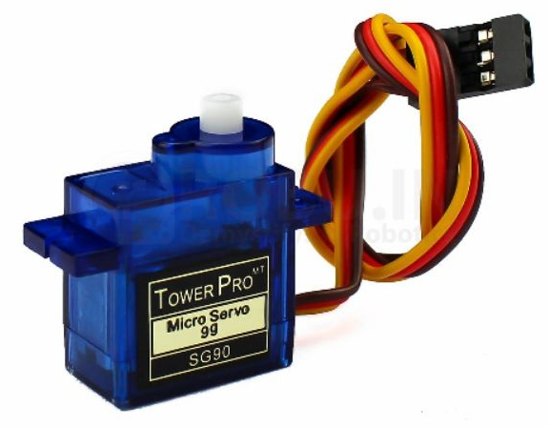
Fig 7: Servo Motor
5. Software
Firebase Database is like a super cool cloud-based database provided by Google. It's a place where developers can store and sync data in real-time between different devices and platforms. It's perfect for building web and mobile apps that need real-time updates and collaboration. And guess what? The Blink app is an awesome application that uses Firebase Database as its main software! It's all about the Automated System for Waste Segmentation and Disposal that we talked about earlier. The Blink app, which is built using Java-based programming, connects to the Firebase Database and gives you a user-friendly interface. With the Blink app, you can control and monitor waste levels in the bins from anywhere in the world. You can see how much waste is in each bin, get real-time updates on the waste segregation process, and even open and close the bins. It's a super convenient way to manage waste disposal efficiently
In our project, we used Java programming language in the Arduino IDE software to program the Arduino Uno and NodeMCU. These two components team up to separate different types of waste, like wet, metallic, and dry waste, into separate bins. Once the waste is successfully sorted, the LCD display shows which type of waste it is. It's a pretty neat way to keep things organized!
One of the really cool things about our project is that we can actually control and keep an eye on the waste levels from anywhere in the world using the Blink app. The Blink app uses a special kind of database software that's based on Java. This software helps create an automated system for waste segregation and disposal. It makes sure that the waste level info is shown accurately on the app, and we can even control when the bins open and close, all from a distance.

6. Circuit Diagram
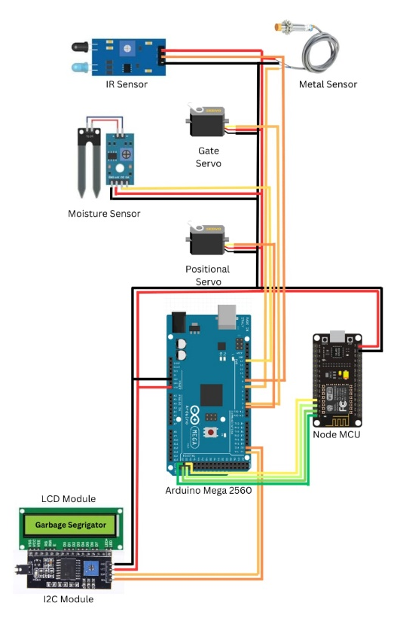

7. Result and Discussion

The segregator bin was tested for various materials . Following some delay, the materials fell into the appropriate compartments. Compartment A is for dry waste, compartment B is for wet waste and compartment C is for metallic waste. The LCD also displays the type of waste that is placed on the tray[8].
Additionally, LCD displays a message that indicates which compartment is full, depending on the readings of two IR proximity sensors fitted in each compartment of the segregator bin[9].

8. CONCLUSIONS
Implementing this system at a local level, such as in societies or educational institutes, can lighten the load on local authorities. The automatic waste segregator is a step towards creating an efficient and cost-effective waste collection system with minimal human intervention and no risk to human life. During the implementation process, we encountered challenges like adjusting the sensing range of the inductive proximity sensor, ensuring accuracy of the moisture sensor, and fine-tuning the range of the IR sensors. Despite these obstacles, we made modifications to make the system as reliable as possible, though it's not perfect.

REFERENCES
- Smart Waste Management System using Arduino, Shwetasree Vijay and Pilla Nitish Kumar, Vellore Institute of Technology, Vellore, India.
- Strength Indicator Values-based Mobile Robot” 2019 IEEE
- Arduino Based Automated Waste Segregator Final Year Project by Arunkumar Balakrishnan Iyer
- Design and Implementation of Automated Waste Segregator with Smart Compression, John Paul S
- Automated Waste Segregation machine using Arduino Controller Jasmine. Loyola Institute of Technology, Chennai, India
- Smart Waste Management System using IoT and Blockchain Technology" by Priyanka Gupta.
- Automated Waste Sorting System Based on Deep Learning" by Jing Wang
- Waste Segregation and Classification using Convolutional Neural Networks"* by Muhammad Khurram Khan
- Automatic Waste Segregation Machine Using Image Processing and Arduino Microcontroller" by Niraj Yadav
- Waste Management System Using IoT and Machine Learning for Waste Segregation" by A. Kirubakaran
- Automated Waste Segregation System using Machine Learning and Internet of Things (IoT)" by Amol Padmakar Dhande

