DESIGN AND COMPARATIVE ANALYSIS OF T-BEAM & BOX GIRDER BRIDGE USING FEA

Avishkar K. Jadhav¹
¹P.G. student, Department Of Civil Engineering, G H Raisoni College Of Engineering And Management, Pune, Maharashtra, India
avishkar.jadhav.mtechstr@ghrcem.net¹, girish.joshi@raisoni.net²

ABSTRACT
The pre-stressed concrete bridges have excellent riding characteristics that minimize traffic vibrations, torsional rigidity, less likely to crack prematurely continuous span, strength and the most noteworthy characteristic is natural frequency of vibration hardly matches with vehicle frequency therefore attained spacious acceptance in freeway, highway flyovers, and in modern metro rail systems. As bridges are the important structures should be capable to withstand static as well as dynamic loads specially, earthquake-induced load to achieve a structure that behave at the level of life safety under enormous earthquakes. The present article shows the linear dynamic behavior of T-beam girder and box girder bridge deck and compares static as well as dynamic behavior. Response spectrum analysis has been performed by using FEM based software in order to check the resonance criteria of bridge and to determine most favorable option from above two. The results show that response parameters for box girder such as bending moment, shear forces, deflection, time period, base reaction, longitudinal stresses and shear stresses are increases as the span length increases while fundamental frequency decreases. From the study it is finalized that box girder is the conservative solution as compared to T-beam girder bridge superstructure.
Keywords: - T-beam girder, Box girder, Dynamic analysis, ANSYS

I. INTRODUCTION

1.1 GENERAL
Bridges are the life line of road network, both in urban and country zones. With fast innovation development, the commonplace bridge has been supplanted by creative practical structural system. One of these courses of action presents basic RCC framework that is T-Beam and Box Girder.
Bridge design is a goal and what's more personalities boggling approach for an structural design. Just as there should rise an occasion of Bridge design, span length and live loads are consistently fundamental variables. These parts affect the conceptualization time of plan. The impacts of live load for different extents are moving. Choice of structural system for a cross is continually a range in which investigate should be possible. Structural system got is influenced by fragments like economy and fancy being created. Code strategy engages us to pick structural system i.e. T- Beam Girder and Box Girder. The decision of sparing and

constructible basic framework relies on upon the outcome.
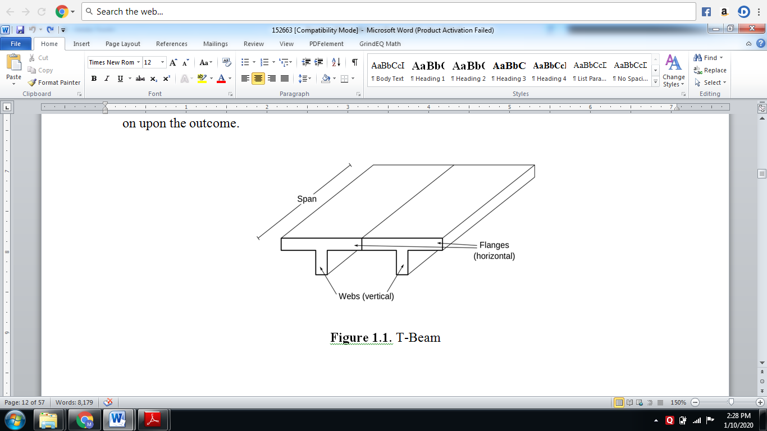
Fig 1: T-Beams

1.1.1 T-Beam
T-beam utilized as a part of construction, is a load bearing structure of reinforced concrete, wood or metal, with a t-formed cross area. The highest point of the t-molded cross segment fills in as a flange or pressure part in opposing compressive stress. The web (vertical area) of the beam beneath the compression flange serves to oppose shear stress and to give more noteworthy detachment to the coupled strengths of bending

1.1.2 Girder
Girder is a term used in construction to refer to a supporting, horizontal beam that can be made from a variety of construction materials such as stainless steel, concrete, or a combination of these materials. A girder bridge is a basic, common type of bridge where the bridge deck is built on top of such supporting beams, that have in turn been placed on piers and abutments that support the span of the bridge. The types of beams used for girder bridges are usually either I- beam girders, so called because their shape is reminiscent of a capital Roman letter I, or box girder beams that are made of steel or concrete and shaped like an open box. Girder bridges are most commonly used for straight bridges that are 33-650 feet (10-200 m) long, such as light rail bridges, pedestrian overpasses, or highway fly-over. The longest girder bridge in the world is 2,300 feet (700 m) long and located in Brazil.
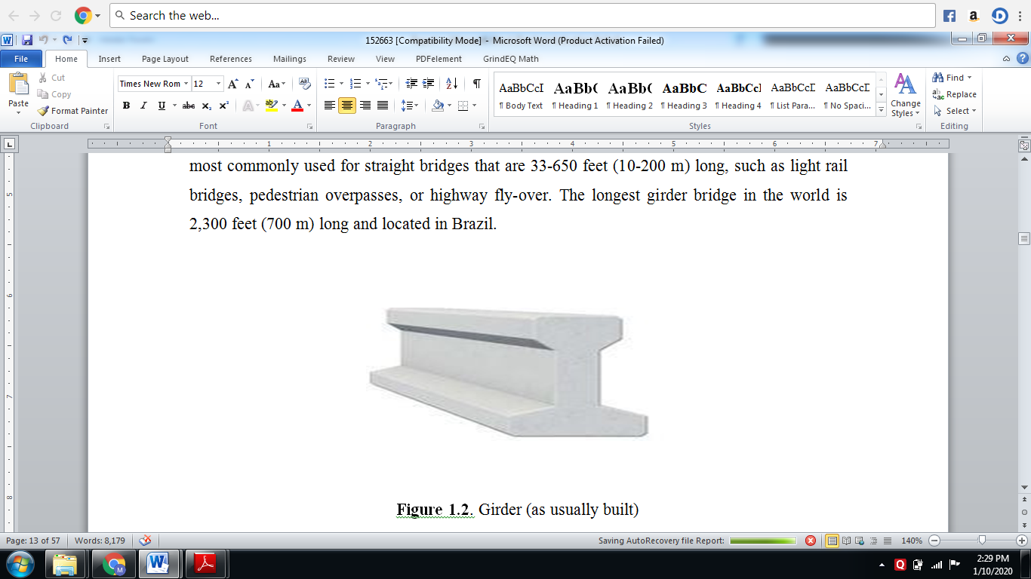
Fig 2: Girder (as usually built)

1.1.3 Box Girder
A Box Girder Bridge is a Bridge in which the primary Beam involve girder in the shape of a hollow box. The box girder typically involves either pre-stressed concrete, structural steel, or a composite of steel and reinforced cement. The box is ordinarily rectangular orin cross-area. Box Girder Bridge is generally utilized for highway flyovers and for present day elevated structures of light rail transport. Although regularly the crate box girder bridge is a type of beam bridge, box girder may likewise be utilized on cable stayed bridges and different structures.
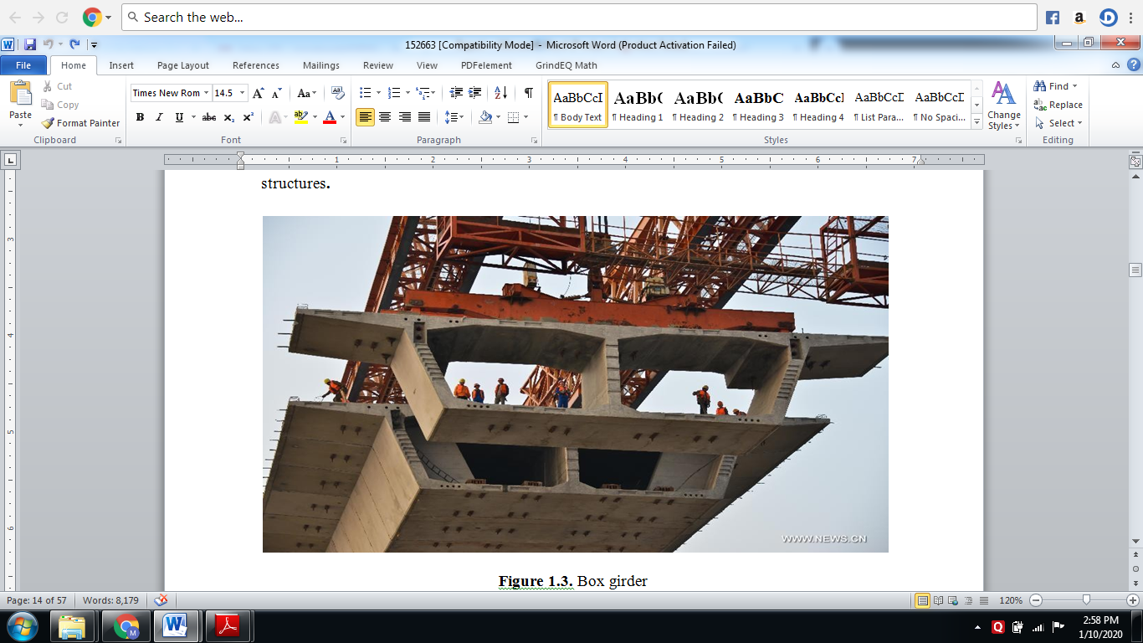
Fig 3: Box girder

1.2 COMPUTERS AND STRUCTURES
ANSYS develops and markets finite element analysis software used to simulate engineering problems. The software creates simulated computer models of structures, electronics, or machine components to simulate strength, toughness, elasticity, temperature distribution, electromagnetism, fluid flow, and other attributes. ANSYS is used to determine how a product will function with different specifications, without building test products or conducting crash tests. For example, ANSYS software may simulate how a bridge will hold up after years of traffic, how to best process salmon in a cannery to reduce waste, or how to design a slide that uses less material without sacrificing safety.
Most ANSYS simulations are performed using the ANSYS Workbench software, which is one of the company's main products. Typically, ANSYS users break down larger structures into small components that are each modeled and tested individually. A user may start by defining the dimensions of an object, and then adding weight, pressure, temperature and other physical properties. Finally, the ANSYS software simulates and analyzes movement, fatigue, fractures, fluid flow, temperature distribution, electromagnetic efficiency and other effects over time. ANSYS also develops software for data management and backup, academic research and teaching. ANSYS software is sold on an annual subscription basis.
The objectives of this study are multi-fold. Firstly, it aims to focus on the analysis of basic RCC T-beam and Box Girder bridges under standard IRC loading conditions. This involves conducting comparative analyses based on analytical modeling using Finite Element Method (FEM) within ANSYS software, considering various spans of the bridge. Additionally, the study seeks to examine the interaction of the deck slab with the IRC-specified loading. Moreover, it aims to assess the suitability of the bridges for both short and long spans. Lastly, the study intends to evaluate code expressions pertaining to live-load distribution factors specifically for concrete girder bridges.

II. LITERATURE REVIEW
Srikrishna Dhale (2018), comparison between the ‘Tee Beam Girder’ and ‘Box Girder’ is carried out. This is helpful when we have two kinds for girder which can be used for same span; in that case the most economical one is to be selected. A bridge is a structure providing passage over an obstacle without closing the way beneath. The required passage may be for road, railway, pedestrians, canal or pipeline. In present study our main concern is with T-Beam Girder Bridge and Box Girder Bridge. This investigation aims to evaluate the structural behavior, efficiency, and performance of these two common bridge types. Through comprehensive analysis, including simulated load conditions, stress distribution, and stability assessments, this study seeks to uncover the distinct advantages and limitations of T-beam and box girder bridges. Prof. Sonal T. Pawar (2016), develop finite element method for analysis of box girder with haunches. Parametric investigations will be performed for box type of bridges with and without haunches Span range is more for box bridge girder as compare to T-beam Girder Bridge resulting in comparatively lesser number of piers for the same valley width and hence results in economy. A bridge is a structure providing passage over an obstacle without closing the way beneath. Recent developments in the field of Bridge engineering, Box Girder Bridges have heightened the need for improving the ability to carry the live load and undertaken as a result of code provisions. In this paper deals with response of haunches in box girder bridges when subjected to standard moving load. Analysis of box girder bridges can be accurately done by finite element method. Maximum bending moment occurs at the junctions of box girder, therefore provision of haunches at junctions may lead to economic solution. Raghabendra Yadav (2018), study the comparison of maximum bending moment due to live load in a girder and slab bridge for varying span length as 15m, 20m and 25m respectively of T Beam bridge using conventional method. The same bridge is analyzed as a three-dimensional model in finite element software as SAP2000, apply the same loading done for conventional methods and compared the results. The maximum bending moment results obtained from finite element model are lesser than Courbon's method which looks more conservative. The most commonly and popular type of bridge used in Nepal is T beam bridge due to it's simple in design, construction and maintenance than other types. T-beam Bridge comprises of a concrete slab integral with girders. This type of bridges is more preferred when it comes to connectivity to short distances. So, it is necessary to update the analysis and design methods. Narendra Singh (2022), In this study about dynamic analysis of PSC precast I-girder bridge and PSC box girder bridge for different parametric variation and different span range have been studied by various researchers. The parameters are geometric parameters, span range, mending moment, shear force, displacement, base shear, base moment, time period, natural frequency, and method of analysis based on different codes. On the above parameters base reaction, base moment, time period, natural frequency, absolute displacement and girder forces of bridge is essential and major concern for the analysis of bridge structure. Rao Jang Sher (2020), analysis and design of box and T beam girder has been performed using SAP2000 in order to find out the most suitable type of bridge superstructure. The main objective of this study is to compare the structural behavior, optimization of materials used in each component and cost comparison of box and T beam girder bridge. Previous research in this regard is based upon working stress method but this research follows limit state design. Detailed comparison shows that box girder is more suitable as compared to T beam girder even for shorter span in terms of structural stability and cost efficiency. Bridges are the most important component of transportation system of any country due to their ability of accelerating the development of the nation. Design of bridge highly depends on its function, nature of soil strata where it is constructed and the material used to construct it. Sandesh Sandesh Upadhyaya K. (2016), The aim of our study was to determine the beam configuration of deck slab. In this study configurations of these bridges, namely ordinary deck slab slab supported on girders and T- sheets for conventional design which gives maximum conventionally analysed for IRC class AA loading study we have considered span lengths of 20m, 24m and loading using Courbon’s method. The process was made and 28m. The deck slab has been maximum Bending Moment and Shear Force values made faster by formulating excel arising due to dead load and live slab, girders and cross beams. Dilip Patidar (2003), investigate the effect of different dimensional variables on strength of box Girder Bridge using techniques of Finite Element Analysis. The CAD modelling and FEA simulation of box Girder Bridge is conducted using ANSYS simulation package. The deformation obtained on the bridge structure is not uniform and found to be mostly at the zones of load application and reduces on other zones. The deformation pattern is almost uniform across length and width of the bridge structure. The bending stress distribution is also observed to be non-uniform and is maximum at the regions of load application. From the structural analysis conducted on box Girder Bridge structure the structural stability is established. Abhinav Kumar, (2020), provides a comprehensive analysis of concrete T-beam girder bridges, focusing on various aspects crucial to their structural integrity and performance. Evaluating a range of research articles, structural analyses, and design methodologies, this review aims to summarize and critically assess the key factors impacting the behavior and efficiency of T-beam girder bridges. It explores the influence of parameters such as material properties, load conditions, and construction techniques on the bridges' overall performance. Bridges are the life line of road network, both in urban and country zones. With fast innovation development, the commonplace bridge has been supplanted by creative practical structural system. One of these courses of action presents basic RCC framework that is T Beam and ordinary Beam.
2.1 Research Gap
The literature extensively compares T-beam and box girder bridges, focusing on their performance under various weights and spans. However, there is a research gap in terms of employing modern design methodologies, such as optimization algorithms or novel building processes, to enhance the performance of these bridges while saving money. In addition, environmental and sustainability considerations have received little attention while selecting and developing bridges. Future research might close these gaps and make bridge architecture more efficient and environmentally benign. Addressing these issues can help progress bridge engineering, resulting in safer, more cost-effective, and environmentally friendly infrastructure solutions.

III. METHODOLOGY

3.1 METHODOLOGY

3.1.1 Dead Load Analysis
Dead load response can be physically figured by considering the dead load because of superstructure (Brace, Stomach and Deck piece). Longitudinal moments are figured similarly by duplicating responses with the longitudinal unconventionality which is the separation between the centerline of wharf and bearing. The response on each bearing because of braces, stomach and deck piece and because of Superimposed Dead Load, SIDL (wearing coat and crash hindrance) is discovered independently.

3.1.2 Live Load Analysis
Road bridge decks have to be designed to with stand the live load specified by Indian Roads Congress (I.R.C:6-2010SectionII)
In India, highway bridges are designed in accordance with IRC bridge comedic: 6 - 2010 – Section II gives the specifications for the various loads and stresses to be considered in bridge design. There are three types of standard loadings for which the bridges are designed namely, IRC class AA loading, IRC class A loading and IRC class B loading.
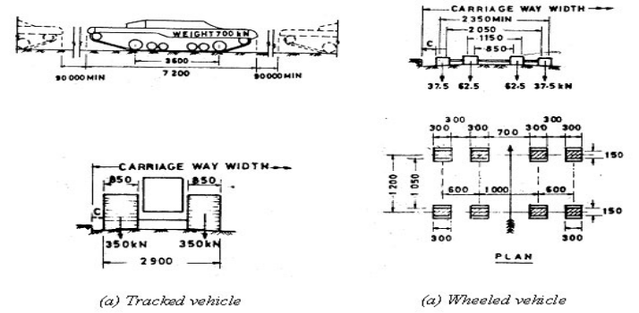
Fig 4: IRC Class AA loading
IRC class AA loading consists of either attacked vehicle of 70 tones or a wheeled vehicle of 40 tones with dimensions as shown in Fig.3.1. The units in the figure are mm for length and tones for load. Normally, bridges on national highway sand state highways are designed for these loadings. Bridges designed for class AA loading should be checked for IRC class A loading also, since under certain conditions, larger stresses may be obtained under class A loading. Some times class 70 R can be used for IRC class AA loading. Class 70 R loading is not discussed further here.
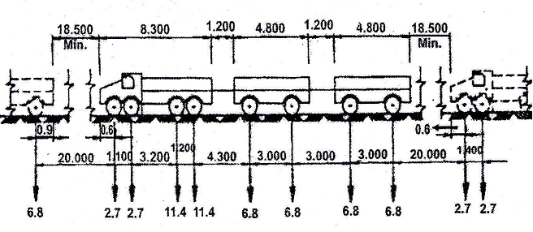
Fig 5: IRC Class A loading
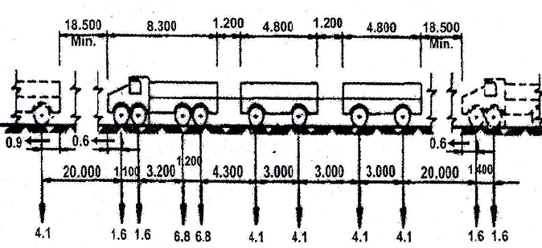
Fig 6: IRC Class B loading
Class A loading shown in Fig 3.2 consists of a wheel load train composed of a driving vehicle and two trailers of specified axle spacing. This loading is normally adopted on all roads on which permanent bridges are constructed. Class B loading shown in Fig 3.3 is adopted for temporary structures and for bridges in specified areas.

3.1.3 Impact Load
The dynamic effect caused due to vertical oscillation and periodical shifting of the live load from one wheel to another when the locomotive is moving is known as impact load. The impact load is determined as a product of impact factor (i) and the live load.
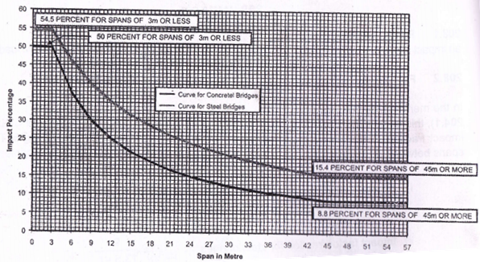
Fig 7: Impact percentage curve for highway bridges for IRC class A and IRC class B loadings.

3.2 PROBLEM STATEMENT
Analyses of box girders are done on Ansys 2016 software. The different cross sections that are chosen are RCCT-beam bridge, trapezoidal section and rectangular section. Both the cross sections are idealized for finite element method.
Ansys 2016 software is widely used finite element software for analysis of bridges. In Ansys 2016 software dynamic condition of loading can be modeled effectively. The analysis outcome of Ansys 2016 software is further used to design the sections manually, using working stress method by adopting code provisions of IRC. Rate of particular grade of concrete is obtained using schedule of rates by Public works department. In IRC loading Class AA and Class, A coding used for the analysis.
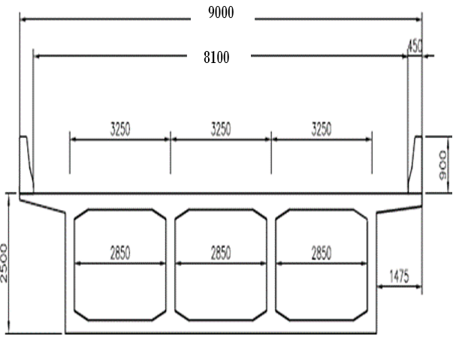
Fig 1; Rectangular Section
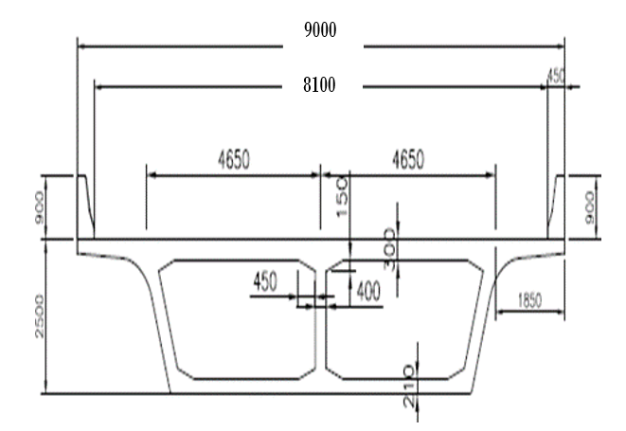
Fig 2: Trapezoidal Section
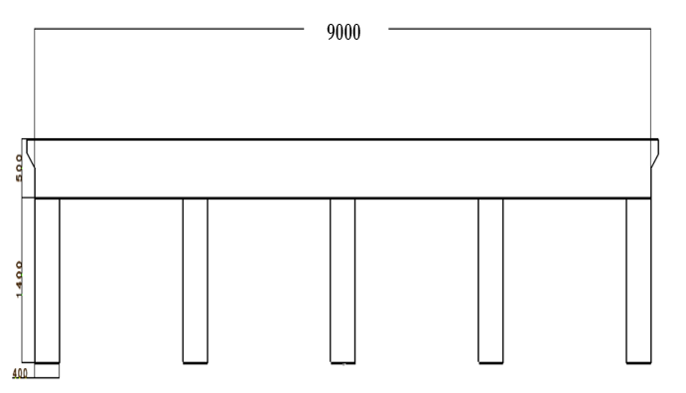
Fig 3: RCC T-Beam Bridge Cross Section
Fig.
Specifications of both rectangular and trapezoidal sections are as follows:

Table 1 Specifications of both rectangular and trapezoidal sections
S. No. | Particulars | Rectangular Section | Trapezoidal Section
01 | Span | 40 m | 40 m
02 | Width of Bridge | 9m | 9m
03 | Thickness of top slab | 0.250 m | 0.300 m
04 | Thickness of bottom slab | 0.200 m | 0.210 m
05 | Thickness of rib | 0.2 m | 0.2 m
06 | Depth | 2m | 2m
07 | Width of hollow box | 2.850 m | 4.250 m
08 | Bottom width of hollow box | 2.850 m | 3.465 m

Table 2 RCC T-Beam Bridge Specifications
Sr. No | Description
01 | Span of Bridge | 40m
02 | Width of Bridge | 9m
03 | Total depth | 2.m
04 | Slab thickness (average) | 0.8m
05 | T-Beam width | 0.4m
06 | T-Beam depth | 1.2m
07 | Type of Loading | IRC

Table 3 Loading Conditions
Sr. No | Description
1 | For Class AA | 700 KN
2 | For Class A | 1.14 KN

3.4. Modelling
RCC Bridge
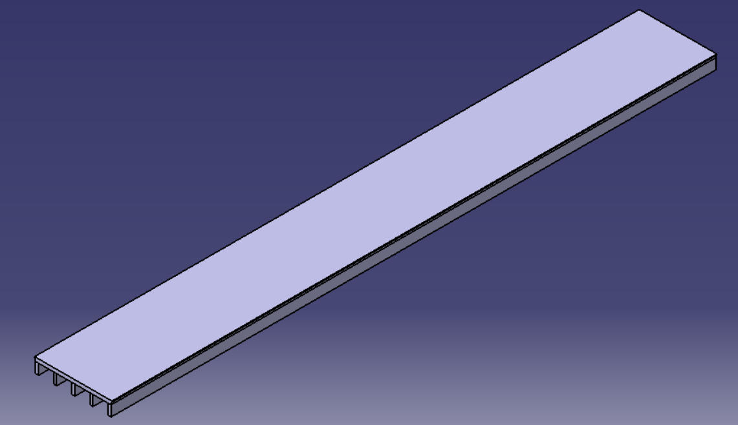
Fig 4: RCC Bridge
Rectangular box girder Bridge
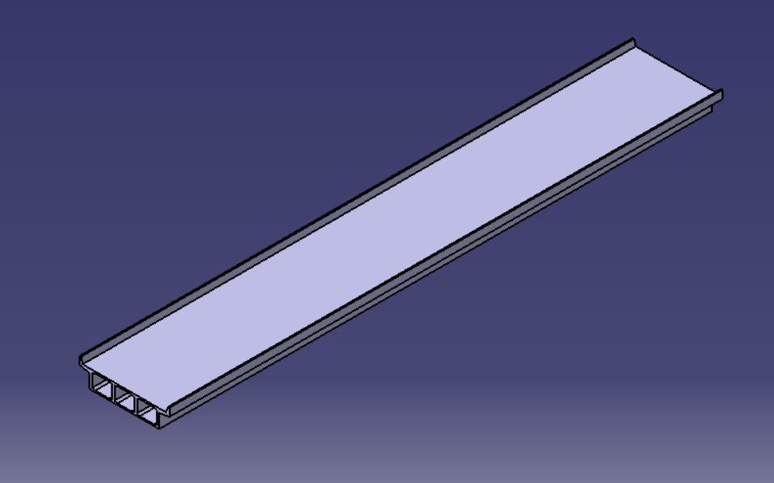
Fig 5: Rectangular box girder Bridge
Trapezoidal box girder Bridge
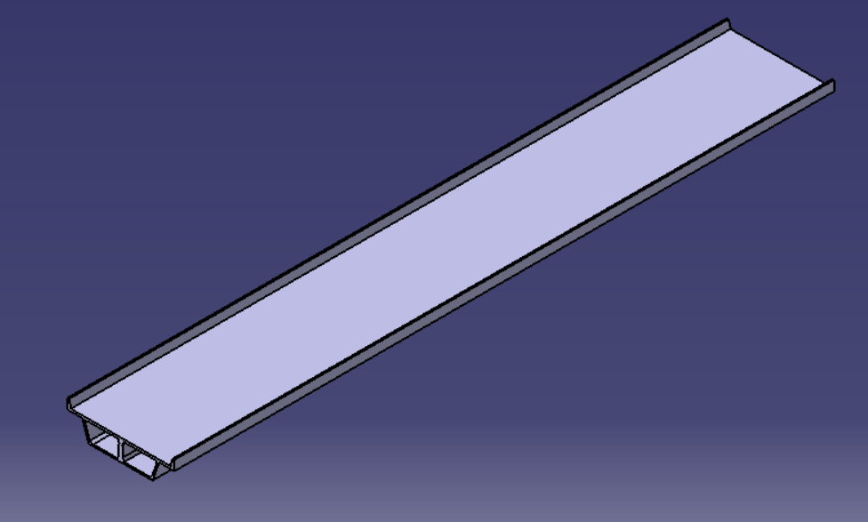
Fig 6: Trapezoidal box girder Bridge

IV. ANALYSIS AND RESULTS

4.1. BOUNDARY CONDITIONS
1. Rectangular Box Girder Bridge
Geometry
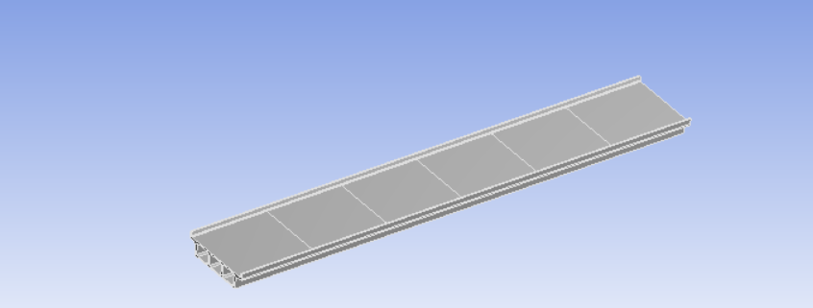
Fig 14: Geometry

2. Trapezoidal Box Girder Bridge
Geometry
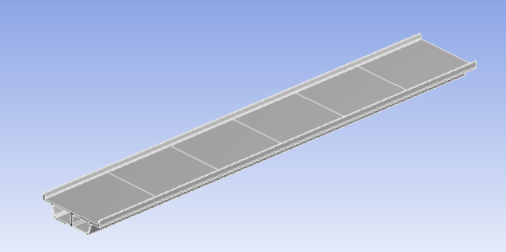
Fig 11: Geometry
. 3. RCC T-Beam Bridge
Geometry
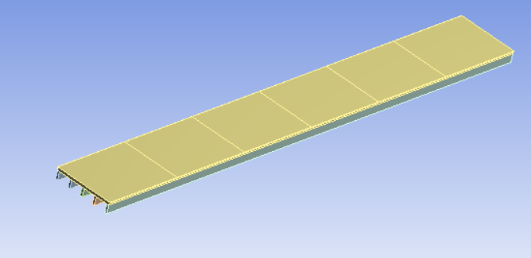
Fig 16: Geometry

4.2 Analytical Results
RCC BRIDGE-CLASS A
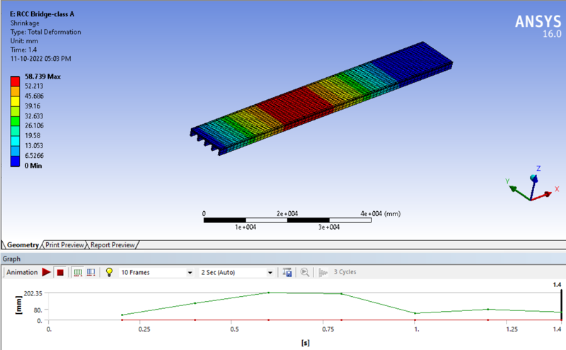
Fig 17: Shrinkage
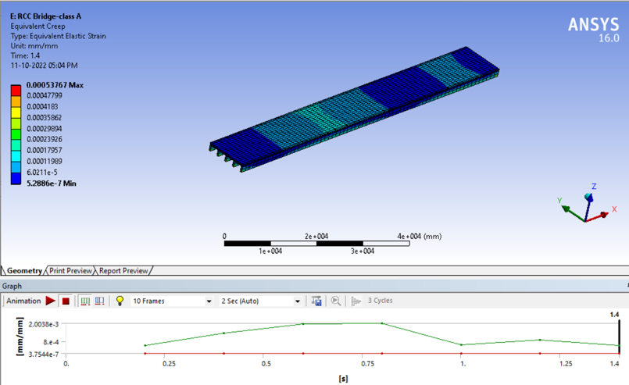
Fig 18: Equivalent Creep
RCC BRIDGE-CLASS AA
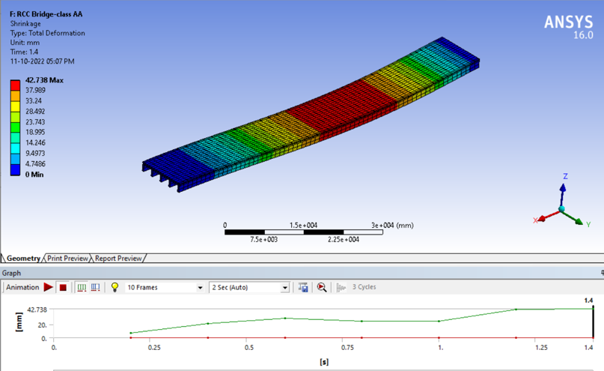
Fig 19: Shrinkage
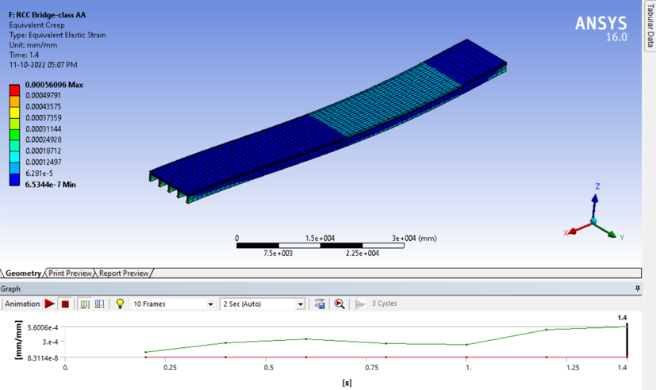
Fig 20: Equivalent Creep

RECTANGULAR BOX GIRDER BRIDGE-CLASS A
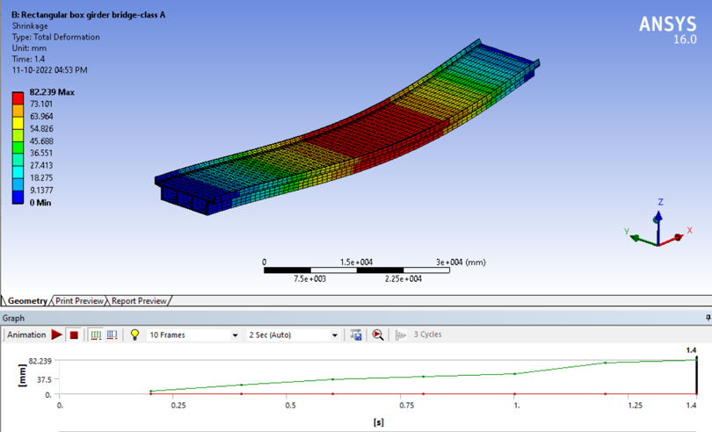
Fig 21: Shrinkage
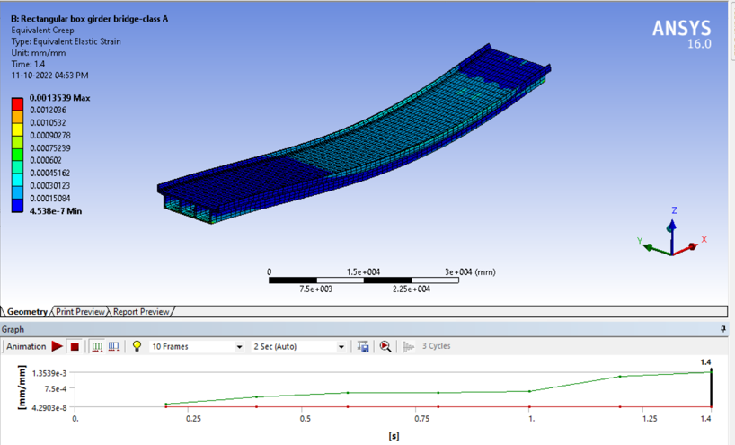
Fig 22: Equivalent Creep
RECTANGULAR BOX GIRDER BRIDGE-CLASS AA
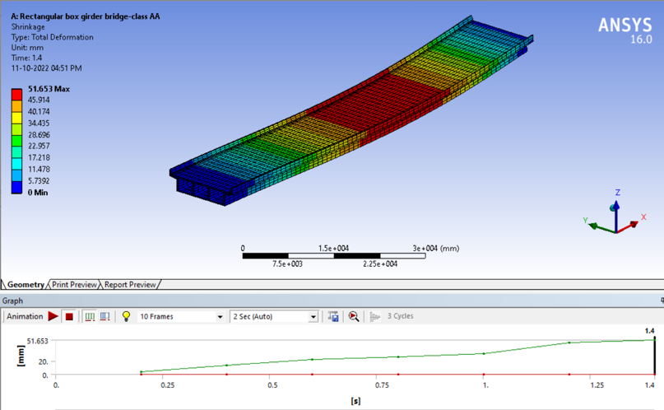
Fig 23: Shrinkage
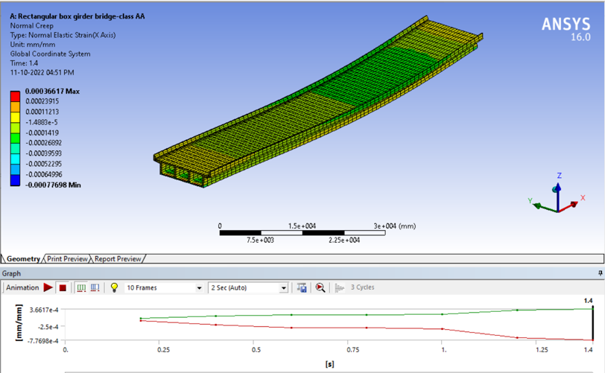
Fig 24: Normal Creep
TRAPEZOIDAL BOX GIRDER BRIDGE-CLASS A

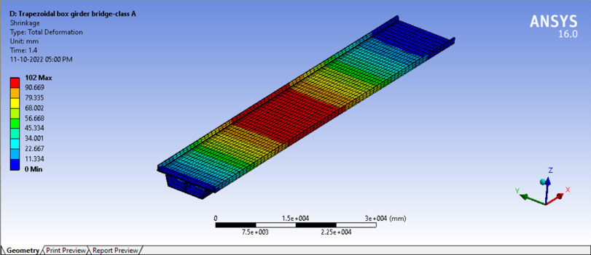
Fig 25: Shrinkage
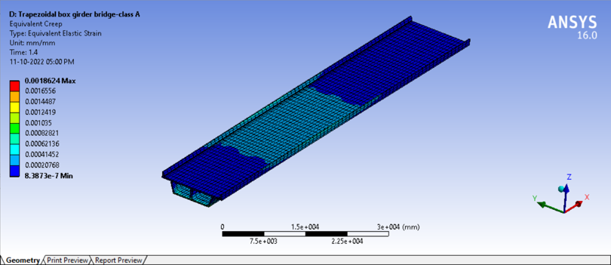
Fig 26: Equivalent Creep
TRAPEZOIDAL BOX GIRDER BRIDGE-CLASS AA
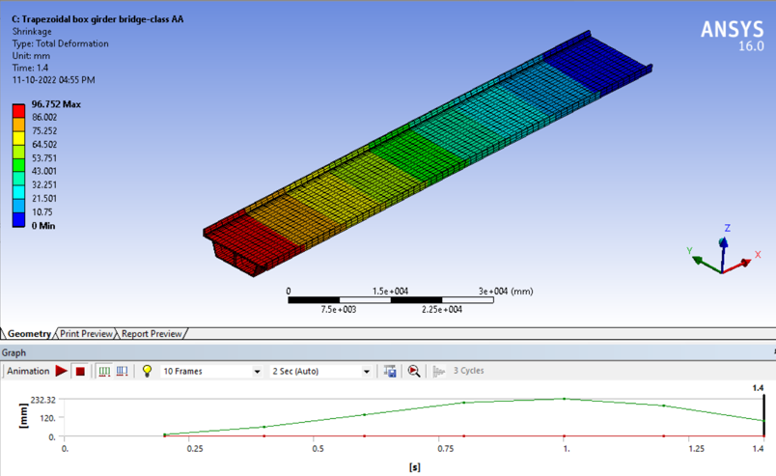
Fig 27: Shrinkage
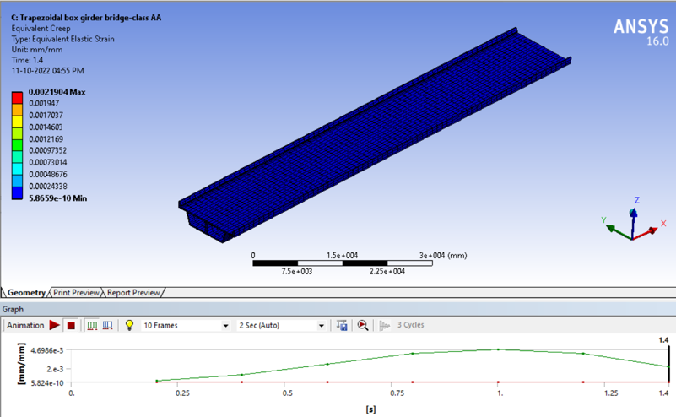
Fig 28: Equivalent Creep

4.3 Graphical Results

4.3.1 FOR CLASS AA SHRINKAGE (MM)

Graph 1 Shrinkage (mm)
The contraction of a hardened concrete mixture owing to the loss of capillary water is known as shrinkage. The total shrinkage of the Rectangular box girder bridge, the Trapezoidal box girder bridge, and the RCC Bridge is shown in the table above, with 120 being the maximum span of the Trapezoidal box girder bridge in comparison to the Rectangular box girder bridge and RCC Bridge.

Graph 2 Equivalent Creep (mm)
Equivalent Creep (mm) Trapezoidal box girder bridge 2.50E-03, Rectangular box girder bridge 5.055E-04, and RCC Bridge 0.00E+00 are illustrated in the graph above. Trapezoidal box girder bridge has the greatest span.

Graph 3 Normal Creep (mm)
All materials undergo creep under some conditions of loading to a greater or smaller extent. As indicated in the graph above, the Trapezoidal box girder bridge has the highest normal creep (mm) as opposed to the Rectangular box girder bridge and RCC Bridge, which both have 1.60E-03.

Graph 4 Shear Creep (mm)
Trapezoidal box girder bridge has a larger shear creep (mm) than RCC Bridge and Rectangular box girder bridge, which is 6.00E-04, as indicated in the graph above.

Graph 5 Equivalent Stress (Mpa)
Equivalent stress (von Mises stress, unit: MPa) distributions for deflection rates a v = 0.25/sec (left column) and b v = 250/sec (right column). The maximum span of a trapezoidal box girder bridge, as depicted in the above graph for the equivalent stress (Mpa), is 7.00E+02, while the minimum span of a rectangular box girder bridge is 2.00E+02.

Graph 6 Normal Stress (Mpa)
At a point, the normal stresses on two mutually perpendicular planes are 120 MPa (Tensile) and 60 MPa (Bending) (Tensile) The maximum normal stress (Mpa) for a trapezoidal box girder bridge is 1.80E+01 more than for a rectangular box girder bridge and an RCC bridge, as seen in the graph above.

Graph 7 Shear Stress (Mpa)
Shear force (MPa) vs shear displacement (mm) for typical experiments According to the graph above, a trapezoidal box girder bridge has a maximum 1.20E+01 span when compared to a rectangular box girder bridge and an RCC bridge for shear stress (Mpa).

4.3.2 FOR CLASS A SHRINKAGE (MM)

Graph 8 Shrinkage (mm)
Above table displays the total shrinkage of the Rectangular box girder bridge, the Trapezoidal box girder bridge, and the RCC Bridge, with 120 being the maximum span of the Trapezoidal box girder bridge in comparison to the Rectangular box girder bridge and the RCC Bridge. The discrepancy between a company's balance sheet inventory and its actual inventory is referred to as shrinkage.

Graph 9 Equivalent Creep (mm)
The graph above depicts the equivalent creep (mm) for trapezoidal box girder bridge 1.50E-03, rectangular box girder bridge 1.50E-04, and RCC Bridge 5.00E+00. The longest span is a trapezoidal box girder bridge.

Graph 10 Normal Creep (mm)
In general, materials with higher melting temperatures, lower diffusivity, & greater shear strength have greater creep resistance. The Trapezoidal box girder bridge has the highest normal creep (mm), as shown in the graph above, compared to the Rectangular box girder bridge and RCC Bridge, which both have 1.60E-03.

Graph 11 Shear Creep (mm)
Creep is a form of metal deformation that often occurs at increased temperatures and loads below the yield strength of a metal. Trapezoidal box girder bridge has a greater shear creep (mm), which is 4.40E-04, than RCC Bridge and Rectangular box girder bridge, as illustrated on the graph above.

Graph 12 Equivalent Stress (Mpa)
The equivalent stress (MPA) Trapezoidal box girder bridge span is 4.00E+01, the Trapezoidal box girder bridge span is 3.00E+01, while the span for RCC Bridge is 3.20E+01. Specifically, the Trapezoidal box girder bridge is larger than the remaining two girders.

Graph 13 Normal Stress (Mpa)
At a single location, the normal stresses on two mutually perpendicular planes are 120 MPa (Tensile) and 60 MPa (Tensile). Above graph shows that a trapezoidal box girder bridge has a higher normal stress (Mpa) than a rectangular box girder bridge or an RCC bridge.

Graph 4. 14 Shear Stress (Mpa)
For selected experiments, shear stress (MPa) as a function of shear displacement (mm). It can be seen from the graph that the maximum span for a normal stress rectangular box girder bridge is 4.00E+00, while the minimum span for a reinforced concrete and steel (RCC) bridge is only 0.00e+00.

V. CONCLUSION

5.1 FINDINGS FOR CLASS AA
- Shrinkage is defined as the contracting of a hardened concrete mixture due to the loss of capillary water The total shrinkage of the Rectangular box girder bridge, Trapezoidal box girder bridge, and RCC Bridge is displayed in the table above, with 120 being the maximum span of the Trapezoidal box girder bridge as compared to the Rectangular box girder bridge and RCC Bridge.
- Equivalent Creep (mm) Trapezoidal box girder bridge 2.50E-03, Rectangular box girder bridge 5.055E-04, and RCC Bridge are illustrated in the graph above. Trapezoidal box girder bridge has the greatest span.
- All materials undergo creep under some conditions of loading to a greater or smaller extent. As indicated in the graph above, the Trapezoidal box girder bridge has the highest normal creep (mm) as opposed to the Rectangular box girder bridge and RCC Bridge, which both have 1.60E-03.
- Trapezoidal box girder bridge has a larger shear creep (mm) than RCC Bridge and Rectangular box girder bridge, which is 6.00E-04, as indicated in the graph above.
- Equivalent stress (von Mises stress, unit: MPa) distributions for deflection rates a v = 0.25/sec (left column) and b v = 250/sec (right column). The maximum span of a trapezoidal box girder bridge, as depicted in the above graph for the equivalent stress (Mpa), is 7.00E+02, while the minimum span of a rectangular box girder bridge is 2.00E+02.
- The normal stresses on the two mutually perpendicular planes at a point are 120 MPa (Tensile) and 60 MPa (Tensile)As seen in the graph above, the maximum normal stress (Mpa) for a trapezoidal box girder bridge is 1.80E+01 compared to a rectangular box girder bridge and an RCC bridge.
- Shear stress (MPa) as a function of shear displacement (mm) for representative experiments According to the graph above, a trapezoidal box girder bridge has a maximum 1.20E+01 span when compared to a rectangular box girder bridge and an RCC bridge for shear stress (Mpa).

5.2 FINDINGS FOR CLASS A
- The table shows the total shrinkage of the Rectangular box girder bridge, Trapezoidal box girder bridge, and RCC Bridge, with 120 being the maximum span of the Trapezoidal box girder bridge when compared to the Rectangular box girder bridge and RCC Bridge. Shrinkage is the difference between recorded inventory on a company's balance sheet and its actual inventory.
- The graph above depicts the equivalent creep (mm) for trapezoidal box girder bridge 1.50E-03, rectangular box girder bridge 1.50E-04, and RCC Bridge 5.00E+00. The longest span is a trapezoidal box girder bridge.
- Generally, materials have better creep resistance if they have higher melting temperatures, lower diffusivity, and higher shear strength The Trapezoidal box girder bridge has the highest normal creep (mm), as shown in the graph above, compared to the Rectangular box girder bridge and RCC Bridge, which both have 1.60E-03.
- Creep is a type of metal deformation that occurs at stresses below the yield strength of a metal, generally at elevated temperatures Trapezoidal box girder bridge has a greater shear creep (mm), which is 4.40E-04, than RCC Bridge and Rectangular box girder bridge, as illustrated on the graph above.
- The equivalent stress (MPA) Trapezoidal box girder bridge span is 4.00E+01, the Trapezoidal box girder bridge span is 3.00E+01, while the span for RCC Bridge is 3.20E+01. Specifically, the Trapezoidal box girder bridge is larger than the remaining two girders.
- The normal stresses on the two mutually perpendicular planes at a point are 120 MPa (Tensile) and 60 MPa (Tensile) The above graph shows that a trapezoidal box girder bridge has a higher normal stress (Mpa) than a rectangular box girder bridge or an RCC bridge.
- Shear stress (MPa) as a function of shear displacement (mm) for representative experiments. It can be seen from the graph that the maximum span for a normal stress rectangular box girder bridge is 4.00E+00, while the minimum span for a reinforced concrete and steel (RCC) bridge is only 0.0.
The behaviour of RCC T-beam and box girder bridges suggested for bridge superstructures with 80-meter spans is investigated. By doing structural analysis, it became evident that the RCC T-beam bridge is an efficient and cost-effective girder system by optimizing the cross-section in comparison to the T-beam girder section using the following static and dynamic responses.

5.3 FUTURE SCOPE

It is possible to create efficient sections with precision. Although the depth is greater and the section is designed as a singly reinforced section, as the purpose of this study was to identify the most efficient section among three, the section can be redesigned for future research by reducing its depth and designing it as a double-reinforced section or as a PSC bridge. The width of the ribs is assumed to be consistent throughout the span, however it may be altered to be taller on supports and lower in the middle.

REFERENCES
- Ahmed, A, et al (2017). “Comparative Analysis and Design of T-Beam and Box Girders.” International Research Journal of Engineering and Technology (IRJET), 4(7), 3085–3093.
- Kumar, A., & Kushwaha, N. (2020). “A Review Study on Analysis of Concrete T Beam Girder Bridge.” International Journal of Trend in Scientific Research and Development (IJTSRD) International Journal of Trend in Scientific Research and Development, 4(6), 93–95.
- Patidar, D., Prof, A., et al. (2003). “Structural Analysis of Box Girder Bridge Structure.” 4–8.
- S. U. K. (2016). “a Comparative Study of T-Beam Bridges for Varying Span Lengths.” International Journal of Research in Engineering and Technology, 05(06), 394–398.
- Saxena, A. (2013). “Comparative Study of the Analysis and Design of T-Beam Girder and Box Girder Superstructure.” IJREAT International Journal of Research in Engineering & Advanced Technology, 1(2), 1–5.
- Meghana, K. V, et al (2020). “Review Paper on Comparative Analysis of T- B eam Bridge and Box Girder Bridge.” 8(14), 128–129.
- Patil, M. B., et al (2016). “Analysis and comparative study of composite bridge girders. International Journal of Civil Engineering and Technology,” 7(3), 354–364.
- Sher, R. J. S., et al (2020). “Analysis and Design of Box Girder and T-Beam Bridge Superstructure - A Comparative Study.” Mehran University Research Journal of Engineering and Technology, 39(3), 453–465.
- Singh, N., & Maru, D. S. (2022). “Review on Comparative Analysis of PSC Box Girder Bridge and PSC Precast I Girder Bridge Structure.” International Journal for Research in Applied Science and Engineering Technology, 10(12), 2313–2321.
- Yadav, R., et al (2019). “Comparative Study of T Beam Bridge with Conventional Method and Finite Element Analysis.” Journal of the Institute of Engineering, 15(1), 62–70.
- Pawar, S. T. (2016). “Analysis of Box Girder Bridges Using Haunches.” International Journal of Scientific Research in Science,Engineering and Technology, 3(3), 473–479.
- Dhale, S., & Thakare, K. (2018). “Comparison of T-Beam Girder Bridge with Box Girder Bridge for Different Span Conditions.” 7(3), 196–199.

