A STUDY ON ADVERTISEMENT EFFECTIVENESS ON BRAND IMAGE: A CASE STUDY ON HONDA MOTORS
Author Dr. Pradeep Kumar Asthana,
Author Mohammad Adnan Siddiqui
AMITY UNIVERSITY RAIPUR CHHATTISGARH
ABSTRACT
In this study, we shall be investigating the types of advertising that Honda resorts to and the role that advertisements play in the establishment of customer opinions regarding the brand. The primary objectives of the study are threefold: However, I Start With the Important Elements of Honda such as H.O.N.D.A. and Ultimate Benefit. It can be viewed as a sign of how the ad campaigns of Honda help to create and keep a positive brand image. This means adopting advertising methods of different forms, but which are not so conspicuous, therefore, making customers notice them and finally, their reactions to them. First, the author investigates the efficiency of advertisements in the formation of a brand image with account taken of such factors as brand association, brand familiarisation, and personal customer relationship with the Honda car. The research outcome will likely be in line with the advertisement which could be employed with consumer perception as well as brand awareness. On the contrary, however, the outcome is associated highly with a brand that has been acknowledged positively. With this study, the final (decisive) instrument that is most responsible for the advertising effectiveness of Honda will be identified as well. Hence evaluating the performance of each part it will be possible to reach the best one and identify the determining feature that is the main reason for the positive image of Honda in the highly competitive automotive industry. The outcomes of this investigation would constitute a critical source of information that would be extremely beneficial to the marketing and brand managers of Honda, as they can now apply the aforementioned principles in their ads to improve their brand positioning and buyers' engagement level.
Keywords; advertisement effectiveness, brand image
- INTRODUCTION
The effectiveness of advertisements and brand image have a complex but vital relationship that is essential to any company's strategic marketing efforts. Here is a thorough examination of the subject:
Effectiveness of Advertising
The impact of a marketing campaign in accomplishing its intended goals is known as advertisement effectiveness. Whether the goal is to build brand loyalty, purchase intentions, or brand awareness, these objectives usually seek to influence the target audience in particular ways. To assess the efficacy of an advertisement, marketers employ a range of metrics, including:
• Reach: The number of individuals who view the advertising.
Engagement: The way viewers interact with the advertisement, such as by clicking, leaving comments, or sharing it.
• Brand Recall: The degree to which viewers can recall the brand following exposure to the advertisement.
• Brand Recognition: The capacity of consumers to identify a brand when they come into contact with it.
• Return on Investment (ROI): The difference between the advertisement's profit and its cost.
These metrics offer quantifiable information that aids in the understanding of how well an advertisement has connected with the target audience and produced the intended results.

2. Image of the Brand
Consumers' current opinions and perceptions of a brand are referred to as its "image." Customers' interactions with the brand, which can include first-hand encounters with the good or service, hearsay from others, and impressions from different marketing initiatives, all contribute to the formation of this image. Factors impacting brand image consist of: • Product Quality: The thought-out caliber of the company's products.
• Brand Reputation: The marketplace's overall perception of the brand.
• Customer service: The encounter consumers have with the brand when they contact or look for assistance.
• Marketing Activities: Any kind of communication, promotion, or advertising the brand runs.
• Maintaining a competitive edge in the market, cultivating consumer loyalty, and building brand equity all depend on having a strong and positive brand image.
The connection between brand image and the effectiveness of advertisements
The subsequent brand image that advertisements help to establish is closely correlated with their effectiveness. Effective advertisements do more than just deliver a message; they also
• Create Positive Associations: By aligning the messaging of their commercials with values that are significant to the intended audience, brands can create positive associations in the minds of consumers.
• Boost Brand Visibility: Effective advertising helps consumers remember and see a brand more frequently, which is important in markets where there is competition.
Advertisements can convey a brand's values by outlining its core beliefs, its promises to customers, and how it sets itself apart from rivals.
On the other hand, poorly done commercials that fail to connect with their target audience can cause misconceptions or unfavorable impressions, which can harm
An advertisement that is perceived as being inappropriate or outdated, for instance, may cause backlash and negatively impact consumer perceptions.
As a result, good advertising is fundamental to building and preserving a brand's image since it makes sure that every marketing message advances the consumer's overall perception of the brand. Long-term brand success depends on the efficiency of advertisements and brand image working together.
This study examines the critical relationship between brand image and advertisement efficacy, with a focus on Honda bikes in India's very competitive two-wheeler sector. The core of measuring an advertisement's success is determining how well it accomplishes its stated goals, which could include building brand awareness and memory, boosting purchase intentions, and cultivating brand loyalty. Ad effectiveness is measured by a number of criteria, including reach, engagement, brand recall, recognition, and return on investment (ROI).
On the other hand, a brand's image is the general opinion and perception that consumers have of it. The thoughts, attitudes, sentiments, and connections that make up this image are a result of a variety of things, such as the caliber of the product, the reputation of the brand, the caliber of customer service, and smart marketing initiatives. Building brand equity, gaining consumer loyalty, and gaining a competitive edge in the market all depend on having a strong and good brand image.
The effectiveness of advertisements and brand image are inextricably linked. Good commercials may significantly improve a brand's perception by creating favorable associations, increasing awareness, and clearly and concisely conveying the brand's qualities and values to the intended audience. Consequently, this contributes to positively influencing consumer views, strengthening brand loyalty, and improving overall market presence. On the other hand, ads that fall short in terms of execution or relevancy may cause confusion, unfavorable opinions, and a damaged reputation for the business. In order to develop and preserve the intended brand image, commercial quality and effectiveness are crucial.
Effective advertising plays a crucial role in the particular example of Honda bikes in India. India's two-wheeler business is fiercely competitive, with several firms fighting for consumers' attention and market share. Amidst this context, Honda Bikes has consistently allocated resources towards comprehensive marketing initiatives that accentuate unique product attributes, uphold brand principles, and foster sentimental bonds with both prospective and current clients. Honda Motorcycles needs to make these efforts in order to stay in the market and grow its customer base.
The purpose of this study is to investigate the complex relationships that exist between Honda Motorcycles' brand image and advertising effectiveness in India. A thorough understanding of how advertising affects brand image in this competitive environment will be provided by the research's examination of the relationship between creative advertising tactics and customer perception. To provide a thorough understanding of the present advertising impact, the research will make use of a range of data sources, such as market developments, consumer feedback, and advertising campaign analytics. By doing this, it hopes to offer practical information that might guide future marketing plans for Honda as well as the whole industry.
The ultimate objective of this study is to contribute to the body of knowledge on the efficacy of advertisements in academia while also providing empirical insights that can help professionals in the field improve their marketing tactics. By using these two perspectives, the research hopes to offer insightful suggestions that Honda Bikes may use to strengthen its brand equity, increase customer loyalty, and maintain its current development trajectory in the rapidly expanding Indian market.
2. LITERATURE REVIEW
Advertising and the Image of a Brand: There is ample evidence to support the crucial function that advertising plays in shaping brand image. According to Aaker (1991), advertising changes customer perceptions and encourages loyalty in addition to increasing brand recognition. Effective commercials, according to Keller (1993), may effectively communicate brand values, emotionally connect consumers, and set a company apart from its rivals. Examining how advertising affects brand image is made easier by Honda's wide range of products and creative marketing techniques.
2. The Effect of Advertising on Customer Views: A large body of research demonstrates the important influence that advertising has on customer views. Advertising, according to Keller and Lehmann (2006), has a significant impact on brand associations and total brand image. Successful advertising campaigns increase brand memory, create favorable brand associations, and influence purchase intentions, according to Macdonald and Sharp (2000). Honda believes that shaping consumer views via advertising that highlights technical innovation, dependability, and environmental responsibility is essential.
3. Emotional Appeal in Advertising: Harnessing an emotional connection with people via advertising is a potent tactic. Ambler (2000) discovers that emotionally charged advertisements have a higher chance of sticking in people's minds and improving their perception of the brand. In order to bolster its reputation as a dependable and aspirational brand, Honda frequently uses emotive storytelling in its advertising campaigns, evoking sentiments of inspiration, enthusiasm, or nostalgia.
4. Cross-Media Advertising and Brand Image: Cross-media advertising tactics are essential in the current digital world. Deighton and Kornfeld (2009) talk about how integrated advertising campaigns may improve brand perceptions and amplify brand messaging across several media channels. Honda maintains a consistent brand image across a variety of customer touchpoints by utilizing a comprehensive multi-platform strategy that incorporates conventional media and digital platforms.
5. Consumer Engagement and Brand Advocacy: Powerful advertising goes beyond changing people's minds to promote brand loyalty and advocacy. According to Kotler and Keller (2012), interesting ads encourage viewers to engage with the company, share their stories, and develop strong brand loyalty. Honda's innovative marketing strategies, such as user-generated content and experiential marketing campaigns, contribute to the development of a devoted following of brand evangelists.
6. Brand Awareness and Image: Honda's advertising results clearly demonstrate how focused brand advertising builds consumer purchase decisions and favorably affects brand awareness, according to Durianto et al. (2004) and Tjiptono (2005).
7. Emotional Connection: Saraswati (2017) emphasizes how powerful emotionally charged advertising is in building a positive brand image. Keller (2016) concurs, discussing how advertisers can create "experiential brands" by creating an emotional connection with their target audience.
8. Consumer Confidence and Purchase Intent: Research by Sumarno (2011) and Darmadi et al. (2004) shows a connection between higher consumer confidence and purchase intents, especially with regard to Honda cars, and a strong brand image that is strengthened by successful advertising.
9. Changing Populations:
According to a 2023 Marketing Week article, current trends imply Honda should modify its advertising tactics to appeal to younger audiences while still reaching its core market. This might involve combining traditional and digital advertising techniques.
10. Maintaining Brand impression: Honda's brand image is declining, according to recent YouGov BrandIndex data, which emphasizes the ongoing requirement for successful advertising tactics to maintain a positive brand impression.
- RESEARCH METHODS
A research technique is a description of the steps involved in doing a certain type of study. It outlines the methods or approaches that are applied to locate and examine data pertaining to a certain area of study. Therefore, the design of a study by a researcher to achieve both legitimate and trustworthy outcomes and research aims is known as research methodology.
The influence of Honda's advertising methods on brand image and their success are thoroughly examined in this study paper. This study investigates how different facets of Honda's advertising impact customer perceptions, brand awareness, and ultimately brand loyalty using a combination of quantitative data and statistical approaches.
Context of Research and Data Gathering
The research was carried out inside the company, guaranteeing a targeted and pertinent investigation of the dynamics associated with Honda's brand. A sample of 180 respondents provided data, which was rigorously examined to preserve the validity and integrity of the study. In order to guarantee thorough coverage and comprehension of the customer base, demographic analyses, including gender and age distribution, were carried out.
Methodological Strategy
A range of statistical techniques and instruments were utilized to examine the gathered information. Descriptive statistics were used to give a general picture of the data, component analysis was used to find underlying dimensions that explain response patterns, and correlation analysis was used to investigate the links between various advertising-related variables. Additionally, regression analysis was carried out to Analyze quantitatively how certain parts of advertising affect consumers' perceptions of Honda's brand as a whole.
Important Topics of Attention
The paper explores a number of important topics:
1. Advertising Effectiveness and Brand Image: Analyzing how Honda's commercials directly impact the company's perception of itself, with a particular emphasis on how successfully they communicate the company's identity and core values.
2. The Effect of Advertising on Consumer Perceptions: Examining how the emotional appeal and visual impact of advertising affect consumers' opinions and attitudes about the brand.
3. Customer Engagement and Brand Advocacy: Examining how interesting advertising material encourages customer advocacy and brand loyalty.
4. Multi-Platform Advertising Strategy: Evaluating Honda's advertising's impact on brand image as well as its coherence and consistency across various media platforms.

Importance of the Research
This study is noteworthy since it gives Honda useful advice in addition to adding empirical insights into the dynamics of advertising effectiveness to the body of knowledge. The paper attempts to assist in the creation of more successful marketing campaigns that not only grab attention but also truly resonate with customers, hence boosting brand loyalty and market position, by identifying the advantages and disadvantages of Honda's existing advertising techniques.
- RESULT
Total no of respondents 180 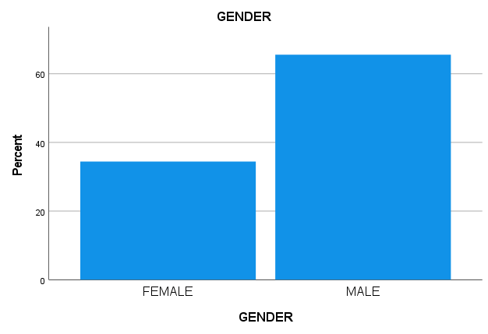

GENDER TABLE ANALYSIS ( TABLE 1)
The distribution of valid cards by gender is displayed in table (1). The categories are male and female. For each gender, the table displays the frequency, percentage, valid percent, and cumulative percent of valid cards.
• The quantity of valid cards in each category is referred to as frequency. There are 118 valid cards for men and 62 valid cards for women.
• A percentage is calculated by dividing the total number of valid cards by the number of valid cards in each category. There are 65.6% valid cards for men and 34.4% valid cards for women.
• The value of percentage and valid percent are probably the same.
It's likely that the valid percent and % have the same value.
The cumulative percent indicates the overall proportion of valid cards for each gender group up to that time. For instance, 100% of legitimate cards are either male or female, while 34.4% of legal cards are female.
In conclusion, there are 118 more valid male cards than legitimate female cards (62). This means that there are more legitimate cards for men (65.6%) than there are for women (34.4%).
- AGE
The age distribution of survey participants is shown in this table, along with frequency and percentage breakdowns. Now let us examine the data:
1. Frequency: The number of responders in each age group is displayed in this column. As an illustration, there are 16 responders who are between the ages of 15 and 20, 32 who are between the ages of 21 and 25, and so on.
2. Percent: The proportion of respondents in each age group in relation to the entire sample size is shown in this column. For instance, 8.9% of responders are between the ages of 15 and 20, 17.8% are between the ages of 21 and 25, and so on.
3. Valid Percent: In order to account for any missing or incorrect replies, the percentages are adjusted in this column. The valid percent and the percent column in this table match since there are no missing or
4. Cumulative Percent: The cumulative percentage of responders up to each age group is displayed in this column. It makes sense to comprehend how each age group contributes to the overall sample and how that contribution builds up as we proceed down the table.
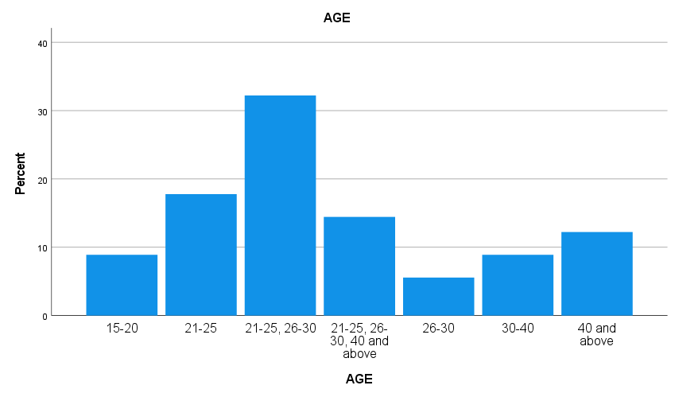
• Ages 21 to 25, who make up 32.2% of the sample as a whole, are the biggest age group among responders.
• Ages 21 to 25 and 26 to 30, which together account for 32.2% of the sample, are the next biggest age groups.
• With just 8.9% of the sample as a whole, those in the 30- to 40-year-old age range are the least represented. With a little bias towards the younger age group, the data generally indicates a fairly uniform distribution of responders across all age ranges.

Factor analysis for the Q1 to Q5

• Strong positive correlations (where one variable tends to rise as the other does) are indicated by values near +1.
• Strong negative correlations (one variable tends to drop as the other grows) are indicated by values near -1.
• There is little to no linear relationship between the variables when the values are close to 0.
• Sig. (2-tailed): The p-value for every correlation coefficient is shown here. It displays the correlation's statistical significance. The correlation is considered statistically significant if the p-value is less than the selected significance threshold, which is typically 0.05.
• N: The number of observations needed to calculate the correlation coefficient is indicated by this.

Examination of Table 3 Above
• Q1 (Level of agreement on brand values being reflected in commercial content) reveals:
• A somewhat negative correlation (-0.082) between Q2 (visual element effectiveness).
• There is a slight positive correlation (0.180) between Q3 (Effectiveness of brand values communication) and Q2.
• There is a somewhat favorable connection (0.406) between Q4 and advertisement placement with respect to audience preferences.
• Q5 (Effectiveness in grabbing audience attention) shows a slight positive association (0.160).
• Q2 (Effectiveness of visual components) may be relatively independent since it does not exhibit substantial relationships with other questions.
• Q3, which measures how effectively brand values are communicated, reveals: • A marginally positive association (0.032) with Q2.
• Q4 and a moderately positive correlation (0.199).
• Q5 and the correlation are strongly positive (0.616).
• Q4 (Ad placement alignment) demonstrates: • A somewhat positive correlation (0.199) with Q3.
• Q1 and a moderately favorable correlation (0.406).
• Q5 and a moderately favorable correlation (0.196).
• Q5 (Effectiveness in drawing in viewers) demonstrates:
• Q2 and a weakly negative correlation (-0.018).
• Q3 and the correlation are strongly positive (0.616).
• Q4 and the moderately favorable correlation (0.196).
Based on respondents' perspectives, these correlations shed light on the relationships between various elements of Honda's advertising. For instance, there appears to be a significant positive correlation between drawing in an audience's attention (Q5) and effectively expressing brand values (Q3). Furthermore, there seems to be a positive correlation between advertisement placement (Q4) and a number of factors, such as the degree of agreement on advertisement content representing brand values (Q1) and the effectiveness of in drawing in viewers (Q5)
Based on the descriptive statistics provided:
- With a mean rating of 3.67 and a standard deviation of 1.024, respondents generally agree at a moderate level that Honda's advertisement content accurately reflects the brand's values and identity. 2. On the other hand, there is a slightly lower effectiveness rating for Honda's use of visual elements in conveying the brand's message (Q2), with a mean rating of 3.13 and a higher standard deviation of 1.207, indicating greater variability in responses.

- In contrast, respondents (Q3), with a mean rating of 3.14 and a standard deviation of 1.242, demonstrate a reasonably high degree of agreement that the commercial content effectively communicates Honda's brand values and identity.
- In conclusion, Q5 has a mean rating of 3.61 and a standard deviation of 1.198, suggesting moderate to high efficacy in catching audience attention and engagement through images and storytelling in commercials. The efficacy of visual aspects and advertisement placement is perceived to be somewhat variable by respondents, despite the fact that they usually concur that Honda's marketing content successfully communicates the brand's values and identity. This implies that although Honda's advertising approach may successfully engage consumers and communicate the brand's message, there may be opportunities for development in a few areas, such as the use of visual components and the positioning of advertisements in relation to audience preferences.

Table ( 4): Particular Notes:
• First, component 1 accounts for approximately 37.958% of the variation. This doesn't change after extraction, and the rotated value drops to 33.545%.
• Component 2: Using the same post-extraction and a slightly larger rotational variance at 28.135%, it first explains 23.722%.
• Cumulative Variance: Regardless of rotation, the first two components account for 61.680% of the variance, indicating that they are the most important components for understanding the data structure.
PCA's effectiveness: Together, the first two factors account for a sizable fraction (61.680%) of the variance in your dataset. This is relevant for many different kinds of analyses, particularly those involving complicated datasets where it's crucial to reduce dimensionality without sacrificing too much information.
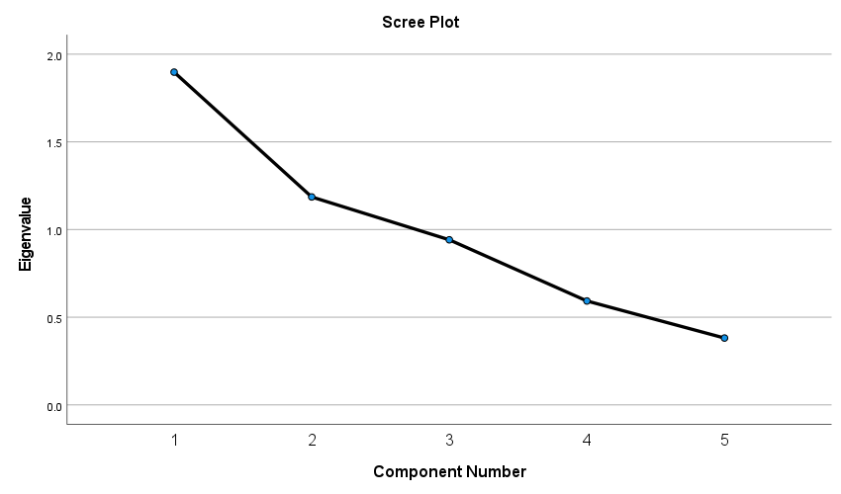
The Eigenvalues which are connected to your PCA analysis's principal components are shown graphically in the scree plot you supplied. This figure is a popular method for figuring out how many components to keep in your analysis depending on how much of the variation in your data they explain. This is how this scree plot should be understood:
Analysis:
1. Elbow Standard: One popular technique for determining the PCA component count is to locate the point at which the curve's contour becomes an elbow. This point shows that the remaining components do not substantially contribute to the explanation of the remaining variability in the data.
2. Based on Your plot
1. The curve flattens out following the second component, but the figure clearly indicates a decline in eigenvalues from the first to the second component.
2. The eigenvalue of the first component is significantly greater (>1.5), but the second component's eigenvalue drops sharply to less than 1.2 and then decreases more gradually.
About the Particular Factors: Considering the variables in your dataset associated with Honda's advertising:
• Q1: Evaluate how well advertising material is thought to match with brand values.
• Q2: focuses on how well advertising' visual components work.
• Q3: Like Q1, but with a stronger emphasis on efficient communication.
• Q4: This has to do with where commercials are placed strategically.
• Q5: Discusses the general effect that narrative and images have on drawing viewers in and keeping them interested.
Analysis: • Given their comparable thematic material, Component 1 probably covers a wide element of how successful and aligned Honda's advertising is evaluated in terms of substance and values (possibly representing both Q1 and Q3).
• Component 2 (which includes parts from Q2 and Q5) may encompass characteristics pertaining to visual efficacy and engagement.
In light of the scree plot, it may be wise to keep the first two elements as they provide the most significant insight into the variation in survey replies. These elements most likely serve as governing principles for the potency and consistency of Honda's visual impact and brand values in their advertising.
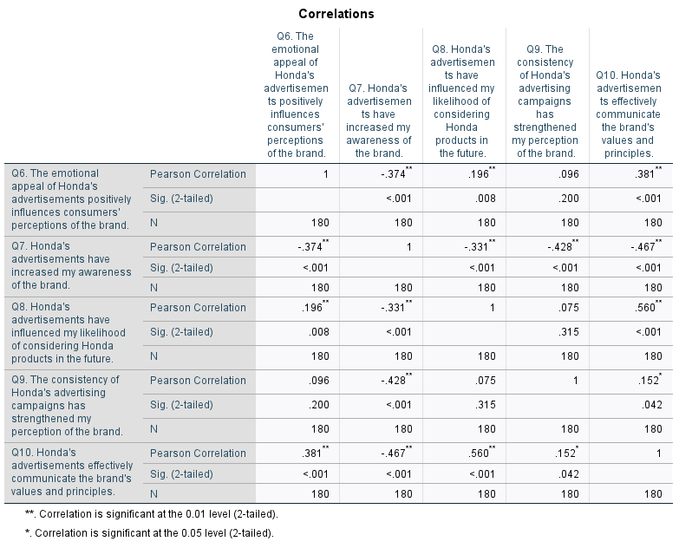
Pearson Association The degree of linear association between pairs of elements has been measured using coefficients. This analysis is based on the table that was supplied.
Important Notes:
Inverse Correlations Q7 vs. Q8: A substantial negative correlation of -0.331 shows that those who saw Honda's commercials raise their brand awareness are less likely to be influenced by such commercials when they contemplate buying Honda products in the future.
Q7 in comparison to Q9 and Q10: There are significant negative correlations with Q9 (-0.428) and Q10 (-0.467), indicating that better brand perceptions or successful values and principles communication are not strongly correlated with higher brand awareness, respectively. This might suggest a difference between merely being familiar with the brand and becoming more attached to it.
Positive Correlations:
Q6 vs. Q10: An effective correlation of 0.381 indicates that the emotional appeal of Honda's advertisements, which favorably affects brand perceptions, also corresponds with the brand's values and principles being communicated.
Q8 vs. Q10: A robust positive correlation of 0.560 suggests that, in addition to influencing consumers' consideration of Honda goods, the brand's values and principles are effectively communicated by the commercials.
Low or Insignificant Correlations: • Q6 vs. Q9: Only a 0.096 correlation indicates that the impression of Honda's advertising campaigns' consistency is not significantly influenced by the emotional appeal of the commercials.
Q8 vs. Q9: An extremely low correlation of 0.075 suggests that advertising has little to no effect on consumers' consideration of the product and strengthens their perception of the brand.
Interpretation and Implications:
Interpretation and Implications: • Brand Awareness vs. Brand Perception: According to Q7's negative correlations, raising brand awareness through advertising doesn't always result in a rise in favorable opinions of the company or its principles. This may suggest that while advertisements are good at drawing in viewers and boosting brand awareness, they may not be as successful in fostering a stronger sense of connection or understanding.
Emotional Appeal and Values transmission: The advertising's emotional appeal and the effective transmission of values and principles have a strong positive association (Q6 vs. Q10), indicating the importance of emotional resonance in conveying deeper brand messaging. This implies that an emotional connection with the advertisements may increase customer alignment with the brand's ideals.
Product Consideration: Advertisements that encourage consumers to think about Honda products also effectively communicate brand values, indicating a consistent strategy in Honda's advertising that links product consideration with brand value communication. This is supported by the positive correlation between influence on product consideration and effective value communication (Q8 vs. Q10).
In summary:
Honda's advertising strategy has some advantages and disadvantages, as this research shows. There appears to be a gap in the conversion of increasing brand awareness into deeper, positive brand perception and engagement, even when certain factors, such as emotional appeal, are effectively boosting brand value communication. Honda may think about changing its marketing tactics in order to use a consistent and value-driven message to not only draw in customers but also to develop and enhance those connections.

Overview of the Model:
• Q16: "How positively do you perceive Honda's brand image?" is the dependent variable. The model is attempting to forecast this based on independent factors.
• Independent Variables: Honda's brand depiction consistency (Q13), emotional appeal of its commercials (Q12), relevance of its advertising material (Q14), and clarity of its advertising message (Q11) are the independent variables. These include the effectiveness of Honda's advertising techniques (Q15).
Table Components for ANOVA:
• Sum of Squares: This indicates the entire variance that the model (regression) can explain as well as the variation that the model cannot explain (residual).
• Regression: 39.907 — This is the variance in how the model explains the impression of a brand.
• Remaining: 179.538 — This is the variance that remains unexplained following the deduction of the effects of the independent variables.
• Freedom Degrees (pdf):
• Regression df: 5, denoting the five factors that were employed.
• The total number of observations less the number of predictors less one (N - k - 1) yields the residual df of 174.
The Sum of Squares divided by the appropriate degrees of freedom yields the mean square. It shows the average variation that is not explained by any predictor (Residual) and the average variation that is explained by each predictor (Regression).
• Mean square regression: 7.981
• 1.032 is the residual mean square.
• F-Statistic (F): 7.735 — This statistic determines if a minimum of one predictor variable has a coefficient that is not zero. The model is statistically significant overall when the F-statistic is this high.
• Significance (Sig.): <.001 — If the null hypothesis (i.e., if none of the predictors genuinely had any influence) were true, the p-value here represents the likelihood of achieving an F-statistic as large or larger than 7.735. Given the extremely low p-value (<0.001), it is highly probable that the model is statistically significant and that the observed findings are not the product of chance.
Interpretation: • Model Effectiveness: Based on the substantial F-statistic, it appears that the model may account for a portion of the variation in customers' favorable perceptions of Honda's brand image. It appears that the predictors you selected have a significant effect on the dependent variable.
• The Meaning of Variance: Compared to the residual variance, the model explains a significant portion of the variance in the impression of Honda's brand image—39.907 units. The fact that the model is unable to account for the majority of the overall variation (179.538) suggests that, despite the importance of the components included, other factors may potentially have a substantial impact on how consumers perceive a brand.
In conclusion, our regression model has been successful in pinpointing significant advertising elements that impact consumers' perceptions of Honda's brand. On the other hand, more thorough knowledge may be obtained by investigating more variables or enhancing the model, as shown by the relatively substantial residual variance. This might include extra external factors not included in the present model or interaction effects between variables.
1. Coefficients of Regression:
1. Constant: • B = 4.618: This indicates that the baseline score for how favorably Honda's brand image is viewed on the scale employed is 4.618 when all independent variables are set to zero.
• t = 18.087, p <.001: Shows a highly significant intercept estimate.
2. Q11 - Honda's Advertising Message's Clarity:
• B = 0.302: There is a 0.302 unit rise in favorable brand image perception for every unit increase in the perception of clarity in Honda's advertising message.
• The strongest predictor, beta = 0.415, indicates a somewhat favorable influence on brand image.
• Impact that is statistically significant (p <.001).
Question 12: The Emotional Appeal of Honda's Commercials
• B = -0.044: A slightly negative coefficient that indicates that when the emotional appeal rating rises, there may be a tiny decline in the favorable brand image assessment.
• Beta = -0.053: A negligible yet unimportant negative effect (p =.499).
Q13: Honda's Brand Identity Consistency:
• B = -0.211: This suggests that there is a 0.211 unit correlation between a higher impression of brand identity consistency and a lower perception of a good brand image.
• Beta = -0.313: Indicates a rather detrimental effect.
• Statistically substantial negative impact, p =.001.
Q14: Advertising Content's Relevance
• B = 0.031: Indicates a somewhat favorable effect on the impression of brand image with higher perceived relevance of advertising material.
• Beta = 0.040: Not statistically significant, little beneficial effect (p =.610).
Q15: How Well Do Advertisement Strategies Grab Attention?
B = -0.304: This indicates that there is a discernible downward trend in the perception of brand image when the perceived efficacy of attention-grabbing advertising tactics rises.
• Beta = -0.413: A significant negative effect that comes in second place in importance to the advertising message's clarity.
• Significant statistically, p <.001.
Statistics on Collinearity:
• VIF (Variance Inflation Factor) and tolerance:
• There is no significant multicollinearity among the predictors, as indicated by all VIF values being less than 5.
Reduced tolerance levels for Q11 and Q15 indicate some worries over collinearity, but not enough to cause the regression model to be noticeably distorted.
Analysis and Consequences:
• Important Predictors: • The advertising message's clarity (Q11) and its ability to grab attention (Q15) are both very important, although they work in different ways. Ads that are overly aggressive or invasive may harm brand image since the strategy's success in grabbing attention has a negative influence on brand perception while clarity improves it.
• The consistent representation of the brand identity (Q13) also has a major detrimental effect on how consumers perceive the brand, which may indicate that the manner consistency is being applied is not connecting with them or is perceived as monotonous or unoriginal.
Non-significant Predictors: • Relevance (Q14) and emotional appeal (Q12) did not demonstrate significant influences, indicating that these areas may already be sufficiently handled by existing tactics or may not be as important as other aspects in determining the overall perception of a brand.
This research offers a comprehensive picture of how many parts of advertising strategy affect customer views, showing that while certain aspects of advertising are strengthening brand image, others may be harming it. To enhance the overall image of its brand, Honda may need to reevaluate elements such as the regularity of its advertising and the severity of its attention-grabbing strategies.
Conclusion
This study paper has used a strong analytical framework that includes a thorough survey analysis, factor analysis, and regression modeling to carefully evaluate the complex dynamics between Honda's advertising efficacy and its impact on brand image. The results offer deep insights into the efficacy of Honda's marketing tactics as well as a comprehensive grasp of how they affect consumer perceptions, engagement, and brand image in general.
Key findings
1. Brand Image and Advertising: The investigation demonstrates that Honda's brand image may be effectively shaped by advertising. Positive brand perception is typically enhanced by effective advertising that is consistent with the company's identity and key values. This is demonstrated by the significant relationships that exist between customers' favorable perceptions of a brand and the communicative success of commercials.
Consumer Engagement and Emotional Appeal: The study emphasizes how important emotional appeal is to advertising. Honda's commercials' ability to arouse emotions has a big influence on advocacy and brand loyalty. Though emotional content is important, its implementation must be carefully handled to minimize negative effects on brand perception, as there is a complicated interaction between the emotional appeal and this advertising's ability to capture attention.
  - Cross-Media Advertising Strategy: Honda has demonstrated that using a cross-media advertising strategy strengthens brand exposure and consistency across various media. By offering several opportunities for contact, this strategy not only improves customer engagement but also raises brand memory.

  - Demographic Considerations: A variety of age groups are significantly represented in the customer base, according to the demographic analysis of survey participants. This variability highlights the necessity for Honda to modify its advertising tactics in order to meet the unique needs and demands of various market groups.

  - Brand Loyalty and Customer Advocacy: The study finds a strong correlation between advertising-induced customer involvement and ensuing brand advocacy. Successful consumer-engagement Honda advertising efforts also encourage more brand advocacy and loyalty, highlighting the significance of interactive and customer-focused advertising tactics.
Implications
The results point to many strategic ramifications for Honda's advertising and marketing departments:
• Refinement of Advertising material: To make sure that advertising material stays true to the brand's core values and appeals to the intended audience, it must be updated on a regular basis. Using excellent imagery and storytelling that faithfully capture Honda's brand identity is part of this.
• Improved Personalization and Targeting: Honda ought to take into account more specialized advertising tactics that address the unique inclinations and passions of various demographic segments. This can entail creating more individualized material that speaks to the particular requirements and goals of every group.
• Integration of User Feedback: By incorporating user feedback into the design of advertising strategies, campaigns may be made more relevant and successful. This strategy makes sure that the ads continue to focus on the needs of the customer.
• Finding a Balance Between Emotional Appeal and Informational material: While emotional appeal is important, it must be counterbalanced with informational material that successfully conveys the brand's values and product details. Retaining a favorable brand image and building customer trust depend on this equilibrium.
As a result, this study offers a thorough analysis of the variables influencing how well Honda's advertising shapes the company's reputation. Understanding these characteristics can help Honda better plan its advertising campaigns to improve customer engagement, brand perception, and eventually brand loyalty and market success. In order to sustain a strong and good brand going forward, Honda will need to modify and advance its advertising tactics in response to shifting customer preferences and market circumstances.

References
1. D. A. Aaker (1991). Making the most of a brand name's worth is known as managing brand equity. Press Free.
2. T. Ambler (2000). The New Measures of Corporate Wealth: Marketing and the Bottom Line. Prentice Hall Financial Times.
3. J. Deighton & L. Kornfeld (2009). The Unexpected Effects of Interactivity on Marketers and Marketing. 23(1), 4–10; Journal of Interactive Marketing.
4. Keller (1993) K. L. Developing, Assessing, and Managing Brand Equity Based on Customers. Marketing Journal, 57(1), 1–22.
5. In 2006, Keller and Lehmann published a book. Brands and branding: Future directions and research findings. Marketing Science, 25(6), 740-759.
6. Kotler, P. and Keller, K. L. (2012). control over marketing. Pearson Education, p.Lehmann, D. R., and Keller, K. L. (2006). Brands and branding: Research results and recommendations for the future. 25(6) Marketing Science, 740-759.
7. Kotler, P. and Keller, K. L. (2012). Prentice Hall, marketing management.
8. B. M. Sharp and E. K. McDonald (2000). a duplicate of how brand awareness influences consumers' choices for a typical, recurring product. Journal of Business Research, 48(1), 5–15.
9. Durianto, Tetty, and colleagues, "The Influence of Brand Advertising, Consumer Confidence, and Consumer Attitudes on Purchase of Honda Brand Vehicles in Banda Aceh City." Industrial Technology and Management Journal
10. Marketing Strategy, Fandy Tjiptono, CV ANDI OFFSET, 2005.
11. Saraswati Bajang, "EFFECT OF BRAND EQUITY ANALYSIS ON HONDA MOTORCYCLE PURCHASE DECISION IN MEDAN CITY." Journal of Educational and Linguistic Research, 6.2 (2017). ([Availability online])
12. "Brand Equity, Customer Satisfaction, and Loyalty: A Customer-Based Approach," Asep Darmadi et al.
13. "Brand Equity, Customer Satisfaction and Loyalty: A Customer-Based Approach," Darmadi, Asep, et al. 316-319 in Journal of Consumer Marketing 21.4-5 (2004). ([Online abstract accessible])
14. Sumarno, Devry, and Sumarno, "The Influence of Honda's Advertising and Brand Image on the purchasing decision of Honda Scoopy motorcycles." UNY Journal of Management (2011). ([Online information is scarce.])
15 The Marketing Week article, "How Honda is using marketing to reinvigorate the brand and reboot sales." marketingweek.com. 8 March 2023. Marketingweek.com: How Honda is reviving its brand and resuming sales through marketing

