Implementation of Small-Scale Industries and Medium-Scale Industries using Agile Manufacturing in Different Methods
Ms Ranjitha R, Prof. Rohith M N
¹Student, ² Assistant Professor, Department of Electronics and Communication Engineering
Sri Jayachamarajendra College of Engineering, JSS Science and Technology University, JSS Technical Institutions Campus, Mysuru-570006

Abstract— The overall market for current power gadgets and get-together structures with related organizations has a gigantic number of individuals with numerous things in different applications like social occasion parts, exhausting and material clearing. Clients are found in adventures like the auto business, off-turnpike vehicles, the equipment business, aeronautics, devices, the energy region, and general present-day get-togethers. In particular, the business area has been powerful in making advanced electric present-day contraptions and systems that assist clients with achieving getting according to their subtleties and cutoff missteps and breaks in progress. With a rising interest in electric vehicles, battery creation, and creating use of lighter materials, the auto business centres around imaginative party plans. The market demands new assembling developments, for example, controlling paste and sealants and self-infiltrating riveting. The market for machine vision ends up being continuously huge, driven by creating revenue in computerization, quality and proficiency in current creation. Machine vision courses of action are used in discrete creation, similar to the vehicle business, and conflicting cycle creation, similar to metal and paper creation, significant level material collecting, and sun-fueled chargers.
Nimble Assembling and Nimble Gathering is a technique for making and Creating things in a manner that is more versatile and Flexible than Standard Systems. This implies Changing or Adjusting the Creation Communication Quickly and Actually to satisfy the Client's endless needs better. The Gathering System is working and has changed to a 21st-century technique. Expected to be Very Responsive. They license makers to rapidly answer changes, whether those changes are in client interest, advancement, or even the business place itself.

Keywords—Agile Manufacturing. Organizations' names are PSR, ABC, and SRR veiled are be the Tainted level, and can't be revived since organizations are Coercion Objects are Situated in Mysore City (India).
- INTRODUCTION
What happened quite a while ago when the Organized improvement was imagined? It affected how programming associations work and make their things. It was a particular benefit that changed the whole scene of the item business.
The surprising part happened immediately. An always expanding number of adventures recognize the beneficial outcome of Agile in the work processes. Business pioneers comprehend that it is more brilliant to pass even more routinely on to the market, accumulate early information, and improve interminably, rather than conveying conceded perfection. A steadily expanding number of associations believe this to be a significant opportunity to answer speedier to serious strain and market revenue and conform to exhibit changes. In that capacity, mastery transformed into a standard in the state-of-the-art business world and an issue of perseverance. Hence, an always expanding number of adventures want to apply Agile procedures to their work cycles to outlast the resistance. Adventures you never suspected could transform from an eroded, obsolete way to deal with doing Expecting we bar the item business, different others utilize Deft techniques for thinking nowadays. Also, . The business world is at present moving to another point of view - business nimbleness. It is at this point lacking to consolidate Kanban and Scrum at a get-together level. More affiliations are beginning to grasp that the whole alliance should think and act the same way, not simply single workplaces or gatherings. Regardless, it is just a storm in a glass of water. various types of ventures using Agile frameworks considersCoordinated Being developed The boardCoordinated advancement is an endeavour of the chief methodology stressing adaptability, coordinated effort, and nonstop improvement in the advancement business. It incorporates isolating colossal exercises into more unobtrusive, more sensible work things and shining on them considering client needs and analysis. The goal is to pass great results quickly and beneficially while changing on to changing necessities and conditions. The quick methodology has been involved commonly in programming headway at this point is ending up being continuously renowned being developed.
The four basic parts of the Deft errand the leaders being developed are:
1. Facilitated endeavours and correspondence among associates and accomplices.
2. Flexibility and adaptability to changes in project necessities or augmentations.
3. Use programming to deal with quality organization and execution by wiping out complex manual cycles.
4. Pass consistently and give input on to key accomplices about definitive limitations.

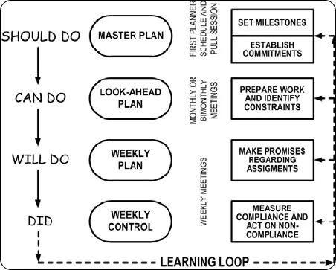

Fig 1.1 Adaveced Learing loop

Another methodology that Grades/Able advancement bunches use is to isolate plans into extra reasonable pieces and progressively elaborate them as they move closer to execution. This is known as the Last Coordinator System (LPS), where the last plans are prepared by those responsible for executing the work. Particularly like any Lean/Flexible end of the leader's method, it propels "structure thinking" rather than neighborhood’s smoothing out". This way of thinking rotates around "pull coordinating", where just the most essential work that ought to be conceivable is considered. Likewise, this adds to the creation of an environment of shared organization.
II. Low Straightforwardness in the Development Cycle
A test that development organizations frequently face is the powerlessness to appropriately follow their cycles from idea to execution, bringing about a climate of confusion. Frequently, there is a great deal of "he said, she expressed" sort of notices with groups following their work in vast bookkeeping sheets. This makes the all-around complex cycles considerably more unwieldy. To manage this issue, Lithe teaches representation in each step of the work process. Truly, this can be accomplished with the reconciliation of Kanban sheets where Deft development groups can imagine the stages (and substages) of their work cycle. In the end, these sheets will transform into esteem stream maps, furnishing groups with the capacity to rapidly find requirements, wipe out squandering, and immediately respond to arising issues.
Unfortunate Correspondence: Insufficient correspondence is given as one of the primary purposes behind many bombed projects, no matter what the business. No big surprise Deft groups set forward "People and Connections" previously "Cycles and Devices". Nonetheless, because of the great intricacy of the development business' work interaction, there is in many cases deficient correspondence and an absence of responsibility.
Coordinating ordinary criticism circles to match up progress and talk about issues is Light-footed's method for settling that. For instance, Lithe development groups take part in everyday gatherings where they present what work has been finished and what they want to finish and examine anything hindering them from achieving that. This keeps everybody in total agreement and guarantees that any blockers are uncovered as fast as could be expected. Colleagues are likewise urged to get into follow-up discussions after the gathering and help one another on the off chance that someone is stuck.
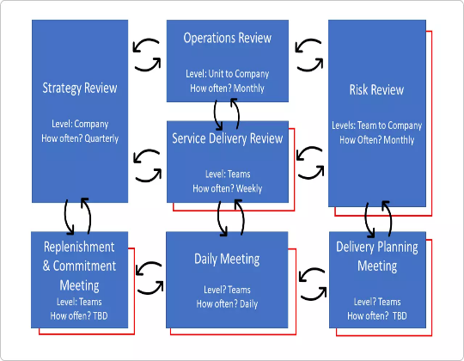
Fig 2.1 Modify Struck model

Moreover, Combined Stream Outlines can likewise help Deft development groups track their work process' steadiness and see where an excess of work gets jumbled. This can assist them with uncovering bottlenecks and upgrading their cycle effectiveness.
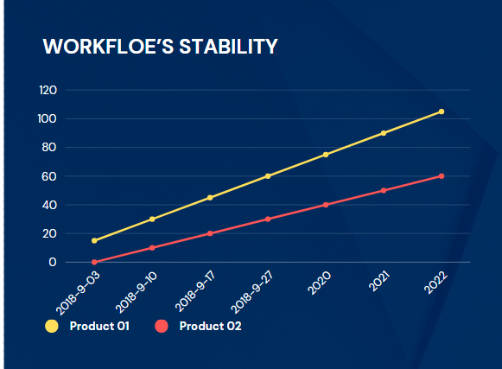
Fif 2.2 Graph of Waterflow Stability
Project Deferrals Due to Revamp
One more justification for broad task postponements and cost overwhelms in the development business is the amassing of steady improvement. For instance, a review shows that around 30% of the work performed by development organizations is revamping.
Lean/Light-footed strategies plan to manage that by presenting customary and short-quality confirmation steps in the venture lifecycle.
Typically, great practice in Lean is to abbreviate however much as could be expected or even eliminate through and through the enormous Quality Control phase of a given result. In any case, while overseeing development projects, that probably won't be imaginable. In any case, by picturing and carrying out successive checking moves toward guaranteeing quality is consistently implicit, you will respond to issues quicker and diminish how many unreasonable adjustments that cause overspending and venture delays.

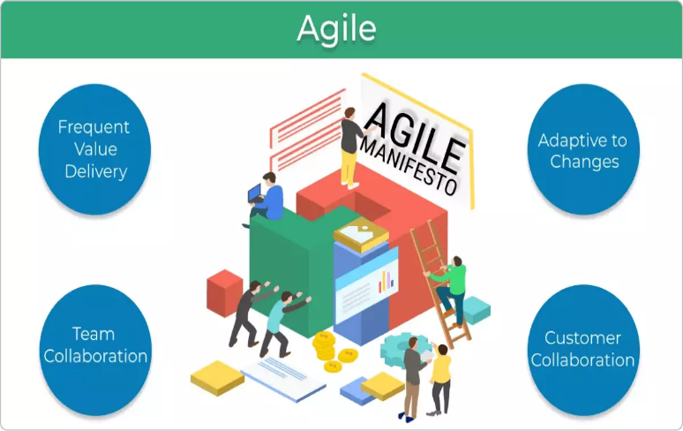
Fig 2.3 Agile Methods

Nimble Venture The board in the Research and development divisions
Driven by client longing for an undeniable level of in-vehicle experience, car organizations shift their concentration from equipment-driven items to more programming-driven vehicles. Expectations show that the product will represent more than 30% of the all-out vehicle content by the start of the following ten years contrasted with just around 10% today.
Coherently, this implies a great deal of new programming in a brief period.
To accomplish this, vehicle makers will likewise have to change their Research and development activities and leave the exceptionally organized approach to working For Deft Venture the executives. With Spry, the task conveyance will incorporate cycles, joined with close and continuous client joint effort. This is particularly useful for an industry, for example, frameworks need to go through extensive accreditation processes before they become completely functional. Consistently matching up plan plans with applicable partners furnishes groups with the capacity to comprehend what they need to do. It likewise permits them to apply any vital changes right off the bat all the while, as any later ones would commonly bring about outrageous overspendings or complete task disappointments.
IIII. CASE STUDY- Problem In certain small and medium-scale industries.
For this situation study, we will get to realize the issue of Diminishing Opp fortuity to Market and Deal with Intricacy Through Cross-Useful Groups
A cross-useful group is a gathering with various practical skills, teaming up towards a shared objective. What we regularly see in customary work structures is the different siloes viewing for assets. There are likewise a ton of hand-offs, miscommunication, and in the end delays.
Despite that, presenting a cross-practical group structure animates joint effort between colleagues with various skills, diminishes the number of hand-offs, and improves correspondence. Further on, the different gatherings are likewise more adaptable, empowering them to share information and take care of issues quickly. Zeroed in on the most proficient method to best utilize the accessible assets together, cross-useful groups naturally decline an opportunity to market of their items.
A model from the practices shows that redesigning workers into item-engaged, Light-footed groups can speed up advancement cycles by 40% and further develop designing and capital proficiency by 25%.
One more advantage of cross-useful groups is better coordination across practical regions. With vehicles turning into a perplexing blend between man-made intelligence, mechanics, programming, and state-of-the-art configuration, having different utilitarian regions teaming up with each other is a viable method for overseeing intricacy. Uniting assorted aptitudes additionally opens the entryways for advancement and better use of currently evolved functionalities, guaranteeing further upper hands.
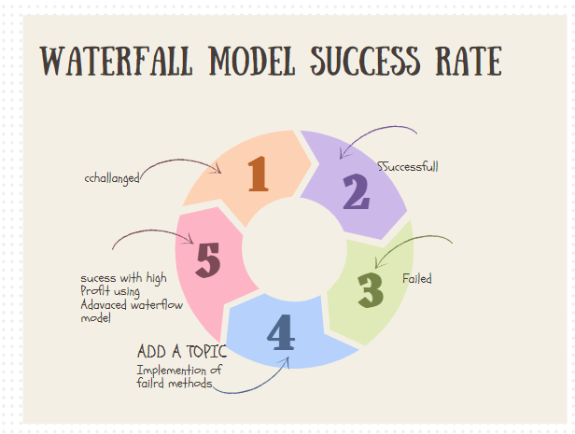
Fig 3.1Waterfall Model Success Rate
IV.INDUSTRIES THAT BENEFIT FROM AGILE ADOPTION
1.Advertising and Checking
Promoting And Stamping Require a Steady Update from the new tracks in the market to such an extent that the organizations can draw in the consideration of the buyers Spry Strategies assist Organizations with pursuing better choices so they can deliver significant substance and rehash the marvel which dexterous made in the IT Business. Numerous New businesses have utilized Deft to handle their turn of events. For example, Teradata Application is a business that Sells Programming to help promote. Coordinated likewise helped them in working on the Correspondence inside the task and fundamentally improved their cycles.


Fig 4.1 Interconnection of Agile Adoption
2. Banking and Money
Banking And Money isn't Equivalent to it was 10 years prior as the money business has taken a significant improvement in the current day. The client generally enquires about the web banking administrations which the bank brings to the table. Dexterous Techniques, for example, Scrum give fourteen days in Ran to foster those highlights and take criticism on whether the elements were valuable are not. Many cycles like gambling the executive’s framework, instalment parades, and staying aware of assumptions for the clients have been successfully taken care of by spry philosophy.
3. non-benefit
Non-Benefit associations have lesser financing and Staff given the way that they exist to serve society. Nonetheless, for these Associations to successfully serve Society. They must be Dexterous in their Cycles. As of now, these Associations utilize longer arranging cycles and attempt to execute their arrangements in the longer run. On the off chance that these plans could be more limited by utilizing Nimble Strategies, they could produce more gifts based on their ideal interest group at a given time.
4. Engineering and Item Advancement
Lithe Strategies are utilized in the data innovation industry where individuals utilize the customary programming techniques, for example, a cascade to foster their items. With the speed increase in market elements, new items are turning out in the market each day and organizations need to rival each other to remain on top of their game. Nimble techniques are demonstrated to diminish the dangers of modifying in maker improvement which saves a critical cast in the organization's budget. One of the main advantages which these ventures is the decrease in the opportunity to market the item as organizations figure out how to function all the more effectively.

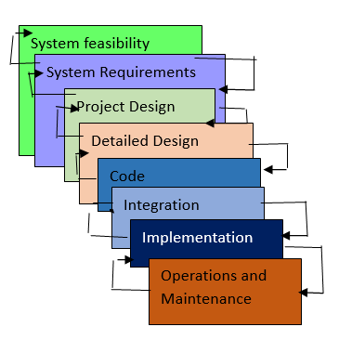

Fig 4.2 Waterfall cycle model
The Water life cycle model gave an acknowledgement that criticism circles are expected between stages. These circles should be bound to successful moves toward keeping away from costly modifications coming about because of criticism across serval stages. The cascade model likewise permits the joining of prototyping in the existence cycle, by an equal step at the necessities and examination stage.
Advanced Waterfall Model
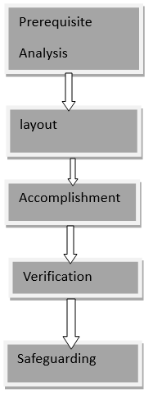
Fig 4.3 Advanced Waterfall Model
Cascade models are generally used to foster venture applications like Client Relationship Executives (CRM) Frameworks, Production Network Board Frameworks, Stock Administration Frameworks, and so forth.
Which Organization utilizes the Cascade Model?
Notable organizations utilize the cascade model in their product improvement process; one of these organizations is Toyota.
History of Cascade Model:
the cascade model is one of the customary programming advancement models. Royce originally recorded the cascade model in 1970. The cascade strategy is a well-known and adaptable variant of life cycle models for the product improvement process. Various enterprises immediately took on the cascade strategy for better venture the executives.
Select an efficient undertaking with more
Highlights of the SDLC Cascade Model
Successive Methodology: The cascade model includes a consecutive way to deal with programming improvement, where each period of the undertaking is finished before continuing toward the following one.
Report Driven: The cascade model depends intensely on documentation to guarantee that the venture is distinct and the undertaking group is pursuing an unmistakable arrangement of objectives.
Quality Control: The cascade model puts a high accentuation on quality control and testing at each period of the venture, to guarantee that the result meets the necessities and assumptions of the partners.
Thorough Preparation: The cascade model includes a thorough arranging process, where the undertaking degree, courses of events, and expectations are painstakingly characterized and checked all through the venture lifecycle. By and large, the cascade model is utilized in circumstances where there is a requirement for an exceptionally organized and methodical way to deal with programming improvement. It tends to be compelling in guaranteeing that huge, complex tasks are finished on time and inside the spending plan, with an elevated degree of value and consumer loyalty.
Significance of SDLC Cascade Model
Lucidity and Straightforwardness: The Direct Type of the Cascade Model offers a basic and unambiguous starting point for project improvement.
Characterized Stages: The Cascade Model's stages each have interesting information sources and results, ensuring an arranged improvement with clear designated spots.
Documentation: An emphasis on intensive documentation assists with programming understanding, upkeep, and future development.
Steadiness in Prerequisites: Appropriate for projects when the necessities are clear and consistent, lessening changes as the task advances.
Asset Streamlining: It supports viable undertaking-centered work without persistently changing settings by assigning assets as per project stages.
Importance of Little Ventures: Practical for unobtrusive undertakings with basic particulars and negligible intricacy.
  - Difference Between the Waterfall Model and the Advanced Waterfall Model
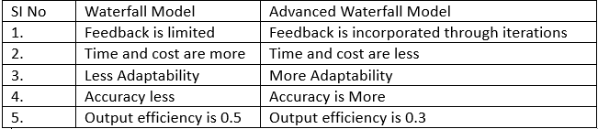
1.1.1Table of Difference

VI. DISCUSSION
A. industry is an exceptionally customary industry that has been developing a successive item improvement approach for the beyond 100 years. To get away from that will be quite possibly of the greatest test on the way to spryness organizations will confront.
B. Next to that, the business is characterized by severe schedule cycles and long inventory chains, which the new techniques should figure out how to regard. Nonetheless, there are as of now various models that applying Light-footed in the car business can do marvels, so it ought not be an issue of "if" to embrace Lithe, yet "how".
C. Before leaping to rebuilding and changing current approaches to working, a significant step is to assess the organization's present status. The objective ought to be to recognize business difficulties and search for the underlying drivers of wasteful cycles. These bits of knowledge can then be utilized to lay out boundaries and objectives for the Light-footed change. Without arrangement around the targets of the change, any outcomes are ill-fated to look unsuitable.
D. Typically, Spry developments will more often than not be base-up coordinated. Be that as it may, the help of the organization chiefs is essential for scaling Coordinated across the association. Without a significant purchase in from the top administration, the new working techniques will be either brief or will remain disconnected in individual divisions.
E. How to deal with the change is likewise a pivotal vital choice. Associations with less Nimble experience ought to go stepwise and "fair and square" from the start. A couple of pilots in individual units can accomplish fast wins and grandstand the methodology's advantages, making energy around its execution.
F. Once a specific degree of development is reached, leaving on a full Light-footed change turns out to be a lot simpler.
VII.CONCLUSION
Agile Manufacturing System Nimble strategies in small and medium-scale enterprises (SMEs) can yield huge advantages regarding flexibility, productivity, and consumer loyalty. Here is a short end on how Dexterous can be worthwhile for industries. Adaptability Nimble strategies permit SMEs to be more adaptable and receptive to changing business sector requests. They can rapidly adjust to shifts in client inclinations or market patterns, empowering them to remain in front of the opposition. Effectiveness By separating projects into more modest, sensible errands, Spry assists SMEs with smoothing out their cycles and further developing productivity. Groups can focus on undertakings in light of their significance and convey worth to clients in more limited periods. Client Concentration Nimble puts serious areas of strength for an on-client coordinated effort and criticism. SMEs can draw in their clients all through the advancement cycle, guaranteeing that the eventual outcome addresses their issues and assumptions. Risk The board Dexterous energizes iterative turn of events and regular testing, which recognizes and relieves gambles from the get-go in the venture lifecycle. SMEs can resolve issues as they emerge, lessening the probability of expensive postponements or disappointments. Group Strengthening Nimble engages cross-useful groups to simply decide and take responsibility for work. This cultivates a culture of joint effort and development inside SMEs, prompting higher worker confidence and efficiency. By and large, Light-footed techniques offer SMEs an essential way to deal with the project the executives that advance versatility, proficiency, and consumer loyalty. By embracing Dexterous standards, little and medium-scale enterprises can upgrade their seriousness and drive maintainable development in the present powerful business climate.
Organizations' names are concealed because undermined level Organizations are Alluded to Demonstrate 1 to 9(a1) Executed and the outcome goes to the model.
VIII.FUTURE WORK
Further future work in the form of items given market requests through more continuous client coordinated effort close by the task's life cycle. Increment item quality through quicker criticism circles and an iterative item advancement approach Handle intricacy through cross-joint effort groups Decline time to showcase by decreasing hand-offs, helping cooperation and expanding the generally functional limit of the groups.

- REFERENCES
- Zhang Shu. Step-by-step instructions to enter China's assembling ventures into 2lst hundred years. Beijing Distributing House Guard Industry, 2008:65
（in Chinese）
2. Zhang Hua Wang Zhilin. The change of minimal expense little furthermore, medium ventures (1) electromechanical joining, 2008.5(2) :18-l9（in Chinese）
3. Hardware Service of Industry and Innovation Division of Quality Management, etc. High-level innovation improvement methodology class procedures. Beijing,2007.5（in Chinese）
4. Wu Xiying, Lv Wenlin, the assembling area, coordinated and globalization [J]. Producing computerization, 2007.9.19 （ in Chinese）
5. "Cisco's Securing Procedure". Contextual analyses in Business Methodology. IV. ICMR: 2. January 2004. BSTR083. Recovered December 21, 2009.

