Enhancing Dairy Farming Efficiency Through Agile Manufacturing
Ms. Meghana U¹, Prof. Rohith M N²
¹Post graduation student, ²Assistant Professor, Department of Electronics and Communication Engineering
Sri Jayachamarajendra College of Engineering, JSS Science and Technology University, JSS Technical Institutions Campus, Mysuru-570006

Abstract—This study investigates the utilization of light-footed assembling standards in the dairy cultivating area, zeroing in on the activities of the Karnataka Milk Alliance (KMF) in Karnataka, India. Dexterous assembling underscores versatility, fast reaction, and adaptability underway cycles to fulfill dynamic market needs. By coordinating nimble standards into dairy cultivating rehearses, KMF plans to upgrade productivity, streamline asset usage, and further develop responsiveness to shopper inclinations. This exploration examines the execution of nimble strategies inside KMF's dairy tasks, dissecting its effect on creation, store network the executives, and consumer loyalty. Through a blend of subjective and quantitative examinations, including contextual analyses and execution measurements, the review assesses the viability of light-footed assembling in improving the seriousness and maintainability of dairy cultivating endeavors. The discoveries contribute important bits of knowledge into the capability of dexterous assembling to upset conventional dairy cultivating practices and drive advancement in the dairy business.
Agile production is a manufacturing method that emphasizes flexibility and responsiveness to unexpectedly converting marketplace needs and client needs. It entails adapting production strategies and structures to efficaciously produce a huge type of merchandise in small batches, regularly in reaction to real-time call for signals.

Keywords— Agile manufacturing, dairy farming, Karnataka Milk Federation (KMF), efficiency, flexibility, responsiveness, market demands, customer preferences, sustainability, innovation
- INTRODUCTION
The dairy business assumes an imperative part in the horticultural economy, particularly in states like Karnataka, India, where milk creation is a huge type of revenue for some ranchers. The Karnataka Milk Organization (KMF) is a vital participant in this area, filling in as the pinnacle body for the dairy co-usable development in the state. KMF's tasks are pivotal for guaranteeing the effective assortment, handling, and appropriation of endlessly milk items across Karnataka.
KMF's process started with the foundation of the main dairy co-agents in 1955 in Kudige, Kodagu Region. Throughout the long term, KMF has developed into a unique association with a solid spotlight on advancement and supportability. One of the key techniques embraced by KMF to improve its tasks is the execution of nimble assembling standards.
Coordinated assembling is an assembling procedure that underlines adaptability, responsiveness, and versatility to fulfill changing business sector needs. With regards to the dairy business, deft assembling can upset conventional dairy cultivating practices and drive development underway, inventory network the executives, and consumer loyalty.
One of the center parts of coordinated assembling is its attention on quick reaction to advertise changes. By utilizing innovation and information investigation, KMF can rapidly change its creation cycles to satisfy fluctuating need designs. This nimbleness further develops effectiveness as well as lessens waste and upgrades efficiency.
One more key component of deft assembling is its accentuation on coordinated effort and correspondence. KMF can team up intimately with dairy ranchers, providers, and wholesalers to smooth out processes and further develop direction. This cooperative methodology can prompt a more incorporated and effective inventory network, eventually benefiting both KMF and its partners.
Moreover, coordinated assembling advances development by empowering trial and error and chance taking. KMF can investigate new creation methods, item contributions, and market systems to remain in front of the opposition. This culture of development can assist KMF with separating its items on the lookout and draw in a more extensive client base.
In addition, nimble assembling advances manageability by streamlining asset usage and limiting ecological effect. KMF can embrace maintainable practices, for example, productive water utilization, environmentally friendly power sources, and waste decrease measures to guarantee long haul feasibility.
All in all, spry assembling can possibly change the dairy business and upgrade KMF's tasks in Karnataka. By embracing nimbleness, KMF can further develop productivity, responsiveness, and manageability, prompting a more cutthroat and versatile dairy area in the state.
The Karnataka Milk League (KMF) is a critical association in the dairy area, filling in as the peak body for the dairy helpful development in Karnataka, India. Laid out in 1974, KMF has developed to become one of the biggest and best dairy cooperatives in the country, with a solid spotlight on advancement and manageability. One of the key techniques that have added to KMF's prosperity is the reception of lithe assembling standards in its tasks. Lithe assembling is a system that underlines adaptability, responsiveness, and flexibility to satisfy changing business sector needs. With regards to the dairy business, dexterous assembling can alter conventional dairy cultivating practices and drive advancement underway, inventory network the board, and consumer loyalty. KMF has implemented agile manufacturing principles across its operations, from milk collection to processing and distribution. One of the key aspects of agile manufacturing adopted by KMF is its focus on rapid response to market changes. By leveraging technology and data analytics, KMF can quickly adjust its production processes to meet fluctuating demand patterns. This agility not only improves efficiency but also reduces waste and enhances overall productivity. Another key element of agile manufacturing adopted by KMF is its emphasis on collaboration and communication. KMF works closely with dairy farmers, suppliers, and distributors to streamline processes and improve decision-making.
This collaborative approach has led to a more integrated and efficient supply chain, benefiting both KMF and its stakeholders. Additionally, agile manufacturing promotes innovation by encouraging experimentation and risk-taking. KMF regularly explores new production techniques, product offerings, and market strategies to stay ahead of the competition.
This culture of innovation has helped KMF differentiate its products in the market and attract a broader customer base. Moreover, agile manufacturing promotes sustainability by optimizing resource utilization and minimizing environmental impact.
II MODEL OF MILK FEDERATION
A venture is an impermanent undertaking embraced to make a novel item or administration. PM is the use of information, abilities, devices, and methods to extend exercises to meet task prerequisites. PM is achieved through the utilization of the cycles, for example, starting, arranging, executing, controlling, and shutting.
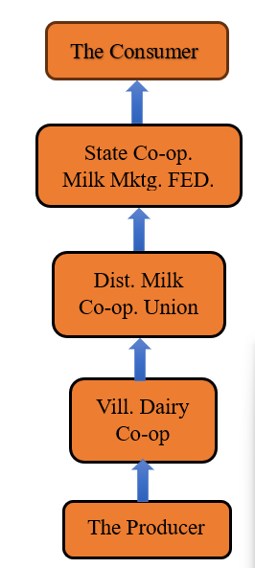

Fig:2.1. The model of Milk Federation
The Karnataka Helpful Milk Makers' League Restricted (KMF) is a helpful organization of dairy cooperatives in Karnataka, India. It was laid out in 1974 as a zenith body to advance dairy improvement exercises in the state. KMF works under the direction of the Public Dairy Improvement Board (NDDB) and is partnered with the Public Helpful Dairy Alliance of India Restricted (NCDFI).
- Primary Dairy Cooperative Societies (DCSs):
These are the essential units of the league, situated at the town or town level. They are possessed and worked by milk makers. The DCSs gather milk from ranchers and give them different administrations and backing. Primary Dairy Cooperative Societies (DCSs) are the foundation of the dairy cooperative movement in Karnataka, India. These societies are formed and managed by milk producers at the village or town level.
1.Formation and Registration: DCSs are registered under the Karnataka Cooperative Societies Act, 1959. They are formed by a group of milk producers who come together to collectively address their common needs and challenges related to milk production and marketing.

2. Ownership and Management: DCSs are owned and managed by their members, who are primarily small-scale dairy farmers. Each member has a share in the society and has a say in its decision-making processes, usually through a democratic voting system.
3. Objectives: The main objectives of DCSs include:
- To collect and procure milk from members.
- To provide members with fair prices for their milk.
- To provide members with access to inputs like cattle feed, veterinary services, and loans.
- To promote dairy development activities among members.
4. Functions: DCSs perform various functions to achieve their objectives, including:
- Milk Collection: They collect milk from members either directly from their farms or at designated collection points.
- Quality Testing: DCSs often have facilities to test the quality of milk to ensure it meets the required standards.
- Payment: They pay members for the milk based on the quantity and quality supplied.
- Input Supply: DCSs provide members with cattle feed, medicines, and other inputs required for dairy farming.
- Training and Extension: They organize training programs and extension services to educate members about best practices in dairy farming.
5. Linkage with Milk Unions: DCSs are affiliated with a milk union, which acts as an intermediary between the DCSs and the federation (KMF). The milk union collects milk from DCSs, processes it, and markets dairy products under the brand name "Nandini."

6. Role in Dairy Development: DCSs play a crucial role in promoting dairy development by:
- Providing a platform for small-scale dairy farmers to collectively market their milk.
- Empowering farmers by giving them ownership and control over the dairy business.
- Improving the socio-economic status of farmers by providing them with a regular source of income.
DCSs are the backbone of the dairy cooperative movement in Karnataka and have been instrumental in transforming the lives of small-scale dairy farmers in the state.
Project planning of AM is to characterize and refine goals furthermore, select the best of the elective strategies such as the do best quality inspection of the fuel to achieve the goals that the task was attempted to address like to supply best quality of fuel is supplied to the engine
- Hall Sensor is used for checking the if there any contamination in fuel is there or not.
- Water presence sensor: This sensor will detect if there any content of water is available or not also will tell how much of quantity is there. According to that we can compare to the data we have to check if the amount is permissible or not.
- Milk Unions:
These are the second-level units, framed by gathering a few DCSs in a specific region. The milk associations gather milk from DCSs, process it, and market dairy items. They additionally offer specialized and administrative help to DCSs.
Development and Construction: Milk associations are shaped by gathering a few Essential Dairy Helpful Social orders (DCSs) in a specific region. They are enrolled under the Karnataka Agreeable Social Orders Act, 1959, and work as helpful social orders themselves. Milk associations have their own administration structure, including a directorate chose by the subsidiary DCSs.
1.Targets: The fundamental goals of milk associations include:
- Gathering and getting milk from DCSs.
- Handling milk into different dairy items like milk, spread, ghee, and cheddar.
- Promoting dairy items under the brand name "Nandini" or other brand names.
- Giving specialized, administrative, and monetary help to DCSs.
- Advancing dairy advancement in their separate areas of activity.
2. Capabilities: Milk associations carry out different roles to accomplish their goals, including:
3. Milk Obtainment: They acquire milk from DCSs in light of settled upon costs and quality principles.
4. Milk Handling: Milk associations process the milk into different dairy items utilizing present day dairy handling gear and strategies.
5.Quality Control: They keep up with severe quality control measures to guarantee that the dairy items fulfill the necessary guidelines.
6. Promoting: Milk associations market the dairy items under their image names through their own outlets, as well as through other dissemination channels.
7. Input Supply: They furnish DCSs with inputs like cows feed, medications, and gear at financed rates.
8. Preparing and Expansion: Milk associations coordinate preparation projects and augmentation administrations for DCS individuals to further develop their dairy cultivating rehearses.
9. Linkage with KMF: Milk associations are partnered with the Karnataka Helpful Milk Makers' Alliance Restricted (KMF), which is the summit body of the dairy agreeable development in Karnataka. The KMF gives direction, sets approaches, and works with the execution of dairy improvement programs through the milk associations.
10. Job in Dairy Improvement: Milk associations assume a urgent part in advancing dairy improvement by:
- Giving a market to the milk delivered by limited scope dairy ranchers.
- Enhancing milk by handling it into different dairy items.
- Guaranteeing fair costs and opportune installments to DCSs for their milk.
- Working on the financial status of dairy ranchers by furnishing them with extra pay amazing open doors.
In general, milk associations are central members in the dairy agreeable development in Karnataka, working with the reconciliation of dairy exercises and guaranteeing the government assistance of dairy ranchers in the state.
- KMF (Federation): This is the apex body that coordinates the activities of the milk unions. It provides overall guidance, sets policies, and facilitates the implementation of dairy development programs. The KMF also markets dairy products under the brand name "Nandini."
- Presenting Coordinated Assembling in a milk organization includes applying the standards of Lithe strategy to work on the productivity and viability of its tasks. Nimble Assembling centers around adaptability, fast reaction to change, and consumer loyalty. This is a prologue to the way Lithe Assembling can help a milk organization:

- Adaptability and Flexibility: Coordinated Assembling permits milk leagues to rapidly adjust to changes in market interest, guidelines, and innovation. This adaptability is pivotal in the dairy business, where variables like milk creation, handling limit, and circulation channels can differ.
- Client Driven Approach: By zeroing in on client requirements and inclinations, Lithe Assembling assists milk leagues with conveying items that meet or surpass client assumptions. This approach can prompt expanded consumer loyalty and devotion.
- Nonstop Improvement: Coordinated Assembling accentuates consistent improvement through iterative cycles and input circles. Milk alliances can involve this way to deal with recognize and address failures in their activities, prompting cost reserve funds and worked on quality.
- Cross-Utilitarian Cooperation: Nimble Assembling energizes coordinated effort among various divisions and groups inside a milk organization. This cross-useful joint effort can prompt better correspondence, quicker navigation, and further developed critical thinking.
- Fast Navigation: Lithe Assembling empowers milk alliances to make speedy, information driven choices. This capacity to answer quickly to changing circumstances can give milk organizations an upper hand on the lookout.
- Upgraded Development: Coordinated Assembling cultivates a culture of development inside milk leagues. By empowering workers to trial and face challenges, milk alliances can foster new items and cycles that drive development and maintainability.
- Further developed Effectiveness: By wiping out squander and streamlining processes, Dexterous Assembling can assist with draining leagues further develop proficiency and lessen costs. This proficiency can convert into higher benefits and better seriousness.
- Spry Assembling offers milk organizations an essential system for exploring the intricacies of the dairy business. By embracing Deft standards, milk leagues can turn out to be more responsive, versatile, and client engaged, situating themselves for long haul achievement.

- INDUSTRIES THAT BENEFIT FROM AGILE ADOPTION

By using of advanced model of milk federation the benefits are:
- Key functions
- Milk Procurement and Collection:
- Systematic collection of milk from members through DCSs.
- Ensuring quality through initial testing for fat content and contaminants.
- Processing and Production:
- Transporting milk to district union processing plants.
- Processing into various dairy products like milk, butter, cheese, yogurt, and milk powder.
- Ensuring adherence to hygiene and quality standards.
- Marketing and Distribution:
- Centralized branding and marketing strategies managed by the state federation.
- Distribution network spanning urban and rural areas.
- Maintaining a robust supply chain to ensure product availability.
- Support Services:
- Veterinary care and artificial insemination services to improve cattle health and productivity.
- Feed and fodder supply at subsidized rates.
- Training programs for farmers on best practices in dairy farming and cooperative management.
- Financial Management:
- Transparent financial dealings ensuring timely payments to farmers.
- Access to credit and financial assistance for members.
- Profit distribution among members based on their contribution.
- Farmer Empowerment:
- Farmers have ownership and control over the cooperative.
- Improved income stability and financial security for farmers.
- Economies of Scale:
- Collective procurement and marketing reduce costs and increase bargaining power.
- Quality Control:
- Standardized quality checks at multiple stages ensure high-quality dairy products.
- Community Development:
- Cooperatives often invest in local infrastructure and community development projects.
- Employment generation within rural communities.

- Challenges

- Management Efficiency:
- Requires effective and transparent management to avoid corruption and inefficiencies.
- Market Competition:
- Facing competition from private dairy companies and changing consumer preferences.
- Logistical Issues:
- Ensuring timely collection, processing, and distribution in diverse geographical areas.
- Technological Adoption:
- Integrating modern technologies for better productivity and efficiency can be challenging.

Primary Dairy co-operative societies
District co-operative milk unions
State Milk Federation

Fig:3.1 Advanced Model of Milk Federation

- CASE STUDY- A Comparative Analysis of Leading Milk Brands in the Market
Looking at changed milk brands should be possible in view of a few factors like cost, quality, accessibility, obtaining practices, and consumer loyalty.
- Farmer Ownership: The organization is possessed and overseen by ranchers, guaranteeing that they have command over the whole worth chain of milk creation and showcasing. Rancher proprietorship is a crucial standard of many milk leagues and dairy cooperatives all over the planet, including the Karnataka Helpful Milk Makers' Organization Restricted (KMF) in India.
- Cooperative Structure: The cooperative structure ensures that benefits are shared among members and that decision-making is democratic. Milk federations operate based on the cooperative principles, which include voluntary and open membership, democratic member control, member economic participation, autonomy and independence, education, training, and information, cooperation among cooperatives, and concern for the community.
- Integration: The three-level construction considers the combination of dairy exercises, from milk creation to handling and promoting. Joining in milk alliances alludes to the coordination and combination of different phases of the dairy esteem chain, from milk creation to handling and promoting. This reconciliation is pointed toward further developing productivity, quality control, and market access.
- Quality Control: The KMF has laid out severe quality control measures to guarantee that its items satisfy the expected guidelines. Quality control is a significant part of milk organizations to guarantee that the dairy items satisfy the expected guidelines of wellbeing, virtue, and quality.
- Market Access: The league has made areas of strength for a presence for its items, empowering it to get to a more extensive market and get better costs for farmers. Market access is a basic part of the activity of milk organizations, as it decides the capacity of the organization to offer its dairy items to buyers.

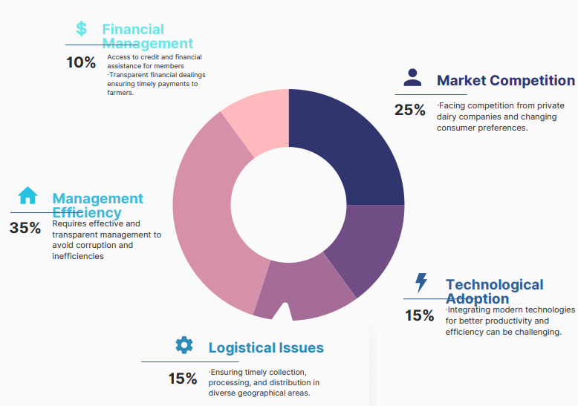
Fig.3.2 Graph of Advanced model of Milk Federation

- DISCUSSION
Adopting agile manufacturing principles could benefit milk federations like the Karnataka Cooperative Milk Producers’ Federation Limited (KMF). Here are some ways it could be implemented:
Flexibility: Agile manufacturing allows for quick adjustments in production to meet changing demands. For KMF, this could mean adjusting milk collection schedules based on seasonal variations in production or sudden changes in demand.
Collaboration: Agile encourages collaboration between different departments or units within an organization. For KMF, this could mean better coordination between milk collection, processing, and distribution units, leading to smoother operations.
Customer Focus: Agile manufacturing puts a strong emphasis on meeting customer needs. KMF could use customer feedback to quickly adjust product offerings or improve service quality.
Innovation: Agile manufacturing encourages innovation in processes and products. KMF could use this approach to develop new products or improve existing ones, staying ahead of competitors.
Efficiency: Agile manufacturing focuses on reducing waste and improving efficiency. For KMF, this could mean optimizing milk collection routes, reducing energy consumption in processing plants, or improving distribution logistics.
Adaptability: Agile manufacturing enables organizations to quickly adapt to changes in the market or business environment. For KMF, this could mean responding quickly to changes in milk prices, government regulations, or competitor actions.
Implementing agile manufacturing principles would require KMF to adopt new ways of thinking and working, but the potential benefits in terms of efficiency, customer satisfaction, and competitiveness could make it a worthwhile endeavor.
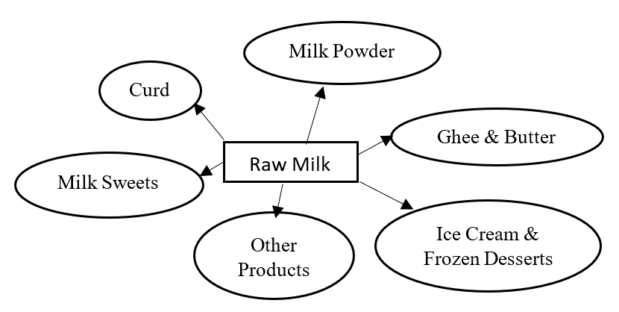
Fig:4.1 Distribution Model
Carrying out Light-footed philosophies in the circulation of crude milk can bring a few advantages, especially with regards to adaptability, productivity, and consumer loyalty. This is the way Light-footed standards may be applied in this specific situation:
Iterative Preparation: Lithe supports iterative preparation, which can be valuable in the circulation of crude milk. Rather than inflexible long-haul plans, groups can decide for more limited periods, changing in view of continuous criticism and changing prerequisites, for example, atmospheric conditions, milk supply, or client interest.
Versatility: Light-footed elevates flexibility to change. For crude milk circulation, this could mean rapidly changing courses, amounts, or timings in view of variables like traffic conditions, hardware breakdowns, or unexpected interest spikes.
Cross-utilitarian Groups: Light-footed accentuates the significance of cross-practical groups. With regards to crude milk conveyance, this could include groups comprising of drivers, planned operations facilitators, and quality control staff cooperating to guarantee convenient and productive conveyance.
Ceaseless Improvement: Spry supports persistent improvement through normal reflection and transformation. In crude milk dissemination, this could include normal audits of conveyance cycles to recognize bottlenecks or failures and make important enhancements.
Client Concentration: Lithe puts areas of strength for an on-consumer loyalty. In crude milk dispersion, this could mean focusing on-time conveyance, guaranteeing item quality, and being receptive to client criticism and solicitations.
Straightforwardness and Correspondence: Nimble advances straightforwardness and open correspondence. In crude milk appropriation, this could include utilizing innovation to give continuous updates to clients on conveyance plans or permitting clients to give criticism on their conveyance experience.
By carrying out Spry philosophies in the appropriation of crude milk, dairy organizations can work on their capacity to answer changing economic situations, increment effectiveness in their dispersion processes, and eventually upgrade consumer loyalty.
Amul and Nandini are two prominent dairy brands in India, each with its own unique history, products, and market presence. Here is a comparison between the two:
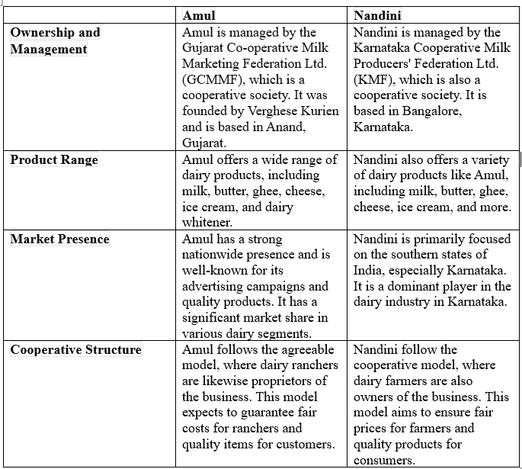
Table 4.1: Comparison between two milk company

The milk federations, including Amul and Nandini, continuously introduce new technologies to improve various aspects of their operations, including milk collection, processing, and distribution. Some of the new technologies that have been introduced or are being explored include:
- Milk Collection and Testing: Introduction of automated milk collection units at village-level dairy cooperatives to improve efficiency and accuracy. Adoption of electronic milk testing equipment for quick and accurate measurement of milk quality parameters.
- Milk Processing: Implementation of advanced milk processing technologies such as ultra-high temperature (UHT) processing for extending the shelf life of milk products. Use of membrane filtration technologies for milk concentration and separation of components.
- Cold Chain and Storage: Implementation of cold chain infrastructure to maintain the quality and freshness of milk and dairy products during transportation and storage. Adoption of solar-powered refrigeration systems to reduce energy costs and improve sustainability.
- Quality Control and Traceability: Implementation of traceability systems using barcodes or RFID tags to track the origin and processing of milk from farm to consumer. Integration of quality control measures and certifications to ensure adherence to food safety standards.
- Data Analytics and Management: Use of data analytics tools to optimize milk collection routes, predict demand, and improve overall operational efficiency. Implementation of cloud-based systems for real-time monitoring of milk procurement, processing, and distribution activities.
- Consumer Engagement: Adoption of mobile applications and online platforms for direct communication with consumers, feedback collection, and product promotion. Introduction of smart vending machines and kiosks for convenient access to fresh milk and dairy products.
These technologies are aimed at improving productivity, quality, and efficiency throughout the milk supply chain, ultimately benefiting both the dairy farmers and consumers.

  - CONCLUSION
Taking on dexterous philosophy could change the working of milk alliances like the Karnataka Helpful Milk Makers' League Restricted (KMF), offering various benefits. By embracing readiness, KMF could upgrade its functional effectiveness, better answer dynamic market requests, and work on its general seriousness in the dairy business.
Executing dexterous assembling standards would empower KMF to:
- Upgrade Adaptability: Immediately adjust to changes in milk creation, request, or economic situations by changing cycles and systems progressively.
- Further develop Joint effort: Cultivate a culture of cooperation and cross-utilitarian collaboration, prompting better correspondence, smoothed out processes, and further developed independent direction.
- Support Advancement: Energize advancement at all levels of the association, prompting the improvement of new items, cycles, and administrations that better address purchaser issues.
- Increment Consumer loyalty: By zeroing in on client requirements and criticism, KMF can convey items and administrations that adjust more intimately with purchaser assumptions, prompting more elevated levels of consumer loyalty.
- Upgrade Asset Usage: Through nimble practices, for example, iterative turn of events and nonstop improvement, KMF can enhance the utilization of assets, decreasing waste and expanding proficiency.
- Adjust to Market Changes: Answer rapidly to changes in the dairy market, administrative climate, or cutthroat scene, guaranteeing that KMF stays nimble and responsive.
All in all, taking on nimble philosophy could change KMF into a more versatile, proficient, and client centered association, situating it for supported development and outcome in the powerful dairy industry scene.
- FUTUREWORK
The future work of milk federations like the Karnataka Cooperative Milk Producers’ Federation Limited (KMF) is likely to be shaped by several key trends and challenges in the dairy industry. Some areas that KMF may focus on in the future include:
Embracing advanced technologies such as Internet of Things (IoT), big data analytics, and artificial intelligence (AI) to enhance operational efficiency, improve milk quality, and optimize supply chain management.
Product Diversification: Expanding product offerings beyond traditional dairy products to meet changing consumer preferences, such as plant-based alternatives, functional foods, and value-added dairy products.
Sustainable Practices: Implementing sustainable practices across the entire value chain, including sustainable sourcing of milk, energy efficiency, waste reduction, and environmental conservation.
Market Expansion: Exploring new markets and distribution channels to increase market penetration and reach a larger consumer base, both domestically and internationally.
Quality and Safety Assurance: Continuously improving quality control measures and food safety standards to ensure that KMF products meet the highest quality and safety standards.
Consumer Engagement: Increasing consumer engagement through marketing campaigns, educational programs, and social media to build brand loyalty and trust.
Collaboration and Partnerships: Collaborating with other dairy cooperatives, research institutions, and government agencies to drive innovation, share best practices, and address common challenges.
Policy Advocacy: Advocating for favorable policies and regulations that support the growth and sustainability of the dairy industry, including support for smallholder farmers and dairy cooperatives.
By focusing on these areas, KMF can position itself as a leading player in the dairy industry, driving growth, innovation, and sustainability in the years to come

  - REFERENCES
[1] Annual Report (2021), Directorate of Economics and Statistics, Bangalore, Government of Karnataka, PP.56-58.
[2] Government of Karnataka (2021), Economic Survey of Karnataka, Planning, Programme Monitoring and Statistics Department, Bengaluru-2021-22.
[3] Dohmwirth, C. (2014). The Impact of Dairy Cooperatives on the Economic Empowerment of Rural Women in Karnataka. Ph.D. Dissertation. Berlin: Humboldt University Berlin.
[4] KMF (2022), Annual Reports of Karnataka Milk Federation (2013-14 to 2022-23), Bengaluru: Progress Report of KMF, Office Records
[5] Murthy, P. S., & Geetha, R. S. (2021). Evolution of Dairy Cooperatives in Karnataka: A Special Focus on Women’s Dairy Cooperatives. Asian Journal of Agricultural Extension, Economics & Sociology, 39(9), 1-7.
[6] Popker, S. M. (2016). The Performance Evaluation of Primary Dairy Milk Co-Operative Societies in Goa (Doctoral dissertation, Goa University).
[7] Ravishankara, K. M., Dixit, A. K., Datta, K. K., & Singh, S. P. (2019). Effect of Cooperative Dairy Society on the Performance of Dairy Farms in Mandya District of Karnataka. Indian Journal of Economics and Development, 15(4), 580-585.
[8] Annual Report (2022), Directorate of Economics and Statistics, Bangalore, Government of Karnataka, PP.56-58
[9] Government of Karnataka (2022), Economic Survey of Karnataka, Planning Programme Monitoring and Statistics Department, Bengaluru-2022-23.
[10] Benni, B. S. (2003). Dairy Co-Operative Societies in Karnataka. Finance India, 17(2), 648.

