“Beyond Books: Exploring AR in Education with Unity3D”
Dr Arjun B C¹, Akash D²
1Prof. And HOD Dept. of Information Science And Engineering, Rajeev Institute Of Technology, Hassan, India
2Information Science And Engineering, Rajeev Institute Of Technology, Hassan, India

---------------------------------------------------------------------***--------------------------------------------------------------------

ABSTRACT

Augmented Reality (AR) is a technology that enables the blending of digital information, such as 3D models, images, or videos, into our real-world environment in real time. Unlike virtual reality, which creates an entirely artificial environment, AR enhances reality by overlaying digital elements. Augmented Reality (AR) is a technological innovation that combines the physical and digital worlds.
It overlays contextual and interactive digital information onto the environment we see, creating an immersive experience. AR can revolutionize various fields such as computer science, human-computer interaction, psychology, medicine, and education. Although the concept of AR dates back to the 1960s, recent advancements in sensor technologies, computational power, and mobile devices have made it more accessible. As AR gains popularity, researchers explore its potential in different fields and study the cognitive processes involved in AR interactions. Understanding the fundamental principles of AR systems is key to unlocking its transformative capabilities. As we go further, we will explore the dimensions of augmented reality, including its evolution, current scientific applications, and prospects for scientific inquiry and innovation.

Key Words: Augmented Reality (AR), Digital Integration,
Immersive Experience, Interdisciplinary Research,
Technological Innovation

INTRODUCTION

In later a long time, innovative headways have revolutionized different viewpoints of our lives, counting how we learn and teach. One such advancement that has earned noteworthy consideration is Increased Reality (AR). Expanded Reality consistently coordinating computerized substance into the real-world environment, giving clients with an enhanced tangible encounter.
This innovation has appeared gigantic potential in changing the scene of instruction by advertising intelligently and immersive learning encounters. Expanded Reality contrasts from its partner, Virtual Reality (VR), in that it overlays advanced data onto the physical world or maybe than submerging clients totally into a virtual environment. This one of a kind characteristic of AR makes it especially well-suited for instructive settings, where understudies can associated with virtual components whereas still locks in with their physical environment. The adequacy of Increased Reality in instruction lies in its capacity to bridge the crevice between hypothetical concepts and real-world applications. By superimposing virtual objects, reenactments, and intuitively components onto the physical environment, AR empowers understudies to visualize theoretical concepts, control virtual objects, and lock in in Handson learning encounters. This approach not as it were upgrades students' understanding of complex subjects but too cultivates dynamic support and maintenance of information.
Furthermore, Increased Reality offers teachers a flexible device for making personalized and versatile learning encounters. Instructors can plan AR-enabled instructive substance custom-made to the particular needs and learning styles of person understudies. Whether it's investigating verifiable points of interest, dismembering virtual living beings, or conducting virtual tests, AR enables teachers to convey energetic and locks in lessons that cater to differing learning inclinations. Additionally, the broad accessibility of AR-enabled gadgets such as smartphones and tablets make it available to a wide run of learners, independent of their geological area or financial foundation.
This democratization of innovation guarantees that all understudies have break even with openings to advantage from AR-enhanced instructive encounters. Mechanical progressions, such as Expanded Reality (AR), have gotten to be catalysts for changing instruction, advertising imaginative ways to lock in learners and upgrade comprehension.
Unlike its immersive partner, Virtual Reality (VR), AR consistently coordinating advanced substance into the genuine world, improving the learning involvement by overlaying virtual components onto physical situations. This integration empowers understudies to connected with virtual objects whereas remaining associated to their environment, cultivating a more profound understanding of complex concepts through hands-on investigation.

LITERATURE SURVEY

Title | Year | Author Name | Proposed Methodology
[1] A Decade of Research on the Effectiveness of Augmented Reality on Students with Special Disability in Higher Education | 2022 | Malek Turki Jdaitawi, Ashraf F Kan'an | This review article explores the use of augmented reality (AR) technology in higher education for students with special needs, focusing on its positive impact on enhancing social skills, relationships, and engagement among students with disabilities. The study highlights the effectiveness of AR in intellectual disability settings and emphasizes the need for further research to fully understand how AR enhances learning outcomes for students with special needs.
[2] New Challenge in education: Enhancing students’ knowledge through augmented Reality | 2017 | Castellanos A, Pérez C. | Illustrates how although AR was not initially intended for educational uses, its applications in that are becoming more and more relevant. AR offers a hybrid learning environment that uses digital technology to  enhance reality.
[3] Research on The Application of AR Technology Based  on Unity3D in Education | 2019 | ChangYuan Li and BaiHui Tang | The authors demonstrate Vuforia's effectiveness in implementing marker-based AR for education, enabling interactive learning experiences through digital overlays on physical markers.
[4] Augmented reality (AR) as a learning material in special needs education | 2020 | Xinxiong Liu1, Jing Zhang1, Guoxiang Hou1 and Zenan Wang2 | It is focused and carried out and that too specially among neurotypical youth or children without any development or learning disorder. High potential for special needs education that can be utilized to help people with disabilities get beyond  obstacles
[5] Augmented Reality for Learning: A Systematic Review | 2019 | Lillgreen M, & Krogstie J. | This review article examines augmented reality (AR) for learning from 2014 to 2018, emphasizing its benefits in enhancing learning outcomes, motivation, and engagement. It discusses AR's potential across different learning styles and subjects, while also addressing its limitations and the necessity for more research on its long- term impact and effective application in education.

APPLICATIONS

Augmented Reality (AR) has emerged as a transformative technology in various sectors, including education. Its ability to overlay digital content onto the real world opens up innovative ways to enhance learning experiences.

3.1 AR in Education Sector:

1. Classroom Learning: Intelligently Visualizations: AR permits teachers to make intuitively 3D models that understudies can control and investigate in real-time, upgrading their understanding of complex concepts in subjects like science, chemistry, and material science. Chronicled Reproductions: History lessons can come to life with AR by overlaying authentic photographs, maps, and artifacts onto real-world areas, permitting understudies to submerge themselves in the past. Dialect Learning: AR applications can show interpretations, elocution guides, and relevant data when understudies point their gadgets at objects or content, making dialect learning more locks in and down to earth.

2. STEM Instruction: Recreations and Tests: AR reenactments empower understudies to conduct virtual tests in science, innovation, designing, and science, giving a secure and cost-effective way to investigate concepts that may be troublesome to illustrate in a conventional classroom setting. Designing Prototyping: AR can be utilized to visualize and associated with 3D models of building plans, permitting understudies to repeat and refine their models some time recently physical development, sparing time and assets.

3. Field Trips and Open air Instruction: Geolocation-based Learning: AR apps can overlay significant data, chronicled truths, and intelligently challenges onto points of interest and characteristic highlights amid field trips, improving the instructive encounter and empowering investigation. Natural Instruction: By superimposing information such as contamination levels, biodiversity hotspots, and environment flow onto the environment, AR can raise mindfulness and encourage dialogs around natural issues and conservation

4. Medical Preparing: Life structures Visualization: AR applications give therapeutic understudies with immersive encounters, permitting them to investigate point by point 3D models of the human body and visualize anatomical structures from different points, moving forward spatial understanding and maintenance. Surgical Reenactment: Specialists can hone complex strategies in a risk-free virtual environment utilizing AR, upgrading their aptitudes and decreasing the require for live quiet preparing.

5. Proficient Advancement: Corporate Preparing: AR is utilized to mimic real-world scenarios and give hands-on preparing for workers in businesses such as fabricating, upkeep, and client benefit, moving forward work status and execution. Delicate Aptitudes Advancement: AR-based reenactments offer openings for learners to hone interpersonal abilities such as open talking, cooperation, and administration in practical scenarios, cultivating individual development and certainty.

6. Uncommon Instruction: Personalized Learning: AR can be customized to oblige the differing needs of understudies with inabilities by giving elective tactile inputs, versatile criticism, and intuitively learning encounters custom-made to person learning styles. Social Abilities Preparing: AR applications can encourage social abilities preparing for understudies with extreme introvertedness range clutter (ASD) by making virtual situations where they can hone social intuitive in a controlled and strong setting. These applications of AR in instruction illustrate its potential to revolutionize conventional educating strategies and engage learners with immersive, intuitively, and personalized learning encounters over different disciplines and instructive settings.

- ARCHITECTURE OF AR

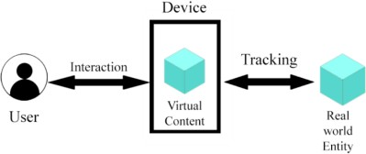

Figure 1: Augmented Reality Architecture

4.1 Components of Augmented Reality Architecture:

1.User
2. Device
3. Interaction
4. Virtual Content
5. Tracking
6. Real life Entity

Augmented Reality Architecture This Architecture comprised of all above components and interactive relationship between them helps to develop augmented reality working model.
1. User: The most fundamental portion of increased reality is its client. The client can be anyone. This client is dependable for creation of AR models.
2. Interaction: It is a process between device and user. The word itself consists of its meaning some action performs by one entity as result in creation or some action performed by other entity.
3. Device: This component is dependable for creation, show and interaction of 3D models. The device can be any device with AR capabilities. Example, mobile, computer, AR headsets etc.
4. Virtual Content: The virtual content is nothing but the 3D demonstrates made or produced by the framework or AR application. Virtual substance is sort of data that can be coordinates in genuine world user’s environment. This Virtual substance can be 3D models, surface, content, pictures etc.
5. Tracking: This component is essentially prepare which makes conceivable creation of AR models. Following is sort of calculation which offer assistance to decide the gadget where to put or coordinated the 3D demonstrate in genuine world environment. There are numerous sorts of Following calculation accessible which can be utilized in advancement of AR applications.
6. Real-life entity: The last component AR architecture is real world entities. These entities can be tree, book, fruits, computer or anything which is visible in screen.AR application does not alter position of real-life substance. It only integrates the digital information with these entities.

- TECHNOLOGIES USED TO DEVELOP AR

  - Unity3D and Vuforia:


5.1.1 Unity3D:

Figure 2: Unity Engine

One well-liked cross-platform game engine for creating augmented reality apps is Unity3D. It offers an easy-to-use interface and facilitates C# scripting for interactive experience creation.
1. Unity and Vuforia Integration: Unity and Vuforia are well-integrated AR development platforms. Marker recognition, tracking, and augmented reality features are offered by Vuforia. Unity developers may quickly create marker-based augmented reality applications by utilizing Vuforia's SDK within Unity.
2. Marker Detection and Tracking: Developers may easily set up marker detection and tracking functionalities with Unity and Vuforia. Developers may precisely overlay digital material onto real-world markers by using Vuforia's computer vision algorithms to recognize and track predetermined markers.
3. Scripting: The main scripting language used by Unity is C#. Scripts can be written by developers to specify the behaviour of the gameobjects, user inputs and other behaviours in the game scenes.


5.1.2 Vuforia:

Figure 3: Vuforia Engine

With Vuforia, developers may construct augmented reality (AR) applications on mobile devices using an SDK. It offers functions like digital content rendering, tracking, and marker detection. It provides features like marker detection, tracking, and rendering of digital content.

1.Setup: Import the Vuforia SDK into the Unity project when it has been created. To set up the license key and adjust the camera settings, according to the Vuforia instructions.

2.Target Database: Use Vuforia's Target Manager to create a target database. Create target datasets by uploading pictures of the markers you want to use in the augmented reality program.

3.Marker Recognition: To implement marker recognition in Unity, equip your AR camera with Vuforia components and set them up to recognize and follow markers from the target database.

Marker-Based AR Application:

Features:

To improve the educational experience, a marker-based augmented reality application may have the following features:
1. Marker Detection: The program must be able to identify and locate particular markers positioned across the real world.
2. Object Augmentation: The program should superimpose pertinent digital content—such as texts, films, or 3D models—atop markers it has detected.
3. Information Display: Educational materials pertaining to the topic should be displayed by the augmented items. Multimedia elements, text descriptions, and diagrams can all be a part of this information.
4.Voice-enabled Interaction: Use speech synthesis and recognition to provide voice commands for user interaction with the augmented content.
5.User Guidance: To assist users in understanding how to engage with the augmented reality material efficiently, provide them with instructions and guidance within the application.

5.3 Implementation Steps:

1. Marker Setup:

a. Select tangible markers to activate augmented reality content.

b. Set up markers in the surroundings at specific spots.

2. Unity Scene Design:

a. Set up the scene's AR cameras, lights, and objects.

b. Use Vuforia to set up the AR camera for marker detection.

3. Digital Content Integration:

a. Bring digital resources into Unity.

b. Link assets to markers in the target database of Vuforia.

4. Interaction Scripting:

a. Create C# scripts to manage events related to marker detection.

b. Specify how digital content and user interactions should be displayed.

5. Testing and Iteration:
  - Examine the app across several platforms.
  - Get input and make necessary iterations to the functionality and design.

5.4 Advantages of implementing AR in education:

There are many advantages to using augmented reality (AR) in the classroom that increases learning pace for both trainers and trainees . Here are a few key advantages:

1. Greater Engagement: Augmented reality (AR) provides engaging and encouraging learning environments to students of different backgrounds that boost trainees' focus and participation. The dynamic and visually engaging nature of augmented reality virtual objects draws learners in and motivates them to actively participate in the learning process.

2. Better Retention and Understanding: Using AR makes understanding of difficult concepts easy for students which they find complex, this can be done through allowing them to participate in meaningful interactions with virtual items and simulations. The experience of seeing, hearing, and even touching virtual objects improves retention and comprehension.

3. Personalized Learning: AR apps offer adaptive material delivery and personalized feedback based on each student's requirements, preferences, and learning style. Because of this personalization, every learner is guaranteed to have a learning experience that is ideal for their speed and comprehension level.

4. Real-world Application: By placing learning into relevant situations and scenarios, augmented reality (AR) helps close the partition between theoretical knowledge and real-world application. Applying what they have learned to real-world situations helps students develop their critical thinking, problem-solving, and transferrable knowledge.

5. Accessible Education: Regardless of physical or geographic constraints, augmented reality technology provides access to educational experiences and materials. With the help of AR glasses or mobile devices, students can interact with AR content, increasing accessibility and inclusivity for a diverse student body.

6. Collaborative Learning: AR fosters collaboration and teamwork among students by enabling shared experiences and cooperative problem-solving activities. Collaborative AR projects promote communication, peer interaction, and the development of interpersonal skills.

7. Cost-effectiveness and Scalability: While initially requiring investment in technology and content development, AR can ultimately reduce long-term costs associated with traditional teaching materials and methods. Once developed, digital AR resources can be easily replicated and distributed to a large number of students, making it a cost-effective solution for scalable education initiatives.

8. Experimental Learning Opportunities: AR enables students to explore and experiment in virtual environments without the constraints and risks of the physical world. They can conduct virtual experiments, explore historical sites, and simulate complex processes, fostering curiosity, creativity, and innovation.

9. Empowerment of Teachers: AR enables teachers to design dynamic, interactive lessons that meet a range of students' needs and goals. Teachers can be more successful educational facilitators by using AR tools to develop lessons that are fascinating assess students' progress, and provide timely feedback.

10. Technological Literacy: Technological Awareness: Students acquire digital skills and technological literacy via the integration of AR into the educational environment, which is growing more and more important in today's digital workforce and society. Students who are more conversant with augmented reality technology will be more equipped for the workforce, picking up new talents along the way, and have useful abilities to function in an increasingly technologically advanced society.

When everything is considered, augmented reality's benefits for education show how it can transform conventional teaching and learning approaches while raising accessibility, efficacy, and student engagement across the board.

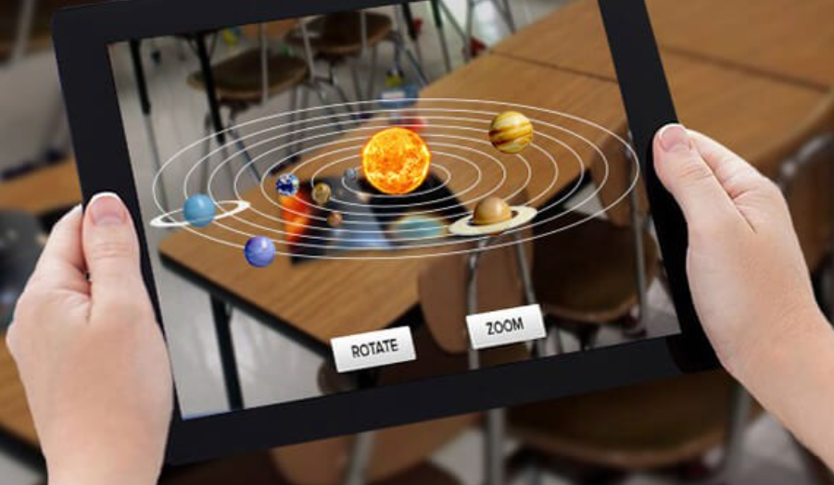

Figure 4: AR application Solar system [6]

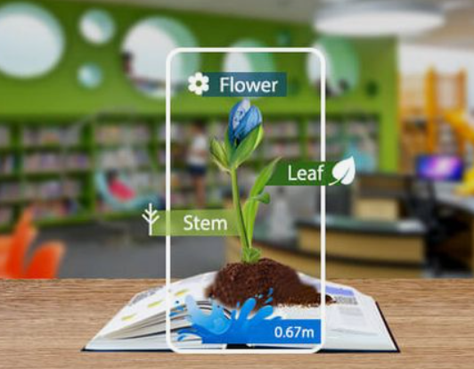

Figure 5: AR application Plant [6]

CONCLUSION

Augmented Reality (AR) has the potential to significantly enhance education by providing immersive and interactive learning experiences. By integrating AR technology into educational settings, we can create a more engaging and effective learning environment for students. AR enables educators to transform abstract concepts into tangible experiences, allowing students to interact with digital content overlaid onto the physical world. This level of engagement fosters deeper understanding and retention of knowledge among learners. Additionally, AR facilitates personalized learning experiences tailored to individual student needs and preferences. Students can explore topics at their own pace and receive personalized feedback, leading to more effective learning outcomes.
Moreover, AR encourages collaborative learning, as students can interact with AR content together, fostering teamwork and communication skills.

REFERENCES

[1] Malek Turki Jdaitawi, Ashraf F Kan'an: A Decade of Research on the Effectiveness of Augmented Reality on Students with Special Disability in Higher Education In CVPR, 2022.
[2] Castellanos A, Pérez C: New Challenge in education: Enhancing students’ knowledge through augmented Reality, 2017.
[3] ChangYuan Li and BaiHui Tang: Research on The Application of AR Technology Based on Unity3D in Education. IEEE, 2019.
[4] Hasan Kose, Nevin Guner-Yildiz. Keep it SMPL: Augmented reality (AR) as a learning material in special needs education, 2020.
[5] Lillgreen, M., & Krogstie: Augmented Reality for Learning: A Systematic Review. In CVPR, 2019.
[6] https://www.linkedin.com/pulse/augmented-reality-education-unlocking-future-learning-ajayi.
[7] https://in.pinterest.com/pin/300122762672660057/

