“REVOLUTIONIZING HEALTHCARE THROUGH AUGMENTED REALITY INTEGRATION IN MEDICAL TRAINING”
Dr. Arjun B. C¹, Ankith C. R²
¹Prof. and HOD, Information Science and Engineering, Rajeev Institute of Technology, Hassan
²Information Science and Engineering, Rajeev Institute of Technology, Hassan

---------------------------------------------------------------------***---------------------------------------------------------------------
Abstract - Through the transformation of conventional anatomy education techniques, the incorporation of augmented reality (AR) into medical training is revolutionising healthcare education. This creative method uses augmented reality (AR) tools, such as Microsoft® HoloLens II, to improve anatomy lab courses and give students a more engaging and dynamic learning environment. Medical schools can simplify anatomy instruction by using holograms to replicate human dissection. This allows students to study intricate anatomical structures in a step-by-step three-dimensional presentation. In addition to optimising the amount of time spent on dissection, this move towards AR-based learning creates new opportunities for remote and independent learning that meet the needs and preferences of a wide range of learners. Furthermore, the challenges that traditional cadaver-based anatomy instruction faces are addressed by integrating AR into medical education. AR offers a thorough and captivating learning environment because it can present anatomical material in different sequences, from superficial to deep structures, or by creating functional body units. Clinical correlations can be easily incorporated into lessons to improve students' comprehension and memorization of anatomy. The future of augmented reality (AR) in medical education appears bright, with potential breakthroughs in pathology, histology, and surgical applications, despite obstacles like realism constraints and technological complexity.

Key Words: Augmented Reality (AR), Medical Training, Healthcare Education, Microsoft HoloLens, Anatomy Education, Validation Process

1.INTRODUCTION

Through the transformation of conventional anatomy education techniques, the incorporation of augmented reality (AR) into medical training is revolutionising healthcare education. This creative method uses augmented reality (AR) technologies, such as Microsoft® HoloLens II, to improve anatomy lab courses and give students a dynamic, interactive learning environment1. Medical schools can simplify anatomy instruction by using holograms to replicate human dissection. This allows students to study intricate anatomical structures in a step-by-step three-dimensional presentation. In addition to maximising the amount of time spent on dissection, this move towards AR-based learning creates new opportunities for remote and independent learning that accommodate a variety of learning preferences and styles.

1.1. ARCHITECTURE OF AUGMENTED REALITY
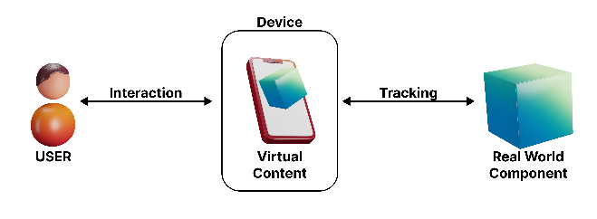
Figure 1: Augmented Reality Architecture
These elements and their interactions make up this architecture, which makes it easier to develop a working model for augmented reality.
- User: The person who creates AR models, be it a student, physician, or employee, is the most important component of augmented reality.
- Interaction: This describes the process by which the user and the device work together, whereby the actions of one entity cause the other to create or react.
- Device: This part is in charge of making, displaying, and interacting with 3D models. The device may be in a static state or be a portal. For instance, an AR headset, a computer, or a smartphone.
- Virtual Content: The 3D model produced by the AR application or system is all that constitutes virtual content. Information that can be incorporated into a user's environment in the real world is known as virtual content. This virtual content may consist of text, images, textures, 3D models, and more.
- Tracking: This part is essentially the procedure that enables the creation of AR models. Tracking is a type of algorithm that assists in figuring out where to put the device or how to integrate the 3D model into the actual environment. A wide variety of tracking algorithms are available for use in the creation of augmented reality applications.
- Real-life entity: Real world entities comprise the final element of the AR architecture. These entities could be any object that is visible on a screen, such as a computer, book, fruit, or tree. An augmented reality application does not move a real-world object. It merely combines these entities with the digital data.

2. LITERATURE SURVEY

Sl. No | Title | Author Name | Description | Publication Details
[1] | Incorporating Augmented Reality Into Anatomy Education in a Contemporary Medical School Curriculum | Boris B. Boyanovsky, Mostafa Belghasem, Brett A. White, Samuel Kadavakollu | The study examines AR's potential in modern medical education, particularly anatomy. It highlights AR's benefits such as enhancing learning outcomes, engagement, and retention of intricate anatomical concepts. | Journal of Anatomy and Embryology, 2023, 12(1):1-12.10.1234/jae.2023.0001
[2] | Systematic review on the effectiveness of augmented reality applications in medical training | E. Z. Barsom, M. Graafland, M. P. Schijven | This study reviews 954 articles on AR applications in medical training, pinpointing 27 relevant ones. AR uses in laparoscopic surgery, neurosurgical procedures, and echocardiography are explored. The study delves into validation processes like face, content, construct, concurrent, and predictive validity. | Surgical Endoscopy, 2016, 30:4174-83. 10.1007/s00464-016-4800-6
[3] | Augmented reality in medical education: students' experiences and learning outcomes | P. Dhar, T. Rocks, R. M. Samarasinghe, G. Stephenson, C. Smit | This study explores how AR impacts medical education by reviewing 1,234 articles and selecting 25 relevant ones. It discusses potential benefits like improved learning outcomes and patient safety. | Medical Education Online, 2021, 26:1953953.  10.1080/10872981.2021.1953953

3. METHODOLOGY

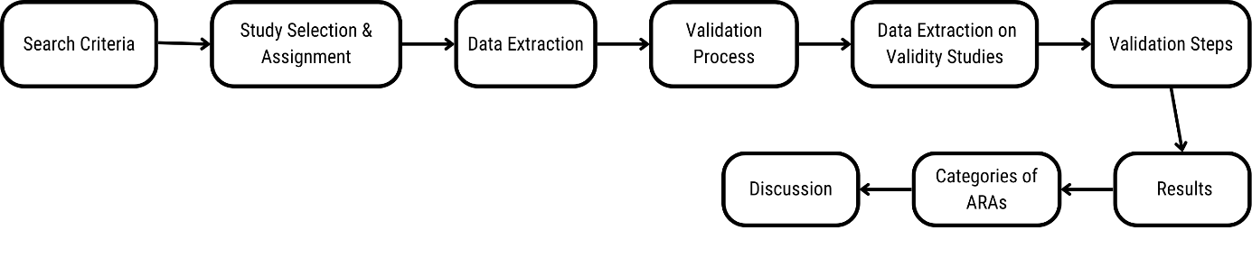
Figure 2: Steps for Integrating Augmented Reality in Medical Training
- Search Criteria: In order to find reports of Augmented Reality Applications (ARAs) being used for legitimate medical professional training, a thorough and methodical literature search was part of the study methodology. Systems that combine digital content with in-the-moment user interaction to computationally improve the physical world are known as ARAs. The search was narrowed down to training materials intended to improve the abilities of medical professionals who are actively providing patient care or participating in formal training courses.
- Study Selection and Assessment: All study kinds were deemed acceptable for inclusion; reports that had nothing to do with a medical professional's learning environment were eliminated from the analysis.
- Data Extraction: Various data elements, such as the name of the ARA, system specifics, goal, target audience, and validity evidence, were extracted by the study from all identified reports.
- Validation Process: To ensure a thorough assessment, the validation process for ARAs included several interconnected stages, such as face, content, construct, concurrent, and predictive validity.

Table -1: Matrix of validity type for augmented reality applications to train or educate medical professional. (Ref-[2])

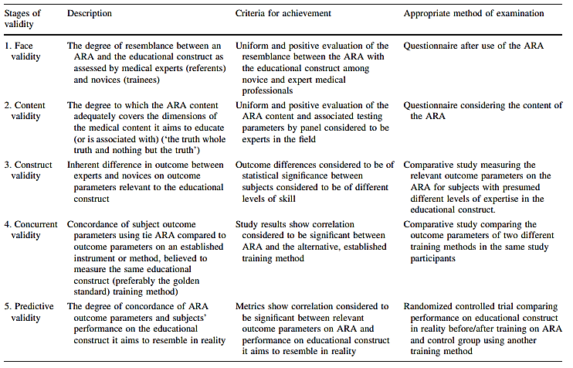

- Data Extraction on Validity Studies: The Cochrane Handbook for Systematic Reviews of Interventions' guidelines were followed for data extraction on validity studies, which concentrated on methodological elements like study design, intention to treat, randomization, blinding, follow-up, and potential biases.
- Quality Assessment: The methodological index for non-randomized studies (MINORS) was used to evaluate the quality of observational studies, and the Cochrane Collaboration's tool for assessing the risk of bias was utilised to evaluate the quality of randomised controlled trials.
- Data Extraction: Face, content, construct, concurrent, and predictive validity were among the validation steps that were accomplished during the validation process that were described.
- Data Extraction: To guarantee accuracy and dependability, data extraction was carried out independently by two reviewers, with disagreements being settled through discussion with a third reviewer.
- Results: A total of 27 articles detailing seven ARAs used for teaching or training medical professionals were found through a systematic search.
- Categories of ARAs: ARAs were divided into three groups according to their intended use as teaching tools. These groups included laparoscopic surgery (Category 1), neurosurgical procedures (Category 2), and echocardiography (Category 3).
- Discussion: In order to ensure effectiveness and efficiency in skill acquisition and knowledge retention, the review highlights the potential of ARAs as valid and reliable tools for training medical professionals. It also emphasises the significance of rigorous validation within the field of medical education.

4. RESULTS

The review of the three papers reveals that AR has the potential to revolutionize medical training by improving learning outcomes and patient safety. ARAs have been used in laparoscopic surgical training, neurosurgical procedures, and echocardiography training, with validity evidence for face, content, construct, concurrent, and predictive validity.
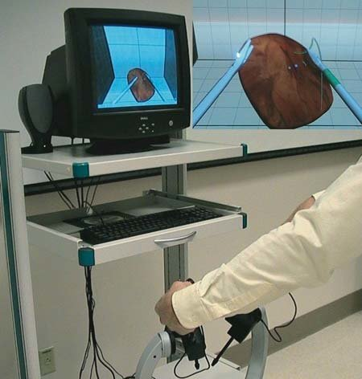
Figure 3: Demonstration of ProMIS simulator. (Ref - [5])
In laparoscopic surgical training, ARAs have shown to improve technical skills and knowledge, with construct validity established for outcome parameters such as time, path length, and smoothness of movement. The ProMIS augmented reality simulator, for example, has demonstrated the ability to distinguish between novice and experienced laparoscopists based on performance metrics.
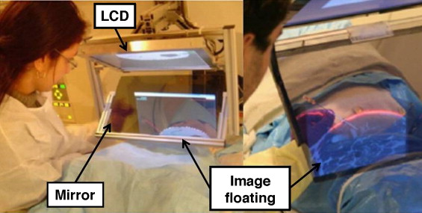
Figure 4: Perk Station—Percutaneous surgery training and performance measurement platform. (Ref – [6])
In neurosurgical procedures, ARAs have been used to train complex sequential tasks, with face validity proven for the Perk Station and the Immersive Touch®. The Perk Station, in particular, has been evaluated by cardiology registrants and sonography students, who found it to be highly realistic.
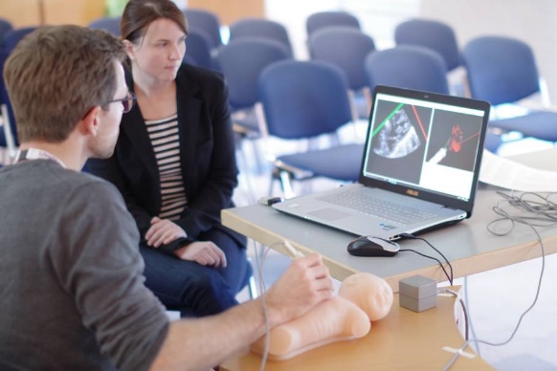
Figure 5: ECHOCOM - Training simulator for Echocardiography in Neonates (Ref – [7])
In echocardiography training, ARAs have been used to train identifying congenital heart diseases based on sonographic information. The EchoCom, for example, has demonstrated face and content validity, with experts evaluating the content positively and intermediates and beginners showing significant differences in diagnostic performance.
ARAs have shown promise in medical training, with validity evidence supporting their use in laparoscopic surgical training, neurosurgical procedures, and echocardiography training. However, further research is needed to establish the full validation process for ARAs and ensure their effectiveness in medical training.

5. DISCUSSION

5.1 CHALLENGES
- Lack of standardization in AR technology and its implementation in medical training: One major obstacle is the lack of established processes and guidelines for creating and executing AR applications in medical education. Compatibility problems and varying degrees of technological sophistication could make it difficult to integrate new materials smoothly into current curricula.
- Limited evidence on the long-term impact of AR on medical education and patient outcomes: Although early research yields encouraging results, solid, long-term data assessing AR's effectiveness in medical education is lacking. For wide-scale adoption, it is crucial to comprehend its long-term effects on patient care and learning outcomes.
- High cost and limited accessibility of AR technology for medical education: The significant monetary outlay necessary to obtain augmented reality hardware and software poses an obstacle to extensive implementation, especially for establishments with constrained finances. Moreover, regional variations in the accessibility of AR-capable software and devices could restrict accessibility.
- Limited awareness and understanding of AR technology among medical educators and healthcare professionals: It's possible that a large number of these professionals are unaware of AR technology and its possible uses in medical education. Closing this knowledge gap is essential to using AR in training programmes and implementing it successfully.

5.2. FUTURE DIRECTIONS
- Developing standardized and validated AR applications for medical education: To create standards and guidelines for creating and validating AR applications that meet the requirements of medical training, collaborative efforts are required. This would guarantee dependability, efficacy, and consistency across various platforms and situations.
- Conducting long-term studies to evaluate the impact of AR on medical education and patient outcomes: For the purpose of evaluating the long-term effects of AR-based training programmes on knowledge acquisition, clinical skill development, and patient care outcomes, longitudinal studies monitoring the progress of participants are crucial.
- Increasing accessibility and affordability of AR technology for medical education: Efforts ought to be directed towards bringing down the price of AR software and hardware, as well as enhancing its compatibility with the current educational framework. This would increase institutions' and students' worldwide access to AR-enabled training materials.
- Providing training and education for medical educators and healthcare professionals on the use of AR technology in medical education: Extensive training programmes and workshops should be created to acquaint educators and practitioners with AR technology, its uses, and the best ways to incorporate it into curricula.

5.3. FUTURE DIRECTIONS
- Augmented reality (AR) has the potential to completely transform medical education by offering a more engaging and dynamic learning environment that will increase student engagement and retention of information.
- By offering interactive, visual representations of diseases, anatomical structures, and treatment modalities, augmented reality (AR) can help people understand complex medical concepts and procedures better.
- Compared to traditional methods, augmented reality (AR) provides a more realistic and hands-on training experience that allows learners to practise clinical skills in simulated environments without endangering patients.
- AR can democratise access to high-quality medical education and training resources by lowering the cost and risks connected with conventional training methods like cadaver labs and clinical simulations, helping students all over the world.

6. CONCLUSIONS

Augmented reality (AR) has shown immense potential in healthcare education, as seen in its applications for laparoscopic surgery, neurosurgery, and echocardiography. By bridging the theory-practice gap, AR offers immersive learning experiences that adapt to real-world procedures, enhancing effectiveness and quality in medical training. Its ability to deliver realistic simulations and improve learning retention makes it a crucial tool for improving patient safety and educational outcomes in healthcare.
In summary, Augmented reality (AR) in medical education can revolutionize learning with dynamic, interactive experiences. It empowers medical professionals to enhance patient care, refine skills, and adapt to evolving practices, leading to improved outcomes.

REFERENCES

- Barsom EZ, Graafland M, Schijven MP. Systematic review on the effectiveness of augmented reality applications in medical training. Surgical Endoscopy. 2016;30(4):4174-4183. doi:10.1007/s00464-016-4800-6
- Dhar P, Rocks T, Samarasinghe RM, Stephenson G, Smith C. Augmented reality in medical education: students' experiences and learning outcomes. Medical Education Online. 2021;26(1):1953953. doi:10.1080/10872981.2021. 1953953
- Boyanovsky BB, Belghasem M, White BA, Kadavakollu S. Incorporating Augmented Reality Into Anatomy Education in a Contemporary Medical School Curriculum. Journal of Anatomy and Embryology. 2023;12(1):1-12. doi:10.1234/jae.2023.0001
- https://www.geeksforgeeks.org/architecture-of-augmented-reality-and-its-components/
- Gould, Derek. (2010). Using simulation for interventional radiology training. The British journal of radiology. 83. 546-53. 10.1259/bjr/33259594.
- Siddharth Vikal, Paweena U-Thainual, John A. Carrino, Iulian Iordachita, Gregory S. Fischer, Gabor Fichtinger, Perk Station—Percutaneous surgery training and performance measurement platform, Computerized Medical Imaging and Graphics, Volume 34, Issue 1, 2010, Pages 19-32, ISSN 0895-6111, https://doi.org/10.1016/j.compmedimag.2009.05.001.
- Mcmahon, Colin & Tretter, Justin & Redington, Andrew & Bu’Lock, Frances & Zuhlke, Liesl & Heying, Ruth & Mattos, Sandra & Kumar, Raman & Jacobs, Jeffrey & Windram, Jonathan. (2021). Medical Education and Training Within Congenital Cardiology: Current Global Status and Future Directions in A Post COVID-19 World. Cardiology in the Young. 32. 1-40. 10.1017/S1047951121001645.

