Assessment of Groundwater and Its Quality in Upper Tons Basin
Girish Kumar¹, Prof. M.M. Singh², Pramod Kumar³,
- Research Scholar, Ph.D, Department of Earth Sciences, University of Bundelkhand, Jhansi.
- Prof. M.M. Singh, Department of Earth Sciences, University of Bundelkhand, Jhansi.
- Assistant Professor, Department of Earth Sciences, University of Bundelkhand, Jhansi.
Abstract: The quality of water is most important compared to quantity of water. The quality of groundwater varies depending on location and the level of the water table and is the outcome of all the activities that take place on the water. The Tons is also known as Tamas River, which originates from NFPI and meets the Ganga River in Allahabad district of Uttar Pradesh. The physic-chemical data have been collected for Amdara, Chorhata, Uchehara, Kakra, Amarpataan1, Naruara, Maihar New, Kusendi, Sabhaganj and Jhukehi in upper tons basin. Physical and chemical properties of groundwater have been done according to standard methods (APHA, 2005). The parameters such as Chloride, Fluorides, Nitrates, Total Dissolved Solids and Electrical Conductivity etc. are having good state in groundwater in upper tons basin. The level of physico-chemical parameters in groundwater in upper tons basin have found within the permissible level which shows that the water is useful for various purpose.
Keywords: Upper Tons, Physico-Chemical, Groundwater, Quality, Quantity

Introduction
Water is one of the most abundant resource available on earth for survival of living being. The plants, animal and other species are directly or indirectly depended on water for their survival on earth. The processes and reactions that have affected the water since it condensed in the atmosphere until it was released by a well determine the quality of groundwater (CPCB, 2008). The quality of water is most important compared to quantity of water. The primary aspects of groundwater and its utility are its chemical, physical, and biological features. Most places in the world, ground water is used for industrial, agricultural, and domestic purposes (Karunakaran et al., 2009). The most prevalent problems related to drinking water include direct or indirect contamination by chemicals, human and animal waste and waste discharge from houses, businesses and municipalities (Deepak and Singh, 2013). In comparison to surface water, ground water is thought to be cleaner and pollution-free (Agrawal, 2010). Due to population growth, urbanization, industry, the failure of the monsoon, and inefficient rainwater management, the ground water potential and quality level in major cities and urban centers are deteriorating (karunakaran et al., 2009).
The quality of groundwater varies depending on location and the level of the water table and is the outcome of all the activities that take place on the water (Shyamala et al., 2008). Aquifer types, evapotranspiration, precipitation, topography, climate, and pumping rates are some of the variables that affect groundwater. Combinations of these elements result in a variety of water types that alter the composition of groundwater throughout time and space (Praveena et al., 2011). Examining the chemical budget of key ions is becoming more significant as it clarifies where the ions come from in groundwater (Rao, 2006). Therefore, it becomes essential to continuously monitor ground water in order to reduce pollution and control the agents that cause it. Continuous ground water monitoring could be made simpler using the creation of a quick technique for measuring water quality without significantly sacrificing the precision of assessment.
Study area
The Tons is also known as Tamas River, which originates from NFPI and meets the Ganga River in Allahabad district of Uttar Pradesh (Figure 1.1). It has divided the whole Tons basin into two parts: first, the Upper Tons basin (Hilly and plateau region) and second, the Lower Tons basin (plain region). Tons river origin is at Tama-kund in the Kaimur Range. The origin is at the height of 610 metres (2,000 ft) from mean sea level. Tons River passes through Satna and Rewa district of Madhya Pradesh. Tons forms many waterfalls in Rewa district. Total flow length of the Tons river is 264 kilometres. It has a total drainage area of 16,860 square kilometres. The axis of Tons River flow is from south-west to north-east, Vindhyan range makes the boundary of water divider of this basin from south-west to north direction and Kaimur range completes this boundary from south-east to north-east. The border high lands grade down towards the middle. The Tons which follow a highly rugged path treading in a south-west to north-east direction bisects the study region in almost two equal halves.

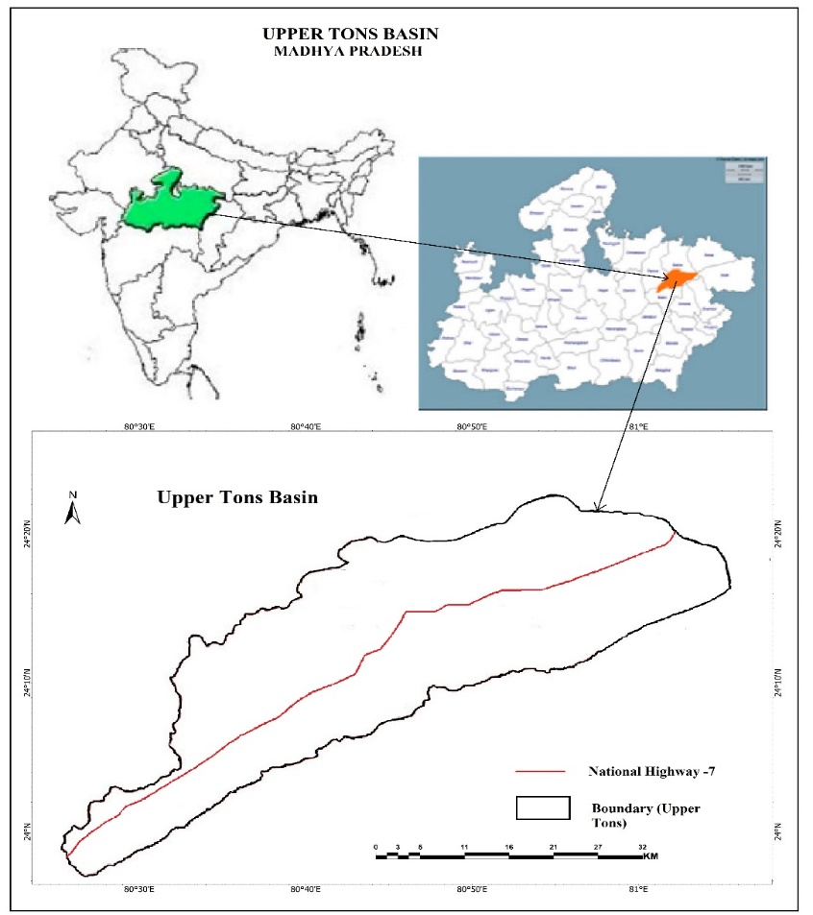
Figure 1.1: Location of Upper tons in Madhya Pradesh
Methodology
The groundwater data upper tons basin has been collected from central ground water commission for the month of May. There eight physico-chemical parameter such as chloride, fluoride electrical conductivity, total hardness, bicarbonate, phosphorus, ortho-phosphate, total dissolved oxygen and water table data were selected for the collection of data. The physic-chemical data have been collected for Amdara, Chorhata, Uchehara, Kakra, Amarpataan1, Naruara, Maihar New, Kusendi, Sabhaganj and Jhukehi in upper tons basin. Physical and chemical properties of groundwater have been done according to standard methods (APHA, 2005) and Hi- Media (WT-023) kit and their specific range for water analysis.
Result and Discussion
Status of Groundwater Level
The groundwater is very dynamic as it results of complex factors such as hydrological, climatological and human intervention. Since there are currently no methods for direct measurements of recharge and discharge, it is challenging to determine these quantities precisely. Therefore, all of the techniques used to estimate groundwater resources are indirect. Considering groundwater as a dynamic and replenishable resource, is typically calculated using the yearly recharge, which might be developed with the use of appropriate groundwater infrastructure. The groundwater status in upper tons basin varies according to their location. It shows that the depth of groundwater level varies in the different place within the basin. Table 1.1 is showing the depth or level of groundwater in the upper Tons basin. The areas such as Jhukehi and Kakra have depth of groundwater level 67 feet and 72 feet respectively, which also describe the low potential of groundwater use and extraction. The areas such as Naruara, Amdara, Uchehara, Maihar new and Chorhata have groundwater level within 30 feet depth from surface. These locations in the upper Tons basin have reflected the high potential use of groundwater and also a good state of groundwater presence in the basin.
Table 1.1 Current status of Groundwater table in Upper Tons Basin
Point /Area | Water table (Feet)
Amdara | 19
Chorhata | 29
Uchehara | 26
Kakra | 72
Amarpatan1 | 40
Naraura | 16
Maihar new | 26
Kusendi | 30
Sabhaganj | 34
Jhukehi | 64
Source: CGWC, 2021
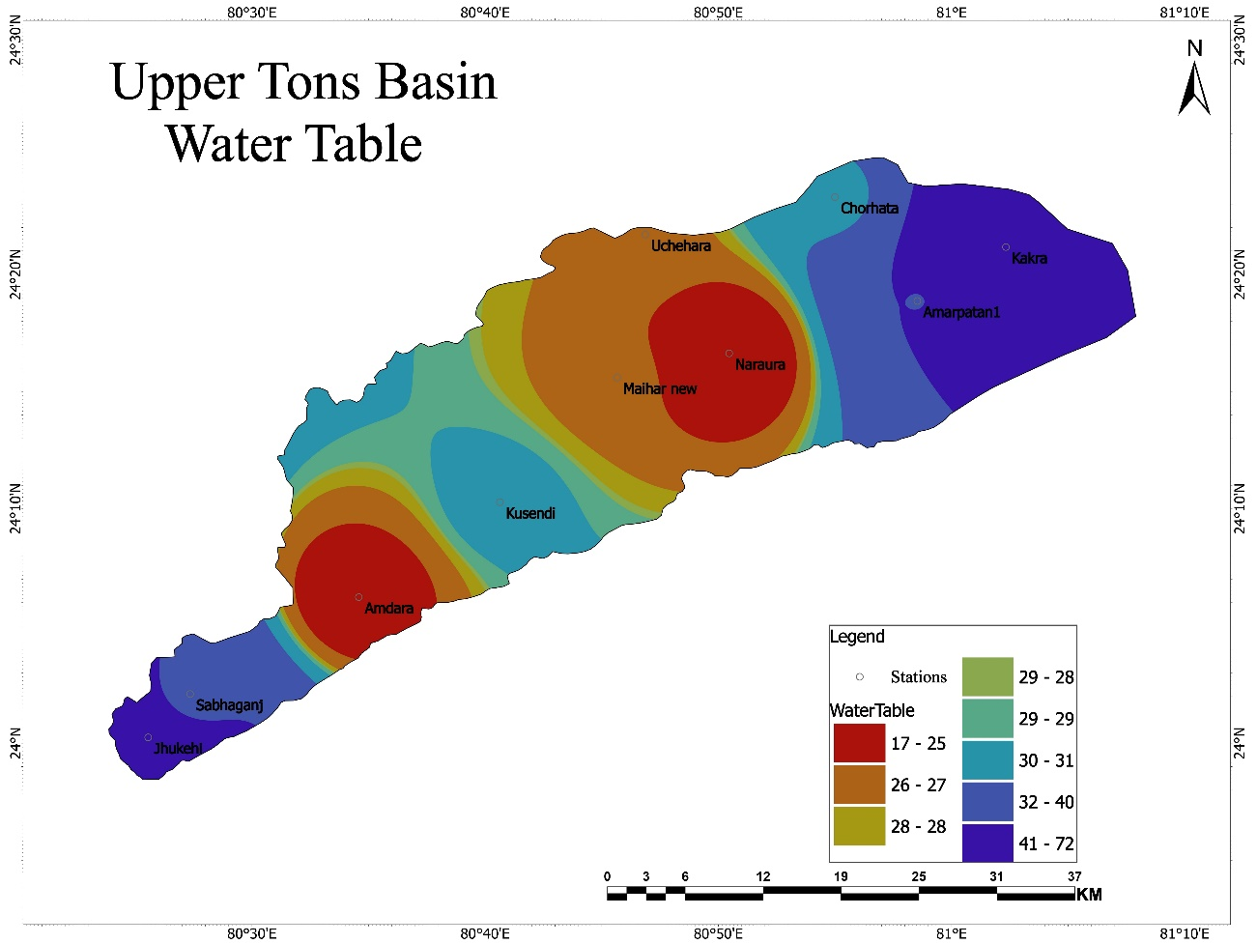
Figure 1.2 Status of Groundwater level in Upper Tons Basin
The figure 1.2 has describe the groundwater level and their level difference from other locations. The locations such as Amdara and Naruara have water table between the 17-25 feet of groundwater level. The location such as Maihar new and Chehara have water table between 26-27 feet which is shown by orange zone (Figure 1.2). The orange zone has surrounded the red zone and that is followed by yellow zone with 28 feet depth of groundwater level in the basin. The Sabhaganj and Chorhata are represented by light blue zone, which has comprised the water level between 32 -40 feet depth. The dark blue zone which found on the margins of upper Tons basin are comprising the locations of Jhukehi and Kakra and Amarpatan1 with water level more than 40 feet depth.
Physico-Chemical Characteristics of Groundwater
The management of the water sources affects the quality of the water resources. Both the area's inherent physicochemical characteristics and anthropogenic discharge would fall under this category.
In many types of geochemical equilibrium or solubility calculations, pH is regarded as a significant ecological aspect and a valuable piece of information (Shyamala et al., 2008). The pH ideal value is 6.5 to 7.2 and pH permissible value is 8.5 as per BIS and ICMR. The present pH value in upper tons basin has varying with different location in the basin. The highest pH value in the upper Tons basin is observed from Amdara with 8.16 pH value in groundwater followed by Maihar new with 8.01. The Sabhaganj has most ideal pH level in the basin followed by amarpatan1 and Kusendi with 7.4 pH and 7.41 pH level of groundwater in the basin. The Jhukehi and Naraura have pH level around 7.5 which shows that groundwater is also in a good condition in these two locations in the basin.
Table 1.2 Physico-Chemical characteristics of groundwater in Upper tons Basin
Point /Area | Chloride (mg/L) | Electrical Conductivity (µS/cm) at 25°C) | Fluoride (mg/L) | Total Hardness (mg/L) | Bicarbonate (mg/L) | Phosphorus, ortho-phosphate (mg/L) | Total Dissolved Solids (mg/L) | pH | Sodium (mg/L)
Amdara | 19.9994 | 1000 | 0.26 | 250 | 305 | 0.08 | 417.3 | 8.16 | 36
Chorhata | 77.4978 | 721 | 1.25 | 180 | 262.3 | 0.07 | 468.65 | 7.55 | 83
Uchehara | 22.4994 | 334 | 0.16 | 85 | 122 | 0.08 | 217.1 | 7.61 | 38
Kakra | 114.997 | 832 | 0.99 | 360 | 193.248 | 0.09 | 540.8 | 7.48 | 30
Amarpatan1 | 52.4985 | 735 | 0.37 | 300 | 344.223 | 0.08 | 477.75 | 7.4 | 45
Naraura | 29.9992 | 617 | 0.58 | 220 | 274.5 | 0.08 | 401.05 | 7.56 | 35
Maihar new | 29.9992 | 484 | 0.48 | 170 | 189.1 | 0.05 | 314.6 | 8.01 | 32
Kusendi | 57.4822 | 608 | 0.35 | 190 | 213.5 | 0.06 | 395.2 | 7.41 | 48
Sabhaganj | 37.1135 | 84 | 0.36 | 328.28 | 392.53 | 0.07 | 546 | 7.26 | 41
Jhukehi | 189.995 | 1305 | 0.39 | 275 | 317.2 | 0.08 | 848.25 | 7.58 | 164
Permissible standard | 1000 | 1000 | 1.5 | 600 | 400 | 0.1 | 2000 | 8.5 | 60
Ideal Standard | 250 | 400 | 0.6-1.2 | 200 | 200 | 0.08 | 500 | 6.5-7.2 | 30
Source: CGWC, 2021
Chloride
The chloride (mg/L) has various forms such as NaCl, CaCl2 and MgCl ans it found in all water throughout the earth’s water. It is mostly entered into the water from sewages and liquid waste coming from various sources. According to Shaikh and Mandre (2009), they get into water by the solvent effect of water on salts that are already present in the soil from sewage and trade waste. In figure 1.3 has different color zones denoting the concentration of chloride in the upper tons basin. The green zones have low concentration of chloride with range between 21 mg/L to 33 mg/L. It is followed by light green zone with range of chloride concentration between 30 mg/L -40 mg/L. the light brown zone has concentration of chloride range between 53 mg/L to 65 mg/L. The dark brown zone has chloride concentration range between 66 mg/L to 87 mg/L. the pink zone in basin has showing the chloride concentration range more than 88 gm/L (Figure 1.3).
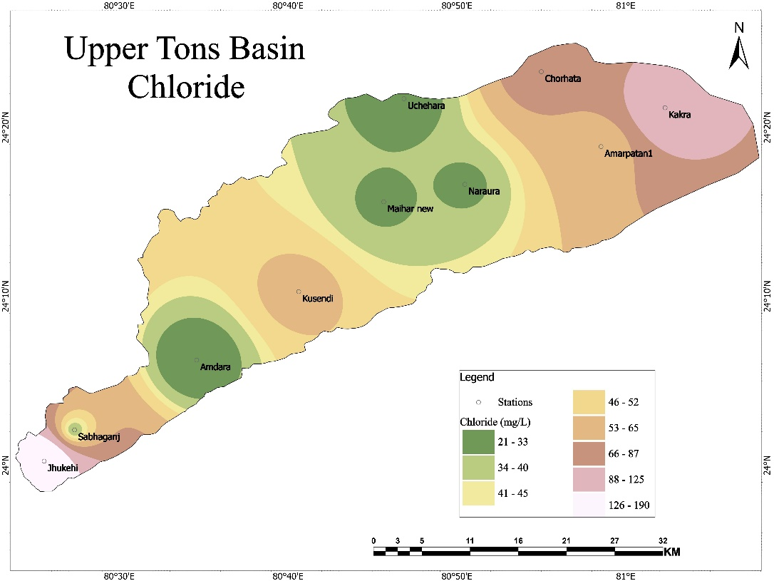
Figure 1.3 Concentration of chloride in the upper Tons basin The ideal chloride is 250 mg/L and permissible is 1000 mg/L but in upper tons basin the chloride level is very low. Amdara has lowest level of chloride level with 19.99 mg/L in the upper Tons basin followed by Uchehara with 22.49 mg/L, Naruara and Maihar new with 29.99 mg/L for each location. The Jhukehi and Kakra have highest chloride level in the basin with 189.99 mg/L and 114.99 mg/L but that is lower than the chloride ideal level into water.
Electric Conductivity
Electric conductivity is an index which denotes the total concentration of soluble salts in water (Purandara et al., 2003). The ideal electric conductivity of water is 400 µS/cm and the permissible electric conductivity is 1000 µS/cm. The location such as Jhukehi and Amdara have highest electric conductivity with 1305 µS/cm and 1000 µS/cm respectively. The Sabhaganj and Uchehara have lowest level of electric conductivity in groundwater in upper tons basin with the value of 84 µS/cm and 334 µS/cm respectively. The Chorhata, Amrpatan1 and Kakra have electric conductivity twice the ideal level 721 µS/cm, 735 µS/cm and 832 µS/cm respectively. The upper Tons basin has divided into eight zones on the basis of electric conductivity found in groundwater in basin (Figure 1.4).
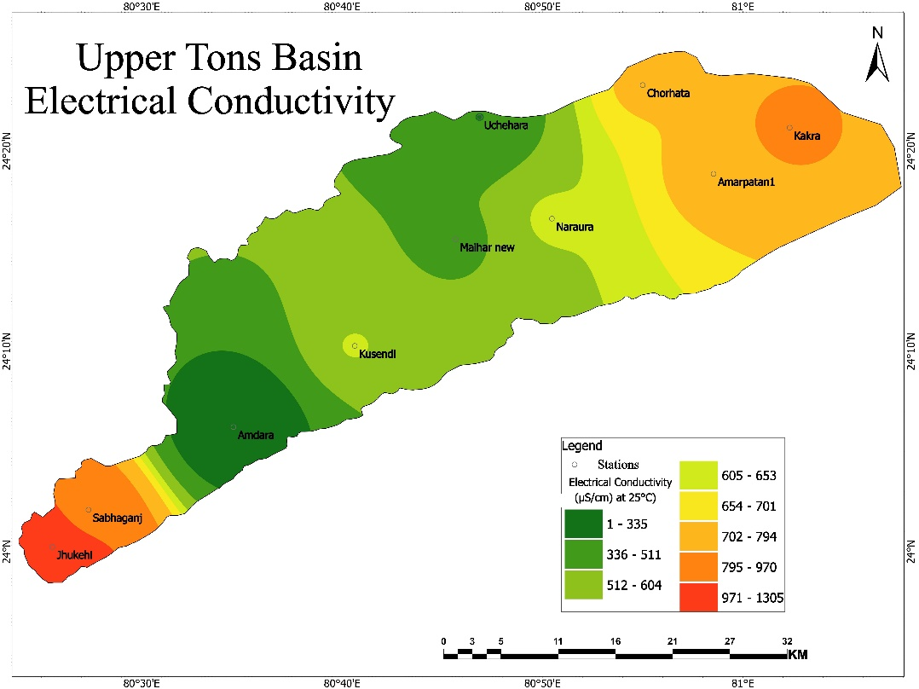
Figure 1.4 Concentration of Electronic Conductivity in the upper Tons basin
The dark green zone has low electric conductivity with range between 1-335 µS/cm. the light green zone represent electric conductivity range between 512 to 604 µS/cm. the yellow zone has 653-701 µS/cm. the orange zone has concentration of electric conductivity range between 795 to 970 µS/cm. The red zone in the basin has highest concentration of electric conductivity in groundwater with range between 971 to 1305 µS/cm.
Fluoride
Fluoride (mg/L) is mineral is white and colorless and it is mainly found in groundwater. The ideal level is 0.6-1.2 mg/L and the permissible level is 1.5 mg/L. The Chorhata has highest level of fluoride in upper Ton basin with 1.25 mg/L. Uchehara and Amdara have lowest level of fluoride in the basin with 0.16 and 0.26 respectively. Naruara has fluoride level of 0.58 mg/L which is nearby the ideal level of fluoride in groundwater.
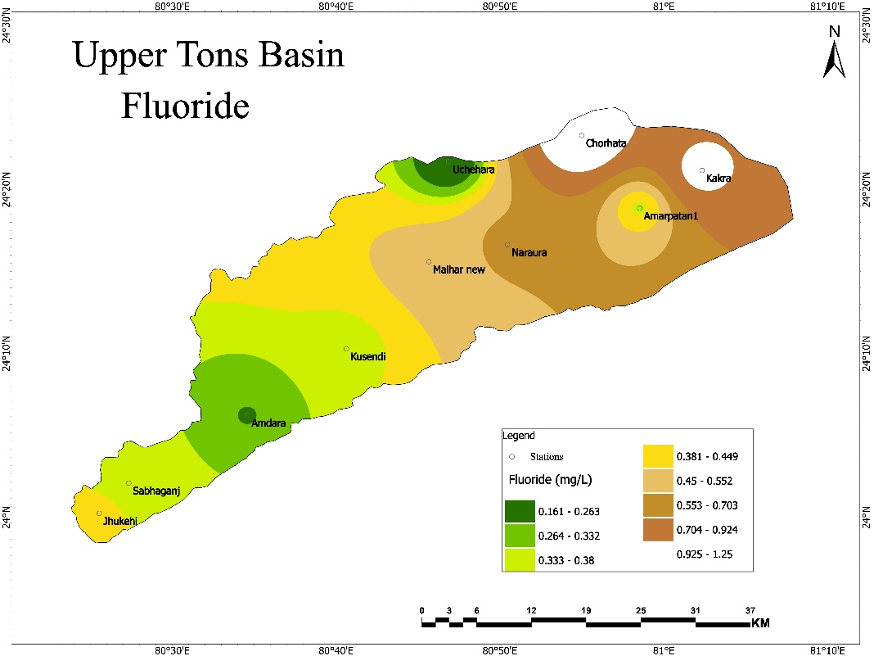
Figure 1.5 Concentration of Fluoride in the upper Tons basin
The green zones have low concentration of Fluoride with range between 0.161 mg/L to 0.263 mg/L. it is followed by light green zone with range of fluoride concentration between 0.264 mg/L to 0.332 mg/L. the yellow zone has concentration of fluoride range between 0.381 mg/L to 0.449 mg/L. The very light brown zone which lies along with yellow zone has fluoride concentration range between 0.450 mg/L to 0.552 mg/L (Figure 1.5). The brown zone in basin has showing the fluoride concentration range between 0.709 gm/L to 0.924 mg/L. The white zone has shown the highest concentration of fluoride with the range between 0.925 mg/L to 1.25 mg/L. The white zone is representing the location of Kakra and Chorhata in upper tons basin.
Total Hardness
Total hardness is property of water which prevents the lather formation with soap and it also increase the boiling point of water (Trivedy and Goel, 1986). The ideal level of hardness in groundwater is 200 mg/L and permissible level of total hardness is 600 mg/L in the basin. Uchehara has lowest level of total hardness in the upper Tons basin with value of 85 mg/L. the amarpatan1, Sabhaganj and Kakra have highest level of hardness in the upper Tons basin with the value of 300 mg/L, 328 mg/L and 360 mg/L respectively.
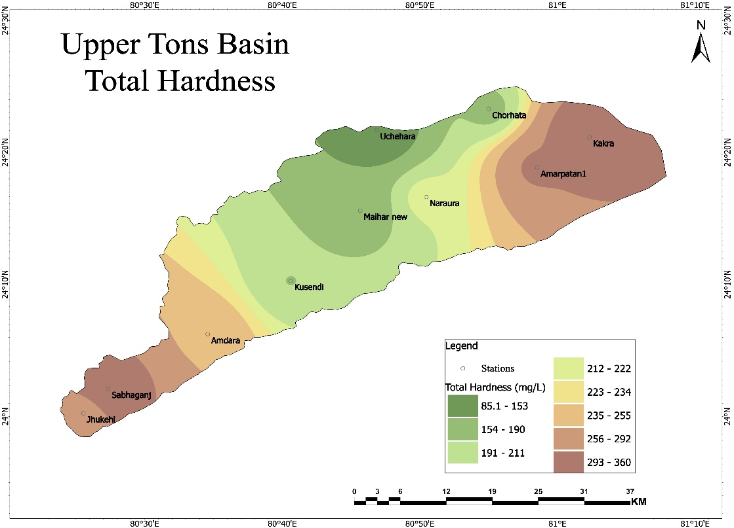
Figure 1.6 Concentration of Total Hardness in the upper Tons basin
The location such as Kusendi and Chorhata in upper tons basin has hardness nearby ideal level of total hardness of water. The total hardness concentration in upper Tons basin represented by eight color zones. The green zones have low concentration of hardness with range between 85 mg/L to 153 mg/L. It is followed by light green zone with range of total hardness level between 154 mg/L –to 190 mg/L. The very light green zone has concentration of hardness range between 212 mg/L to 222 mg/L (Figure 1.6). The light brown has hardness level range between 256 mg/L to 292 mg/L. The dark brown zone in basin has hardens level range between 293 mg/L to 360 mg/L.
Bicarbonate
The bicarbonate in water represents the alkalinity of water. It also represents the buffer against the acidic effect of such water (Dawodu and Ipeaiyeda, 2008). The ideal level of carbonate presence in groundwater is 200 mg/L and permissible level is 400 mg/L. the highest level of bicarbonate is found in Sabhaganj 392.53 mg/L followed by Amarpatan with 344.22 mg/L and Jhukehi with 317.2 mg/L. The lowest level of Bicarbonate is found in Uchehara and Maihar new with 122 mg/L and 189.1 mg/L respectively.
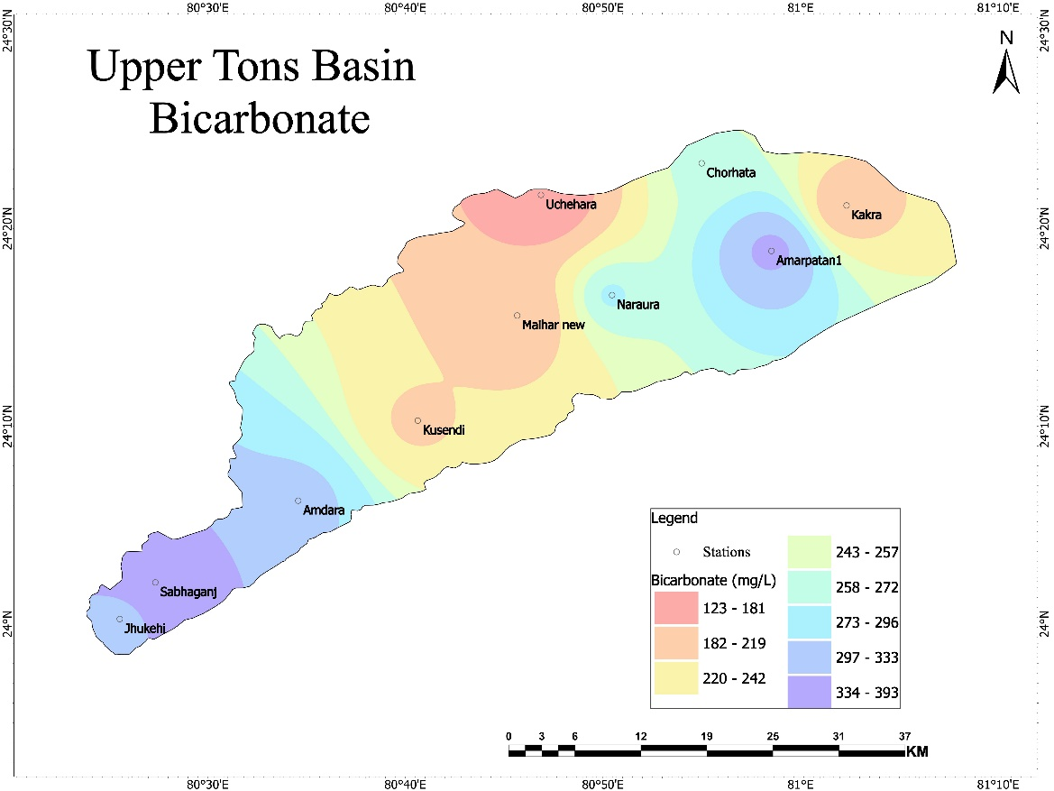
Figure 1.7 Concentration of Bicarbonate in the upper Tons basin
Kusendi has ideal level of bicarbonate in the basin with 213.5 mg/L. The bicarbonate concentration in basin has represented by different color zones. The pink color zones has low concentration of bicarbonate in groundwater with range between 123 mg/L to 181 mg/L. It is followed by light orange zone and yellow zone with bicarbonate range of 182 mg/L to 219 mg/L and 220 mg/L to 242 mg/L. The sky-blue zone has concentration range between 273 mg/L to 296 mg/L. The blue zone in basin has showing the bicarbonate concentration range between 297 gm/L to 333 mg/L (Figure 1.7). The purple zone has shown the highest concentration of bicarbonate with the range between 334 mg/L to 393 mg/L.
Phosphorus
Phosphorus is one of the contaminants of groundwater and it is found in both natural and anthropogenic elements. The ideal level of phosphorus in groundwater is 0.08 mg/L and permissible level of Phosphorus in groundwater is 0.1 mg/L. Phosphorus is one of the contaminants of groundwater and it is found in both natural and anthropogenic elements. The ideal level of phosphorus in groundwater is 0.08 mg/L and permissible level of Phosphorus in groundwater is 0.1 mg/L.
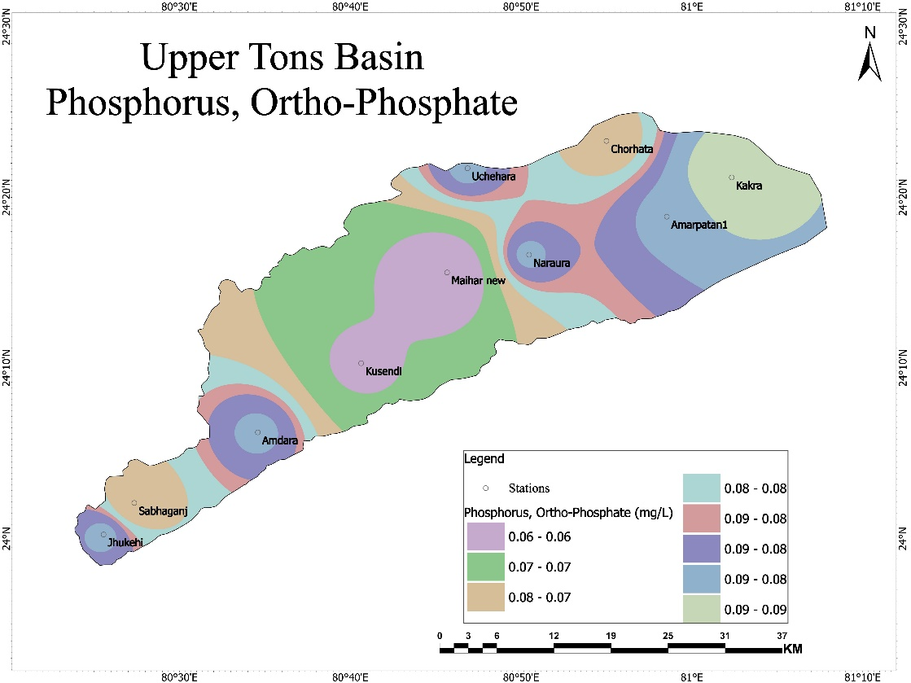
Figure 1.8 Concentration of Phosphorus in the upper Tons basin
The lowest level of phosphurs in upper tons basin is found in the Maihar new with 0.05 mg/L. The Location such as Amdara, Uchehara, Amarpatan1, Naraura, and Jhukehi have ideal level of Phosphorus in the upper Tons basin with the value of 0.08 mg/L for each location. There is only Kakra has highest phosphurs level with 0.09 mg/l in the basin. The phosphorus concentration in the upper Tons basin has very low level of variation which is shown on the map (Figure 1.8).
Total Dissolved Oxygen
Total Dissolved Oxygen (TDS) value are typically correlated with conductivity and characterize the overall quality of the water. While higher concentrations of TDS (more than 500 mg/l) are not recommended for use in drinking water sources, more mineralized water can be utilized in situations when better quality water is not available (Jain, 2002). The permissible level is 2000 mg/L of TDS is allowed for various non-drinking purpose. The Jhukehi has highest level of TDS found in the basin with 848.25 mg/L.
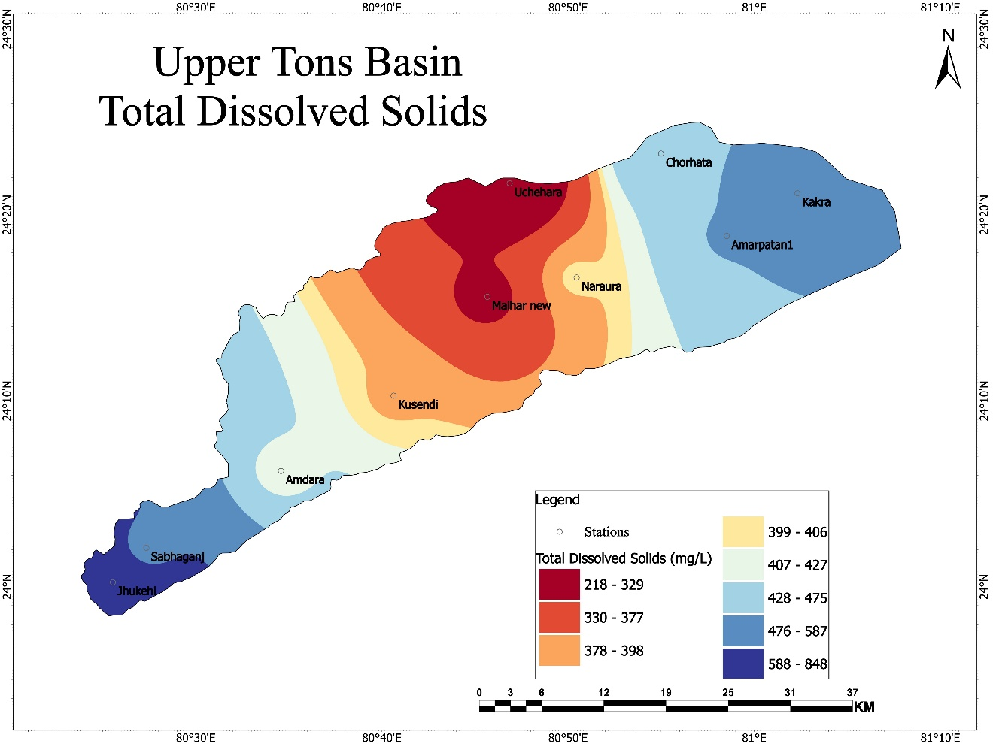
Figure 1.9 Concentration of TDS in the upper Tons basin
Uchehara has lowest level of YDS in basin with 217.1 mg/L value in groundwater. Other locations such as Chorhata and Amarpatan have TDS level nearby the ideal level of TDS into the water with 468 mg/L and 477 mg/L respectively. The TDS concentration over the map has represented by different color zone. The red zone has TDS concentration range between 219 mg/L to 328 mg/L. The orange zone has concentration of TDS range between 378 mg/L to 398 mg/L. The sky-blue zone in basin has showing the TDS concentration range between 428 gm/L to 475 mg/L (Figure 1.9). The blue zone has shown the highest concentration of TDS with the range between 588 mg/L to 848 mg/L. Sodium is sodium chloride which is common salt found in groundwater. The ideal level of sodium in water is 30 mg/L and permissible level is 60 mg/L. The Kakra has lowest of sodium 30 in the upper tons basin and Jhukehi has highest level of sodium with 164 mg/L. The locations such as Maiher new, Naruara and Uchehara have sodium level more than nearby ideal level with 32 mg/L, 35mg/L and 38 mg/L.
Correlation between Physico-Chemical Parameters
Correlation between various groundwater characteristics and groundwater depth. Everything but calcium showed a negative correlation with groundwater depth. Higher salinity was also noted in regions where groundwater levels were only a short distance below the surface by Hu et al. (2005). Chloride has strong relationship high positive correlation with fluoride and total dissolved oxygen and showed a moderate association with electric conductivity and total hardness. The chloride has strong positive correlation between the fluoride (0.822) and Total dissolved oxygen (0.868) and moderate relationship with electric conductivity (0.307) and total hardness (0.401). There is low level of correlation of fluoride with bicarbonate (0.134) and almost no correlation (0.31) with phosphorus is found. The fluoride has strong relationship with total dissolved oxygen (0.808) and moderate relationship with total hardness (0.407). Fluoride has low correlation with phosphorus
Table 1.3 Correlation between the Physico-Chemical Parameters
 | Chloride (mg/L) | Fluoride (mg/L) | Electrical Conductivity (µS/cm) at 25°C) | Total Hardness (mg/L) | Bicarbonate (mg/L) | Water table | Phosphorus, ortho-phosphate (mg/L) | Total Dissolved Solids (mg/L)
Chloride (mg/L) | 1
Fluoride (mg/L) | 0.822 | 1
Electrical Conductivity (µS/cm) at 25°C) | 0.307 | 0.287 | 1
Total Hardness (mg/L) | 0.401 | 0.462 | 0.188 | 1
Bicarbonate (mg/L) | 0.134 | 0.336 | -0.084 | 0.641 | 1
Water table | 0.846 | 0.719 | 0.283 | 0.617 | 0.041 | 1
Phosphorus, ortho-phosphate (mg/L) | 0.31 | 0.134 | 0.098 | 0.428 | 0.129 | 0.433 | 1
Total Dissolved Solids (mg/L) | 0.868 | 0.808 | 0.172 | 0.661 | 0.592 | 0.708 | 0.319 | 1
Source: Calculated by author
(0.134) and electric conductivity (0.287). The electric conductivity has low relationship with all parameters such as total dissolved oxygen (0.172), phosphorus (0.098), total hardness (0.188), and there is no relation found between the electric conductivity and bicarbonate (-0.084). The bicarbonate has strong relationship between total dissolved oxygen (0.592) and low relationship between bicarbonate with phosphorus (0.129). The phosphorus has moderate relationship with total dissolved oxygen (0.319).
Conclusion
The Physico-chemical parameters of groundwater in upper tons basin has large portion which does support the water quality level given by BIS. The depth of groundwater level is good and can be used for human purpose. The parameters such as Chloride, Fluorides, Nitrates, Total Dissolved Solids and Electrical Conductivity etc. are having good state in groundwater in upper tons basin. The level of physico-chemical parameters in groundwater in upper tons basin have found within the permissible level which shows that the water is useful for various purpose. The study's findings unequivocally showed that the groundwater is fit for human consumption.

References
Central Pollution Control Board. 2008. Status of Groundwater Quality in India-Part-II.
Karunakaran, K., Thamilarasu, P., & Sharmila, R. (2009). Statistical study on physicochemical characteristics of groundwater in and around Namakkal, Tamilnadu, India. Journal of Chemistry, 6, 909-914.
Deepak, S., & Singh, N. U. (2013). Water quality index for Ground Water (GWQI) of Dhar town MP, India. International Research Journal of Environment Sciences, 2(11), 72-77.
Agrawal, R. (2010). Physico-chemical analysis of some groundwater samples of Kotputli town Jaipur, Rajasthan. International Journal of Chemical Environmental and Pharmaceutical Research, Rajasthan, Vol. 1, No.2, 111-113.
Shyamala, R., Shanthi, M. and Lalitha, P. (2008). Physicochemical analysis of borewell water samples of
Telungupalayam area in Coimbatore District, Tamilnadu, India. E-Journal of chemistry, Vol.5, No.4, pp.924-929.
Shyamala, G., Rajesh Kumar, K., Gobinath, R., & Saravanakumar, N. (2021). Suitability Evaluation of Groundwater Quality for the Intent of Irrigation. Nature Environment & Pollution Technology, 20(2).
Praveena, S. M., Abdullah, M. H., Bidin, K., & Aris, A. Z. (2011). Understanding of groundwater salinity using statistical modeling in a small tropical island, East Malaysia. The environmentalist, 31, 279-287.
Subba Rao, N. (2006). Groundwater potential index in a crystalline terrain using remote sensing data. Environmental geology, 50, 1067-1076.
APHA, 2012. Standard method for examination of water and wastewater (22nd Edition). American Public Health Association, American Water Works Association, Water Environment Federation, Washington DC, USA.
Purandra, B.K., Varadarajan, N. and Jayashree, K. (2003). Poll Res., 22(2), 189.
Trivedy, R.K. and Goel, P.K. (1986). Chemical and biological methods for water pollution studies. Environmental Publication, karad.
Dawodu, M. O., & Ipeaiyeda, A. R. (2008). Evaluation of groundwater and stream quality characteristics in the vicinity of a battery factory in Ibadan, Nigeria. African Journal of Biotechnology, 7(12).
Jain, C.K. (2002). A hydro-chemical study of a mountainous watershed: the Ganga, India, Water Research, 36(5), 1262-1274.
Hu, K., Huang, Y., Li, H., Li, B., Chen, D. and White, R. E. 2005. Spatial variability of shallow groundwater level, electrical conductivity and nitrate concentration, and risk assessment of nitrate contamination in North China Plain. Environment International, 31, pp.896-903.

