DESIGN AND IMPLEMENTATION OF SMART ELECTRIC FENCE BUILT ON SOLAR WITH AN AUTOMATIC IRRIGATION SYSTEM

P. ROHINI¹, P. HIMA BINDU², V. SAI NAVEEN³, S. KASI VISWANADHAM⁴, A. MURALIDHAR⁵
Dr. B. SIVA PRASAD⁶
^{1,2,3} ^{,4,5}UG Students,⁶Professor
Department of ECE, N. S. Raju Institute of Technology, Sontyam, Visakhapatnam, A.P, India

Abstract:
The agricultural sector faces significant challenges due to crop damage caused by animals, resulting in substantial financial losses and maintenance efforts for farmers. To mitigate this issue, a smart electric fence is proposed, energized upon animal approach and deactivated upon their retreat. The system administers minimal shock pulses to immobilize animals harmlessly. Additionally, an automated irrigation system is integrated, activating the pump during dry soil conditions and deactivating it when soil moisture is sufficient. Solar energy powers the entire system. The prototype features infrared sensors distributed across the fence, detecting approaching animals. A high-frequency switching transformer generates shock pulses, controlled by an IC 555 configured in an astable mode. The Arduino Nano serves as the main processing unit, displaying soil moisture and motor status on an LCD and transmitting data via Wi-Fi to a smartphone app. The system aims to provide efficient and sustainable solutions to agricultural challenges.

Introduction:

Our project represents a paradigm shift in agricultural management by integrating cutting-edge technologies to address pressing challenges faced by farmers worldwide. At its core, the smart electric fence revolutionizes crop protection by leveraging sophisticated sensors and control units to detect and deter animal intruders effectively. By eliminating the need for grid electricity, this innovative solution not only reduces operational costs but also enhances farm security, safeguarding valuable crops from damage and loss.Moreover, the automatic irrigation system powered by solar energy marks a significant advancement in water management practices. By harnessing the
power of the sun, this system optimizes water usage by precisely monitoring soil moisture levels and local weather conditions in real-time. The integration of smart sensors ensures that crops receive the right amount of water at the right time, promoting healthy growth and maximizing agricultural productivity while conserving water resources. The seamless integration of these two components into a unified framework offers numerous benefits to farmers and agricultural communities. Enhanced farm security provides peace of mind to farmers, allowing them to focus on other aspects of farm management without worrying about crop damage due to animal intrusion. Additionally, the efficient use of water resources contributes to sustainability efforts, mitigating the impact of water scarcity on agricultural production and ecosystem health. Overall, our project represents a holistic approach to agricultural management, leveraging the power of renewable energy and smart technology to create a more resilient and sustainable farming environment. By empowering farmers with innovative tools and solutions, we aim to foster greater resilience and prosperity in agricultural communities around the world.
Literature Survey
The literature review underscores the importance of integrating renewable energy sources, such as solar power, into agricultural practices to enhance sustainability and efficiency. Studies have demonstrated the effectiveness of solar-powered irrigation systems in optimizing water usage and reducing dependence on conventional energy sources, thereby lowering operational costs and minimizing environmental impact. Moreover, research on smart agriculture technologies has highlighted the transformative potential of IoT-enabled sensors and monitoring systems in improving crop yields, resource management, and decision-making processes on the farm.

Additionally, the review of electric fencing and perimeter security solutions emphasizes the critical role of these technologies in protecting agricultural assets from intruders and wildlife. Electric fencing systems, when integrated with advanced sensors and control units, offer a proactive approach to deterring trespassers and minimizing crop damage, enhancing overall farm security and productivity.

Furthermore, investigations into IoT platforms and notification management systems underscore their significance in enabling real-time monitoring, data analysis, and remote control of agricultural operations. By leveraging IoT platforms, farmers can access valuable insights into soil conditions, weather patterns, and crop health, facilitating informed decision-making and proactive management practices. Additionally, effective notification management ensures timely alerts and communication, enhancing situational awareness and response capabilities on the farm.Overall, the literature review highlights the synergistic benefits of integrating renewable energy, smart agriculture technologies, electric fencing, IoT platforms, and notification management systems. Our project builds upon these insights to offer a holistic solution that addresses key challenges in agriculture, from resource management and security to decision support and sustainability. By leveraging the collective potential of these technologies, we aim to empower farmers with innovative tools and strategies to enhance productivity, resilience, and environmental stewardship in agricultural communities.
Implementation:
In our implementation, the NodeMCU ESP8266 module plays a central role in facilitating wireless communication and data transmission within the system. With its built-in Wi-Fi connectivity and GPIO pins, it serves as the backbone for integrating sensors, actuators, and the Blynk IoT platform seamlessly. Whether programmed using Arduino IDE or Lua, the NodeMCU ESP8266 module enables efficient and reliable wireless communication, allowing for real-time monitoring and control of the agricultural system. Our system architecture consists of three main components: the solar battery charger, irrigation model, and fencing model. The solar battery charger acts as the power source for the entire system, regulating voltage from a solar panel to charge a 12V battery. This battery, in turn, powers both the irrigation and fencing modules, ensuring continuous operation even in remote or off-grid locations. By harnessing solar energy, our system reduces reliance on traditional energy sources and promotes sustainability in agricultural practices. The irrigation model, controlled by an Arduino Uno microcontroller, intelligently adjusts water flow based on soil moisture levels detected by sensors. This dynamic irrigation system optimizes water usage by delivering precisely the amount of water needed by crops, thereby promoting healthier growth and conserving water resources. With automated control capabilities, farmers can remotely monitor and adjust irrigation schedules, ensuring optimal crop hydration while minimizing water wastage.
Meanwhile, the smart fencing model serves as a robust perimeter security measure, detecting intrusions and deterring potential threats to the farm. Upon intrusion detection, the fencing model generates high-voltage impulses, effectively safeguarding the farm perimeter and protecting valuable crops from wildlife and trespassers. By integrating advanced sensors and control units, our system offers proactive security measures, enhancing farm security and minimizing crop damage.
Overall, our implementation leverages cutting-edge technologies and sustainable practices to address key challenges in agricultural management. By combining wireless connectivity, solar energy, and intelligent control algorithms, our system offers a comprehensive solution that enhances productivity, efficiency, and security in agricultural operations. With its modular design and scalable architecture, our system can be tailored to meet the specific needs of farmers and agricultural communities, empowering them to achieve greater success and sustainability in their endeavors.
Block Diagram
Blynk Server
Solar Pannel
Irrigation
System
Fence
System
NODE MCU
ESP8266

Fig.no.1: Block diagram of the project
Results and Discussion:
Blynk IoT platform facilitates remote monitoring and control of the system via a mobile app. The platform's widgets enable users to visualize sensor data and control actuators. The system's deployment enhances farm security, promotes water conservation, and improves crop yield. Future enhancements include advanced analytics, AI integration, sensor network expansion, and community engagement initiatives.

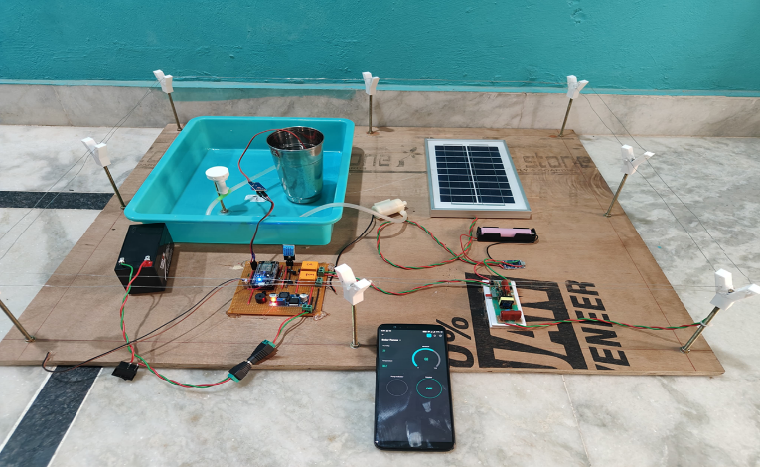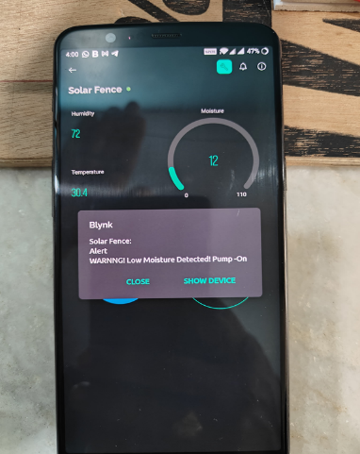

Fig.no.2: Working Project Prototype
Conclusion and Future Work:
The integrated electric fence and irrigation system represent a significant advancement in agricultural technology. Leveraging renewable energy and IoT capabilities, the system offers enhanced security, optimized irrigation, and efficient energy utilization. Future work includes AI integration, sensor network expansion, and community engagement initiatives to further improve agricultural practices.

REFERENCES
- Manishkumar Dholu, Mrs. K. A. Ghodinde, “Internet of Things (IoT) for Precision Agriculture Application”, Proceedings of the 2nd International Conference on Trends in Electronics and Informatics (ICOTEI), Mumbai, pp. 339-342, 2018.
- Nikesh Gondchawar, Dr. R.S.Kawitkar, “IoT Based Smart Agriculture”, IJARCCE, Vol.5, Issue 6, June 2016.
- N. Ahmed, D. De, and I. Hussain, “Internet of Things (IoT) for smart precision agriculture and farming in rural areas”, IEEE Interne Things J., vol. 5, no. 6, pp. 4890-4899, Dec. 2018.
- Mohammad Salah and al,” IoT Based Real-time River Water Quality Monitoring System”, The 16th International Conference on Mobile Systems and Pervasive Computing, August 19-21, 2019, Canada. .
- M.K.Gayatri, J.Jayasakthi, Dr.G.S.Anandhamala,“Providing Smart Agriculture Solutions to Farmers for Better Yielding Using IoT”, IEEE International Conference on Technological Innovations in ICT forAgriculture and Rural Development (TIAR 2015)
- Chetan Dwarkani M, Ganesh Ram R, Jagannathan S, R.Priyatharshini, “Smart Farming System Using Sensors for Agricultural Task Automation”, IEEE InternationalConference on Technological Innovations in ICT for Agriculture and Rural Development (TIAR 2015).
- S. R. Nandurkar, V. R. Thool, R. C. Thool, “Design and Development of Precision Agriculture System Using Wireless Sensor Network”, IEEE International Conference on Automation, Control, Energy and Systems (ACES), 2014.

