A STUDY ON MEASURING RAPIDLY CHANGING VIEWER’S PERCEPTION IN TV INDUSTRY
DR. MONICA SAINY, BHUMIKA DAYAMA
Amity University Chhattisgarh, India
Abstract
This study conducts a comprehensive investigation of the dynamic domain of television viewer preferences, highlighting the swift changes noted in audience decisions and actions. Given the number of available viewing alternatives and technical developments, it is critical for all parties involved in the TV industry to comprehend these changes. This research uses a combination of qualitative, quantitative and binary analysis to examine key factors that influence viewer choices, such as socio demographic characteristics, streaming services, platforms for viewing, and types of material. By utilizing strong analytical techniques, the research seeks to uncover practical understandings of the fundamental forces behind these changing habits. The results are expected to provide content producers, broadcasters, and marketers with essential insight that will enable them to better match their strategies with the constantly shifting preferences of today's diverse audience.
Keywords: Media, TV Viewership, Social Media, Media Consumption, Future of TV industry
Introduction
Entertainment & Media Industry
Entertainment and media industry have 10 components in which we work to understand total industry. All these components are Television, Online Gaming, Animation and VFX, Out of Home (OOH), Music, Digital Media, Live Events, Films Entertainment, Print, and Radio.
TV Industry
By the end of the 20th century, the television industry had developed into a major economic force responsible for the majority of mass media's expenditures, earnings, and potential social and psychological repercussions. Television production encompasses a wide range of activities, from theoretical discussions of the concept of "authorship" in the context of television's necessarily collective production processes to studies of political regulations, ownership, and other aspects of the industry's economics. Participant observation in broadcasting institutions and independent production companies is also common.
A television network makes money by selling manufacturers in the product market advertising spaces, and it invests in programming to draw viewers in order to monetize this revenue stream. Through advertising, the manufacturers in the product markets increase sales. There are decreasing returns to TV advertising because more advertising generally results in fewer TV viewers. Furthermore, there is a problem with TV advertising congestion: the more a company uses a specific TV channel to promote its own items, the less viewers are left for other manufacturers to use. All forms of advertising have an impact on viewers, but television is one of the most effective because of its wide distribution, which allows it to affect not just a person's attitude, behavior, way of life, and exposure, but over time, the entire nation's culture (Kumar and Raju, 2013).
Segments of Indian media and Entertainment industry:
As per the report shared by Indian brand and equity foundation TV industry has 30% market share in 2023. They foretasted this market share to be dipped at 24.9% in 2026. This is a significant decline in the share but still the ad revenue is going to be increased from 3.81 Billion USD IN 2022 to 5.42 Billion USD in 2024. This shows that decline in market share will not have that much of impact on revenue part of TV industry.
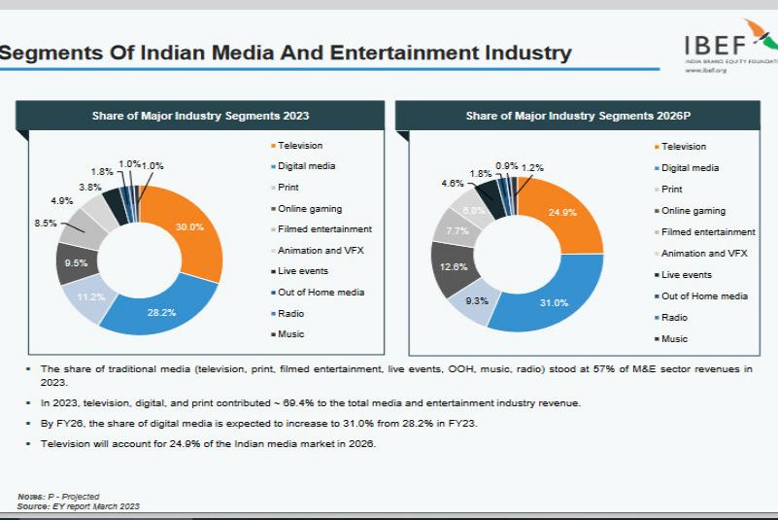

Social media and television
The phenomena of Social Television, an emerging digital communication technology centered on real-time interactivity using digital media presented on television, is the result of several links and relationships between social media and television. The primary goal of social television is to provide viewers with a more interactive television experience. Social media platforms and websites made it possible to watch TV shows online in the 2010s on a variety of desktop and mobile computers, cell phones, and smart TVs—devices that are still developing in the 2020s. In addition, digital video clips and TV show snippets can be shared online with other fans via social networking platforms, or users can share whole shows.
Numerous social media platforms allow individuals to express comments about the programmer online in a number of ways, both favorable and bad. When viewing a TV show, viewers can become involved by leaving comments online. Other viewers can see and react to these exchanges in real time. TV viewers can watch downloaded digital files of episodes or "stream" digital files of shows on a variety of devices, both at home and while on the go, thanks to technologies like smart phones, tablets, and laptop computers. In the 2020s, a lot of TV producers and broadcasters promote viewers' social media engagement by displaying "hash tags" on the TV screen while episodes are airing. Using these hash tags, viewers can leave online comments about the show that could be viewed by other social media users or, in certain situations, even shown on the screen while the show is airing.
Television Programming
Since its establishment, television programming has undergone tremendous evolution to reflect shifts in technology, society, and viewer preferences. At first, there were only a few channels with scheduled content, mostly news, dramas, and variety shows. But the television environment changed radically with the introduction of cable and satellite services, which provided specialized channels for a wide range of interests, including sports, documentaries, and reality TV, and niche genres like science fiction or food.

Television programming saw even more revolution with the emergence of streaming services like Netflix, Amazon Prime, and Hot Star. The idea of binge-watching was popularized by these sites, which let users watch whole seasons of TV at their own leisure. They also made it possible to produce excellent original programming, which frequently drew prominent actors from the movie business. This change not only affected the way people viewed content, but it also made it harder to distinguish between traditional television and films.

In the future, television programming will probably keep evolving to reflect societal trends, shifting viewing habits, and technology breakthroughs. By merging virtual reality, interactive storytelling, and artificial intelligence, the viewing experience may become even more customized, obfuscating the distinction between content producers and viewers. Furthermore, creating engaging and varied content will become more crucial as streaming services multiply and the competition heats up in order to draw in and hold onto viewers in a media environment that is becoming more and more fractured.

Audience Engagement and Interaction
In the television industry, audience contact and engagement are crucial, especially given how quickly viewer preferences are shifting. Understanding and monitoring these changing tastes is critical for both broadcasters and content creators, as technology continues to change how people consume material. The purpose of this project is to investigate the dynamics of audience interaction and engagement in the television industry, with a particular emphasis on assessing and responding to quickly shifting viewer preferences.

In the current digital era, viewers can access an unparalleled variety of material on a range of platforms, including social media, streaming services, and traditional television broadcasts. Through the use of data analytics, audience feedback systems, and interactive storytelling techniques, this project aims to investigate how television broadcasters and content creators may successfully assess and adapt to these changing tastes and increase viewer engagement.

Company Profile
With a viewership of over 120 million, IBC24 is the top Hindi Heartland News Television Channel in MPCG. Its mission is to win over the hearts and minds of new and existing viewers and customers. The Multimillion Goel Group includes IBC24."Sawal Aapka Hai" (It is a query about you) is the channel's tagline.
It has been noted that this reporting network is the strongest. The channel covers the most recent news in all important and unexplored areas, including politics, culture, entertainment, astrology, and current affairs from regional, national, and international sources. It concentrates on Madhya Pradesh and Chhattisgarh news 24 hours a day.
Actively producing documentaries, short films, and a variety of other government projects in addition to brand activation.
About IBC24
Country of Origin: India
Broadcast: India
Network: Broadcast television and online
Slogan: “Sawal Aapka Hai” (English: “It’s Your Question”)
Headquarters: Raipur, India
Programming:
Language(s): Hindi & Chhattisgarhi
Picture format: 4:3 (576i, SDTV)
Ownership:
Owner: S.B. Multimedia Pvt. Ltd.
History:
Launched: 1 October 2008
Links:
Website: www.ibc24.in

Literature Review
- Liebeck (1998) asserts that teens today possess greater information. They genuinely belong to the internet generation, and television is how they mostly obtain their news and information. The most desirable and significant media for advertising is television. The majority of youth’s watch television intently and take pleasure in what they see. Many businesses seek to target youngsters since they utilize and consume a wide range of products and services (Chandok, 2005).
- (Lafferty & Goldsmith, 2002) The goal of advertising is to increase consumer awareness, preference, and choice for goods and services. The attitude-towards-the-ad theory is the most influential one in marketing and advertising research. Nonetheless, a consumer's attitude towards the advertisement influences their view of the brand and their inclination to make a buy.
- Traditional hierarchy-of-effects models state that exposure to advertising causes people to think about the brand and the advertisement, which in turn influences their attitude towards the brand and the advertisement until they intend to make a purchase (Mendelson & Bolls, 2002). Teenagers are targeted by advertisers due to their high disposable income, ability to influence parent purchases, early brand loyalty, and widespread belief that they make impulsive purchases (Fox 1996).
- The definition of "consumer behavior" according to Schiffman and Kanuk (2004) is the behavior of a consumer that takes the form of obtaining, purchasing, using, evaluating, or consuming a good, service, or idea to satisfy their own needs. It also refers to the study of how consumers make decisions about how much money, time, and resources to spend on goods and services, including (1) what to buy, (2) why to buy, (3) how to buy, (4) when to buy, (5) where to buy, and (6) how often to buy.
- Sharma (2007) found that modern consumers are not easily swayed by a celebrity in a commercial; instead, they need detailed product information together with the brand name, overall appeal, and music/jingle. Celebrity endorsements are seen as less desirable, and their use might not have a big influence on what people decide to buy.
- ICRA (2011) came to the conclusion that GECs' content costs were rising due to intense competition; yet, GECs' ad revenue was predicted to increase over the following two to three quarters due to the addition of new programming content. Channel pricing might be improved and subscription leakage could be stopped with digitization. According to the TRP (Target Rating Points), a channel's popularity is determined by its well-crafted content and targeted market segmentation.
- The subject of reporting frequency is the one that has received the most attention, according to BARC INDIA (2013). BARC India stated in an official statement that reporting frequency is expected to be weekly, with the exception of some data categories for which it may aggregate data by time period, time range, or area. Additionally, it states that because there are currently few families with several TVs, it will not publish this statistic individually but will instead assess the number of TVs in each sample home. Its goal is to concurrently release Adex data and viewership data at the same time. The soon-to-be rating agency further asserts that it is equipped for the future with the technology necessary to report even The subject of reporting frequency is the one that has received the most attention, according to BARC INDIA (2013). BARC India stated in an official statement that reporting frequency is expected to be weekly, with the exception of some data categories for which it may aggregate data by time period, time range, or area.
- Additionally, it states that because there are currently few families with several TVs, it will not publish this statistic individually but will instead assess the number of TVs in each sample home. Its goal is to concurrently release Adex data and viewership data at the same time. The soon-to-be rating agency further asserts that it is equipped for the future with the technology necessary to report even
- Reality shows nowadays are more animated, honest, and emotional. To draw viewers in and hold their attention for a longer amount of time, there is a suspenseful tale, comedy, social viewpoint, or depressing tale (Jaggi & Mujumdar, 2009). As stated by Jain and Kohli (2019). The study conducted by Sinha, S. (2016) emphasized the patterns of TV channel audience preferences. The study concentrated on factors such as the amount of time spent watching TV, with a particular emphasis on TV channels, channel preferences, viewership, the drawbacks of, the impact of, and changes to the content. The study found that, in addition to TV networks, other content has an influence, including comedies, sports, news, and entertainment.
- Star Plus, Zed TV, Colors, and Sony are the four primary entertainment channels vying for the top spots. The quantity of original programming hours that are broadcast on television and the expense of creating a new hour of content define the cost of content. Another significant issue is the growing expense of content. The average cost of production has increased by 30–35% even after televised sporting events like the Football Cup, Cricket World Cup, and IPL.
- The trustee and the meaning of "media" in "media trust" are two more difficult questions. Early studies (Gaziano & McGrath, 1986; Kiousis, 2001; Metzger et al., 2003; Newhaven & Nass, 1989; Westley & Severin, 1964) found that although there is typically a correlation between the two, trust in and credibility of television and newspapers tend to differ. Furthermore, according to recent research, there are differences in the levels of trust people have in the media based on the type of news being discussed—general news, news that people use, news in digital and social media, or news in general (Newman et al., 2019). Additionally, the type of news being discussed—specific news sources or an undefined referent like "the press" or "the media" (Daniller et al., 2017; Eberl, 2019), and if it's talking about public service versus commercial television news (Matsa, 2018). Additionally, there may be differences in media trust between particular news outlets, between national and local media, and between the coverage of various issues (Matsa et al., 2018; Metzger et al., 2003; Mitchell et al., 2014; Mitchell et al., 2016).
- As a result, in today's high-choice media environments with more media than ever, the term "media" can refer to a wide variety of somewhat overlapping distinct aspects of media. This is crucial when evaluating time trends and answering inquiries about vague media. When people responded to questions about media trust in prior low choice media environments, they probably had fairly similar thoughts about mainstream news media, assuming that accessibility bias was at play (Ladd, 2012; Tsfati, 2002; Tsfati & Peri, 2006).
- Just as our bodies are nourished by the vital nutrients we eat, so too is the human mind nourished by the news and information that are readily available to us thanks to contemporary technology (Bashir & Bhat, 2017). According to Bashir and Bhat (2017), social media refers to electronic communication platforms that facilitate the establishment of online societies where users exchange ideas, information, and other resources. For some social media users, online communication has become second nature and is an integral part of their everyday routines. Huremović (2019) asserts that social media plays a critical role in disseminating health-related information and issues. As a result, social media has had a significant impact on a number of facets of its users' digital lives, including marketing, politics, education, and health as a vital component of human connection. On the other hand, social media has made users of the internet aware of some consequences that may have a positive or negative impact on their everyday and social behavior as well as their psychological well-being (Bashir & Bhat, 2017).
- Pandemic is an epidemic that spread over the world with huge health implications. The world has witnessed many pandemics, such as the Antonine plague in 165 AD, the Black Death from 1346 to 1354, the Spanish flu from 1918 to 1920, and the COVID-19 pandemic (Obi-Ani; Anikwenze & Isiani, 2020). According to Doshi (2011), a pandemic is an influenza that affects a large human population without immunity to several deaths. Such a pandemic is the H1N1 virus, COVID-19, and many more as declared by World Health Organization (WHO). As global influenza, the consequences and effects are deadly and infectious.
- "Newly received information about an event that is currently occurring or developing" is referred to as breaking news. Regular news typically develops gradually, with further information coming to light as time goes by. On the other hand, unexpected occurrences that happen very quickly and with little information about what happened or what will happen next are more commonly the subject of breaking news. It has a surprising list of subtopics that are largely absent from the data that is currently available. A prime example was the 9.0 magnitude earthquake that struck Japan in 2011, which was followed by a tsunami and the meltdown of three nuclear reactors at Fukushima. This serious outcome is not what most people would anticipate. Because of its nature, breaking news is frequently linked to numerous rumors on social media. In actuality, the number of rumors is strongly correlated with how important a topic is to people. As a result, rumors are frequently spread about delicate subjects and breaking news. This is particularly true when the topic is new, unclear, and receiving a lot of attention in the early phases of diffusion.
- Due to their wide distribution, broadcast media—such as radio and television—are among the most popular in India (Farooq & Latif, 2011; Fill, 2009). Newspapers are a vital and efficient form of communication in India. This is because it is present in practically every region of the nation. With over 330 million daily newspaper circulations, India boasts the largest newspaper market in the world (Jayaraj, 2011). According to Statista (2016), advertisers continue to favor traditional media like print and television for their ads. TV advertisements accounted for 44.7% of the overall advertising spend in India, while print advertisements accounted for 29.8%. With a growth rate of 15.5%, the digital advertisement spends ranked third in size (Pahwa, 2017). This is a result of the growing number of Internet users in India following Reliance JIO's entry into the telecom industry.
- The Internet's multilayered structure makes it a more interesting medium than print. Users of the Internet have greater control over what they can see than they do while reading newspapers and publications (Bezjian-Avery, Calder, & Iacobucci, 1998). For the purposes of this study, digital channels such as Facebook, Twitter, Instagram, YouTube, and email are all considered to be part of the "internet" (Ducoffe, 1996; Gilaninia, Taleghani, & Karimi, 2013; Mishra & Vashiath, 2017; Trivedi, 2017a). Opeodu and Gbadebo (2017) noted that an advertisement across several media channels is crucial in influencing a consumer's decision due to the diverse influence of these platforms.
- Therefore, selecting the right media outlet for advertisements is essential for promoting goods and services (Singh, 2012). Compared to other sources, advertisements are a highly regarded source of information among consumers, so advertisers must carefully consider their media mix choices (Shrivastava, 2014).
- People, healthcare providers, and organizations use social media platforms to share information about pandemics. Social media platforms have greatly improved human communication in the present era (González-Padilla & Tortolero-Blanco, 2020). Like the COVID-19 virus and other past pandemics, these platforms have made it possible for people to communicate with one another and share information about the pandemic quickly and easily. However, information shared on social media may not be current or reliable (Obi-Ani et al., 2020; González-Padilla & Tortolero-Blanco, 2020). The incorrect information may be called an infodemic. This book defines a pandemic as an outbreak that has impacted a huge number of individuals across several continents or nations. It can be described as a spontaneously appearing virus that spreads quickly.
- The nature and content of television viewing have changed significantly during the past ten years. People can now share knowledge and voice their ideas by watching television (Sengupta, Singh, Ganjoo, 2021). Regardless of storyline or subject matter, previous television serials ran for a sufficient amount of time. Her ideal of selflessness would be embodied by a woman in the starring part. This was mostly because most of the channels that were watched by women were (Deori et al., 2021; Puthiyakath & Goswami, 2021). Furthermore, the production and shooting of reality-based shows is done to maximize total viewership. The initial plan for the show, which was to create real content, has changed (K. G. Suresh, & Ganjoo M., 2022).
Research Objectives
- To know technological advancement & media consumption trends.
- To Rank media consumption patterns based on user’s preferences.
- To understand future impact of TV on viewer’s perspective.
- To know preferred news channel of national & MPCG market.

Research Methodology
Research Design
This study adopts a mixed-methods approach, combining Quantitative analysis with Qualitative insights, and some Binary approach. The research design is primarily descriptive, aiming to provide an in-depth understanding of audience behaviors and preferences in consuming TV in media Industry.
Nature of the study | Descriptive study
Types of data | Primary data and secondary data
Method of data collection | Questionnaire
Nature of population | The TV audience of Madhya Pradesh & Chhattisgarh are the population of the study and the population is  Infinite.
Sample unit | Sample unit is the TV viewers in Madhya Pradesh & Chhattisgarh
Sampling method | purposive sampling
Sample size | 330

Sampling Data
Data Collection Method
Sample Size: The study involved a sample of 330 respondents. Sample for the surveys were selected from the Chhattisgarh & Madhya Pradesh. The respondents were regular viewers of television and selected with the help of convenience sampling method. Data collection was done by online methodology by Google forms.
Data Analysis & Interpretation
Demographic characteristics of the respondents.

Measure | Item | Number of Respondents
Age | 15-30 | 164
Age | 31-45 | 132
Age | 46-60 | 27
Age | 60+ | 7
Gender | Male | 149
Gender | Female | 181
Gender | Transgender | 0
Gender | Prefer Not to Say | 0
Location | Rural | 43
Location | Urban | 248
Location | Semi-Urban | 39
Occupation | Student | 101
Occupation | Professional | 159
Occupation | Homemaker | 38
Occupation | Retired | 3
Occupation | Others | 29
Total Respondents |  | 330
Interpretation: The survey included respondents from various age groups, genders, locations, and occupations. Out of all the respondents, 164 were aged between 15 and 30, while 132 were between 31 and 45. In terms of gender, there were 149 males and 181 females. Most respondents, 159, lived in urban areas, while 43 were from rural areas. When it comes to occupation, 101 respondents were students, 159 were professionals, and 38 were homemakers. This variety helps in understanding the perspectives of different demographic groups.
Question 1: What is the source of news content for you?
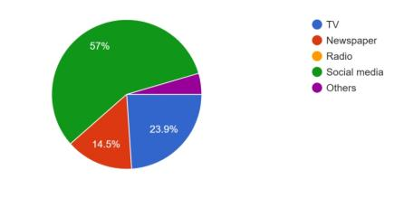
Interpretation: Major response for this question was that 57% of the respondents get news from social media while 23.9% get it from TV and 14.5% from Newspaper.
Question 2: Do you prefer watching TV?
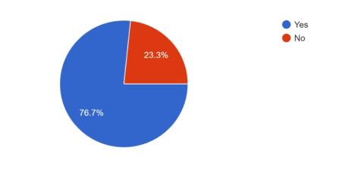
Interpretation: Of those surveyed, 76.7% said they watch TV while 23.3% said they did not.
Question 3: If yes, for which content do you prefer TV?
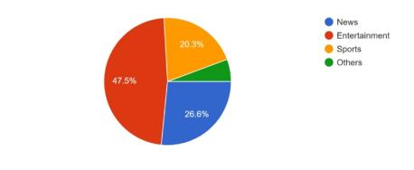
Interpretation: Among those who watch TV 47.5% said they prefer entertainment content while 26.6% prefer News and 20.3% prefer Sports.
Question 4: If you are willing to watch TV but you are away from it, how do you watch?
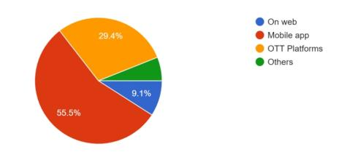
Interpretation: 55.5% of the respondent watch TV on mobile app while 29.4% on OTT platforms while away from TV.
Question 5: Has there been a change in your media consumption habits over the past years?
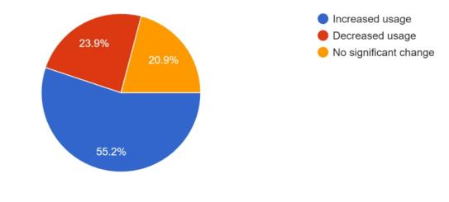
Interpretation: 55.2% of the respondents have increased media consumption while 23.9% have decreased media consumption also there are 20.9% respondents who don’t have any change.
Question 6: If you are not watching TV then what alternate platforms you use for media consumption.
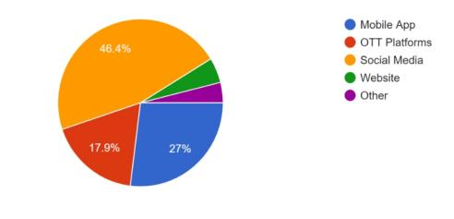
Interpretation: As an alternative media consumption platform apart from TV, social media is preferred by 46.4% of respondents, mobile apps are preferred by 27%.
Question 7: Rank Media platforms based on your consumption time.
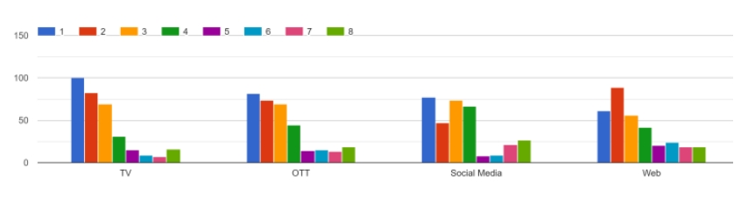
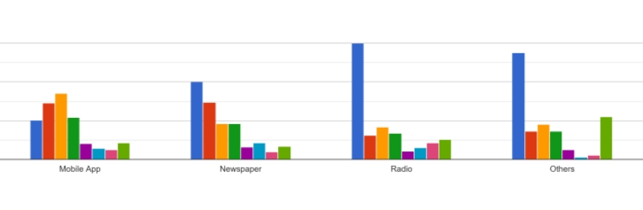
Interpretation: 150 respondents ranked 1st to Radio, 138 to others, 100 to TV and Newspaper.
Question 8: Rank Social Media platforms uses.
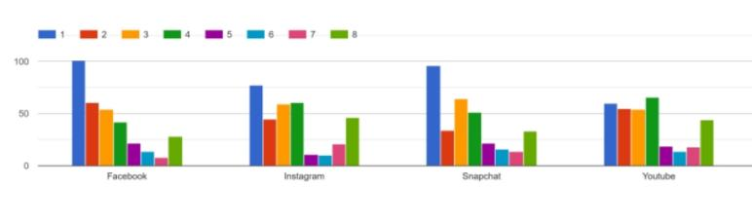
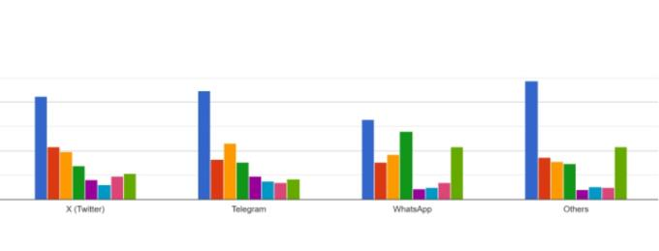
Interpretation: 122 respondents ranked 1st to others, 112 to Telegram, and 106 to Twitter (X)
Question 9: Which channel is the most preferred national news channel for national & international news?
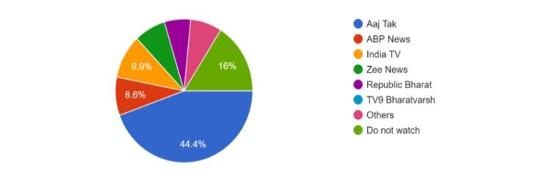
Interpretation: For national and international news, 44.4% of respondents prefer Aaj Tak.
Question 10: Which channel is the most preferred regional news channel for regional and national news?
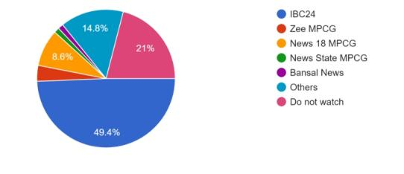
Interpretation: For local and national news, 49.4% of respondents prefer IBC24 News channel
Question 11: What will be the future of News on TV?
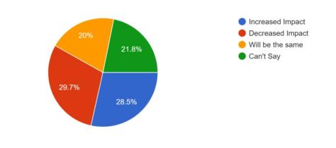
Interpretation: 29.7% of respondents believe that TV will have decreased impact while 28.5% believes it will have increased impact while 21.8% aren’t able to predict.
Question 12: How often do you watch out news updates?
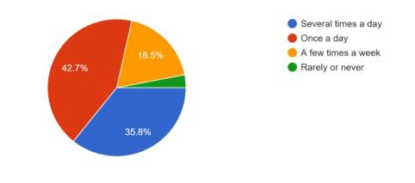
Interpretation: 42.7% of people go once for news updates while 35.8% go several times.
Question 13: Which news topic interests you the most?
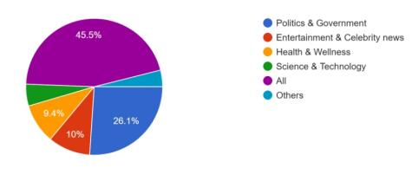
Interpretation: 45.5% of respondents have interest in all topic of news while 26.1% have interest in politics & govt.
Question 14: Does the advertisement run on TV changes your buying behavior?
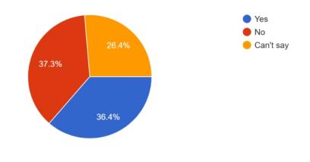
Interpretation: 37.3% of respondent have no impact on buying habits by TV advertisement while 36.4% have impact on it.
Finding
After this research I found following results:
- Source of News content is social media for 57% of the respondents.
- Out of the total respondents only 76.7% prefer to watch TV.
- Out of the total respondents watching TV, 47.5% prefer watching TV for Entertainment content
- 55.5% are watching Mobile app for TV, if they don’t have the access of TV.
- 55.2% of the respondents are saying that there is increase in the media consumption habits over past years.
- 46.4% of the respondents prefer consuming social media if they are not watching TV.
- 150 respondent ranked 1st to Radio, 138 to others, 100 to TV and Newspaper.
- 122 respondent ranked 1st to others, 112 to telegram, 106 to Twitter (X).
- Aaj Tak is most preferred News channel in National & International News for 44.4% respondents.
- IBC 24 is most preferred News channel for Regional & National News for 49.4% respondents.
- 29.7% respondents assume that there will be a decreased impact of TV in future.
- 42.7% of the respondents prefer watching News only once a day.
- 45.5% of respondents prefer watching news of all categories.
- 37.3% of the respondents assume that there will be no change in buying behavior by TV advertisement.

Conclusion
In this age of rapid technological advancement, people are shifting from traditional TV to on-demand services in search of engaging and varied programming. Through this research, conclusion is that for respondent media consumption habits has been increased and it has been seen that social media is most preferred for media trends. And according to respondent ranking to media consumption, radio is no. 1, then other media and 3 and 4 rank to TV & Newspaper. Future of News on TV might not be the same as per the analysis. And at last to know the most preferred news channel of national in MPCG is IBC24.
Limitation
- Participants might not always give genuine or accurate answers because of social desirability bias.
- Certain topics could be challenging to fully capture in a questionnaire, particularly if they call for in-depth explanations or nuanced comprehension.
- Google forms were used to distribute the forms online, and the researchers relied on the information subsequently acquired from the forms.
References
- Biesok__Wyrod-Wrobel_2012_Customer_satisfaction-libre.pdf
- barc-india-updates-tv-universe-total-tv-viewership-jumps-up-by-a-whopping-18-percent.pdf
- Impact of Covid-19 on advertising: a perception study on the effects on print and broadcast media and consumer behavior B Ansari, M Ganjoo - Purakala, 2020

- Strömbäck, Jesper (2022), et al. "News media trust and its impact on media use: Toward a framework for future research."

- Mishra, Nandita (2023), P. S. Aithal, and Aditya Iyer. "A Study of the Changing Trends in the Television Industry."

