Title: The Snakes in Captivity

Byline- Dhruv Patel

Text:

Evolution has favoured the modification and disrupted the way the reptiles live and evolve. India is an incredible destination for reptiles, home to countless deadly elapids, colubrid, multiple vipers, narrow-snouted pythons, aquatic keelbacks, four of the world's flying snakes, and vermicious caecilians. However, many misconceptions exist about reptile diversity. They live everywhere except Antarctica. Although this is a slightly misleading perception in and of itself, the general public has frequently believed that snakes are "venomous creatures." There are over 3000 snake species in existence today, only about 700 of which are venomous.

In order to maintain balance with other species, snakes have taken up a certain area in the ecological environment. Often recognised for their predatory tendencies, snakes have evolved to adapt to the unpredictable environment and can now adapt to the new kinds of food and shelter. . Since they no longer pose a threat to humans or cause conflicts between humans and wildlife, snakes have migrated over time and are now observed in captivity, changing the dynamics of the new environment. The snakes in captivity now draw a parallel with the human empire and thus it is essential to see the rhymes between the snakes and the human world.

The handling of snakes kept in captivity needs to be adequate. Before trying to handle the snake, it should first feel at ease. After the snake has consumed multiple meals in a row, you can begin handling it. Avoid handling a snake immediately after feeding it, as this may cause it to regurgitate its food (a highly stressful event for snakes). After feeding, depart at least 48 hours later. When handling hatchlings, exercise extreme caution because they are easily bruised if pressed. It is important to wash hands before and after handling.

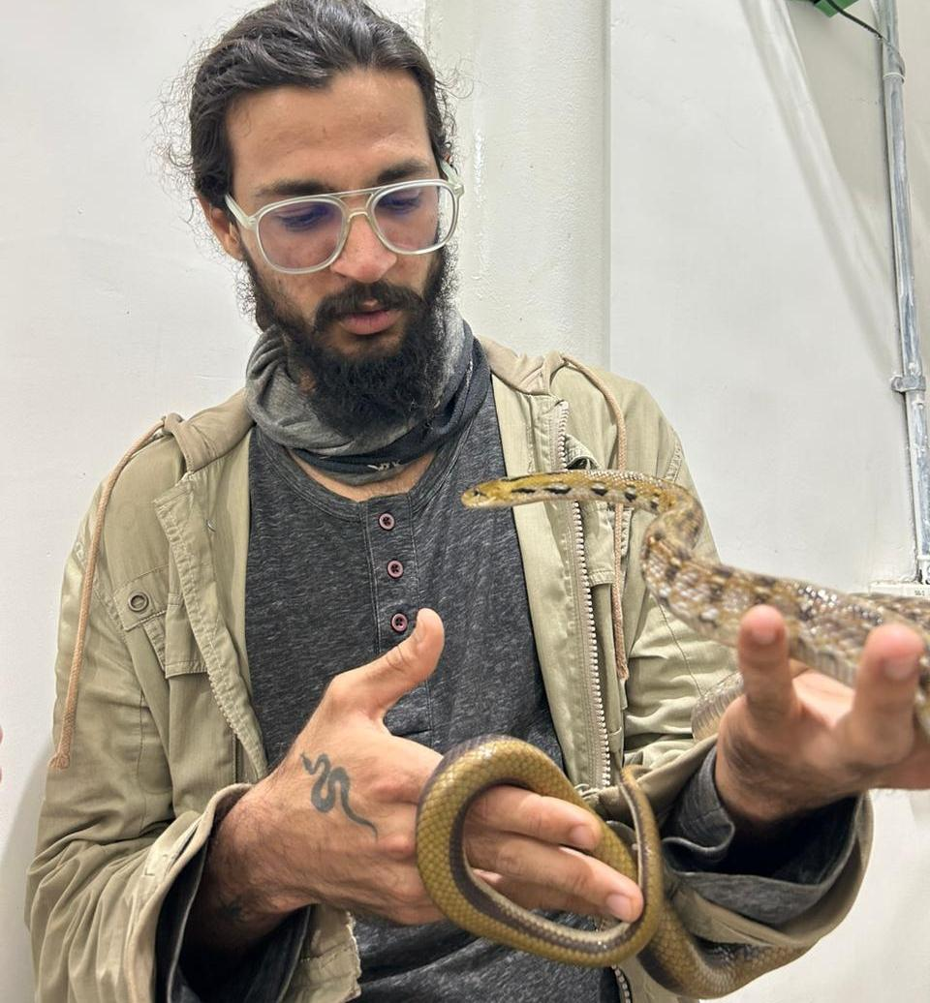
(1,1 Handling of the snake)

Building a Snake Enclosure
Determining what the ideal enclosure temperature should be is crucial when creating a habitat for the snakes. Will the species be active at all? Do the snakes desire to ascend? Prior to designing the enclosures, it is imperative to comprehend the fundamental factors that should satisfy the snakes' physical and psychological requirements.

Primarily prevalent in tropical areas, they are recognised for their cold-blooded nature. Several kinds prefer the warmth, and snakes frequently bask in order to stay warm. On the other hand, snakes that are used to chilly environments can provide adequate warmth. Dwelling into the size of the habitat, it is ideal to keep the size of habitat of approximately 10-20 gallons for juveniles and approximately 20-40 for adult species. The snake's size and rate of growth must be taken into account when designing the enclosure.
Pc: Dhruv Patel
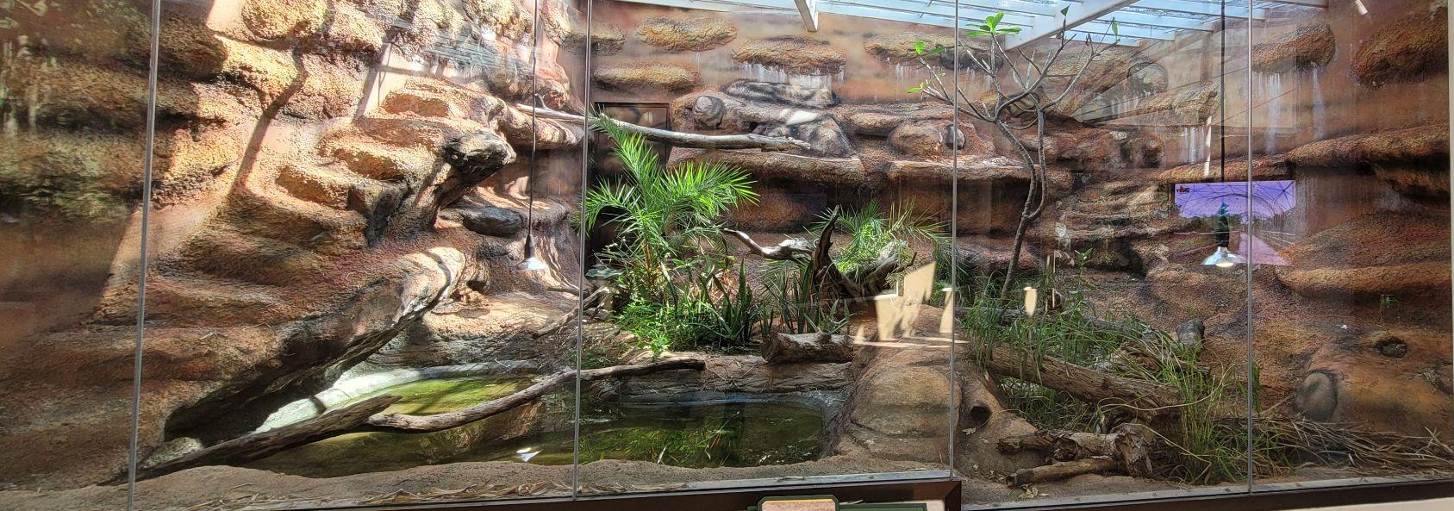
(1.2 The optimal arrangement for a snake enclosure)

The enclosure's width can be as much as 40 cm, its height can be as much as 35 cm, and its depth should not be less than 30 cm. The optimal dimensions for an adult species are 70 cm in width, 40 cm in depth, and up to 50 cm in height. It should be designed in such a manner that it resembles the true wild environment, and the snakes should be able to move freely. Snakes feel more secure when they are able to conceal themselves in tight fitting spaces. To allow the snakes to enjoy burrowing and hiding within, a thick layer of bedding can be included during the design. You can add up to two inches of soil and can use aspen bedding as well. It is essential to replace the substrate entirely every few weeks and to eliminate any filthy areas as soon as they are spotted. Before putting in fresh bedding, make sure the enclosure is thoroughly cleaned and disinfected.

The Ideal Temperature
As species, snakes have evolved to be ectotherms, or creatures that adjust their body temperature to match the environment. It is crucial to choose the right heating form and temperature for them after giving it considerable thought. The enclosure's optimal temperature can be found at either 21°C or 70°F on the colder side or 35°C or 95°F on the hot end. By positioning the heating mat or lamp on one side of the enclosure, the snakes are able to select to bask under it for their comfort. The heating light inside the enclosure shouldn't never be placed close to the water source.

Pc: Dhruv Patel
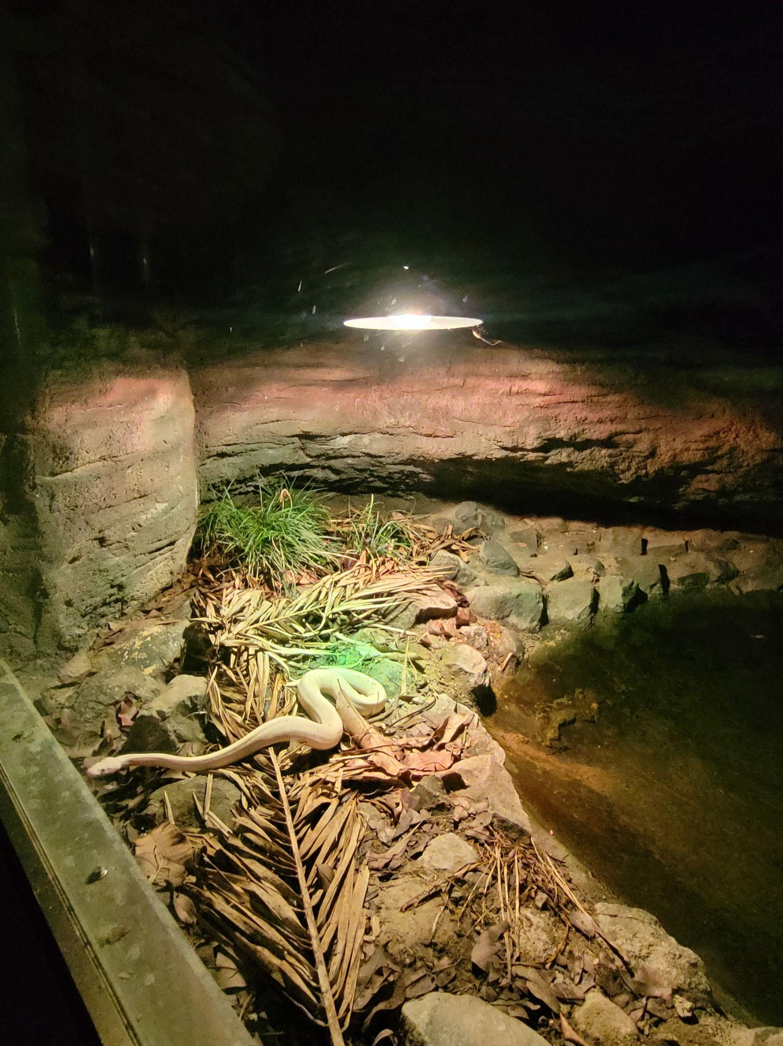
(1.3 The snake basking under the heating lamp)

Specific to a species requirements for humidity vary, but optimal ranges are between 40 and 50 kelvin. Typically, it benefits snakes throughout their skin-shedding process. The humid area must have adequate ventilation, and the snakes should have a suitable hiding place or hide box. There is a variety of hides available in these humidity shelters for both the warm and chilly end. The water dish is positioned at the cooler end of the enclosure, and it should only be partially filled to reduce the likelihood of spills.
Pc: Dhruv Patel
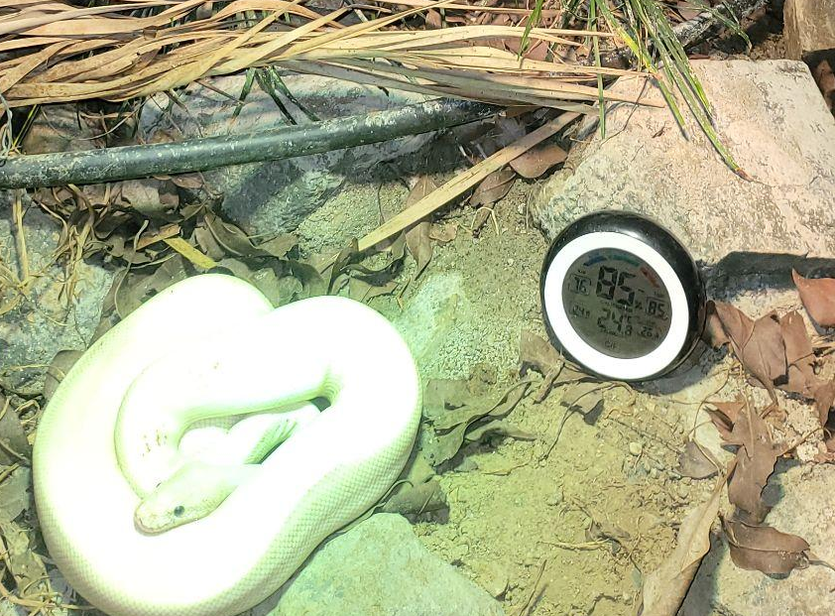
(1.4 Placement of thermohygrometer)

Enriching the Enclosure
The enriching process ensures that through various enrichment programs it promotes natural behaviour. One of the best ways to encourage the snakes to engage in some of its natural digging behaviours is to provide them with a beautiful digging space within their enclosure. It is possible for snakes to become uninterested, and when that occurs, you may observe undesirable consequences such as altered behaviour or even disease. You can create foraging areas, puzzle feeders, and even rearrange the entire enclosure's décor in your snake's enclosure, offering semi-arboreal and terrestrial animals plenty of climbing possibilities is a terrific strategy to support their development of muscle mass for a healthier animal.
Pc: Dhruv Patel
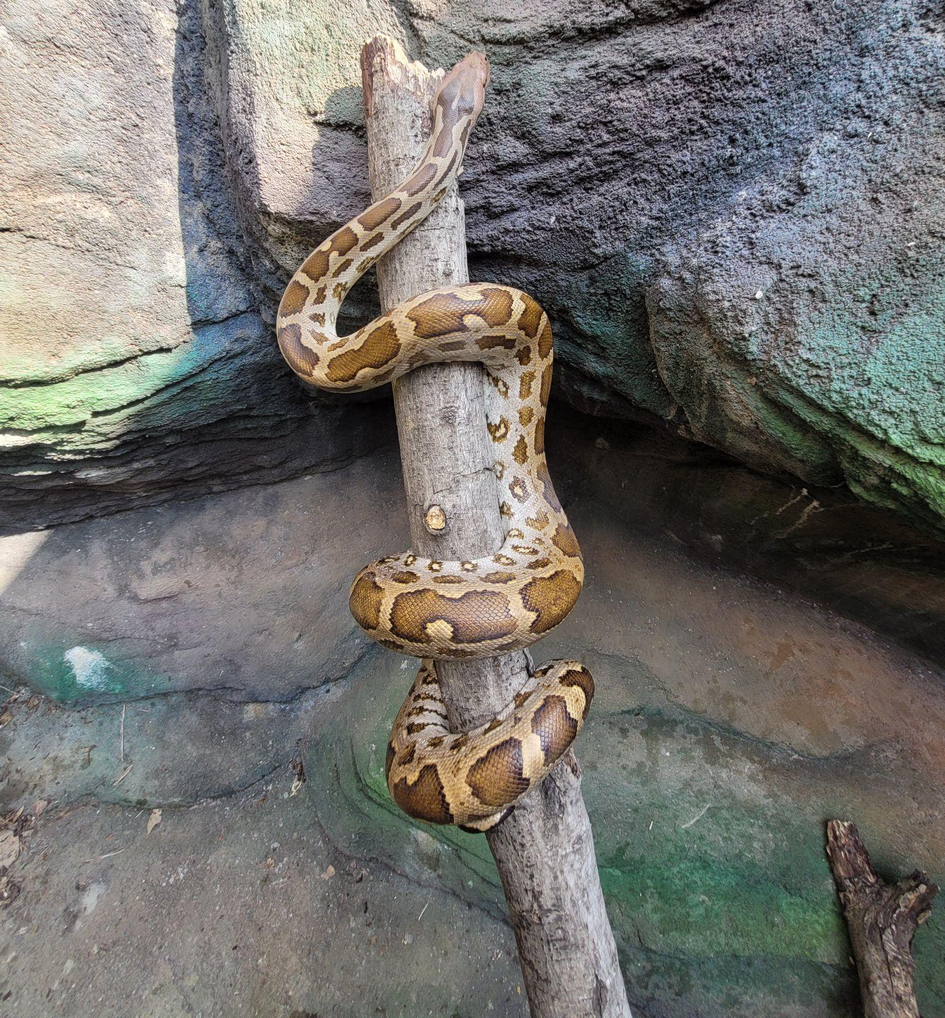
(1.5 The physical enriching process is aided by the wood logs placed in the enclosure.)

It is essential to clean and replenish the water dish once a day. Also regularly do visual inspection of snakes. Ensure to make sure the right humidity and temperature are being kept, eliminating any residue or stains. Make sure you remove the shed skin. Check that the weight of the snakes is taken (if needed), the enclosure has been disinfected, and that the snakes are physically inspected once a week. Perform a thorough cleaning and replacement of all substrates once a month.

Keeping the Snakes Healthy

The snakes retain their health when you provide them with a stress-free habitat, the right temperature, and regularity. A snake is considered healthy if it is active, attentive, has clean eyes (except from when it sheds), eats frequently, maintains a healthy weight, has smooth, supple skin, sheds its skin in whole sections on a regular basis, and is free of ticks and mites.

Every seven days, give baby snakes food. Feed mice or chicks roughly equivalent in size to a snake's girth. Older snakes typically eat once a week or once every two weeks. Avoid feeding during shedding. The majority of snakes that consume defrosted rodents can also be provided with chicks.

Common symptoms include hard breathing, bubbles coming from the mouth and nose, difficulty in shedding, frequent or infrequent shedding, vomiting or regurgitating, lethargy or reluctance to eat, abnormal faeces, bumps or spots on skin, red or pink skin colour possibly indicating systemic infection, and some swelling.

xxx

