A STUDY ON ANXIETY MANAGEMENT TOWARDS WHITE COLLAR EMPLOYEES
Dr. H. MICKLE AANCY¹ DINESH S²
¹Associate Professor Dept. of Management Studies, Panimalar Engineering College,Chennai.
²Student Dept. of Management Studies, Panimalar Engineering College,Chennai.
Abstract - The examines anxiety management among white-collar employees at Vy Systems, a leading global technology consulting firm in Chennai. Through a descriptive research design, it investigates factors influencing workplace anxiety, demographic influences, and employee satisfaction levels. Findings emphasize the importance of addressing workplace anxiety to enhance employee wellbeing and organizational performance. Recommendations for future research and anxiety reduction strategies are proposed. Data collection from structured questionnaires and the company website, along with convenience sampling of 195 employees, informs the analysis. Percentage calculations, Spearman correlation, Mann-Whitney U-test, and Kruskal-Wallis H test techniques are applied. The research aims to understand workplace anxiety factors, demographics, and employee satisfaction, offering insights into anxiety reduction strategies. The workplace anxiety among white-collar employees using descriptive statistics. Findings highlight male dominance, younger demographics, and undergraduate qualifications among employees
Keywords: Anxiety Management, White Collar Employees
- INTRODUCTION
In contemporary society, the workplace has evolved into a dynamic arena where individuals from diverse backgrounds converge to pursue professional aspirations. Amidst the hustle and bustle of corporate life, the term "white-collar employee" stands as a symbol of the modern workforce, often associated with corporate settings, professional attire, and desk-bound roles. However, beneath the veneer of prestige and stability, lies a prevalent yet often overlooked issue – anxiety.
The concept of anxiety in the workplace is multifaceted, encompassing a spectrum of experiences that manifest in various forms. From the subtle unease of navigating office politics to the debilitating panic induced by looming deadlines, anxiety permeates through the fabric of professional life, impacting individuals at all levels of the organizational hierarchy. Despite its omnipresence, anxiety remains a taboo subject in many workplaces, shrouded in stigma and misconceptions. This reluctance to address anxiety not only perpetuates the cycle of distress but also hinders the creation of supportive and inclusive work environments. One of the primary drivers of workplace anxiety stems from the relentless pursuit of success in a hypercompetitive landscape. In an era defined by globalization and technological advancement, the pressure to excel is omnipresent, fueling a culture of overwork and burnout. White-collar employees, in particular, find themselves ensnared in the relentless pursuit of productivity, often at the expense of their mental well-being. The constant fear of falling behind or failing to meet expectations creates a perpetual state of anxiety, wherein individuals feel compelled to prioritize work over their own health and happiness. Moreover, the modern workplace is characterized by a myriad of stressors that exacerbate feelings of anxiety among employees. Rapid changes in technology, organizational restructuring, and the uncertainty of job security contribute to a sense of instability and apprehension. Additionally, the pervasive use of digital communication tools blurs the boundaries between work and personal life, leading to a constant barrage of notifications and a sense of being constantly tethered to the job. As a result, individuals struggle to disconnect and unwind, further exacerbating feelings of anxiety and overwhelm. Furthermore, the hierarchical nature of many organizations can exacerbate feelings of inadequacy and imposter syndrome, particularly among marginalized groups. Women, people of color, and individuals from underrepresented backgrounds often face systemic barriers and biases that compound their experiences of anxiety in the workplace. The pressure to conform to traditional standards of professionalism and the fear of being perceived as incompetent or unfit for their roles can weigh heavily on these individuals, leading to heightened levels of stress and anxiety.
The rise of remote work, accelerated by the global COVID-19 pandemic, has introduced a new set of challenges for white-collar employees, further exacerbating feelings of isolation and anxiety. While remote work offers flexibility and autonomy, it also blurs the boundaries between work and home, making it increasingly difficult for individuals to unplug and recharge. The lack of face-to-face interaction with colleagues can also lead to feelings of loneliness and detachment, further amplifying feelings of anxiety and disconnection. Despite the pervasiveness of workplace anxiety, efforts to address this issue have been sporadic and often inadequate. Many organizations prioritize productivity and performance metrics over employee well-being, perpetuating a culture of silence and stigma around mental health issues. Moreover, the lack of awareness and education surrounding anxiety further compounds the problem, leaving individuals to suffer in silence rather than seeking the support they need. However, there is a growing recognition of the importance of prioritizing employee well-being in the modern workplace. Employers are increasingly investing in mental health resources and support services to help employees cope with anxiety and stress. From employee assistance programs to mindfulness workshops, organizations are taking proactive steps to create supportive and inclusive work environments where individuals feel empowered to prioritize their mental health.
- REVIEW OF LITERATURE

- Athar Hameed and Muddasar Ghani Khwaja (2023) The role of involvement in HRM practices, self-efficacy, and hope. Researchers have highlighted that as work-from-home (WFH) mechanisms have progressed during the pandemic COVID-19, there is a likelihood that occupational stress levels may rise considerably. The mental health of the employees may deteriorate due to work-related stress. Hence, it remains important to explore during a pandemic, how involvement in human resource management practices would affect the stress levels of the employees. Perceived work-based self-efficacy, employee stress management, and hope were estimated as mediating constructs among involvement in HRM practices and the mental well-being of employees.
- Suchismita Satapathy, Meghana Mishra (2023) Work stress due to long working hours, complex work culture, family problems, etc. white-collar jobs are official jobs with less physical load and more mental pressure. Awkward (continuous sitting posture), long working hours, more mental stress to compete with co-workers, and goal (target)-oriented jobs detach the person from social life.
- Zeyu Chen. (2023) Mobile young white-collar workers not only have the characteristics of mobile young people but also have the characteristics of general white-collar workers. Under the influence of both, their mental health may be suffering from a “double disadvantage”. So, based on an ecological model of the stress process, this paper tries to use the data of the questionnaire on the mental health of mobile young white-collar workers in Zhejiang Province to explore the influence of some factors in the middle workplace and residence place on the mental health of micro individuals.
- Ali Osman Uymaz (2022) The effect of t-anxiety on the career self-management dimensions which are Personal Mastery (PM), Verbal Persuasion (VP), and Vicarious Learning (VL), and the moderator effect of s- anxiety about layoffs due to the COVID-19 pandemic on these relationships. The causal comparison screening approach was adopted. Hypotheses were investigated by the SEM method. It was also found that positive and significant relationships exist between t-anxiety and VP and VL. A negative relationship between s-anxiety about layoffs due to the COVID-19 pandemic and PM was determined.
- Alkım KOÇAK (2022) Ten interviews with Turkish white-collar employees from six different multicultural firms were conducted. Our findings indicate that salary and supervision were shown to be crucial in enhancing Turkish white-collar employees' job satisfaction, according to the findings, based on Herzberg's Two-Factor Theory. White-collar employees expect good guidance and effective supervision from their managers, and a good salary has been shown to increase their job satisfaction
- DR. CHEGE THENYA MUCHIRI (PhD) (2022) The operational duties of their work, by their nature, may at any time place the employees at high-stress levels. In addition to the operational stressors inherent in disciplined services work especially the police, numerous studies have shown that factors related to organizational structure and climate can be an even greater source of stress for the disciplined officer. In the disciplined services, officers.
- Gusti Made Suwandana, (2022) The company's human resources (HR) is the company's main asset that must be managed and utilized effectively efficiently and humanely. Employee performance is a very important thing for a company. To improve performance, there are several aspects such as Job Stress, work conflict, and workload so that the performance of each employee can be improved. The purpose of this study was to explain the effect of Job Stress, work conflict, and workload on employee performance. This research was conducted at PT. Family Circus in Badung.
- Liana Paramita (2022) Good human resources are a determining factor for the company's success. Bank Perkreditan Rakyat (BPR) is a financial institution that specializes in fund-lending facilities for communities. This study aims to analyze the role of work stress in mediating the effects of compensation and work-life balance on employee performance. This research was conducted at BPR Sandi Raya Utama, with 51 respondents. Data was collected by distributing a questionnaire that was measured by a Likert scale. The data analysis technique used in this research is Smart PLS. The results of this study indicate that compensation and work-life balance have a positive significant effect on employee performance but have a negative significant effect on work stress, while job stress has a negative significant effect on employee performance. Work stress partially mediates the relationship between compensation and work-life balance on employee performance.
- Zafer ADIGÜZEL İrem KUCUKOGLU (2022) Work stress experienced by employees under intense work pressure can both adversely affect employees psychologically and cause organizations to get negative outcomes. That employees experience workload does not indicate that they are under stress. It is necessary to be aware that workload and stress are different concepts. Employees experiencing workload can be positively reflected in the organization when they do their job gladly, willingly, and fondly.
- Gunilla Krantz, Leeni Berntsson, Ulf Lundberg (2021) This study aimed to analyze how paid work, unpaid household tasks, child care, work–child care interactions, and perceived work stress are associated with reported symptoms in male and female white-collar employees. A questionnaire was mailed to 1300 men and 1300 women belonging to the white-collar sector, with at least 35 hours of regular employment a week and participant age of between 32 and 58 years. It contained items relating to total workload (hours spent on paid work, unpaid household tasks, and childcare), subjective indices for work stress, and symptoms.

- NEED OF THE STUDY
The study aims to understand factors contributing to workplace anxiety at VY Systems, Chennai, facilitating effective stress reduction strategies. This addresses the crucial need to enhance employee well-being in white-collar settings. The cross-sectional study acknowledges limitations in establishing causality but aims to capture a snapshot of anxiety levels among white-collar employees at VY Systems. This acknowledgment is crucial for accurate interpretation and drawing meaningful conclusions. Employees experiencing high levels of anxiety may struggle to concentrate, meet deadlines, or collaborate effectively with colleagues. This can lead to reduced productivity, increased absenteeism, and higher turnover rates, all of which can negatively impact the overall performance of the organization. Despite cross-sectional limitations, the study addresses work place anxiety, offering insights and stress reduction strategies. It lays the groundwork for future research, emphasizing ongoing efforts to enhance employee well-being and productivity at VY Systems. By addressing workplace anxiety proactively, organizations can enhance employee satisfaction, boost morale, and ultimately improve overall productivity and performance.
- OBJECTIVES OF THE STUDY

- To find factors that influences the anxiety of the employees.
- To identify demographic factors influence Anxiety Management.
- To identify the level of satisfaction of the employees at Vy systems.
- To find suggestions to reduce the Anxiety of the employees.

- RESEARCH METHODOLOGY
DESCRIPTIVE RESEARCH DESIGN
The descriptive research design which is Descriptive research studies are those studies which are concerned with delivery the characteristics of a particular individual group. A descriptive design studies is concerned with specific prediction with narration of facts and characteristics concerning individuals group or situations.
CONVENIENCE SAMPLING
Convenience sampling is a non-probability sampling method where units are selected for inclusion in the sample because they are the easiest for the researcher to access. This can be due to geographical proximity, availability at a given time, or willingness to participate in the research.
SAMPLE SIZE
The population in the VY Systems is 400 employees. According to the Morgan’s table if population N=400 then the sample size s=195 (i,e) 195 respondents.
Normality Test
Null Hypothesis (H0): The sample data is not significantly different than the normal population.
Alternate Hypothesis (H1): The sample data is significantly different than the normal population.

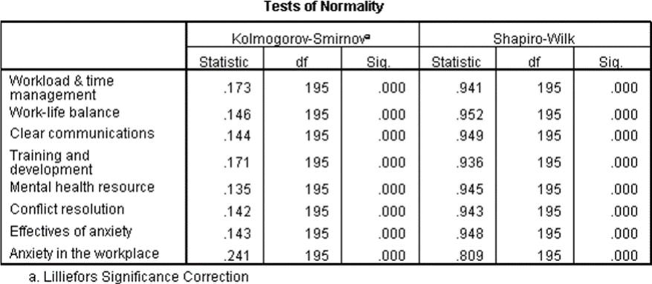

Inference:

Both the Kolmogorov-Smirnov and Shapiro-Wilk tests reveal non-normality (p < 0.05), indicating that the data for workload and time management does not adhere to a normal distribution.
The non-normality of the data for work-life balance was confirmed by both tests (p < 0.05), with the absence of mention regarding the Lilliefors significance correction indicating deviation from normal distribution.
The non-normality of the data for clear communications, indicated by both tests (p < 0.05) and without mention of the Lilliefors correction, implies it does not follow a normal distribution.
The data for training and development do not follow a normal distribution, as indicated by both tests showing non-normality with a significance level of p < 0.05.
The mental health resource data deviates from normal distribution (p < 0.05), without mention of Lilliefors correction, implying non-normality based on both tests.
The mental health resource data deviates from normal distribution (p < 0.05), without mention of Lillie for correction, implying non-normality based on both tests.
The data for the effectiveness of anxiety is non-normally distributed based on both tests indicating non-normality with a significance level below 0.05, without mention of the Lilliefors significance correction.
Both tests indicate non-normality (p < 0.05), suggesting that the data for anxiety in the workplace does not conform to a normal distribution, with no Lilliefors correction mentioned.
Since, the significance value of all the factors of studies is lesser than the P value [0.05]. Hence when [P < 0.05] Reject Null Hypothesis H0. Therefore, the factor of studies follows NON-PARAMETRIC TEST.
NON-PARAMETRIC TESTS
- CORRELATION
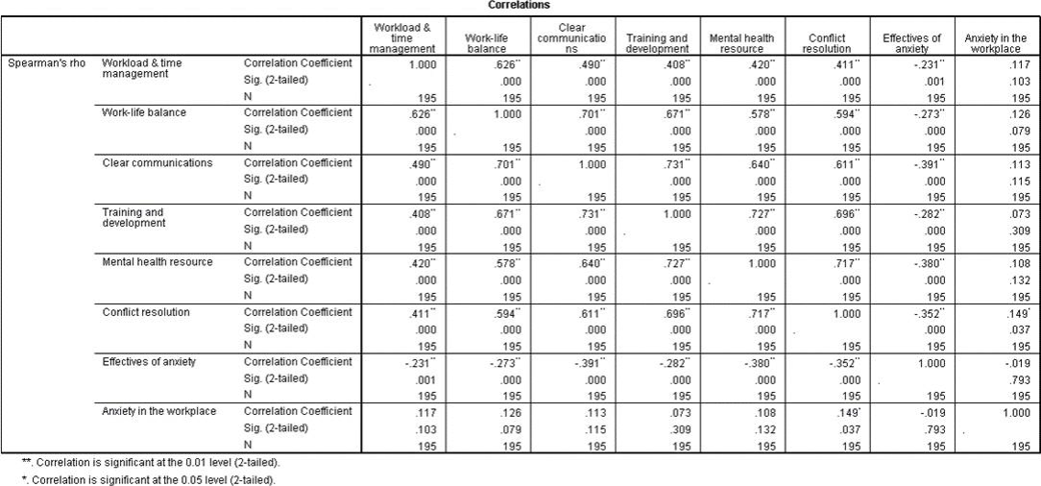
Inference:
Effective workload and time management strategies are strongly correlated with work-life balance, clear communication, training and development, mental health resources, and conflict resolution, moderately correlated with anxiety effectiveness, and weakly correlated with workplace anxiety.
Achieving a good work-life balance is closely tied to efficient workload management, clear communication, training and development opportunities, alongside adequate mental health resources and reduced anxiety levels.
Clear communication significantly correlates positively with workload & time management, work-life balance, training and development, mental health resources, and conflict resolution, while weakly correlating negatively with the effectiveness of anxiety.
Prioritizing training and development programs correlate positively with workload & time management, work-life balance, clear communication, mental health resources, and effectiveness of anxiety, suggesting holistic organizational benefits.
Investing in mental health resources positively influences work-life balance, clear communication, and training, while also correlating with improved workload management, conflict resolution, and reduced workplace anxiety.
Effective conflict resolution is strongly correlated with clear communication, training, and mental health resources, moderately correlated with workload management, and weakly correlated with work-life balance and anxiety management effectiveness.
Higher effectiveness in managing anxiety is associated with better clear communication, training and development opportunities, access to mental health resources, efficient workload management, and potentially improved work-life balance.
Weak positive correlations with Clear communications, Mental health resources, and Conflict resolution.

II. MANN WHITNEY U TEST

Null hypothesis (H0): There is no significant difference in the distributions of the variable between the two gender groups (Male and Female).
Alternative hypothesis (H1): There is a significant difference in the distributions of the variable between the two gender groups (Male and Female)

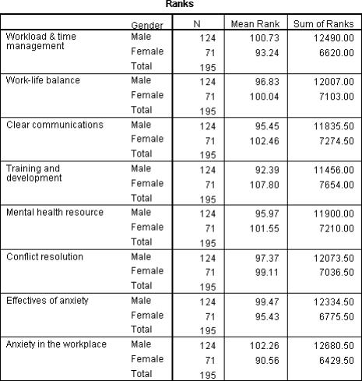
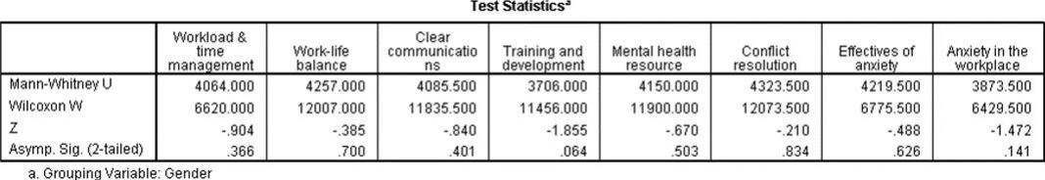

Inference:

There is no significant difference in workload and time management between genders (p = 0.366).
There is no significant difference in work-life balance between genders (p = 0.700).
There is no significant difference in perceptions of clear communication between genders (p = 0.401). There is no significant difference in access to training and development opportunities between genders (p = 0.064).
There is no significant difference in access to mental health resources between genders (p = 0.503).
There is no significant difference in the effectiveness of conflict resolution between genders (p = 0.834).
There is no significant difference in the effectiveness of anxiety management between genders (p = 0.626).
There is no significant difference in the levels of anxiety experienced in the workplace between genders (p = 0.141).

III. KRUSKAL WALLIS H TEST

Null hypothesis (H0): There is no significant difference in the distributions of the variable among the different age groups.
Alternative hypothesis (H1): There is a significant difference in the distributions of the variable among the different age groups
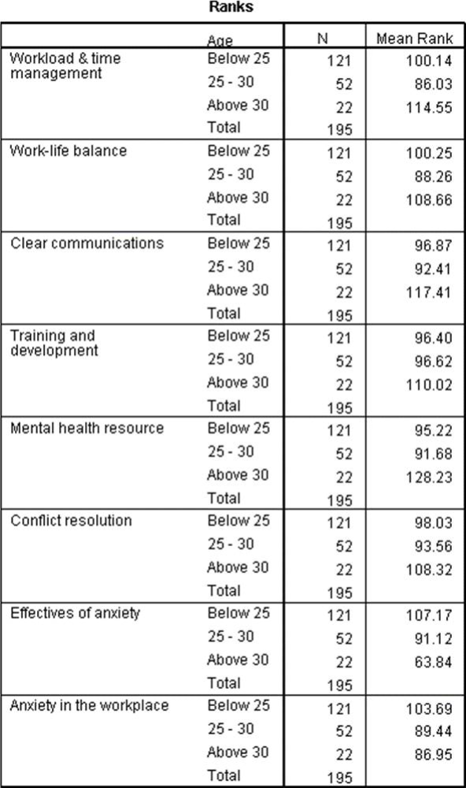
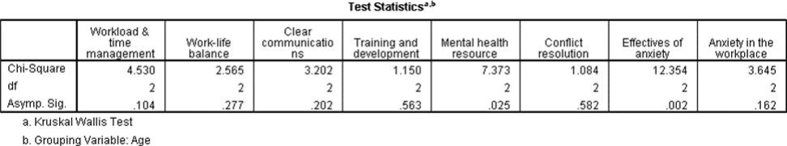
Inference:

The Chi-Square test with a statistic of 4.53, 2 degrees of freedom, and an asymptotic significance value of 0.10 suggests no significant variance in perceptions of workload and time management across age groups (p > 0.05).
The Chi-Square test with a 2.57 value and 2 degrees of freedom yielded a non-significant p- value of 0.28, indicating no significant variation in perceptions of work-life balance across age groups.
The chi-square test yielded a statistic of 3.20 with 2 degrees of freedom and an asymptotic significance of 0.20, suggesting no significant disparity in clear communication perceptions across various age groups (p > 0.05).
The Chi-Square test yielded a statistic of 1.15 with 2 degrees of freedom and an asymptotic significance of 0.56, indicating no significant variance in perceptions of training and development across age groups.
The Chi-Square test (χ² = 7.37, df = 2, p = 0.03) revealed a significant difference in perceptions of mental health resources across age groups, suggesting varied attitudes.
The Chi-Square analysis with 2 degrees of freedom revealed a non-significant p-value of 0.58, indicating no significant variance in perceptions of conflict resolution across various age groups. The Chi-Square analysis (χ² = 12.35, df = 2, p < 0.05) reveals a significant difference in perceptions of anxiety effectiveness across age groups, indicating diverse perspectives.
The Chi-Square test yielded a p-value of 0.16 (df = 2), indicating no significant difference in perceptions of workplace anxiety across various age groups.

- SUGGESTIONS

A significant majority of male respondents, consider initiatives to promote gender diversity and inclusivity within the workplace. Given the predominance of respondents below the age of 25, tailor training and development programs to cater to the needs and career aspirations of this youthful demographic. While most respondents hold undergraduate qualifications, encourage ongoing learning and upskilling opportunities to support career growth and advancement. Despite a sizable portion agreeing to a good work-life balance, continue to implement policies and practices that foster employee well-being and flexibility. Address the mixed perceptions on time management effectiveness by providing training and tools to improve organizational skills and productivity. Ensure the confidentiality and effectiveness of support channels for employees experiencing workplace anxiety by promoting trust and accessibility. Advocate for open dialogue on mental health concerns and implement awareness campaigns and resources to reduce stigma and encourage support-seeking behaviors.

- CONCLUSION

Managing anxiety among white-collar employees is a critical aspect of promoting overall well-being and productivity in the workplace. The several key strategies for anxiety management among white-collar employees, including promoting work-life balance, providing mental health resources, fostering a positive work culture, encouraging physical activity, and offering training programs on stress management. Employers can encourage employees to set boundaries between work and personal life, such as avoiding after-hours emails or scheduling regular breaks during the workday. By prioritizing time for relaxation and personal activities, employees can recharge and reduce anxiety levels. Managing anxiety among white-collar employees requires a multifaceted approach that addresses work-life balance, mental health resources, work culture, physical activity, and stress management training. Employers can offer wellness programs, gym memberships, or on-site fitness classes to encourage employees to prioritize physical activity.
References
- Athar Hameed and Muddasar Ghani Khwaja (2023), Exploring the Mental Pressure of Workers Engaged in White-Collar Jobs.
- Suchismita Satapathy, Meghana Mishra (2023) The direct and indirect influence of mindfulness on techno-stressors and job burnout
- Zeyu Chen. (2023), Examining the Commitment to the Organization of the Employees Who Work in an Organization against Stress, Workloadand Psychological Empowerment.
- Ali Osman Uymaz (2022), Differential Effects ofMindfulness-Based Intervention Programs at Work on Psychological Wellbeing and WorkEngagement
- Alkım KOÇAK (2022), Work-Life Balance, Work Performanceand Job Satisfaction of White-Collar Employees in a Work-At-Home Setu
- DR. CHEGE THENYA MUCHIRI (PhD) (2022), Accentuating dirty work: Coping with psychological taint in elite management consulting.
- Gusti Made Suwandana, (2022), Flexible Work Arrangements and Health in WhiteCollar Urban Professionals

