A STUDY ON COMPETENCY MAPPING WITH REFERENCE TO HYUNDAI WIA
DINESH V
PG Student Dept. of Management Studies, Panimalar Engineering College, Chennai, TamilNadu.
Abstract - Competency mapping has emerged as a crucial tool for aligning individual skills with organizational objectives. In today's rapidly evolving business landscape, organizations are continually challenged to enhance employee performance to remain competitive and achieve their strategic goals. The study focuses on competency mapping in HYUNDAI WIA with 217 respondents. This abstract outlines a comprehensive initiative aimed at competency mapping and its profound impact on employee performance. The conceptual foundations of competency mapping, exploring its evolution from traditional job descriptions to dynamic skill-based models aligned with contemporary business needs. The study investigates how organizations identify, assess, and leverage competencies to enhance employee performance, drive talent management strategies, and achieve competitive advantages. The findings of this study have practical implications for HR practitioners, organizational leaders, and policymakers seeking to optimize human capital management strategies and drive sustainable business growth in a rapidly evolving global landscape. The study aims to highlight certain behavioral characteristics that influence competency mapping performance. This study encompasses vital part of behavioral characteristics enhancing the performance of competency mapping as a strategic tool for organization.  Key Words—Behavioral Traits, Competence Mapping, Competence, Employee Performance  - INTRODUCTION  The global scenario of the economy to maintain a competitive edge, the global economic environment demands creative personnel management strategies. The study insight will take through the impact of Competency Mapping in automobile manufacturing industry to bring potential capabilities of human resource to meet expected standards.  The study made an effort in identifying individual behavioral traits influencing the performance of competency mapping, the vital part of behavioral characteristics enhancing the performance of competency mapping as a strategic tool for organization.  Organizations need to be dynamic and growth-oriented in order to sustain in the competitive market and this is possible only through the competence of the human resources. The food industry has always gained a predominant role in the world regarding the development and maintenance of a skilled workforce.  Human resource management in these industries is  A well-designed competency framework serves as a valuable tool for talent management, providing a structured approach to assessing, developing, and aligning the skills and behaviors of individuals with the strategic objectives of the organization. It promotes a consistent and transparent approach to managing human capital within the organization.  Overall, the benefits of competency mapping include employee development, increased productivity and better alignment of organizational goals and workforce capabilities. By fostering a talent-centric approach, organizations can better navigate the dynamic business landscape and achieve sustainable success. By investing in the development of competency maps, organizations can ensure that they have the right people with the right competencies in the right roles, which ultimately leads to a more efficient and effective workforce.  - REVIEW OF LITERATURE  Abderrazak Boumane, Fadoua Benhamza Hlihel, Youness Chater, (2024) This study aims to establish a maintenance 4.0 competency model that can be tailored to the unique requirements of each industrial sector, thereby making it applicable to all of them. Four categories are used to organize competencies: technical, methodological, social, and personal. The article's contribution to the improvement of maintenance competencies has social ramifications. This model can be applied by individuals to further their own personal growth. Given that it covers the most pertinent competences for each of the three hierarchical levels, this model is distinct, general, and integrative. This approach might be helpful in hiring new maintenance staff, assessing their performance, and determining what kind of training is required to handle the latest shifts in maintenance competencies.  Afdila Santri Nurhalima, (2023) The digital era has created new demands for employees to have competitive and relevant skills, a mismatch between the skills they possess and the demands of the constantly changing job market. Several important points can be drawn from this article, including the following: competency-based training is recognized as an effective method of enhancing skills in line with job demands, employee development programmes have the potential to positively affect an organization's competitiveness in the digital era, and competency-based training programmes not only improve skills but also contribute to employee motivation and engagement.  Alamsyan Budi, Haji Mustaqim, Rudi Alhempi, Siregar, (2023) It looks at the relationship between employee engagement and goal orientation towards competence, as well as the relationship between competence and employee performance in financial Durgeshwary Kolhe, Joel Mathew Jose, Prashant Bamania, Rekhawagani, (2023) It focuses on the linked dynamics of gender diversity, cultural competency, and employee retention in the workplace. Our focus is on determining if organisations that actively promote gender diversity and have strong cultural competency see increased employee retention. Cultural competency is an organization's ability to comprehend, respect, and adapt to cultural variations, hence promoting inclusivity and innovation. This study emphasises the complex relationship between gender diversity, cultural competency, and employee retention, highlighting their critical role in increasing job satisfaction and retention.  Fatmasari Wijayanti, Retno Titi Sari, (2023) The article provides an in-depth examination of the research on competency, employee performance, and the relationship between the two. The findings of these research could provide empirical evidence that organisations require individuals that are highly competent at work. This can be accomplished by competency mapping and training that is appropriate for the job needs, ensuring that personnel have up-to-date competencies relevant to the job and changes in the organization's environment. Competency mapping has the potential to boost staff productivity and performance, as well as the overall efficiency, effectiveness, and competitiveness of the organisation.  Firlia Candra Kartika, Yonathan Alfapri Damaika, (2023) Its goal is to close the gap between written job descriptions and work descriptions in the field, as well as to establish competency criteria for each role. Interviews, observation, and literature research are the methods used to collect data for job analysis. The study's findings reveal an improvement in job descriptions and competency mapping for each role.  Herman Sjahruddin, Jefri Putri Nugraha, Rezky Nurbakti, Yakup, (2023) Work competencies are divided into two categories: threshold competencies, which are the primary characteristics that someone must possess in order to perform their job properly, and differentiating competencies, which are the factors that distinguish high performers from low performers. Employee competency and job placement have a favourable and significant impact on employee work productivity.  - NEED OF THE STUDY  Competency mapping is aimed at identifying and developing employee’s skills, knowledge, and abilities required for their job roles. The study enhances employee performance by helping organizations understand how competence mapping may increase employee performance and productivity, resulting in improved business outcomes. It helps employees to NORMALITY TEST  Null Hypothesis (H0): The sample data is not significantly different than the normal population.  Alternate Hypothesis (H1): The sample data is significantly different than the normal population.  Interpretation :  The factor of studies Competency Mapping Evaluation, Job Performance Analysis, Competency Driven Safety Analysis, Skill Gap Analysis, Competency Enhancement Training as a significance value of (P= 0.00).  Since, the significance value of all the factors of studies is lesser than the P value [0.05]. Hence when [P < 0.05] Reject Null Hypothesis H0. Therefore, the factor of studies follows NON-PARAMETRIC TEST.  NON-PARAMETRIC TESTS  CORRELATION  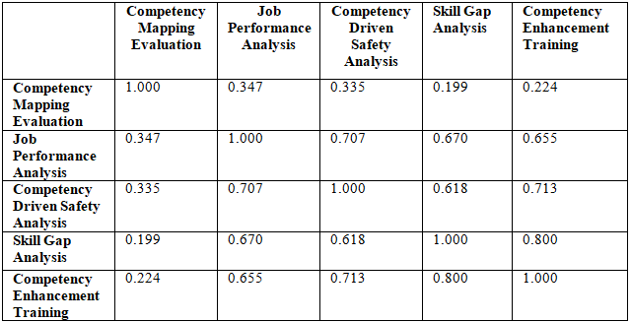  Interpretation:  There is weak relationship between Competency Mapping Evaluation & Job Performance Analysis[r=0.34]. There is weak relationship between Competency Mapping Evaluation & Competency Driven Safety Analysis[r=0.33]. There is weak relationship between Competency Mapping Evaluation & Skill Gap Analysis[r=0.19]. There is weak relationship between Competency Mapping Evaluation & Competency Enhancement Training[r=0.22]. There  KRUSKAL WALLIS H TEST  HYPOTHESIS:  Null Hypothesis H0: There is no significance difference between the mean ranks of respondent age with respect to the factors of studies.  Alternative Hypothesis H1: There is significance difference between the mean ranks of respondent age with respect to the factors of studies.  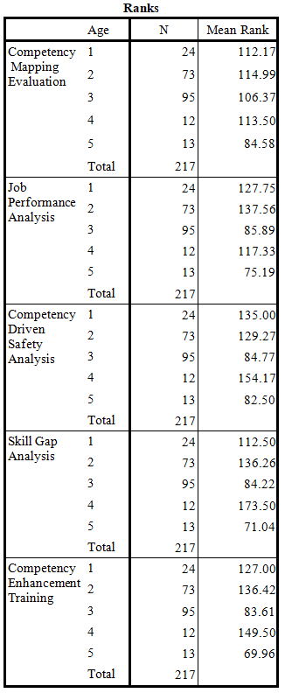  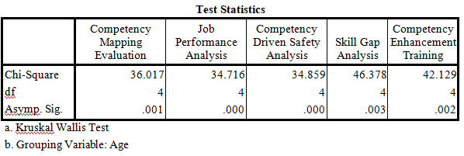  Interpretation:  Since, p value is less than 0.05 for all the factors of studies with respect to respondent age. Hence Reject Null Hypothesis H0. There is significance difference between mean ranks of respondent age with respect to the factors of studies.  - The positive view of competency mapping shows its potential. HR can deepen its integration by creating personalized development plans, facilitating mentorship, and enabling internal mobility based on competency assessments. This will align individual career goals with organizational needs. By implementing these data-driven strategies, HR can create a more engaged, diverse, and productive workforce.  VII. CONCLUSION  Competency mapping ensures that talent is directed towards successfully accomplishing corporate objectives by matching employee skills and competencies with organisational goals and strategies. By identifying high-potential individuals, filling in skill shortages, and assisting with succession planning projects, it makes improved talent management possible. By offering specialised training programmes and chances for skill improvement, competency mapping supports workers' professional development. Organisations may drive performance improvements, promote a culture of learning and innovation, and optimise personnel management processes by using competency mapping as a strategic tool. It is regarded as an effective tool for organisation. When used effectively, competency mapping is an endless cycle that benefits both the organisation and the project managers.  REFERENCES  [1] Abderrazak Boumane, Fadoua Benhamza Hlihel, Youness Chater, Developing a competency model for maintenance 4.0 stakeholders.  [2] Afdila Santri Nurhalima, Building competitive employees in the digital era with competency-based training.  [3] Alamsyan Budi, Haji Mustaqim, Rudi Alhempi, Siregar, The relationship between employee engagement and goal orientation towards competence and employee performance.  [4] Andrei A Krasko, Kirill Lavrenyuk, Lev Mazelis, Modeling the development of employee competence by investing in well-being program activities.  [5] Arunmozhi, Bhoyar, Priyanka Ji, Sanjay PanditPatil, Performance management and competency mapping.  [6] Bhanu muv, sivakalyan kumar, Employee development through competency mapping: a conceptual study.  [7] Deshmukh, KuPurva Fuse, WechansingSuliya, A need analysis of competency mapping for improvement in effectiveness and culture of organization. | assigned the responsibility to classify the competencies required to deliver the company‘s strategy, however every management seeks competitive advantage through committed and capable work force.  Competence: Competence refers to the ability, capability, or proficiency of an individual to perform a specific task or job effectively. It involves a combination of knowledge, skills, experience, and personal attributes that enable someone to excel in their professional role. Competency levels are often used in competency mapping, performance management, and talent development processes within organizations.  Competency Mapping: Competency mapping is a the process of determining and characterizing the behaviors, knowledge, skills, and functions necessary for certain job tasks within an organization. It involves the systematic approach of mapping and evaluating the competencies of employees in an organization to identify gaps and areas for development.  Competency mapping goes beyond traditional job descriptions by focusing on the specific abilities and behaviors that contribute to individual and organizational success. It involves the systematic identification, evaluation, and documentation of essential competencies, ensuring that employees possess the skills needed to excel in their roles and drive organizational success.  The act of evaluating and identifying one's strengths as a worker and as a member of the organization is known as competency mapping.  Competency mapping takes some time, thinking, and analysis to properly map competencies, and some people might not want to put in the necessary effort. Competency is the set of success elements required to accomplish significant goals in a certain job or work capacity inside a given organization. Combinations of abilities, knowledge, and traits that are defined in terms of particular behaviors that are exhibited by top performers in those positions are known as success factors. Personal qualities, traits, motivations, ideals, or modes of thought that influence a person's behavior are examples of attributes.  Competency Framework: A competency framework is a structured and organized collection of competencies, skills, knowledge, and attributes that are essential for effective job performance within an organization. It serves as a reference guide for employees, managers, and HR professionals to align individual capabilities with organizational goals.  institutions. This study makes recommendations on methods and policies for promoting employee productive work behaviour and boosting organisational performance. Another unique component of this study is that employees must think and act outside the box in order to improve their skills and become excellent employees. As a result, staff continue to receive great ratings from the leadership.  Andrei A Krasko, Kirill Lavrenyuk, Lev Mazelis, (2023) The study was carried out in the context of an urgent assignment aimed at modelling the growth of employee competence through the implementation of the organization's well-being programme, consequently contributing to the attainment of important employee performance indicators. It describes the effect of investing in the activities of the organization's well-being programme on the development of staff competencies. It gives extra analytical data to help make decisions about the design and growth of the organization's corporate environment, taking into account the impact of its individual elements on employee competency development. In the future, it will determine well-being programme actions to promote the attainment of the target values of key performance indicators for employees.  Arunmozhi, Bhoyar, Priyanka Ji, Sanjay PanditPatil, (2023) Managing employee performance entails not only assuring their competency but also encouraging their personal development. Competency mapping refers to the practice of discovering the behavioural and technical factors that differentiate great performance from mediocre performance. It enables firms to identify and foster behaviours and abilities that lead to great performance. The manner in which business professionals manage their personnel is as significant in determining organisational success as the organization's structures and available resources. Managers have access to a highly important tool in the shape of a project management system (PMS), which helps them to better manage their employees' progress, career goals, and expectations.  Deshmukh, KuPurva Fuse, WechansingSuliya, (2023) The competency is an employee's inner potential that allows them to accomplish their job. Competency comes in numerous forms, including capability, ability, physical power, thinking, and wisdom. Different types of prospective employees use at work to complete tasks and increase their effectiveness. Competency mapping is a predetermined assessment of an employee's latent potential or capability for doing tasks. Estimating potential is critical for job planning and benchmarking. Power needs to be estimated in order to complete a specific task. Potential is a human's hidden power that can be used to enhance themselves in the future. Competency is an inner strength that allows you to improve your knowledge and abilities while also increasing your productivity at work  identify their strengths and weaknesses, and create a career development to improve their skills and competencies. It supports succession planning by pinpointing potential leaders and facilitates targeted training and development programs based on identified competencies. Competency mapping ensures that job profiles are aligned with the required skills, enhancing the effectiveness of the hiring process.  - OBJECTIVES OF THE STUDY  - To identify the impact of competency mapping on employee behavioral traits.  - To find out the relationship between employee competency mapping and their overall job performance.  - To identify the influence of competencies on conformance to safety protocols and regulations within the Hyundai.  - To evaluate the effectiveness of competency mapping in identifying skill gaps and training needs of employees and determine their potential for future roles.  - To suggest the training for improvement in competency skills of employee’s.  - RESEARCH METHODOLOGY  DESCRIPTIVE RESEARCH DESIGN  The descriptive research design which is Descriptive research studies are those studies which are concerned with delivery the characteristics of a particular individual group.  PROBABILITY SAMPLING  Probability sampling is also known as random sampling. In the probability random sampling, every element in the population has known and equal chance of being selected. It minimizes bias and ensures that the sample accurately reflects the characteristics of the entire population.  SOFTWARE USED  SPSS 16.0  SPSS (Statistical Package for Social Sciences) 16.0 is a comprehensive system for analyzing data. SPSS can accept data from practically any file type to create tabulated reports, distribution and trend charts and plots, descriptive statistics, and advanced statistical analyses. SPSS makes statistical analysis easier for beginners and more convenient for advanced users. Simple menus and dialogue box selections allow you to do complicated analysis without typing a single line of command syntax. The Data Editor provides a straightforward and efficient spreadsheet-style interface for entering data and browsing the working data file.  is strong relationship between Job Performance Analysis & Competency Driven Safety Analysis[r=0.70]. There is moderate relationship between Job Performance Analysis & Skill Gap Analysis[r=0.67]. There is moderate relationship between Job Performance Analysis & Competency Enhancement Training [r=0.67]. There is moderate relationship between Competency Driven Safety Analysis & Skill Gap Analysis[r=0.61]. There is moderate relationship between Competency Driven Safety Analysis & Competency Enhancement Training [r=0.71]. There is strong relationship between Skill Gap Analysis & Competency Enhancement Training [r=0.80].  MANN WHITNEY U TEST  HYPOTHESIS:  Null Hypothesis H0: There is no significance difference between the mean rank of men and women with respect to the factors of studies.  Alternative Hypothesis H1: There is significance difference between the mean rank of men and women with respect to the factors of studies.  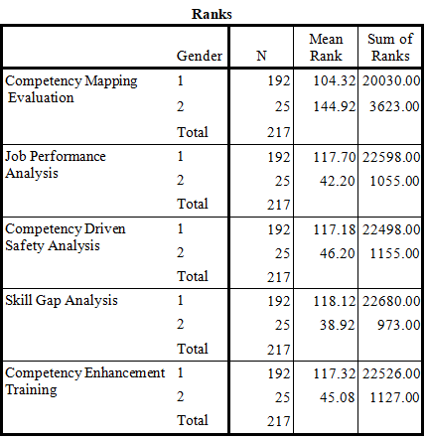  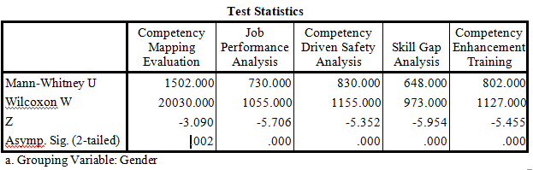  Interpretation:  Since, p value is less than 0.05 for all the factors of studies. The mean ranks of men are more deviated than women for the factor of studies of Job Performance Analysis, Competency Driven Safety Analysis, Skill Gap Analysis, Competency Enhancement Training. Hence Reject Null Hypothesis H0. There is significance difference between mean rank of men and women with respect to the factors of studies.  WEIGHTED AVERAGE  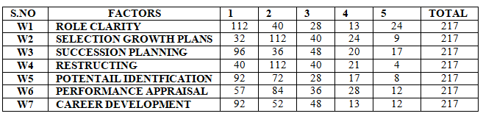  CALCULATION:  W1 : [(112*1)+(40*2)+(28*3)+(13*4)+(24*5)]/15=30 [ Rank 6]  W2 : [(32*1)+(112*2)+(40*3)+(24*4)+(9*5)]/15=35 [ Rank 1]  W3 : [(96*1)+(36*2)+(48*3)+(20*4)+(17*5)]/15=32 [ Rank 4]  W4 : [(40*1)+(112*2)+(40*3)+(21*4)+(4*5)]/15=33 [ Rank 3]  W5 : [(92*1)+(72*2)+(28*3)+(17*4)+(8*5)]/15=29 [ Rank 7]  W6 : [(57*1)+(84*2)+(36*3)+(28*4)+(12*5)]/15=34 [ Rank 2]  W7 : [(92*1)+(52*2)+(48*3)+(13*4)+(12*5)]/15=31 [ Rank 5]  Interpretation:  From the above calculation, Selection growth plans is Rank 1 & Performance appraisal is Rank 2 & Restructing is Rank 3 & Succession planning is Rank 4 & Career development is Rank 5 & Role clarity is Rank 6 & Potential identification is Rank 7.  - SUGGESTIONS  - The male-dominated workforce calls for targeted recruitment efforts to attract and retain women in traditionally male fields. Fostering inclusivity will create a better-rounded team.  - To foster a positive work environment, HR can promote company values, encourage open communication, and celebrate individual and team achievements. This will create a culture that values diverse perspectives and drives growth.  - Employees value feedback on their performance. Establish regular evaluations to provide constructive criticism so they can identify strengths and areas for improvement, leading to increased satisfaction and productivity.  - While most employees feel adequately trained, safety is paramount. Regular drills, ongoing training, and integrating best practices into daily operations will ensure a comprehensive safety program.  [8] Dhani Shanker Chaubey, Nidhi Maithel, Vishal Gupta, Employees perception towards competency mapping practices.  [9] Durga Bhavani, Kamal Ganugula, Naga Kumari Yedma, Competency mapping.  [10] Durgeshwary Kolhe, Joel Mathew Jose, Prashant Bamania, Rekhawagani, Exploring the relationship between gender diversity, cultural competency, and employee retention in the workplace.
  Tests of Normality
   | Kolmogorov-Smirnovª |  |  | Shapiro-Wilk
   | Statistic | df | Sig. | Statistic | df | Sig.
  Competency Mapping Evaluation | .197 | 217 | .000 | .910 | 217 | .000
  Job Performance Analysis | .122 | 217 | .000 | .963 | 217 | .000
  Competency Driven Safety Analysis | .136 | 217 | .000 | .971 | 217 | .000
  Skill Gap Analysis | .176 | 217 | .000 | .934 | 217 | .000
  Competency Enhancement Training | .232 | 217 | .000 | .850 | 217 | .000

