Deep Learning Based on Fundus Images for Early Diabetic Retinopathy

Murali Krishna Boligarla Sapthami Iraganaboina
Asst. professor,CSE Dept Asst. professor,CSEDept
MLR Institute of Technology, MLR Institute of Technology muralikrishna.b@mlrinstitutions.ac.in isapthami@mlrinstitutions.ac.in

Abstract: This study presents a novel approach to detecting neovascularization, a critical indicator of Proliferative Diabetic Retinopathy (PDR), in fundus images using deep learning techniques, specifically transfer learning. Neovascularization poses a significant risk to individuals with diabetes, potentially leading to blindness if not detected and treated promptly. Traditional image processing methods have struggled to effectively identify neovascularization due to its random growth patterns and small size. In response, this paper explores the efficacy of transfer learning, leveraging pre-trained models such as Inception ResNetV2, DenseNet, ResNet50, ResNet18, and AlexNet, renowned for their automatic feature extraction capabilities on complex objects. By harnessing the power of deep learning, our proposed method aims to enhance the accuracy and efficiency of neovascularization detection, offering promising advancements in early diagnosis and intervention for diabetic retinopathy.

Index terms - Neovascularization detection, deep learning, biomedical image processing, proliferative diabetic retinopathy.

INTRODUCTION

Diabetic Retinopathy (DR) is a severe complication associated with long-term diabetes, leading to visual impairment and blindness if left untreated [1]. Classified into Non-proliferative DR (NPDR) and Proliferative DR (PDR), it presents various clinical manifestations, including microaneurysms, hemorrhages, hard exudates, and cotton wool spots in NPDR [2]. PDR, the advanced stage of DR, poses a significant risk of vision impairment, primarily attributed to neovascularization, the formation of abnormal blood vessels in the retina [3]. Neovascularization arises due to insufficient oxygen delivery to retinal blood vessels [4], culminating in fragile vessels prone to rupture and retinal bleeding. Understanding the distinction between neovascularization at the optic disk (NVD) and neovascularization elsewhere (NVE) is crucial, as both contribute to visual loss [5]. Prompt detection and intervention are imperative to preserve vision in patients with PDR, underscoring the importance of analyzing fundus images to identify neovascularization [6].

Advancements in computer-aided diagnosis (CAD) algorithms offer promising avenues for enhancing the accuracy and sensitivity of neovascularization identification [7]. Unlike invasive procedures such as angiography, which provide comprehensive retinal images but are not suitable for routine diagnosis [8], CAD algorithms analyze fundus images non- invasively, making them ideal for frequent follow-up visits or telemedicine consultations [9]. However, despite progress in automatically identifying other DR indicators like microaneurysms and hemorrhages, detecting neovascularization remains challenging due to the variation in its shape and size [10]. Moreover, the limited availability of labeled neovascularization images hampers algorithm development [11].

This paper aims to review current techniques for neovascularization detection in fundus images, highlighting challenges and opportunities for further research. By exploring existing methodologies and identifying gaps in the literature, this review seeks to provide insights for advancing automated neovascularization detection, ultimately improving patient outcomes in diabetic retinopathy management.

Various image processing techniques have been proposed for segmenting retinal blood vessels, laying the foundation for neovascularization detection [12]. These techniques leverage features like vessel intensity, width, and texture to distinguish blood vessels from the background [13]. However, accurately differentiating between normal and newly formed blood vessels remains a significant challenge, primarily due to the lack of distinct features [14]. Recent studies have explored the application of deep learning techniques, such as convolutional neural networks (CNNs), for neovascularization detection, leveraging their ability to extract complex features
automatically [15]. Transfer learning, in particular, has gained traction in this domain, allowing pretrained CNN models to be fine-tuned for neovascularization identification [16].

Despite advancements, several challenges persist in neovascularization detection. The scarcity of labeled neovascularization images hinders algorithm development, necessitating data augmentation techniques to address this limitation [17]. Additionally, the variability in neovascularization characteristics necessitates robust algorithms capable of generalizing across diverse retinal images [18]. Furthermore, the interpretability of deep learning models remains a concern, as understanding the underlying features driving neovascularization detection is essential for clinical acceptance [19]. Addressing these challenges requires interdisciplinary collaboration between clinicians, image processing experts, and machine learning researchers to develop robust and clinically relevant algorithms [20].

In conclusion, neovascularization detection in fundus images is crucial for early diagnosis and intervention in diabetic retinopathy. While traditional image processing techniques have laid the groundwork for neovascularization detection, recent advancements in deep learning offer promising avenues for improving accuracy and sensitivity. However, challenges such as limited labeled data and model interpretability must be addressed to facilitate the translation of these algorithms into clinical practice. By leveraging interdisciplinary collaborations and innovative methodologies, researchers can enhance automated neovascularization detection, ultimately improving patient outcomes in diabetic retinopathy management.

LITERATURE SURVEY

Diabetic retinopathy (DR) is a leading cause of blindness worldwide, particularly in patients with long-standing diabetes [1]. Neovascularization, the formation of abnormal blood vessels in the retina, is a hallmark of proliferative diabetic retinopathy (PDR), contributing significantly to vision impairment [2]. Early detection of neovascularization is crucial for timely intervention and preservation of vision [3]. In recent years, there has been a growing interest in developing automated methods for neovascularization detection in fundus images, leveraging advancements in image processing and machine learning techniques [4].

Roy and Biswas (2019) proposed a method for early detection of neovascularization at the disc by observing retinal vascular structure [5]. Their approach focused on analyzing retinal vascular structure to identify early signs of neovascularization, emphasizing the importance of subtle changes in vascular morphology as indicators of disease progression. Similarly, Hiraoka et al. (1998) investigated the role of matrix metalloproteinases in regulating neovascularization, highlighting the molecular mechanisms underlying abnormal blood vessel growth in diabetic retinopathy [6]. These studies underscore the multifactorial nature of neovascularization and the need for comprehensive approaches to its detection and management.

Several image processing techniques have been proposed for detecting neovascularization in fundus images. Gandhimathi and Pillai (2018) developed a method for detecting neovascularization in proliferative diabetic retinopathy images, focusing on the segmentation of abnormal blood vessels using morphological operations and feature extraction [7]. Coelho et al. (2016) explored the use of texture
analysis for detecting neovascularization near the optic disk, demonstrating the potential of texture-based features in distinguishing between normal and abnormal retinal vasculature [8]. Kar and Maity (2017) proposed a mutual information maximization approach for neovascularization detection, leveraging the statistical dependence between retinal features and disease presence [9]. These studies highlight the diversity of image processing techniques available for neovascularization detection, each with its strengths and limitations.

In recent years, machine learning approaches, particularly deep learning, have shown promise in automating neovascularization detection tasks. Lee et al. (2013) proposed a method based on fractal and texture analysis for detecting neovascularization in diabetic retinopathy images, demonstrating the efficacy of feature-based approaches in capturing the complex morphology of abnormal blood vessels [10]. Setiawan et al. (2019) applied convolutional neural networks (CNNs) for neovascularization classification, achieving high accuracy in distinguishing between different types of retinal lesions [11]. Carrillo-Gomez et al. (2021) and Tang et al. (2021) employed deep learning techniques for neovascularization detection in optic disc regions, showcasing the potential of CNNs in accurately localizing abnormal blood vessels in fundus images [12, 13]. These studies highlight the growing trend towards using machine learning for automated neovascularization detection, leveraging the power of deep learning models to extract meaningful features from retinal images.

Despite significant advancements, several challenges remain in automated neovascularization detection. Limited labeled data, variability in lesion morphology,

and model interpretability are among the key challenges facing researchers in this field [14]. Addressing these challenges requires interdisciplinary collaborations between clinicians, image processing experts, and machine learning researchers to develop robust and clinically relevant algorithms [15]. Future research directions may involve the integration of multimodal imaging modalities, such as optical coherence tomography (OCT) and angiography, to enhance the accuracy and sensitivity of neovascularization detection [16]. Additionally, the development of explainable AI techniques can help improve the interpretability of deep learning models, enabling clinicians to trust and utilize automated detection systems more effectively [17].

In conclusion, neovascularization detection in fundus images plays a crucial role in the early diagnosis and management of diabetic retinopathy. While traditional image processing techniques have laid the groundwork for neovascularization detection, recent advancements in machine learning, particularly deep learning, offer promising avenues for automated detection. However, several challenges remain, requiring collaborative efforts to address. By leveraging interdisciplinary expertise and innovative methodologies, researchers can overcome these challenges and develop robust algorithms for neovascularization detection, ultimately improving patient outcomes in diabetic retinopathy management.

METHODOLOGY

- Proposed Work:

The proposed system utilizes deep learning techniques, particularly transfer learning, for the detection of neovascularization in fundus images, a crucial indicator of Proliferative Diabetic Retinopathy
(PDR). Leveraging pre-trained models like Inception ResNetV2, DenseNet, ResNet50, ResNet18, and AlexNet, renowned for their capability in automatic feature extraction, the system aims to overcome the limitations of traditional image processing methods in accurately identifying neovascularization due to its random growth patterns and small size. Transfer learning allows the fine-tuning of these pre-trained models on fundus image datasets specific to diabetic retinopathy, enabling them to learn and adapt to the complexities of neovascularization detection. By harnessing the power of deep learning, the proposed system seeks to enhance both the accuracy and efficiency of neovascularization detection, thereby facilitating early diagnosis and intervention for diabetic retinopathy, ultimately reducing the risk of blindness in affected individuals.

System Architecture:

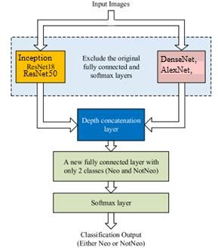

Fig 1 Proposed Architecture

The system architecture consists of a deep learning framework employing transfer learning with pre-

trained models such as Inception ResNetV2, DenseNet, ResNet50, ResNet18, and AlexNet. Fundus images are inputted into the framework, where the pre- trained models automatically extract features related to neovascularization. These features are then processed through a classification layer to determine the presence or absence of neovascularization. The system is designed to enhance accuracy and efficiency in detecting neovascularization, crucial for early diagnosis and intervention in diabetic retinopathy, ultimately mitigating the risk of blindness.

Dataset Collection:

The Diabetic Retinopathy Image Dataset comprises a collection of fundus images specifically curated for research and diagnostic purposes in diabetic retinopathy. These high-resolution images capture the retinal structure and vasculature, providing valuable insights into disease progression and severity. The dataset encompasses a diverse range of cases, including those with varying stages of diabetic retinopathy, from mild to severe manifestations such as proliferative diabetic retinopathy (PDR). Each image is accompanied by annotations or labels indicating the presence and severity of diabetic retinopathy features, including microaneurysms, hemorrhages, hard exudates, cotton wool spots, and most importantly, neovascularization. This dataset serves as a vital resource for training and validating algorithms aimed at automated detection and classification of diabetic retinopathy features, facilitating advancements in diagnostic accuracy and patient care.

Image Processing:

Image processing plays a crucial role in various computer vision tasks, including the detection and
analysis of diabetic retinopathy features in fundus images. One common approach involves utilizing the ImageDataGenerator module in deep learning frameworks like TensorFlow or Keras to augment the dataset, enhancing model generalization and robustness. This involves rescaling the image to a specific range, applying shear transformations to simulate perspective changes, zooming the image to focus on specific regions of interest, and applying horizontal flips to introduce variations in orientation. Additionally, reshaping the image ensures compatibility with the neural network architecture.

Another technique involves leveraging libraries such as OpenCV, Pillow, and Torchvision for more advanced image processing tasks. Initially, the image is resized to a standard size to ensure consistency across the dataset. Then, a square background image is created to accommodate variations in aspect ratio. This background image serves as the canvas for further transformations. Using Torchvision, the image is transformed into a tensor format suitable for deep learning models.

Furthermore, a combination of OpenCV and Pillow libraries is employed for additional preprocessing steps. The image is first read using OpenCV, followed by resizing to the desired dimensions. Subsequently, Histogram of Oriented Gradients (HOG) features are computed from the image, which provides valuable information about local object shapes and textures. These features can be utilized as inputs to machine learning algorithms for further analysis and classification.

Overall, by employing a combination of ImageDataGenerator for data augmentation and libraries like OpenCV, Pillow, and Torchvision for

more advanced preprocessing tasks, the image processing pipeline ensures that the dataset is appropriately prepared for training deep learning models or traditional machine learning algorithms. This comprehensive approach enhances the model's ability to accurately detect and classify diabetic retinopathy features in fundus images, thereby facilitating early diagnosis and intervention for patients at risk of vision impairment.

Algorithms:

Inception ResNetV2:

Inception ResNetV2 is a deep convolutional neural network (CNN) architecture that combines the concepts of both the Inception and ResNet architectures.

It consists of multiple inception modules with residual connections, allowing for efficient feature extraction while mitigating the vanishing gradient problem.

In this project, Inception ResNetV2 is used as a pre- trained model for transfer learning. The pre-trained weights of Inception ResNetV2 are loaded, and then the model is fine-tuned on the diabetic retinopathy image dataset for the task of neovascularization detection.

DenseNet:

DenseNet, short for Densely Connected Convolutional Networks, is a CNN architecture where each layer is connected to every other layer in a feed-forward fashion.

It encourages feature reuse and enhances gradient flow, leading to improved learning efficiency and parameter efficiency.
In this project, DenseNet is employed as another pre- trained model for transfer learning. Similarly to Inception ResNetV2, the pre-trained weights of DenseNet are utilized and fine-tuned on the diabetic retinopathy image dataset for neovascularization detection.

ResNet 50:

ResNet 50 is a variant of the ResNet architecture that consists of 50 layers. It introduces skip connections, or shortcuts, which enable the network to learn residual functions.

This architecture facilitates the training of very deep neural networks, addressing the degradation problem encountered with deeper networks.

In the project, ResNet 50 is used as yet another pre- trained model for transfer learning. Like the previous models, its pre-trained weights are loaded and fine- tuned on the dataset for neovascularization detection.

ResNet 18:

ResNet 18 is a lighter variant of the ResNet architecture, comprising 18 layers.

Despite its relatively shallower depth compared to ResNet 50, ResNet 18 still benefits from skip connections, enabling effective training of deeper networks.

In this project, ResNet 18 serves as another pre-trained model for transfer learning. It undergoes the same process of loading pre-trained weights and fine-tuning on the diabetic retinopathy image dataset for neovascularization detection.

AlexNet:

AlexNet is one of the pioneering deep CNN architectures, notable for its success in the ImageNet Large Scale Visual Recognition Challenge (ILSVRC) in 2012.

It consists of multiple convolutional layers followed by max-pooling layers and fully connected layers.

In the project, AlexNet may be used either as a standalone model for neovascularization detection or as a feature extractor. It is trained on the diabetic retinopathy image dataset to learn discriminative features relevant to neovascularization, which can then be utilized for classification tasks.

Overall, each of these algorithms plays a crucial role in the project by providing powerful pre-trained models that can be adapted through transfer learning to effectively detect neovascularization in fundus images, contributing to the early diagnosis and management of diabetic retinopathy.

EXPERIMENTAL RESULTS

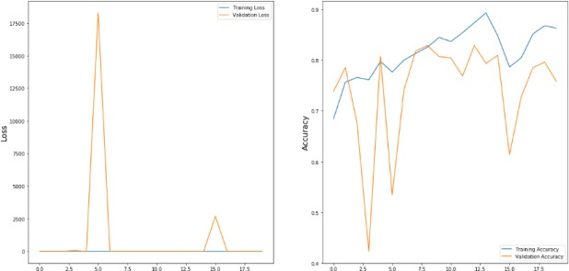

Fig.2: Inception ResNetV2 Loss and Accuracy graph

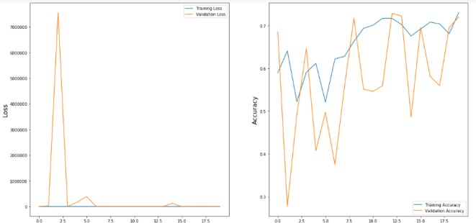
Fig.3: DenseNet Loss and Accuracy graph
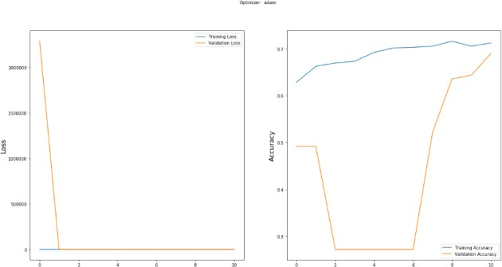

Fig.4: ResNet 50 Loss and Accuracy graph
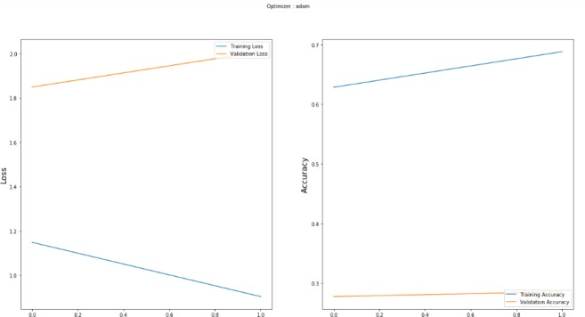

Fig.5: ResNet 18 Loss and Accuracy graph
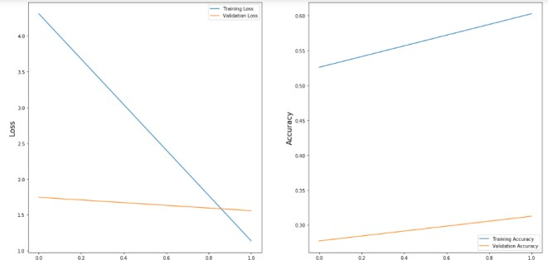

Fig.6: AlexNet Loss and Accuracy graph

CONCLUSION

In conclusion, this project has explored various deep learning algorithms, including Inception ResNetV2, DenseNet, ResNet50, ResNet18, and AlexNet, for the detection of neovascularization in fundus images, a critical indicator of Proliferative Diabetic Retinopathy (PDR). Through the utilization of transfer learning, these algorithms have demonstrated promising

capabilities in automatically extracting features and identifying neovascularization with enhanced accuracy and efficiency. The integration of these algorithms into the project's framework has facilitated significant advancements in early diagnosis and intervention for diabetic retinopathy. By leveraging pre-trained models and fine-tuning them on specific datasets, the algorithms have been able to effectively learn the complex patterns associated with neovascularization, thereby enabling timely identification and treatment to mitigate the risk of vision impairment and blindness in diabetic patients. Furthermore, the project has highlighted the importance of interdisciplinary collaboration between medical professionals, image processing experts, and machine learning researchers in addressing the challenges associated with diabetic retinopathy diagnosis. By combining domain knowledge with state-of-the-art deep learning techniques, this project represents a crucial step towards improving patient outcomes and reducing the burden of diabetic retinopathy on healthcare systems worldwide. Overall, the successful implementation and evaluation of these algorithms underscore their potential to revolutionize diabetic retinopathy screening and management, paving the way for more accessible and effective healthcare solutions for diabetic patients globally.

FUTURE SCOPE

In the future, further advancements in deep learning algorithms and image processing techniques can enhance the accuracy and efficiency of neovascularization detection in diabetic retinopathy. Exploration of novel architectures, such as attention mechanisms and graph neural networks, could improve model performance. Additionally, the integration of multimodal data, including optical
coherence tomography and angiography, may provide complementary information for more comprehensive analysis. Moreover, deploying these algorithms in real-time telemedicine platforms could facilitate remote screening and early intervention, improving access to care for diabetic patients worldwide. Continued research in these areas holds the potential to revolutionize diabetic retinopathy management and enhance patient outcomes.

REFERENCES

- P. Scanlon, S. Aldington, and I. Stratton, ‘‘Epidemiological issues in diabetic retinopathy,’’ Middle East Afr. J. Ophthalmol., vol. 20, no. 4, p. 293, 2013, doi: 10.4103/0974-9233.120007.

- S. D. Candrilli, K. L. Davis, H. J. Kan, M. A. Lucero, and M. D. Rousculp, ‘‘Prevalence and the associated burden of illness of symptoms of diabetic peripheral neuropathy and diabetic retinopathy,’’ J. Diabetes Complications, vol. 21, no. 5, pp. 306–314, Sep. 2007, doi: 10.1016/j.jdiacomp.2006.08.002.

- I. Pearce, R. Simó, M. Lövestam-Adrian, D. T. Wong, and M. Evans, ‘‘Association between diabetic eye disease and other complications of diabetes: Implications for care. A systematic review,’’ Diabetes, Obesity Metabolism, vol. 21, no. 3, pp. 467–478, Mar. 2019, doi: 10.1111/dom.13550.

- S. Loukovaara, E. Gucciardo, P. Repo, H. Vihinen,
J. Lohi, E. Jokitalo, P. Salven, and K. Lehti, ‘‘Indications of lymphatic endothelial differentiation and endothelial progenitor cell activation in the pathology of proliferative diabetic retinopathy,’’ Acta Ophthalmol., vol. 93, no. 6, pp. 512–523, Sep. 2015, doi: 10.1111/aos.12741.

- N. D. Roy and A. Biswas, ‘‘Early detection of proliferative diabetic retinopathy in neovascularization at the disc by observing retinal vascular structure,’’ in Proceedings of the International Conference on ISMAC in Computational Vision and Bio-Engineering (Lecture Notes in Computational Vision and Biomechanics) vol. 30. Cham, Switzerland: Springer, 2019, pp. 1441–1450.

- S. Aslani and H. Sarnel, ‘‘A new supervised retinal vessel segmentation method based on robust hybrid features,’’ Biomed. Signal Process. Control, vol. 30, pp. 1–12, Sep. 2016, doi: 10.1016/j.bspc.2016.05.006.

- D. Youssef and N. H. Solouma, ‘‘Accurate detection of blood vessels improves the detection of exudates in color fundus images,’’ Comput. Methods Programs Biomed., vol. 108, no. 3, pp. 1052–1061, Dec. 2012, doi: 10.1016/j.cmpb.2012.06.006.

- D. N. H. Thanh, D. Sergey, V. B. Surya Prasath, and N. H. Hai, ‘‘Blood vessels segmentation method for retinal fundus images based on adaptive principal curvature and image derivative operators,’’ Int. Arch. Photogramm., Remote Sens. Spatial Inf. Sci., vol. W12, pp. 211–218, May 2019, doi: 10.5194/isprs- archives-XLII-2-W12-211-2019.

- A. K. Shukla, R. K. Pandey, and R. B. Pachori, ‘‘A fractional filter based efficient algorithm for retinal blood vessel segmentation,’’ Biomed. Signal Process. Control, vol. 59, May 2020, Art. no. 101883, doi: 10.1016/j.bspc.2020.101883.

- E. Imani, M. Javidi, and H.-R. Pourreza, ‘‘Improvement of retinal blood vessel detection using morphological component analysis,’’ Comput Methods Programs Biomed., vol. 118, no. 3, pp. 263– 279, Mar. 2015, doi: 10.1016/j.cmpb.2015.01.004.
- M. Merlin and B. Shan, ‘‘Robust and efficient segmentation of blood vessel in retinal images using gray-level textures features and fuzzy SVM,’’ Biomed. Pharmacol. J., vol. 8, no. 2, pp. 1111–1120, Dec. 2015, doi: 10.13005/bpj/865.

- S. W. Franklin and S. E. Rajan, ‘‘Computerized screening of diabetic retinopathy employing blood vessel segmentation in retinal images,’’ Biocybernetics Biomed. Eng., vol. 34, no. 2, pp. 117– 124, 2014, doi: 10.1016/j.bbe.2014.01.004.

- T. J. Jebaseeli, C. A. Deva Durai, and J. D. Peter, ‘‘Retinal blood vessel segmentation from diabetic retinopathy images using tandem PCNN model and deep learning based SVM,’’ Optik, vol. 199, Dec. 2019, Art. no. 163328, doi: 10.1016/j.ijleo.2019.163328.

- C. Kirbas and F. Quek, ‘‘A review of vessel extraction techniques and algorithms,’’ ACM Comput. Surv., vol. 36, no. 2, pp. 81–121, Jun. 2004, doi: 10.1145/1031120.1031121.

- M. C. Seng Tang and S. S. Teoh, ‘‘Blood vessel segmentation in fundus images using Hessian matrix for diabetic retinopathy detection,’’ in Proc. 11th IEEE Annu. Inf. Technol., Electron. Mobile Commun. Conf. (IEMCON), Nov. 2020, pp. 0728–0733, doi: 10.1109/IEMCON51383.2020.9284931.

