A STUDY ON THE EXAMINATION OF GENDER EQUITY AND FEMALE PARTICIPATION IN SPORTS

AUTHOR

Ms.Dheepiksha.R,
3rd year ,BA,LLB(Hons),
Saveetha School of Law,
Saveetha Institute of Medical and Technical Sciences (SIMATS), Mobile No. :9585199926 E-mail Id no: dheepiksharajendran@gmail.com

CO- AUTHOR

Prof.Dr. Anju Mohan,
Professor of law,
Saveetha School of Law,
Saveetha Institute of Medical and Technical Sciences (SIMATS), MobileNo.7904490781 : , E-mail Id: anjumohan.ssl@saveetha.com

A STUDY ON THE EXAMINATION OF GENDER EQUITY AND FEMALE PARTICIPATION IN SPORTS

Ms.Dheepiksha,
Prof.Dr. Anju Mohan

ABSTRACT:

The purpose of this paper is to explore the history that surrounds the issues of gender equity in sport, what actions have been taken to provide equal opportunity for women in sports, the current issues facing women in sports today, the research surrounding the issues pertaining to gender equity in sport, and also to discuss the findings and present recommendations for further research in this area.Undertake to close the gap in investment in women's sport and promote equal economic opportunities for women and girls. Promote women's equal participation and bias free representation in the media. Provide equal opportunities for girls in sports, physical activity and physical education.The main aim of this research is to know about the gender equity and female participation in sports.Empirical research is used for the purpose of the study.Convenient sampling method is used to collect the samples.Samples are collected based on the ease of access or availability.The sample size of this paper is 200. Statistics used in the research are clustered bar graphs.The information was collected from secondary sources like journals,articles,books and so on.

Keywords: equal opportunity, women ,sports,gender equity ,physical education.

INTRODUCTION:

Gender equity has been an issue in society since the beginning of time. In recorded history, one can find many accounts of where women faced issues of equity in relationships, their career, education, and athletic opportunities. The purpose of this paper is to explore the history that surrounds the issues of gender equity in sport, what actions have been taken to provide equal opportunity for women in sports, the current issues facing women in sports today, the research surrounding the issues pertaining to gender equity in sport, and also to discuss the findings and present recommendations for further research in this area.Equity, on the other hand, means everyone is provided with what they need to succeed.Khelo India Programme is a national yojana/scheme for the development of sports in India. It was launched in the year 2018 by the then Sports Minister Col. Rajyavardhan Singh Rathore in Delhi. This program has been launched to improve the sports culture in India.Sports for women is also one of the categories of khelo india programme . Title IX requires that women be provided an equitable opportunity to partici- pate in sport; that female athletes receive athletic scholarships proportional to their participation; and that female athletes receive equal treatment, for example in the provision of equipment and supplies, scheduling of games and practice times, coaching, practice and competitive facilities, access to tutoring, publicity and promotions, and recruitment of student athletes. Title IX has also increased the salaries of coaches for women’s teams.Title IX and gender equality in sport: Lack of time, lack of knowledge, family problems and lack of money and companion, are indicated as the most significant recreational constraints in the way of female participation in sport.Major issue affecting gender equity in the sports government is Hegemonic masculinity is an operating principle within sport organizations that restricts women’s access to leadership positions within sport .Another issue affecting gender equity in sports government is the influence of power. Another issue women face in sport media is a focus on femininity, heterosexuality, and sexism. Essentially, sport media reinforces patriarchal sovereignty by focusing on female athletes’ femininity and heterosexuality, which serves to degrade their athletic accomplishments and athleticism There is not just inequality in participation and opportunity, but also with pay. That comes mainly in professional sports, wherein in almost all cases, men make more money than women. Male athletes in basketball, golf, soccer, baseball and tennis make anywhere from 15% to 100% more than female athletes.As the Tokyo 2020 Olympics kick-off on 23 July 2021, almost 49 per cent of participating athletes will be women, making it the most gender-balanced Games in history. All 206 National Olympic Committees also
have at least one female and one male athlete representative.The IOC said women's participation in Tokyo will be 49%, up from 45% at Rio, a nearly even split with the men. The committee also noted that when women made their Olympic debut at the Paris Games in 1900, there were only 22 females out of 997 total athletes. Those pioneers competed across five sports, among them croquet and equestrian.Tokyo 2020 is predicted to be the most gender equal yet with female participation, the IOC said.In Australia, women are under-represented in organised sport—as participants, coaches, officials, administrators, and board members—when compared to their male cohort. A variety of strategies exist to help equalise opportunities for girls and women, however, concerns continue on how gender bias may prevent them from receiving the full benefits sport and physical activity (PA) can offer.The USA and Australia have developed different strategies for trying to improve women’s participation and involvement in sport.Undertake to close the gap in investment in women's sport and promote equal economic opportunities for women and girls. Promote women's equal participation and bias free representation in the media. Provide equal opportunities for girls in sports, physical activity and physical education.The main aim of this research is to know about gender equity and female participation in sports.

OBJECTIVES :

● To know about the gender equity and female participation in sports
● To analyse the factors affecting gender equity in sports
● To learn government initiatives regarding female participation in sports
● To promote equal participation and bias free representation in the media.

REVIEW OF LITERATURE :

● women face gender equity issues as athletes and as sport governance officials. There is a lack of women in leadership positions in (Harvey and Price)sport due to the fact that sport is a gendered institution and that all processes operate within a hegemonic masculine norm .
● Hegemonic masculinity is an operating principle within sport organizations that restricts women’s access to leadership positions within sport . (Yenilmez)Based on a study on the influence of hegemonic masculinity on the rate of advancement of women and women in senior leadership positions in intercollegiate athletics, it was found that men maintain control of athletic director positions at the highest level of intercollegiate sport and have higher rates of organizational success.
● Another issue affecting gender equity in sports government is the influence of power. One study examined affirmative action policies, (Eugene et al.)and how such policies are interpreted in sport organizations.
● Male leaders of the examined sport organizations discussed the importance of women’s inclusion as members of Boards of Directors, (Sidani)but these leaders did not show any support for any policy changes that would effectively increase the number of women on those boards.
● Furthermore, recruitment and selection of women included a gender fit, which included that they have no young children,(“Gender Equity”) are well educated, held high jobs previously, had flexible schedules, and behaved properly based on the standards of male leaders.
● Therefore, it was demonstrated that male leaders use power to ensure that male leadership remains dominant, and the participation of(Norman) women is limited to those who fit the model of leader as determined by the men on the boards studied.
● Alongside the theme of masculinity comes the issue of access and treatment discrimination. These types of discrimination occur at the organizational level and can negatively impact women in leadership positions(Devine) in sport organizations .
● In relation to women in sport, they are often impacted by treatment discrimination as they are denied access tor rewards, resources, (Tjønndal)or opportunities on the job that they legitimately deserve.
● Gender marking is a common issue women face in sport media, and this term represents the verbal and visual presentation of male athletes and men’s sports as being the norm, while rendering female athletes(Stefani) and women’s competitions as secondary .
● how the media affects gender equity in sports and promotes the masculinization of sports, and also, how society is affecting gender (Cunningham)equity and female sports participation through feminization of women.
● Essentially, sport media reinforces patriarchal sovereignty by focusing on female athletes’ femininity and heterosexuality,(Capranica et al.) which serves to degrade their athletic accomplishments and athleticism .

● The most common theme of sexualization in sport for women is in reference to their appearance, which many studies have observed that print media focus on the physical appearance of women athletes much more than their athletic(Soler et al.) skills or abilities
● women had a rough entrance into the sports arena as it was seen as an unwelcoming intrusion into the realm of masculinity, and this caused women who played sports to be viewed as masculine or(Voet) lesbians.
● A major factor contributing to the feminizing of women in sports and reinforcement of hegemonic (Oecd and OECD)masculinity is the portrayal of female athletes by the media.
● Women’s sport is grossly under-represented both in the newspapers and on the television(Lopiano).By increasing the amount of publicity in women’s sport, the number of female role models will increase.
● With increasing exposure, more companies will offer sponsorship deals to women. This will aid the process (De D’Amico et al.)of turning female sport from predominantly amateur to predominantly professional.
● In the Ancient Games, women were excluded from the Olympics and men had to compete naked in order to prevent women from sneaking(Hayhurst et al.) in. If they did, they were sentenced to death.
● Nonetheless, it was 1981 when the International Olympic Committee (IOC) had any female delegates. This number has continued to increase, but there (Hayhurst et al.; Roper)is still a huge imbalance between the amount of males and females in dominant roles within the IOC.
● Girls were always discouraged from being aggressive and/or competitive, whereas these characteristics were encouraged in boys.(Pfister and Hartmann-Tews)Equally, it was thought that sport was physiologically harmful to women, and thus, it was strongly discouraged.
● In the 21st century a woman is no longer a second class citizen. BUT, there is still resistance to female equality.There is still (Rahman et al.)the role of housewife and mother – not athlete and sports personality.

METHODOLOGY:
The research method followed here is empirical Research. A total of 200 samples have been taken out of which is taken through convenient sampling.The sample frame taken by the research through the general public based on a questionnaire .The primary sources are taken from the general public in the form of survey method. The information was collected from secondary sources from journal articles, books and reports of presidency non governmental organisations.The independent variable taken here is age, gender,education,occupation.The dependent variables are the female participation does have a huge impact in sports ,the sports in India being masculinised ,the government showing importance to women's sports ,gender equity still exists in coed sports ,women being criticised negatively in sports. The statistical tool used here in this research is graph(mean) and scaling .

ANALYSIS AND INTERPRETATION :
Figure 1:
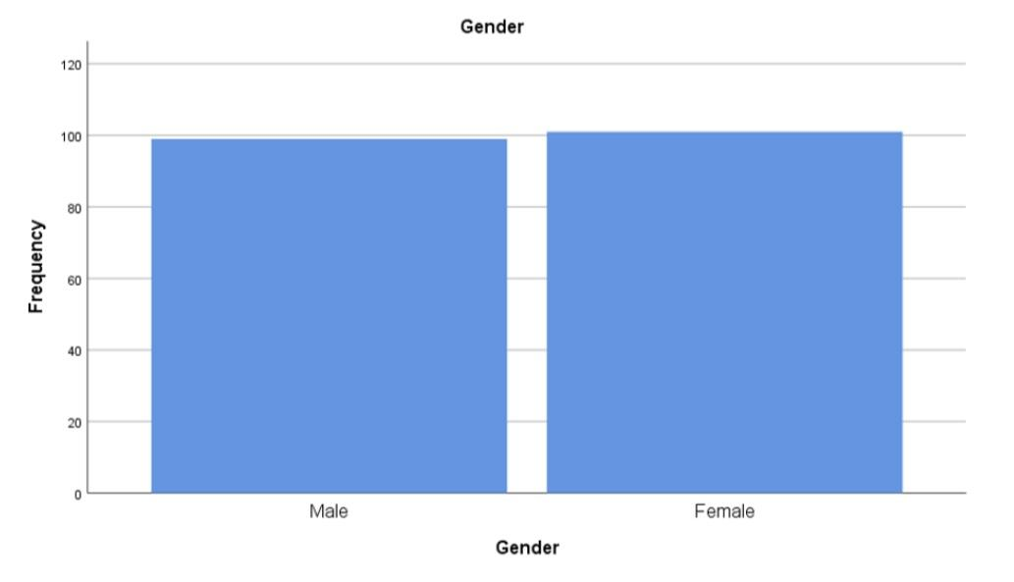

Legend:
The above figure deals about Gender with respect to examination of gender equity and female participation in sports.

Figure 2:
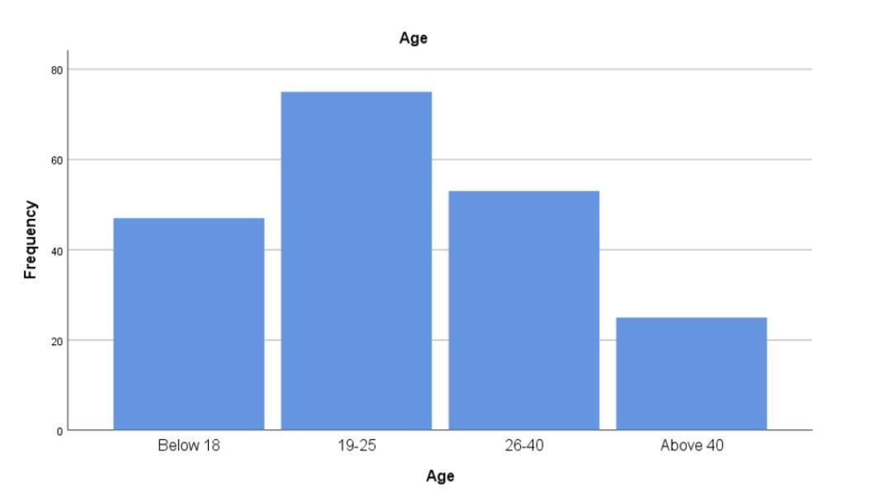

Legend:
The above figure deals about age with respect to examination of gender equity and female participation in sports.

Figure 3:
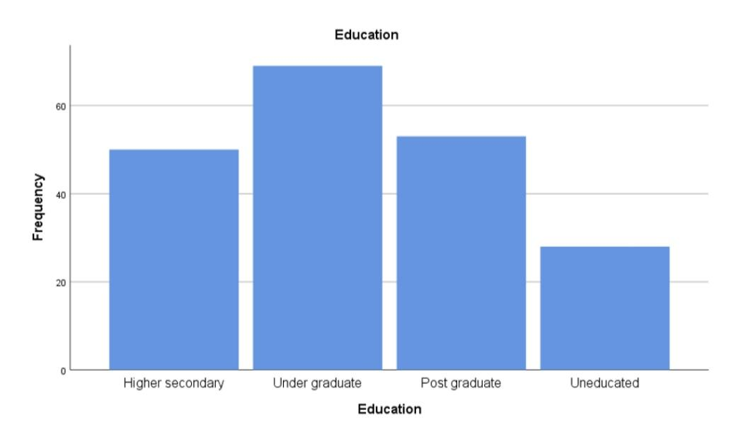
Legend:
The above figure deals about education with respect to examination of gender equity and female participation in sports.

Figure 4:
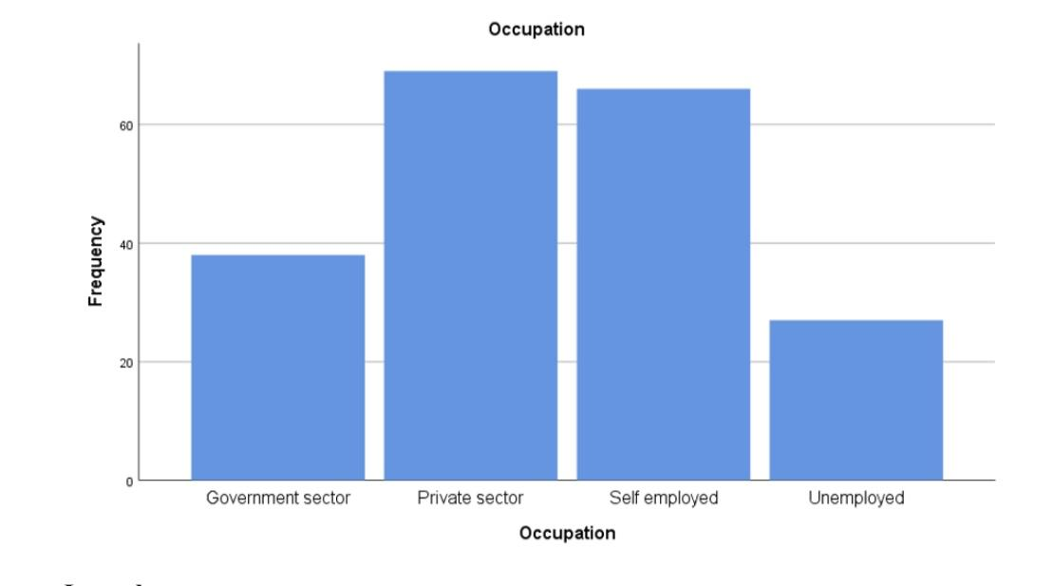
Legend:
The above figure deals about occupation with respect to examination of gender equity and female participation in sports.

Figure 5:
Do you think female participation does have a huge impact in sports?
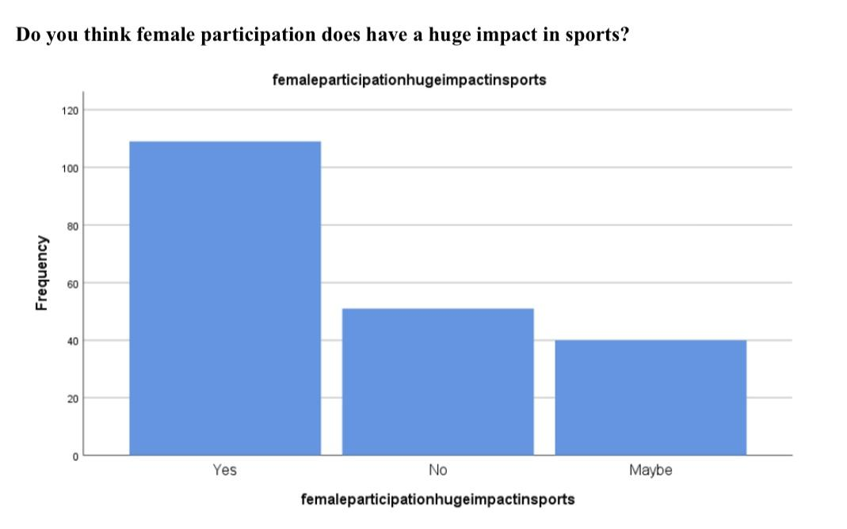
Legend:
The above figure deals with the fact that female participation does have a huge impact in sports . Most of them said yes with respect to this question.

Figure 6 :
Do you think most of the sports in India are masculinised?
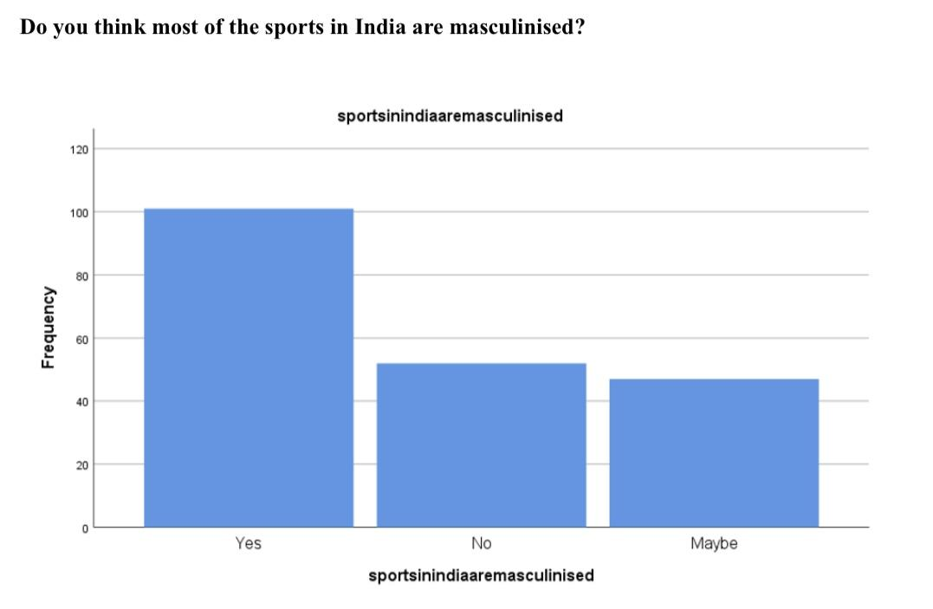
Legend:
The above figure deals with the fact that sports in India are masculinised.Most of them said yes with respect to this question.

Figure 7:
On the scale of 1-10 rate how much does the government show importance to women's sports?
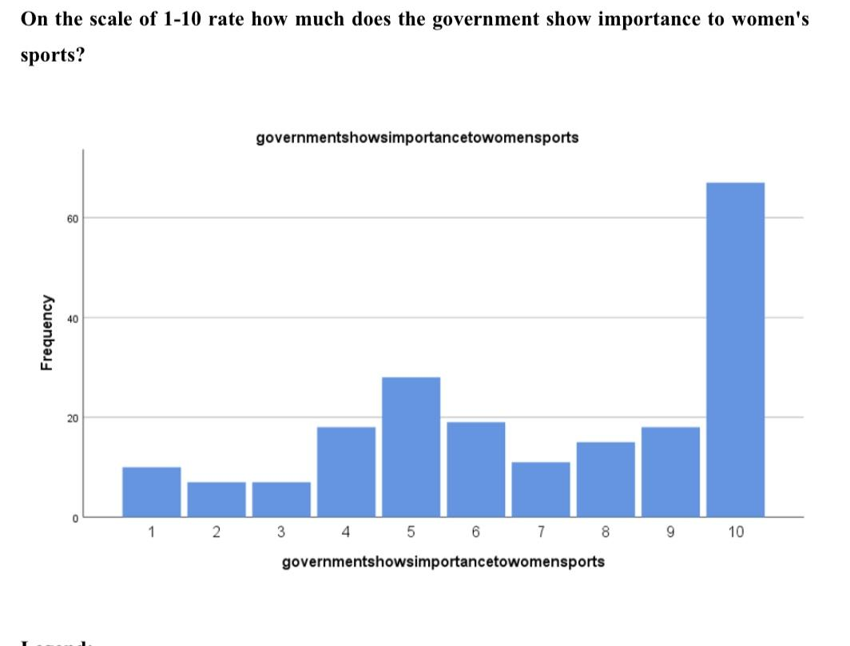

Legend:
The above figure deals with the government showing importance to women's sports.most of them rate 10 with respect to the question.

Figure 8:
Do you agree gender equity exists in coed sports?
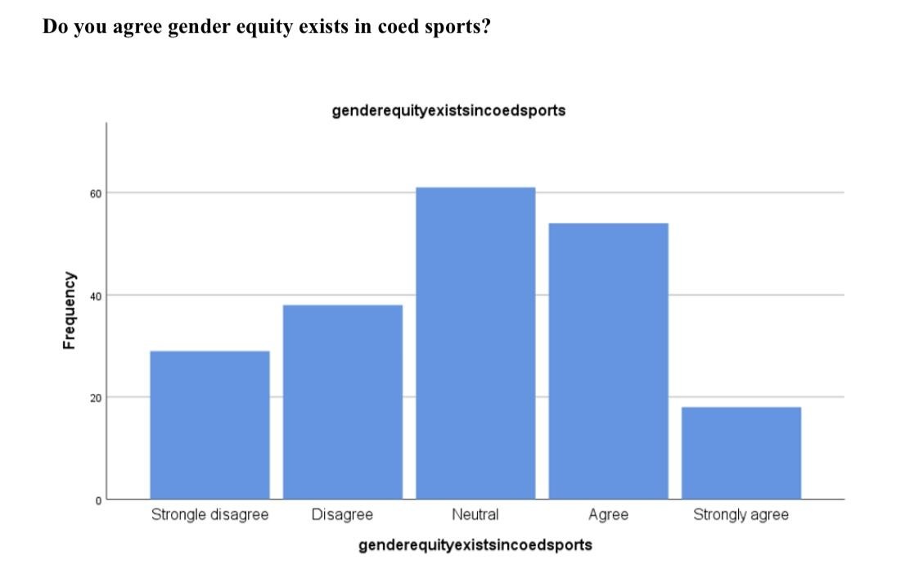
Legend:
The above figure deals about gender equity exists in coed sports.most of them said neutral with respect to this question .

Figure 9:
Do you agree women are being criticised negatively in sports?
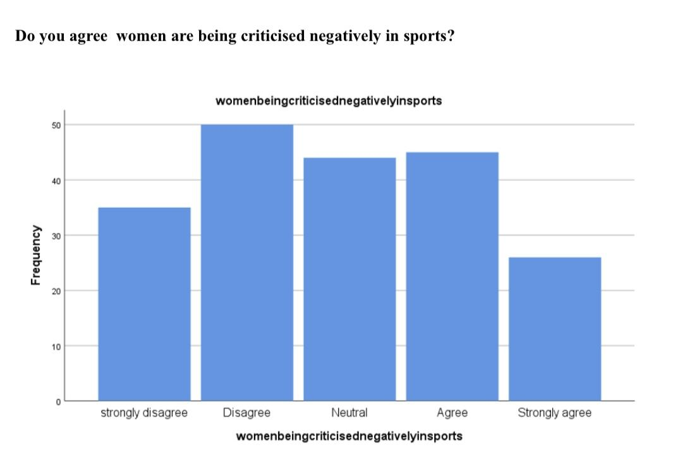
Legend:
The above figure deals with women being criticised negatively in sports. Most of them strongly disagree with this question.

RESULTS:

● In Figure 1 , most of the female respondents compared to male are aware of gender equity and female participation in sports.and totally most of the people have knowledge about this.
● In Figure 2, mostly 19 to 25 age groups of people have knowledge about gender equity and female participation in sports.
● In Figure 3,compared with other graduates most of the UG People have more awareness about gender equity and female participation in sports.
● In Figure 4, private sector people have more knowledge with respect to gender equity and female participation in sports.
● In figure 5,most of the people said yes with respect to the opinion that female participation does have a huge impact in sports .
● In figure 6,Most of them said yes with respect to the sports in India being masculinised.
● In figure 7,most of the people rate 10 with respect to the government showing importance to women's sports.
● In Figure 8,most of the people's suggestion is neutral with respect to the opinion that gender equity still exists in coed sports.
● In figure 9, most people strongly disagree with women being criticised negatively in sports.

DISCUSSION:

From figure 1 we can observe that most of the individuals (female respondents)agreed that they have awareness about gender equity and female participation in sports ,and they said female participation does have a huge impact in sports .
From figure 2 we can observe that most of the individuals (19 to 25) age groups of people agreed that they have knowledge about gender equity and female participation in sports,and they said female participation does have a huge impact in sports .
From figure 3 we can observe that most of the individuals (UG people) agreed that they have awareness about gender equity and female participation in sports.It was observed that they has knowledge about this.
From figure 4 we can observe that most of the individuals (private sector) agreed that they have more knowledge with respect to gender equity and female participation in sports ,and they said female participation does have a huge impact in sports .
From figure 5 we can observe that most of the people said yes with respect to the opinion that female participation does have a huge impact in sports . It was observed that female participation has a huge impact in sports.
From figure 6, we can observe that most of the people said yes with respect to the opinion that the sports in India are being masculinised.It was observed that sports in India are masculinised.
From figure 7, we can observe that most of the people rate 10 with respect to the government showing importance to women's sports. It was observed that the government showed more importance to women's sports.
From figure 8, we can observe that most of the people's suggestions are neutral with respect to the opinion that gender equity still exists in coed sports.It was observed that gender equity is neutral in coed sports.
From figure 9,we can observe that most respondents strongly disagree with women being criticised negatively in sports. It was observed that there was no negative criticism in women's sports.

SUGGESTION:

Understandably, women are less likely to participate in sports towards the end of high school due to the increased recognition of gender norms and derogatory comments received from male peers for wanting to participate in sports, or for being successful at masculine sports. Society needs to stop socially conditioning youth into masculine and feminine roles, and needs to stop ridiculing and underrepresenting women in athletics. Further research could examine the impact of having a female coach of a male sports team on participation by males, and the impact of having a male coach over a female sports team, and also a female to female sports team as well as a male to male sports team to examine the effects on sports participation of having like and opposite gender coaches.

CONCLUSION :

The research indicates gender equity and female participation in sports. However, it appears that women are still faced with gender equity issues in sports governance, athletic media representation, and perception in sports. Therefore, while the opportunity to participate in sports is ever present for women, there is the perception and socially conditioned notion that women should not participate in masculine sports because it makes them appear lesbian and causes them to be ridiculed. However, women athletes that are perceived as beautiful and graceful, are able to get media coverage, but not for their actual athletic abilities, only their appearance. Research shows that sport is still strongly masculine, and strongly in favor of men as the primary controller of sports. It is important to give women equal opportunity in sport governance because gender diverse sport organizations are found to be more successful than those that are all male. Further, in order for women to have true equality in sport, the media will need to begin to recognize women for their athletic ability and not their looks or personal life alone, but also, society will need to move away from the social conditioning of women into gender stereotyped roles and allow for young girls to choose their own path, especially if that includes an interest in sports. Men must begin to see women as equals before women can truly be equals.

LIMITATIONS:
The methodology and the questionnaire designed for this study have several limitations.The present study highlights that unequal salaries, unavailability of sports facilities for women, media misrepresentation, and pressures from the family, are some of the factors limiting the participation of females .

PLAGIARISM :

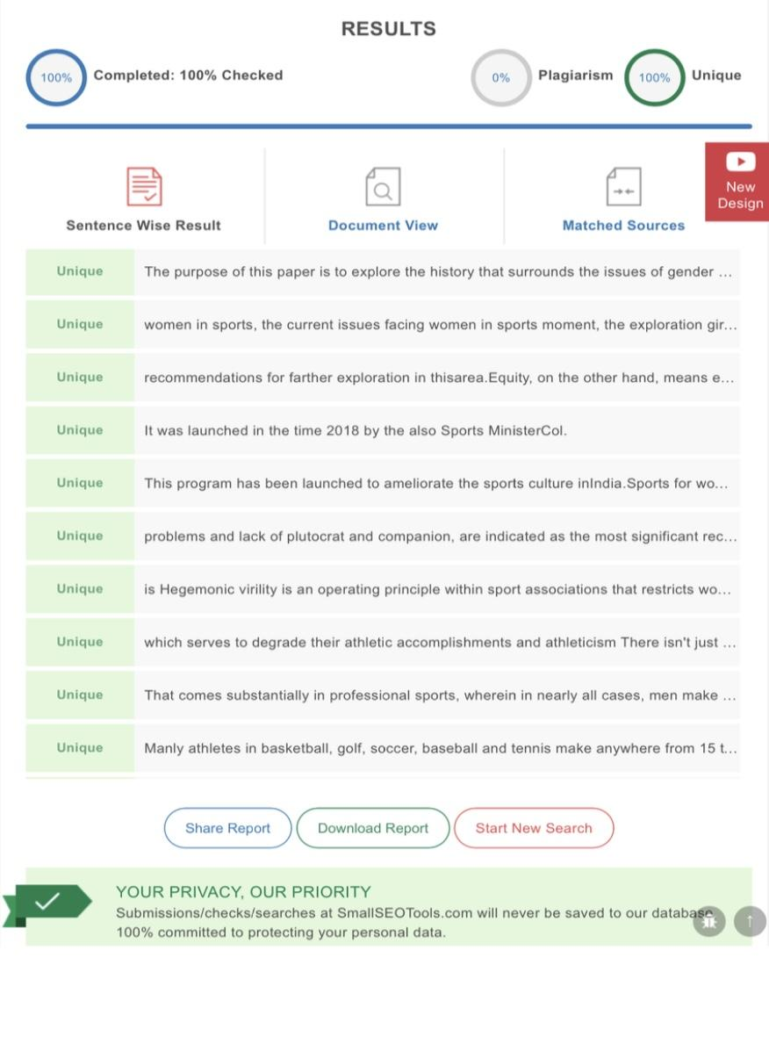
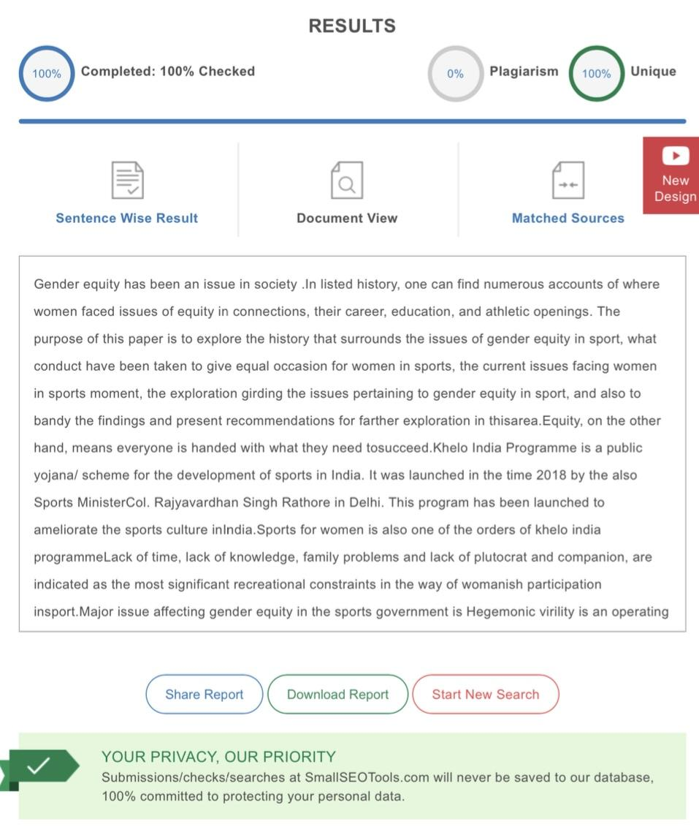

REFERENCES :
1.Capranica, Laura, et al. “The Gender Gap in Sport Performance: Equity Influences Equality.” International Journal of Sports Physiology and Performance, vol. 8, no. 1, Jan. 2013, pp. 99–103.
2.Cunningham, George B. “The Glass Cliff, Gender, and Sport Leadership.” Improving Gender Equity in Sports Coaching, 2021, pp. 11–29, https://doi.org/10.4324/9781003028642-3.
3.De D’Amico, Rosa Lopez, et al. Women and Sport in Asia. Routledge, 2021.
4.Devine, Cathy. “Female Sports Participation, Gender Identity and the British 2010 Equality Act.” Sport, Ethics and Philosophy, 2021, pp. 1–23,
https://doi.org/10.1080/17511321.2021.1993982.
5.Eugene, Alagbu Chukwubuikem, et al. “Perceived Effects of Female Genital Mutilation on
Gender Sports Participation and Performance: Implications to Sports Administration and Management in Nigeria.” Journal of Sports Science, vol. 3, no. 3, 2015, https://doi.org/10.17265/2332-7839/2015.03.005.
6.“Gender Equity.” Encyclopedia of Sports Management and Marketing, 2011, https://doi.org/10.4135/9781412994156.n299.
7.Harvey, Stephen, and Letitia Price. “Barriers and Supports in the Career Trajectories of Graduate-Level Female Sports Coaching Students.” Improving Gender Equity in Sports Coaching, 2021, pp. 70–88, https://doi.org/10.4324/9781003028642-7.
8.Hayhurst, Lyndsay M. C., et al. Sport, Gender and Development: Intersections, Innovations and Future Trajectories. Emerald Group Publishing, 2021.
9.Lopiano, D. A. “Modern History of Women in Sports. Twenty-Five Years of Title IX.” Clinics in Sports Medicine, vol. 19, no. 2, Apr. 2000, pp. 163–73, vii.
10.Norman, Leanne. Improving Gender Equity in Sports Coaching. 2021, https://doi.org/10.4324/9781003028642.
11.Oecd, and OECD. Regional Gender Participation Rates: Asia and Oceania. 2009, https://doi.org/10.1787/reg_glance-2009-graph19_5-en.
12.Pfister, Gertrud, and Ilse Hartmann-Tews. Sport and Women: Social Issues in International Perspective. Routledge, 2005.
13.Rahman, Md Mizanur, et al. “Effects of Attitude, Motivation, and Eagerness for Physical Activity among Middle-Aged and Older Adults.” Journal of Healthcare Engineering, vol. 2020, Aug. 2020, p. 1014891.

14.Roper, Emily A. Gender Relations in Sport. Springer Science & Business Media, 2014. 15.Sidani, Yusuf Munir. “Gaps in Female Labor Participation and Pay Equity: The Impact of Cultural Variables.” Gender in Management: An International Journal, vol. 28, no. 7,
2013, pp. 424–40, https://doi.org/10.1108/gm-11-2012-0089.
16.Soler, Susanna, et al. “Gender-Equity Policies in Sport in Practice.” Improving Gender
Equity in Sports Coaching, 2021, pp. 121–37,
https://doi.org/10.4324/9781003028642-10.
17.Stefani, Raymond T. “The Relative Power Output and Relative Lean Body Mass of World
and Olympic Male and Female Champions with Implications for Gender Equity.” Journal of Sports Sciences, vol. 24, no. 12, 2006, pp. 1329–39, https://doi.org/10.1080/02640410500520559.
18.Tjønndal, Anne. “Gender Equity and Sports Coaching in Norway.” Sports Coaching in Europe, 2021, pp. 76–89, https://doi.org/10.4324/9781003088448-5.
19.Voet, Rian. “Citizenship and Female Participation.” Gender, Participation and Citizenship in the Netherlands, 2019, pp. 11–24, https://doi.org/10.4324/9780429455636-2.
20.Yenilmez, Meltem Ince. “Gender Inequality and Female Sports Participation in Turkey.” Central European Journal of Sport Sciences and Medicine, vol. 33, 2021, pp. 27–41, https://doi.org/10.18276/cej.2021.1-03.

Ms.Dheepiksha.R,3rd year ,BA,LLB(Hons),Saveetha School of Law,Saveetha Institute of Medical and Technical Sciences (SIMATS).
Prof.Dr. Anju Mohan,Professor of law,Saveetha School of Law,Saveetha Institute of Medical and Technical Sciences (SIMATS).

