ECONOMIC ANALYSIS OF A HYBRID PHOTOVOLTAIC-THERMOELECTRIC GENERATOR CONFIGURATION
Sujeet Kumar Ram¹, Rone², Akhilesh Pati Tiwari³
¹Sujeet Kumar Ram Author FCEM College
²Rone, Assistant Professor FCEM College
³Akhilesh Pati Tiwari, Assistant Professor FCEM College

---------------------------------------------------------------------***---------------------------------------------------------------------
Abstract - Current research trend is going on the hybrid systems to enhance the amount of power generation from a single source. The same idea is implemented in the Photo- voltaic/Thermal (PV/T) systems, where the light energy utilized by the PV system to convert it into electrical energy while the heat energy is the source for all the PV/T system configurations. So a simple analysis to predict the module temperature for dif- ferent climatic conditions is required. The module temperature depends on the climatic conditions such as solar irradiation, ambient temperature and wind velocity. These pa- rameters continuously vary non-linearly with respect to time. In this work, used the real time climatic data measured at Nagpur location for the duration of 15 days and proposes a novel approach to find the module temperature by using the Adaptive Neuro Fuzzy Interface System (ANFIS) tool in MATLAB/SIMULINK.
This work majorly concentrates on the Thermoelectric Generator (TEG) integrated with the PV systems and is referred as the PV-TEG. First the simulation for the indi- vidual systems of commercially available PV and TEG systems are made and they are combined to make PV-TEG configuration. This approach is helpful for the commer- cialization of the PV-TEG configuration in effective way. The individual and combined performance of PV-TEG is analyzed with the overall efficiency of the system. The over- all efficiency of PV system is increased by integrating the TEG is 6% at Standard Test Conditions (STC).
.

Key Words: PV-TEG, Thermoelectric generator, Energy conservation, Seebeck effect

1.INTRODUCTION

The development of any nation depends on the per capita power consumption of the nation. Power is one of the major parameter for the nation’s growth. In recent years, all the sectors (industrial, commercial, public) have increased their utilization of electric power due to the technological advancements in the automation industry. The amount of energy generated by the renewable energy sources gain more attention from all the sectors due to its advantages such as clean-green energy, no mechanical rotation parts and an abundant amount of input energy (Singh 2013). In developing countries like India still 17% of rural population do not have access to the electric power. The real time scenario related to the renewable power generation is the motivation to carry out the present research work.
1.2 Energy
The definition of energy in physics terminology is ”The property of matter and radiation which is manifest as a capacity to perform work (such as causing motion or the
interaction of molecules)”.In other words, ”Energy is the capacity for doing work. It may exist in various forms such as potential, kinetic, thermal, electrical, chemical, nuclear, or other forms. In the energy process heat transfer from one body to another. After it has been transferred, energy is always designated according to its nature. Hence, heat transferred may become thermal energy, while work done may manifest itself in the form of mechanical energy”.The Laws of thermodynamics defines the basic behaviour of energy, temperature and entropy. The four laws of thermodynamics clearly describe the characterization of the energy quantities with respect to various circumstances.
The Zeroth Law of Thermodynamics states that ”If two thermodynamic systems are each in thermal equilibrium with a third, then they are in thermal equilibrium with each other”. This law defines the concept of temperature.
The First Law of Thermodynamics is also known as Law of conservation of energy and it states that ”Energy can neither be created nor destroyed; energy can only be
transferred or changed from one form to another”. i.e.,When energy passes as work, as heat, or with matter, in or out from a system, the system’s internal energy changes in accord with the law of conservation of energy.
Second law of thermodynamics indicated the irreversibility of natural processes and states that ”The entropy of an isolated system not in equilibrium will tend to increase over time, approaching a maximum value at equilibrium”. In simple words, the entropy of the universe (the ultimate isolated system) only increases and never decreases. Third law of thermodynamics states that ”As temperature approaches absolute zero, the entropy of a system approaches a constant minimum”. This law defines the concept of entropy. The above mentioned four laws convey the concept of energy behaviour and the nature of temperature process. These laws help in the performance analysis with respect to solar energy studies.

Economic Analysis Of Pv-Teg Configuration

Introduction to Economics
This section gives a clear view of economic aspects of PV/T configurations. The eco- nomic aspects are the major concern for commercialization of any system. The cost of any system is the sum of material cost, production cost, operation and maintenance cost (O and M), interest and depreciation cost. Some of the patented design works came out as a commercialized product in PV/T configurations but many configurations are not yet released by any manufacturer due to the economic validations. In this work, the Levelized Cost of Energy (LCOE) for different PV/T configurations are considered, due to lack of data availability in the investment and O and M costs of PV/T configurations.
The economics in each PV/T configuration is the sum of cost incurred with PV, thermal extraction medium and its configuration designs. The PV system is the major source for generation of electrical energy and the thermal designs supports the PV to enhance its overall efficiency. In major literature works, the economics assessment has been performed for the PV/T configurations by making the sum of assumptions present in the standalone PV systems and the solar thermal system. In this work, the overall cost of PV/T configuration is considered which is the sum of PV cost and the additional thermal extraction cost influenced on the investment, operational and maintenance expenses are clearly specified in the following sub sections.
In this analysis uniform 5kW electrical capacity of all PV/T configurations are con- sidered. The different PV/T configurations have the difference in costs influencing parameters such as front layer cost, back layer cost, extra components cost, Balance of System (BOS) power, BOS area costs and additional components cost. These cost pa- rameters influence the module cost and installation cost of the system. The energy yield and efficiency of the system is sum of electrical and thermal energy extracted/utilized by the PV/T configurations and it influences the LCOE of the system.
The front layer cost includes cost of glass covers on PV surface and it is measured in $/m2. The cell cost is influenced by the type of PV cell i.e.,(PV wafer cost) used in the system which is measured in $/m2 . This cost varies for different silicon wafers. The back layer cost includes the cost of polymer or polymer glass used in the PV mod- ule. The Non-cell module cost includes the cost of encapsulation, cell interconnection, junction box, leads, connectors, nameplate, frame, and its testing and it is measured in $/m2. The extra component cost for PV is zero and for the PV/T systems it varies according to the design configuration and it is measured in $/m2. The O and M cost includes the cost of troubleshooting, repairs, and cleaning considered per year and it is measured in $/kW/m2. The BOS cost, power-scaling includes the cost of inverters and electrical components regardless of physical size and it is measured in $/W. The BOS cost, area-scaling includes the cost of racking, wiring, and installation labour and it is measured in $/m2. The performance of the system analysed with respect to the energy yield and its efficiency. The electrical efficiency of the system is measured at the STC conditions are taken into account and the thermal efficiency varies with respect to the time. The overall efficiency is the sum of electrical and thermal efficiencies per annum and it is expressed in (%). The energy yield in PV/T is the sum of electrical and thermal system. The electrical yield calculated as per the data sheet and its annual degradation. The thermal energy is measured in Btu/hr and it is converted into respective units of kW. The total energy yield of PV/T system is the sum of electrical and thermal energy yields and it is measured in kWh/kW .
In this analysis uniform 5kW electrical capacity of all PV/T configurations are con- sidered. The different PV/T configurations have the difference in costs influencing parameters such as front layer cost, back layer cost, extra components cost, Balance of System (BOS) power, BOS area costs and additional components cost. These cost pa- rameters influence the module cost and installation cost of the system. The energy yield and efficiency of the system is sum of electrical and thermal energy extracted/utilized by the PV/T configurations and it influences the LCOE of the system
The front layer cost includes cost of glass covers on PV surface and it is measured in $/m2. The cell cost is influenced by the type of PV cell i.e.,(PV wafer cost) used in the system which is measured in $/m2 . This cost varies for different silicon wafers. The back layer cost includes the cost of polymer or polymer glass used in the PV mod- ule. The Non-cell module cost includes the cost of encapsulation, cell interconnection, junction box, leads, connectors, nameplate, frame, and its testing and it is measured in $/m2. The extra component cost for PV is zero and for the PV/T systems it varies according to the design configuration and it is measured in $/m2. The O and M cost includes the cost of troubleshooting, repairs, and cleaning considered per year and it is measured in $/kW/m2. The BOS cost, power-scaling includes the cost of inverters and electrical components regardless of physical size and it is measured in $/W. The BOS cost, area-scaling includes the cost of racking, wiring, and installation labor and it is measured in $/m2. The performance of the system analyzed with respect to the energy yield and its efficiency. The electrical efficiency of the system is measured at the STC conditions are taken into account and the thermal efficiency varies with respect to the time. The overall efficiency is the sum of electrical and thermal efficiencies per annum and it is expressed in (%). The energy yield in PV/T is the sum of electrical and thermal system. The electrical yield calculated as per the data sheet and its annual degradation. The thermal energy is measured in Btu/hr and it is converted into respective units of kW. The total energy yield of PV/T system is the sum of electrical and thermal energy yields and it is measured in kWh/kW .
The PV system is considered for all PV/T configurations are multi crystalline silicon PV cell with a glass-polymer back sheet package installed in roof top having a fixed tilt. The cell technology influences the cell cost, efficiency, energy yield, degradation rate and Balance of System (BOS). In the present work, a multi crystalline silicon PV cell is used and it has the efficiency of 18% with a 0.4% depreciation rate. The different PV/T configurations depreciation rate varies with respect to its constructional design configuration.
Economic parameters | Value
Investment cost | 3000 $/kW
Life time | 25 years
Discount rate | 5%
Operational cost | 10 $/kW/year
Maintenance cost | 10 $/kW/year
Depreciation rate | 0.4%/year
The initial cost of the project is applied at the time of starting so the discount rate should not apply for life time. In this analysis, LCOE is considered for a 5kW PV

Table 2.1 Economic aspects of PV system
system having the mean capital, O and M costs taken from the National Renewable Energy Laboratory (NREL) database (LCOE 2018) as shown in Table 2.1 .
The module cost is the sum of all the module components and 15% marginal profit to the manufacturer (shown by 2.2).

Liquid type PV/T configuration
One of the liquid PV/T configuration is shown in Fig. 2.1 (Jin et al. 2017). The investment and O and M cost of liquid PV/T configuration is more than the standalone PV system. This liquid PV/T configuration shown is for a single module system. For a large system like 5kW it requires a bulk water tank, control valves and piping system. So the investment cost increases by 1000 $/kW power generation and operational cost increases by 7 $/kW/year due to control operations. The maintenance cost is increases by 7 $/kW/year due to rusting and damaging of piping and control valve structures. The overall cost of the system increases by 30 to 40% of investment than the standalone PV system. The depreciation rate of liquid PV/T configuration is increased by 0.1% due to it water flow and life of flow structures. The amount of energy extracted from the liquid type PV/T configuration is increased by 20 to 40% depending on the coolant, flow rate and effective maintenance.
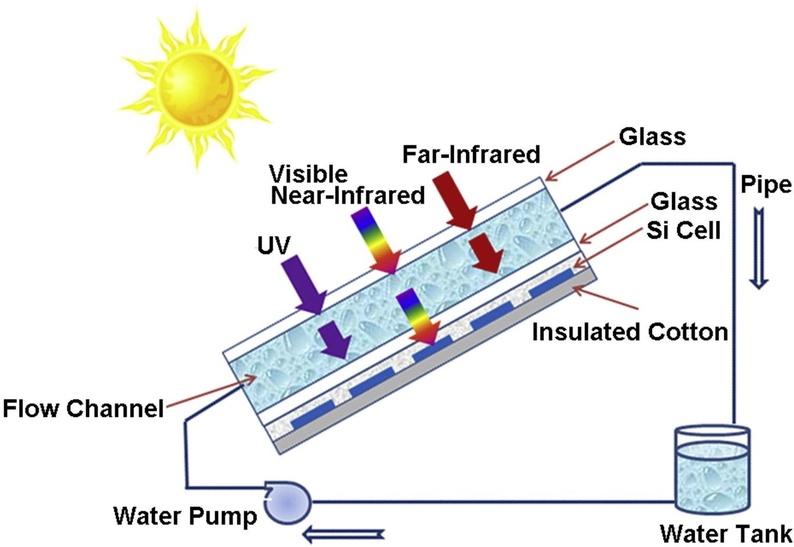
The cost of the liquid type configurations varies depending on its configuration type such as active /passive. The active systems cost 0.1% higher than Fig. 2.1 Active type Liquid PV/T Configuration
the passive systems because of its forced pumping add-ons. The passive configurations works with the
thermosyphon. principle to flow the coolant from tank. This type configurations needs more attention while designing for a particular location. The tilt angle, average temperature and flow pipe diameter, Table 2.2 Assumptions in Economic aspects of liquid type PV/T configurations
varies for different locations. The electrical and thermal energy gain leads to increase in the total useful energy by 15% of standalone PV system.

Air type PV/T configuration
In air type PV/T configuration, active method is the only suitable method to extract the heat from the module. But in the active air there are two types of configurations which are more popular
    - Single pass Air PV/T Configuration
    - Dual pass Air PV/T Configuration
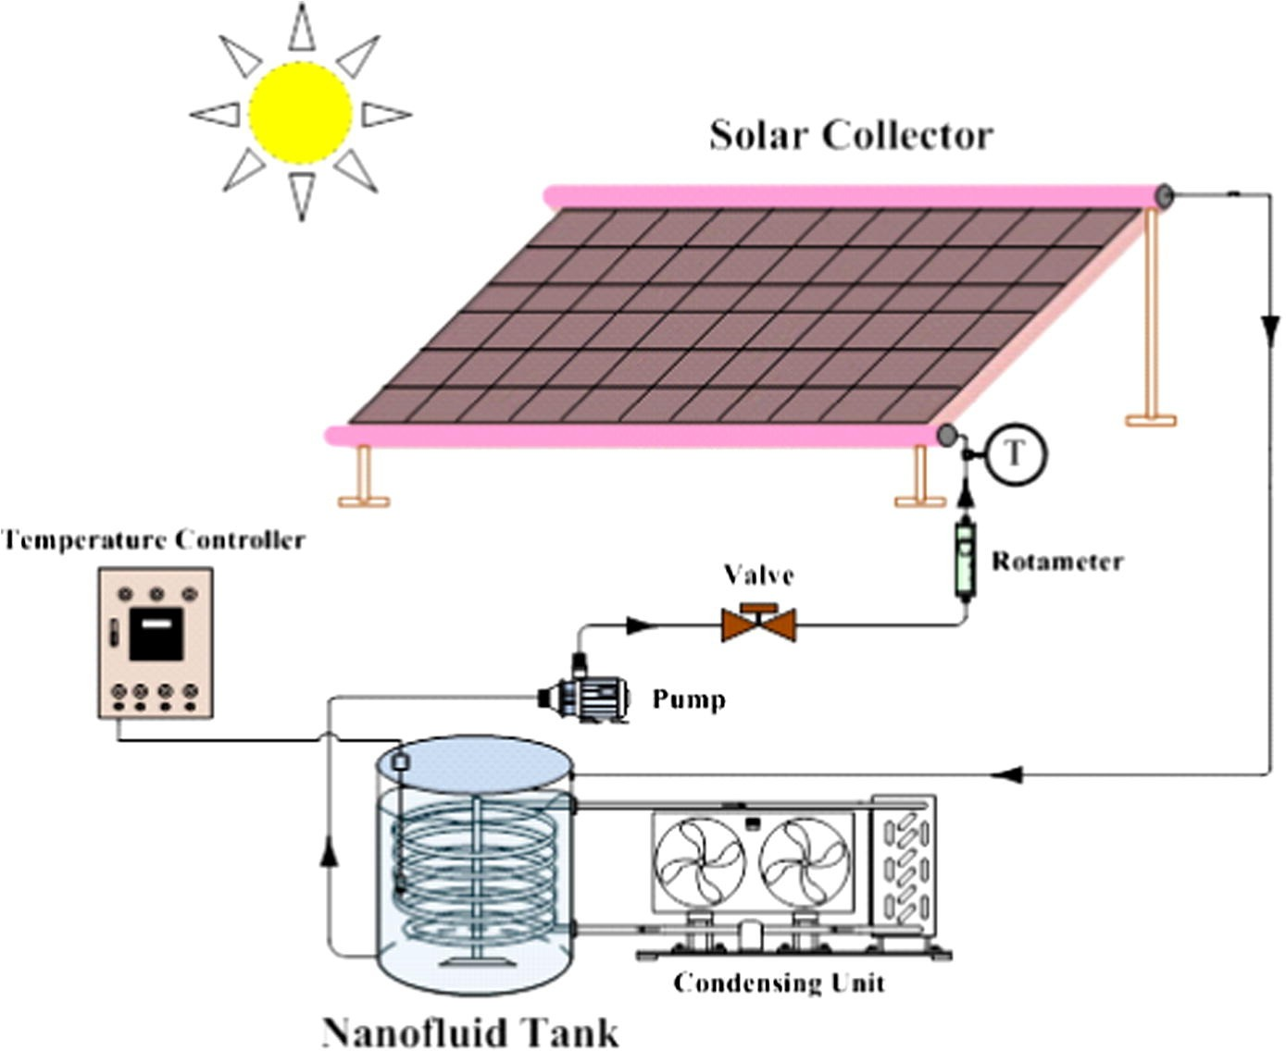
The Figure 2.2 (Aste et al. 2008) shows the active single pass system. The cost of single pass and dual pass varies very slightly in the aspects of investment, and O and M depends upon the storage. In the single pass or dual pass, one blower is needed to force the air in side PV layers. In a single pass the hot air is collected at another end by a reservoir but in the dual pass the air gets IN in one layer and comes OUT in another layer. So the designs are made to collect the hot air in the same end. The investment cost of the system increases by 0.1% due to the air compression storage. This cost is excluded in the case of non-storage configurations. The life span of this configuration is higher than the liquid type system. The degradation rate is also same as the PV because it doesnt impact on any physical parts like liquid type. The maintenance cost is high for the storage based configurations than the non-storage configurations.
The air type PV/T configuration is mainly used for the hot air applications such as space heating, agriculture drying. In some air type configurations like space heat- ing, it needs the hot air storage and some configurations doesnt need any storage like agriculture drying. The cost varies with respect to the hot air storage. The assumptions considered in economic aspects of air type PV/T configurations are shown in Table 5.4.
  - Nano fluid based PV/T configuration
The Nano fluid based PV/T configuration is the advanced method in extracting the heat from the module. In this configuration Nano fluids such as Al2O3, CuO, Graphite, Carbon nanotube(CNT), TiO2 and Cu are mixed with the base fluids such as water, oil, and acetone are used to flow by means of external force in the system which is shown in Fig. 2.3 (Mahian et al. 2014). The cost of Nano fluids depends upon the particle size and fraction of mix of particles. So the investment cost of this configuration is higher than the liquid and air type configurations. But the amount of energy extraction by using Nano fluid is 10% higher than the liquid/ air type configurations because of the
Economic Parameters | Value
Economic Parameters | Active | Passive
Investment cost | 4400$/kW | 4000$/kW
Life time | 25 years | 25 years
Discount rate | 5% | 5%
Operational cost | 18$/kW/year | 17$/kW/year
Maintenance cost | 18$/kW/year | 17$/kW/year
Depreciation rate | 0.5%/year | 0.5%/year
Energy gain | 18% | 15%
Table 2.2

Table 2.3 Assumptions in Economic Aspects of Air type
Economic Parameters | Value
Economic Parameters | Active | Passive
Investment cost | 4400$/kW | 4000$/kW
Life time | 30 years | 30 years
Discount rate | 5% | 5%
Operational cost | 15$/kW/year | 15$/kW/year
Maintenance cost | 15$/kW/year | 15$/kW/year
Depreciation rate | 0.4%/year | 0.4%/year
Energy gain | 22% | 18%

Table 2.4 Assumptions in Economic Aspects of Nano Fluid based PV/T Configuration
Economic Parameters | Value
Investment cost | 4500$/kW
Life time | 25 years
Discount rate | 5%
Operational cost | 15$/kW/year
Maintenance cost | 15$/kW/year
Depreciation rate | 0.4%/year
Energy gain | 20%

Nano fluid properties. The Operation and maintenance of the Nano fluid configuration is same as the storage based air type PV/T. The life time of this system depends on the degradation of Nano fluid properties.
The Nano Fluid based PV/T configurations are suitable for the thermal applications to enhance the quality of heat extraction than the liquid and air type configurations. In recent years the Nano fluids plays a vital role in the applications of solar stills and fuel cells.The assumptions considered in economic aspects of Nano fluid based PV/T configuration.

PCM based PV/T configuration
The PCM based PV/T configuration uses the Phase Change Materials to store the ther- mal energy. There are two types of PCM which are available in the market they are or- ganic and inorganic. In the recent years organic based PCM such as Rubitherm RT20, RT21, RT25, RT27, RT31, RT35, RT42, RT44, RT60, RT10HC, RT18HC. RT25HC,
RT35HC , SP220A, Walksol A, and Calcium chloride hexahydrate are used. The in- vestment cost of PCM based PV/T configuration is high because of the closed loop control design of PCM flow, storage structures and safety measures. The operational cost is same as the PV system but the Maintenance cost increases due to the constant requirement of replacement of PCM, and regular inspection of the system flow. The life time of the PCM based PV/T is high as there is no dynamic operations in the system. One of the PCM based PV/T configuration is shown Fig. 5.4 (Hasan et al. 2015).
Economic Parameters | Value
Investment cost | 3300$/kW
Life time | 30 years
Discount rate | 5%
Operational cost | 11$/kW/year
Maintenance cost | 11$/kW/year
Depreciation rate | 0.4%/year
Energy gain | 15%
Table 2.6 Assumptions in Economic Aspects of PCM based PV/T Configuration

Table 2..7 Assumptions in Economic Aspects of TEG based PV/T Configuration
Economic Parameters | Value
Investment cost | 4500$/kW
Life time | 25 years
Discount rate | 5%
Operational cost | 12$/kW/year
Maintenance cost | 16$/kW/year
Depreciation rate | 0.5%/year
Energy gain | 12%

TEG based PV/T configuration (PV-TEG)
The TEG integrated PV is most simple configuration than all other configurations listed above because it doesnt have any dynamic controls and complex closed loop systems. All the energy conversion process are basic principles of photon and heat conversion without any external forces. The additional investment cost for this configuration is the one incurred by Thermoelectric Generators. There is no need of any additional operational and maintenance cost for TEG. The life time of TEG is about 30 years and the degradation rate is low.
The flat plate PV-TEG configuration has more feasibility for the roof top power gen- eration applications than the PCM, Nano Fluid based PV/T systems. The assumptions considered in economic aspects of TEG based PV/T configurations is shown in Table 2.7

Conclusion
In the proposed work, PV module temperature is estimated with the Adaptive Neuro Fuzzy Interface System. The results shows that, climatic data input fed prediction is more suitable for the module temperature estimation rather than the photovoltaic out- put data. The simulations are run for the two different time periods. For two months data training, the minimum RMSE for the proposed ANFIS model is 1.719939 which is 45.61% less error than the existing ANFIS model. For one year data training, the minimum RMSE for the proposed ANFIS model is 2.747 which is 15.09% lesser than the existing ANFIS model. In this work, done the mathematical simulation of commer- cially available PV and TEG modules. The higlighted results with respect to change of irradiation and ambient temperature. The change in irradiance directly impacts the amount of power generated by TEG and it is around 5% of its rating.TEG contributes around 2 to 7% increase in power generated when the ambient temperature changes from 100C to 500C, with a constant irradiance of 1000W/m2. The total power gen- erated by the PV-TEG configuration is compared with standalone PV system and it is found that there is increase in 8.3% of generated power at the STC conditions.The Multi crystalline fed PV-TEG configuration produces additional energy of 1.3% with an ef- ficiency of 24% as compared with other crystalline PV systems. The electrical output of PV-TEG configuration for a real time climatic data (measured for 15 days) is 7.68% highter than the standalone PV system.
In the view of commercialization, considered the economic analysis of PV/T con- figurations by using the standard calculating tool Levelized cost of energy (LCOE). In this economic analysis, 5 popular PV/T configurations are considered which are i) Liquid type PV/T, ii) Air type PV/T, iii) Nano fluid based PV/T, iv) PCM based PV/T, and v) TEG based PV/T (PV-TEG). The LCOE of proposed PV-TEG configuration is 8.71% higher than the standalone PV system and it is the least LCOE as compared with other PV/T system configurations. The LCOE of the all PTS configurations in- creases from 8.7% to 90% as compared to standalone PV system.The module cost per watt power generation for the proposed PV-TEG is 0.55% higher than the standalone
PV system.The energy gain by the PTS configurations is 10% to 50% as compared to standalone PV system. These metric shows the cost per unit generation is increases by 3% to 12% for the PV/T configurations.

REFERENCES

- Agrawal, S. (2011), ‘Experimental validation of glazed hybrid micro-channel solar cell thermal tile’, Solar Energy 85(11), 3046–3056.
- Al-Shohani, W. A., Sabouri, A., Al-Dadah, R., Mahmoud, S. and Butt, H. (2016), ‘Ex- perimental investigation of an optical water filter for photovoltaic/thermal conversion module’, Energy conversion and management 111, 431–442.
- Amori, K. E., Abd-AlRaheem and Mustafa, A. (2014), ‘Field study of various air based photovoltaic/thermal hybrid solar collectors’, Renewable Energy 63, 402–414.
- Anderson, T. N., Duke, M., Morrison, G. and Carson, J. K. (2009), ‘Performance of a building integrated photovoltaic/thermal (bipvt) solar collector’, Solar Energy 83(4), 445–455.
- Aste, N., Chiesa, G. and Verri, F. (2008), ‘Design, development and performance moni- toring of a photovoltaic-thermal (pvt) air collector’, Renewable energy 33(5), 914–927.
- Attivissimo, F., Di Nisio, A., Lanzolla, A. M. L. and Paul, M. (2015), ‘Feasibility of a photovoltaic–thermoelectric generator: performance analysis and simulation results’, IEEE Transactions on Instrumentation and Measurement 64(5), 1158–1169.
- Babu, T. S., Ram, J. P., Sangeetha, K., Laudani, A. and Rajasekar, N. (2016), ‘Param- eter extraction of two diode solar pv model using fireworks algorithm’, Solar Energy 140, 265–276
- Bahaidarah, H. M., Baloch, A. A. and Gandhidasan, P. (2016), ‘Uniform cooling of photovoltaic panels: A review’, Renewable and Sustainable Energy Reviews 57, 1520– 1544.
- Bjørk, R. and Nielsen, K. K. (2015), ‘The performance of a combined solar photovoltaic (pv) and thermoelectric generator (teg) system’, Solar Energy 120, 187–194.
- BP (2017), ‘Energy data’.URL: https://www.bp.com/en/global/corporate/energy-economics/statistical-review- of-world-energy.html
- Buker, M. S., Mempouo, B. and Riffat, S. B. (2015), ‘Experimental investigation of a building integrated photovoltaic/thermal roof collector combined with a liquid desiccant enhanced indirect evaporative cooling system’, Energy conversion and management 101, 239–254.
- Buonomano, A., De Luca, G., Figaj, R. D. and Vanoli, L. (2015), ‘Dynamic simulation and thermo-economic analysis of a photovoltaic/thermal collector heating system for an indoor–outdoor swimming pool’, Energy conversion and management 99, 176–192.
- Cha´vez Urbiola, E. A. and Vorobiev, Y. (2013), ‘Investigation of solar hybrid elec- tric/thermal system with radiation concentrator and thermoelectric generator’, Interna- tional Journal of Photoenergy 2013.
- Cha´vez-Urbiola, E., Vorobiev, Y. V. and Bulat, L. (2012), ‘Solar hybrid systems with thermoelectric generators’, Solar energy 86(1), 369–378.
- Chemisana, D., Iba´n˜ez, M. and Rosell, J. (2011), ‘Characterization of a photovoltaic- thermal module for fresnel linear concentrator’, Energy conversion and management 52(10), 3234–3240.
- Chow, T., Ji, J. and He, W. (2007), ‘Photovoltaic-thermal collector system for domestic application’, Journal of solar energy engineering 129(2), 205–209.
- Chow, T. T., Pei, G., Fong, K., Lin, Z., Chan, A. and Ji, J. (2009), ‘Energy and ex- ergy analysis of photovoltaic–thermal collector with and without glass cover’, Applied Energy 86(3), 310–316.
- Cotfas, D. T., Cotfas, P. A., Machidon, O. and Ciobanu, D. (2016), Investigation of the photovoltaic cell/thermoelectric element hybrid system performance, in ‘IOP Confer- ence Series: Materials Science and Engineering’, Vol. 133, IOP Publishing, p. 012037.
- Coventry, J. S. (2005), ‘Performance of a concentrating photovoltaic/thermal solar col- lector’, Solar energy 78(2), 211–222.
- Cristofari, C., Canaletti, J. and Notton, G. (2011), Patented twintex hybrid pv/t col- lector: Level of performances and comparison with thermal solar collector, in ‘2011 International Conference and Utility Exhibition on Power and Energy Systems: Issues and Prospects for Asia (ICUE)’, IEEE, pp. 1–7.
- Cui, T., Xuan, Y. and Li, Q. (2016), ‘Design of a novel concentrating photovoltaic– thermoelectric system incorporated with phase change materials’, Energy Conversion and Management 112, 49–60.
- Dallan, B. S., Schumann, J. and Lesage, F. J. (2015), ‘Performance evaluation of a photoelectric–thermoelectric cogeneration hybrid system’, Solar Energy 118, 276–285.
- Deng, Y., Zhu, W., Wang, Y. and Shi, Y. (2013), ‘Enhanced performance of solar- driven photovoltaic–thermoelectric hybrid system in an integrated design’, Solar energy 88, 182–191.
- Dimri, N., Tiwari, A. and Tiwari, G. (2017), ‘Thermal modelling of semitransparent photovoltaic thermal (pvt) with thermoelectric cooler (tec) collector’, Energy Conver- sion and Management 146, 68–77.
- DiOrio, N. A., Blair, N. J., Freeman, J. M., Habte, A. M., Elgqvist, E. M., Deceglie,
- M. G., Jordan, D., DiOrio, N. A., Blair, N. J., Freeman, J. M. et al. (2018), Solar system modeling at nrel, Technical report, National Renewable Energy Lab.(NREL), Golden, CO (United States).
- Du, D., Darkwa, J. and Kokogiannakis, G. (2014), Numerical modeling and simula- tion of an integrated teg/pcm system for the enhancement of pv power output, in ‘12th International Energy Conversion Engineering Conference’, p. 3970.
- Dutreuil, J. A. and Hadim, H. A. (2011), Design parameters for high-efficiency hybrid pv/thermal solar energy systems, in ‘ASME/JSME 2011 8th Thermal Engineering Joint Conference’, American Society of Mechanical Engineers, pp. T20070–T20070.
- Dzib, J. T., Moo, E. A., Bassam, A., Flota-Ban˜uelos, M., Soberanis, M. E., Ricalde, L. J. and Lo´pez-Sa´nchez, M. J. (2016), Photovoltaic module temperature estimation: a com- parison between artificial neural networks and adaptive neuro fuzzy inference systems models, in ‘International Symposium on Intelligent Computing Systems’, Springer, pp. 46–60
- El Chaar, L., El Zein, N. et al. (2011), ‘Review of photovoltaic technologies’, Renew- able and sustainable energy reviews 15(5), 2165–2175.
- Gang, P., Huide, F., Jie, J., Tin-Tai, C. and Tao, Z. (2012), ‘Annual analysis of heat pipe pv/t systems for domestic hot water and electricity production’, Energy Conversion and Management 56, 8–21.
- Good, C. (2016), ‘Environmental impact assessments of hybrid photovoltaic–thermal (pv/t) systems–a review’, Renewable and Sustainable Energy Reviews 55, 234–239

