SOLAR ELECTRIC VEHICLE
SIVASANKARAN.S, SUBASH.M ,POOVARASAN.P ,UMAR FAROOK.N
N.VENKATRAMAN ME,(AP/EEE)
Undergraduate AND Assistant Professor Department of Electrical and Electronics Engineering.
AVS Engineering College

ABSTRACT:
The overall objective of the project is to design and fabricate a solar powered electric vehicle. The objective of the project thus far was to produce a detailed first iteration design with planning materials. The vehicle is to adhere to the engineering guidelines stated for the Shell Eco Marathon Urban Division competition. The competition does not require the use of a solar module, but this project will incorporate the use of solar energy to charge the

vehicle battery. This competition is based on efficiency; therefore, energy efficiency will be of higher priority.
Other major constraints on the project were the time and budget. To accomplish this goal, subsystems such as the frame, drivetrain, power, suspension, and steering, were designed individually and integrated into a master assembly model. SolidWorks, a computer aided design (CAD), software was used for design and modeling, as well as finite element analysis (FEA). Secondary support software such as Excel, Vsusp, and solar analyzing software were used to assist in the planning of the various subsystems as well as data collection and assortment. Subsystems that were modeled and analyzed through quantitative methods were purchased and fabricated. Subsystems that did not complete the design and analysis phase were not constructed. Further analysis is required to move these subsystems forward. In the future, optimization and new subsystem configurations should be prioritized. This project concluded with the first iteration of what will someday be a Shell Eco-marathon competition vehicle.
Keywords: CAD, Competition vehicle, Design, Engineering, Electric Vehicle, FEA, Solar, Solar Energy, Shell Eco-marathon, Vehicle Subsystem .
INTRODUCTION:
Currently, one of the greatest engineering issues to tackle is the need for clean energy sources. Much of the world is highly dependent on natural gases and coal to produce electricity. Although this power source is abundant, it is shown to assist in global warming. Furthermore, extraction methods such as fracking are shown to have detrimental effect on the environment, namely earthquakes. One source of energy being heavily studied is solar energy. Until recently, the efficiency of the solar panels, used in collection of solar energy, was too low for it to be a viable option for replacing energy obtained from fossil fuels. Advances in materials has paved the way for using solar energy as a renewable resource that is slowly meeting the energy demands that society has become accustomed to. According to the EPA, transportation accounted for 26% of the total Greenhouse Gas emissions in the year 2014 [1]. For this project, the concept of a solar vehicle will be designed and fabricated. Vehicles have already been modified to run on alternative sources for fuel, so for this project, an urban application solar car will be designed under specifications for the Shell Eco marathon Urban Concept Battery Electric competition. The project is focused on the design of an electric driven vehicle that can regenerate power using solar energy technology. If this type of vehicle became a standard commercial vehicle, the demand for fuel would decrease substantially. Designing this vehicle for practicality is the primary difficulty.
LITERATURE SURVEY
2.1) INTRODUCTION
In this section, we would be discussing briefly on various literatures.
available pertaining to designing of smart and low-cost E-vehicle.
for individual transportation.

2.2)LITERATURESURVEY

fuels, SEVs have emerged as a potential gamechanger in the automotive industry. By integrating solar panels onto vehicles, SEVs can harness the abundant and clean energy from the sun to power electric propulsion systems. This symbiotic relationship between solar power and electric vehicles offers numerous advantages, including reduced carbon emissions, enhanced energy efficiency, and increased energy autonomy. The concept of SEVs has gained significant attention in recent years, prompting extensive research and development efforts worldwide. This literature survey aims to provide an overview of the existing body of knowledge on SEVs, highlighting key findings, technological advancements, and research trends. By examining the current state of research, this survey seeks to identify knowledge gaps and areas that require further investigation, ultimately contributing to the advancement and adoption of solar electric vehicle (SEV).
3)EXISTING SYSTEM:
The existing system is a fixed solar panel. These Solar panels convert the solar energy into electrical energy. There is a key component of the solar panel system. Most commonly available panels of today are either poly-crystalline or mono- crystalline solar panels [6]. The cells in solar panels collect the solar energy and turn it into direct current (DC) electricity.
4)METHODOLOGY
Solar power has increasingly become popular over the past years. With its uncountable improvement and cost-
effective ways, more and more people are opting to switch over to solar energy rather than their regular form of energy. Solar charging is based on the use of solar panels for converting light energy into electrical energy (DC). The dc voltage can be stored at battery bank. There are reverses charging protection circuit which is provided for the backflow of energy from the battery to a solar panel. To control the motor, we have used dual tone multiple frequency (DTMF) and motor driver(L293D) which controls the vehicle as seen in figure.1. To measure battery voltage, a voltage sensor is used. The battery voltage is measured by microcontroller, it will also display battery low status, whenever battery voltage falls below a certain level.
PROPOSED SYSTEM:
In the designed vehicle, solar panel is used as the power source and developed voltage, stored in the battery, is used to the drive the permanent magnet DC motor which drives the rear wheel of the vehicle.
PROPOSED SYSTEM BLOCK DIAGRAM
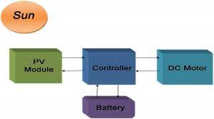

WORKING:
The block diagram hybrid bicycle driven by DC motor fitted on middle shaft of bicycle & operated by battery energy shown in fig1. The solar panel mounted on carriage. Solar panel generates 12v power when sun light falls on it and its terminals are connected to charge controller.
Dynamo (motor) is mounted on side shaft of bicycle, supports in such a manner that dynamo shaft is touching the back wheel tyres. As wheel rotates dynamo shaft rotates and generates 12V power. Its terminals are also connected to charge controller.
When the bicycle is idle in day time, the solar panel will charge the battery. Due to non-uniform sunlight and varying in wheel speed, output voltage from both solar panel and dynamo is varying in nature. Charge controller adjusts the constant voltage of 12 volt and charges the battery.
The power flow acts in parallel with the power delivered by the rider via the pedaling. The rider of an solar bicycle can opt the motor completely or pedaling (as in conventional bicycle).

MODEL DIAGRAM:
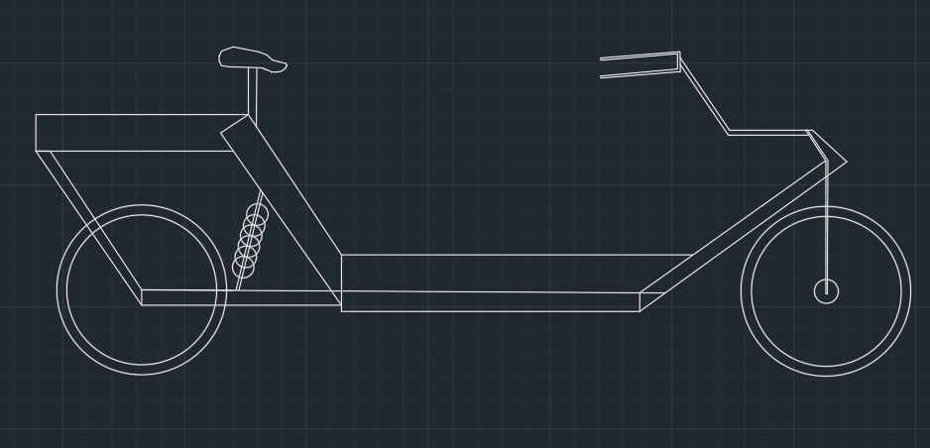

CONCLUSION
In conclusion, solar electric vehicle projects represent a promising avenue for sustainable transportation and reducing reliance on fossil fuels. While there are limitations and challenges to overcome, ongoing research, development, and innovation in solar panel technology, energy storage, vehicle integration, and infrastructure can address these issues and enhance the viability of solar electric vehicles. Solar electric vehicles have the potential to contribute to reduced greenhouse gas emissions, improved energy efficiency, and decreased reliance on traditional charging infrastructure. They offer the benefits of utilizing renewable solar energy and reducing operating costs for vehicle owners. However, it's important to recognize that solar energy alone maynot provide a complete solution for long-range or heavy-duty transportation needs.
REFERENCES
1. Deepak Mohanraj, Ranjeev Aruldavid, Rajesh Verma, K. Sathiyasekar,
Abdulwasa B. Barnawi, Bharatiraja Chokkalingam, (Senior Member, IEEE),
And Lucian Mihet-popa, (Senior Member, IEEE) “A review of BLDC motor:
state of art, advanced control techniques, and applications”, Received March
20, 2022, accepted May 9, 2022, date of publication May 13, 2022, date of
current version May 27, 2022. Digital Object Identifier
10.1109/ACCESS.2022.3175011
2. Ching-lon Huang, (Student Member, IEEE), Feng-chi Lee, Chia-jung Liu,
Jyun-you Chen, (Student Member, IEEE), Yi-jen Lin, (Graduate Student
Member, IEEE), And Shih-chin Yang, (Senior Member, IEEE), “Torque ripple
reduction for BLDC permanent magnet motor drive using dc-link voltage and
current modulation”, Received March 28, 2022, accepted April 20, 2022, date
of publication May 9, 2022, date of current version May 18, 2022. Digital
Object Identifier 10.1109/ACCESS.2022.3173325

