Enhancing Voice Assistants with Generative AI Language Models for Interactive Conversations
Shivam Hajong, Techi Dol, Kipa Peter *Biswajit Das, Sonali Mondal
Department of Computer Science, Arunachal University of Studies, Namsai, Arunachal Pradesh, India
*Corresponding author E-mail: biswajit195313@gmail.com, sonali.mondal20387@gmail.com

---------------------------------------------------------------------***---------------------------------------------------------------------
Abstract - This paper presents comprehensive research for the development of a voice assistant application using HTML/CSS, JavaScript, Python, SQLite, and the Hugging Face API. The proposed methodology encompasses key steps in data collection, model training, frontend and backend development, integration, testing, and deployment, ensuring the creation of a robust and user-friendly voice assistant system. By leveraging a combination of web technologies and Al tools, the developed voice assistant application offers an interactive and intelligent user experience across its users.

Key Words: Voice assistant, HTML/CSS, JavaScript, Python, SQLite, Hugging Face API, LLMs, AI.

1.INTRODUCTION

In modern era, with the fast-paced development of computer technologies, lifestyle of people has changed a lot when it comes to searching for any information or solution to any problems in their day-to-day life. Now people can get answers to their questions with simple search using search engines or using inbuilt voice assistant that comes with various digital devices nowadays. For examples Google's voice assistant that come inbuilt with Android devices, Apple's Siri voice assistant that comes with iPhones, Microsoft's Cortana that comes with Windows OS and other specific voice assistant speakers such as Alexa from Amazon. These voice assistants are designed to respond to human languages using natural language processing modules of deep learning models. Overall, Voice assistant technology has gained widespread adoption in recent years, revolutionizing the way users interact with digital devices and services. In this paper, we outline a methodology for the development of a voice assistant application that integrates seamlessly with web-based interfaces using HTML/CSS, JavaScript for frontend development, Python for backend functionality, SQLite for database modeling, and the Hugging Face API for generative Al capabilities. The proposed methodology aims to provide a structured approach to building a versatile and efficient voice assistant application that meets user needs and expectations.

2. LITERATURE REVIEW
literature review provides a brief overview of key research contributions and technological innovations that have shaped the evolution of voice assistants, spanning from early experiments to current futuristic systems in use.
Early research in the field of speech recognition that laid the foundation for voice assistant software dates back to the 1950s and 1960s. Early systems, such as IBM's Shoebox and Bell Labs' Audrey, demonstrated the feasibility of converting spoken language into text using initial pattern recognition techniques but these systems were limited in vocabulary size and accuracy, restricting their practical utility [1].
In 1990 the approach of statistical modelling and machine learning techniques marked a leap ahead in speech recognition research. Hidden Markov Models (HMMS) and Gaussian Mixture Models (GMMs) enabled more robust and scalable speech recognition systems, leading to commercial applications in automated phone systems and dictation software.[2]
In recent time, the development of deep learning algorithms, particularly Convolutional Neural Networks (CNNS) and Recurrent Neural Networks (RNNS), has revolutionized the field of natural language processing and voice recognition. Deep learning approaches have demonstrated superior performance in speech recognition tasks, surpassing the accuracy of conventional statistical methods.[3]
Moreover, cloud computing infrastructure and advancement in distributed computing have played a crucial role in the scalability and accessibility of voice assistant technologies. Cloud-based voice recognition services, such as Google Cloud Speech-to-Text and Amazon Transcribe, provide developers with scalable and cost-effective solutions for integrating speech recognition capabilities into their applications.
Overall, the development of voice assistant technologies has gone through incredible evolution, driven by advancements in Al, natural language processing, and human-computer interaction. From early experiments in speech recognition to current futuristic systems powered by deep learning and cloud computing.
3. OBJECTIVES
•Develop a voice assistant application capable of understanding user commands and responding with relevant information or performing specified tasks.
•Integrate the voice assistant seamlessly with web-based interfaces, allowing users to interact with the application across various devices and platforms.
•Utilize generative Al capabilities provided by the Hugging Face API to enhance the natural language understanding and response generation capabilities of the voice assistant.
•Implement backend functionality using Python to handle user requests, process data, and interact with external APIs and databases.
•Utilize SQLite for database modeling to store user preferences, session data, and other relevant information securely.
4. PROJECT DESCRIPTION
The aim of this project is to develop a smart voice assistant using Hugging Face API as a core response generator to user queries. Hugging Face is an opensource research and development community in the field of artificial intelligence and machine learning. It specifically focuses on training LLMs (Large language Models) which are basically pre-trained generative AI chatbots that can generate personalized responses to specific user queries, based on the large amount of data that it has been trained with. Hugging Face have its own chatbot interface called Hugging Chat that has a great feature for user to switch between different LLMs such as Google’s Gemini, Meta’s AI model and many more. We will integrate the Hugging Chat into our own voice assistant in the backend to redirect the user query to generate adequate responses which will occur as a verbal output in our own assistant.
Python programming will be used for the processing of the input and output of the user queries along with linking the frontend with the backend. Specific modules of the Python libraries will be used for different purposes. A module called “eel” will be used to link the frontend interface made using HTML, CSS and JavaScript with the backend processing done using Python. For natural language processing (NLP) or in other word recognizing user speech we will be using Pythons own “speech recognition” module and also “pyttsx3” module for text to speech conversion of queries and responses. Additionally, we will use SQLite for database modeling to design and implement database schemas for storing user preferences, session data, and to implement opening applications such as web browsers and YouTube.

5. METHODOLOGY
5.1 Data Collection:
Implementing diverse dataset of user commands, questions, and responses relevant to the intended functionalities of the voice assistant application.
5.2 Model Training:
Utilizing the Hugging Face API which is similar to the option such as OpenAI to train a generative Al model on the collected dataset to improve the natural language understanding and response generation capabilities of the voice assistant.
5.3 Frontend Development:
The frontend of the voice assistant application uses HTML/CSS and JavaScript to create an intuitive and user-friendly interface for interacting with the voice assistant.
5.4 Backend Development:
Designing backend functionality using Python to handle user requests, process data, and interact with external APIs and databases.
5.5 Database Modeling:
Utilizing SQLite for database modeling to design and implement database schemas for storing user preferences, session data, and other relevant information securely.
5.6 Integration:
Integration of the frontend and backend components of the voice assistant application to ensure seamless communication and interaction between the user interface and the backend services.
5.7 Testing:
Comprehensive testing of the voice assistant application to identify and address any bugs, errors, or usability issues across different devices and platforms.
5.8 Deployment:
Deploying the voice assistant application to production environments, ensuring reliability, and security in handling user requests and data.
6. RESULTS
6.1 Project Initializing From Development Environment
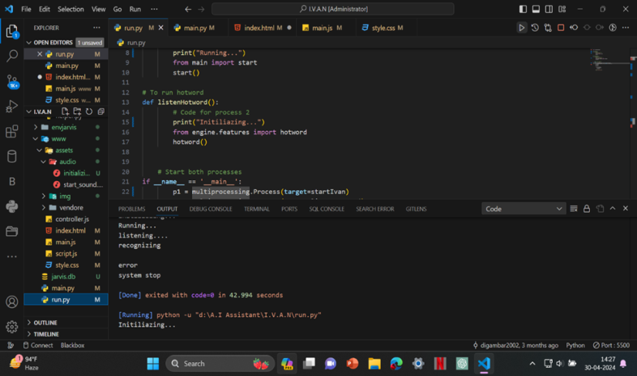
6.2 Voice Assistant Interface
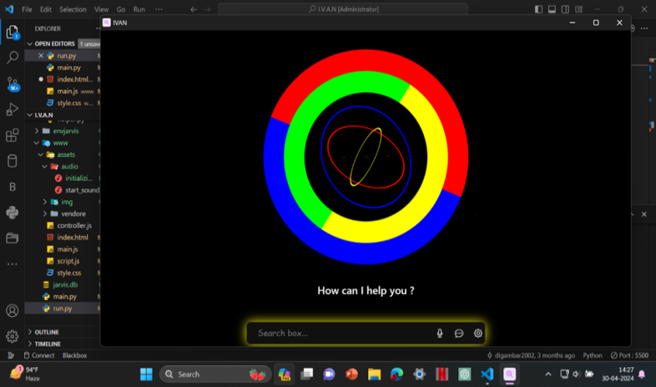

6.3 listening Voice Command
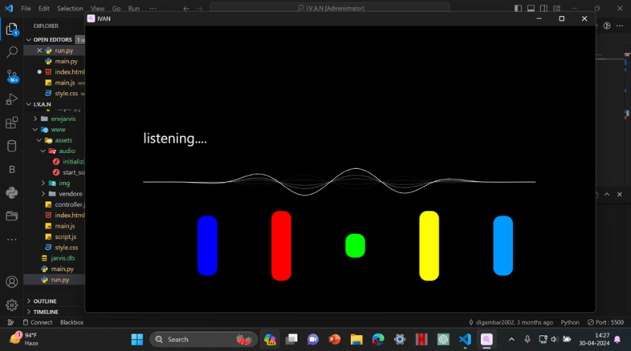
6.4 Display of the Recognized Query
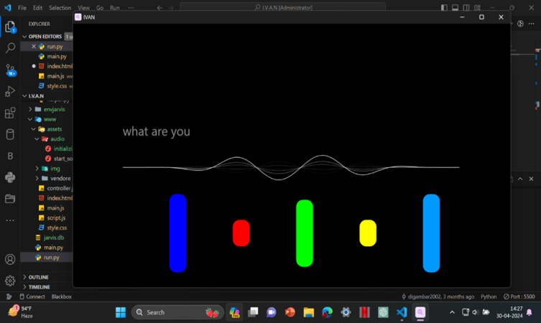

6.5 Verbal Dictation of the Response Generated
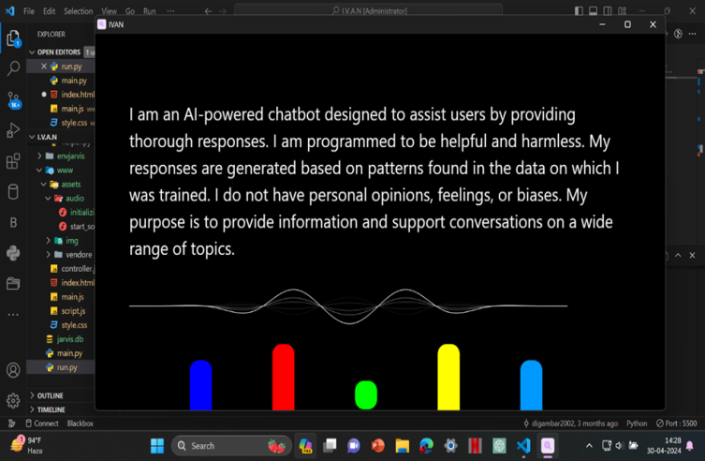

7. DISCUSSIONS
Voice assistants are becoming a regular part of people's lives. They bring benefits to both society and individuals. In workplaces, Al voice assistants can help people work more efficiently. For individuals, they offer convenience in daily life and can even provide some emotional support. Some people enjoy chatting with voice assistants, especially as life gets busier. While they don't have emotions like humans, voice assistants can be good listeners. People can become emotionally attached to them. However, the development of voice assistant technology also raises questions about emotions. For example, when companies like Apple and Amazon give their voice assistants names and personalities, it makes us wonder if they have feelings. Even though we know that voice assistants are created by computer programming, as technology advances, it's worth considering whether they could develop with emotional intelligence.
8. CONCLUSION
The proposed methodology provides a systematic approach to the development of a voice assistant application using HTML, CSS, JavaScript, Python, SQLite, and the Hugging Face API. By following the outlined steps, developers can create a versatile and efficient voice assistant system that offers an interactive and intelligent user experience, thereby enhancing user productivity and satisfaction.

REFERENCES
[1] Mishra, A., Dhanda, N., Gupta, K.K. and Verma, R., 2024, March. Speech Recognition Using Machine Learning Techniques. In 2024 2nd International Conference on Disruptive Technologies (ICDT) (pp. 1142-1146). IEEE. https://doi.org/10.1109/ICDT61202.2024.10489508
[2] Marwala, T., Mahola, U. and Nelwamondo, F.V., 2006, July. Hidden Markov models and Gaussian mixture models for bearing fault detection using fractals. In The 2006 IEEE international joint conference on neural network proceedings (pp. 3237-3242). IEEE. https://doi.org/10.1109/IJCNN.2006.247310
[3] Banerjee, I., Ling, Y., Chen, M.C., Hasan, S.A., Langlotz, C.P., Moradzadeh, N., Chapman, B., Amrhein, T., Mong, D., Rubin, D.L. and Farri, O., 2019. Comparative effectiveness of convolutional neural network (CNN) and recurrent neural network (RNN) architectures for radiology text report classification. Artificial intelligence in medicine, 97, pp.79-88. https://doi.org/10.1016/j.artmed.2018.11.004 unavoidable.

