Optimizing Last Mile Delivery Operations: A Comprehensive Case Study on Flipkart's Innovative Approach

Kritika Agrawal¹, V. Sudhakar Rao²
¹Student, Amity Business School, Amity University, Chhattisgarh, India
²Assistant Professor, Amity Business School, Amity University,
Chhattisgarh, India

Abstract
Effective last-mile delivery operations are essential for both customer happiness and long-term business growth in the ever-changing world of e-commerce. This study thoroughly examines the ground-breaking tactics and creative solutions that Flipkart, one of the biggest e-commerce companies in India, used to streamline its last-mile delivery processes. After a thorough examination that takes into account strategic network development, customer-centric efforts, and technical advancements, this paper clarifies the various tactics that have helped Flipkart become a leader in last mile delivery excellence. This paper examines the larger implications and practical insights for transforming last mile delivery operations in the e-commerce business, based on the analysis of Flipkart's case study.
Keywords: Flipkart, supply chain management, e-commerce, last-mile delivery, and logistics optimization.

Introduction
Electronic commerce, or e-commerce, is the term used to describe the purchasing and selling of goods and services via the internet. It includes a broad range of operations, such as digital goods and services, online markets, and retail storefronts. Electronic commerce can take place in four different contexts: business-to-business (B2B), business-to-consumer (B2C), consumer-to-consumer (C2C), and consumer-to-government (C2G). It has completely changed how customers and businesses interact by providing accessibility, convenience, and frequently affordable prices. E-commerce platforms enable the exchange of goods and services between customers and sellers by offering online storefronts, payment gateways, and logistics solutions.

Since its founding in 2007, Flipkart has grown to become one of the biggest e-commerce sites in India, serving millions of consumers all over the country with its extensive range of goods and services. Tasked with the enormous responsibility of guaranteeing timely and economical order delivery, particularly in the vital last mile, Flipkart has set out on an innovative and optimized journey.
E-commerce has revolutionized the retail industry by providing consumers with unmatched ease on a global scale. The smooth running of last-mile delivery services is essential to the success of e-commerce endeavors. This study looks at Flipkart's tactics for maximizing last-mile delivery. Flipkart is a major participant in the Indian e-commerce market. By doing this, we hope to highlight Flipkart's creative strategies and extract insights that apply to the larger e-commerce sector.
The significance of elements like technological integration, network development, and customer-centric activities is emphasized in theoretical frameworks related to last mile delivery optimization. Last mile delivery has been transformed by technological advancements such as real-time tracking systems, machine learning, and sophisticated algorithms. In a similar vein, client-centric strategies and network growth tactics are essential for raising customer happiness and operational effectiveness.

Need for study
Optimizing last-mile delivery operations is a crucial challenge for businesses looking to meet customers' expectations of prompt and dependable delivery in the ever-changing world of e-commerce. For a number of reasons, a thorough case study highlighting Flipkart's inventive strategy in this area is imperative. First off, Flipkart is a perfect example of an excellent case for analysis since, as one of the biggest e-commerce companies in India, it has been at the forefront of innovative techniques to expedite last-mile deliveries. Second, comprehending Flipkart's strategies illuminates the larger e-commerce sector and offers insightful information to businesses across the globe facing comparable logistical difficulties. This research paper seeks to uncover practical methods and best practices that can transform last-mile delivery operations, eventually improving customer satisfaction, by exploring Flipkart's creative solutions, which range from technology integration to strategic partnerships.

Objectives of the Study

1. To analyze Flipkart's strategies for cutting expenses, speeding up last-mile delivery, and minimizing delays.
2. To assess Flipkart's last-mile efforts based on customer happiness, timeliness, accuracy, and convenience.
3.To evaluate Flipkart's partnerships to ensure effective order fulfillment and last-mile delivery.
Literature Review
1. A study by Kishore, Waghmare, and Johnvieira (2022) explores the advantages of EVs in lowering emissions and enhancing delivery operations' efficiency in last-mile delivery for business-to-consumer (B2C) operations[1].
2. Iwan, Kijewska, and Lemke's (2016) study examines parcel locker effectiveness as a last-mile delivery option, emphasizing how they can lower emissions and increase delivery operations' sustainability[2].
3. With an emphasis on the possible efficiency gains of up to 30%, a research by Ranathunga, Wijayanayake, and Niwunhella (2021) offers a comprehensive literature analysis of solution approaches for merging first-mile pickup and last-mile delivery in e-commerce logistics networks.
4. The importance of speed, timeliness, correctness, and precision in product deliveries is emphasized in a case study on last-mile delivery difficulties in the FMCG business (2022), which is critical for consumer satisfaction[4].
5. Reviews of the literature on the idea of last-mile delivery and the application of EVs emphasize the importance of this last phase of the distribution process as well as the contribution of EVs to the promotion of environmentally friendly supply chain practices[1].
6. Yuen, Wang, and Ng's (2018) study highlights the significance of practical and effective delivery alternatives by examining consumers' desire to use self-collection services for last-mile delivery[2].
7. Yoo, Yu, and Jung's (2018) research highlights the potential of drones to improve the sustainability and effectiveness of last-mile delivery by examining the elements influencing the public's attitude and intention to adopt drone delivery[2].
8. A metaheuristic for the time-dependent vehicle routing problem is presented in a paper by Rincon-Garcia, Waterson, Cherrett, and Salazar (2020), taking into account driving hours laws and its use in city logistics[2].
9. Comprehensive summaries on the state of last-mile delivery, including the deployment of drone delivery, parcel lockers, and other creative solutions, may be found in literature studies on last-mile logistics innovations (2018)[2].
10. A 2017 study by Fancello, Paddeu, and Fadda explores last-mile food delivery, outlining the demands for food delivery and emphasizing the significance of effective and long-lasting last-mile delivery solutions[2].
11. Research by Wang, Zhang, Liu, Shen, and Lee (2016) highlights the potential of crowd-sourcing in boosting delivery efficiency by presenting an efficient crowd-tasking model with scalable solutions for increasing last-mile delivery[2].
12. A study by Lachapelle, Burke, Brotherton, and Leung (2018) looks into parcel lockers in a city where cars are the primary mode of transportation, emphasizing how they can lower emissions and increase the sustainability of last-mile delivery[2].

Research Methodolgy
Google Forms were used for the survey since they were the most convenient to distribute and gather data from. The form was deliberately sent to clients that fit both the male and female gender categories, representing a population that is frequently regarded as prime customers in various markets. About 90 forms were sent out, which allowed for manageable data processing and a large enough sample size for statistical analysis. The survey questions were carefully crafted to get detailed responses on a range of customer satisfaction topics and how they saw the operational management strategies used by the selected companies.

Data Analysis
1.Gender

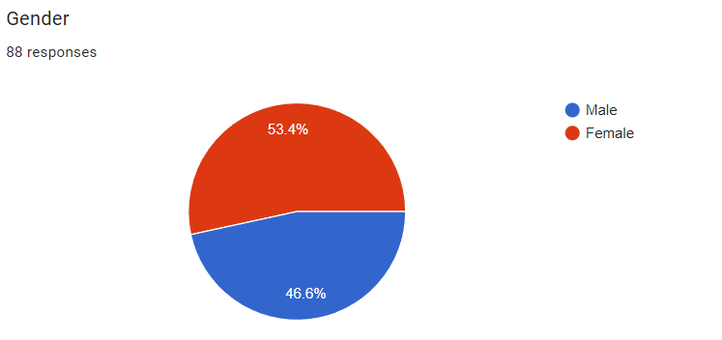

This figure is divided into two different colours Blue & Red. In which Blue denotes male and Red denotes Female,representing a population that is frequently regarded as prime customers in various markets.53.4% is the male dominant market.

2.Do you believe Flipkart's use of route optimization algorithms has improved delivery transit times ?

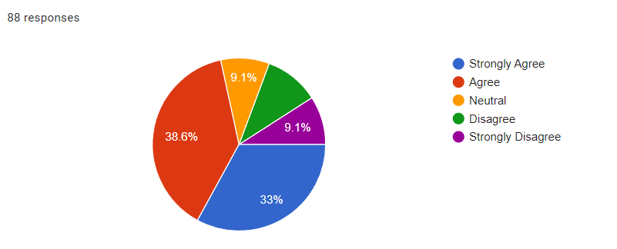

This figure is divided into 5 different colours Blue, Red, Orange,Purple and Green. In which Blue denotes Strongly agree, Red = Agree, Orange = Neutral, Green = Disagree, Purple= Strongly disagree . Figure shows 38.6% of customer Agree route optimization algorithms has improved delivery transit times our company and 33% of customer strongly agree route optimization algorithms has improved delivery transit times our company.

3. Do you perceive that localized warehousing facilities have helped in streamlining last-mile delivery processes for Flipkart?

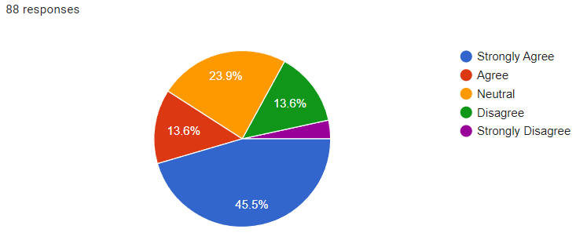
This figure is divided into 5 different colours Blue, Red, Orange,Purple and Green. In which Blue denotes Strongly agree, Red = Agree, Orange = Neutral, Green = Disagree, Purple = Strongly disagree . Figure shows 45.6% of customer Strongly Agree that localized warehousing facilities have helped in streamlining last-mile delivery processes for Flipkart and 23.9% of customer have given neutral response.

4. Have the delivery slot optimization strategies employed by Flipkart led to a reduction in transit times for your orders ?

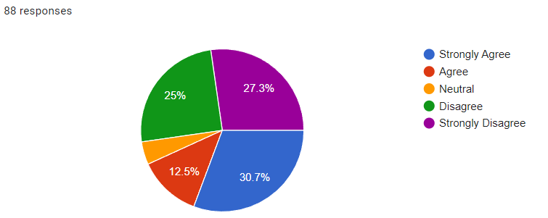

This figure is divided into 5 different colours Blue, Red, Orange,Purple and Green. In which Blue denotes Strongly agree, Red = Agree, Orange = Neutral, Green = Disagree, Purple = Strongly disagree . Figure shows 30.7% of customer Strongly Agree that the delivery slot optimization strategies employed by Flipkart led to a reduction in transit times for their orders and in contrast 27.3% of customer stongly disagree that delivery slot optimization strategies employed by Flipkart led to a reduction in transit times for their orders.

5. Do you find Flipkart's estimated delivery times to be accurate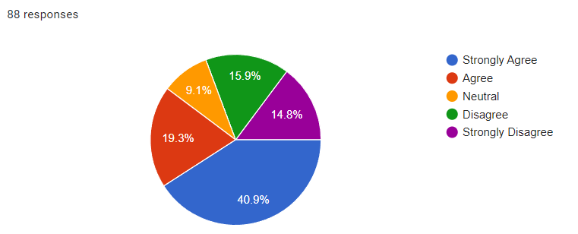

This figure is divided into 5 different colours Blue, Red, Orange,Purple and Green. In which Blue denotes Strongly agree, Red = Agree, Orange = Neutral, Green = Disagree, Purple = Strongly disagree . Figure shows 40.9% of customer Strongly Agree that Flipkart's estimated delivery times to be accurate and 19.3% of customer agree that Flipkart's estimated delivery times to be accurate meanwhile on the contrast 15.9% disagree with Flipkart's estimated delivery times to be accurate.

6. Do you perceive Flipkart's flexibility in allowing changes to delivery addresses as satisfactory?

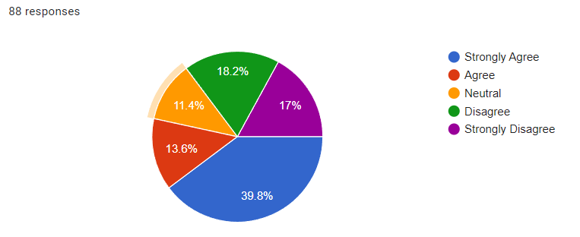

This figure is divided into 5 different colours Blue, Red, Orange,Purple and Green. In which Blue denotes Strongly agree, Red = Agree, Orange = Neutral, Green = Disagree, Purple = Strongly disagree . Figure shows 39.8% of customer Strongly Agree that Flipkart's flexibility in allowing changes to delivery addresses as satisfactory and in contrast 18.2% of customer Disagree that Flipkart's flexibility in allowing changes to delivery addresses as satisfactory.

7. Have you noticed any improvement in delivery efficiency due to Flipkart's engagement with local vendors for last-mile fulfillment?

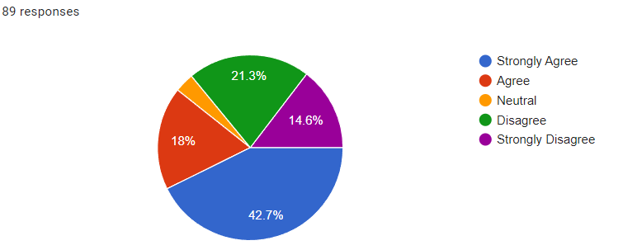

This figure is divided into 5 different colours Blue, Red, Orange,Purple and Green. In which Blue denotes Strongly agree, Red = Agree, Orange = Neutral, Green = Disagree, Purple = Strongly disagree . Figure shows 42.7% of customer Strongly Agree that they have noticed any improvement in delivery efficiency due to Flipkart's engagement with local vendors for last-mile fulfillment and in contrast 21.3% of customer Disagree that they have noticed any improvement in delivery efficiency due to Flipkart's engagement with local vendors for last-mile fulfillment.

8. Do you think Flipkart's implementation of collaborative technology solutions with supply chain partners has enhanced last-mile delivery reliability?

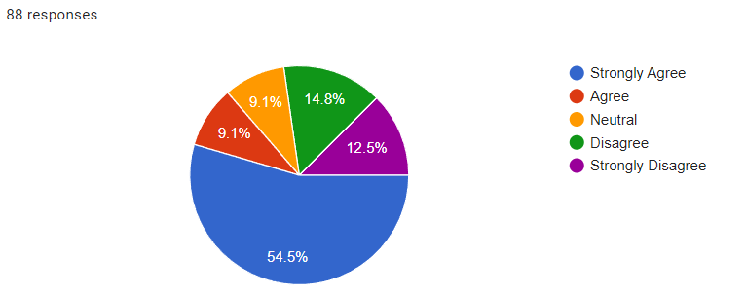

This figure is divided into 5 different colours Blue, Red, Orange,Purple and Green. In which Blue denotes Strongly agree, Red = Agree, Orange = Neutral, Green = Disagree, Purple = Strongly disagree . Figure shows 54.5% of customer Strongly Agree that Flipkart's implementation of collaborative technology solutions with supply chain partners has enhanced last-mile delivery reliability and in contrast 14.8% of customer Disagree that Flipkart's implementation of collaborative technology solutions with supply chain partners has enhanced last-mile delivery reliability.

9. In your opinion, have third-party delivery service providers contributed to Flipkart's ability to ensure timely order delivery?

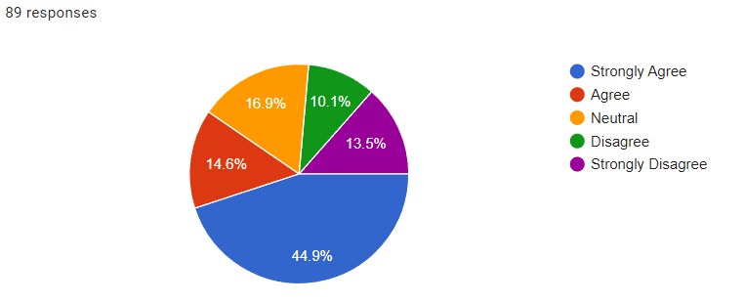

This figure is divided into 5 different colours Blue, Red, Orange,Purple and Green. In which Blue denotes Strongly agree, Red = Agree, Orange = Neutral, Green = Disagree, Purple = Strongly disagree . Figure shows 44.9% of customer Strongly Agree that third-party delivery service providers contributed to Flipkart's ability to ensure timely order delivery and 14.6% of customer agree that third-party delivery service providers contributed to Flipkart's ability to ensure timely order delivery.

10. Do you believe Flipkart's collaboration with logistics partners has positively influenced the reliability of last-mile delivery?

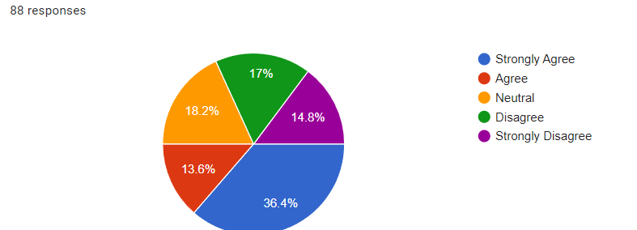

This figure is divided into 5 different colours Blue, Red, Orange,Purple and Green. In which Blue denotes Strongly agree, Red = Agree, Orange = Neutral, Green = Disagree, Purple = Strongly disagree . Figure shows 36.4% of customer Strongly Agree that Flipkart's collaboration with logistics partners has positively influenced the reliability of last-mile delivery and 13.6% of customer agree Flipkart's collaboration with logistics partners has positively influenced the reliability of last-mile delivery.

Technological Integration in Last Mile Delivery
Part of the reason Flipkart has been successful in optimizing last-mile delivery is because of its strong technology infrastructure. The business optimizes delivery scheduling, vehicle allocation, and route planning using cutting-edge algorithms and machine learning models. Customers may keep an eye on the progress of their orders with real-time tracking systems, which promotes openness and confidence. Flipkart has also made investments in robots and automation to increase order processing speed and warehousing efficiency.

Network Expansion Strategies
A key component of Flipkart's last-mile delivery optimization initiatives is the strategic expansion of its fulfillment infrastructure. Flipkart reduces delivery distances and transit times by placing fulfillment centers, warehouses, and delivery hubs in strategic locations. Flipkart's delivery network is expanded to outlying locations through partnerships with local courier firms and third-party logistics suppliers, guaranteeing statewide coverage.

Customer-Centric Initiatives
Through a number of customer-focused initiatives, Flipkart places a high priority on client pleasure. Adaptable delivery choices, such as same-day and next-day delivery, satisfy a range of client requirements. Easy exchange and return procedures improve consumer loyalty and retention by creating a smooth purchasing experience.

Challenges and Future Directions
Notwithstanding its achievements, Flipkart still has to deal with issues including clogged roads, limited infrastructure, and varying demand throughout the year. Flipkart is currently investigating novel approaches like drone delivery and crowd-sourced logistics to surmount these obstacles and enhance its last-mile delivery efficiency.

Comparative Analysis with Industry Practices
Flipkart's leadership in last-mile delivery optimization is shown by a comparative analysis with industry norms. The case study of Flipkart provides insightful lessons for e-commerce businesses looking to improve their customer experiences and logistics capacities. Beyond Flipkart's business operations, the consequences will influence how last-mile delivery develops going forward in the e-commerce sector.

Case Study: Flipkart's Last Mile Delivery Operations
The efficacy of Flipkart's customer-centric initiatives, network development tactics, and technical integration are demonstrated by a thorough investigation of the company's last mile delivery process. Flipkart's strategic network growth assures wide coverage, while its utilization of cutting-edge technology improves operating efficiency. High levels of client satisfaction and loyalty are a result of customer-centric activities.

Conclusion
In conclusion, the e-commerce sector can learn from Flipkart's creative approach to last mile delivery optimization. Flipkart has altered the norms of excellence in last mile delivery by utilising technology, growing its network, and placing a high priority on customer pleasure. The insights gained from Flipkart's case study are useful in directing future projects aimed at improving last mile delivery operations as the e-commerce landscape continues to change.

References
Here are 15 relevant references for optimizing last-mile delivery operations for your dissertation:

1. Ozarik, S. S. (2023). Data-Driven Decision-Making in Last-Mile Logistics (Doctoral dissertation, Eindhoven University of Technology). [1]

2. Muthukalyani, A. R. (2023). Optimizing Last-Mile Delivery in Retail Through AI-Powered Routing and Scheduling. International Journal of Computer Engineering and Technology, 14(2), 194-204. [2]

3. Schryen, G. (2023). Combining machine learning and optimization in last-mile delivery routing. LinkedIn. [3]

4. Sawik, B. (2024). Optimizing Last-Mile Delivery: A Multi-Criteria Approach with Automated Smart Lockers, Capillary Distribution and Crowdshipping. Logistics, 8(2), 52. [4]

5. Alves, L. A. (2022). A structured method for the optimization of the existing last mile logistic flows (Master's thesis, Universidade Nova de Lisboa). [5]

6. Giuffrida, N., Fajardo-Calderin, J., Masegosa, A. D., Werner, F., Steudter, M., & Pilla, F. (2022). Optimization and Machine Learning Applied to Last-Mile Logistics: A Review. Sustainability, 14(9), 5329. [2]

7. Kiba-Janiak, M., Marcinkowski, J., Jagoda, A., & Skowrońska, A. (2021). Sustainable last mile delivery on e-commerce market in cities from the perspective of various stakeholders. Literature review. Sustainable Cities and Society, 71, 102984. [2]

8. Perboli, G., Rosano, M., Saint-Guillain, M., & Rizzo, P. (2018). Simulation–optimisation framework for City Logistics: An application on multimodal last-mile delivery. IET Intelligent Transport Systems, 12(3), 262-269. [2]

9. Vakulenko, Y., Shams, P., Hellström, D., & Hjort, K. (2019). Online retail experience and customer satisfaction: the mediating role of last mile delivery. The International Review of Retail, Distribution and Consumer Research, 29(3), 306-320. [2]

10. Korsita, B., & Hoxha, Z. (2021). Supply Chain Disruptions after the Covid-19 Pandemic. International Journal of Management, 12(6), 331-336. [2]

11. Sorooshian, S., Sharifabad, S. K., Parsaee, M., & Afshari, A. R. (2022). Toward a Modern Last-Mile Delivery: Consequences and Obstacles of Intelligent Technology. Applied System Innovation, 5(4), 82. [2]

12. Suguna, M., Shah, B., Raj, S. K., Srinivasan, R., & Srinivasan, S. (2023). A study on the influential factors of the last mile delivery projects. Materials Today: Proceedings. [2]

13. Peppel, M., Spinler, S., & Winkenbach, M. (2024). Integrating mobile parcel lockers into last-mile delivery networks: An operational design for home delivery, stationary, and mobile parcel lockers. International Journal of Physical Distribution & Logistics Management, early access. [4]

14. Yi, Q., Jashim, K., Yuyang, S., Jiao, T., & Shuo, Z. (2023). Impulse buying tendency in live-stream commerce: The moderating role of last-mile delivery. Journal of Retailing and Consumer Services, 75. [4]

15. Bates, O., Friday, A., Allen, J., Cherrett, T., McLeod, F., Bektas, T., ... & Wise, S. (2018). Transforming last-mile logistics: Opportunities for more sustainable deliveries. In Proceedings of the 2018 CHI Conference on Human Factors in Computing Systems (pp. 1-14). [5]

