Fabrication and Characterization of Functionally Graded Composite Materials with Egg Shell Powder and Char Coal Powder
B. V. Siva Prasad Reddy ¹, A. Sreekanth², Dr. Y. Hariprasada Reddy³
¹²³Department of Mechanical Engineering & Rayalaseema University College of Engineering
---------------------------------------------------------------------***---------------------------------------------------------------------
Abstract - Synthetic composite materials are prevalent in today's environment and frequently incorporate natural fibers. Exploring natural composite materials that can compete with synthetic ones is becoming more and more popular, though. Natural composite materials have exceptional mechanical qualities. This project uses eggshell and charcoal powder to create and characterize functionally graded composite materials. Finding out these materials' mechanical characteristics is the main goal. Eggshell and charcoal powders are carefully blended during the production process to produce a functionally graded composite specimen. To fully comprehend the behaviour of the composite, a series of tests is then carried out, including microscopic analysis, tensile and compression tests, and impact testing. To ensure a comprehensive investigation of their properties within the composite material, this experimental study carefully manipulates the ratios of eggshell to charcoal powder. Experiments are carried out precisely to reveal information about the composite's performance. This research not only advances the study of natural composite materials but also shows how uncommon materials like eggshells and charcoal powder may be used to create composites.

Key Words: composite, natural fibers, microscopic analysis, tensile test, compression test, impact test

1. INTRODUCTION
The non-uniform microstructure of functionally graded composite materials (FGCMs) causes a constant variation in the material's characteristics. In recent decades, researchers from a wide range of industries, including engineering, aerospace, and biomaterials, have shown a significant deal of interest in graphene graphene composite materials (FGCMs) because of its unique features. Functionally graded materials (FGCMs) exhibit location-dependent microstructure, chemical composition, or atomic order. This can lead to a persistent difference in material properties, including mechanical, electrical, and thermal properties, with respect to position. A form of advanced material known as composite material consists of one or more materials with different physical and chemical properties mixed in solid states.
Composite materials are lighter and provide an exceptional blend of qualities not found in either of the individual parent materials. Wood is a natural composite material made of cellulose embedded in a lignin matrix. Under severe operating conditions, composite materials will delamination (separation of fibers from the matrix) and fail. This may occur, for instance, in applications involving high temperatures and two metals having dissimilar coefficients of expansion. When faced with this dilemma in the mid-1980s while working on a hypersonic space plane project that needed a thermal barrier, researchers in Japan developed a novel material known as Functionally Graded Composite Material (FGCM) to overcome this problem.
A class of advanced materials with different qualities over a changing dimension is represented by the revolutionary material known as Functionally Graded Composite Material (FGCM). Functionally graded materials, such as teeth and bones, are found in nature. These materials were created by nature to fulfill their intended functions. Similar to how artificial neural networks are used to simulate the human brain, this concept is borrowed from nature to tackle engineering challenges. The abrupt interfaces present in composite materials, which are the source of failure, are eliminated by functionally graded material. It swaps out this abrupt interface for a gradient interface that creates a seamless transition between materials. FGM has the potential to customize a material for a particular use, which makes it unique.

2. METHODOLOGY
2.1 Hand Lay Up Process
Hand lay-up: applying resin to a mold and manually layering fiber-reinforced material to increase thickness. Any trapped air is released with hand or roller pressure.
Differences in manual lay-up are: A rubber bag that is fastened over the mold is used in vacuum bag molding. In order to compress the reinforcement and resin together and release any trapped air, a vacuum is placed between the mold and the bag. Curing takes place inside an oven. Similar to vacuum bag molding, pressure bag molding involves applying pressure above the bag. Suitable for thicker section components.
Hand lay-up utilizing sheet mold compounding (SMC): clamped if needed and heated to cure to further minimize air pockets.
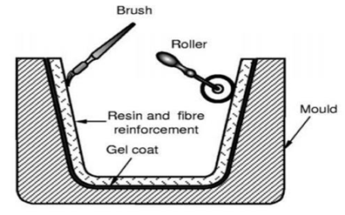
Fig 1. Shows hand lay-up process
2.2 Experimental Procedure
2.2.1Workstation Preparation
When dealing with composites, a basic standard practice is to first prepare all the materials and instruments that will be employed. This is mostly because, after the hardener and resin are combined, the hardener's rate of chemical reaction with the epoxy to produce an exothermic reaction limits the amount of time that may be worked on before the resin mix gels. Additionally, the woven cloth needs to be cut in accordance with the part's shape as part of the preliminary preparation.
2.2.2 Mold Preparation
Adequate mold preparation is required prior to beginning the lay-up process. In order to prevent the resin from sticking, this preparation mostly entails cleaning the mold and putting a release agent on its surface. To prepare the mold for this experiment, just tape the plastic sheeting to the table. If not, the mold is cleaned by taking the below actions.
- Using a fresh cloth, wipe off the mold.
- Apply and distribute the release agent across the mold's surface.
- Make sure to set up the release agent beforehand.
- Use a fresh cloth to buff
2.2.3 Lay-up Process
Mixing the hardener and resin is the first step. The provider will often provide the proportions, which are listed on the hardener or resin containers. To avoid adding too many air bubbles to the resin, the mixing must be done slowly in the mixing containers using the mixing stick. Before applying, be sure to thoroughly combine and stir for a full two minutes. A "flat" stick, like a tongue depressor, is ideal to use; circular sticks are less effective. Because Hand-layup Process 5 does not "paddle" the mixture to adequately integrate it, it cannot generate composites.
Next, enough mixed resin and hardener is added to the mold, and the entire surface is covered with it using a brush or roller while pieces of paper card are added for reinforcement. It's crucial to avoid adding too much resin, which could result in an excessively thick layer, or too little, which could leave the part with holes on its surface when it cures. After that, the fiber reinforcement's initial layer is applied. To allow the resin added in the previous stage to soak up through the fiberglass fabric, this layer needs to be wetted with resin and then gently pressed with a brush or roller.
More resin can be poured on top and distributed around the fiber if it's not totally wet. At this point, a second glass fiber layer is applied, and it is crucial to remove any air bubbles that may be present. You can achieve this by using a paintbrush to brush out any air bubbles or by rolling out any air bubbles using a small hand rolling tool. You keep doing this until you reach the appropriate thickness.
2.2.4 Curing
The part can be cured at room temperature or at high temperatures with the use of an oven. Typically, the supplier lists the working and required curing times for each type of resin-hardener on the back of the containers. Room temperature curing is sufficient for this experiment, which uses an epoxy resin system.
2.2.5 Cleaning
When the part is prepared for curing, it needs to be relocated to the proper location. In this situation, it can either be placed in a curing oven or left where it is to cure until the next day. Next, there needs to be cleanup. Acetone and a piece of cloth are required to clean all of the used materials (brushes, rollers, mixing equipment, scissors, etc.), including the table.

3. FABRICATION PROCESS
3.1 FABRICATION PROCESS
Volume of a composite = Volume of matrix + volume of reinforcement
Matrix = Epoxy Resin & Hardener
Reinforcement = Egg Shell Powder & Coal Powder
Volume = Length * Width * Height
Volume of composite = 20*20*0.05 = 20 cm³
3.1.1 Density of Composite
Matrix
Density of Matrix = 1.2g/cc Reinforcement
Density of Coal powder = 1.1g/cc
Density of Egg shell powder = 2.25g/cc
Mass of epoxy = 20*80/100*1.2 = 19.2 g
Hardener = 1.92g
3.1.2 Fabrication process for Layer-1
Mass of epoxy = Volume of Epoxy*Density of Epoxy
= 20*80/100*1.2 = 19.2 g
Mass of Hardener = 1.92 g
Mass of Coal powder = 20*20/100*2.25 = 9 g
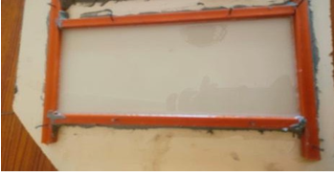
Fig 2. Shows fabrication of layer 1

3.1.3 Fabrication process for layer-2
Mass of epoxy = 20*80/100*1.2 = 19.2 g
Mass of Hardener = 1.92 g
Mass of Egg shell powder = 20*15/100*2.25
= 6.75 g
Mass of Coal powder = 20*5/100*1.1 = 1.1 g
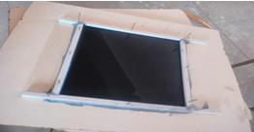
Fig 3. Shows fabrication of layer 2

3.1.4 Fabrication process of layer-3
Mass of epoxy = 20*80/100*1.2 = 19.2 g
Mass of Hardener = 1.92 g
Mass of Coal powder = 20*10/100*1.1 = 2.2 g
Mass of Egg Shell powder = 20*10/100*2.25
= 4.5 g
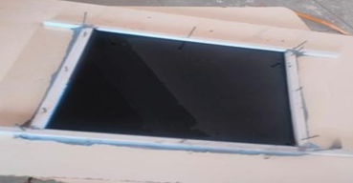
Fig 4. Shows fabrication of layer 3

3.1.5 Fabrication process of Layer-4
Mass of epoxy = 20*80/100*1.2 = 19.2g
Mass of Hardener = 1.92g
Mass of Coal powder = 20*15/100*1.1 = 3.3g
Mass of Egg shell powder = 20*5/100*2.25 = 2.25g

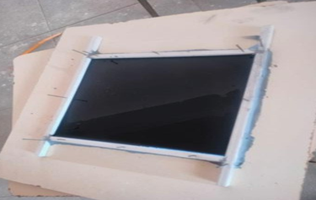
Fig 5. Shows fabrication of layer 4

3.1.6 Fabrication process of Layer-5
Mass of epoxy = 20*80/100*1.2 = 19.2g
Mass of Hardener = 1.92g
Mass of Coal Powder = 20*20/100*1.1 = 0.3g
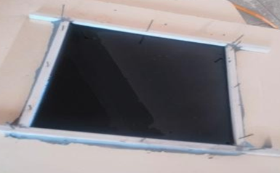
Fig 6. Shows fabrication of layer 5

4. RESULTS AND DISCUSSION
4.1 Results of Tensile Test
4.1.1 Result of Tensile test on Egg Shell Material
Fig 7. Shows tensile test on egg shell

4.1.2 Result of Tensile test on Char Coal Material
Fig 8. Shows tensile test on char coal

4.1.3 Result of Tensile test on FGCM of Egg Shell and Char Coal Material
Fig 9. Shows tensile test on FGCM of egg shell
and char coal

4.1.4 Comparison of Tensile test FGCM with Individual specimen Behaviour
Fig 10. Shows comparison of tensile test of FGCM
with individual specimen behavior

4.2 Results of Flexural Test
4.2.1 Result of Flexural Test on Egg Shell Powder Material
Fig 11. Shows behaviour of egg shell specimen while flexural test

4.2.2 Result of Flexural Test on Char Coal Powder Material
Fig 12. Shows char coal material behaviour while testing
4.2.3 Result of Flexural test on FGCM of Egg Shell and Char Coal Powder Material
Fig 13. Shows material behaviour
while testing of FGCM

4.2.4 Comparison of Flexural Test FGCM with Individual Specimen Behaviour
Fig 14. Shows comparison of flexural test FGCM with individual specimen behaviour

5. CONCLUSIONS
The combination of eggshell and charcoal in the FGCM clearly shows promising mechanical capabilities in both tensile and flexural testing, based on the data that was acquired. The tensile stress value of 27.13 MPa that the FGCM displayed in the tensile testing is similar to the individual tensile strengths of eggshell (34.97 MPa) and charcoal (37.85 MPa). This implies that the FGM maintains the advantageous properties of both materials, which supports the material's overall mechanical integrity. Similar to this, the FGCM's flexural stress value of 40.29 MPa in the flexural testing demonstrated its resistance to bending forces. Even though eggshell (34.71 MPa) and charcoal (51.66 MPa) have slightly higher flexural strengths individually, the FGCM still performs competitively in this area.

REFERENCES

1. Yoshihisa Uchida, Properties of functionally graded materials,Manufactured by Progressive Lamination Method for Applications, 39- 51-B, Vol. 39-B, Mar., 2004.
2. Takahashi M., Itoh Y, Kashiwaya H., Fabrication and evaluation of W/Cu gradient material by sintering and infiltration technique, in proceeding of the first international symposium on functionally gradient materials FGM, Sendai – Japan, 1990, 129-34.
3. Boch, P., Chartier, T., & Huttepain, M. (1986). Tape casting of AL2O3/ZrO2 laminated composites. Journal of the American Ceramic Society, 69(8), 191-192.
4. Bishop, A., Lin, C.Y., Navaratnam, M., Rawlings, R.D., & McShane, H.B. (1993). A functionally gradient material produced by a powder metallurgical process. Journal of Materials Science Letters, 12(19), 1516-1518.
5. Koizumi, M. (1993). The concept of FGM. Ceramic Transactions, Functionally Graded Materials, 34, 3-10.
6. Kieback, B., Neubrand, A., & Riedel, H. (2003). Processing techniques for functionally graded materials. Materials Science and Engineering, A362, 81- 105.
7. Uchida, Y. (2004). Properties of functionally graded materials manufactured by progressive lamination method for applications. Journal Name, Volume(Issue),
8. Zhong, Z., & Yu, T. (2007). Analytical solution of cantilever functionally graded beam. Composites Science and Technology, 67(3-4), 481-488.
9. Moya, J.S., Sanchez-Herencia, A.J., Requena, J., & Moreno, R. (1992). Functionally gradient ceramics by sequential slip casting. Materials Letters, 14(5-6), 333-335.
10. Miyamoto, Y., Kaysser, W.A., Rabin, B.H., & Kawasaki, A. (Eds.). (1999). Functionally graded materials: Design, processing and applications. Materials Technology Series, Vol. 5.
11. Mévrel, R. (2009). Les systems barrières thermiques pour aubes de turbine. PlastOx 2007 Proceedings, 255–264.
12. Mistler, R.E. (1973). High strength alumina substrates produced by a multiple-layer casting technique. American Ceramic Society Bulletin, 52(11), 850-854.

