Global Trade - A Study of New Trade centers in Coorg, Issues.
Author1:-Ylv reddy, Content Writer & Researcher
Department of Information Sciences, Student of PGDLAN Course
TNOU, Chennai, TN-500033
laxman417@outlook.com
phone no:- +91-9490621957.

ABSTRACT: The extent of business services industry has increased tremendously in the last decades, both in terms of more users and of a vast choice of products on the market. From a historical perspective this can be explained by a number of factors such as the growing prosperity in society, Laws, Volatility and Spread new modes of communication, urbanization and a rapid growth in population, a platform for Economic Sustainability, Global reach, Market strategy to build and re-build, flora, fauna, Sustainability, Technology, BIG DATA, Iot(Internet of things). Massive New Business Centres in Coorg plays a vital role in dissemination of information in 21st century. Market Research refers to the process of evaluating the validity of new service or product through research conducted directly with potential customers.

With Economic-feasibility, you can define a single owner reshapes our economy in different ways to suit Stake-holder’s methods and ideas to the global society...
Keywords: Economic-feasibility, Market Research, BIG DATA.

REVIEW OF LITERATURE
Donadati Pedda Rami Reddy, Retd., PGT in Economics from MJPAP Schools, His ideology in bringing new ideology in practising the Trade in terms of Micro-economics, Terms of Trade (TOT) is key economic metric of a Company’s health measured through what it imports and exports. TOT expressed as a ratio that reflects the number of exports that are needed to buy a single unit of imports.
The main difference between Trading and Traditional investing is the former’s short-term compared to long term horizon of the Later. Make sure that our operations are financially sustainable.

Donadati Rami Reddy, Retd., LECTURER IN Business Studies (&) Business Economics, An Alumni of Regional College of Education, Mysuru, from KVS railway Colony, Bengaluru, his ideology in bringing All Tarde together with a study of Global access to Trade involving Traders outside the world, Economic feasibility, Global Diversity, Use of SAP Software, which is highly securable when compared to other Software.
Using Macro-economics, trade usually refers to international Trade, a system of Exports and imports that connects the global economy, Exports that account for a significant source of wealth for well-connected New Business Practices.
Vaka Brahamananda Reddy, P.G.T in Economics in AP Social Welfare Schools, An Alumni of Regional College of Education, Mysuru, his ideology in bringing Trade to promote Economy is that Economic growth often driven by consumer spending business investment. Tax cuts and rebates are used to return money to consumers and boost spending. Deregulation relaxes the rules imposed on businesses and has been credited with creating growth but can lead to excessive risk-taking.
From Vaka’s Research, He stated Economic factors are variables that impact the economy as a whole, as well as individual businesses. Economic factors include tax rates, exchange rates, inflation, labour supply and demand, wages, laws and policies, government activities, and recessions.
He quoted that Economic growth generates job opportunities and hence stronger demand for labour, the main and often sole asset of the poor. Broadly speaking, Growth matters both for fiscal stabilization and for raising living standards. Economic growth in Coorg over the next decade will be much closer to the 2 percent average rate the Congressional Budget Office(CBO) projects than to the 3 Percent or better the Government Administration is promising.
Any way in his Research, he found Coorg is an administrative district in Karnataka state,
History tells it that in 1670, a Muslim pilgrim named Baba Budan snuck seven coffee beans in his beard aboard a ship to India. Upon arrival, he planted these beans in the Chikmagalur region near Coorg in Karnataka. At this time, it was illegal to transport green coffee beans outside of Yemen, and the ports were strictly monitored in an effort to maintain a monopoly on local coffee production and trade.
Coffee in south India is a competitive commodity to the infamous tea that dominates India’s northern states. Estates are plentiful in the southern Indian states of Karnataka, Kerala and Tamil Nadu. The plants grow beneath thick, natural shade in ecologically diverse and sensitive regions of the Western and Eastern Ghats. Coffee plantations simultaneously contribute to the biodiversity of the local ecosystem and to the socioeconomic development of these hilly, rural regions.
Coorg grows 40 percent of India’s coffee, and the local economy relies heavily on it. The majority of the uninhabited land is cultivated coffee farms, many of them still owned by families as they were when coffee estates first emerged in the mid-19th century.
Today, Karnataka yields 140,000 tons of coffee a year and is the largest producer of coffee in the country. As a whole, India produces 299,300 tons of coffee annually, according to a 2019-2020 census by THE COFFEE BOARD OF INDIA. India is the third-largest producer and exporter of coffee in Asia and the sixth-largest producer and fifth-largest exporter of coffee in the world. It accounts for 3.14 percent of the global coffee production. Seventy percent of India’s coffee is exported, and thirty percent is distributed and consumed domestically.

Pepper, the King of Spices and Cardamom, the Queen of Spices along with nutmeg and clove are grown mainly in the western ghat region of Coorg, Hassan, Chikmagalore, Shimoga and North Karnataka districts.
According Ramesh Pothireddy, Sr. SAP ABAP Consultant, California, his vision in bringing Trade as Global Outreach is that, Digital platforms and data analytics enable coffee producers, traders, and retailers to measure and report on these diverse metrics. This transparency empowers consumers to make choices that align with their values and encourages industry stakeholders to continually improve their practices
Mr. Ravi Kumar Pothireddy, Sr. engineering Manager at Omni Cell Inc., Mountain View California, his ideology in bringing how Technology helps in globalization -- what technology used in production of coffee? AI technology has become commonplace in the coffee industry, providing many benefits like optimizing processing and packaging while ensuring higher water quality.
He quoted that, Improvements in Telecommunications and Computers have eased the conduct of International Business. Several observers have identified advancements in Computers and telecommunications as also playing a key role in the rise of globalization. The decline in code of such services has been nothing less astonishing.
According to Rangaswami Reddy, M.sc., in Agriculture, Retd., Scientist in A.P Market Yards, his ideology states that- “Healthy soil is essential for the growth of healthy Coffee plants.” He Sates “ if soils have low fertility levels, as well as PH (high acidity) and water retention capacity, it will limit the growth and productivity of high-quality coffee.”
Basically, Doctor Rangaswami Reddy is a Cartoonist, his ideology in bringing into matters that- what causes slow plant growth, stunted growth can be a symptom of a more significant problem, indicating that your plant is sick. To determine what is causing this slow development, you will need to figure out the leading causes. Once you identify the primary causes of this pace, you can take some of the measures mentioned above in the article to help your plants regain energy and composure.
As cartoons are communicative and social artifacts (Sani et Al., 2012), the study proved that they can be a complementary tool in wider strategy to help the public understand better the social phenomenon behind crop biotechnology and in building and shaping public opinion based on empirical information.
According to Bangara Reddy, Retd, Principal & PGT in Economics in APREI Society, Broadly speaking, there are two main sources of Economic growth: growth in size of the workforce and growth in productivity(output per hour worked) of that workforce. Either can increase the overall size of the economy but only strong productivity growth can increase per capita GDP and income.
GDP measures the market value of goods and services produced in the country, but it captures only market activity and is not designed to be a measure of economic welfare. Health, safety, and environmental regulations can impose costs on business that may slow measured GDP growth, but any such costs must be compared with the benefits of better health, safer workplaces, and a cleaner environment that may not be captured in GDP.
Finally founded from his Research, a full assessment of the benefits of economic growth requires consideration of how widely American Scientists share in that economic growth. There’s a big difference between growth like that they experienced between 1948 1nd 1973, which doubled living standards up and down the income distribution, and the growth accompanied by widening income inequality we have experienced it.
According to Author YLV REDDY, CBO projects that, under current laws and policies, the economy will grow 2.3 percent this year but the growth will average 1.9 percent a year between now and 2027. It is not unusual for an administration’s economic forecast to be somewhat more optimistic than CBO’s , since administration is presumably proposing policies it expects will improve economic performance over current laws and policies.
According to his ideology, an economy recovering from a recession can temporarily achieve relatively high rates of “catch-up” growth as demand for goods and services rebounds from weak recession levels. Businesses can readily meet the rise in demand for their output by hiring unemployed workers and more fully utilizing productive capacity that had been idled by the recession.
From his findings, found that Economists use the term “potential output” or “potential GDP” to describe the economy’s maximum sustainable level of economic activity.
Actual GDP falls short of potential GDP in a recession, when aggregate demand is strong. But, over the longer periods, actual GDP and potential GDP tend to grow together.
According to Author, How Big Data works in Trading Industry, New Trade Centres in In Coorg, His ideology in bringing business in collective way, financial services, in particular, have widely adopted big data analytics to inform better investment decisions with consistent returns. In conjunction with big data, algorithmic trading uses vast historical data with complex mathematical models to maximize portfolio returns.
With data science, we can perform analyses and provide recommendations that allow traders to make informed decisions on buying, selling, or determining the right makeup of a trading portfolio to meet specific financial goals or objectives based on a set period.

Data collected from Google, Articles from Times, that’s how the flow goes from one end to the other. Example: In SAP Sales and Distribution module, flow goes from Sales Order, Shipping and Billing.

1.2 METHODOLOGY
Research includes any gathering of data, information and facts for advancement of knowledge.
In our research, data collected by survey through telephone, method used is Telephone survey method.
We did survey among people of Coorg among 20 young Traders and 50 working professionals.
According to Author, Coorg is best for plantation walks are among the most interesting things to do in Coorg as the region is bet known for its coffee and spice production.

The main crop grown in Coorg is coffee with citrus (Coorg mandarins) and pepper interplanted within. Rice grown in all the valleys and cardamom. Coffee is grown under natural jungle shade is grown to trees as standards. Cultivation of all the above crops is intensive.
Coffee has been grown in Coorg for well over 100 years. Coffee was first planted in the Nalknad area by Moplahs, but it was not until that the first plantation was opened in Madikeri area.
In South Coorg, the first plantation was opened in the Bamboo District, pollibetta and by 1894 over 28,733 hectares was in bearing. Much of this coffee was opened by planters from Ceylon, where the coffee estates had been ravaged by severe attacks of leaf disease (Hemileia vastratix). Unfortunately, the Ceylon planters had brought their practice of growing coffee without shade to South India and many early estates were wiped out by white-stem Borer (Xylotrechus quadripes). It was not until the mysore practice of growing coffee under shade was introduced, that the estates made any headway.
According to Author, the economy of the district of Coorg is pepper, coffee and cardamom. Paddy is farmed once per year and the majority of the agriculture in Coorg is fed by rain. Horticulture products such as cardamom, bananas and oranges are inter-planted within the estates of coffee.
Much land in Kodugu is sued for agriculture. Characteristically and historically, paddy fields are found on the valley floors, with Coffee and Pepper as agro-forestry in the surrounding hills mainly near Madikeri. The most common plantation crop is coffee, especially Coffee of Robusta variety.

1.3 DATA ANALYSIS & FINDINGS
Conducted Research for the purpose of acquiring information. In my Research, E-business Centres should systematically monitor their programs and services for potential barriers to access and strive to eliminate them when they occur.
Research questions?
1. E-commerce canters have to examine the policies and procedures, particularly those involving Trade, or other user charges like GST, and actively move towards eliminating any that may create potential barriers to access to achieve Good Business Communication.
2. Economic barriers are not limited solely to financial constraint and a user’s ability to pay fines on-time. It should consider waiving or reducing the cost, at its discretion, based on the user’s ability to pay.
3. Technology obsolescence: With time, the technology changes; the changes come in data as well as data formats. Technology obsolescence is also a challenge standing in front of the digitization. File formats are also changing with the new discoveries.
4. From our study& Research, Hypothesis (i). How to enact policies that cater to the desires of the economically fortunate at the expense of the economically unfortunate.
(ii). Quality of Metadata: As most of the metadata is available in non-digital form, its efficiency highly relies on Economists. Lack of knowledge about the hierarchy and ontology of Feasibility Classification may lead to variations in the results.

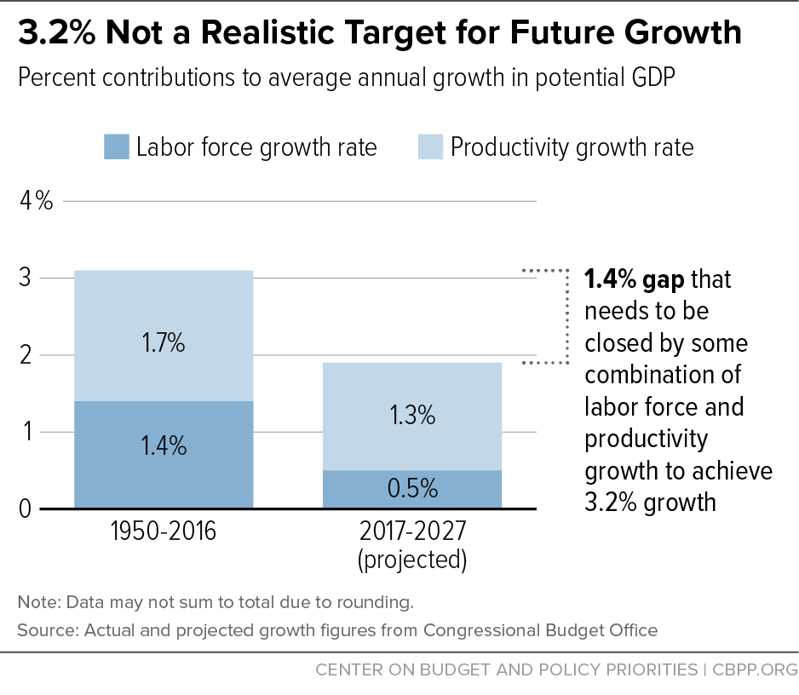
(iii). Market-feasibility Analysis:- Traders can rely on Market Survey daily and practice it once Goods gets ready, fulfil the Consumer needs, ensure Low-Cost budgeting, will assure good profits after enhancing the productivity at the right time.
For example: The Value of Robusta Coffee varies interestingly after it was been sent for shipment i.e, called Final goods, afford a tangible Price of Comfort for a Trader.

Areas of Research in Economics are:-
- Economic Development
- Monetary policy
- Micro economics
- Macro-economics
- Econometrics
- Behavioural economics.

According to Author, Economic factors variables that impact the economy as a whole, as well as individual business. Economic factors include tax rates, exchange rates, inflation, labor supply and demand, wages, laws and policies, government activities, and recessions.
Economic development results in higher levels of education, greater employment opportunities, and higher income levels.

William Easterly of NYU talks about why nations escape poverty while others do not, why aid almost always fails to create growth, and what can realistically be done to help poorest people in the world.
Richard Epstein of the University of Chicago spoke with Econ Talk host Russ Roberts about the relationship between happiness and wealth, the effects of inequality on happiness, and the economics of envy and altruism. He also applies the theory of evolution to explain some of the findings of the happiness literature.

According Vaka Brahmannda Reddy, if economic growth is widely accepted, it seems to be, as a desirable attribute of a well-functioning economic system, public policies aimed at increasing the rate of growth may seem advisable. Implicit in any public action to stimulate growth is the assumption that the rate of growth produced by individual choices within the institutional complex of social, economic, and political forces is less than a “desire” or “optimum” rate.

According to Author, How Technology helps in Globalization? He narrates in his way that how Technology fulfils user needs in Global trading is that- Free-market capitalism became the dominant economic force, leading to the economic success of the west. Technological advancements in transportation, communication, and resource extraction and development facilitated the rapid economic growth and international connectedness of 20th century globalization.

The specific form and extent of technology globalisation for developing countries bears important consequences for their government action, and implies an especially active attitude towards innovation policies.

According to Author, Productivity- the amount of output per unit of input- is a basic yardstick of an economy’s health. When productivity is growing, living standards tend to rise. When is stagnating, so, generally, is well-being..

Productivity can be defined in two basic ways. The most familiar, labour productivity, is simply output divided by number of workers or, more often, by the number of hours worked. Output can be anything from tons of steel to airline miles flown, but more generally it is some very broad aggregate like gross domestic product. Measures of labour productivity, however, actually capture the contribution to output of other inputs than hours worked.
Total factor productivity, by contrast, captures the contribution to output of everything except labour and capital: innovation , managerial skill, organization, even luck..

5. What is the purpose of a Trade Centres?
It Supplies business with access to international trade services and facilities and seeks to simplify and stimulate Trade by bringing together the Offices of government and industry that serve and carry on trade.
- Are data analysts good traders?
Data analysis and data science was the top ranked skill for the next one to three years by traders across asset classes, followed by market and market structure knowledge.
- How do technologies contribute to global trading?
Technology has revolutionized international trade by enhancing communication, simplifying transactions, and improving supply chain efficiency. Digital communication, e-commerce platforms, automation, data analytics, and customs facilitation systems have all contributed to streamlining global trade processes.

1.4 Conclusion:- The service industries like Special Trade Centres, E-commerce Suit has potential to become one of the top Trade centres in the world, with its cultural diversity, Historical landmarks, diversity mechanisms in accessing information, Life-long learning and warm hospitality.

1.5 Limitations and References:
- GOI, Funding agencies should promote New Trade Centers in urban areas and provide financial incentives for eco-friendly business practices.
- Practice of Digital Marketing, for rapid growth of business in both Public/ private sectors. Digital Marketing tool is a latest trend in advancing our business to newer heights.

REFERENCES :
- A New Introduction to Trade Business by Peter Hudson
- Principles of Macroeconomics by H.L. Ahuja

