Flyback Converter for a Multi-Chemistry Battery Balancer
S.Gokul¹,P.gokulraj²,E.ragul.³,D.SELVAGANAPATHI ⁴,G.SOUNDARYA ⁵ ME..,
IV year EEE, Assistant Professor
Department of Electrical and Electronics Engineering
AVS Engineering College , Salem

Abstract This paper presents the development and testing of a Flyback converter for multi-chemistry battery balancer. The development was done considering that this circuit must ensure efficiency, reliability and safety for battery balancers that equip Li-Ion and Pb-acid batteries. The design was done using LtSpice software, and the testing was done in Matlab/Simulink environment using real data for several batteries. Keywords: Flyback, Multi-chemistry Battery, Active Balancer,,
I. In t r o d u c t io n
In the last period, a serious concern about the reduction of pollution was the new trend [1]. These include Renewable Energy Sources (RES) for their eternal nature, economical reasonable and reliable energy storage [1]-[3], and electric vehicles (EVs) for their energy-efficient, noise-free and zero GHG (Greenhouse Gases) emission performances [4], [5]. Another essential aspect to consider is COVID-19 pandemic, which triggered a global economic shock in such a short time. Consequently, drastic measures have been taken worldwide, from the restriction of pedestrian flow to the closure of workplaces, manufacturing activities, schools, stores and so on [6], [7]. Thus, most of the countries have approached a new perspective towards societies, businesses and by 18% per week. In contrast, the electricity demand the economy. In this sense, working from home and online school were implemented to ensure social distancing. Thus, a drastic change in energy consumption took place and according to [6] and [8], the energy demand dropped by 25% on average per week during full lockdown, while in partial lockdown, energy consumption decreases on an average for residential customers has risen with about 15% during a full lockdown and 7.5% during the reopening period [7]. Most applications, from EVs and RES to portable devices and home appliances, use batteries for the power supply or store electricity. Moreover, a significant request in batterybased medical devices has emerged as a necessity to control and maintain the virus's spread from human to human, such as self-activating sanitizer [9] or breathe devices [10]. Lead-Acid and Lithium-Ion batteries are mainly used on the market due to their cost-effectiveness and popularity [4], [5], [11]—[13]. These are configured in series and/or parallel to achieve the application's power requirement [11] because there are many battery cells in a pack. However, different balancing problems
In the last period, a serious concern about the reduction of pollution was the new trend [1]. These include Renewable Energy Sources (RES) for their eternal nature, economical reasonable and reliable energy storage [1]-[3], and electric vehicles (EVs) for their energy-efficient, noise-free and zero GHG (Greenhouse Gases) emission performances [4], [5]. Another essential aspect to consider is COVID-19 pandemic, which triggered a global economic shock in such a short time. Consequently, drastic measures have been taken worldwide, from the restriction of pedestrian flow to the closure of workplaces, manufacturing activities, schools, stores and so on [6], [7]. Thus, most of the countries have approached a new perspective towards societies, businesses and by 18% per week. In contrast, the electricity demand for the economy. In this sense, working from home and online school were implemented to ensure social distancing. Thus, a drastic change in energy consumption took place and according to [6] and [8], the energy demand dropped by 25% on average per week during full lockdown, while in partial lockdown, energy consumption decreases on an average residential customers has risen with about 15% during a full lockdown and 7.5% during the reopening period [7]. Most applications, from EVs and RES to portable devices and home appliances, use batteries for the power supply or store electricity. Moreover, a significant request in batterybased medical devices has emerged as a necessity to control and maintain the virus's spread from human to human, such as self-activating sanitizer [9] or breathe devices [10]. Lead-Acid and Lithium-Ion batteries are mainly used on the market due to their cost-effectiveness and popularity [4], [5], [11]—[13]. These are configured in series and/or parallel to achieve the application's power requirement [11] because there are many battery cells in a pack. However, different balancing problems
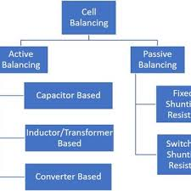
Fig. 1. The topologies o cell balancing
The fixed-shunting resistor and switching-shunting resistor methods are highly recommended for their ease of implementation, design simplicity and low-cost solution, but fall short when it comes to efficiency due to energy dissipation as heat, equalization speed is low and are only suitable for low power applications [4], [11], [18], [20], [23]. Among the passive topologies, the analogue shunting method is the most efficient one, but it requires drivers with analogue capability [4]. On the other hand, active methods overcome the
deficiency of passive methods regarding energy transfer by delivering it to or from cell-to-cell, pack-to-cell, module-tocell, or vice versa [4], [5]. The capacitor-based methods stand out for their excellent efficiency and simplicity in design and control; however, the volume is considerable, and the equalization speed is not good enough [4], [11], [23]. On the other hand, for inductive/transformer-based methods, the equalization speed is high, the efficiency is good and not limited to the numbers of the battery cells in the modules. However, these methods are costly, have some magnetizing losses, the control is complex, and the volume is considerable [11], [21], [23]. Converter-based methods have a high balancing efficiency and speed, but they require complex and intelligent control; the design and implementation are quite costly and complex [4], [11], [20], [23].
Among all these methods and circuit configurations, combining Converter-based methods facilities and the cell-tomodule energy transfer seems to be the best solution in terms of efficiency and safety. This statement comes from the fact that the Flyback converter has few magnetizing losses, good equalization speed, high efficiency, and its most important property is the galvanic insulation between the source and load [4], [12], [18], [23]. The drawbacks of this method, as shown in [4], [11] and [12], are only related to cost and control complexity. Moreover, according to [12], [14] and [17], this method is highly suitable in unidirectional or bidirectional energy transferring modes such as cell-to-pack, pack-to-cell and cell-to-pack-to-cell topology where the power requirements are high and very good equalization performance is required.
Our proposed solution for cell-to-module topology is meant to be used as an active balancing method to meet the requirements of efficiency and reliability, together with a Flyback converter, for its wide input/output facility that fits perfectly with a multi-chemistry design and the galvanic insulation. This paper focuses on providing a simple circuit for the cellto-module active balance that ensures high efficiency, good balancing speed and safety for multi-chemistry batteries. The main contributions of this paper are the development of and simulation of a Flyback converter that accepts a wide input voltage range and is adapted for battery balancing condition by minimizing the current consumption and isolating the module from the cell. Starting from an overall analysis of Flyback converters (Section 2), the process of adapting it into a multichemistry battery balancer is detailed in Section 3. Section 4 presents the simulation results obtained using the Matlab/Simulink environment. Finally, Section 5 highlights the conclusions of this work.
II. FLYBACK CONVERTER
Basically, a Flyback converter is an upgraded version of single switched inductor because of the galvanic insulation feature provided by two inductors coupled [11]. The block diagram of the Flyback converter can be seen in Fig. 2.
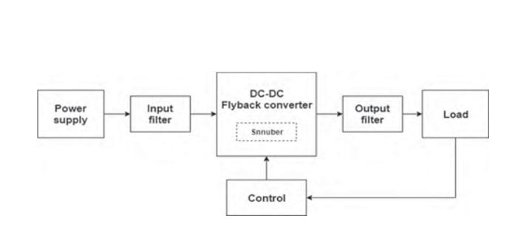
Fig. 2. Block diagram of Flyback converter
The main advantages of this circuit, besides the galvanic insulation, are the removal of the inductive filter and the low component number compared to other SMPS (Switched-mode power supply) circuits, containing only one switch for unidirectional energy transfer and two for bidirectional [12], [24], [25]. Therefore, the operation of the circuit is relatively straightforward: with the help of the switch, the circuit is closed and the current increases linearly to the peak value passing through the primary winding of the transformer and accumulates energy [25], [26], as shown in Fig. 3. a). Then, when the switch opens, the energy is transferred to the secondary winding and current decreases linearly [25], [26], as shown in Fig. 3. b). Moreover, Flyback converter can operate in three modes, namely: CCM (Continuous conduction mode), DCM (Discontinuous conduction mode) and BCM (Boundary conduction mode) [26], [27]. All of them is defined by the load of the electrical current and magnetizing inductance [18], [26]. As described in [26], [27], the differences between these modes are: in DCM, the current in the secondary winding reaches zero before the next switch, while in CCM, the same current never falls to zero. For BCM, every switching cycle begins every time the transformer current goes through zero.
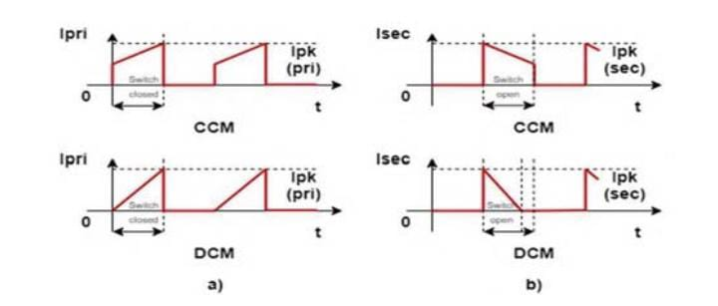Fig. 3. a) The current in the primary winding for CCM and DCM b) The current in the secondary winding for CCM and DCM
As we have seen before, various researches- such as [4], [11] and [12], state that the major disadvantage of the Flyback converter is given by the control complexity. However, this is valid only for the traditional control strategies that could only be performed with optocoupler or auxiliary winding [28]. These components raised the issue of polarization and compensation methods for optocoupler, interference and increased cost for auxiliary winding [28], [29]. Fortunately, the development of technology and the evolution of integrated circuits have made it possible to measure the output voltage without the need for optocoupler or auxiliary winding ( for example, LT8301 [29]).
III. ACTIVE BALANCE SYSTEM SIMULATION
The functionality of the system is analyzed and observed with the simulations performed in LTspice, for the power stage, and in MATLAB, for the battery balance dynamics. A. Power stage simulation To analyze the power stage for the system proposed, LTspice tool was used. The scheme of the implemented circuit is shown in Fig. 4.
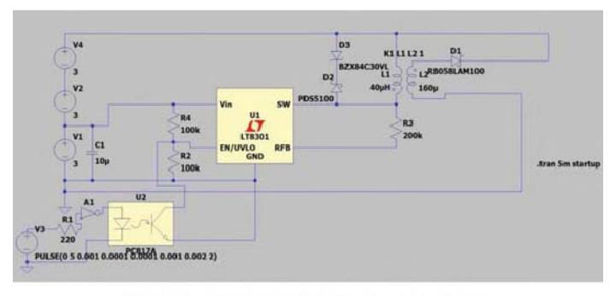
The circuit LTC8301 from Analog Devices is the heart of the system. The main features are: wide input voltage range (2.7V-42V), internal power switch (1.2A, 65 V), low quiescent current (100 ^A in sleep mode and 350 ^A in active mode), boundary mode operation at heavy load, low-ripple burst mode operation at light load, easy regulation of output voltage, output short-circuit protection and internal compensation and soft-start [29]. In order to obtain the best performances and safety, the following design steps have to be made: choosing the proper transformer, designing snubber circuit, selecting the feedback resistor and ensuring safe control. The choice of transformer is critical in determining the capability of the converter and usually refers to the selection of primary inductance and turns ratio, which is calculated using (1) [29]:
The Flyback snubber is used to reduce the conduction loss and voltage stress on the switch, improving the system reliability and feasibility [25], [30], [31]. To design the snubber circuit, Eq. 2 was used [29]:
V ZENER(MAX) ^ 65V V IN(MAX) [V]
As described in [29], the feedback resistor, which is used to modify the output voltage, should be adjusted accordingly using equation
Eq. 3: r fb ^ Npsm{VQUT+VF) _ 100#A [$] (3)
Finally, to ensure safe control and to protect the integrated circuit, an optocoupler is used for galvanic insulation.
B. Battery balance simulation We integrated the solution in the proposed system together with the active cell-to-module balancer for 6 Li-Ion and 4 Lead Acid cells. In order to validate the results, the performance of the solution will be compared with an unbalanced system for 6 Li-Ion cells, shown in Fig. 5 a), respectively, an unbalanced system for 4 Lead Acid cells, shown in Fig. 5 b).
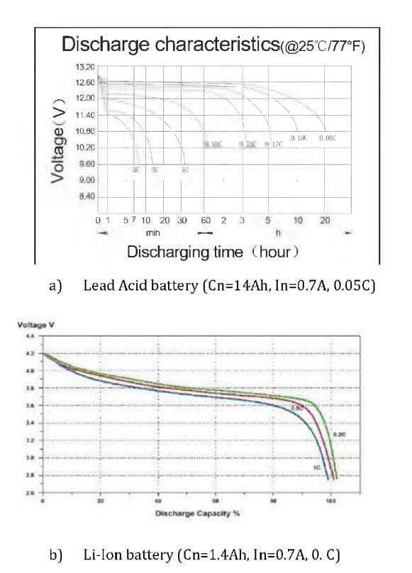Fig. 5. The implemented circuit in MATLAB - a) without balance system for 6 Li-Ion batteries b) without balance system for 4 Lead Acid batteries c) with balance system for 6 Li-Ion or 4 Lead Acid batteries
The first two schemes used for the unbalancing system consist of the battery pack, the measuring block and the load, which is basically a resistance. Instead, the scheme of the system with active balance has, in addition, the Flyback converter and the control block - Fig. 5c.
IV. RESULTS AND DISCUSSION
As we can see in Fig. 7, the chip turns on the primary power switch when the secondary current is zero; thus, the primary current increases until the peak current is limited internally. In boundary conduction mode, the secondary current is returned to zero every cycle. In this way, parasitic resistive voltage drops do not cause load regulation errors
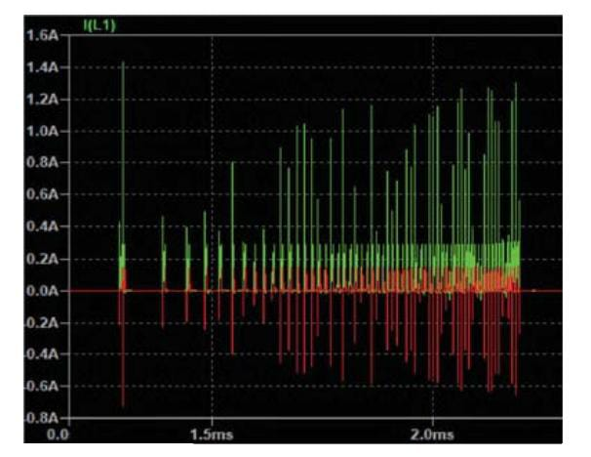
Fig. 7. The characteristic of the primary current (Green) and of the secondary current (Red)
Once the switch current hits the overcurrent limit, a soft-start cycle initiates back both switch current limit and switching frequency, as shown in Fig. 8. Thus, the short output protection prevents the switch current from running away and limits the average output diode current.
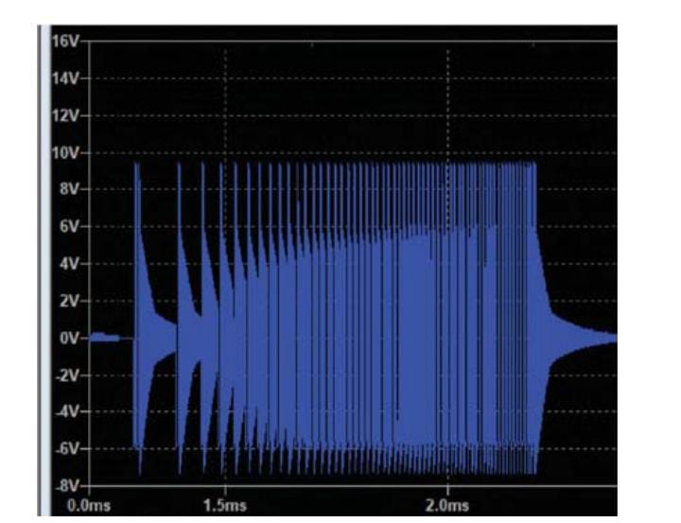
Fig. 8. Secondary winding output with a soft-start extended view
To prevent voltage spikes and leakage inductance which can cause poor performances of the circuit, a diode-Zener snubber (DZ) circuit was designed. The DZ snubber ensures consistent clamping voltage with high power efficiency, as shown in Fig

V. CONCLUSIONS
The paper presents the development and testing of a Flyback converter for multi-chemistry battery balancers. The converter uses specialized circuits to ensure a low current consumption and a high balancing speed, keeping the battery within its safety limits at all times. To demonstrate the efficiency of the design, a simulation was developed starting with real battery discharge curves. In this scenario, for a Li-Ion battery pack, an energy efficiency improvement of 36.92% was observed, while for lead-acid batteries, the efficiency improved was 8.58%.
Acknow l edgement
This research is supported by the Ministry of European Investments and Projects, Managing Authority for the Operational Program Competitiveness (Directorate-General for European Competitiveness Programs) Competitiveness Operational Program, Grant no. 115939.
References
[1] I. Zilberman, J. Schmitt, S. Ludwig, M. Naumann, and A. Jossen, "Simulation of voltage imbalance in large lithium-ion battery packs influenced by cell-to-cell variations and balancing systems," J. Energy Storage, vol. 32, no. August, p. 101828, 2020. [2] L. Barote, C. Marinescu, and I. Serban, "Energy Storage for a Stand-Alone Wind Energy Conversion System," Rev. Roum. Des Sci. Tech. Electrotech. Energ., vol. 55, no. 3, pp. 235-242, 2010. [3] Y. Yang, E. G. Okonkwo, G. Huang, S. Xu, W. Sun, and Y. He, "On the sustainability of lithium ion battery industry - A review and perspective," Energy Storage Mater., vol. 36, 186-212, 2021. [4] M. M. Hoque, M. A. Hannan, A. Mohamed, and A. Ayob, "Battery charge equalisation controller in electric vehicle applications: A review," Renew. Sustain. Energy Rev., vol. 75, 2016, pp. 1363-1385, 2017. [5] S. Lee, M. Kim, J. W. Baek, D. W. Kang, and J. Jung, "Enhanced Switching Pattern to Improve Cell Balancing Performance in Active Cell Balancing Circuit Using Multi-Winding Transformer," IEEE Access, vol. 8, pp. 149544-149554, 2020. [6] M. A. Aktar, M. M. Alam, and A. Q. Al-Amin, "Global economic crisis, energy use, CO2 emissions, and policy roadmap amid COVID-19," Sustain. Prod. Consum., vol. 26, pp. 770-781, 2021. [7] L. S. GRIGORE, I. PRIESCU, I. ONCIOIU, Applications of Unmanned Ground Vehicle (UGV) to Recognition the Rapid Spread of the Ongoing COVID-19 Epidemic, ISSN: 2227-9717, CODEN: PROCCO. [8] M. Mofijur et al., "Impact of COVID-19 on the social, economic, environmental and energy domains: Lessons learnt from a global pandemic," Sustain. Prod. Consum., vol. 26, no. September 2020, pp. 343-359, 2021. [9] M. M. Srihari, "Self-Activating Sanitiser with Battery Imposed System for Cleansing Hands," Proc. 2nd Int. Conf. Inven. Res. Comput. Appl. ICIRCA 2020, pp. 1102-1105, 2020. [10] M. Z. Chaari, R. Al-Rahimi, M. Abdelfatah, and A. S. Khamis, "Use of reverse engineering method for respirator devices in COVID-19 crisis," pp. 1-4, 2021. [11] J. Carter, Z. Fan, and J. Cao, "Cell equalisation circuits: A review," J. Power Sources, vol. 448, no. April 2019, 2020. [12] O. Alexa, I. Coropetchi, A. Vasile, I. Oncioiu, L.S. Grigore, "Considerations for determining the coefficient of inertia masses for a tracked vehicle", Journal MDPI SENSORS, 20(19), 5587, 29 September 2020 Special Issue Sensors with Machine Learning Methods for Assisted Systems - Recent Advances and Future Trends [13] Enache, B. A., Grigorescu, S. D., Seritan, G. C., Argatu, F. C., Adochiei, F. C., & Constantinescu, L. M. "Modelling the Discharge of a Lithium Iron Phosphate Battery at Low Temperatures", In 201911th International Symposium on Advanced Topics in Electrical Engineering (ATEE) (pp. 1-6), 2019. [14] J. Gallardo-Lozano, E. Romero-Cadaval, M. I. Milanes-Montero, and M
A. Guerrero-Martinez, “Battery equalisation active methods,” J. Power Sources, vol. 246, pp. 934-949, 2014.
[15] Z. B. Omariba, L. Zhang, and D. Sun, "Review of Battery Cell Balancing Methodologies for Optimising Battery Pack Performance in Electric Vehicles," IEEE Access, vol. 7, pp. 129335-129352, 2019. [16] H. Ren, Y. Zhao, S. Chen, and T. Wang, "Design and implementation of a battery management system with active charge balance based on the SOC and SOH online estimation," Energy, vol. 166, 2019. [17] Y. Shang, C. Zhang, N. Cui, and J. M. Guerrero, "A cell-to-cell battery equaliser with zero-current switching and zero-voltage gap based on quasi-resonant lc converter and boost converter," IEEE Trans. Power Electron., vol. 30, no. 7, pp. 3731-3747, 2015. [18] J. Cao, B. Xia, and J. Zhou, "An Active Equalisation Method for Lithiumion Batteries Based on Flyback Transformer and Variable Step Size Generalized Predictive Control," Energies, 14, 1, 2021. [19] A. Tavakoli, S. A. Khajehoddin, and J. Salmon, "A Modular Battery Voltage-Balancing System Using a Series-Connected Topology," IEEE Trans. Power Electron., vol. 35, no. 6, pp. 5952-5964, 2020. [20] S. Ci, N. Lin, and D. Wu, "Reconfigurable Battery Techniques and Systems: A Survey," IEEE Access, vol. 4, pp. 1175-1189, 2016. [21] Y. Shang, B. Xia, C. Zhang, N. Cui, J. Yang, and C. C. Mi, "An Automatic Equalizer Based on Forward-Flyback Converter for SeriesConnected Battery Strings," IEEE Trans. Ind. Electron., vol. 64, no. 7, pp. 5380-5391, 2017. [22] B. Anton, A. Florescu, and §. G. Ro§u, "Standalone analog active cellbalancing circuit for automotive battery management systems," Rev. Roum. des Sci. Tech. Ser. Electrotech. Energ., vol. 63, no. 3, pp. 306-313, 2018. [23] M. Daowd, N. Omar, P. Van Den Bossche, and J. Van Mierlo, "Passive and active battery balancing comparison based on MATLAB simulation," 2011 IEEE Veh. [15] Z. B. Omariba, L. Zhang, and D. Sun, "Review of Battery Cell Balancing Methodologies for Optimising Battery Pack Performance in Electric Vehicles," IEEE Access, vol. 7, pp. 129335-129352, 2019. [16] H. Ren, Y. Zhao, S. Chen, and T. Wang, "Design and implementation of a battery management system with active charge balance based on the SOC and SOH online estimation," Energy, vol. 166, 2019. [17] Y. Shang, C. Zhang, N. Cui, and J. M. Guerrero, "A cell-to-cell battery equaliser with zero-current switching and zero-voltage gap based on quasi-resonant lc converter and boost converter," IEEE Trans. Power Electron., vol. 30, no. 7, pp. 3731-3747, 2015. [18] J. Cao, B. Xia, and J. Zhou, "An Active Equalisation Method for Lithiumion Batteries Based on Flyback Transformer and Variable Step Size Generalized Predictive Control," Energies, 14, 1, 2021. [19] A. Tavakoli, S. A. Khajehoddin, and J. Salmon, "A Modular Battery Voltage-Balancing System Using a Series-Connected Topology," IEEE Trans. Power Electron., vol. 35, no. 6, pp. 5952-5964, 2020. [20] S. Ci, N. Lin, and D. Wu, "Reconfigurable Battery Techniques and Systems: A Survey," IEEE Access, vol. 4, pp. 1175-1189, 2016. [21] Y. Shang, B. Xia, C. Zhang, N. Cui, J. Yang, and C. C. Mi, "An Automatic Equalizer Based on Forward-Flyback Converter for SeriesConnected Battery Strings," IEEE Trans. Ind. Electron., vol. 64, no. 7, pp. 5380-5391, 2017. [22] B. Anton, A. Florescu, and §. G. Ro§u, "Standalone analog active cellbalancing circuit for automotive battery management systems," Rev. Roum. des Sci. Tech. Ser. Electrotech. Energ., vol. 63, no. 3, pp. 306-313, 2018. [23] M. Daowd, N. Omar, P. Van Den Bossche, and J. Van Mierlo, "Passive and active battery balancing comparison based on MATLAB simulation," 2011 IEEE Veh. Power Propuls. Conf. VPPC 2011. [24] B. N. Mali and V. B. Waghmare, "Simulstion Analysis of Universal Flyback Converter Using Matlab Simulink," Proc. 3rd Int. Conf. Electron. Commun. Aerosp. Technol. ICECA 2019, 2019. [25] R. Kanthimathi and J. Kamala, "Analysis of different flyback Converter topologies," 2015 Int. Conf. Ind. Instrum. Control. ICIC 2015, no. IClC, pp. 1248-1252, 2015. [26] N. Coruh, S. Urgun, and T. Erfidan, "Design and implementation of flyback converters," Proc. 2010 5th IEEE Conf. Ind. Electron. Appl. ICIEA 2010, vol. 2, pp. 1189-1193, 2010. [27] A. C. Kyritsis, E. C. Tatakis, and N. P. Papanikolaou, "Optimum design of the current-source flyback inverter for decentralised gridconnected photovoltaic systems," IEEE Trans. Energy Convers., vol. 23, no. 1, pp. 281-293, 2008. [28] V. Petre, D. Oancea - "Case study for designing a battery charger with minimum required components", 10th International Symposium on Advanced Topics in Electrical Engineering (ATEE), 2017 [29] ***, ”LT8301: 42VIN Micropower No-Opto Isolated Flyback Converter with 65V/1.2A Switch Data Sheet”, Analog Devices, 2020. [30] T. F. Wu, Y. C. Chen, J. G. Yang, and C. L. Kuo, "Isolated bidirectional full-bridge DC-DC converter with a flyback snubber," IEEE Trans. Power Electron., vol. 25, no. 7, pp. 1915-1922, 2010. [31] T. F. Wu, J. G. Yang, C. L. Kuo, and Y. C. Wu, "Soft-switching bidirectional isolated full-bridge converter with active and passive snubbers," IEEE Trans. Ind. Electron., 61, 3, 2014. Authorized licensed use limited to: CALIFORNIA INSTITUTE OF TECHNOLOGY. Downloaded on May 25,2021 at 16:20:13 UTC from IEEE Xplore. Restrictions apply Power Propuls. Conf. VPPC 2011. [24] B. N. Mali and V. B. Waghmare, "Simulstion Analysis of Universal Flyback Converter Using Matlab Simulink," Proc. 3rd Int. Conf. Electron. Commun. Aerosp. Technol. ICECA 2019, 2019. [25] R. Kanthimathi and J. Kamala, "Analysis of different flyback Converter topologies," 2015 Int. Conf. Ind. Instrum. Control. ICIC 2015, no. IClC, pp. 1248-1252, 2015. [26] N. Coruh, S. Urgun, and T. Erfidan, "Design and implementation of flyback converters," Proc. 2010 5th IEEE Conf. Ind. Electron. Appl. ICIEA 2010, vol. 2, pp. 1189-1193, 2010. [27] A. C. Kyritsis, E. C. Tatakis, and N. P. Papanikolaou, "Optimum design of the current-source flyback inverter for decentralised gridconnected photovoltaic systems," IEEE Trans. Energy Convers., vol. 23, no. 1, pp. 281-293, 2008. [28] V. Petre, D. Oancea - "Case study for designing a battery charger with minimum required components", 10th International Symposium on Advanced Topics in Electrical Engineering (ATEE), 2017 [29] ***, ”LT8301: 42VIN Micropower No-Opto Isolated Flyback Converter with 65V/1.2A Switch Data Sheet”, Analog Devices, 2020. [30] T. F. Wu, Y. C. Chen, J. G. Yang, and C. L. Kuo, "Isolated bidirectional full-bridge DC-DC converter with a flyback snubber," IEEE Trans. Power Electron., vol. 25, no. 7, pp. 1915-1922, 2010. [31] T. F. Wu, J. G. Yang, C. L. Kuo, and Y. C. Wu, "Soft-switching bidirectional isolated full-bridge converter with active and passive snubbers," IEEE Trans. Ind. Electron., 61, 3, 2014. Authorized licensed use limited to: CALIFORNIA INSTITUTE OF TECHNOLOGY. Downloaded on May 25,2021 at 16:20:13 UTC from IEEE Xplore. Restrictions apply

