Iot Based Smart Energy Meter Monitoring and Billing System.
Abhilash C P ¹, Naveen Bhajantri ¹, Nikhita N Pawar ¹ , Priyanka Balmi ¹ , Dr. Poornima Raikar ² ,Prof Girish.S² ¹U.G. Student [B.E.], Dept. of CSE , KLS Vishwanathrao Deshpande
Institute of Technology,Haliyal
²Assistant Professor, Dept. of CSE , KLS Vishwanathrao Deshpande
Institute of Technology,Haliyal

Abstract— Paper introduces a system which provides a platform for a consumer to monitor the meter reading via cloud and control the energy consumption, it will also support in keeping the track of energy meter billing. This system helps us to reduce turmoil’s and energy related dissent. The system is implemented using ESP32 microcontroller and Wi-Fi module. This system do not require the replacement of the energy meter but we associate this system with the installed energy meter that benefit the consumer, the base for designing and implementation of a system is IoT (Internet of Things). The instantaneous data will be fetched from the meter and uploaded on the server IoT cloud platform.

Keywords— IOT, Energy Meter Billing, ESP8266, Relay, Potential Transformer, Arduino Uno, LCD, Light Dependent Resistor, Rectifier unit , filtering unit.

I.INTRODUCTION
An electric meter is a device that measures the amount of electric energy consumed by a residence, a business, or an electrically powered device. Electric utilities use electric meters installed at customer’s premises for billing purposes. At the end of the month, a person from the electricity department has to visit the consumer premises and note down the reading. This system makes trouble-free for the electricity department to access the energy consumed by the consumer from the customer ID. Also, the consumer monitors the energy consumed per day, and every day, the bill gets generated on the webpage. The system reads the data from the energy meter without tampering with it. The proposed model is used to calculate the energy consumption of the household. Hence, the wastage of energy is less, and it also brings awareness among all.

LITERATURE SURVEY
“Energy Meter with Automatic Electricity Bill Generation and Monitoring Systems ”.Hemasilviavinothini, S.Subhaharini , M. Sneka , P. Rohini4 , S. Iniya Assistant Professor - existing meter reading practices in India are examined, and a thorough investigation of the various energy measuring tools now in use is done. To measure usage in the current system, either an electronic energy meter or an electro mechanical meter is put in the building. The only unit of measurement available to the meters in use right now is the kwh. Meter readers must still record the monthly usage of kWh units on foot. A corporation that reads meters must process the recorded data. “Evolution of Smart Energy Meter Monitoring and Billing using IOT” K.
T. Venkatraman¹, K. T. Meenaabarna (2020)-This project likely explores the development and advancement of smart energy metering systems over time, with a focus on incorporating IoT (Internet of Things) technologies for monitoring and billing electricity consumption. “IOT Based Energy Meter Reading System with Automatic Billing”

P.C. Kishore Kumar, J. Antony Veera Puthira Raja, B. Ebenezer Abishek, S.Vishalakshi, G. Vidhya5.(2018) This project likely presents a system that utilizes IoT technology to remotely read energy meters and automate the billing process. It may include features such as real-time data transmission, automated billing generation, and monitoring of energy usage “IOT Based Energy Meter Billing and Monitoring System - A Case Study” Sasane Nikita N., Sakat Swati N., Nemane Shital K., Prof. Vipul Ranjan Kaushik2,Prof. Pallav P.K.-(2017) This project may present a case study of an IoT-based energy metering and billing system. It likely discusses the implementation of IoT technology for remote meter reading, billing automation, and monitoring of energy consumption patterns.

- Existing method: The present system only provides feedback to the customer at the end of the month that how much power is consumed in the form of bill. The consumer has no way to track their energy usage on a more immediate basis. The consumers are growing exponentially fast and load on power providing divisions is rapidly rising. In the existing system meter tampering can be done easily and it’s one of the major drawbacks for an energy crisis.
- Proposed method: In the proposed system, consumer can do power management by knowing energy usage time to time. The Customer needs to pay the bill on schedule, if couldn’t, the electric power connectivity can be turned off autonomously from the distant host.

III .METHODOLOGY

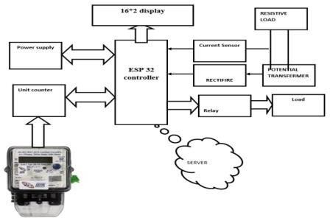
Figure 1 : Block Diagram

ESP 32 :
The ESP32, developed by Espressif Systems, builds upon the legacy of the renowned ESP8266 SoC as a low-cost System on Chip (SoC) microcontroller. Featuring both single-core and dual-core variants of Tensilica's 32-bit Xtensa LX6 microprocessor, it seamlessly integrates Wi-Fi and Bluetooth functionalities.
Voltage Dividers :
Voltage dividers, alternatively referred to as potential dividers, derive their name from the unit of voltage, the "Volt," which signifies the magnitude of potential difference between two points.

IOT SMART ENERGY METER MONITORING AND BILING SYSTEM ©2024 IEEE

Current sensing unit(Hall effect sensor):
IoT-based smart energy meters, Hall effect sensors serve as the current sensing unit, accurately detecting and measuring the flow of electrical current through the system. By integrating Hall effect sensors into the metering system, real-time data on energy consumption is captured, enabling precise monitoring and analysis for efficient energy management and conservation in IoT networks.

Step down transformer:
A step-down transformer reduces high-voltage electricity from the mains to a lower voltage suitable for consumption by household devices, thereby optimizing energy usage and improving efficiency.
Filtering unit :Filter circuits which are usually capacitors, acting as a surge arrester, always follow the rectifier unit. This capacitor is also called as a decoupling capacitor or a bypassing capacitor, is used not only to ‘short’ the ripple with frequency of 120Hz to ground but also to leave the frequency of the DC to appear at the output

LCD Display:
The LCD display on the IoT-based smart energy meter provides real-time information on energy consumption, allowing users to monitor their usage patterns and make informed decisions to optimize energy efficiency.

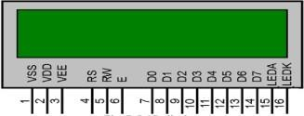

Energy Meter :
IoT-based smart energy meters enable real-time monitoring of energy consumption patterns, providing users with detailed insights into their electricity usage at any given moment.

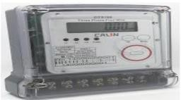

Arduino Uno :
The Arduino Uno serves as the central control unit in an IoT- based smart energy meter, facilitating the integration of sensors to monitor parameters such as voltage, current, and power consumption in real-time.
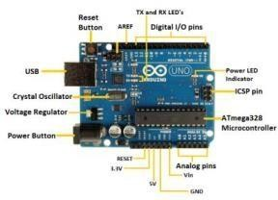

Current Sensor :
Current sensors in IoT-based smart energy meters enable real- time tracking of electrical currents flowing through circuits, providing insights into power consumption patterns and identifying potential energy wastage or anomalies.

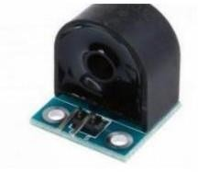

Power supply circuit:
The power supply circuit in IoT-based smart energy meters ensures a stable and reliable source of power to all components, guaranteeing uninterrupted operation and accurate data collection even during fluctuations in the main power supply.

WORKING :
The Arduino Uno is powered via USB or an external power supply such as an AC to DC adapter or a battery, with a suggested voltage range of 7V to 12V. Wifi communication is facilitated through an ESP8266 module, sending data to a database via a hotspot connection. Voltage and current recognition models utilize potential and current transformers respectively, converting AC input to DC for Arduino compatibility. ADC pins on the microcontroller facilitate voltage measurement, while current measurement is achieved through a current transformer connected to analog pins. Load control is managed by a relay controller, automating load cutoff based on software signals. Light dependent resistors (LDRs) are employed for comparative purposes, sensing variations in light levels corresponding to load consumption. Data calculated by the meter is sent to a MySQL database via ESP8266, using HTTP POST method to a specified IP address, typically hosted on services like 000Webhost, with three tables: admin, meter, and user_account.

Client –Server Architecture:
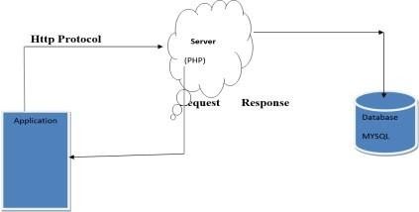
Data Flow Diagram :

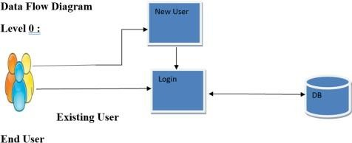

DESCRIPTION

Data Collection: In an IoT-based smart energy meter, sensors gather data on electricity usage, including voltage, current, and power consumption, in real-time or at regular intervals.
Wireless Connectivity: These meters are equipped with wireless communication capabilities, such as Wi-Fi, Bluetooth, or cellular connectivity, allowing them to transmit the collected data to a central server or cloud platform.

Remote Monitoring: Users can access their energy usage data remotely via mobile apps or web portals, providing them with insights into their consumption patterns and enabling them to track their energy usage over time.
Analytics and Insights: Advanced analytics algorithms process the collected data to generate insights into energy consumption trends, peak usage periods, and potential areas for efficiency improvements.
Automation and Control: IoT-enabled energy meters may also support automation features, allowing users to remotely control connected devices, set energy-saving schedules, or receive alerts for abnormal usage patterns, thereby empowering them to optimize their energy usage and reduce costs .

SOFTWARE DESCRIPTION
Software Required :-
Front End Coding Language : JAVA,XML Back End Coding Language: PHP, JSON Database: MYSQL

V. ADVANTAGES
- Real-time monitoring: Users can track energy usage remotely and in real-time.
- Enhanced efficiency: Insights from data analytics enable optimized energy management.
- Cost savings: By identifying inefficiencies and promoting better energy usage habits, users can reduce utility bills.

- RESULT

Hardware Part :
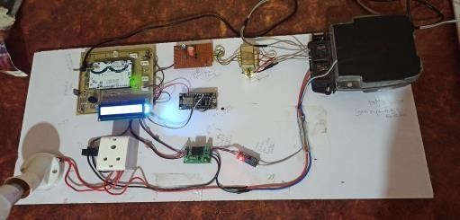
Fig 2 : Hardware Setup

Webpage Part :
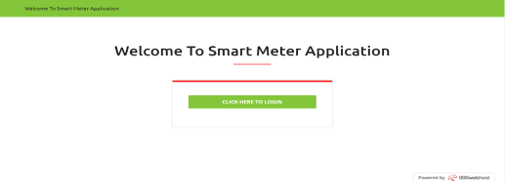
Fig 3 :Welcome page

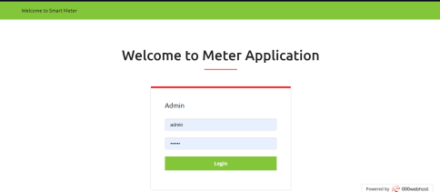

Fig 5: Login Page
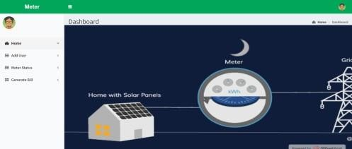

Fig 4: Home page
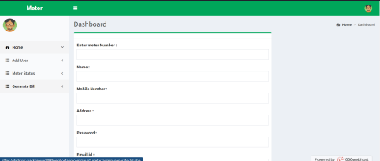
Fig 5: Add user page
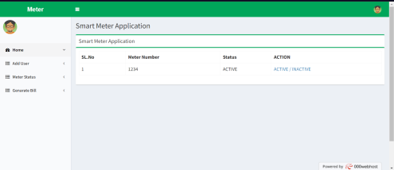
Fig 6: Meter Status page
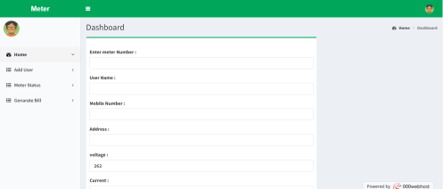
Fig 7: Generate Bill page

Android Part :
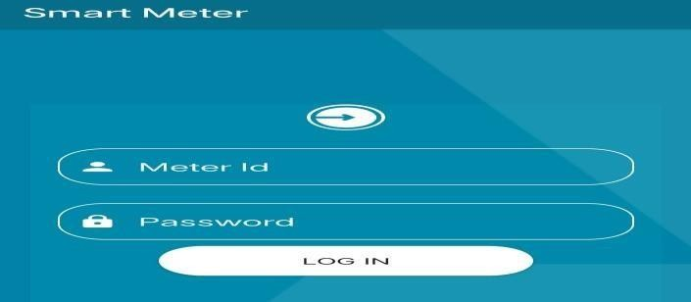
Fig 8: Android Login Page
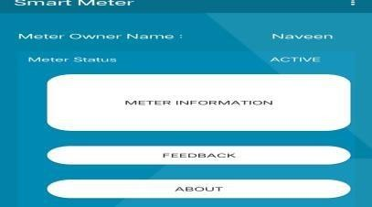
Fig 9: Android Home page

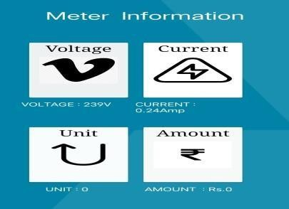
Fig 10: Meter Information

CONCLUSION
An electric meter is a device that measures the amount of electric energy consumed by a residence, a business, or an electrically powered device. Electric utilities use electric meters installed at customer’s premises for billing purposes at the end of the month a person from the electricity department has to visit the consumer premises and note down the reading. This system makes trouble-free for electricity department to access the energy consumed by the consumer from the customer Id also the consumer monitor the energy consumed per day and every day bill get generated on the webpage. The system reads the data from the energy meter without tampering it, the proposed model is used to calculate the energy consumption of the household. Hence the wastage of energy is less and it also bring awareness among all.
  - FUTURE WORK
Blockchain Integration for Security: Evaluate the potential of integrating blockchain technology to enhance the security and privacy of data transmitted by the smart energy meter.

  - ACKNOWLEDGMENT
We, the team, extend our heartfelt gratitude to KLS Vishwanathrao Deshpande Institute of Technology for providing us with the necessary resources, facilities, and
Throughout this project, we received invaluable support and encouragement, without which this research endeavor would have been unattainable. We extend our sincere appreciation to our guide, Dr. Poornima Raikar, and Prof. Girish, for their unwavering guidance, mentorship, and support at every stage. Their expertise and dedication were pivotal in shaping our research journey and nurturing our development as aspiring researchers. We are profoundly grateful for their contributions and mentorship.

  - REFERENCES
- Evolution of Smart Energy Meter Monitoring and Billing using IOT
K. T. Venkatraman1, K. T. Meenaabarna (2020)

- IoT Based Energy Meter Reading System with Automatic Billing
P.C. Kishore Kumar, J. Antony Veera Puthira Raja, B. Ebenezer Abishek, S.Vishalakshi, G. Vidhya5.(2018)

- Energy Meter with Automatic Electricity Bill Generation and Monitoring System
S. Hemasilviavinothini1, S. Subhaharini, M. Sneka3, P. Rohini, S. Iniya -2023

- IOT Based Energy Meter Billing and Monitoring System
- A Case Study
Sasane Nikita N., Sakat Swati N., Nemane Shital K., Prof. Vipul Ranjan Kaushik2,Prof. Pallav P.K.-(2017)

