SMART ROBOTIC TOILET
MAINTENANCE FOR EDUCATIONAL INSTITUTIONS
K. Inbasekaran¹, G.M. Aashiq Sulaiman², K. Karthik³, S. Mohamed arief⁴, M. Sakthiswaran⁵
¹ Assistant Professor -Mechanical Engineering & M.A.M College of Engineering and Technology
² Students-Mechanical Engineering & M.A.M College of Engineering and Technology
³ Student-Mechanical Engineering & M.A.M College of Engineering and Technology
⁴ Student-Mechanical Engineering & M.A.M College of Engineering and Technology
⁵ Student-Mechanical Engineering & M.A.M College of Engineering and Technology

---------------------------------------------------------------------***---------------------------------------------------------------------
Abstract – “The Bluetooth-Controlled Automatic Toilet Cleaning Robot is a user-friendly and automated solution designed to simplify the task of cleaning toilet basis. This project eliminates the need for manual effort and introduces the convenience of remote control through Bluetooth. The system incorporates a DC motor, cleaning brush, and two water pumps for efficient cleaning. Bluetooth technology enables remote control, allowing users to manage the cleaning process wirelessly. The system uses a water pump for precise distribution of soap oil and cleaning liquid during cleaning. Upon receiving Bluetooth commands, the microcontroller activates the water pump and DC motor, initiating the cleaning process. The setup then reverses its action to complete the task.
This project offers advantages such as a quick cleaning process, ease of maintenance, and remote control via Bluetooth. While implementation costs area consideration, the Bluetooth-Controlled Automatic Toilet Cleaning Robot is suitable for various settings, provide in gas and efficient solution for automated toilet cleaning”.

Key Points : Bluetooth, water pipes, DC motor, Microprocessor.”

1.INTRODUCTION
In the realm of household maintenance, the task of cleaning toilet basinsh as long been associated with manual effort, often proving time-consuming and labor- intensive. To overcome these challenges, our project introduces the Automatic Toilet Cleaning Robot. This innovative solution combines Bluetooth technology for remote control with a water pump, offering an automated and user-friendly approach to toilet maintenance.

By replacing traditional methods with a streamlined robotic system, this project aims to enhance efficiency, reduce manual effort, and introduce a convenient solution for maintaining optimal cleanliness in toilet facilities. The integration of a DC motor, cleaning brush, and precise water distribution reflects a commitment to modernizing house hold chores, making them more accessible and efficient for users.
2. EXPERIMENTAL PROCESSS
The conventional method of manually cleaning toilet basins is a time consuming and often unpleasant task. The aim of this project is to address the challenges associated with manual toilet cleaning by introducing an innovative Automatic Toilet Cleaning Robot.
The project seeks to eliminate the need for human effort in toilet cleaning, offering a convenient and automated solution. The project aims to provide an innovative and user-friendlysolutiontothechallengesassociatedwithmanualtoiletcleaning.The system should be efficient, easy to use, and suitable for implementation in various settings such as apartments, hotels, and houses.

2.1 SOFTWARE REQUIREMENT
Arduino IDE
2.2 HARDWARE REQUIREMENTS
2.2.1 Power Supply
The ac voltage, typically 220V rms, is connected to a transformer, which steps that ac voltage down to the level of the desired dc output. A dio de rectifier then provides a full-wave rectified voltage that is initially filtered by a simple capacitor filter to produce a dc voltage. This resulting dc voltage usually has some ripple or ac voltage variation.
2.2.2. Micro Controller– Arduino UNO
A microcontroller is a complete microprocessor system built on a single IC. Microcontrollers were developed to meet a need for microprocessors to be put into low cost products. Building a complete microprocessor system on a single chips reduces the cost of buildings implement products which use the microprocessor's power to implement their function, because the microprocessor is a natural way to implement many products.
This means the idea of using a microprocessor for low cost products comes up often. But the typical 8-bit microprocessor based system, such as one using a Z80 and 8085 is expensive. Both 8085 and Z80 system need some additional circuits to make a microprocessor system. Each part carries costs of money. Even though a product design may requires only very simple system, the parts needed to make this system as a low cost product.
2.2.3. CISC microcontrollers
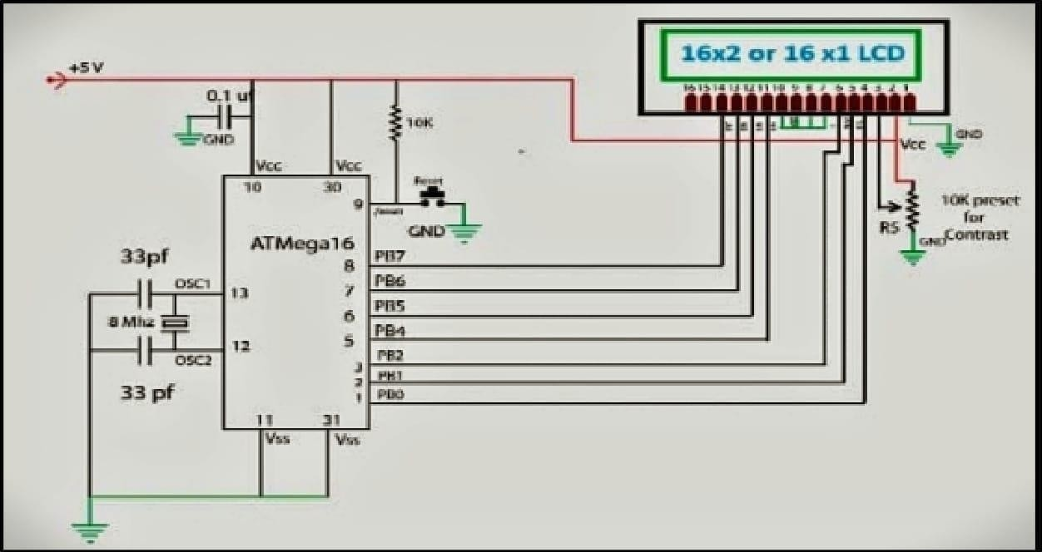
The AT mega16 provides the following features:16K bytes of In-System Programmable Flash Program memory with Read While-Write capabilities, 512 bytes EEPROM, 1K bytes RAM, 32 general purpose I/O lines, 32 general purpose working registers, a face for Boundary scan, On-chip Debugging support and programming, three flexible Timer/Counters with compare modes, Internal and External Interrupts, a serial programmable USART, a byte oriented Two-wire Serial Interface, an 8-channel, 10-bit ADC with optional differential input stage with programmable gain (TQFP package only), a programmable Watchdog Timer with Internal Oscillator, an SPI serial port, and six software electable power saving modes. The Idle mode stops the CPU while allowing the USART, Two-wire interface, A/D Converter, SRAM, Timer/Counters, SPI port, and interrupt system to continue functioning. The Power- down modes a the register contents but freezes the Oscillator, disabling all other chip functions until the next External Interrupt or Hardware Reset.
3 PIN DESCRIPTIONS
Port A(PA7..PA0)
Port A serves as the analog inputs to the A/D Converter. Port A also serves as an 8-bit bi-directional I/O port, if the A/D Converter is not used. Port pins can provide internal pull-up resistors (selected for each bit).
Port-B(PB7..PB0) :
Port B is an 8-bit bi-directional I/O port with internal pull-up resistors (selected for each bit). The Port B output buffers have symmetrical drive characteristics with both high sink and source capability.
Port-C(PC7..PC0) :
Port C is an 8-bit bi-directional I/O port with internal pull-up resistors (selected for each bit). The Port C output buffers have symmetrical drive characteristics with
both high sink and source capability.
Port-D(PD7..PD0) :
Port-D is an 8-bit bi-directional I/O port with internal pull-up resistors. The Port D output buffers have symmetrical drive characteristics with both high sink and source capability. As inputs, Port D pins that are externally pulled low will source current if the pull-up resistors are activated. The Port D pins are tri-stated when a reset condition becomes active, even if the clock is not running.
4 MICROCONTROLLER CIRCUIT
The microcontroller circuit is connected with reset circuit, crystal oscillator circuit, LCD circuit the reset circuit is the one which is an external interrupt which is designed to reset the program. And the crystal oscillator circuit is the one used to generate the pulses to microcontroller and it also called as the heart of the microcontroller here we have used12mhz crystal which generates pulses up to 12000000 frequency which is converted it machine cycle frequency when divided by 12 which is equal to 1000000hz to find the time we have to invert the frequency so that we get one micro second for each execution of the instruction.

Fig 4.1: Arduino board with connections

5. PARING MECHANISM
Bluetooth
Bluetooth is a proprietary open wireless protocol for exchanging data over short distances (using short length radio waves) from fixed and mobile devices, creating personal area networks (PANs). It was originally conceived as a wireless alternative to RS-232 data cables. It can connect several devices, overcoming problems of synchronization.
Implementation
Bluetooth uses a radio technology called frequency-hopping spread spectrum, which chops up the data being sent and transmits chunks of it on up to 79 bands of 1 MHz width in the range 2402-2480 GHz.
This is in the globally unlicensed Industrial, Scientific and Medical (ISM) 2.4 GHz short-range radio frequency band.

6. SYSTEM ARCHITECTURE

1. User initiates cleaning via Bluetooth.
2. Microcontroller activates the motor and pump based on the command.
3. Brushes scrub the bowl back and forth.
4. Water pump dispenses cleaning solution on to the bowl.
5. Sprayer (if included) enhances fluid distribution.
6. Up on completion or receiving as top command, the robot halts its operation.
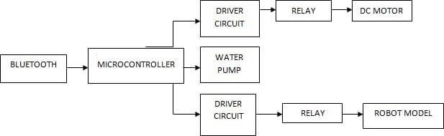

Fig 6.1: System Architecture
7. CODING FOR BLUETOOTH CONTROLLER
#include<LiquidCrystal.h> LiquidCrystal lcd(13,12,11,10,9,8);
char t;
void setup() {
pinMode(2,OUTPUT); //left motors forward pinMode(3,OUTPUT); //left motors reverse pinMode(4,OUTPUT); //right motors forward pinMode(5,OUTPUT); //right motors reverse pinMode(A5,OUTPUT); //Led Serial.begin(9600);
lcd.begin(16,2); delay (500);
lcd.print("* SUBSTATION *"); lcd.setCursor(0,1);
}
void loop() { if(Serial.available()){

t = Serial.read(); Serial.println(t);
}

if(t == 'F'){ //move forward(all motors rotate in forward direction) digitalWrite(2,HIGH);
digitalWrite(3,LOW); digitalWrite(4,HIGH); digitalWrite(5,LOW); lcd.print("* FORWARD *"); Serial.println("FORWARD"); lcd.setCursor(0,1);
}
else if(t == 'B'){ //move reverse (all motors rotate in reverse direction) digitalWrite(2,LOW);
digitalWrite(3,HIGH); digitalWrite(4,LOW); digitalWrite(5,HIGH); lcd.print("* BACKWARD *"); Serial.println("BACKWARD"); lcd.setCursor(0,1);
}
else if(t == 'L'){ //turn right (left side motors rotate in forward direction, right side motors doesn't rotate)
digitalWrite(2,HIGH); digitalWrite(3,LOW); digitalWrite(4,LOW);

digitalWrite(5,HIGH); lcd.print("* LEFT *");
Serial.println("LEFT"); lcd.setCursor(0,1);
}
else if(t == 'R'){ //turn left (right side motors rotate in forward direction, left side motors doesn't rotate)
digitalWrite(2,LOW); digitalWrite(3,HIGH); digitalWrite(4,HIGH); digitalWrite(5,LOW); lcd.print("* RIGHT *");
Serial.println("RIGHT"); lcd.setCursor(0,1);
}
else if(t == 'W'){ //turn led on or off) digitalWrite(A5,HIGH);
lcd.print("* LED IS ON *"); lcd.setCursor(0,1);
}
else if(t == 'w'){ digitalWrite(A5,LOW); lcd.print("* LED IS OFF *"); lcd.setCursor(0,1);
}
else if(t == 'S'){ //STOP (all motors stop)

digitalWrite(2,LOW); digitalWrite(3,LOW); digitalWrite(4,LOW); digitalWrite(5,LOW); lcd.print("* STOP *");
Serial.println("STOP"); lcd.setCursor(0,1);
}
}

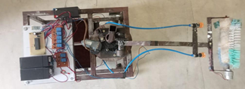

Fig 7.1: System

8. CONCLUSIONS

In this paper, automatic toilet bowl cleaner is presented that cleans the toilet bowl with very less human interference. It will help human beings with semiautomatic cleaning. The Robotic arms are used for cleaning the toilet and liquid stream jet is provided which will maintain hygiene and clean environment in toilet. Many hazardous and contagious diseases can be prevented. In future, different sensors will be used to make the system fully automation.

REFERENCES

• Kazuyoshi Wada & Naoyuki Takesue. (2023) Design Philosophy of Restroom Cleaning Competition. Design Philosophy of Restroom Cleaning Competition.
• Patil, Ashwini & Patil, Rutuja & Phalke, Snehal & Khot, Sucheta. (2022). AUTOMATIC TOILET BOWL CLEANER 1 2 3 4.
• A. Yeshmukhametov, A. Baratova, A. Salemkhan, Z. Buribayev, K. Ozhikenov and Y. Amirgaliyev, "Design and modeling of self- sustainable bathroom floor cleaning robot system," 2021 21st International Conference on Control, Automation and Systems (ICCAS), Jeju, Korea, Republic of, 2021, pp. 1860- 1865, doi: 10.23919/ICCAS52745.2021.9649969.
• Krishnan RH. A brief review on lavatory cleaning devices and their feasibility in public toilets in developing countries. Int J Intell Robot Appl. 2020;4(3):354-
369. doi: 10.1007/s41315-020-00143-2. Epub 2020 Jul 8. PMID: 32838030; PMCID: PMC7340857.
• Patil, Akshata and Awati, Jayashree, Design and Development of Automatic Indian Lavatory Cleaning Robot (March 14, 2019). Proceedings of International Conference on Sustainable Computing in Science, Technology and Management (SUSCOM), Amity University Rajasthan, Jaipur - India, February 26-28, 2019, Available at
• SSRN: https://ssrn.com/abstract=3352345 or http://dx.doi.org/10.2139/ ssrn.3352345
• AUTOMATIC TOILET CLEANER", International Journal of Emerging Technologies and Innovative Research (www.jetir.org), ISSN:2349-5162, Vol.6, Issue 5, page no.103-105, May-2019, Available
:http://www.jetir.org/papers/JETIRBQ06018.pdf
• Sota Tezuka, Kazuyoshi Wada, Akihito Hori, Naoya Shinoki, Tomohir o Kariya,

Keigo Ohi, Tetsuo Tomizawa & Toshihiko Suzuki (2022) Development of a restroom cleaning system for convenience stores, Advanced Robotics, 36:23, 1230- 1240, DOI: 10.1080/01691864.2022.2130710
• Bharadwaj, A. & Kumar, C. & Balasubramanian, R. & Gowtham, P.. (2015). Autonomous Lavatory Cleaning System. IAES International Journal of Robotics and Automation (IJRA). 4. 311. 10.11591/ijra.v4i4.pp311-315.
• Development of a restroom cleaning system for convenience stores. Taylor & Francis. Tezuka, Sota; Wada, Kazuyoshi; Hori, Akihito; Shinoki, Naoya; Kariya, Tomohiro; Ohi, Keigo; et al. Irawan, Yuda et al. “Automatic Floor Cleaning Robot Using Arduino and Ultrasonic Sensor.” Journal of Robotics and Control (JRC) (2021).

