StoryCraft AI: Exploring Generative Approaches to Story Narration through AI
Pethota Swaroopa¹, Bynapalem Hemanth Kumar², Chakravarthula Kalyani³, Mula Shirisha⁴, Penmatsha Sai Krishnamraju⁵
¹Assistant Professor, Computer Science and Engineering, ACE Engineering College, India
^{2,3,4,5} Student, Computer Science and Engineering, ACE Engineering College, India
---------------------------------------------------------------------***---------------------------------------------------------------------
Abstract - In this project, we demonstrate a Storytelling AI system, which can generate short stories and complementary illustrated images with minimal input from the user. The system makes use of a text generation model, a text-to-image synthesis network, and a neural style transfer model. The final project is deployed into a website where users can build their stories. The field of AI has made significant changes in various domains, including Natural Language Processing and Generative models. One captivating application of these advancements is in the realm of storytelling. This project introduces a novel approach to story narration using a Generative AI model, specifically leveraging the GPT architecture. Traditional storytelling involves human creativity, imagination, and the ability to craft engaging narratives. However, the integration of AI into storytelling brings about new opportunities and challenges. In this project, we delve into the methodologies and techniques used to train a GPT-based model for generating coherent and captivating stories. In the end, we found that using computers for storytelling can be exciting, but we need to work together to ensure the stories are great and meaningful.

Key Words: Artificial Intelligence (AI), Generative Adversarial Network (GAN), Generative Pre-trained Transformer (GPT)

1.INTRODUCTION
In the enchanting realm where technology intertwines with creativity, a groundbreaking innovation emerges — StoryCraft AI: A Generative Approach to Story Narration. This transformative technology ventures beyond the boundaries of conventional narrative creation, ushering in a new era where artificial intelligence becomes a collaborative companion in the art of storytelling. At its essence, StoryCraft AI is a marvel that harnesses the power of generative algorithms to craft imaginative tales from the depths of data and human experiences. It seamlessly blends the intricacies of language, emotion, and cultural nuances to produce stories that captivate the mind and stir the soul. This innovative approach invites storytellers of all walks of life to embark on a journey where creativity is amplified, and the boundaries of imagination are stretched beyond the imaginable.
Imagine a world where a few keystrokes or spoken words can conjure forth a tapestry of narrative brilliance, where StoryCraft AI acts as a co-creator, understanding the essence of your ideas and breathing life into them with a stroke of algorithmic genius. It adapts to your unique style, learns from your preferences, and transforms the mundane into the extraordinary, all while respecting the artistic fingerprint of the human storyteller. In this realm, the interface of StoryCraft AI becomes a portal to endless possibilities.
Writers, poets, and dreamers alike can input their visions, and with the rhythmic dance of code and creativity, witness their thoughts evolving into intricate plots, vivid characters, and captivating dialogues. It's a collaborative dance, where the human touch guides the AI, and the AI, in turn, enhances the expressive potential of the human narrative. Yet, as we delve into this realm of limitless storytelling, questions emerge. What role does Storytelling AI play in preserving the authenticity of human expression? How does it navigate the delicate balance between technological innovation and the rich tradition of storytelling passed down through generations? As we embrace this technological marvel, we embark on a quest to redefine the boundaries of storytelling, exploring the synergy between human creativity and artificial intelligence.
In a world where creativity meets cutting-edge technology, StoryCraft AI emerges as a groundbreaking innovation, revolutionizing the art of storytelling. This generative approach to story narration marks a significant leap forward, blending the boundless possibilities of artificial intelligence with the timeless magic of storytelling. Imagine a realm where stories are not merely written but crafted by an intelligent algorithm that understands the nuances of plot, character development, and emotional arcs. StoryCraft AI invites authors, storytellers, and enthusiasts alike to embark on a journey where the boundaries of imagination are stretched beyond conventional limits.
At its core, StoryCraft AI is designed to assist and inspire, acting as a collaborator to storytellers seeking to transcend the ordinary. This innovative platform seamlessly weaves together the threads of creativity and computational prowess, enabling users to explore new realms of narrative potential. Gone are the days of staring at a blank page, grappling with the challenge of where to take your story next. StoryCraft AI steps in as a muse, suggesting plot twists, character interactions, and unexpected developments, all while maintaining the unique voice and style of the storyteller. It doesn't replace human ingenuity; instead, it amplifies it, offering a co-authorship that expands the horizons of storytelling.
This generative approach to story narration opens doors to unparalleled creativity, fostering a symbiotic relationship between the human storyteller and the artificial intelligence. As authors input their ideas and preferences, StoryCraft AI transforms them into a rich tapestry of words, creating a collaborative dance between human imagination and machine intelligence. Join the movement that is reshaping the future of storytelling. With StoryCraft AI, the art of narrative takes a giant leap forward into uncharted territories, inviting storytellers to embrace the limitless possibilities that emerge when creativity meets technology. Welcome to a new era where stories are not just told but crafted in collaboration with the boundless potential of artificial intelligence – the era of StoryCraft AI.
As technology continues to advance, the potential applications and impact of AI in the realm of storytelling are vast. Here are some key aspects of the future scope:
1. Personalized Storytelling: AI algorithms can analyze user preferences, behaviors, and historical data to create personalized and tailor-made stories. This approach ensures that the audience receives content that resonates with their tastes and interests.

2. Interactive Narratives: AI can enable interactive storytelling experiences where users can influence the plot or characters' decisions. This level of engagement creates a more immersive and dynamic narrative, making storytelling a participatory experience.

3. Cross-Platform Integration: Storytelling AI can seamlessly integrate with various platforms, including virtual reality (VR), augmented reality (AR), and mixed reality (MR). This integration can elevate storytelling experiences by providing users with a multi-sensory and immersive environment.

4. Multi-Modal Story Generation: Future AI systems may develop the ability to generate stories using multiple modalities, such as combining text with visuals, audio, and even haptic feedback. This holistic approach enhances the overall storytelling experience and caters to a wider range of audience preferences.

5. Ethical and Inclusive Storytelling: AI algorithms can be developed with a focus on promoting ethical storytelling by avoiding biased content and stereotypes. Additionally, AI can contribute to creating inclusive narratives that represent diverse perspectives and cultures, fostering a more globally aware and empathetic audience.

6. Collaboration with Human Creators: AI can serve as a collaborative tool for human creators, assisting writers and storytellers in generating ideas, refining plots, or even automating certain aspects of the creative process. This partnership between AI and human creativity can lead to groundbreaking and innovative storytelling.

7. Educational Applications: Storytelling AI can play a significant role in education by creating engaging and interactive learning materials. These AI-generated stories can cater to individual learning styles and adapt to the pace and preferences of each learner, making education more personalized and effective.

In conclusion, storytelling AI by using a generative approach holds immense potential for transforming the way stories are created, consumed, and shared. As advancements continue, the collaboration between AI and human creativity is likely to open up new horizons in the world of storytelling.

2. LITERATURE SURVEY
1. Exploring Generative AI in Education and Marketing
The intersection of generative AI, natural language processing (NLP), and storytelling holds immense potential across diverse domains, as evidenced by recent research. In "AIStory" (Han, 2023), the focus lies on leveraging generative AI for educational purposes, empowering children to actively engage in creative processes. By soliciting insights from stakeholders such as parents, therapists, teachers, and AI researchers, the study underscores the role of generative AI in fostering digital content creation among children. This highlights a paradigm shift in education, where generative AI acts as a catalyst for personalized and interactive learning experiences.
In parallel, "Generative AI-Driven Storytelling" (Vidri, 2023) sheds light on the transformative impact of generative AI in marketing. Organizations are increasingly embracing AI-driven storytelling to create captivating narratives that resonate with their target audiences. By harnessing the power of generative AI, businesses can craft dynamic and engaging marketing campaigns that adapt to individual preferences and trends. This underscores the evolution of marketing strategies in the digital age, where AI-driven storytelling serves as a cornerstone for building brand identity and driving consumer engagement.

2. Innovations in Interactive Storytelling and Image Synthesis
"StoryBuddy" (Zhang & Xu, 2022) presents an AI-enabled system designed to facilitate parent-child interactive storytelling. The system's adaptable design accommodates dynamic user needs, balancing parental involvement with fostering independent storytelling experiences for children. Through features such as parent-led and agent-led question answering, StoryBuddy enhances parent-child bonding while promoting creativity and imagination. This exemplifies the integration of generative AI into everyday activities, enriching interpersonal connections and fostering collaborative storytelling ventures.
On the technological front, advancements in text-to-image synthesis have gained traction, as demonstrated in "Text to Image Synthesis using Stacked Conditional Variational Autoencoders and Conditional Generative Adversarial Networks" (Tibebu et al., 2022). By leveraging stacked generative models, this research explores the synthesis of images based on textual descriptions, paving the way for innovative applications in fields such as digital content creation and visual storytelling. Furthermore, studies such as "One-shot ultra-high-resolution generative adversarial network" (Oh et al., 2022) push the boundaries of image synthesis, enabling the generation of high-resolution images on consumer-grade GPUs. These breakthroughs underscore the transformative potential of generative AI in shaping visual storytelling landscapes and driving creative expression.

3. Bridging Generative AI and Visual Creativity
In the realm of visual storytelling, the convergence of generative AI and image synthesis techniques opens up new avenues for creative expression and artistic exploration. "Generative Adversarial Text to Image Synthesis" (Tahmid & Alam, 2022) presents innovative deep architectures aimed at bridging the gap between textual descriptions and visual representations. By employing advanced generative adversarial networks (GANs), researchers strive to translate textual narratives into photorealistic images, mirroring the inherent challenges of language translation at a visual level. This synthesis of textual and visual modalities lays the groundwork for immersive storytelling experiences and interactive multimedia content creation.
Moreover, the "Optimal text-to-image synthesis model for generating portrait images using generative adversarial network techniques" (Berrahal & Azizi, 2022) delves into the nuances of generating portrait images from textual descriptions. Through the development of robust generative models, researchers demonstrate the ability to generate diverse and realistic human faces, driven by contextual cues provided in the input text. This breakthrough not only showcases the technical prowess of generative AI but also underscores its potential applications in diverse fields such as digital art, character design, and avatar creation. As such, the fusion of generative AI and visual storytelling fosters a symbiotic relationship between human creativity and machine intelligence, enriching the creative landscape and pushing the boundaries of artistic innovation.

4. Advancing Generative AI for Semantic Consistency and Training Stability
The pursuit of semantic consistency and training stability remains a key focus in the development of generative AI models. "Generative Adversarial Networks Based on Dynamic Word-Level Update for Text-to-Image Synthesis" (Wang et al., 2022) introduces a novel GAN architecture featuring dynamic word-level updates, enhancing the generator's ability to produce images with high semantic consistency. By incorporating attention mechanisms and adaptive learning strategies, this approach mitigates common challenges such as mode collapse and preserves the integrity of textual descriptions throughout the image synthesis process.
Furthermore, ongoing research endeavors aim to enhance the interpretability and transferability of generative AI models. "Text to Image Synthesis using Stacked Conditional Variational Autoencoders and Conditional Generative Adversarial Networks" (Tibebu et al., 2022) explores the integration of symbolic representation mechanisms with stacked generative models, facilitating the development of explainable and transferable generative models. By elucidating the underlying mechanisms governing the generation process, researchers strive to democratize access to advanced AI technologies and foster interdisciplinary collaborations across domains such as computer vision, linguistics, and cognitive science.

3. PROPOSED METHODOLOGY

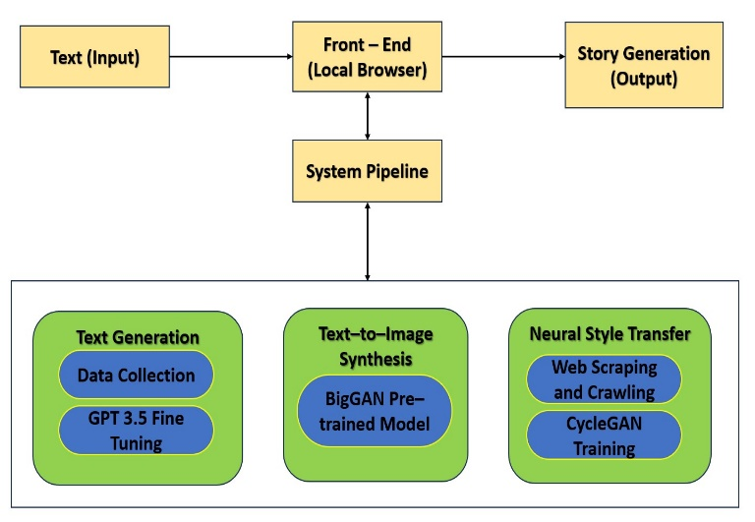
The Architecture of our system mainly focuses on the following three goals which are as follows:
- Text Generation: The model GPT-3.5 turbo generates the story based on the input(prompt) given by the user.
- Text-to-Image Generation: The model dall-e-2 which is a Generative Adversarial Network generates the images related to the story.
- Neural Style Transfer: One can generate images of different resolutions from low to high.

- Algorithm
In our project, analysis of algorithms is done based on the input (prompt) provided by the user.
Step 1: The user enters the prompt or provides the input and clicks the Generate Button to submit the prompt.
Step 2: Respective functions run in the background.
Step 3: The function Story Generation will generate the story related to the prompt entered by the user. For this, the model GPT-3.5 turbo model is used.
Step 4: The function Image Generation will generate the images related to the story by using the model dall-e-2.
Step 5: The images are generated based on the resolutions provided in the background.
GPT-3.5 turbo model:
- Used for the Story Generation
OpenAI has introduced fine-tuning capabilities for its GPT-3.5 Turbo model, with plans to extend this to GPT-4 later. Fine-tuning allows developers to customize the model for specific use cases, potentially surpassing base GPT-4 performance in certain tasks. Fine-tuning also allows for shorter prompts while maintaining performance, potentially reducing prompt size by up to 90%. The GPT-3.5 Turbo model supports up to 4k tokens for fine-tuning, doubling the previous limit. This feature is most effective when combined with other techniques like prompt engineering and information retrieval.
Dall-E-2 model:
- Used for the Realistic Image generation
DALL·E 2 is an AI system that can create realistic images and art from a description in natural language. A model that can generate and edit images given a natural language prompt.
4. RESULTS AND DISCUSSION
The result shows the generated story and the images for the prompt given by the user, that is “Chronicles of Narnia”.
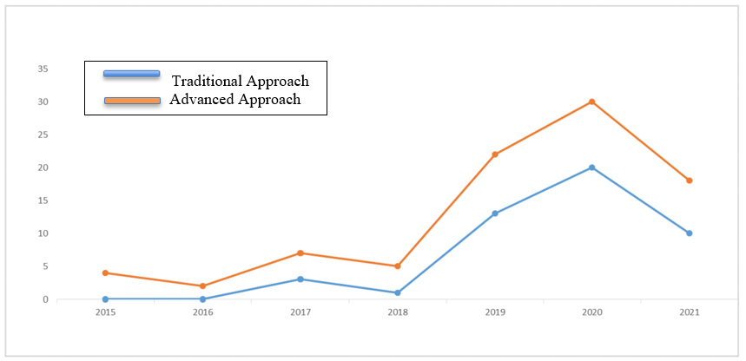
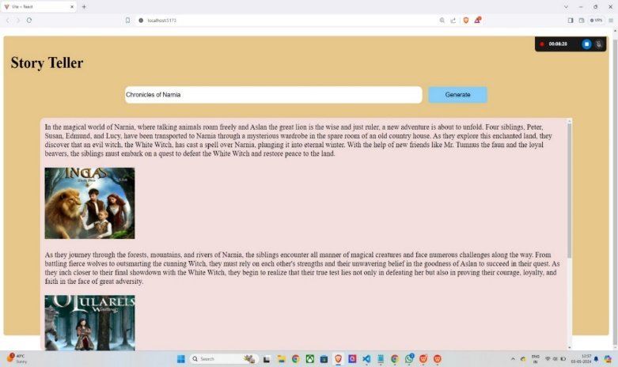
Figure 1: Generation of Story and the Images.

Figure 2: Generation of text using traditional & Advanced approaches of GPT models

Aspects | Existing Models | Proposed Model
Purpose | Existing models like GPT-3 are designed to generate text based on the input provided to them. They excel at tasks like text completion, translation, question answering, and text generation. | Storycraft AI, on the other hand, specifically focuses on generating coherent and engaging narratives or stories. It aims to mimic human storytelling abilities by creating different characters and images.
Functionality | Existing models can perform a wide range of text-related tasks, from simple language understanding to complex natural language generation. They operate by predicting the next word or sequence of words based on the input text and the context provided. | Storycraft AI is specialized in crafting narratives. It goes beyond simple text generation by considering elements such as story structure, character development, and plot coherence to create compelling stories.
Methodology | Existing models like GPT-3 are based on large-scale deep learning architectures, trained on vast amounts of text data. They learn to generate text by identifying patterns in the training data and predicting the most likely next word or sequence of words. | Storycraft AI often combines deep learning techniques with narrative theory and storytelling principles. It may involve additional components such as story planning algorithms, character modeling, and dialogue generation modules to ensure coherence and engagement in the generated narratives.
Applications | Existing models find applications in various domains such as customer service chatbots, language translation services, content generation for websites, and even creative writing assistance. | Storycraft AI is primarily used in entertainment, gaming, education, and creative writing domains. It can be integrated into storytelling platforms, interactive fiction games, or writing tools to assist authors in generating story ideas or developing plotlines.

Table 1. Comparison Between Existing System and Proposed System

5. CONCLUSION
In this work, we demonstrate a Storytelling AI that uses generative models to create stories with complementing illustrations with minimal user input. Our aim with this project was to study generative models and their competency in generating original content. We believe that given the advanced state of technology, AI techniques can generate human-like content but it requires human intervention and supervision to a great extent. With research being conducted towards more controllable generations, we believe with a well-curated data set, generative models can help conceptors in creating novel and personalized advertisement sketches, designs, and images. In conclusion, StoryCraft AI represents a remarkable journey into the realm of story creation through artificial intelligence. Through innovative algorithms and deep learning techniques, StoryCraft AI has demonstrated its ability to craft compelling narratives, sparking imagination and creativity in ways previously thought impossible.
6. REFERENCES
- Ariel Han, Seungmin Jeong, Sun Myung Choi, Zhenyao Cai “AIStory: design implication of using generative arts AI for visual storytelling” published in International Conference on Computer Communication and Artificial Intelligence (CCAI) published in 2023. http://creativitylabs.com/pubs/2023%20-%20J23HanAIStory.pdf
- Marko Vidrih, Shiva Mayahi “Generative AI-Driven Storytelling: A New Era for Marketing” published in arXiv.org in 2023. https://doi.org/10.48550/arXiv.2309.09048
- Aadin Malik, V. D. Silva,Haileleol Tibebu “Text to Image Synthesis using Stacked Conditional Variational Autoencoders and Conditional Generative Adversarial Networks”, a conference paper published in Intelligent Computing: Proceedings Of The 2022 Computing Conference, Springer in 2022. https://doi.org/10.1007/978-3-031-10461-9_38
- Kalim Akram, Kazi Muhammad Asif Ashrafi, Samiul Alam,Marjana Tahmid “A study on Generative Adversarial Text to Image Synthesis”, published in 3rd International Conference on Electrical, Computer, Communications and Mechatronics Engineering (ICECCME) in 2023. https://doi.org/10.1109/ICECCME57830.2023.10253143
- Akhil Sharma, Shabeg Singh Gill, Sunil K. Singh, M. Chopra “A Comparative Study of Generative Adversarial Networks for Text-to-Image Synthesis”, published in International Journal of Software Science and Computational Intelligence in 2022. https://doi.org/10.4018/ijssci.300364
- Donghwee Yoon, Injung Kim,Junseok Oh “One-shot ultra-high-resolution generative adversarial network that synthesizes 16K images on a single GPU”, published in Image and Vision Computing in 2022. https://doi.org/10.1016/j.imavis.2023.104815
- M. Azizi,Mohammed Berrahal “Optimal text-to-image synthesis model for generating portrait images using generative adversarial network techniques”, published in Indonesian Journal of Electrical Engineering and Computer Science in 2022. https://doi.org/10.11591/ijeecs.v25.i2.pp972-979
- F. Lindseth, L. Ruspini, M. Sarmad “Photo-Realistic Continuous Image Super-Resolution with Implicit Neural Networks and Generative Adversarial Networks” published in Proceedings of the Northern Lights Deep Learning (NLDL) Workshop in 2022. https://doi.org/10.7557/18.6285
- Haoran Kong, Huailei Cui, Huaxiang Zhang, Li Liu, Yuanke Chen, Yue Ma, Zekang Wang “Generative Adversarial Networks Based on Dynamic Word-Level Update for Text-to-Image Synthesis” published in IEEE conference in 2022. https://doi.org/10.1109/ICIVC55077.2022.9886095
- Jeff Donahue, K. Simonyan, Andrew Brock “Large Scale GAN Training for High Fidelity Natural Image Synthesis”, published in the International Conference on Learning Representations (ICLR) in 2018. https://arxiv.org/pdf/1809.11096
- M. Tschannen, Marvin Ritter, Olivier Bachem, S. Gelly, Xiaohua Zhai, Mario Lucic “High-Fidelity Image Generation with Fewer Labels”, published in the International Conference on Machine Learning in 2019. https://arxiv.org/pdf/1903.02271
- James Alfred Walker, Liam Maloney, S. Concannon, S. Missaoui, J. Chubb “Interactive storytelling for children: a case study Of design and development considerations for ethical conversational AI”, published in the International Journal of Child-Computer Interaction (IJCCI) In 2021. https://doi.org/10.1016/j.ijcci.2021.100403
- A.Torralba, David Bau, Jun-Yan Zhu, Tongzhou Wang, Steven Liu. Diverse Image Generation via Self-Conditioned GANs published in Computer Vision and Pattern Recognition in 2020. https://doi.org/10.1109/cvpr42600.2020.01429
- B. Schiele, Honglak Lee , Lajanugen Logeswaran, Xinchen Yan, Zeynep Akata,Scott E. Reed. Generative Adversarial Text to Image Synthesis, published at the International Conference on Machine Learning in 2016. https://arxiv.org/pdf/1605.05396
- Ali Zaidi. Text to Image Synthesis Using Stacked Generative Adversarial Network published in Stanford University Education in 2017. https://cs231n.stanford.edu/reports/2017/posters/316.pdf
- Alexei A. Efros, Jun-Yan Zhu, Tsinghua Zhou, Phillip Isola. Image-to-Image Translation with Conditional Adversarial Networks published in the Computer Vision and Pattern Recognition in 2016. https://doi.org/10.1109/CVPR.2017.632
- Eric Nichols, Leo Gao, R. Gomez. Collaborative Storytelling with Large-scale Neural Language Models Published in Motion in Games in 2020. https://doi.org/10.1145/3424636.3426903
- Dimitris N. Metaxas, Hongsheng Li, Shaoting Zhang, Tao Xu, Xiaogang Wang, Xiaolei Huang, Han Zhang. StackGAN: Text to Photo-realistic Image Synthesis with Stacked Generative Adversarial Networks published in IEEE International Conference on Computer Vision in 2016. https://doi.org/10.1109/ICCV.2017.629
- Guangyu Sun, Haodong Duan, Zhichao Liu, Bingzhe Wu. SRPGAN: Perceptual Generative Adversarial Network for Single Image Super Resolution published in arXiv.org in 2017. https://arxiv.org/pdf/1712.05927

