Smart Fault Detection on Transmission Lines via IoT Technology
^{Pardhavi Sai Sree T}
Assistant Professor,School of Engineering and Technology,SPMVV,Tirupati,Andhra Pradesh,India

---------------------------------------------------------------------***---------------------------------------------------------------------
Abstract - In today's society, the reliability of electricity supply is paramount for sustaining essential services and infrastructure. However, power transmission networks, crucial for distributing electricity over vast distances, are vulnerable to faults that can cause equipment damage and service disruptions. Rapid fault detection is crucial to minimize these risks. This paper proposes an innovative IoT-based solution for detecting faults in transmission lines. The system integrates a center-tapped transformer and switches to simulate fault conditions, allowing real-world testing of fault detection mechanisms. Voltage signals from the transmission line are meticulously analyzed using opto-couplers and a micro-controller, which compare these signals with predefined references. Upon fault detection, immediate notifications are displayed on an LCD and transmitted via a WiFi-enabled IoT system for swift action. Furthermore, all data is logged on a central server for comprehensive analysis and ongoing monitoring. This research endeavors to significantly enhance the reliability and efficiency of transmission line operations by implementing advanced fault detection technologies, thereby reinforcing the resilience of electricity supply networks essential for modern society.

Key Words: IoT,WiFi Module,Micro-controller,Transmission line.

1.INTRODUCTION

The modern power grid serves as a vital backbone for delivering electricity across extensive distances, supporting essential services and industries on a global scale. However, the efficiency and reliability of this critical infrastructure face ongoing challenges, particularly due to faults that occur within overhead transmission lines. These faults, including line-to-line (L-L) and line-to-ground (L-G) faults, manifest as sudden changes in voltage and current, generating high-frequency signals known as travelling waves that propagate along the transmission line.

The occurrence of faults can disrupt power flow, leading to unbalanced voltages and potential damage to equipment, which poses significant operational and safety risks. Rapid detection and localization of faults are imperative to ensure uninterrupted power supply and mitigate extensive damage. Traditional fault detection methods often fall short, especially in pinpointing underground faults accurately.

To address these challenges, innovative approaches leveraging Internet of Things (IoT) technology have emerged. IoT-based fault detection systems deploy wireless sensors along transmission lines to collect and transmit real-time data on electrical parameters. These systems enable faster fault localization, accurate fault diagnosis, and condition-based maintenance, ultimately reducing operational costs and enhancing grid reliability.

This paper explores the implementation of an IoT-based transmission line fault detection system utilizing a micro-controller and WiFi module. The proposed system detects abnormal electrical fluctuations and initiates protective measures to safeguard connected loads. By integrating IoT technology with transmission line monitoring, utilities can gain actionable insights into line health, enabling proactive maintenance and timely response to faults.

The convergence of IoT and power system monitoring signifies a transformative shift towards intelligent grid management, empowering utilities to enhance reliability, minimize downtime, and optimize resource allocation. This paper aims to contribute to the development of cost-effective and scalable solutions for improving the reliability and security of power transmission networks through advanced fault detection using IoT technology.

Line-to-Line (LL) faults in power transmission systems occur when two adjacent lines are short-circuited, often due to external factors like bird perching or tree branches falling across multiple lines. These faults lead to high fault currents, posing significant risks to the electrical system's integrity. Rapid detection and isolation using protective devices such as circuit breakers and fuses are essential to prevent equipment damage and maintain system safety.

Single-Line-to-Ground (SLG) faults are another prevalent issue in power transmission, where a conductor makes contact with the ground or neutral wire, commonly caused by conductor failure or external interference like fallen tree branches during storms. These faults can disrupt power supply and pose safety hazards. Prompt detection and isolation using protective devices like circuit breakers are vital for ensuring system reliability and preventing equipment damage, underscoring the importance of identifying and addressing SLG faults to uphold operational integrity in power transmission networks.

2.METHODOLOGY

The methodology for the described system involves several interconnected steps to detect and monitor faults in a transmission line using various components and technologies. Initially, an alternating current (AC) supply is applied to a primary winding of a power transformer, where it can be stepped down from 230V AC to 15V AC across the secondary winding. Rectification of this AC voltage to direct current (DC) is achieved using a bridge rectifier composed of four diodes (4*IN4007), which converts the AC output into pulsating DC. This rectified DC voltage is then smoothed into pure DC using a 1000μF capacitor.

The output from the bridge rectifier and capacitor is regulated to a fixed 5V DC using a voltage regulator, which powers both the micro-controller (Arduino UNO based on the ATmega328) and an alphanumeric LCD display (HD1234). Additionally, a separate 3.3V DC supply is generated for the ESP8266 Wi-Fi module using three diodes connected in series.

Two step-down transformers are employed in the setup: a center-tapped transformer and a general-purpose step-down transformer. The center-tapped transformer is used to simulate faults by short-circuiting phases A and B, creating an over-current condition. Current transformers (CT) are connected to the transformer outputs to measure phase currents, and these measurements are processed by the micro-controller's analog-to-digital converter (ADC).

The micro-controller interfaces with the ESP8266 Wi-Fi module through its transmit (T_{x}) and receive (R_{x}) pins for wireless communication. The micro-controller reads the current values (I₁ and I₂) from the CTs and identifies the type of fault (such as L-L or L-G). Data collected by the micro-controller is transmitted to a central server via the Wi-Fi module, where it can be accessed and monitored remotely through a URL interface.

This methodology integrates hardware components, fault simulation, data acquisition, and wireless communication using IoT technologies to enable efficient fault detection and monitoring in transmission line systems, enhancing reliability and facilitating proactive maintenance.

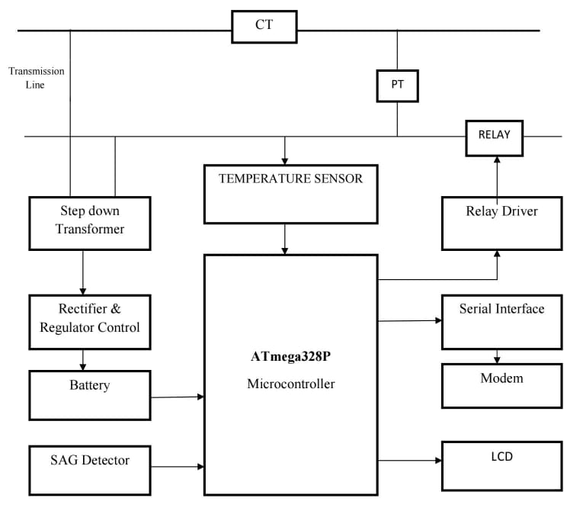
Figure-1: Block Diagram

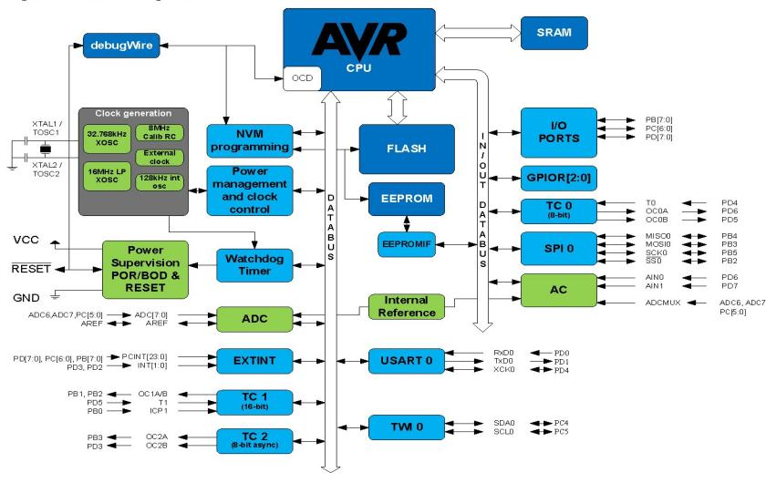
Figure-2: Micro-controller Block Diagram

3.HARDWARE CONFIGURATION

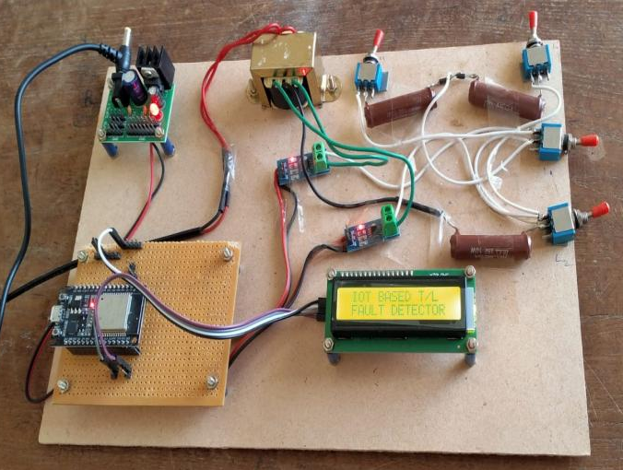
Figure-3: Hardware Setup

AC Voltage Step-Down: A 230V AC input is applied to the primary winding of a transformer, which steps down the voltage to 15V AC across the secondary winding. This lower voltage is suitable for powering the subsequent components of the circuit.

Rectification using Diodes: Solid-state diodes are used for rectification, allowing current flow in one direction only. During the negative half-cycle of the AC input, electrons conduct through the diodes, ensuring unidirectional current flow for rectification.

Bridge Rectifier for Full Wave Rectification: A bridge rectifier configuration, employing four diodes (e.g., 4*IN4007 diodes), is utilized for full wave rectification. This setup efficiently converts AC voltage to pulsating DC, which is then further filtered to provide a steady and constant DC output.

Micro-controller (ATmega328) Control: The ATmega328 micro-controller serves as the central processing unit, featuring various digital I/O pins (including PWM outputs), analog inputs, and precise timing with a 16 MHz crystal oscillator. It provides control and interfacing capabilities within the circuit.

Alphanumeric LCD Display (HD1234): An HD1234 alphanumeric LCD is used for visual feedback and information display. Data pins are connected to the micro-controller's port D, enabling data communication and interaction with the system.

ESP8266 Wi-Fi Module for Connectivity: The ESP8266 Wi-Fi module enables wireless connectivity, integrating a TCP/IP protocol stack for IoT capabilities. It facilitates network access and can host applications independently or offload Wi-Fi networking functions from other processors.

Fault Simulation Using Switches: Faults are simulated using switches within the circuit setup. Different switch configurations create specific fault conditions, such as L-L (line-to-line) and L-G (line-to-ground) faults, which can be monitored and analyzed by the micro-controller and transmitted via the Wi-Fi module.

4.RESULTS

When the circuit is powered ON, the display shows the title name as shown in figure. When no key is pressed, i.e., no fault is present in system.
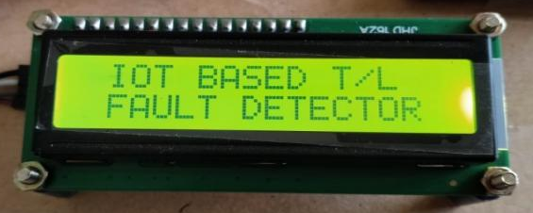
Figure-4: LCD Displaying name
When L₁/L₂ switch is pressed, transmission line under goes phase to ground fault which in turns shows in LCD display as below:
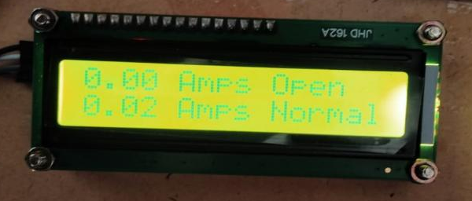
Figure-5: LCD Displaying L-G fault

The analysis of fault detection and location system of transmission line. Whether it is any type of fault that can be detected and located. When fault get occurs on the transmission line, the signal is send to the mobile phone. The message receive on the mobile that is the fault which is like
L-G & L-L. The signal that appears on the control room or mobile phone is the L-G or any other type of fault occurred on the transmission line.

5.CONCLUSION
The IoT-based Wi-Fi module system for transmission line fault detection signifies a transformative leap in utility monitoring, fostering proactive fault prevention and cost-effective maintenance. Its wireless deployment and predictive analytics bolster reliability, energy efficiency, and service quality, paving the way for broader adoption and integration into utility networks.

REFERENCES

- Chen, M., Li, X., Li, Y., & Zhang, W. (2021). Fault Diagnosis of Transmission Lines Based on Convolutional Neural Network. IEEE Transactions on Power Delivery, 36(2), 1062-1072.
- Kumar, V., Pappula, L., & Kamarajugadda, R. K. (2020). IoT Based Fault Detection and Identification in Overhead Transmission Lines. IEEE Transactions on Power Delivery, 35(1), 407-416.
- Arti Sanganwar, Kapil Chalkhure, Shivani Jijankar, Anand Dhore, Prof. Vikramsingh R.Parihar "Transmission Line Multiple Fault Detection" ISSN: 2393 - 8374, (Online): 2394 - 0697, Volume-4, Issue - 10, 2017.
- T. Takagi, Y. Yamakoshi, M. Yamaura, R. Kondow, and T. Matsushima,“Development of a new type fault locator using the one-terminal voltage and current data,” IEEE Trans. Power App. Syst.,vol. PAS-101, no. 8, pp. 2892–2898, 1982.

