Metamaterial-Inspired Electrically Compact Triangular Antennas Loaded with CSRR
Sivasankari Narasimhan¹, Pooja A², Paavai Shree K³
¹Associate Professor, Department of ECE, Mepco Schlenk Engineering College
²UG student, Mepco Schlenk Engineering College
³UG student, Mepco Schlenk Engineering College

---------------------------------------------------------------------***---------------------------------------------------------------------
Abstract - In this paper, simulation of two distinct kinds of metamaterial (MTM) antennas are proposed for fifth generation (5G) indoor distributed antenna systems (IDAS). Both antennas operate in the sub-6 GHz 5G band, i.e., 3.5 GHz and to analyze various factors like gain, directivity, return loss, radiation intensity for the frequency of 3.5 GHz. The simulation of this metamaterial antenna is carried out in ANSYS HFSS v2021. Results like return loss, radiation pattern, 3D polar plot, side lobe level, beamwidth, radiated power, accepted power have been obtained using HFSS v2021. This research on metamaterial gives a great view on how it can be designed and used at 3.5GHz frequency has a measured gain/bandwidth characteristic of 100 MHz/2.6 dBi and 700 MHz/2.3 dBi, respectively. The main advantage of this antenna is it can be used as both transmitting and receiving antenna.

Key Words: Metamaterial, CSRR, return loss, triangular CSRR

1.INTRODUCTION

Metamaterial antennas are a class of antennas which use metamaterials to increase performance of miniaturized (electrically small) antenna systems. Their purpose, as with any electromagnetic antenna, is to launch energy into free space. However, this class of antenna incorporates metamaterials, which are materials engineered with novel, often microscopic, structures to produce unusual physical properties. Antenna designs incorporating metamaterials can step-up the antenna's radiated power. Conventional antennas that are very small compared to the wavelength reflect most of the signal back to the source. A metamaterial antenna behaves as if it were much larger than its actual size, because its novel structure stores and re-radiates energy. Established lithography techniques can be used to print metamaterial elements on a PC board. The use of metamaterials in antenna design is an attractive trend not only to reduce the size, improve the power gain, enhance bandwidth but also to design multifrequency-band antennas. The unit cells of metamaterials can be used as radiation components, a part or loaded part of the ground plane of the antenna.Some advantages of using metamaterial structures are :
- Metamaterial antenna design has size five times smaller with wider bandwidth.
- It does not require active phase shifters or amplifiers unlike traditional phased array antenna.
- It offers wide angle scanning and excellent beam performance.
- It offers electronically controlled pointing and polarization.
- It consumes very low power.
- Antennas are flat, light in weight and small in size.
- It uses software to steer instead of mechanical parts.
- It is compatible for planar integration with other components.
Let us discuss about some works related to metamaterial structure.
Arshad Karimbu Vallappil et al[1]., proposed the design of two distinct kinds of metamaterial (MTM) antennas are proposed for fifth generation (5G) indoor distributed antenna systems (IDAS). Both antennas operate in the sub-6 GHz 5G band, i.e., 3.5 GHz. The antenna’s radiating structure is based on a combination of triangular and rectangular patches, as well as two complementary split-ring resonators (CSRR) unit-cells etched on the top layer. The bottom layer of the first MTM antenna is a complete ground plane, while the bottom layer of the second MTM antenna is etched by a 3 X3 cross-slot MTM structure on the ground plane.The use of these structures on the ground plane improves the antenna bandwidth. The proposed antennas are designed using two different substrates i.e., a high-end Rogers thermoset microwave materials (TMM4) substrate (h = 1.524 mm/Er = 4.5/tan d = 0.002) and a low-end flame-resistant(FR4) epoxy glass substrate (h = 1.6 mm/Er = 4.3/tan d = 0.025), respectively. The two MTM antennas have an overall dimension of 18 _ 34 mm2, demonstrating that the proposed design is 60 percent smaller than a standard microstrip patch antenna (MPA). The two proposed MTM antenna designs with complete ground plane and 3X3 cross-slot MTM on the bottom layer using FR4 substrate have a measured gain/bandwidth characteristic of 100 MHz/2.6 dBi and 700 MHz/2.3 dBi, respectively.

Md. Mehedi Hasan et al.[2].,proposed a design of low-profile Split Ring Resonator loaded metamaterial inspired antenna for Bluetooth/WiFi/WLAN/WiMAX communication systems. The antenna’s overall dimensions are 30 × 31 mm2 where two metamaterial unit cells are placed parallel to each other and a zig-zag feed line is connected with the SubMiniature version A connector. The defected ground technique was used to improve the antenna’s operational bandwidth.The Agilent N5227A VNA and anechoic chamber-based Satimo Star Lab were used to measure the antenna’s scattering parameters, voltage standing wave ratio, gain, efficiency and radiation patterns. The proposed metamaterial antenna had 200 MHz (2.40–2.60 GHz) and 390 MHz (3.40–3.79 GHz) overall bandwidth, which are similar to the simulated data. The measured results were applicable for Bluetooth (2.40–2.485 GHz), WiFi (2.4 GHz), WLAN (2.40–2.49 GHz and 3.65–3.69 GHz), and WiMAX (3.40–3.79 GHz) applications. The antenna’s average gain was 1.50 dBi, with the maximum and minimum gains of 2.25 dBi and 0.88 dBi, respectively, in addition to omnidirectional radiation patterns at operating bands.
Mahmoud Abdelrahman Abdallaet al.[3].,proposed the design meta-material inspired loaded monopole antenna for multiband operation are reported. The proposed antenna consists of multi resonators inspired from half mode composite right/left handed cells, which has a simple structure, compact size, and provides multiband functionalities.The antenna's operating principle and design procedures with the aid of electromagnetic full wave simulation and experimental measurements are presented. The antenna has good omnidirectional patterns at all three bands. The monopole patch size is 13.5 × 6.5 mm2 and the whole antenna size (including the feed line) is 35 × 32 mm2. Compared with conventional single band microstrip patch radiator, the radiator size of this antenna is only 8.5% at 2.5 GHz, 17% at 3.5 GHz, and 37% at 5.5 GHz.

M.Vinothet al[4].,proposed the square patch metamaterial antenna using Arlon AD 1000 (tm) substrate. The proposed antenna is designed to be compact in size, higher gain and suitable for higher frequency bands. This antenna has been modeled with square patch and pi shape reflectors to achieve precise narrowband operation.The measured results shows that the square patch metamaterial antenna has a return loss of -15dB at 15.5GHz and -23dB at 19.1GHz, meanwhile it has a gain of 2dB and directivity of 3dB. This antenna was designed for satellite applications such as live broadcasting, naval satellite downlink application, etc.

Jiafeng Zhouet al.,[5] writes a comprehensive review of metamaterials and meta surfaces for wireless power transfer (WPT) and wireless energy harvesting (WEH) is presented in this paper. According to the features of the electromagnetic field from the source to the receiver, WPT is divided into nonradiative near-field technology and radiative (near and farfield) technologies. Many different and important designs are reviewed and compared. It is shown that metamaterials and meta surfaces can significantly improve the power transfer efficiency and operational distance for WPT systems. A rectenna is a critical element for both WPT and WEH. It is shown that metamaterial-based rectennas can achieve a higher RF to DC conversion efficiency. Furthermore, metamaterials can also be used as either parasitic elements or loading components to improve performance in terms of circuit size, beamwidth, and conversion efficiency.

2. Method of design
The design of antenna focused at 3.5 GHz.
Where Patch length 23mm; Patch width : 14mm ; Feed length 17mm ; Feed width 1.6mm
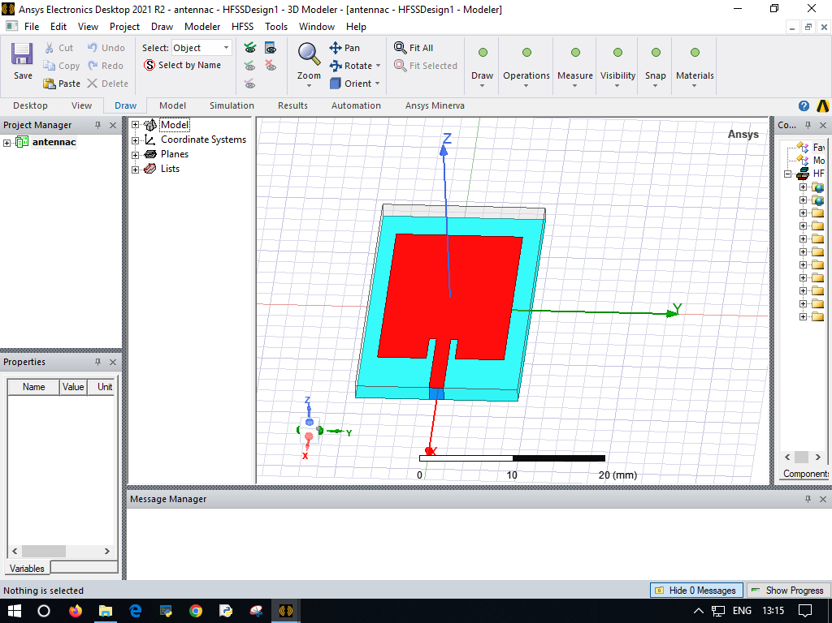
Figure 1 : Basic microstrip patch antenna
From this using polyline the triangular patch of side-length 14 mm is created. CSRR structures are created using the circular CSRR structure.; then it is subtracted from the main patch. The final structure after subtracting it from patch is as shown in the Figure 2.

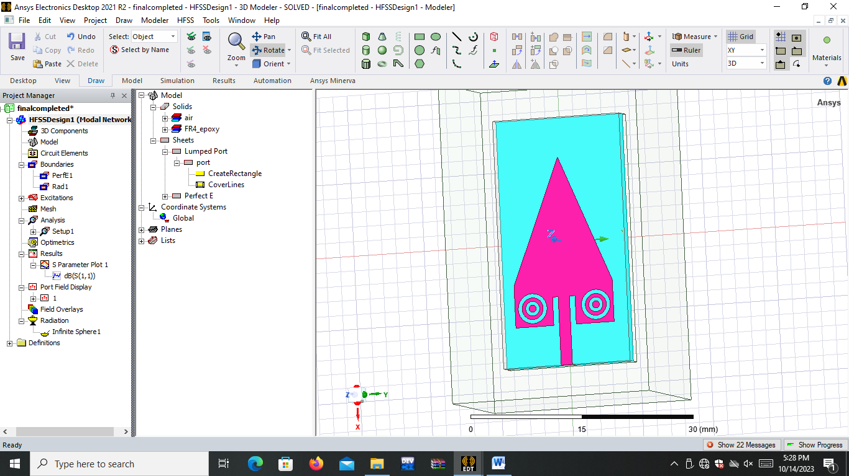
Figure 2: Triangular patch-CSRR structure
At the back side, some frequency selective parts are introduced in backside.

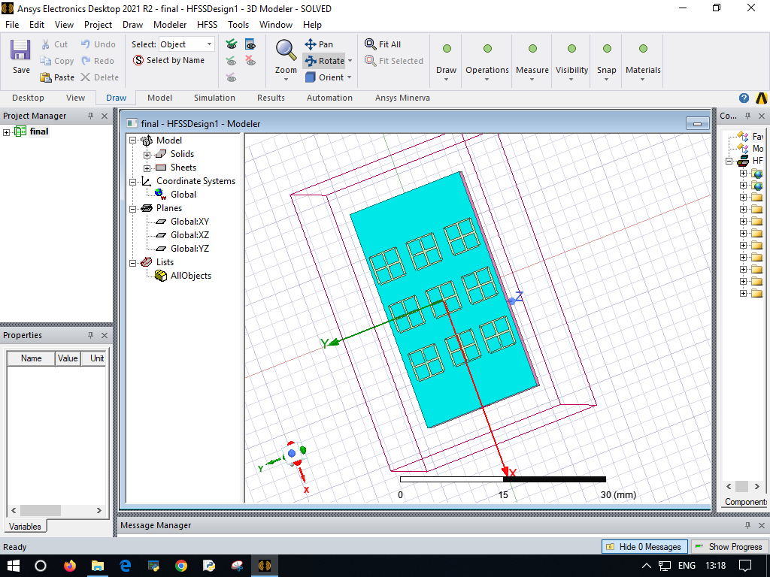
Figure 3 : Back side structure

3. Simulation results and discussion
Return loss: At 3.5 GHz and 6 and 6.5 GHz return loss of about -25 dB has been obtained.
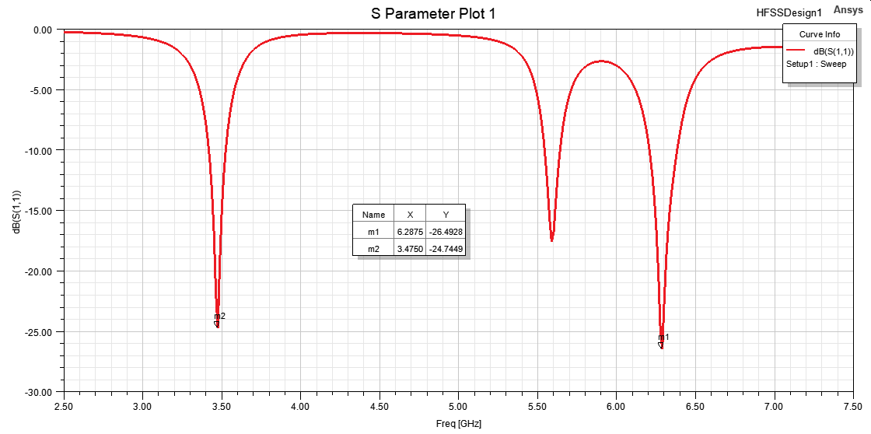
Figure 4 : Return loss

VSWR: At the above specified frequencies, nearly 1.04 VSWR is obtained. Return loss and VSWR results are portrayed in Figure 4 and 5 respectively. Radiation pattern and gain pattern results are given in Figures 6 and 7 respectively.

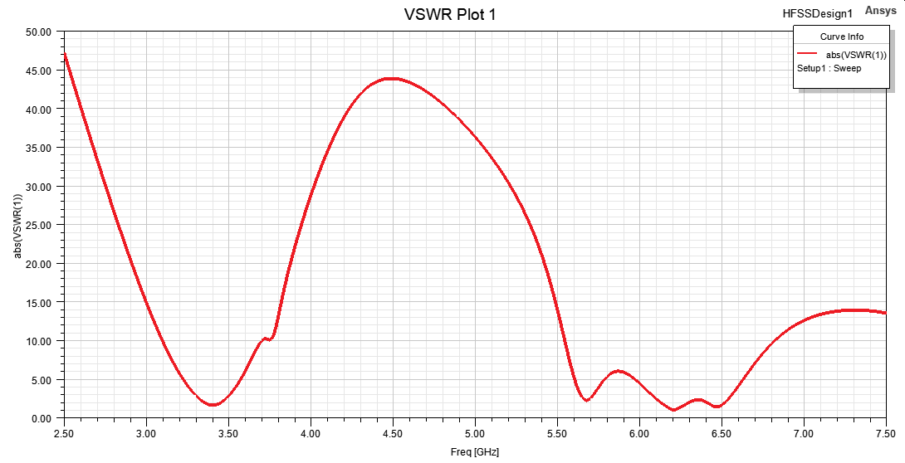
Figure 5: VSWR

Radiation pattern
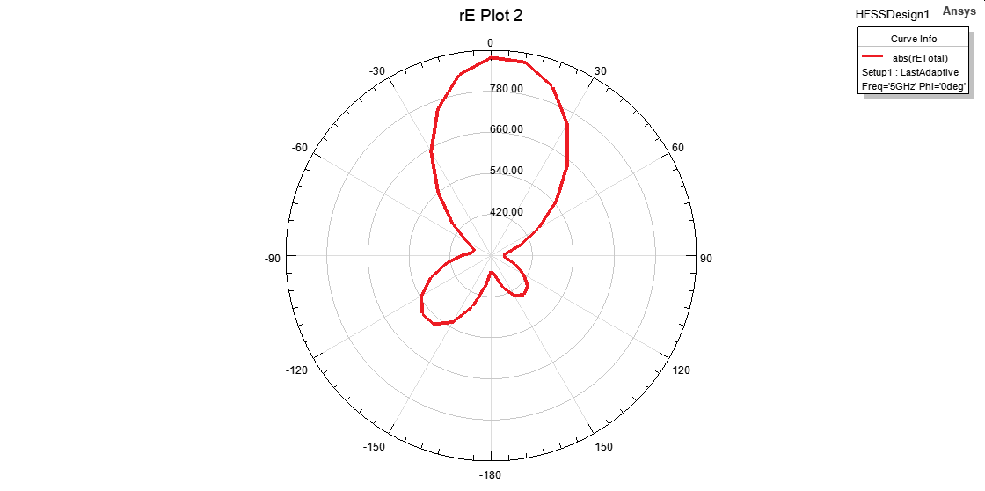
Figure 6 : Radiation pattern
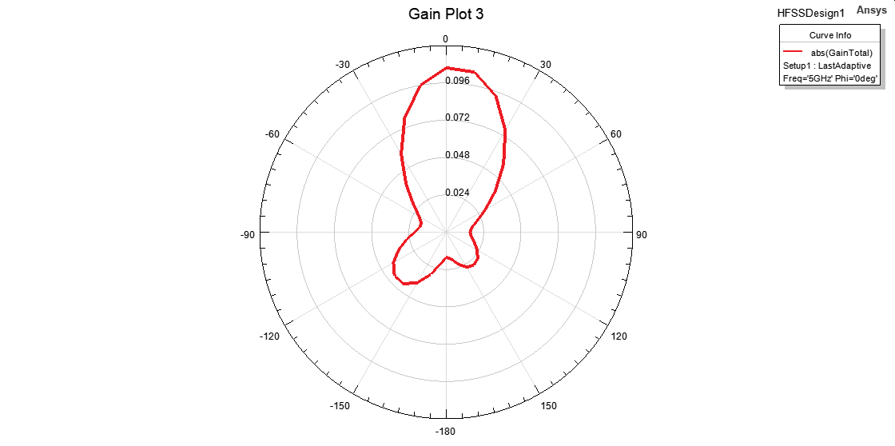
Figure 7 : Gain pattern

Electric field distribution plot: Maximum of 1883 V/m electric field distribution is obtained over the surface of this patch antenna.

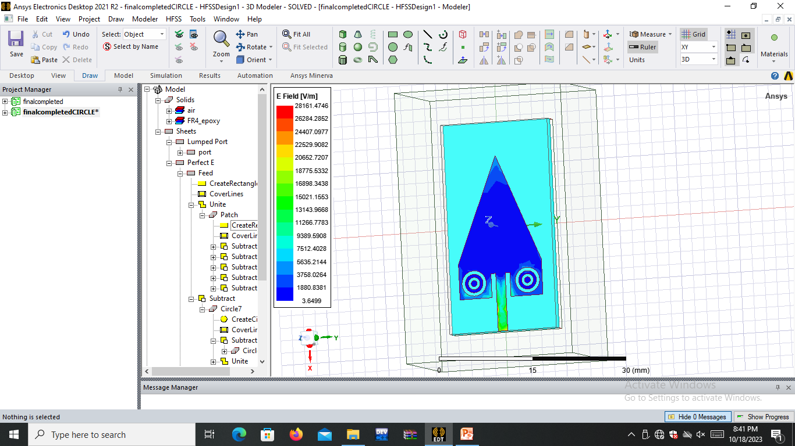

Table -1: Sample Table format

PARAMETER | VALUE
Peak directivity | 1.2823
Peak gain | 5.56 dB
Radiation efficiency | 82.46 %
Radiated power | 10.03mW
Front to back ratio | 6.4837

3. CONCLUSIONS

The metamaterial is mainly used in Wideband and multiband operation. Metamaterial antennas can be designed to operate across broad frequency ranges or support multiple frequency bands simultaneously. This versatility is valuable in applications such as broadband wireless communication, cognitive radio systems, and software-defined radios. This metamaterial antenna using line feed is simulated in Ansys HFSS v2021. According to the simulated results the return loss is -22.65dB at 3.5 GHz and gain is 0.10569dB for the metamaterial antenna. Thus, the designed antenna can be used for broadband wireless communication, cognitive radio systems, and software-defined radios. Thus, optimization of the antenna properties is done successfully over the HFSS software platform.

REFERENCES

1. Karimbu Vallappil, A.;Khawaja, B.A.; Rahim, M.K.A.;Iqbal, M.N.; Chattha, H.T.,”Metamaterial-Inspired Electrically Compact Triangular Antennas Loaded with CSRR and 3X 3 Cross-Slots for 5G Indoor Distributed Antenna Systems. Micromachines 2022, 13, 198. https://doi.org/10.3390/mi13020198

2. Md.Mehedi Hasan et al " Electrically Compact SRR-Loaded Metamaterial Inspired Quad Band Antenna for Bluetooth/WiFi/WLAN/WiMAX System Electronics 2019, 8(7), 790; https://doi.org/10.3390/electronics8070790

3. Mahmoud Abdelrahman Abdalla “Analysis and design of a triple band metamaterial simplified CRLH cells loaded monopole antenna” International Journal of Microwave and Wireless Technologies Cambridge University Press and the European Microwave Association, 2016 doi:10.1017/S1759078716000738

4. M.Vinoth “Design and Analysis of Wideband Metamaterial Patch Antenna” International Journal of Scientific Research & Engineering Trends Volume 6, Issue 3, May-June-2020.

5. Jiafeng Zhou “Metamaterials and Metasurfaces for Wireless Power Transfer and Energy Harvesting” INSPEC Accession Number: 21525595 Publisher: IEEE Volume: 110, Issue: 1, January 2022

