Detection of Animal and Human Trespassing Using Deep Learning Techniques
Peruru Vishmati¹, Begari Prashanth Raj², Harshit Goyal³, Kritika Sonare⁴
---------------------------------------------------------------------***---------------------------------------------------------------------
Abstract - Human-wildlife conflict poses a major threat in agricultural fields and forests, leading to significant resource loss and endangering lives. This conflict has devastating consequences, causing people to lose their homes, vehicles, crops, and sometimes even their lives. To address this issue, continuous monitoring of these areas is crucial to prevent wild animals from entering. This document proposes a system for building a field monitoring device that utilizes a Camera and Deep learning. The system first captures an image of the trespassing animal or human and then employs a specific deep-learning technique to identify it. This approach allows the system to classify animals and humans in the form of photos and notify the user accordingly, potentially preventing further conflict and safeguarding both humans and wildlife.

Key Words: CNN, ReLU, Sigmoid, Softmax, Polling, Arduino, Raspberry pi

1.INTRODUCTION

Wild animals pose a growing threat on our roads, with species like tigers, elephants, deer, and leopards causing frequent accidents in forested areas. Human-animal collisions have risen significantly in recent decades, impacting wildlife populations, causing property damage, and endangering human lives. This rise in conflict stems from several factors, including human encroachment on animal habitats, poaching, urbanization pushing animals closer to settlements, and even the introduction of non-native species. In India alone, over 3,000 animal deaths occurred on roads in 2022, highlighting the severe threat to wildlife.
Researchers are developing an innovative solution, an animal detection system that alerts people. This system will rely on camera-trap networks to monitor and analyze wildlife activity. However, a major challenge lies in the high level of clutter found in real-world road images, which can lead to missed detections and false alarms. To overcome this hurdle, the researchers are turning to Convolutional Neural Networks (CNNs), a powerful type of artificial intelligence. By leveraging CNN features alongside data from a comprehensive camera-trap database containing information on potential animal species, this system aims to create a robust animal and human detection algorithm.
This system employs a multi-pronged approach to effectively identify and alert people of approaching wildlife. Firstly, ultrasonic sensors strategically placed at field corners detect animal incursions, triggering a camera to capture images of the trespassing animals. This ensures animal detection even in low-light conditions, as the system is equipped with motion sensors and cameras, allowing it to function effectively both in daylight and at night.
Furthermore, the system utilizes a powerful machine learning algorithm called a Convolutional Neural Network (CNN). Trained on a vast dataset encompassing various scenarios, this algorithm boasts an impressive accuracy of around 84.89% in identifying animals. This comprehensive approach aims to significantly reduce the number of animal-human intrusion by providing an alert message to warn people.
2.Related Works
^{[1]} The aim of the research conducted by Shahram Taheri is to develop a novel method for animal face classification using score-level fusion of convolutional neural network (CNN) features and appearance-based descriptor features. The method involves combining information from two different types of classifiers to improve classification accuracy. The proposed method utilizes CNN as an automatic feature extractor and kernel Fisher analysis (KFA) for feature extraction. Experimental results demonstrate that the score-level fusion approach significantly improves the classification accuracy, achieving a 95.31% classification rate on animal faces, outperforming other state-of-the-art methods. ^{[2]} The main idea of the research conducted by A.W.D. Udaya Shalika and Lasantha Seneviratne is to develop a system using image processing and machine learning techniques to automatically detect and recognize wild animals, addressing the challenges faced by animal researchers and wildlife photographers. The techniques used include feature extraction using the ACE media project, support vector machine (LIBSVM) for probabilistic outcomes, and the use of multiple descriptors for animal recognition. The results show that combining descriptors led to improved recognition accuracy for both positive and negative images of animals. ^{[3]} The objective of the document developed by Anand Rakesh in Animal Trespassing Detection System using cameras and image processing is to detect animals like elephants and wild boars in agricultural fields, particularly in the northern region of Kerala, India. The technique involves the use of machine learning and deep learning algorithms for real-time animal and human detection, alerting forest officials and the public of potential threats, and reducing panic due to false alarms. The system aims to identify animals and issue alarms when a threat is detected, ultimately minimizing human casualties and preventing damage to agricultural fields. The result acquired is the successful development of a system that can detect and classify animals, issue alerts, and aid in preventing human casualties and agricultural damage caused by animal trespassing. ^{[4]} The aim of the study conducted by Felix A. Wichmann and his team was to assess whether human observers make use of power spectral differences between animal and no-animal images when rapidly classifying natural scenes. The technique involved conducting a series of experiments using spatial 2-AFC discrimination tasks and Fourier analysis of images from the Corel database. The results showed that human observers' ability to rapidly detect animals in the images was essentially independent of the power spectrum, suggesting that they rely on local features such as edges and contours rather than global power spectrum. Additionally, the study found evidence suggesting that the spectral differences between animal and no-animal images in the Corel database may be an artifact of the image capturing process. ^{[5]} The main idea of the research conducted by Sachin Umesh Sharma is the development of a practical animal detection and collision avoidance system using computer vision techniques, specifically for Indian highways. The system utilizes a combination of Histogram of Oriented Gradients (HOG) and boosted cascade classifier for animal detection, achieving an accuracy of approximately 82.5%. The study addresses the challenges of detecting animals on highways, such as varying backgrounds and moving objects, and proposes a method to alert drivers and prevent collisions with animals. The system aims to detect animals up to a distance of 20 meters and provide different alert messages based on the animal's proximity to the vehicle. ^{[6]} The aim of the research conducted by Marcel P. Huijser and Patrick T. McGowen is to provide an overview of animal detection and animal warning systems in North America and Europe, with a focus on their operational status, characteristics, and potential impact on reducing animal-vehicle collisions. The techniques used include categorizing the systems into area-cover and break-the-beam systems, identifying unique systems, and describing their parameters such as location, target species, technology, and installation costs. The result is a comprehensive account of 27 operational and planned locations for these systems, highlighting their effectiveness, limitations, and the need for further research and development. ^{[7]} The paper published by Zhi Zhang - Animal Detection from Highly Cluttered Natural Scenes Using Spatiotemporal Object Region Proposals and Patch Verification focuses on animal object detection and segmentation from wildlife monitoring videos captured by camera-traps. It aims to address the challenges of low detection rates due to low contrast and high false positive rates from dynamic backgrounds. The authors developed a spatiotemporal object proposal method using multilevel graph cut and a cross-frame temporal patch verification method. They also constructed an efficient feature description for animal detection using joint deep learning and histogram of oriented gradient features encoded with Fisher vectors. The proposed framework demonstrated superior performance over state-of-the-art methods, including Faster-RCNN, improving animal object detection accuracy by up to 4.5% on challenging camera-trap data. ^{[8]} The paper Titled Animal Detection in Natural Images: Effects of Color and Image Database, aimed to investigate the role of low-level image features in the recognition of objects (specifically animals) within natural scenes. The researchers recorded saccadic eye movements and event-related potentials (ERPs) while human subjects detected animals in previously unseen natural images. Two experiments were conducted using a new natural image database called ANID (Animal Natural Image Database). The ANID was specifically designed to avoid potential artifacts present in other commonly used image databases. Color and grayscale images were selected from the ANID and another widely used database (COREL). The images contained animals and natural scenes. Event-related potentials (ERPs) were recorded while participants performed animal detection tasks. The researchers analyzed the N1 component of the EEG signal, which reflects early visual processing. Comparison: The study compared the influence of color and grayscale images on animal detection performance and ERP responses. The researchers concluded that the ANID database is better suited for investigating natural scene processing than other commonly used databases. Color images induced a greater N1 EEG component at earlier time points than grayscale images. Both ANID and COREL images showed ultra-fast processing of animal images, irrespective of the specific database. The difference between color and grayscale images was more pronounced in the ANID database, suggesting that color plays a significant role in animal detection. The study highlighted the importance of using appropriate image databases for investigating natural scene processing. ^{[9]} The goal of Night vision animal detection, paper published by David Forslund is to reduce traffic accidents involving animals, a major global traffic concern. Autoliv developed a vehicle-mounted night vision animal detection system, using: A cascade boosting classification approach robust to occlusion, pose, and scale variations. A large FIR video data database with hundreds of thousands of animal images in traffic. A tracking approach for animal movement and state estimation. A validation approach to minimize false detections. Advanced HMIs like marking lights to actively illuminate at-risk animals. The system detects animals up to 200 meters away with very few false warnings and provides quick, accurate information to the driver to avoid potential accidents. It is used by Audi, BMW, and Daimler and is the first to reach the customer market. ^{[10]} The study conducted by Y.H. Sharath Kumar in a paper titled Animal Classification System: A Block-Based Approach proposes a method for classifying animals in images. It focuses on segmenting the animal from the background and then partitioning the segmented images into blocks for feature extraction. The authors used a graph cut based method for segmentation and extracted color texture moments from the blocks. For classification, they employed Probabilistic Neural Network (PNN) and K-Nearest Neighbors (KNN) algorithms. An experiment with a dataset of 25 classes of animals and 4000 sample images showed that the KNN classifier achieved good performance in terms of classification accuracy. ^{[11]} The aim of the study conducted by John E. Trowbridge in the paper Alternative Conceptions in Animal Classification: A cross-age Study is to examine students’ alternative conceptions of animal classification across different educational levels—elementary, secondary, and college. The study utilized a cross-age design, clinical interviews, a classification task, and a multiple-choice/free-response instrument to probe understanding. Students often have a restricted view of animals, mostly labeling vertebrates, particularly common mammals, as animals. A variety of alternative conceptions emerged when students were asked to distinguish between vertebrate and invertebrate animals and to classify species into vertebrate groups. Some alternative views persisted throughout the school years, while others were corrected through formal instruction or non-school experiences. ^{[12]} The research paper titled “Understanding Students Ideas about Animal Classification” was conducted by Zofia Anna Chyleńska and Eliza Rybska from the Department of Nature Education and Conservation at Adam Mickiewicz University in Poznań, Poland. The aim of the study was to investigate Polish students’ conceptions and attitudes towards animal classification and to identify discrepancies between these and current scientific knowledge. The researchers employed surveys and in-depth interviews with 34 primary school pupils to gather data. The results revealed that students had similar ideas about animal classification and recognized its purpose but struggled with practical application. They tended to use different criteria for classifying animals compared to the scientific community, such as the animals’ diet, respiratory system, and utility for humans. The study suggests that educational lessons on animal classification should emphasize these aspects more. ^{[13]} The research paper titled “Aquatics, Flyers, Creepers and Terrestrials — students’ conceptions of animal classification” was conducted by Ulrich Kattmann. The aim of the study was to investigate the criteria students use for classifying animals, particularly focusing on whether they prefer habitat and locomotion as the basis for classification. The technique involved analyzing students’ classification choices and comparing them to biological taxonomy. The results revealed that students indeed favored classifying creatures based on their habitat and method of movement, even after being taught the scientific categories of taxonomy. This led to the hypothesis of an implicit theory of natural kinship among animals. The paper discusses the implications of these findings for biology education, especially in the areas of taxonomy, biodiversity, and evolution. The study emphasizes the need for educational strategies that address students’ intuitive classifications and align them with scientific concepts. ^{[14]} The research paper titled “PCA-Based Animal Classification System” was conducted by Emre Dandil and Rukiye Polattimur. The aim of the study was to develop a system for the recognition and classification of different species of animals using Principal Component Analysis (PCA). The technique involved creating an application software that could identify animals most resembling a given animal in an image dataset. The results of experimental studies on cow, cat, dog, goat, and rabbit species showed a high success rate, with 92% accuracy in the first nearest recognition and 83% in the second nearest recognition. The findings suggest that the PCA-based system has potential for use in classifying various kinds of animals. The paper was presented at the 2018 2nd International Symposium on Multidisciplinary Studies and Innovative Technologies (ISMSIT) in Ankara, Turkey. ^{[15]} The research paper titled “When research animals become pets and pets become research animals: care, death, and animal classification” was conducted by Alexandra Palmer, Tess Skidmore, and Alistair Anderson. The aim of the study was to explore the dynamics of care, decisions about life extension or termination, and the classification of animals as they transition between being research subjects and pets. The researchers employed in-depth qualitative research methods, focusing on three main areas: the rehoming of laboratory animals, veterinary clinical research, and the role of the Named Veterinary Surgeon (NVS) in UK animal research. Their findings revealed the complex ethical, affective, and practical elements of care that are intertwined in the laboratory setting. They also investigated the arguments for and against ending and extending animal life through clinical research and rehoming, bringing to light the norms and dilemmas surrounding animal death in both the laboratory and veterinary clinic. The study concluded by emphasizing the importance of understanding the fluid boundaries between animal categories to grasp the intricacies of care and death, contributing to the broader discourse within geography on animal care, death, and categorization. The key contributions of their work include insights into the division of care roles, the context-dependency of practices of killing, and the flexible nature of animal classifications. ^{[16]} The research paper titled “Applications of machine learning in animal behaviour studies” was authored by John Joseph Valletta, Colin Torney, Michael Kings, Alex Thornton, and Joah Madden. The aim of the study was to introduce animal behaviorists to machine learning (ML) techniques that are well-suited for analyzing complex behavioral data sets that exhibit nonlinear dependencies and unknown interactions across multiple variables. The paper reviews key ML approaches and illustrates them through case studies, demonstrating how ML can be a valuable tool in the animal behaviorist’s analytical toolkit. The techniques discussed include unsupervised and supervised learning, feature selection, and the development of data analytical pipelines for tasks such as classifying species, individuals, vocalizations, or behaviors within complex data sets. The results showcased the potential of ML to address a wide range of tasks in animal behavior research, translating complex data sets into scientific knowledge. ^{[17]} The aim of the study conducted by Michael A. Tabak was to apply machine learning techniques to classify wildlife species in camera trap images, with a focus on ecology. The researchers utilized convolutional neural networks with the ResNet-18 architecture and trained the model using over 3 million images. The trained model achieved a high level of accuracy, with the ability to classify approximately 2,000 images per minute and achieving 98% accuracy in identifying species in the United States. Additionally, the model achieved 82% accuracy in Canada and correctly identified 94% of images containing an animal in a dataset from Tanzania. The study's findings demonstrate the potential of machine learning in revolutionizing wildlife research and monitoring, particularly in the field of ecology. ^{[18]} The research conducted by Olayinka O. Ogundile discusses the application of machine learning tools to classify animals based on their unique attributes, as opposed to using image recognition methods. It evaluates the classification abilities of several ML tools, including support vector machines (SVM), K-nearest neighbours (KNN), and decision trees (random forest (RF) and J48), using a dataset from the Irvine machine learning repository. The study compares the performance of these classifiers in terms of their sensitivity and false discovery rate, with the SVM classifier exhibiting superior performance. The document emphasizes the relevance of the study in the context of animal classification and its potential applications for ecological investigations. ^{[19]} The research conducted by Wei Ouyang discusses the Human Protein Atlas (HPA) Image Classification competition, which aimed to classify subcellular protein localizations in fluorescence microscopy images. The top-ranking solutions predominantly utilized deep learning models, with variations of Resnet, Densenet, and Inception as backbone architectures. Strategies such as automated data augmentation, model ensembling, and metric learning were employed to improve model performance. The winning models significantly outperformed previous efforts, showcasing the potential for biological applications and the development of a model zoo to host the source code and trained models from the selected teams. Additionally, the document explores the use of class activation maps (CAMs) to assess the biological relevance of the winning model's predictions. ^{[20]} The aim of the research conducted by Gustavo Carneiro is to stimulate a new sub-field of art image analysis within the computer vision community by providing a comprehensive and principled investigation on artistic image understanding. The technique used involves the development and evaluation of various annotation methodologies, including random annotation, bag of features, label propagation, inverted label propagation, matrix completion, and structural learning. The results indicate that the inverted label propagation method produces the best outcomes, particularly in the automatic annotation and retrieval problems. The study also highlights the potential for future research, such as exploring context cues and the use of people and face detectors in art images to improve results.
System Representation
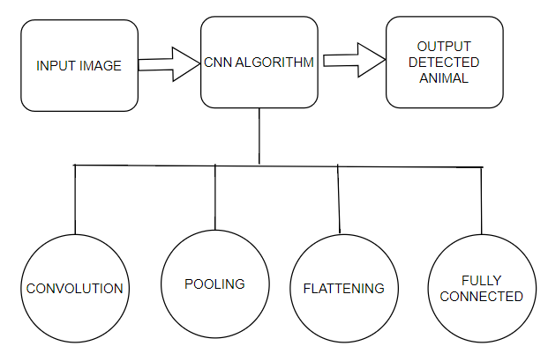
Fig.1: Block Diagram of system representation

3.Methodology
Convolutional neural network
Convolutional neural networks (CNNs) are a powerful type of artificial intelligence specifically designed to excel in analyzing data like images and text. Their ability stems from their unique architecture, incorporating several key layers :
1. Input Layer: Serves as the entry point, receiving raw data such as the pixel values of an image (typically represented as Red, Green, and Blue channels).
2. Hidden Layers:
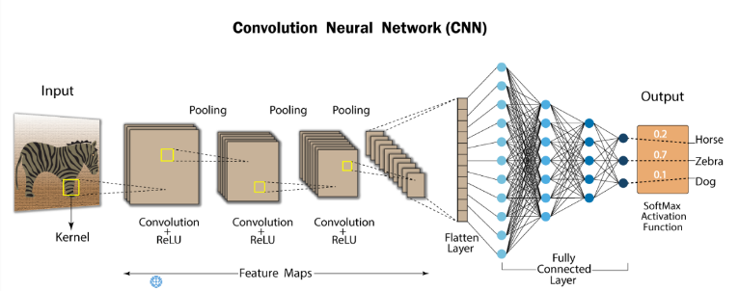
Fig. 2: Overall structure of CNN
- Convolutional (CONV) Layer: This layer is the heart of a CNN. It performs convolutions, a mathematical operation that involves sliding a filter (also known as a kernel) across the input data. This process extracts features from localized regions of the input. Each neuron in the CONV layer computes the dot product between its weights and the corresponding region covered by the filter, generating a feature map.
Input Image X Feature Detector = Feature Map
Activation Functions
It acts like a filter that decides how a neuron in an artificial neural network reacts to incoming signals like ReLU, help the network learn faster. Others, like Sigmoid and tanh, can slow things down because they make the connections between neurons too strong or too weak over time.
f (x) = max(0, x)
Classification loss functions
This measure how good a model's guesses about which category something belongs to are compared to what the actual category is. Two common functions which we used in our paper for classification are Sigmoid and Softmax, and they can also be used to calculate this loss. Sigmoid is useful for situations where there are only two categories, because it squishes the output between 0 and 1, which makes it easy to interpret as a probability.
$$σ(x) = 1 / (1 + exp(-x))$$
$$ŷ = σ(W^T h + b)$$
Before applying Softmax, the classifier outputs a bunch of numbers (unnormalized log probabilities) that don't directly represent probabilities. The Softmax function takes these numbers, puts them through a mathematical formula, and spits out easy-to-interpret probabilities as the classifier's final output.
$$z = Wᵀh + b$$
$$Softmax(zi) = exp(zi) / Σj exp(zj)$$
To know how good the prediction is we use cross entropy. It's a way to measure the difference between what the model thinks is likely (y^) and what's true (y). By minimizing this difference (loss), we train the model to get better at predicting class probabilities.
cross entropy = - Σ yi log(ŷi)
Localization Loss
The model's accuracy in localization is measured by the localization loss. This loss is calculated by comparing the predicted bounding boxes (areas around the objects) to the actual locations of the objects in the image.
Regularization loss
It acts like a penalty that discourages the model from having overly large weights for its features. By keeping the weights smaller, the model is less likely to memorize quirks of the training data and more likely to learn general patterns that apply to unseen data as well.
$$R(θ) = ||θ||₂² = Σ θi²$$

Optimizer
They take cues from the loss function, which indicates how well the model is performing, and update the model's settings to minimize that loss. We used Adam optimizer in our model. It merges the strengths of other optimizers and tackles challenges like sparse gradients and noisy data, ultimately leading to a well-performing model.
Rectified Linear Unit (ReLU) Layer: This layer applies a non-linear activation function, often ReLU, to the outputs of the CONV layer. ReLU essentially sets all negative values to zero, allowing the network to learn more complex features.
Y = max(0,x)
For Example: In a given matrix (M),
M = [[-3, 19, 5], [7, -6, 12], [4, -8, 17]]
ReLU converts it as
[[0, 19, 5], [7, 0, 12], [4, 0, 17]]
Pooling Layer: This layer performs down sampling, reducing the dimensionality of the data by summarizing local regions using techniques like max pooling (taking the maximum value) or average pooling (taking the average value). This helps to control overfitting and reduce computational costs.
4. Output Layer:
Fully-Connected (FC) Layer: This layer acts like a traditional neural network layer, where each neuron is connected to all neurons in the previous layer. It takes the flattened output from the previous layers and performs computations to generate the final results.
Convolution layer
This layer is essential for identifying crucial features within an image. This can be achieved by analyzing small, specific regions of the image data. This process involves performing calculations on two inputs: the image itself and a filter. By applying filters, convolutional layers can accomplish various tasks, such as detecting edges, blurring, and sharpening images.
Pooling
This layer plays a crucial role in managing large images by reducing the number of parameters needed for processing. Max pooling is achieved by selecting the most significant element from each section of the processed image called a feature map. Another process called as down-sampling, effectively reduces the image's overall size while retaining key features.
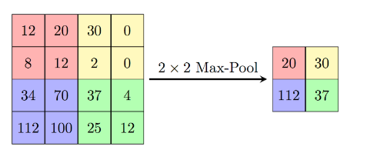
Fig.3: Diagram representing Max Pooling
Flattening
In our model flattening is a critical step that transforms the multi-dimensional output from convolutional layers into a single, simplified vector. This process essentially "unfolds" the data, arranging all the elements in a continuous line. This flattened vector then becomes the input for subsequent layers, typically used for final classification tasks.

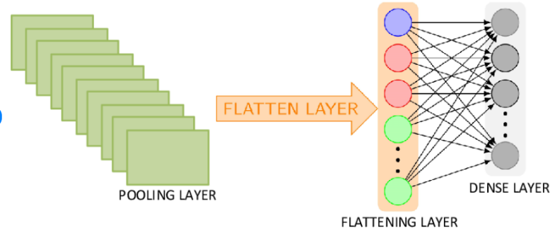
Fig.4: Structure of Flattening layer
Fully connected
It shows the hidden layers inside a Convolutional Neural Network that are called Fully Connected Layers. This is used to combine the features into more attributes that predict the outputs more accurately
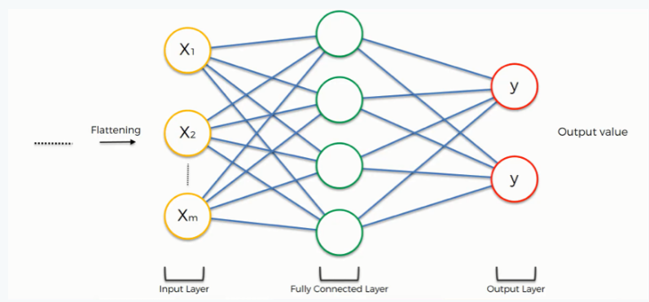
Fig.5: Fully connected layer
This system operates continuously, analyzing video feeds and motion sensor data in real time to identify potential intrusions. A built-in algorithm sifts through this data, pinpointing and classifying suspicious activity with accuracy. When an intrusion is detected, a message alert containing details is automatically generated. These details include its location and even visual evidence such as images or video clips. This text notification are then sent to designated individuals, such as security personnel or property owners, who can then take appropriate action based on the information received.
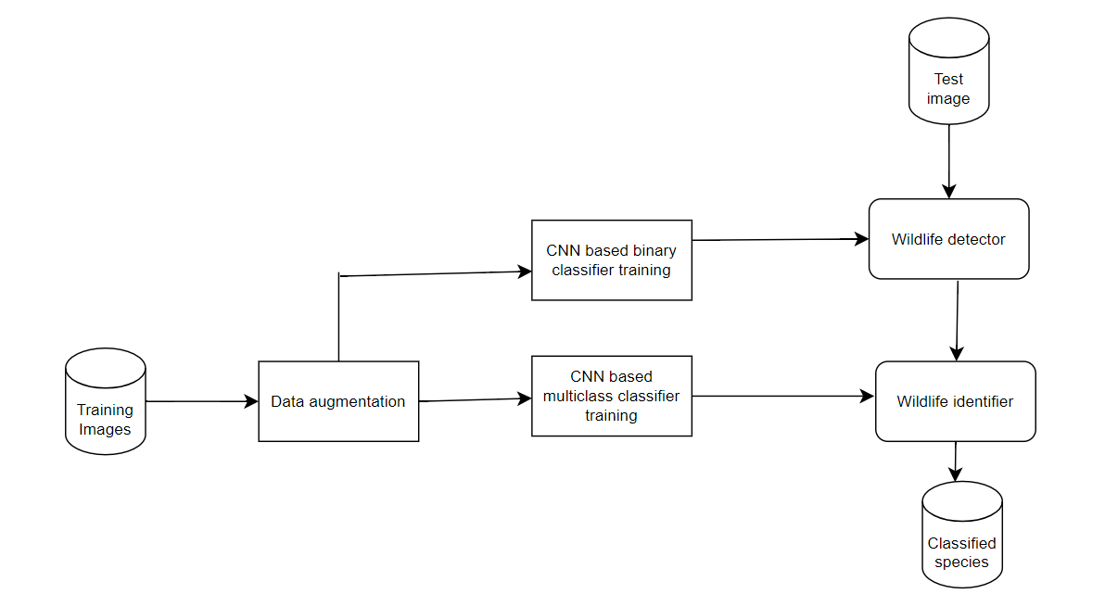
Fig.6: Overall diagram of systems Trained images
An in-depth study of camera traps using deep learning
Camera traps are a great way to study wildlife because they're cheap, easy to set up, and don't bother the animals. However, going through millions of pictures they take can be super time-consuming. That's where computer vision, especially a type of AI called convolutional neural networks (CNNs), comes in. These tools can automatically analyze the images and pick out the interesting stuff, saving researchers a ton of time and effort.
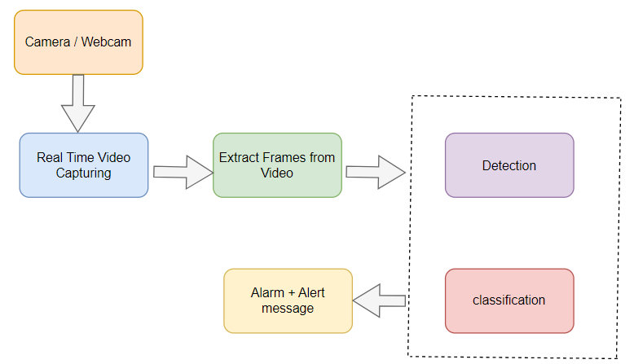
Fig.7: Representation of Capture and Alert system

Wild Animals Dataset
SL no. | Source | Images | Species Collected
1. | Google | 672 | Cheetah, Jaguar, Human
2. | Unsplash | 275 | Buffalo, Elephant, Giraffe, Leopard, Lion, Rhinoceros
3. | Kagle dataset | 170 | Cheetah, Jaguar, Leopard, Lion, Tiger
4. | Snapshot Kruger | 369 | Buffalo, Elephant, Leopard, Lion, Zebra
5. | Snapshot Serengeti | 943 | Buffalo, Leopard, Lion, Rhinoceros
6. | Wild_animals_Kagle | 478 | Bear, Chinkara, elephant, lion, peacock, tiger
7. | Human_detection_Kagle | 559 | Human

Table:1 – Dataset

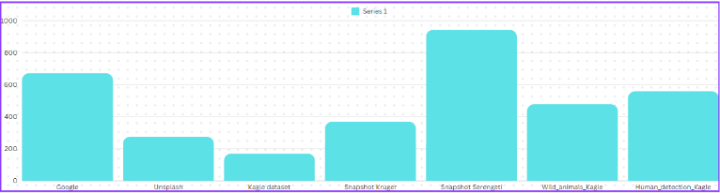
Fig.8: Representation of the distributed dataset
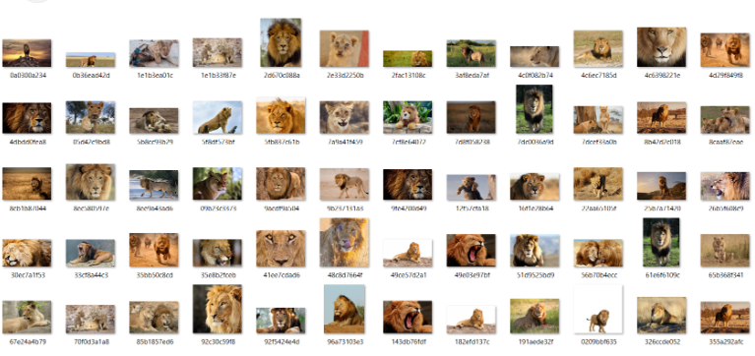
Fig.9: Lion Training dataset
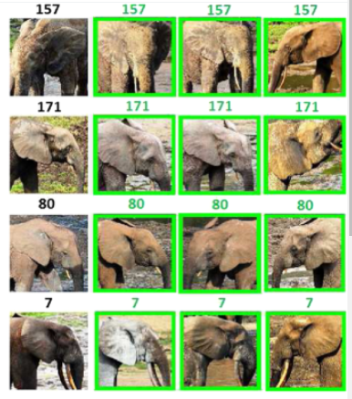
Fig.10: Elephant Testing Dataset
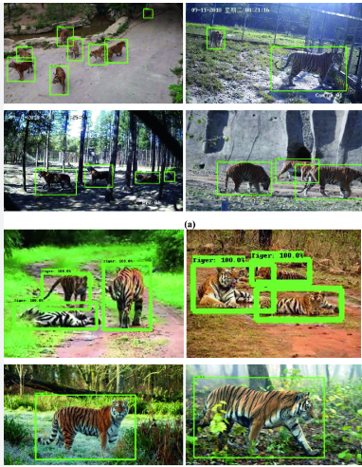
Fig.11: Image Capturing of Tigers

Result and Evaluation
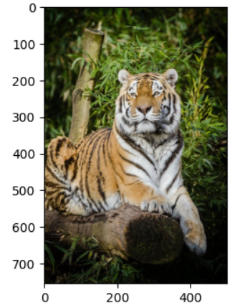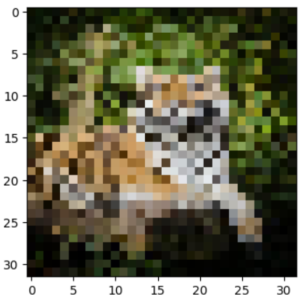
Fig.12: Sample Image Captured
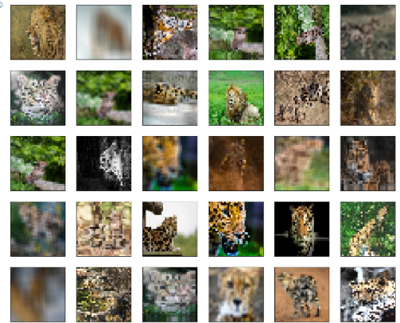
Fig.13: Tiger Testing Dataset
The concept of Precision and Recall are necessary to build a complete machine learning model that produces more precise and accurate results. Some machine learning models require more accuracy and some models require more memorization. So it is important to create balance between accuracy and recall.
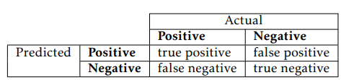
Table:2 - Terms to describe the relationship between the predicted detection and the actual.
Precision
It is the ratio of true positives to true positives to false positives. This indicates how close the measurement values ​​are to each other..
precision = true positive / (true positive + false positive)
Recall
It is the ratio of true positives to true positives and false negatives. It represents the ability of the model to find all relevant cases in the data set..
recall = true positive / (true positive + false negative)
F1- Score
The F1 score is an evaluation matrix that combines two matrices: precision and recall into one metric by taking their harmonic mean. Simply put, the f1 score is a weighted average of precision and recall.
F1 = 2 * P * R / (P + R)
F1 = (2 * Precision * Recall) / (Precision + Recall)

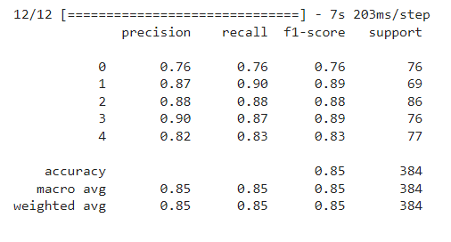
Fig.14: Precision, Recall, F1-Score results
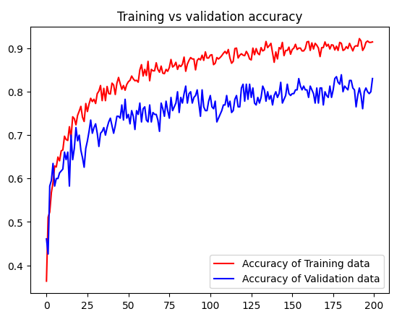
Fig.15: Training vs Validation accuracy
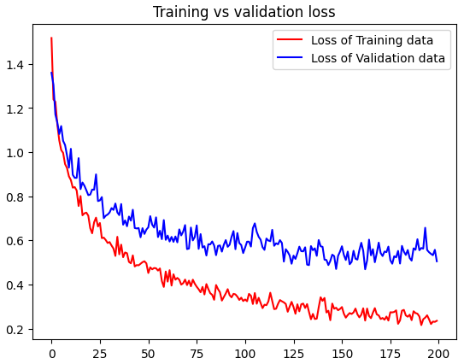
Fig.16: Training vs validation loss

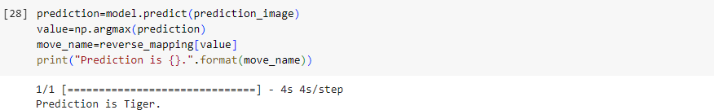
Fig.17: Accurate Prediction of Captured Image

Fig.18: Accuracy Obtained

Alarm and Alerting: -
Mobile integration of image intrusion detection alerts
Mobile modules provide a reliable way to send intrusion alerts with images taken from remote locations. Here's a detailed breakdown of how it works:
Components: -
Cellular Module: This small electronic device connects your system to the cellular network. It usually contains a SIM card like a phone. Choose a module compatible with your chosen carrier and network (2G, 3G, 4G, etc.).
Microcontroller: It acts as the brain of your system, processing the image data from your camera and operating the cellular network, and intrusion detection modules such as Raspberry Pi and Arduino.
Camera: Choose an appropriate camera for your application (day/night vision, resolution) to which your microcontroller can be connected.
How the Process works: -
1. Trespass Detection: A deep-learning CNN model running on your microcontroller analyzes the camera input after detecting an animal or human intruder, it will trigger the alarm
2. Image capture: The microcontroller instructs the camera to take a picture of the intruder. Depending on the module and camera capabilities, this can be a single image or a short video.
3. Activation of the cellular module: The microcontroller sends a message to the mobile phone, which initiates a connection to the cellular network.
4. Structure of an alert message: The microcontroller generates an alert message that may contain, a text message about the intrusion event. Captured image data that is compressed (eg JPEG) for efficient transmission.
5. Message Transmission: The cellular module sends a formatted message (text and image) to predefined phone numbers or to a server.
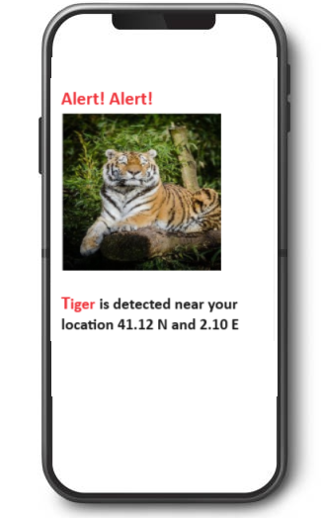
Fig.19: Sample Alerting Message
CONCLUSION
This research paper presents a comprehensive system for detecting animal and human trespassing using deep learning techniques, particularly Convolutional Neural Networks (CNNs). By leveraging a combination of camera traps, motion sensors, and CNNs, the system can accurately identify and classify various species and humans in real time. The integration of this technology addresses the pressing issue of human-wildlife conflict, which poses significant risks to both human safety and wildlife conservation.
The system's architecture involves capturing images through strategically placed cameras, analyzing these images using CNNs trained on extensive datasets, and generating real-time alerts to notify users of potential intrusions. This approach not only enhances the accuracy of detection but also ensures timely intervention, potentially preventing accidents and property damage. Additionally, the implementation of a mobile integration module enables remote monitoring and immediate alerting, providing visual verification through captured images. This feature is particularly beneficial for monitoring large or remote areas, such as farms or nature reserves, where human presence is limited.
In summary, the proposed system offers a scalable and effective solution to mitigate human-wildlife conflicts by utilizing advanced deep learning techniques for real-time detection and classification with an accuracy of 84.89%. Its ability to provide accurate, timely alerts can significantly enhance safety measures, protect resources, and contribute to wildlife conservation efforts.
Future Work
Future research can focus on improving the system's accuracy and robustness by incorporating additional sensors, such as thermal cameras, to enhance detection capabilities under various environmental conditions. Further development of lightweight detection algorithms can enable the system to run on low-power devices, making it even more accessible for remote and resource-constrained areas. Additionally, integrating machine learning models that can predict potential intrusion patterns based on historical data could provide proactive measures to prevent conflicts.
In conclusion, the integration of deep learning techniques in wildlife monitoring and human-animal conflict mitigation represents a significant advancement in real-time detection and classification systems. This research paves the way for more effective and scalable solutions, ultimately contributing to safer human-wildlife coexistence and enhanced conservation efforts.

REFERENCES

[1] Shahram Taheri, Onsen Toygar. Animal classification using facial images with score-level fusion.IET 2018;12:679-685.
[2] A. W. D. Udaya Shalika, Lasantha Seneviratne. Animal Classification System Based on Image Processing & Support Vector Machine. Science Research 2016;4
[3] N. Banupriya, S. Saranya, Rashmi Jayakumar, Rashmi Swaminathan, Sanchithaa Harikumar, Sukitha Palanisamy. Animal Detection Using Deep Learning Algorithm. First International Conference on Intelligent Digital Transformation ICIDT – 2019;1
[4] Felix A. Wichmann, Jan Drewes, Pedro Rosas, Karl R. Gegenfurtner. Animal detection in natural scenes: Critical features revisited. Journal of Vision April 2010, Vol.10, 6.
[5] Sachin Umesh Sharma, Dharmesh J. Shah. A Practical Animal Detection and Collision Avoidance System Using Computer Vision Technique. IEEE Access 2016;5:347-358
[6] Marcel P, Patrick T. Overview of animal detection and animal warning system in North America and Europe. UC open Access Publication 2003
[7] Zhi Zhang, Zhihai He, Guitao Cao, Wenming Cao. Animal Detection From Highly Cluttered Natural Scenes Using Spatiotemporal Object Region Proposals and Patch Verification. IEEE 2016;18:2079-2092
[8] Sebastien M. Crouzet, Oliver R. Joubert, Simon J, Michale Fabre. PLOS ONE 2013;8(12)
[9] David Forslund, Jon Bjarkefur. Night vision animal detection. IEEE 2014
[10] Y.H. Sharatha Kumar, N.Manohar, H.K. Chethan. Animal Classification System: A Block Based Approach. Procedia Computer Science 2015;45:336-343
[11] John E. Trowbridge, Joel J. Mintzes. Alternative conceptions in animal classification: A cross-age study. Journal of Research in Science Teaching. 1988;25:547-571
[12] Zofia Anna Chyleńska, Eliza Rybska. Understanding Students Ideas about Animal Classification. EURASIA Journal of Mathematics, Science and Technology Education. 2018;14:2145-2155
[13] Ulrich Kattmann. Aquatics, Flyers, Creepers and Terrestrials — students' conceptions of animal classification. Journal of Biological Education. 2001;35:141-147
[14] Emre Dandil, Rukiye Polattimur. PCA-Based Animal Classification System. IEEE. 2018
[15] Alexandra Palmer, Tess Skidmore, Alistair Anderson. When research animals become pets and pets become research animals: care, death, and animal classification. Social & Cultural Geography. 2023;24:1519-1537
[16] John Joseph Valletta, Colin Torney, Michael Kings, Alex Thornton, Joah Madden. Applications of machine learning in animal behaviour studies. Animal Behaviour. 2017;124:203-220
[17] Michael A. Tabak, Mohammad S. Norouzzadeh, David W. Wolfson, Steven J. Sweeney, Kurt C. Vercauteren, Nathan P. Snow, Joseph M. Halseth, Paul A. Di Salvo, Jesse S. Lewis, Michael D. White, Ben Teton, James C. Beasley, Peter E. Schlichting, Raoul K. Boughton, Bethany Wight, Eric S. Newkirk, Jacob S. Ivan, Eric A. Odell, Ryan K. Brook, Paul M. Lukacs, Anna K. Moeller, Elizabeth G. Mandeville, Jeff Clune, Ryan S. Miller. Machine learning to classify animal species in camera trap images: Applications in ecology. Methods in Ecology and Evolution. 2018;10:585-590
[18] Olayinka O. Ogundile, Ayoade A. Owoade, Phebe B. Emeka, Obaloluwa S. Olaniyan. Animals’Classification: A Review of Different Machine Learning Classifiers. University of Ibadan, Journal of Scienceand Logics in ICT Research. 2023;9:2714-3627
[19] Wei Ouyang, Casper F. Winsnes, Martin Hjelmare, Anthony J. Cesnik, Lovisa Åkesson, Hao Xu, Devin P. Sullivan, Shubin Dai, Jun Lan, Park Jinmo, Shaikat M. Galib, Christof Henkel, Kevin Hwang, Dmytro Poplavskiy, Bojan Tunguz, Russel D. Wolfinger, Yinzheng Gu, Chuanpeng Li, Jinbin Xie, Dmitry Buslov, Sergei Fironov, Alexander Kiselev, Dmytro Panchenko, Xuan Cao, Runmin Wei, Yuanhao Wu, Xun Zhu, Kuan-Lun Tseng, Zhifeng Gao, Cheng Ju, Xiaohan Yi, Hongdong Zheng, Constantin Kappel, Emma. Analysis of the Human Protein Atlas Image Classification competition. Nature Methods. 2019;16:1254-1261
[20] Gustavo Carneiro, Nuno Pinho da Silva, Alessio Del Bue & João Paulo Costeira. Artistic Image Classification: An Analysis on the PRINTART Database. SpringerLink. 2012;7575:143-157

