TURNING FOOD WASTE INTO GREEN ENERGY A BIO-GAS REVOLUTION
R. Ravichandran¹, S. Arunkumar², M. Jayaram³, J. Siju Micheal⁴
¹ Assistant Professor -Mechanical Engineering & M.A.M College of Engineering and Technology
² Students-Mechanical Engineering & M.A.M College of Engineering and Technology
³ Student-Mechanical Engineering & M.A.M College of Engineering and Technology
⁴ Student-Mechanical Engineering & M.A.M College of Engineering and Technology

---------------------------------------------------------------------***---------------------------------------------------------------------
Abstract – “The Bio Gas Revolution stands as a beacon of sustainable innovation, revolutionizing waste management by converting discarded food into valuable green energy through biogas production. This abstract encapsulates the multifaceted approach of this revolution, encompassing waste food diversion strategies, cutting-edge anaerobic digestion technologies, renewable energy generation processes, circular economy principles, and the ensuing environmental-economic sustainability benefits. It underscores the transformative potential of harnessing waste food as a fundamental resource for renewable energy, heralding a new era of environmental preservation, resource optimization, and economic viability in the global energy land scape. It highlights the transformative potential of utilizing waste food as a critical resource for renewable energy, leading to significant environmental benefits, resource efficiency gains, and economic opportunities.. It emphasizes the transformative potential of harnessing waste food as a valuable resource for renewable energy production, contributing significantly to environmental preservation, resource efficiency, and economic viability”

Key Words: Food Waste Management, Green Energy, Biogas Production, Sustainable Waste Disposal

1.INTRODUCTION
In recent years, the world has been grappling with the dual challenges of waste management and sustainable energy production. One groundbreaking solution that has emerged is the conversion of waste food into green energy through the process of biogas production. This innovative approach not only addresses the pressing issue of food waste but also contributes significantly to renewable energy generation and environmental conservation. The concept of biogas production involves harnessing the natural decomposition process of organic matter, such as food waste, to produce a mixture of methane and carbon dioxide gases. This biogas can then be utilized as a renewable energy source for various applications, including electricity generation, heating, and cooking. Unlike fossil fuels, biogas is a clean and sustainable energy alternative that significantly reduces greenhouse gas emissions and mitigates the harmful impacts of climate change.

2. EXPERIMENTAL PROCESSS
Anaerobic digestion and biogas properties Anaerobic digestion is the process used for the digestion of organic matter. An end product of anaerobic digestion is biogas, a mixture of methane, carbon dioxide and some minor amount of other gases, such as hydrogen sulphide and other sulphur compounds

2.1 INCREASING THE TEMPERATURE IN DIGESTER
External heating is considered as a suitable alternative for improving the temperature in the digester during biogas production. At the same time external heating for small scale biogas plant is too extensive Passive Heating and Insulation Passive heating, solar heating is possible option for digester heating. This technique is currently using in countries like China and Bolivia. In Bolivia on the Altiplano the bag digester soaks up heat because of its black coating, this help to increase the temperature of digestion and simultaneously reduce the HRT. That bag digester has little insulation. (Oslaj et al.,2010). Deenbandhu digester is a experimentally proved digester used in India.. Bag digester is not suitable in cold regions, because sludge in the bag digester would quickly freeze on cold climate and it is very difficult to provide insulation on the surface of the bag digester because it is always varying depending on the amount of gas and amount of manure. From the study that was conducted in India on Deenbandhu digester found that, insulating both walls and dome of the digester reduces the temperature loss further, (Chen et al., 2012). Deenbandhu model have lowest surface to volume ratio, due to this they required only less amount of insulation.

2.2 USES OF BIOGAS PLANT
The most commonly used biogas plant models are,
1. Floating gas holder type biogas plant
2. Fixed dome type biogas plant
3. Fixed dome type with expansion chamber biogas Plant
2.3 COLLECTION AND CATEGORIZATION OF WASTE VEGETABLES SOURCES

2.3.1 Household Waste: This includes vegetable scraps and leftovers from households, such as peels, trimmings, and spoiled vegetables discarded during meal preparation or after consumption.
2.3.2 Restaurants and Cafeterias: Food service establishments generate a significant amount of waste vegetables, including trimmings, spoiled produce, and plate waste from customers, which can be collected for sustainable disposal or bio gas production.
2.3.3 Wholesale Markets: Vegetable waste from wholesale markets includes unsold or damaged produce, expired goods, and trimmings generated during sorting and packaging processes.
2.3.4 Food Processing Industry: Food processing facilities generate vegetable waste during processing operations, such as peels, cores, seeds, and by-products like pulp or pomace from juicing or extraction processes.
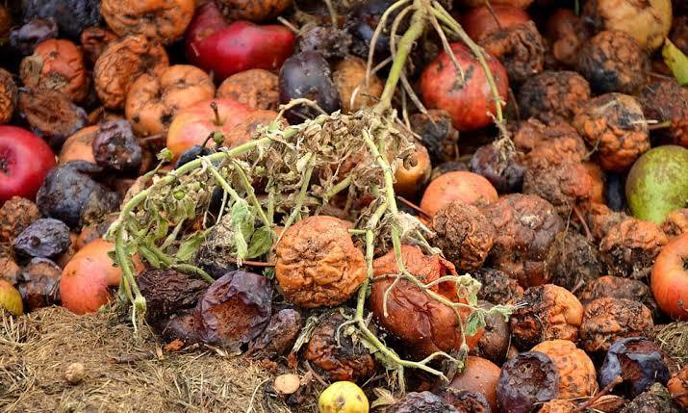

Fig.1 Waste Vegetable

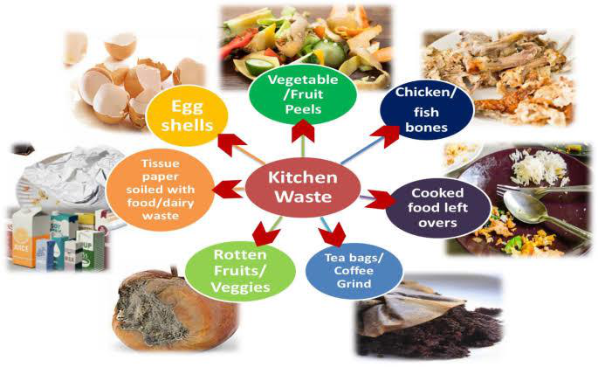

Table -1: Sample Table format

Fig.2 Community Collection Programs

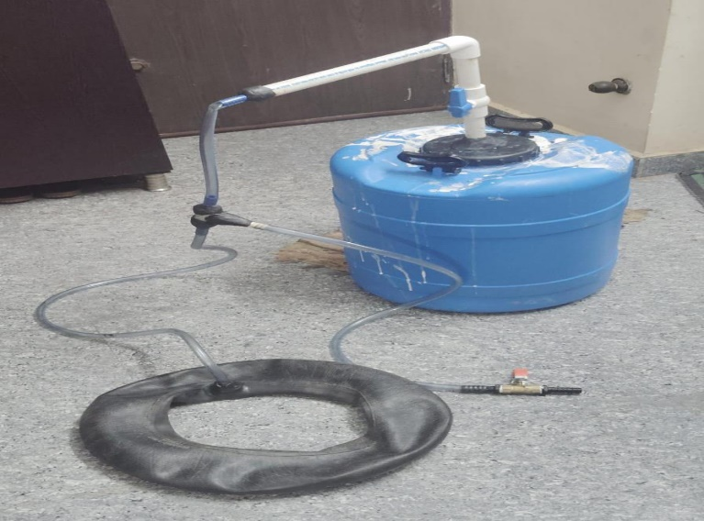

Fig.3 Experimental Setup
3.Methodology
“This research involved a review of published peer-reviewed papers and official reports on sources of biogas, its production processes, and applications. The literature used was published between 1932 and 2022 to give a clear view of the past and status of biogas technology and applications. The sustainability dimensions of biogas energy were covered including social, institutional, technical, economic, and environmental at local and international levels. A review of policies and regulations on national and international levels is presented. Based on literature and the requirements of sustainable energy transformation, the role of biogas is clearly defined now and in the future. Biogas feedstocks, feed preparation, conditions for optimal production, and composition of both biogas and biomethane are presented. Additionally, biogas upgrading technologies are also presented including quality and process sustainability. Finally, current and future applications of biogas are also presented as a sustainable energy option in the energy transition.”
3.1 Biogas Production Process
Biogas is generated from different organic matter through anaerobic digestion. Anaerobic digestion is the culmination of different chemical and biological processes that organic matter goes through for biogas production and also waste management. The process of biogas production constitutes a systematic breakdown of large organic polymers by the anaerobic action of different microorganisms into smaller molecules. Anaerobic digestion for the production of biogas from biomass is a chemical process that involves hydrolysis, acidogenesis, acetogenesis, and methanogenesis.
Biogas is produced by the microbial action in the digester soon after biomass is prepared and fed into a reactor by a gradual fermentation process. Therefore, the process is a result of microbes feeding on the organic matter in form of proteins, carbohydrates, and lipids/fats, whose digestion leads to production of gases mainly in form of methane and carbon dioxide. The stages in biogas production can be classified as pretreatment, hydrolysis, hydrolysis, acidogenesis, acetogenesis, and methanogenesis. The process of biogas production starts with feedstock processing or pretreatment before feeding the digester for actual digestion process through anaerobic degradation. Feedstock pretreatment is a necessary procedure to minimize failures and improve the generation and quality of digestate among other benefits.

4. CONCLUSIONS

Turning waste food into green energy represents a significant step towards a green energy revolution with multiple benefits. This innovative approach not only addresses environmental challenges associated with food waste but also contributes to renewable energy production and sustainable resource management. In conclusion, here are key points highlighting the potential of turning waste food into green energy Converting waste food into green energy reduces the amount of organic waste ending up in landfills, mitigating methane emissions and environmental pollution. Renewable Energy Generation: By harnessing biogas, biofuels, or other forms of energy from waste food, we can diversify our energy sources, decrease reliance on fossil fuels, and promote a more sustainable energy mix. Circular Economy Promotion: This approach aligns with circular economy principles by closing the loop on food waste, transforming it into valuable resources like energy, compost, or nutrient-rich materials for agriculture. Climate Change Mitigation: Green energy derived from waste food contributes to mitigating climate change by reducing greenhouse gas emissions, particularly methane, which has a significant impact on global warming. In conclusion, turning waste food into green energy represents a transformative shift towards a more sustainable, circular, and resilient energy future, emphasizing the interconnectedness of environmental protection, energy security, and socioeconomic progress. This green energy revolution is not just an aspiration but a practical and achievable goal through concerted efforts, innovation, and collective action at global, regional, and local levels.

REFERENCES

1. Smith, P., et al. (2020). "Food waste as a valuable resource for the production of chemicals, materials, and fuels. A review." Bio resource Technology.
2. Song, H., et al. (2019). "Advances in waste-to-energy technologies: A review." Bio resource Technology Reports.
3. IPCC Special Report on Climate Change and Land (2019). Intergovernmental Panel on Climate Change.
4. Cherubini, F. (2019). "The bio refinery concept: Using biomass instead of oil for producing energy and chemicals." Energy Conversion and Management.
5. Mata-Alvarez, J., et al. (2014). "A critical review on anaerobic co-digestion achievements between 2010 and 2013." Renewable and Sustainable Energy Reviews.
6. Ragauskas, A. J., et al. (2014). "Lignin valorization: Improving lignin processing in the bio refinery." Science.
7. European Commission - Directorate-General for Research and Innovation (2016).
"Food waste valorization technologies - Technological and policy options for sustainable outcomes."
8. National Renewable Energy Laboratory (NREL) - U.S. Department of Energy. (2020). "Bioenergy Basics: Anaerobic Digestion."
9. U.S. Environmental Protection Agency (EPA). (2021). "Anaerobic Digestion: Process." EPA - AgSTAR Program.International Energy Agency (IEA) Bioenergy. (2020). "

