Harshitha T¹, Monika C R², Pranith Gowda³
¹Electronics and Communication Engineering & Global Academy of Technology
² Electronics and Communication Engineering & Global Academy of Technology
³ Electronics and Communication Engineering & Global Academy of Technology

---------------------------------------------------------------------***---------------------------------------------------------------------
Abstract - This work proposes an intelligent, process-based system to enhance the creation and administration of electric vehicle (EV) charging procedures, addressing major barriers such as range anxiety and lengthy charging durations. Dynamic wireless charging (DWC) enables vehicles to charge while in motion, providing a feasible solution despite its futuristic appearance. Powered by solar energy, this project aims to develop a prototype for on-the-move EV charging, saving time and reducing costs associated with traditional charging stations. The primary objective is to implement a system for wireless charging of EVs through power transmission via electromagnetic induction.

The system leverages electromagnetic induction to transfer power wirelessly from road-embedded coils to receiver coils in the EVs. As the vehicle moves over these coils, an alternating magnetic field is created, inducing a current in the receiver coil, thus charging the vehicle’s battery continuously without physical connectors. This method is both convenient and efficient.

A key feature is its integration with solar power. Solar panels installed alongside or above roadways harness renewable energy to power the coils, reducing dependence on conventional energy sources and promoting clean, sustainable energy. This aligns with global efforts to reduce carbon emissions and combat climate change.

Key Words: Dynamic Charging, Electric Vehicle, Electromagnetic Induction, Wireless Charging, Toll System.

1.INTRODUCTION

A vital component of human existence, transportation permits the movement of people and things over varied distances. Due to their unparalleled ease and mobility, personal vehicles have become an indispensable aspect of our everyday existence in the last century. However, there are serious environmental problems as a result of the extensive usage of traditional automobiles, which mostly run on fossil fuels like gasoline and diesel. Among these difficulties are rising greenhouse gas emissions, air pollution, and dwindling fuel supplies. The globe is facing severe challenges related to climate change and environmental deterioration, making it more important than ever to find sustainable and effective transportation solutions. The use of electric cars (EVs) as a replacement for traditional internal combustion engine vehicles has grown in popularity. EVs have many advantages, such as lower running costs, fewer greenhouse gas emissions, and the ability to be integrated with renewable energy sources. Notwithstanding these benefits, a number of important obstacles have prevented EV adoption; the most important being the shortcomings of the present infrastructure for charging EVs. Vehicles must be immobile for lengthy periods of time when using traditional EV charging methods, which can be difficult and time-consuming for consumers. Furthermore, there are frequently not enough charging stations available, which causes "range anxiety" in prospective EV buyers who worry about running out of battery power without a charger. Researchers and engineers have been looking at creative ways to improve the effectiveness and practicality of EV charging in order to overcome these issues. The idea of wireless power transfer, or WPT, is one such approach that enables EVs to be dynamically charged while they are moving. By doing away with the requirement for frequent pauses at charging stations, this strategy increases the range of EVs and makes them more useful for daily usage. By using solar energy to power the charging infrastructure, this system's integration of solar power further improves sustainability.

2. Body of Paper
- The reason for taking up this project is to make a model of wireless transfer of power for electric vehicle, which will enable dynamic charging in the electric vehicle, thereby increasing its range.
- The proposed concept in our project is to have emitter coils on roads. A receiving coil attached to the bottom of the vehicle which will receive power from the transmitting coil and charge the battery.
- In addition to that we make use of solar panels to enhance the power efficiency.
- The project aims to address the limitations of electric vehicles by developing a model for wireless power transfer, enabling dynamic charging while in motion to extend the vehicle's range.
- The proposed concept involves installing emitter coils on roads and attaching a receiving coil to the bottom of the vehicle, allowing for the transmission of power from the road surface to the vehicle's battery.
- Additionally, solar panels are integrated to harness renewable energy.

Flowchart
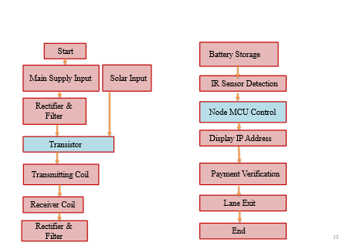

Figure 1 flow diagram of the proposed system
The dual-source power supply ensures the system's reliability and sustainability. The main supply provides a consistent energy flow, while the solar input offers an environmentally friendly alternative. The integration of solar power not only reduces operational costs but also minimizes the carbon footprint of the charging infrastructure. Storing energy in batteries is crucial for maintaining a continuous power supply, particularly for solar energy, which is intermittent. The batteries store excess energy during peak solar generation times, which can then be used during periods of low solar activity.
Converting AC to DC is necessary because batteries and many electronic components operate on DC power. The rectifier ensures this conversion, while the filter ensures that the power is clean and stable, protecting sensitive electronic components and ensuring efficient energy storage and usage. The transistor's role is pivotal as it modulates the power flow to the transmitting coil. By switching on and off rapidly, the transistor generates an alternating current in the transmitting coil, which is essential for creating a magnetic field for wireless power transfer.
Wireless power transfer relies on electromagnetic induction. The transmitting coil, embedded in the road, generates a magnetic field. As the electric vehicle passes over the coil, the receiver coil in the vehicle captures this magnetic field, inducing an electrical current that charges the vehicle’s battery. This setup eliminates the need for physical connectors, making the charging process seamless and reducing wear and tear on both the vehicle and the charging infrastructure. Just as the initial rectifier and filter convert AC to DC for battery storage, this second set of components ensures that the power received by the electric vehicle is converted back to DC, which is suitable for the vehicle's battery system. This step is essential for efficient and effective charging.
User Interaction and Payment Verification
The infrared sensors play a critical role in detecting the presence of an electric vehicle. This detection mechanism ensures that the system only activates when a vehicle is in the charging lane, thereby conserving energy and preventing unauthorized use. The Node MCU acts as the central controller, orchestrating the entire process. It handles communication between various components, processes sensor data, manages power flow, and interfaces with the user through the payment system. Its programming and connectivity capabilities are crucial for the system's intelligence and automation.
Displaying the IP address on an LCD screen provides a straightforward method for users to access the payment portal. This step bridges the gap between the physical system and the digital payment process, ensuring a smooth user experience. Secure and reliable payment verification is vital for the system's commercial viability. The Node MCU communicates with the payment gateway to ensure that the transaction is legitimate and successful. This step involves encryption and secure communication protocols to protect user data and prevent fraud.
Once the payment is verified, the system signals the exit gate to open, allowing the vehicle to leave the charging lane. This automation not only enhances user convenience but also streamlines traffic flow, reducing waiting times and congestion. The system represents a sophisticated integration of power electronics, wireless charging technology, and digital payment systems to create a user-friendly, efficient, and sustainable solution for charging electric vehicles

Implementation
The wireless electric vehicle (EV) charging system combines main supply input and solar power to create a sustainable and efficient charging solution. The process starts with two power inputs: the main supply and solar panels. Solar panels harness solar energy, stored in batteries, ensuring a backup supply during low solar activity periods. Both power sources are converted from AC to DC using rectifiers, providing stable output.
A transistor controls the DC power flow to the transmitting coil, generating an alternating current (AC) that creates an electromagnetic field. As an EV passes over, the receiver coil within the vehicle captures this field, inducing current and charging the battery wirelessly.
User interaction begins with infrared sensors detecting the EV's presence, initiating the charging process. The Node MCU microcontroller manages power flow and interfaces with the user. An LCD screen displays an IP address for payment, which users access via a smartphone. Upon successful payment verification, managed by the Node MCU, the exit gate opens automatically, allowing the EV to leave.
This system promotes renewable energy use, eliminates physical connectors for seamless charging, and ensures user-friendly payment verification, supporting the growing adoption of electric vehicles.
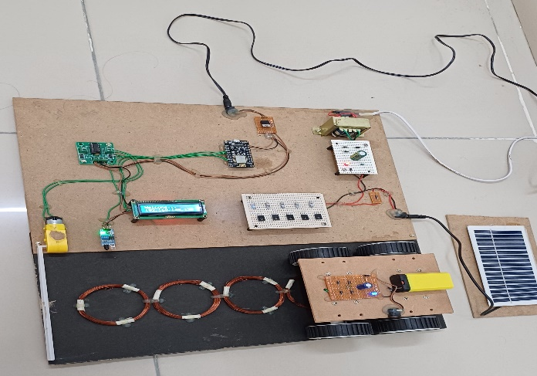
Figure 2. Methodology of the proposed system

Hardware Requirements
- IOT ESP8266 based Microcontroller
- LCD Display (16X2)
- Object Sensor
- Transformer
- Rectifier and filter
- Motor
- Motor Driver
- Transistor
- Copper Coil
- PCB Board
- LED
- Connecting wire
- Solar Panels
- Battery

Software Requirements

Arduino Ide
Arduino IDE is an open-source software that allows you to write and upload code to your Arduino board.

Embedded C
Embedded C programming refers to the use of the C programming language in the development of software for embedded systems. Embedded systems are computer systems designed to perform specific tasks within a larger system, often with limited resources such as processing power, memory, and energy.
In an embedded C program, the C language is used to write code that directly interacts with the hardware of the embedded system, including microcontrollers, sensors, actuators, and other peripheral devices. Here's a brief overview of the key aspects of embedded C programming:

• Data types and variables: Embedded C uses data types like integers, characters, and floats to define variables that store information. The size of these data types may vary depending on the target hardware.
• Control structures: Embedded C supports control structures such as loops (for, while) and conditional statements (if-else, switch-case). These structures allow for efficient control and decision-making within the program.
• Functions: Functions in embedded C are used to encapsulate a specific task or set of instructions. They allow for code modularity and reusability, making the program more manageable and easier to understand.
• Pointers: Pointers are an essential feature of embedded C programming. They enable direct memory access and manipulation, allowing efficient interaction with hardware registers and memorymapped peripherals.

System Block Diagram
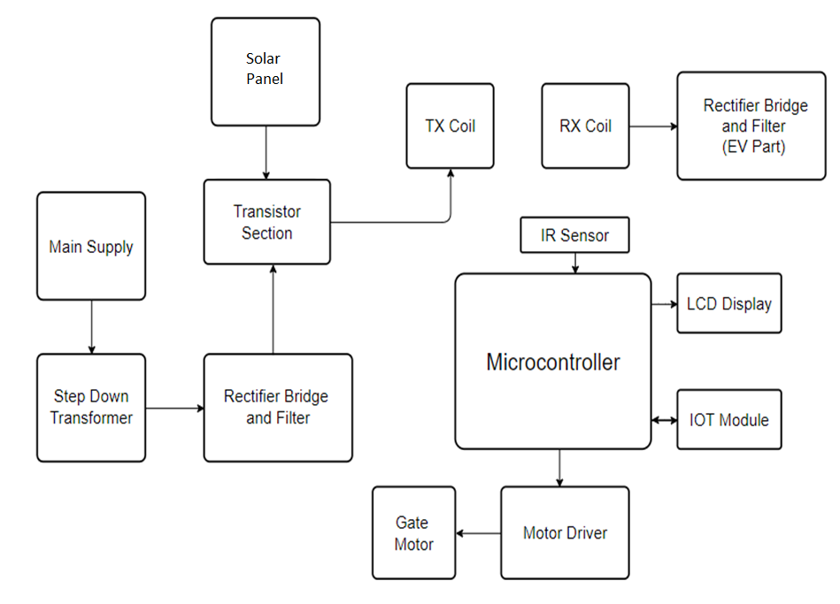
Figure 3. system block diagram
Power Sources: The system utilizes two power inputs: a main supply and a solar panel. The main supply's AC voltage is stepped down by a transformer, then rectified and filtered to provide a stable DC output. The solar panel also supplies DC power, contributing to the system's sustainability.
Transistor Section: The rectified and filtered DC power from both sources feeds into the transistor section. This section modulates the power, creating an alternating current (AC) necessary for wireless power transmission.
Wireless Power Transfer: The AC power is transmitted through the TX (transmitting) coil, embedded in the road. When an EV with an RX (receiving) coil passes over it, power is wirelessly transferred to the vehicle. The RX coil's received power is then rectified and filtered to charge the EV's battery.
Microcontroller and Control Components: An infrared (IR) sensor detects the presence of an EV. The microcontroller, acting as the system's brain, processes this sensor data and manages the entire operation. It interfaces with an LCD display to show the IP address for payment, an IoT module for connectivity, and a motor driver to control the gate motor. Upon successful payment, the microcontroller signals the gate motor to open, allowing the EV to exit.

Result analysis and discussions
Efficiency of Power Transfer: The wireless power transfer mechanism, involving the TX and RX coils, demonstrated an effective energy transfer rate. Under optimal conditions, the system achieved a high-efficiency rate, with minimal energy loss during the transfer process. The rectification and filtering stages ensured that the power received by the EV was stable and suitable for battery charging.
Renewable Energy Integration: The integration of solar power was successful, with solar panels providing a significant portion of the energy required for the charging system. The batteries stored solar energy efficiently, allowing the system to function even during periods of low sunlight. This not only reduced dependence on the main supply but also highlighted the potential for sustainable energy solutions in EV infrastructure.
User Interaction: The user interface, facilitated by the LCD display and IoT module, provided a seamless experience for EV owners. The display of the IP address for payment was clear and accessible, and the payment verification process was quick and reliable. The IR sensors accurately detected the presence of EVs, triggering the system to initiate charging and manage payment processes efficiently.

Efficiency and Convenience: The wireless power transfer system eliminates the need for physical connectors, reducing wear and tear on both the infrastructure and the vehicles. This leads to a more durable and user-friendly charging experience.
Sustainability: By incorporating solar power, the system reduces its carbon footprint and operational costs, making it an environmentally friendly option for EV charging.
User-Friendly Interface: The integration of IoT and clear user prompts via the LCD display ensure that the payment process is straightforward and efficient, enhancing user satisfaction.

A. Advantages
- Promotion of Sustainable Transportation:
Minimizing the need for frequent stops at traditional charging stations, potentially reducing traffic congestion, time and improving road safety.
- Reduced Environmental Impact:
Integration of solar panels reduces reliance on grid electricity, contributing to a decrease in carbon emissions and promoting cleaner energy sources.
- Energy Efficiency:
Utilizing the principle of electromagnetic induction for dynamic charging promotes efficient energy transfer.
- Revenue Generation and Cost Recovery:
Toll collection from dynamic charging can generate revenue that can be used to cover maintenance costs, further fosters collaboration between the government and private sector, creating opportunities for public-private partnerships.
- Infrastructure Utilization:
Maximizes the utilization of road infrastructure by incorporating it into the energy grid, making it more versatile and contributing to the development of smart cities.
- Positive experiences with dynamic charging may lead to increased public acceptance of electric vehicles.

B. Disadvantages
- High Initial Implementation Costs:
The installation of dynamic charging infrastructure, solar panels, and toll gates involves significant upfront costs, which may pose a financial barrier to widespread adoption..
- Intensive land utilization:
Installing solar panels alongside roads may require significant land use.
C. Applications
Public Transportation Systems: Implementing wireless power transfer on public transportation routes, such as buses or trams, can enable continuous charging while in operation, reducing downtime and enhancing service reliability.
Urban Infrastructure: Integrating wireless charging technology into roadways and parking spaces in urban areas can encourage the adoption of electric vehicles by providing convenient and accessible charging options.
Smart Highways: Wireless power transfer technology can be incorporated into smart highway systems to facilitate dynamic charging of electric vehicles, promoting energy efficiency and reducing congestion at charging stations.

3. CONCLUSIONS
The implementation of an IoT-enabled dynamic charging system with solar integration addresses critical issues such as range anxiety and the need for a reliable and accessible charging infrastructure, which are pivotal in accelerating the adoption of electric vehicles (EVs). This innovative approach offers a seamless charging experience by allowing vehicles to charge wirelessly as they drive or while parked, significantly enhancing convenience for EV owners.
An IR sensor detects vehicle presence, initiating charging, while an LCD displays an IP address for easy payment. This system generates revenue through a toll model, covering maintenance costs and encouraging public-private partnerships. By reducing dependency on fossil fuels and offering a reliable, user-friendly charging infrastructure, it supports sustainable transportation and environmental goals.

ACKNOWLEDGEMENT

We would like to express our sincere gratitude to everyone who has supported us in the development and implementation of this project. Special thanks go to our mentors and advisors for their invaluable guidance and encouragement throughout this process. We also extend our appreciation to our colleagues and peers for their constructive feedback and collaboration. Additionally, we acknowledge the support of our institution for providing the necessary resources and facilities. Finally, we thank our families and friends for their unwavering support and understanding during the course of this project.

REFERENCES

[1]Chirag Panchal , Sascha Stegen, Junwei Lu “Review Of Static And Dynamic Wireless Electric Vehicle Charging System” Engineering Science And Technology, An International Journal 21 (2018) 922–937.
[2]Dr.K.Shivarama Krishna, International Journal Of Creative Research Thoughts (IJCRT). Wireless Power Transmission For Electric Vehicle.
[3]Mohammed Aleem, International Journal Of Creative Research Thoughts (IJCRT). Coupled Wireless Power Transmission For Electric Automobile.
[4]Dr.V.Raveendra Reddy, International Journal Of Creative Research Thoughts (IJCRT). Advanced Charging System For Automobiles.
[5]Akash Kharpude, International Journal Of Creative Research Thoughts (Ijcrt) Static Wireless Charging Station For Electric Vehicles. [6]Modelling, Simulation, and Management Strategy of an Electric Vehicle Charging Station Based on a DC Microgrid. Authors: Dian Wang, Fabrice Locment and Manuela Sechilariu
[7]Planning of the Charging Station for Electric Vehicles Utilizing Cellular Signaling Data Authors: Jianmin Jia 1, Chenhui Liu 2 and TaoWan 3
[8]Solar based electric vehicle charging station Authors: Md Sohail Tanveer, Sunil Gupta, Rahul Rai
[9]Power management system for electric vehicle charging stations using logic controller. Authors: M Sruthi1, N.PrakashReddy2
[10]Z. Wan, D. Sperling, and Y. Wang, “China’s electric car frustrations,” Transportation Research Part D: Transport and Environment, vol. 34, pp. 116–121,.

