Development of a Smart Shopping Cart for Enhanced Retail Experience
Prof. Manisha Mhetre, Tinish Uge, Sharvit Shewade, Atharva Patil, Kuber Markad
Department of Instrumentation and Control Engineering & VIT, Pune
---------------------------------------------------------------------***---------------------------------------------------------------------
Abstract - This research introduces a novel approach to revolutionize the shopping experience through the development of a Smart Shopping Cart. The system integrates technologies such as RFID, weight sensors, and real-time inventory management to provide instantaneous updates and an engaging user interface. The project’s primary objectives include enhancing inventory management efficiency and establishing a seamless RFID connection. Future enhancements envisage increased automation, enhanced security measures, personalization options, and connectivity improvements. The system employs RFID, weight sensors, a Tkinter GUI, and MySQL for database management. Key performance indicators include response time, database efficiency, RFID scanning speed, and overall system throughput. By amalgamating these technologies, this project aspires to transform the retail sector, augmenting customer satisfaction and operational efficiency.

Key Words: Internet of Things (IoT), Radio-Frequency Identification (RFID), Automated Systems, Intelligent Retail Solutions, Arduino-based Hardware, Python Programming, Database Management Systems (DBMS), Real-time Inventory Control, MySQL Database, Load Cell Technology, Data-driven Analytics, User Interface Design, Real-time Updates, Weight Sensing, Tkinter GUI, Operational Efficiency, Customer Satisfaction

1.INTRODUCTION

The advent of advanced technology has ushered in a new era in the retail sector. The conventional in-store shopping experience is being redefined in this digital age where speed and convenience are paramount. The integration of state-of-the-art technologies into contemporary shopping practices is a key catalyst for this transformation. This project delves into this innovative sphere with a singular objective: to develop a smart shopping cart that will redefine retail shopping.

The concept of a “smart shopping cart” symbolizes the fusion of the digital and physical realms, creating a synergy that could drastically alter the way consumers engage with brands and stores. As our society becomes increasingly interconnected, consumer expectations have evolved, demanding a seamless and personalized shopping experience. The Smart Shopping Cart emerges in response to these demands, offering a dynamic platform that not only simplifies the shopping process but also introduces an element of intelligence and interactivity that is lacking in traditional retail environments.

As we embark on our exploration of the Smart Shopping Cart, it is essential to comprehend the broader context in which this project is situated. The retail industry, long considered a cornerstone of commerce, is now grappling with unprecedented challenges as it must adapt to remain relevant in the digital age or risk becoming obsolete. E-commerce platforms have gained immense popularity due to their unparalleled convenience and extensive variety. This has exerted pressure on traditional retailers to evolve or risk losing relevance. However, the allure of physical stores remains unrivaled. For many shoppers, the tangible experience of browsing through aisles, physically examining products, and having immediate possession of purchases is incomparable. Recognizing this, the Smart Shopping Cart has been designed to strategically enhance the in-store experience by leveraging technology to accentuate the unique advantages of physical retail, rather than as a countermeasure to the rise of e-commerce.

This project is driven by a dual commitment: to enhance customer satisfaction and to provide retailers with tools that optimize operational efficiency. Equipped with RFID technology, Internet of Things (IoT) capabilities, and sophisticated data analytics, the Smart Shopping Cart offers a win-win solution for customers and retailers. Real-time data insights, tailored recommendations, and automatic product identification have the potential to revolutionize the shopping experience by enhancing its usability, engagement, and capacity to cater to individual preferences.

This project aspires to contribute not only a novel invention but also to the broader discourse on the future of retail by traversing the realms of technology, consumer behavior, and retail dynamics. The Smart Shopping Cart represents more than just a practical solution; it signifies a shift in perspective, a bridge between the traditional and the futuristic, and a testament to the enduring spirit of innovation in the face of a constantly evolving commercial landscape.

2. LITERATURE REVIEW
Conventional supermarket shopping usually involves lengthy checkout queues and tedious tasks like item scanning and bagging. In order to improve the retail experience and tackle inefficiencies, experts have been investigating the creation of intelligent shopping carts that are outfitted with cutting-edge technologies. The goal of this review is to identify important trends, advantages, and disadvantages in this developing subject by analyzing recent research papers that explore different smart shopping cart designs and functionality.

Thomas Arciuolo et al. proposes a novel approach for increasing the efficiency of supermarket shopping. The key idea is to eliminate the repetitive handling of products during the shopping process. This is accomplished by combining three critical operations - product shopping, bagging, and cashier checkout - into a coherent process. This method streamlines shopping by letting users scan things with RFID/barcode technology and deposit them in bags within the cart, removing the need for traditional checkout. A load cell-based scale provides accurate scanning, while a central control computer constantly tallies things and prepares the cart for rapid checkout. The GPS connection provides a help request feature, and the smart cart network forms a Wireless Sensor Network, offering real-time insights for store management. [1]

Tapan Kumar Das et al. provide a solution to the common problem of waiting in long lines for billing and payment when shopping. The proposed method involves building a smart trolley that can handle both shopping and invoicing procedures. With this system, customers can enter the store, use the smart trolley to shop, and then simply walk out. They will receive an e-bill through email and can access their purchase details through the store's website. The technology components used for this system include an Arduino board, a Radio-Frequency Identification (RFID) reader, RFID tags, an LCD, an ESP8266 Wi-Fi module, a database manager, and a website for maintaining product and customer information. [2]

Kowshika S et al. address the persistent appeal of traditional shopping, despite the growth of e-commerce. It focuses on one of the common challenges in traditional shopping, which is waiting in line for the billing process. The proposed solution combines IoT technology with a mobile cart application to streamline and expedite the payment of bills. The cart utilizes RFID tags and a receiver for product scanning, load cells to prevent theft, an LCD, and a Raspberry Pi. Additionally, customers can browse a list of things they have purchased and the amounts associated with them, log in, and pay their bills using a mobile application. [3]

Akshay Kumar et al. present a solution to reduce shopping time in supermarkets by introducing a smart shopping cart equipped with a barcode scanner and touchscreen display. Customers can scan products, view product information and costs, and pay bills using various online payment options. The solution optimizes the consumer experience and reduces shopping time. [4]

Sakorn Mekruksavanich et al. acknowledge the crowded shopping malls and offer a smart shopping basket with RFID technology, a barcode reader, and a weight sensor system. Customers can scan products with RFID tags, and the basket displays product information and calculates the total cost in real-time. The system enhances the shopping experience, eliminates the need for estimating total costs, and improves inventory management. [5]

Viswanadha V et al. propose a solution to expedite the shopping process in supermarkets. The key innovation is a smart shopping cart equipped with a barcode scanner and a touchscreen display. Customers can efficiently scan products and access detailed product information, including costs, in real-time. Additionally, the cart facilitates quick and convenient bill payment through various online payment options, enhancing the overall consumer experience and reducing shopping time. [6]

Rajeev Ratna Vallabhuni et al. explore the applications of Radio Frequency Identification (RFID) technology in the context of a smart shopping cart system. The primary objective is to provide a digital billing system that allows customers to receive bills through their registered email. The system uses RFID tags/cards attached to product compartments, which store purchasing product information. This data is used to generate bills, both on an LCD and the central server. This system demonstrates the potential of RFID technology in making shopping more convenient and secure and emphasizes its contribution to the future of shopping by focusing on improving customer experiences. [7]

You-Chiun Wang et al. introduce the concept of a sensor-based smart shopping cart system, known as a 3S cart. It leverages sensor technology to detect customer behavior and respond in real-time. The prototype involves modularized sensors placed on shopping carts, making it lightweight and easy to deploy. The paper demonstrates two applications: a sales-promotion feature that tailors sales information to customers, and a product-navigation system that helps customers find products efficiently. The 3S-cart system explores the potential of sensor technology to provide interactive and context-aware shopping experiences in supermarkets. [8]

Khalid Yusuf et al. focus on enhancing the performance of smart shopping carts based on passive RFID technology. It addresses the issue of long queues at clothing stores during peak seasons. The proposed system equips each item with an RFID tag and the shopping cart with an RFID reader. The system scans and calculates items in real-time, significantly reducing cashier transaction times. To support the smart shopping cart's performance, a decision tree algorithm is implemented for classifying consumer shopping lists and determining discounts. The study demonstrates that the decision tree algorithm can determine discounts with high accuracy, enhancing the overall shopping experience.

Ruchi Gupte et al. explore a fully automated shopping cart system that places a strong emphasis on reducing human interaction, particularly in the context of the COVID-19 pandemic. The proposed system employs Radio-frequency identification (RFID) technology as the core identification mechanism. Each product in shopping malls and supermarkets is equipped with an RFID tag for identification. The shopping cart is designed with a Product Identification Device (PID) containing a microcontroller, LCD, RFID reader, EEPROM, and ZigBee module. Product information is read via the RFID reader and stored in the EEPROM, which is then transmitted to a Central Billing System through the ZigBee module. The central billing system accesses the product database, calculates the total cost of items in the cart, and aims to eliminate queues in malls and supermarkets.

3. METHODOLOGY

- Components
Arduino UNO - Responsible for processing RFID data, coordinating actions, updating the GUI, managing database communication, and overseeing the security aspect through Load Cell integration and anomaly detection.

RFID Reader (MFRC522) - The RFID reader scans RFID tags attached to products, retrieving product information using the UIDs of the respective products.

20 kg Load Cell - The Load Cell, capable of measuring up to 20kg, is integrated into the shopping cart.

HX711 Amplifier Module - The Load Cell's output is amplified by the HX711 Amplifier, providing accurate weight measurements.

Tkinter Library - The Tkinter Library in Python is employed to create a Graphical User Interface (GUI) for the smart shopping cart.

MySQL Database - The database stores information such as product details, pricing, quantities, weights, and RFID UIDs.
- Design – Circuit Diagram
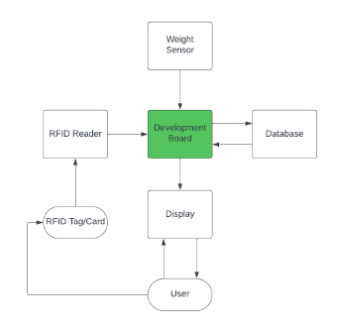
Fig:1: Flowchart

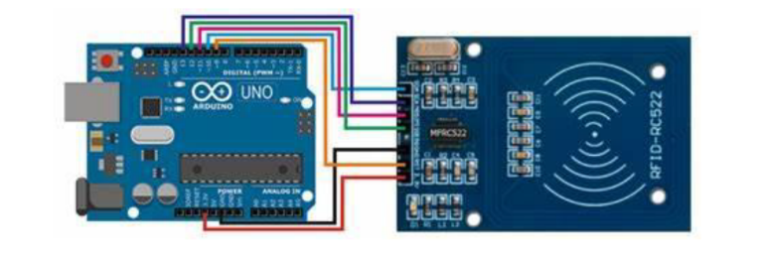
Fig:2: Arduino UNO to RFID

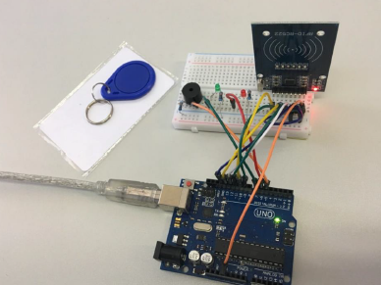
Fig: 3: On Breadboard Implementation
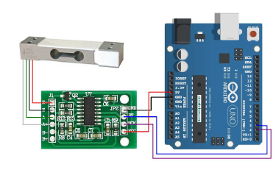
Fig: 4: Arduino UNO to Weight-HX711 Module

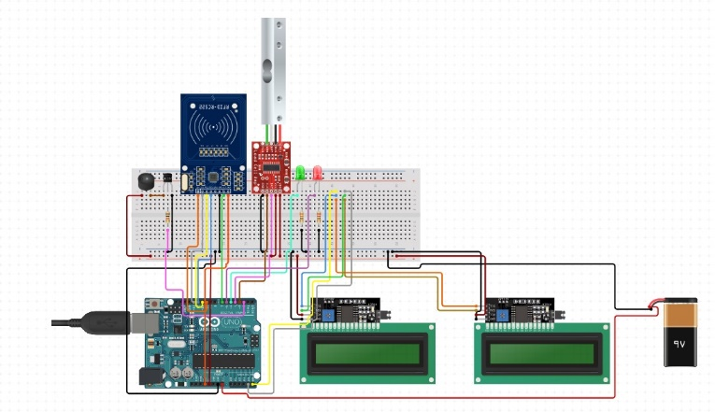
Fig: 5: Complete Circuit Representation

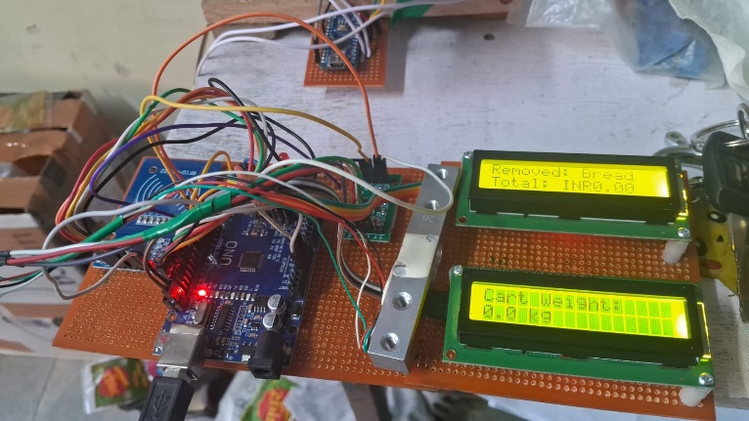
Fig: 6: as Product Implementation

- Pseudo Code
Developed Arduino code to interface with the MFRC522 RFID Reader –

1. Initialize LCDs, RFID reader, and other hardware components
2. Define known RFID tags and corresponding products with their prices
3. Initialize total amount and cart weight to zero

4. In the main loop:
4.1 Display cart weight on the second LCD
4.2 If a new RFID card is present:
4.2.1 Read the card serial
4.2.2 Compare the read UID with known UIDs
4.2.3 If the tag is matched:
4.2.3.1 Beep and blink green LED
4.2.3.2 If the product is in the cart, remove it; otherwise, add it
4.2.3.3 Calculate and display the total amount on the first LCD
4.2.4 If the tag is not matched:
4.2.4.1 Beep and turn on red LED
4.2.4.2 Display "Unknown RFID Tag" on the first LCD
4.3 If there are incoming serial commands:
4.3.1 If the command is "Red_LED_ON", turn on the red LED

SQL Script for creating Database –

1. Create a new database named "Test_Retail" if it doesn't already exist
2. Use the "Test_Retail" database
3. Create a new table named "products" with columns for id, name, price, description, and quantity
4. Insert initial product data into the "products" table
5. Update the quantity of each product to 10
6. Add a new column named "weight" to the "products" table
7. Update the weight of each product based on its name
8. Add a new column named "uid" to the "products" table
9. Update the uid of each product based on its name

4. RESULTS AND DISCUSSIONS

The anticipated outcomes of the major project involve a thorough assessment across multiple performance indicators. A key metric, response time, gauges the system’s responsiveness in refreshing the graphical interface following user activities such as RFID scans or cart alterations. The speed of database queries is vital, evaluating the system’s ability to quickly fetch and update data from the MySQL database, thereby ensuring peak performance.

Immediate updates are crucial, demonstrating the system’s capacity to swiftly reflect cart changes on the Tkinter GUI. The speed of RFID scanning assesses the system’s efficiency and accuracy in processing RFID UIDs, while the accuracy of Load Cell measurements determines the system’s precision in identifying weight variances.

The time taken to detect anomalies is essential, quantifying the system’s speed in spotting potential theft or unauthorized item removal. Scalability is examined to confirm the system’s smooth adaptation to a growing number of products, RFID UIDs, and user interactions. Data maintenance’s consistency and integrity are vital, and the user interface’s responsiveness is checked for fluid interactions.

The response time of the alert mechanism measures the system’s promptness in alerting relevant staff of anomalies. The overall system throughput takes into account the combined performance of RFID scanning, database interaction, GUI updates, and anomaly detection, providing a comprehensive perspective of the capstone project’s operational efficiency and dependability.

5. LIMITATIONS

1. Maldonado, M., Chang, C.-C.K., Gravano, L., Paepcke, A.: The Stanford Digital Library Metadata Style. Int. J. Digit. Libr. 1 (1997) 108–121
2. Bruce, K.B., Carcelle, L., Pierce, B.C.: Linking Object Encodings. In: Abadi, M., Ito, T. (eds.): Notional Aspects of CPU Software. Lecture Notes in Computer Science, Vol. 1281. Springer-Verlag, Berlin Heidelberg New York (1997) 415–438
3. van Leeuwen, J. (ed.): Computer Skill Today. Recent Trends and Developments. Lecture Proceedings in Supercomputer Science, Vol. 1000. Springer-Verlag, Berlin Heidelberg New York (1995)
4. Michalewicz, Z.: Genetic Systems + Data Structures = Evolution Programs. 3rd edn. Springer-Verlag, Berlin Heidelberg New York (1996)

6. FUTURE SCOPE

The universal implementation of RFID readers across products, irrespective of size or cost, presents cost efficiency challenges. Affixing the same RFID reader to items of varying sizes and price points could lead to unnecessary costs. While the use of a universal RFID reader for lower-cost items is a potential solution, it brings about complexities. The challenge lies in striking a balance between ensuring precise product identification and maintaining the system’s overall cost-effectiveness. This challenge becomes even more significant when accommodating products with significantly different values, like a $1 item versus a $100 item. Achieving the right balance in RFID technology deployment is critical for maximizing efficiency without excessively increasing the financial investment in the Smart Shopping Cart system.
7. CONCLUSION

The Smart Shopping Cart project is a transformative blend of technology and retail, poised to reshape the traditional shopping experience. It doesn’t merely react to the rise of e-commerce but strategically enhances the in-store experience, valuing the unique appeal of physical stores. The project’s key objectives involve integrating RFID technology, IoT capabilities, and advanced data analytics to foster a symbiotic relationship between customers and retailers. It creates an intelligent shopping cart that combines the convenience of online shopping with the tangible experience of physical stores. The project envisions a future where personalization is key, with user profiles, interactive displays, and supermarket infrastructure connectivity promising a more tailored shopping experience. It incorporates security measures like blockchain integration and biometric authentication, reflecting a commitment to innovation without compromising safety. The project’s methodology, from hardware integration to software sophistication, demonstrates its systematic and multidisciplinary approach. The literature survey places the project in the broader context of intelligent shopping carts, showcasing diverse approaches to enhancing the retail experience. In essence, the Smart Shopping Cart is not just a technological advancement; it’s a strategic response to the evolving retail industry demands, heralding a future where retail is efficient, personalized, and a harmonious blend of the conventional and futuristic.

8. ACKNOWLEDGEMENT

We the member of this group would like to thank to our guide (Prof. Manisha Mhetre) who gave us the guidance regarding this project and also, they helped us to make this paper successfully. In this research we came to know many more things about the publishing of the paper that how exactly a paper is published and what contents and contexts are required.

9. REFERENCES

1. T. Arciuolo and A. -s. Abuzneid, "Simultaneously Shop, Bag, and Checkout (2SBC-Cart): A Smart Cart for Expedited Supermarket Shopping," 2019 International Conference on Computational Science and Computational Intelligence (CSCI), Las Vegas, NV, USA, 2019, pp. 1162-1167, doi: 10.1109/CSCI49370.2019.00219.
2. T. K. Das, A. K. Tripathy and K. Srinivasan, "A Smart Trolley for Smart Shopping," 2020 International Conference on System, Computation, Automation and Networking (ICSCAN), Pondicherry, India, 2020, pp. 1-5, doi: 10.1109/ICSCAN49426.2020.9262350.
3. S. Kowshika, S. S. Madhu mitha, G. Madhu Varshini, V. Megha and K. Lakshmi, "IoT based Smart Shopping Trolley with Mobile Cart Application," 2021 7th International Conference on Advanced Computing and Communication Systems (ICACCS), Coimbatore, India, 2021, pp. 1186-1189, doi: 10.1109/ICACCS51430.2021.9441866.
4. Kumar, A. Gupta, S. Balamurugan, S. Balaji and R. Marimuthu, "Smart Shopping Cart," 2017 International conference on Microelectronic Devices, Circuits and Systems (ICMDCS), Vellore, India, 2017, pp. 1-4, doi: 10.1109/ICMDCS.2017.8211723.
5. S. Mekruksavanich, "Design and Implementation of the Smart Shopping Basket Based on IoT Technology," 2019 14th International Joint Symposium on Artificial Intelligence and Natural Language Processing (iSAI-NLP), Chiang Mai, Thailand, 2019, pp. 1-6, doi: 10.1109/iSAI-NLP48611.2019.9045336.
6. V. V., P. K. P. and C. R. S., "Smart Shopping Cart," 2018 International Conference on Circuits and Systems in Digital Enterprise Technology (ICCSDET), Kottayam, India, 2018, pp. 1-4, doi: 10.1109/ICCSDET.2018.8821103.
7. R. R. Vallabhuni, S. Lakshmanachari, G. Avanthi and V. Vijay, "Smart Cart Shopping System with an RFID Interface for Human Assistance," 2020 3rd International Conference on Intelligent Sustainable Systems (ICISS), Thoothukudi, India, 2020, pp. 165-169, doi: 10.1109/ICISS49785.2020.9316102.
8. Y. -C. Wang and C. -C. Yang, "3S-cart: A Lightweight, Interactive Sensor-Based Cart for Smart Shopping in Supermarkets," in IEEE Sensors Journal, vol. 16, no. 17, pp. 6774- 6781, Sept.1, 2016, doi: 10.1109/JSEN.2016.2586101.
9. K. Yusuf, M. Abdurohman and A. G. Putrada, "Increasing Passive RFID-Based Smart Shopping Cart Performance using Decision Tree," 2019 5th International Conference on Computing Engineering and Design (ICCED), Singapore, 2019, pp. 1-5, doi: 10.1109/ICCED46541.2019.9161139.
10. R. Gupte, S. Rege, S. Hawa, Y. S. Rao and R. Sawant, "Automated Shopping Cart Using RFID with a Collaborative Clustering Driven Recommendation System," 2020 Second International Conference on Inventive Research in Computing Applications (ICIRCA), Coimbatore, India, 2020, pp. 400-404, doi: 10.1109/ICIRCA48905.2020.9183100.

