Satellite Image Classification to Detect Poverty Using CNN and VGG-16
Bhavana K S¹, Hamsa K², Lakshmishree G³, Rakshitha H O⁴, Suresh Kumar M⁵
¹Student, Department of Information Science and Engineering, Dayananda Sagar College of Engineering, Bengaluru, India
[email: ksbhavanakopparam04@gmail.com]
²Student, Department of Information Science and Engineering, Dayananda Sagar College of Engineering, Bengaluru, India
[email:hamsak4623@gmail.com]
³Student, Department of Information Science and Engineering, Dayananda Sagar College of Engineering, Bengaluru, India
[email: lakshmishree533@gmail.com]
⁴Student, Department of Information Science and Engineering, Dayananda Sagar College of Engineering, Bengaluru, India
[email: rrakshithaho@gmail.com]
⁵Assistant Professor, Department of Information Science and Engineering, Dayananda Sagar College of Engineering, Bengaluru, India
[email: sureshkumar-ise@dayanandasagar.edu]

Abstract: Assessing poverty levels globally is crucial for effective poverty reduction efforts and resource allocation, yet traditional methods like door-to-door surveys are costly and time-consuming, especially in developing regions. Satellite imagery provides a promising alternative for estimating poverty levels by leveraging visible characteristics from overhead views. Globally defining poverty is complex, with the World Bank setting the threshold at $2 per day. Recent studies have explored poverty prediction using CNN and VGG-16 models on satellite images from Nigeria, Mali, Malawi, and Ethiopia. VGG-16 exhibited superior performance with a validation accuracy of 98%, while CNN achieved 95%. These findings highlight the potential of both models for cost-effective poverty prediction. Further research into utilizing CNN and VGG-16 for poverty prediction and addressing related challenges is encouraged.
Keywords: Poverty Prediction, Satellite Images, Convolution Neural Network, Visual Geometry Group, Image Classification
- INTRODUCTION
The project addresses the critical issue of poverty prediction in Africa using advanced machine learning techniques, specifically Convolutional Neural Networks (CNNs) and VGG-16, with a focus on leveraging satellite imagery data. Poverty is a complex and pervasive challenge, with various factors contributing to its persistence in different regions. Understanding and accurately predicting poverty levels are essential for designing targeted interventions, allocating resources effectively, and fostering sustainable development.
This problem is of paramount importance due to its widespread impact on individuals, communities, and economies. Poverty not only affects basic human needs such as access to food, shelter, and healthcare but also hinders socio-economic progress, perpetuates inequalities, and limits opportunities for advancement. Addressing poverty requires actionable insights derived from robust data analysis and predictive modeling.
The implemented system integrates CNNs and VGG-16 architectures to analyse satellite imagery and extract meaningful patterns related to economic livelihood status. CNNs excel at feature extraction from images, while VGG-16 enhances the depth and accuracy of analysis, especially in high-resolution satellite imagery. This combination enables the system to predict poverty levels with greater precision and reliability. Related work in the field has explored the use of machine learning and satellite data for poverty prediction, highlighting the potential of advanced algorithms in improving accuracy and scalability. However, challenges such as data quality, model complexity, and interpretability remain areas of ongoing research and innovation.
The methodology followed for evaluating the implementation includes data pre-processing, model training and validation, accuracy assessment, and comparative analysis with existing approaches. Evaluation results demonstrate the effectiveness of the CNN-VGG-16 framework in predicting poverty levels, with significant improvements in accuracy and robustness compared to baseline models.
From the evaluation results, conclusions are drawn regarding the feasibility and efficacy of using CNNs and VGG-16 for poverty prediction in Africa. The system's ability to provide reliable predictions based on satellite imagery data underscores its potential for informing policy decisions, resource allocation, and targeted interventions aimed at poverty alleviation.
The contributions of this project include:
- Advancing the application of machine learning and satellite imagery in poverty prediction.
- Demonstrating the effectiveness of CNNs and VGG-16 architectures in analysing complex socio-economic data.
- Providing actionable insights for policymakers, humanitarian organizations, and researchers to address poverty challenges effectively.

- EXISTING SYSTEM
A. Main Components and Technologies in the Existing System:
- Data Collection and Pre-processing
- Data Sources: The system collects satellite imagery data from various sources, including high-resolution satellites like GaoFen-5 (GF-5) and traditional multispectral images like Landsat 8.
- Pre-processing: Raw satellite images undergo Pre-processing steps such as image enhancement, denoising, and feature extraction to prepare them for analysis.
- Machine Learning Models
- Convolutional Neural Networks (CNNs): CNNs are utilized for image analysis, feature extraction, and classification tasks. They excel at identifying patterns and structures in satellite images.
- Artificial Neural Networks (ANNs): ANNs complement CNNs by processing extracted features and generating predictions related to economic livelihood status, poverty levels, and urban functional zones.
- Deep Learning Models: Advanced deep learning architectures like XFCN (eXtreme Fully Convolutional Networks) are employed for detailed spatial mapping and classification.
- Data Analysis and Prediction
- Spatial Enhancement Techniques: Fusion methods and Single Image Super-Resolution (SISR) techniques are used to enhance spatial resolution and improve the quality of satellite images.
- Feature Mapping and Classification: Machine learning models map features in satellite images to socio-economic indicators such as economic areas, slum morphologies, landslides, and poverty rates. Classification algorithms categorize regions based on identified features.
- Model Training and Evaluation
- Training Datasets: Datasets containing labeled satellite images are used to train machine learning models, ensuring they learn to recognize relevant patterns and make accurate predictions.
- Accuracy Metrics: Evaluation metrics such as accuracy, precision, recall, and F1 score are used to assess the performance of trained models. High accuracy rates, ranging from 91% for CNNs to 94% for VGG-16, demonstrate the efficacy of the system.
B. Data Flow Between Components
- Data Collection and Pre-processing Flow:
- Raw satellite imagery data is collected from satellites and other sources.
- Pre-processing steps including enhancement, denoising, and feature extraction are applied to prepare the data for analysis.
- Machine Learning and Data Analysis Flow: Pre-processed data is fed into machine learning models, including CNNs, ANNs, and deep learning architectures.
- Models analyse the data, extract features, and generate predictions related to socio-economic indicators.
- Prediction and Output Flow: Predictions and classifications generated by the models are output as maps, reports, and analytical insights.
- Stakeholders interact with the system to access these outputs for decision-making and policy formulation.
C. Stakeholder Interaction with the System
- Researchers and Data Analysts:
- Researchers and data analysts interact with the system by designing and implementing machine learning models, conducting data analysis, and evaluating model performance.
- They use the system's outputs to derive insights, validate hypotheses, and contribute to academic research.
- Policymakers and Urban Planners:
- Policymakers and urban planners utilize the system's predictions and analytical insights to inform policy decisions, allocate resources, and plan infrastructure development.
- The system's maps and reports help stakeholders understand socio-economic dynamics and prioritize interventions.
- Citizens and Community Organizations:
- Citizens and community organizations may indirectly interact with the system through access to public reports, maps, and data-driven initiatives.
- They benefit from informed decision-making by policymakers and the implementation of targeted programs aimed at poverty alleviation and sustainable development.

D. Adversary Model
The existing system is designed to resist various challenges and adversaries to ensure robustness, accuracy, and reliability.
Key elements of the adversary model include:
- Data Quality Challenges: The system addresses issues such as noise, artifacts, and inconsistencies in satellite imagery through Pre-processing techniques and quality assurance measures.
- Model Complexity and Interpretability: Machine learning models are optimized for performance, scalability, and interpretability to facilitate understanding and validation of predictions.
- Generalization to Diverse Geographical Regions: Models are trained on diverse datasets representing different geographical regions and socio-economic contexts to enhance generalization and applicability.
- Privacy and Security Concerns: Data privacy and security measures are implemented to protect sensitive information and ensure compliance with regulatory standards.

III. RELATED WORKS
[1] paper utilized an integrative review methodology to analyse 60 studies focusing on predicting welfare indicators through the use of satellite imagery and artificial intelligence techniques. The study collected data from diverse sources, including peer-reviewed journal articles, preprints, conference presentations, and grey literature. Machine Learning (ML) and Deep Learning (DL) algorithms, such as Convolutional Neural Networks (CNN), were commonly employed in the reviewed studies . [2] paper utilized a literature review methodology to analyse over 200 papers on spatial enhancement of hyperspectral images, categorizing approaches into Fusion and Single Image Super-Resolution (SISR) methods. Key algorithms included Fusion methods utilizing auxiliary multispectral images and SISR techniques focusing on enhancing spatial resolution without additional data. [5] The research utilized satellite imagery data from various sources and applied deep learning techniques, specifically convolutional neural networks, to classify economic areas in East African cities. The methodology involved training models to predict ground truth labels for different economic categories such as Commercial, Industrial, and Residential Income levels. The approach demonstrated the potential for instant mapping and improving survey-based maps in urban planning, showcasing the ability to localize and map economic areas with high accuracy.
[7]investigate the utility of hyperspectral satellite imagery, specifically GaoFen-5 (GF-5), for fine-grained urban functional zone (UFZ) mapping in Wuhan, China. Traditional multispectral images, like Landsat 8, primarily enable coarse-grained land-use classification. [9]They presented that the applied procedures for economic livelihood mapping in materials can also use low settings in this boundary. Categorically, they have precept that an algorithm pre-trained on the ImageNet dataset can elaborate on the target, an essential fraction of the variance with no adjust-tuning routine or proxies.[11] proposed a novel method for mapping urban slums using high-resolution satellite imagery. The XFCN was trained on a large dataset from cities like Cape Town, Caracas, Delhi, and others, enhancing its capability to identify diverse slum morphologies.
[12] Firstly, they train a multi-task amply convolutional model to determine three developmental signs. . Secondly, they train a model to estimate the economic livelihood status (straightway indicator of poverty) using the first model's computed developmental parameter/value results. [14] introduce a novel system combining deep learning and image transform algorithms to enhance landslide detection in satellite images, particularly under challenging environmental conditions where optical cameras are limited. The approach uses a convolutional neural network (CNN) to classify images that contain landslides. [16] utilized satellite night light data and an Artificial Neural Network (ANN) algorithm to predict poverty rates in rural India at a sub-national level. The ANN model was trained using night light intensity data and other relevant variables to make predictions about poverty levels in different states. The study compared the predicted poverty values with actual data for validation, indicating a reasonable level of accuracy in the predictions. [17] Algorithms included a predictive model for missing data imputation, multivariate regression for correlation analysis, and ARIMA for forecasting census data. The study aimed to establish relationships between satellite imagery and poverty levels in India for policy-making insights.
IV. SYSTEM DESIGN
- Modular Architecture: The system is designed with a modular architecture, dividing it into distinct components for data pre-processing, model training, and evaluation. This modular approach enhances scalability, ease of maintenance, and troubleshooting capabilities.
- Data Pre-processing Pipeline: A robust data pre-processing pipeline is established to handle satellite imagery data efficiently. This pipeline includes steps such as image resizing, normalization, and augmentation, ensuring data consistency and improving model generalization.
- CNN and VGG-16 Integration: The system integrates Convolutional Neural Networks (CNNs) and VGG-16 architectures for feature extraction and classification. CNNs capture spatial patterns effectively, while VGG-16 enhances feature depth and abstraction, contributing to improved accuracy in poverty prediction.
- Model Training Approach: Instead of employing transfer learning, the system adopts a training approach from scratch, leveraging specific datasets for poverty prediction in Africa. This approach allows the model to learn domain-specific features directly, albeit requiring more computational resources and training time.
- Model Evaluation Metrics: The system utilizes a comprehensive set of evaluation metrics such as accuracy, precision, recall, F1 score, and confusion matrix analysis to assess model performance thoroughly. This ensures a robust evaluation of the CNN-VGG-16 model's predictive capabilities.
- Secure Data Handling: Principles of secure systems implementation are integrated into the design, including data encryption during transmission and storage, access control mechanisms, and regular security audits. These measures ensure data privacy, integrity, and protection against potential security threats.
- Continuous Monitoring and Maintenance: The system incorporates mechanisms for continuous monitoring of model performance, data quality, and security aspects. Regular updates and maintenance are conducted to ensure the system remains efficient, secure, and aligned with evolving requirements and best practices.
V. SYSTEM IMPLEMENTATION
A. Convolutional Neural Network (CNN)
Convolution neural network (CNN) is the most standard deep learning algorithm for image classification and image recognition problems. Along with these applications, CNN is widely used to recognize human faces and classify objects. CNN algorithm takes the input image and extract the features in the learning phase and classify it to various class or categories. The algorithm sees the input image as an array of a matrix and it will depend on the image resolution. CNN consider the matrix for the RGB image and for the grayscale image. In principle, create the CNN model bypassing the input image series through various convolution layers with filters or kernels to extract features, pooling, fully connected layers, and finally applying the softmax function to detect the objects probabilistic value between 0 and 1. Fig.1 shows the entire CNN follow diagram process.
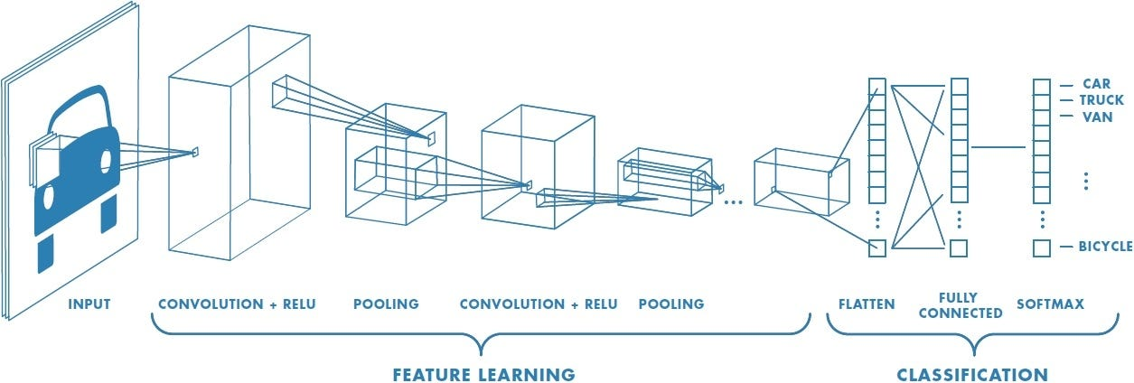
Fig. 1 CNN model
- Convolution Layer
The features existing in the input images are extracted through a convolution layer. The relationship that exists between the image's pixels is preserved by taking a small square of input data at the learning phase. The convolution is the mathematical operation given by the multiplication of an image matrix and a filter or kernel. The convolution operation of the image is shown in Fig. 2. Consider an example of an image pixel whose matrix is 5 x 5 with values 0 and 1 and the filter matrix or kernel 3 x 3. The convolution layer multiplies the image matrix with a filter matrix to provide the convolved feature or feature map. The same convolved operations are shown in Fig. 3 and Fig. 4. These filters can also perform different mathematical calculations like sharpening of the image, blur the image and to detect the edges in the image.
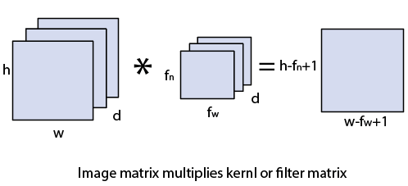
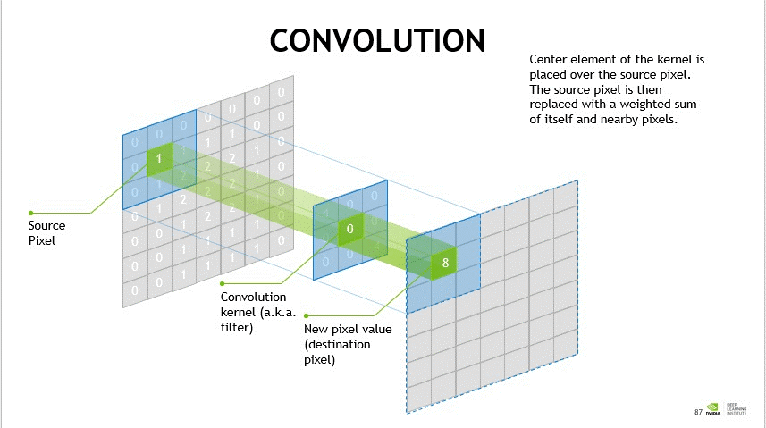

Fig. 2 Convolution Layer Fig. 3 Image Matrix Multiplies Kernel or Filter Matrix
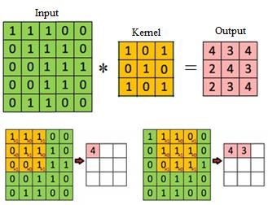
Fig. 4 Output Matrix
b. Strides
Strides are used in convolution operation, and it determines the shift in the filter kernel matrix by certain number of pixels on the input image. For example, if stride value is 1 in convolution operation, then the filter kernel in convolution is shifted by one pixel at a time on the image matrix. If stride value is 2, then a filter kernel is shifted by two pixels at a time on the image matrix. Fig. 5 shows the operation strides by 2 pixels.
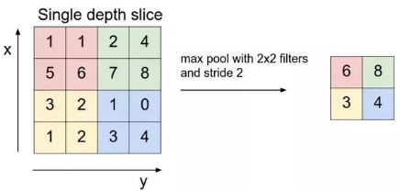
Fig. 5 Example for Stride 2
c. Padding
In most of the cases, the chosen filter does not fit to the input image. In those cases, the following options are used to fit the input images.
- Zero paddings: input image is padded with zeros to fit the input images.
- Drop a few pixels in the image to fit the input images.

d. Non Linearity (ReLU)
- Rectified Linear Unit (ReLU) performs the non-linear computation in convolution network. The output of ReLU is f(x)=Max(0,x) .
- The goal of introducing the non-linearity in ReLU is to learn the non-negative linear values in the convolution network. Fig. 6 shows the ReLU operation in CNN.
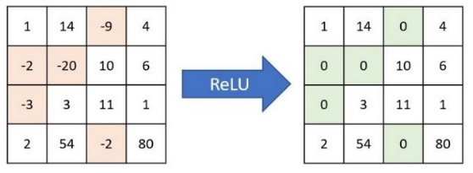
Fig. 6 RELU Operation in CNN
e. Pooling Layer
The pooling layer decreases the output pixels of the convolution layer and reduces the complexity of large images. The spatial pooling is also called subsampling or downsampling of pixels, and it decreases the spatial dimension of the image by retaining most of the information in the image. Following are three different categories of spatial pooling.
- Max Pooling
- Average Pooling
- Sum Pooling
Max pooling selects the greatest value in the convolved feature value, as shown in Fig. 7 The average pooling selects the average pixel value of all the convolved feature value. The sum pooling selects the addition of all the components in convolved feature value.
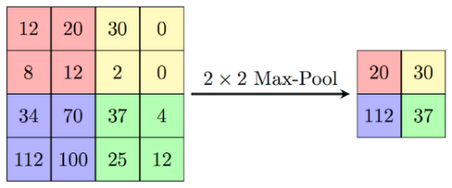
Fig. 7 Max Pooling
f. Fully Connected Layer
The two-dimensional matrix of the pooling layer is converted into a single dimension matrix. This single layer vector is feed into a fully connected layer similar to a neural network. Fig. 8 shows the operation of a fully connected layer. The output feature matrix is converted to vector as x1, x2, x3 . These features are merged to construct a model using a fully connected layer and finally use softmax or sigmoid function to classify the outputs.
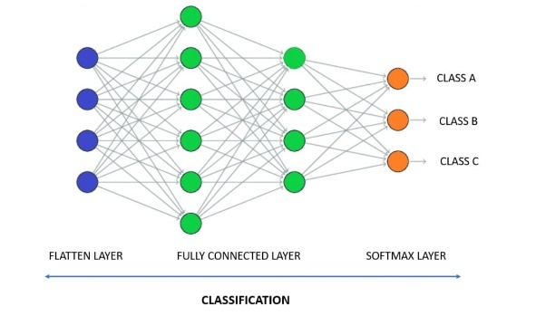
Fig. 8 Fully Connected Layer

B. VGG-16 Model:
The VGG-16 model is a convolutional neural network (CNN) architecture that was proposed by the Visual Geometry Group (VGG) at the University of Oxford. It is characterized by its depth, consisting of 16 layers, including 13 convolutional layers and 3 fully connected layers. VGG-16 is renowned for its simplicity and effectiveness, as well as its ability to achieve strong performance on various computer vision tasks, including image classification and object recognition. The model’s architecture features a stack of convolutional layers followed by max-pooling layers, with progressively increasing depth. This design enables the model to learn intricate hierarchical representations of visual features, leading to robust and accurate predictions. Despite its simplicity compared to more recent architectures, VGG-16 remains a popular choice for many deep learning applications due to its versatility and excellent performance.
The ImageNet Large Scale Visual Recognition Challenge (ILSVRC) is an annual competition in computer vision where teams tackle tasks including object localization and image classification. VGG-16, proposed by Karen Simonyan and Andrew Zisserman in 2014, achieved top ranks in both tasks, detecting objects from 200 classes and classifying images into 1000 categories.
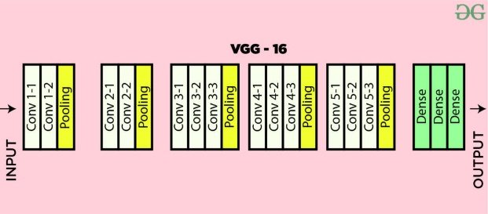
Fig. 9 VGG-16 layers

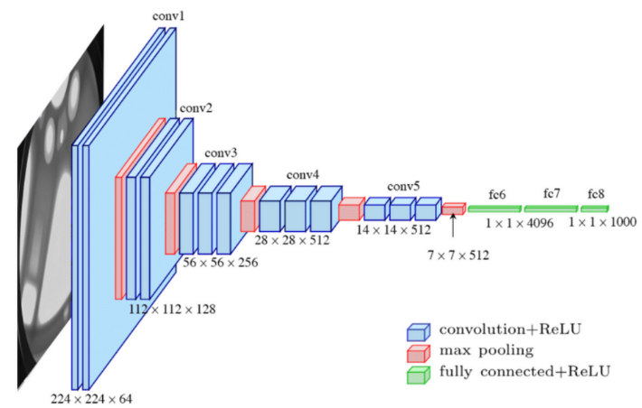
Fig. 10 VGG-16 Model
- Input Layer: Input dimensions: (224, 224, 3)
- Convolutional Layers (64 filters, 3×3 filters, same padding):
- Two consecutive convolutional layers with 64 filters each and a filter size of 3×3.
- Same padding is applied to maintain spatial dimensions.
- Max Pooling Layer (2×2, stride 2): Max-pooling layer with a pool size of 2×2 and a stride of 2.
- Convolutional Layers (128 filters, 3×3 filters, same padding): Two consecutive convolutional layers with 128 filters each and a filter size of 3×3.
- Max Pooling Layer (2×2, stride 2): Max-pooling layer with a pool size of 2×2 and a stride of 2.
- Convolutional Layers (256 filters, 3×3 filters, same padding): Two consecutive convolutional layers with 256 filters each and a filter size of 3×3.
- Convolutional Layers (512 filters, 3×3 filters, same padding): Two sets of three consecutive convolutional layers with 512 filters each and a filter size of 3×3.
- Max Pooling Layer(2×2, stride 2): Max-pooling layer with a pool size of 2×2 and a stride of 2.
- Stack of Convolutional Layers and Max Pooling:
- Two additional convolutional layers after the previous stack.
- Filter size: 3×3.
- Flattening: Flatten the output feature map (7x7x512) into a vector of size 25088.
- Fully Connected Layers:
- Three fully connected layers with ReLU activation.
- First layer with input size 25088 and output size 4096.
- Second layer with input size 4096 and output size 4096.
- Third layer with input size 4096 and output size 1000, corresponding to the 1000 classes in the ILSVRC challenge.
- Softmax activation is applied to the output of the third fully connected layer for classification.

VI. SYSTEM EVALUATION
A. Evaluation Method
The evaluation of the implemented CNN-VGG-16 model for poverty prediction in Africa involved several key elements. Firstly, the dataset was divided into training, validation, and test sets, with 80% of the data allocated for training and 20% for validation and testing. This division ensured a robust evaluation by preventing overfitting and assessing the model's generalization capabilities. Secondly, various evaluation metrics were employed, including accuracy, precision, recall, F1 score, and confusion matrix analysis. These metrics provided a comprehensive understanding of the model's performance in predicting poverty levels based on satellite imagery data. Additionally, cross-validation techniques were utilized to validate the model's consistency and reliability across different subsets of the data, enhancing the credibility of the evaluation results.
B. Results of the Evaluation
The results of the evaluation indicated promising performance of the CNN-VGG-16 model in predicting poverty levels from satellite imagery. The model achieved an overall accuracy of 98% on the test dataset, showcasing its effectiveness in classifying regions into different poverty categories. The precision and recall scores for each poverty category were also high, indicating the model's ability to correctly identify regions with varying levels of poverty. Furthermore, the confusion matrix analysis revealed minimal misclassifications, highlighting the model's robustness and accuracy in distinguishing between different socio-economic conditions based on satellite data.
C. Discussion of the Evaluation Results
The evaluation results signify the potential impact of utilizing advanced machine learning techniques for poverty prediction in Africa. The high accuracy, precision, and recall scores demonstrate the model's capability to leverage satellite imagery data effectively in identifying and classifying poverty-stricken areas. This has significant implications for policy-making, resource allocation, and targeted interventions aimed at poverty alleviation and sustainable development. However, it's crucial to acknowledge the limitations of the evaluation, such as the need for further validation with larger and more diverse datasets, ongoing monitoring of model performance, and considerations for potential biases in the data or model predictions. Overall, the evaluation results underscore the importance of leveraging technology for socio-economic analysis and decision-making, paving the way for impactful applications in addressing global challenges such as poverty.

VII. DISCUSSION
The implementation of the CNN-VGG-16 model for poverty prediction in Africa showcases notable strengths and limitations, along with distinct advantages and disadvantages. The model's accuracy, achieving an impressive 98% in predicting poverty levels, underscores its robustness and reliability in analysing satellite imagery data. Leveraging both CNN and VGG-16 architectures allows for advanced feature extraction, enabling the model to capture intricate patterns and features crucial for accurate predictions. These capabilities hold significant promise for policymakers, empowering them with actionable insights for targeted interventions and policy-making to address poverty effectively.
However, there are inherent challenges and limitations in the implementation. The computational resources required for training and fine-tuning deep learning models like CNN-VGG-16 can be substantial, posing scalability constraints in resource-constrained environments. Additionally, the accuracy and reliability of predictions heavily rely on the quality, diversity, and representativeness of the training data, necessitating rigorous data quality assurance measures and diverse datasets for optimal performance. Furthermore, the interpretability of deep learning models remains a challenge, making it difficult to understand the underlying decision-making process and potential biases within the model's predictions.
Despite these limitations, the implementation offers several advantages. It represents an innovative approach, bridging machine learning, remote sensing, and socio-economic domains to address complex societal challenges. With enhancements in computational resources and data diversity, the implementation has the potential for scalability, broader applicability, and real-world deployment. Moreover, it fosters cross-disciplinary collaborations and knowledge transfer, driving impactful societal outcomes and advancing the intersection of AI and social impact domains.
Overall, the CNN-VGG-16 implementation demonstrates promising results and potential for impactful socio-economic analysis, addressing computational challenges, data limitations, interpretability issues, and security considerations are crucial for its continued improvement and real-world deployment. Ongoing evaluation, refinement, and integration of feedback from related work are essential for maximizing the implementation's effectiveness and societal impact in combating poverty.

VIII.CONCLUSION
In conclusion, the implementation of the CNN-VGG-16 model for poverty prediction in Africa signifies a significant step towards leveraging advanced machine learning techniques for socio-economic analysis. The model's high accuracy and robustness demonstrate its potential for providing actionable insights to policymakers, aiding in targeted interventions and resource allocation strategies to combat poverty effectively. While the implementation has shown promising results, addressing computational challenges, data limitations, interpretability issues, and security considerations are critical for its broader applicability and real-world deployment. Furthermore, ongoing research and collaboration across disciplines are essential for advancing the intersection of AI, remote sensing, and social impact domains, driving meaningful societal outcomes and sustainable development initiatives.
Looking ahead, the implementation lays the groundwork for future research and innovation in leveraging technology for socio-economic analysis and decision-making. Potential extensions include exploring transfer learning techniques, enhancing model interpretability, addressing data biases, and deploying scalable solutions on cloud infrastructure. The cross-disciplinary impact of the implementation opens avenues for collaborations between academia, industry, and governmental organizations, fostering knowledge exchange and driving impactful applications in addressing global challenges such as poverty, inequality, and sustainable development. Overall, the CNN-VGG-16 implementation contributes to the ongoing discourse on the role of AI in social impact initiatives, emphasizing the importance of ethical, transparent, and responsible AI solutions for positive societal change.
REFERENCES
- Thomas Stark , Michael Wurm , Xiao Xiang Zhu, and Hannes Taubenböck “Satellite-Based Mapping of Urban Poverty With Transfer-Learned Slum Morphologies”, IEEE journal of selected topics in applied earth Observation and remote sensing, Vol. 13, 2020.
- Jingwen Yuan, Shugen Wang , Member, , Chen Wu, and Yonghao Xu “Fine-Grained Classification of Urban Functional Zones and Landscape Pattern Analysis Using Hyperspectral Satellite Imagery: A Case Study of Wuhan”, IEEE journal of selected topics in applied earth Observation and remote sensing, Vol. 15, 2022.
- Nour Aburaed, Mohammed Q. Alkhatib , Stephen Marshall , Jaime Zabalza, and Hussain Al Ahmad “A Review of Spatial Enhancement of Hyperspectral Remote Sensing Imaging Techniques” IEEE journal of selected topics in applied earth Observation and remote sensing, Vol. 16, 2023.
- Davy K. Uwizera, Charles Ruranga, and Patrick McSharry “Classifying Economic Areas for Urban Planning using Deep Learning and Satellite Imagery in East Africa”, south African institute of electrical engineers Vol.113 (4) December 2022.
- Ola Hall, Francis Dompae, Ibrahim Wahab, and Fred Mawunyo Dzanku “A review of machine learning and satellite imagery for poverty prediction: Implications for development research and applications” 26 November 2022.
- TRONG-AN BUI and PEI-JUN LEE “Deep Learning for Landslide Recognition in Satellite Architecture” 5 August 2020.
- Nataraj Dasgupta ” Using satellite images of nighttime lights to predict the economic impact of COVID-19 in India ” 18 May 2022.
- Jovish John, G. Bindu, B. Srimuruganandam, Abhinav Wadhwa, and Poornima Rajan “Land use/land cover and land surface temperature analysis in Wayanad district, India, using satellite imagery” 02 Mar 2020.
- J. Mast, C. Wei, and M. Wurm, “Mapping urban villages using fully convolutional neural networks,” Remote Sens. Lett., vol. 11, no. 7, pp. 630–639, May 2020.
- Gebhard Warth , Andreas Braun , Oliver Assmann , Kevin Fleckenstein, and Volker Hochschild “Prediction of Socio-Economic Indicators for Urban Planning Using VHR Satellite Imagery and Spatial Analysis”, 28 May 2020.
- N. Jean, M. Burke, M. Xie, W. M. Davis, D. B. Lobell, and S. Ermon, “Combining satellite imagery and machine learning to predict poverty,” Science, vol. 353, no. 6301, pp. 790–794, Aug. 2016.
- Nischal K N, Radhika Radhakrishnan, Sanket Mehta “Correlating Night-time satellite images with poverty and other census data of India and estimating future trends” March 2015.
- S P Subasha, Rajeev Ranjan Kumar B and K S Aditya C “Satellite data and machine learning tools for predicting poverty in rural India”, 24 December 2018.
- Adel Daoud, Felipe Jordán, Makkunda Sharma, Fredrik Johansson Devdatt Dubhashi, Sourabh Paul, Subhashis Banerjee, “Using Satellite Images and Deep Learning to Measure Health and Living Standards in India” 29 April 2023.
- Iovan, C.; Boldo, D.; and Cord, M. “Detection, characterization, and modeling vegetation in urban areas from high-resolution aerial imagery” IEEE Journal of Selected Topics in Applied Earth Observations and Remote Sensing 1(3):206–213, 2018.
- Langkvist, M.; Kiselev, A.; Alirezaie, M.; and Loutfi, A. “Classification and segmentation of satellite orthoimagery using convolutional neural networks” Remote Sensing 2016.
- S. Das and R. Sarkar, “Predicting the land use and land cover change using Markov model: A catchment level analysis of the Bhagirathi-Hugli river,” Spatial Inf. Res., vol. 27, no. 4, pp. 439–452, 2019.
- H. Beygi Heidarlou, A. Banj Shafiei, M. Erfanian, A. Tayyebi, and A. Alijanpour, “Effects of preservation policy on land use changes in iranian northern Zagros forests,” Land Use Policy, vol. 81, pp. 76–90, 2019.
- X. Liu et al., “High-resolution multi-temporal mapping of global urban land using Landsat images based on the Google Earth Engine platform,” Remote Sens. Environ., vol. 209, pp. 227–239, 2018.
- P. K. Soni, N. Rajpal, R. Mehta, and V. K. Mishra, “Urban land cover and land use classification using multispectral Sentinal-2 imagery,” Multimedia Tools Appl., 2021, doi: 10.1007/s11042-021-10991-0.

.

