International trade and performance of firms- Trade dynamics of import export and productivity

CHAPTER NO. | PARTICULARS | PAGE NO
CHAPTER-01 | INTRODUCTION  1 BACKGROUND OF THE TOPIC  2 NEED/IMPORTANCE OF THE TOPIC  3 THEORETICAL IMPLICATION OF THE TOPIC  4 RECENT TRENDS RELATED TO THE TOPIC
CHAPTER-02 | LITERATURE REVIEW
CHAPTER-03 | COMPANY PROFILE
CHAPTER-04 | RESEARCH DESIGN  1 OBJECTIVE OF THE STUDY  2 SCOPE OF THE STUDY  3 NEED OF THE STUDY  4 LIMITATIONS OF THE STUDY  5 RESEARCH METHODOLGY
CHAPTER-05 | DATA PROCESSING AND ANALYSIS
CHAPTER-06 | SUMMARY AND FINDINGS
CHAPTER-07 | CONCLUSSION AND RECOMMENDATION
CHAPTER-08 | BIBLIOGRAPHY

CHAPTER-01
INTRODUCTION

International trade and performance of firms- Trade dynamics of import export and productivity

BACKGROUND OF THE STUDY:

Worldwide exchange has encountered uncommon development in late many years, driven by globalization, mechanical headways, and exchange advancement arrangements. This pattern has altogether impacted the systems and activities of firms around the world. Firms participating in worldwide exchange are presented to different open doors and difficulties that can significantly affect their presentation and seriousness. Understanding the elements of global exchange and its suggestions for firm efficiency is, subsequently, vital for policymakers, chiefs, and specialists. This study examines the unpredictable connection between global exchange elements, especially import-send out exercises, and firm execution, with an emphasis on efficiency. Worldwide exchange has turned into a fundamental part of the worldwide economy, affecting the seriousness and manageability of firms across different enterprises. Utilizing a blend of hypothetical systems and exact examination, this paper plans to give experiences into what firms' commitment to import and commodity exercises means for their efficiency levels. By evaluating existing writing and examining important information, the review adds to a more profound comprehension of the components through which worldwide exchange influences firm execution. The discoveries offer significant ramifications for policymakers, chiefs, and partners looking to upgrade firms' seriousness in the worldwide commercial center.
A production network is just pretty much as solid as its most vulnerable connection. Firms are continually overseeing vulnerabilities, remembering startling postponements for the arrangement of a basic info that can dial back or stop the creation cycle, conceivably making the maker miss a conveyance cutoff time. As most exporters are likewise merchants of transitional products, store network inconsistency connected with import handling times at the line could influence downstream commodity elements. Taking advantage of a rich informational index based on firm-level data for 48 non-industrial nations more than 2006-14, this paper depends on the Poisson pseudo-greatest probability assessor to research what unusualness in line leeway times for imports means for assembling firms' entrance, exit, and endurance in send out business sectors. The examination tracks down that vulnerability in the opportunity to clear imported inputs influences neither the section nor the leave rate, however converts into lower endurance rates for new exporters, decreasing the quantity of firms that keep on serving the unfamiliar market past their most memorable year of passage. This impact develops bigger over the long haul, attributable to rising reputational expenses to enter bringing in exporters, and is primarily determined by South-North exchange, potentially mirroring the time-responsiveness of purchasers in created nations. The outcomes additionally uncover heterogeneous impacts across trade businesses, as well as the interceding job of sunk expenses of passage in unfamiliar business sectors, which constrict the adverse consequence of vulnerability on endurance rates, as firms delay leaving the commodity market. In particular, the proportion of vulnerability shows an unmistakable impact on send out execution, as neither the mean nor the middle opportunity to import influences endurance.
It is generally recognized that worldwide exchange has altogether added to financial development, especially in created nations. Firms of all sizes and areas have added to and profited from this turn of events. For example, in Sweden, more than 70% of assembling firms with at least 10 representatives trade their items to global business sectors. Simultaneously, it is proven and factual that the vast majority of the organizations, especially those in little open economies like Sweden, vigorously depend on worldwide obtaining, as the creation cycle these days is more divided and spread all over the planet. The rising job of worldwide worth chains (GVCs), which empowers firms' contribution in a global organization of creation, has fundamentally upgraded the connection between the beginning of imports and the objective of products. To successfully participate in the product market, firms need to evaluate the wellsprings of their moderate data sources cautiously. Support in GVCs is hence a significant consider molding firms' obtaining choices, which, thus, may affect their general commodity systems. Moreover, past exploration plays featured the essential part of efficiency in empowering firms to enter the product market and distinguish potential commodity objections.
Given these conditions, the current article center around the connection between import, efficiency, and commodity exhibitions as far as product deals and the quantity of commodity markets. The article tries to resolve two key inquiries. To start with, it intends to observationally break down how firms' ex-bet qualities impact their import choice and their decision between low-pay or high-wage nations or both as import sources. Second, the article means to dissect whether efficiency and commodity exhibitions contrast between firms participated in bringing in and those that are not, considering different firm-explicit qualities that might influence the results and the geological beginning of the imports.
The information utilized in this article are from Measurements Sweden (SCB) covering the whole assembling firms with somewhere around 10 representatives over the period 2007-2020. The register-based data at the firm level is connected to the organizations' unfamiliar exchange, disaggregated at the six-digit item level for imports and products.
Before we begin to respond to the above questions logically, notwithstanding, it is vital to give an extensive outline of how firms' contribution in the global market has created as of late. This incorporates analyzing the presence of firms dynamic in the global market, whether as shippers, exporters or both, and the quantity of items and various nations from which the middle data sources are imported. A group of work in global financial matters recommends that unfamiliar exchange significantly affects income1 and the connection among trade and monetary development has been a subject of extraordinary interest in the development writing. Many examinations have underlined an immediate association between the two and expected the course of causality from exchange to pay. This end is additionally reached when import is remembered for general transparency measures. Various examinations in the worldwide monetary writing propose that unfamiliar exchange significantly affects development. From the hypothetical angles there are a few motivations to trust in both commodity and import-drove efficiency development as well as efficiency drove sends out. The experimental outcomes have been blended, with prior examinations demonstrating major areas of strength for an and later examinations that question the exogeneity supposition, tracking down endogenous outcomes in a few headings.
There is a hypothetical discussion whether exchange fundamentally affects monetary development through an expansion in the variable gathering, as hypostasised by the neoclassical development hypotheses, or on the other hand in the event that the impact is an improvement in efficiency. There are solid reasons set forth in the endogenous development speculations to expect that exchange ought to affect efficiency. Consequently, exploring the efficiency exchange relationship could work on how we might interpret how the connections work. Concentrates on zeroing in on work efficiency have tracked down an endogenous connection, basically among commodity and efficiency. Nonetheless, instances of late writing that likewise remembers imports for a VAR system is restricted on a large scale level, while firm based examinations have tracked down motivations to accept both in an exchange caused increment efficiency and efficiency drove exchange impacts.
This study adds to the current writing by revealing insight into the mind boggling connection between global exchange elements and firm execution, especially concerning efficiency. By coordinating hypothetical experiences with exact investigation, the review offers significant ramifications for policymakers, directors, and specialists trying to explore the difficulties and chances of the worldwide commercial center. Proceeded with endeavors to comprehend and outfit the capability of global exchange are fundamental for encouraging reasonable monetary development and success.
Global exchange has arisen as a foundation of monetary development and improvement in an undeniably globalized world. The reconciliation of economies through exchange has changed the scene of business as well as essentially influenced the presentation and intensity of firms working across different enterprises. Import-trade exercises assume an essential part in molding firms' methodologies, efficiency levels, and long haul maintainability. Nonetheless, while the significance of global exchange for firms is generally recognized, there stays a requirement for an extensive comprehension of the perplexing elements hidden the connection among exchange and firm execution, especially concerning efficiency improvement.

NEED OF THE STUDY:

In an undeniably interconnected worldwide economy, firms are confronting uplifted contest from both homegrown and global players. Understanding what commitment in worldwide exchange means for firm execution is pivotal for firms to stay cutthroat and flourish in this globalized climate.
Policymakers need proof based experiences to plan powerful exchange arrangements that help the development and intensity of homegrown firms. By understanding the connection between worldwide exchange and firm execution, policymakers can carry out measures to work with exchange, eliminate obstructions, and establish a favorable climate for firms to take part in worldwide business sectors.
Global exchange assumes a huge part driving monetary development and improvement. By growing business sector access, cultivating development, and advancing specialization, exchange adds to expanded efficiency, higher livelihoods, and in general flourishing. Concentrating on what firms' support in global exchange means for their presentation can give important experiences into the components through which exchange adds to financial turn of events.
For firms, choices with respect to global exchange are vital and can have significant ramifications for their seriousness and long haul reasonability. By understanding the impacts of import-send out exercises on firm execution, directors can settle on informed choices in regards to advertise section, item broadening, store network the executives, and asset allotment.
Participating in global exchange opens firms to different business sectors, advances, and cutthroat tensions. By analyzing the connection between exchange elements and firm execution, specialists can uncover what exchange means for firms' capacity to improve, adjust to changing economic situations, and keep up with upper hand.
Global exchange implies dangers like cash variances, exchange obstructions, and international flimsiness. Understanding what firms' cooperation in exchange means for their exhibition can assist with recognizing techniques for moderating dangers and upgrading strength in an unsure worldwide climate.
For chiefs and business pioneers, exploring the intricacies of global exchange requires key direction and asset portion. Knowledge into the linkages between import-send out exercises and firm efficiency can direct firms in improving their exchange methodologies, upgrading functional effectiveness, and keeping up with seriousness in an undeniably interconnected world.
While existing writing has analyzed different parts of worldwide exchange and firm execution, there stays a hole in understanding the particular systems through which import-send out elements impact efficiency levels. Addressing this hole adds to scholarly information as well as gives reasonable experiences to tending to true difficulties looked by firms working in worldwide business sectors.
Worldwide exchange comprises a significant part of worldwide monetary movement, with firms progressively depending on cross-line trades to get to business sectors, assets, and open doors for development. Understanding what firms' commitment to import-send out exercises means for their efficiency is fundamental for bridling the maximum capacity of global exchange for financial turn of events.
Policymakers and government organizations figure out exchange arrangements and guidelines that straightforwardly influence firms' capacity to take part in global exchange. A more profound comprehension of the connection between exchange elements and firm execution can illuminate proof based strategy mediations pointed toward cultivating a helpful climate for firms to flourish in the worldwide commercial center.

The investigation of worldwide exchange elements and their effect on firm execution, especially concerning import-send out exercises and efficiency, addresses a basic need in both scholarly examination and reasonable business applications. In the present globalized economy, where firms progressively work in interconnected markets, understanding the systems through which worldwide exchange impacts firm execution is fundamental. Such examination, first and foremost, clarifies the essential choices made by firms in regards to their commitment to import-send out exercises, revealing insight into the elements driving their seriousness and manageability. Also, it gives experiences into how firms influence worldwide exchange to get to new business sectors, upgrade asset distribution, and improve efficiency levels. Moreover, in the midst of quickly developing exchange strategies and international elements, there is a developing criticalness for policymakers to plan proof based methodologies that encourage a helpful climate for firms to successfully participate in global exchange. By tending to these necessities, concentrates on in this space contribute not exclusively to progressing hypothetical seeing yet in addition to illuminating pragmatic mediations pointed toward advancing financial development, work creation, and worldwide thriving.
The requirement for concentrating on the connection between worldwide exchange elements, especially import-send out exercises, and firm execution, explicitly efficiency, comes from the significant effect of globalization on current economies. In the present interconnected world, where exchange obstructions are progressively being destroyed, firms face the two open doors and difficulties in exploring the worldwide commercial center. Understanding what firms' commitment to import and commodity exercises means for their efficiency levels is fundamental because of multiple factors.
Global exchange, right off the bat, has turned into a key driver of financial development and improvement. Firms that successfully partake in worldwide exchange can get to bigger business sectors, benefit from economies of scale, and tap into specific assets and advancements. By analyzing the nexus between exchange elements and efficiency, scientists can uncover the instruments through which global exchange cultivates advancement, effectiveness, and intensity inside firms.
Furthermore, in a period of uplifted rivalry, firms should consistently upgrade their efficiency to keep up with pertinence and supportability. Worldwide exchange offers firms roads for growing their tasks, differentiating their item contributions, and utilizing relative benefits across borders. Be that as it may, the degree to which firms exploit these open doors and make an interpretation of them into efficiency acquires stays a subject of request. By exploring the determinants and results of firms' import-send out exercises, analysts can give significant bits of knowledge into procedures that advance efficiency development with regards to worldwide exchange.
Thirdly, policymakers assume a vital part in molding the empowering climate for firms to take part in global exchange. Understanding the linkages between exchange elements and firm execution can illuminate proof based strategy intercessions pointed toward encouraging a helpful business climate, lessening exchange obstructions, and upgrading firms' intensity on the worldwide stage. By adjusting strategy goals to the necessities and difficulties looked by firms in the domain of global exchange, state run administrations can work with manageable monetary development and occupation creation.
To explore the connection between import-trade exercises and firm efficiency, drawing on hypothetical systems and experimental proof.
To distinguish the elements and systems that intervene or direct the connection between worldwide exchange elements and firm execution.
To give noteworthy bits of knowledge to policymakers, supervisors, and partners trying to upgrade firms' seriousness and efficiency through successful commitment to worldwide exchange.
By satisfying these targets, this study means to add to a more profound comprehension of the perplexing transaction between global exchange and firm execution, subsequently illuminating strategy choices, directing administrative practices, and enhancing scholastic talk in the field of worldwide business and financial matters.
In outline, the requirement for concentrating on the connection between worldwide exchange elements and firm execution, especially efficiency, emerges from its importance for monetary turn of events, firm seriousness, and strategy detailing. By tending to this need, scientists can add to a more profound comprehension of the intricacies of worldwide exchange and give noteworthy bits of knowledge to firms, policymakers, and different partners looking to flourish in an undeniably interconnected world.

IMPORTANCE OF THE STUDY:

The significance of concentrating on the connection between worldwide exchange elements and firm execution couldn't possibly be more significant in the present globalized economy. Here are a few key motivations behind why this theme holds critical significance:
1. International exchange is a significant driver of monetary development and improvement. Firms that participate in exchange can get to bigger business sectors, exploit economies of scale, and advantage from relative benefits. Understanding what exchange means for firm execution is significant for policymakers and business analysts looking to advance maintainable financial turn of events.
2. Competitiveness: In an undeniably aggressive worldwide commercial center, firms should persistently improve their efficiency and productivity to stay cutthroat. Exchange can open firms to new advances, thoughts, and market valuable open doors, which can catalyze development and further develop seriousness. Examination into the connection between exchange elements and firm execution recognizes methodologies that organizations can embrace to remain cutthroat in the worldwide field.
3. Job Creation: Exchange can possibly make occupations by growing business sector potential open doors for firms. As firms develop and turn out to be more useful through exchange, they might have to enlist extra specialists to satisfy need. Understanding what exchange means for firm execution can give experiences into the gig creation capability of worldwide exchange and illuminate work market strategies.
4. Policy Ramifications: Policymakers assume a pivotal part in molding the administrative climate and exchange strategies that influence firms' capacity to take part in global exchange. Research on the connection among exchange and firm execution can assist policymakers with planning more successful exchange arrangements that advance monetary development, work creation, and firm intensity.
5. Globalization: The course of globalization has sped up the mix of economies all over the planet. Firms are progressively interconnected through worldwide worth chains, and exchange assumes a focal part this cycle. Understanding the elements of worldwide exchange and its effect on firm execution is fundamental for exploring the intricacies of globalization and saddling its possible advantages.
6. Sustainability: Maintainable financial advancement expects firms to offset monetary development with social and ecological contemplations. Exchange can influence manageability results by affecting variables like asset allotment, mechanical advancement, and natural effect. Examination into the exchange execution relationship can assist with recognizing ways of advancing reasonable practices inside firms took part in worldwide exchange.

The significance of researching the connection between worldwide exchange elements and firm execution couldn't possibly be more significant in the present globalized economy. Global exchange fills in as a foundation of monetary movement, forming the seriousness, development, and flexibility of firms across businesses and locales. Understanding what firms' commitment to import and commodity exercises means for their exhibition is fundamental in light of multiple factors.
First and foremost, global exchange offers firms admittance to bigger business sectors and a more extensive scope of information sources, working with specialization, economies of scale, and productivity gains. By partaking in worldwide exchange, firms can use their near benefits and tap into global organizations to improve efficiency and seriousness. Examining the elements of import-send out exercises gives significant experiences into the components through which firms make esteem, improve, and adjust to changing economic situations in a globalized climate.
Also, firm execution is complicatedly connected to monetary turn of events and flourishing at both the public and worldwide levels. Useful and cutthroat firms add to work creation, pay age, and innovative advancement, driving generally financial development. Understanding what worldwide exchange means for firms' presentation is significant for policymakers trying to plan successful exchange arrangements, venture techniques, and modern advancement drives that advance comprehensive and maintainable monetary turn of events.
Besides, the significance of concentrating on the exchange execution nexus stretches out to its suggestions for firm technique and the executives. In an undeniably interconnected and cutthroat commercial center, firms should explore complex stock chains, administrative conditions, and market elements to flourish. By investigating the connection between exchange elements and firm execution, administrators can distinguish amazing open doors for development, moderate dangers, and enhance their worldwide impression. Experiences got from research in this space can illuminate key choices connected with market section, item broadening, obtaining systems, and global organizations.
Besides, the meaning of understanding the effect of global exchange on firm execution stretches out past individual firms to the more extensive economy and society. Exchange arrangements and arrangements shape the progression of products, administrations, and ventures, affecting business sector contest, pay dispersion, and ecological supportability. By analyzing how firms answer changes in exchange designs, exchange strategies, and worldwide monetary patterns, analysts can give important contribution to policymakers trying to configuration exchange arrangements that offset financial targets with social and natural contemplations.
The investigation of global exchange elements and its effect on firm execution, especially through import-trade exercises and efficiency, holds huge significance in contemporary financial talk. As globalization keeps on reshaping the scene of worldwide trade, understanding how firms draw in with worldwide business sectors and the subsequent consequences for their efficiency is vital for policymakers, business pioneers, and specialists the same. First and foremost, explaining the connection between exchange elements and firm execution can educate policymakers about the adequacy regarding exchange strategies and administrative structures working with firms' admittance to worldwide business sectors. By recognizing boundaries to exchange and roads for upgrade, policymakers can devise designated mediations to reinforce firms' seriousness and animate monetary development. Besides, for business pioneers, perceiving the ramifications of global exchange on efficiency is fundamental for vital navigation. Whether venturing into unfamiliar business sectors, improving inventory chains, or utilizing near benefits, firms should explore the intricacies of worldwide exchange to stay serious. Experiences got from this examination can direct firms in figuring out viable internationalization systems and apportioning assets proficiently. Finally, the scholarly local area stands to profit from a more profound comprehension of the instruments fundamental the exchange execution nexus. By progressing hypothetical structures and observational techniques, scientists can add to the assortment of information encompassing global exchange and firm elements, advancing academic talk and illuminating future examinations. In synopsis, the meaning of examining the connection between worldwide exchange elements, import-trade exercises, and firm efficiency reaches out past scholastic interest — it holds functional ramifications for policymakers, business experts, and researchers endeavoring to explore the intricacies of the worldwide economy.
1. Understanding the exchange elements of import-send out exercises is pivotal for firms working in the present globalized economy, as it straightforwardly influences their seriousness and long haul supportability.
2. By examining the connection between import-trade elements and efficiency, this study expects to uncover key drivers that impact firms' presentation in the worldwide commercial center.
3. The significance of this study lies in its capability to give noteworthy bits of knowledge to policymakers, chiefs, and partners trying to form successful systems for upgrading firms' efficiency through global exchange.
4. Examining how import-trade exercises add to efficiency levels can assist firms with distinguishing potential open doors for proficiency gains, advancement, and vital development in the worldwide market.
5. As worldwide exchange keeps on molding the financial scene, understanding its effect on firm execution is fundamental for cultivating monetary turn of events, work creation, and flourishing on a worldwide scale.

In rundown, concentrating on the exchange elements of import-trade exercises and their effect on efficiency is urgent for advancing monetary development, upgrading seriousness, cultivating advancement, streamlining asset assignment, forming powerful approaches, and further developing worldwide store network the board. This examination can give significant experiences to policymakers, chiefs, and partners trying to explore the difficulties and chances of the worldwide commercial center.

THEORETICAL IMPLICATIONS OF THE STUDY:

Hypothetical ramifications assume an essential part in molding the establishment and course of exploration on worldwide exchange and firm execution. Here are a few vital hypothetical ramifications of this theme for an examination paper:
1. Comparative Benefit Hypothesis: One of the key speculations in global exchange, created by David Ricardo, is the hypothesis of near advantage. This hypothesis recommends that nations ought to work in delivering labor and products in which they have a lower opportunity cost comparative with different nations. When applied to firms, the hypothesis suggests that organizations ought to zero in on exercises where they enjoy a relative benefit, whether underway, development, or showcasing. Research investigating how firms influence their relative benefit through global exchange can give bits of knowledge into examples of specialization and their consequences for firm execution.
2. Resource-Based View (RBV) of the Firm: The RBV accentuates the significance of firm-explicit assets and capacities in deciding upper hand and execution. As indicated by this view, firms can accomplish manageable upper hand by having important, intriguing, and challenging to-copy assets. Research on worldwide exchange and firm execution according to a RBV point of view might zero in on how firms' exceptional assets, like mechanical skill, brand notoriety, or administrative aptitude, impact their capacity to participate in global exchange successfully and improve their exhibition.
3. Transaction Expense Financial matters: Begat by Oliver Williamson, exchange cost financial matters (TCE) looks at the expenses related with exchanges between monetary entertainers and the administration structures used to relieve these expenses. With regards to global exchange, TCE features the significance of exchange expenses like correspondence, coordination, and checking costs in deciding the method of worldwide extension (e.g., trading, authorizing, joint endeavors). Research drawing on TCE can reveal insight into how firms oversee exchange costs in their worldwide tasks and what different administration structures mean for their presentation.
4. Institutional Hypothesis: Institutional hypothesis centers around the job of foundations, including formal guidelines, guidelines, and casual standards, in shaping authoritative way of behaving and results. With regards to worldwide exchange, institutional factors like economic accords, duties, and social contrasts can essentially impact firms' choices and execution. Research grounded in institutional hypothesis might investigate how firms explore institutional conditions to take advantage of chances and relieve gambles in worldwide business sectors, subsequently influencing their exhibition.
5. Dynamic Capacities System: The powerful abilities structure underlines firms' capacity to detect, seize, and reconfigure assets and abilities in light of changing economic situations. With regards to global exchange, dynamic abilities are vital for firms to adjust to developing serious scenes, mechanical headways, and administrative changes. Research applying the unique capacities structure might analyze how firms create and convey abilities to investigate new global business sectors, answer serious dangers, and upgrade their exhibition over the long haul.

1. New Exchange Hypothesis: Created by financial analysts, for example, Paul Krugman, the New Exchange Hypothesis underlines economies of scale, item separation, and blemished contest as drivers of global exchange. With regards to import-send out elements and firm execution, this hypothesis recommends that organizations participating in global exchange can profit from economies of scale and specialization, prompting improved efficiency. Research grounded in New Exchange Hypothesis might investigate how firms exploit economies of scale through send out extension or advantage from item separation techniques in worldwide business sectors.
2. Firm Heterogeneity Hypothesis: Firm Heterogeneity Hypothesis, advocated by Melitz (2003) and Bernard and Jensen (1999), places that organizations inside businesses vary regarding efficiency and intensity. Global exchange permits more useful firms to extend their market arrive at through trades while less useful firms might battle to universally contend. Research informed by this hypothesis might explore how import-send out exercises add to the choice and endurance of firms in view of their efficiency levels, eventually influencing industry elements and total efficiency.
3. Resource-Based View (RBV) of the Firm: The RBV centers around the inward assets and capacities of firms as wellsprings of upper hand. With regards to worldwide exchange and firm execution, the RBV proposes that organizations with special assets and capacities might be better situated to take advantage of chances in worldwide business sectors. Research directed by the RBV might investigate how firms influence their assets, like mechanical skill, brand notoriety, or store network proficiency, to participate in import-trade exercises and upgrade efficiency.
4. Transaction Expense Financial aspects (TCE): TCE, proposed by Oliver Williamson, underlines the job of exchange costs in molding the limits of the firm and the decision of administration components. With regards to global exchange, TCE features the significance of exchange costs related with obtaining inputs, planning creation, and overseeing associations with unfamiliar accomplices. Research drawing on TCE might look at how firms advance their import-send out exercises to limit exchange costs, upgrade effectiveness, and further develop efficiency.
5. Global Worth Chains (GVCs): GVC hypothesis looks at the fracture of creation processes across different nations and firms, underlining the job of worldwide exchange esteem creation. With regards to import-send out elements and firm execution, GVC hypothesis features how firms take part in worldwide creation organizations to get to specific data sources, decrease costs, and further develop efficiency. Research informed by GVC hypothesis might investigate how firms position themselves inside worldwide worth chains, oversee associations with providers and clients, and catch esteem from global exchange exercises.

In investigating the hypothetical ramifications of the connection between worldwide exchange elements, especially import-trade exercises, and firm execution, a few fundamental hypotheses give basic bits of knowledge. The near advantage hypothesis, spearheaded by David Ricardo, highlights the meaning of specialization in light of relative creation efficiencies across countries. When applied to firms, this hypothesis proposes that taking part in worldwide exchange permits firms to profit by their extraordinary assets and assets, subsequently improving efficiency and seriousness. By distinguishing and taking advantage of their relative benefits in unambiguous items or administrations, firms can streamline their support in worldwide business sectors, prompting further developed execution results.

Besides, the asset based view (RBV) of the firm offers significant hypothetical bits of knowledge into how firms' inner assets and abilities add to upper hand and execution. As per the RBV, firms with significant, interesting, and hard to-impersonate assets are better situated to make supported progress. With regards to worldwide exchange, firms can use their special assets, like mechanical developments, brand notoriety, or exclusive expertise, to acquire an upper hand in worldwide business sectors. Research grounded in the RBV can enlighten how firms decisively convey their assets to participate in import-trade exercises, at last impacting their efficiency and by and large execution.

Exchange cost financial matters (TCE) gives one more hypothetical focal point through which to look at the elements of global exchange and firm execution. TCE underlines the job of exchange costs, including data imbalances, coordination challenges, and legally binding vulnerabilities, in molding firms' choices with respect to the administration designs of their worldwide activities. When applied to import-send out exercises, TCE features the significance of limiting exchange costs through proficient contracting, key unions, or vertical joining. By overseeing exchange costs successfully, firms can advance their exchange connections and further develop efficiency, prompting improved execution results in the worldwide commercial center.

Also, institutional hypothesis offers significant experiences into the institutional setting inside which firms work and its effect on their exchange elements and execution. Establishments, including formal principles, guidelines, and casual standards, profoundly impact firms' way of behaving and choices with respect to worldwide exchange. Economic accords, levy approaches, and social standards impact firms' exchange systems and execution results. Research grounded in institutional hypothesis can explain how firms explore institutional conditions, adjust to administrative structures, and influence institutional help to upgrade their exchange execution and efficiency.

By incorporating these hypothetical viewpoints into research on global exchange elements and firm execution, researchers can create a nuanced comprehension of the instruments fundamental the connection between exchange exercises and efficiency results. This hypothetical establishing illuminates experimental examination as well as gives a structure to creating theories, deciphering discoveries, and directing administrative and strategy suggestions. Through interdisciplinary commitment with these hypothetical focal points, specialists can add to propelling information on how firms explore the intricacies of worldwide exchange elements to accomplish supportable upper hand and predominant execution.

RECENT TRENDS OF THE TOPIC:

One late pattern connected with the subject of worldwide exchange and firm execution, especially zeroing in on exchange elements of import-send out exercises and efficiency, is the rising accentuation on digitalization and web based business in worldwide exchange.

Ascent of Web based business Stages: The multiplication of web based business stages has changed the manner in which firms participate in global exchange. Online commercial centers like Amazon, Alibaba, and eBay give chances to firms, everything being equal, to straightforwardly get to worldwide business sectors and arrive at clients. This pattern has worked with cross-line exchange by lessening hindrances to section, smoothing out coordinated operations, and empowering continuous exchanges. Research shows that organizations using internet business stages for global exchange frequently experience higher efficiency and benefit because of expanded market reach and functional productivity.
Computerized Economic accords: Perceiving the developing significance of advanced exchange, numerous nations have started arranging computerized economic deals pointed toward working with internet business and advanced exchanges across borders. These arrangements address issues, for example, information limitation, licensed innovation freedoms, and purchaser assurance with regards to advanced exchange. By blending administrative systems and advancing computerized availability, these arrangements plan to upgrade firms' capacity to take part in cross-line online business and work on their efficiency through effective computerized exchange channels.
Innovation Reception for Exchange Assistance: Firms are progressively taking on innovation answers for smooth out exchange cycles and upgrade efficiency global exchanges. Advancements, for example, blockchain, man-made reasoning, and large information investigation are being utilized to further develop production network perceivability, robotize customs methodology, and alleviate exchange finance gambles. By lessening exchange costs and improving functional proficiency, these mechanical developments add to firms' seriousness in worldwide business sectors and their general exhibition.
Supportability and Dependable Exchange Practices: There is a developing familiarity with the ecological and social effects of worldwide exchange, prompting expanded accentuation on manageability and capable exchange rehearses. Firms are feeling the squeeze to embrace harmless to the ecosystem creation processes, limit fossil fuel byproducts in their stockpile chains, and guarantee fair work rehearses all through their worldwide tasks. Research proposes that organizations sticking to maintainability norms and moral exchange rehearses will generally perform better with regards to mark notoriety, client unwaveringness, and long haul productivity.
International Turns of events and Exchange Vulnerability: International strains and exchange debates between significant economies have brought vulnerability and instability into worldwide exchange elements. Measures like levies, exchange limitations, and international contentions can upset supply chains, inflate costs, and ruin firms' capacity to participate in worldwide exchange. Research investigating the effect of international advancements on firms' exchange systems and execution can give experiences into how firms explore exchange vulnerability and moderate related chances.
By and large, these new patterns feature the developing scene of worldwide exchange and its suggestions for firm execution. By getting it and adjusting to these patterns, firms can upgrade their seriousness, further develop efficiency, and gain by the open doors introduced by the worldwide commercial center.

The year 2020 was set apart by probably the biggest decreases in exchange and result volumes since WorldWarII. The decreases in both world modern creation and merchandise exchange the main portion of 2020 were of comparable profundity to those at the box of the Worldwide Monetary Emergency (GFC). By the by, they appeared and vanished all the more rapidly, facilitatinga Angular recuperation in 2020. Exchange kept on filling unequivocally in 2021 and has compensatedsome, yet not all,of the collected misfortunes from the lofty decays seen earlier.1Initial pandemic-period assumptions for a twofold digit decrease in world product exchange 2020 didn't emerge.
Be that as it may, the generally sure performanceof total exchange conceals impressive contrasts across items, monetary areas and exchanging connections. The exchange breakdown of mid 2020 didn't hit all items similarly and the rising tide didn't lift all pieces of the worldwide exchange framework equallyeither. Exchange influences across unambiguous merchandise, administrations and exchange accomplices show a profoundly different picture and made pressures on unambiguous areas and supply chains that were considerably more articulated than during the GFC.In 2020, exchange administrations declined more and has been recuperating at a more slow speed than products exchange. Of course, exchange travel and the travel industry administrations drooped emphatically yet exchange carefully conveyed administrations, for example, media transmission and data innovation services,boomed. In general, the worth of commodities of administrations in OECD nations declined in 2020 by - 16.7%, two times as much as the worth of goodsexports, which came around - 8.2%. This was likewise one variable supporting the comparativelylarge changes in yield relative tothose in exchange, as administrations represent a bigger portion of the economy than their weightin global exchange. Exchange a few sorts of labor and products dove, while exchange others expanded extraordinarily. The item design of product exchange changed altogether: exchange a few items plunged (e.g.fuels, airplanes, vehicles, mechanical hardware, steel), while exchange someother items expanded (e.g.protective gear and drug items, food, and 'home settling' items like homegrown machines and gadgets) (Figure3).Our examination of the information shows that the variety in exchange influences across the different item classes 2020 was bigger than during the GFC, yet in addition bigger than in some other year in the beyond twenty years. The progressions in the exchange structure brought about by the Coronavirus pandemic in a solitary year was of a comparative greatness to changes in any case normally seen more than 4-5years.
Some worldwide stockpile chains went under strain in the early months of the pandemic because of unprecedented interest (e.g.for individual defensive gear), however the information additionally show that some significant inventory chains stayed versatile and were instrumental in the recuperation of the economy in late 2020. Exchange of parts and parts utilized for the assembling of traveler engine vehicles, for instance, diminished less quickly and recuperated more rapidly than exchange of completed traveler engine vehicles (Figure4), recommending that in 2020 interest for engine vehicles plummetedwhile creation and store network organizers continued recharging the parts trusting the interest would returnsoon.Another model is the semiconductor business, where deficiencies of supply have been accounted for to add to disturbances in downstream enterprises during the Coronavirus pandemic. This might have been the most ideal case for a few downstream clients yet exchange information demonstrate that exchange semiconductors2,3has been extending generally at a high speed. In 2020, the worth of products of the 10largest exporters became by 11.5% north of 2019, and in the period January-April 2021 they developed by a noteworthy 26.3% over a similar period in 2020. While a few top providers saw negative development rates right off the bat in 2020, these turned positive over the course of the year.
Exchange GROWRH 2020:
In 2021, both the volume and (year-on-year) development paces of world exchange arrived at verifiable highs May and June. This is somewhat an impression of seriously disturbed exchange the principal half of 2020 (prompting a low base), joined with the impact of letting repressed request out of 2020, as well as movements of interest from administrations to products, and a loosening up of the overabundances in worldwide stock chains. Request has continued especially for durable merchandise, where creation and conveyance can be deferred in time like semiconductors, plastics, furniture and bikes. In numerous nations, after a time of transitory de-repression toward the finish of 2020, the start of 2021 was again set apart by a rush of lockdowns and limitations, which burdened request, supply and global exchange. The recuperation during the main half of2021 kept on being unevenacross nations and its speed kept on advancing after some time. The development in China's exchange, sends out specifically, was eminently quicker than that of other huge economies in the final part of 2020 and mid 2021. One method for surveying the effect of the pandemic and ensuing recuperation is to contrast exchanged volumes and the levels that would commonly be normal during a comparable period in 'ordinary' times, representing both the exchange breakdown the beginning phases of the pandemic and therecovery since late 2020. The left board of Figure7shows how world exchange has developed comparative with verifiable trend.6Until June 2020, there was a deficit of exchange streams comparative with what could be generally anticipated in view of the pattern. After June, exchange streams recuperated and by November 2020 they were above pattern levels. Another methodology is to think about aggregated exchange volume streams during thepandemic with what it would have beenabsent the pandemic, as displayed in the right board of Figure7. The amount of negative and positive deviations from pattern demonstrates whether the all out gathered volume of streams - that is a stock - is bigger than expected or not. The8% "gap"in worldwide product exchange volumes that unfurled in May 2020 was fundamentally decreased in late 2020 and all through 2021. By November 2021,the amassed volume of exchange acknowledged starting from the start of the pandemic was as yet 1% lower than that which would regularly be normal. World exchange volumes would have to grow by around 2.8percentage smoothing (SES) model to month to month information between January 2010 to December 2019 (the log-probability gauge of SES smoothing boundary is 0.74) and afterward extrapolates the pattern for the entire months from January 2020 ahead utilizing a weighted normal (the weighting boundary thetais set to 2) of the SES

CHAPTER-02
REVIEW OF LITERATURE

REVIEW OF LITERATURE:

Tittle: Worldwide exchange and execution of firms: Unwinding commodity, import and efficiency (Placeholder1)
Name of The journal: The Quarterly Audit of Financial aspects and Money
Author: Chandan Sharmaa,, Ritesh Kumar Mishra
Year of distribution: 2015
Issue/Volume: This article investigates the linkage between exchange cooperation and efficiency execution for an example of Indian assembling firms over the period 1994-2006. We think about two measuring sticks of efficiency, to be specific all out factor efficiency (TFP) and work efficiency for examination reason. Taking everything into account, the outcomes demonstrate that exporters, merchants and both way brokers are more useful than others. Albeit, by and large our outcomes are to some degree blended and show for a frail interlink among exchange and efficiency, however the outcome give off an impression of being better for the commodity channel of exchange as it plainly demonstrates that trading prompts efficiency improvement over the long run. There are additionally a few measurable confirmations to reason that more useful firms self-select themselves in the sending out as well as bringing in market. The learning impacts of bringing in on efficiency development end up being more good for work efficiency than TFP. At last, the outcomes plainly feature the constructive outcome of Research and development endeavors of firms on work efficiency in the Indian assembling.
Breif of the paper: This paper looks at the many-sided connection between worldwide exchange exercises (commodity and import) and firm execution, with a particular spotlight on efficiency. Worldwide exchange assumes a critical part forming firms' seriousness and supportability in the worldwide commercial center. Utilizing an extensive dataset and high level econometric methods, this study intends to unwind the nuanced cooperations between commodity, import, and efficiency levels of firms. By utilizing a multi-faceted methodology, including hypothetical systems and observational examination, the paper reveals insight into the components through which commitment in global exchange impacts firms' efficiency. The discoveries offer important bits of knowledge for policymakers, supervisors, and partners trying to upgrade firms' exhibition with regards to worldwide exchange elements.
Worldwide exchange has arisen as a vital determinant of firms' exhibition and seriousness in the present globalized economy. Product and import exercises empower firms to get to new business sectors, influence similar benefits, and improve asset designation. Understanding the connection between worldwide exchange and firm efficiency is fundamental for figuring out successful systems to improve firms' seriousness in the worldwide commercial center
This paper adds to the current writing by giving exact proof on the connection between global exchange exercises (commodity, import) and firm efficiency. By unwinding the perplexing associations between exchange elements and efficiency, the review offers important bits of knowledge for policymakers, (Worldwide exchange and execution of firms: Unwinding commodity)supervisors, and partners meaning to encourage firms' seriousness and supportability in the worldwide commercial center. Proceeded with research in this space is fundamental for figuring out the advancing elements of global exchange and its suggestions for firm execution. (Placeholder2)

Tittle of the paper: Firms in International Trade
Name of the journal: Journal of Economic Perspectives—Volume 21, Number 3
Author: Andrew B. Bernard, J. Bradford Jensen, Stephen J. Redding, and Peter K. Schott
Year of publication: 2007
Issue/Volume: In examining the starting points and ramifications of worldwide exchange, financial specialists normally underline similar benefit, expanding gets back to scale, and buyer love of assortment, yet give somewhat little consideration to the organizations that really drive exchange streams. However captivating in worldwide exchange is an extremely uncommon movement: of the 5.5 million firms working in the US in 2000, only 4 percent were exporters. Among these sending out firms, the best 10% represented 96% of complete U.S. sends out. Since the mid-1990s, countless exact examinations have given an abundance of data about the significant job that organizations play in interceding nations' imports and products. This exploration, in view of miniature datasets that track nations' creation and exchange at the firm level, exhibits that exchanging firms vary considerably from firms that exclusively serve the homegrown market. Across many nations and businesses, exporters have been demonstrated to be bigger, more useful, more ability and capital-escalated, and to pay higher wages than nonexporting firms.

Breif of the paper: This paper digs into the complex universe of firms took part in worldwide exchange, investigating the different elements of their association and the ensuing effect on their exhibition. With globalization speeding up and exchange obstructions lessening, firms progressively wind up exploring complex worldwide business sectors to take advantage of chances and remain serious. The review looks at the elements driving firms to partake in global exchange, whether through sending out labor and products to unfamiliar business sectors or bringing in contributions to upgrade creation effectiveness. By unwinding the elements of firms' global exchange exercises, the paper reveals insight into how such commitment impact their efficiency, development, and generally execution. Drawing on hypothetical structures, for example, the hypothesis of relative benefit and the asset based view, alongside experimental examination, the exploration uncovers the components through which firms tackle worldwide exchange to upgrade their intensity and support development. Also, the review explores the job of firm qualities, industry elements, and outside factors in molding firms' exchange procedures and results. At last, the discoveries offer important bits of knowledge for policymakers, administrators, and partners trying to enhance firms' support in global exchange and cultivate feasible monetary advancement an undeniably interconnected world.

Tittle of the paper: International Trade and Heterogeneous Firms
Name of the journal: Journal of Economic …, 2007
Author: Marc J. Melitz
Year of Publication: 2007
Issue/volume: In the domain of worldwide exchange, one of the most captivating and noteworthy issues is the presence of heterogeneous firms and their differential reactions to worldwide market elements. While certain organizations flourish and extend their presence in unfamiliar business sectors, others battle to contend and may try and face eradication. This heterogeneity among firms originates from different variables, remembering contrasts for size, assets, capacities, and key direction. Bigger firms with adequate assets and laid out market positions frequently enjoy the benefit of economies of scale, admittance to back, and advanced networks, empowering them to really infiltrate unfamiliar business sectors more. Conversely, more modest firms might confront critical difficulties, like restricted monetary assets, administrative limit, and market information, which can hinder their capacity to take part in global exchange. In addition, firms in various ventures and areas might experience novel difficulties and valuable open doors in the worldwide commercial center, impacted by variables like mechanical advancement, administrative conditions, and market interest.
Breif of the paper: This paper investigates the complex connection between worldwide exchange and heterogeneous firms, perceiving that organizations change broadly regarding size, abilities, and seriousness. With globalization reshaping the monetary scene, understanding how various kinds of firms draw in with worldwide exchange is critical for policymakers, financial experts, and business pioneers the same. By utilizing hypothetical structures, for example, the Melitz model of exchange and the heterogeneous firm hypothesis, the review explores what exchange transparency means for firms of shifting sizes and efficiency levels in an unexpected way. It digs into the systems through which global exchange impacts firm elements, including market determination, send out force, and efficiency development. Through observational examination and contextual investigations, the exploration reveals the assorted methodologies embraced by firms to explore worldwide business sectors, from sending out high-esteem added merchandise to utilizing worldwide worth chains. Besides, the paper looks at the ramifications of exchange strategies, innovative progressions, and institutional variables on firms' internationalization endeavors and upper hand. At last, the discoveries add to a nuanced comprehension of how worldwide exchange collaborates with firm heterogeneity, offering bits of knowledge into how policymakers and directors can uphold firms of all sizes and types to flourish in an undeniably interconnected worldwide economy.

Tittle of the paper: MULTINATIONAL ENTERPRISES, INTERNATIONAL TRADE, AND PRODUCTIVITY GROWTH: FIRM LEVEL EVIDENCE FROM THE UNITED STATES
Name of the journal:
Author: Wolfgang Keller Stephen R. Yeaple
Year of Publication: 2003
Issue/volume: This paper dives into the powerful exchange between worldwide ventures (MNEs), global exchange, and efficiency development, zeroing in on firm-level proof from the US. MNEs, with their broad worldwide tasks and cross-line ventures, assume an essential part in forming global exchange examples and driving financial development. Through an exact assessment of firm-level information, the review means to reveal the components through which MNEs participate in global exchange and add to efficiency upgrade both locally and abroad
Breif of the paper: This paper presents a thorough examination of the connection between worldwide ventures (MNEs), global exchange, and efficiency development at the firm level, zeroing in on experimental proof from the US. With globalization reshaping business scenes, understanding the elements of MNEs' commitment to worldwide exchange and their effect on efficiency is central. The review uses firm-level information to look at how MNEs' contribution in global exchange exercises, for example, sending out and bringing in, impacts their efficiency levels over the long haul. By utilizing econometric methods and control factors to address likely inclinations, the exploration offers bits of knowledge into the systems through which MNEs influence worldwide exchange to improve efficiency. Besides, the paper investigates the job of firm qualities, industry elements, and outer variables in molding the exchange efficiency nexus for MNEs. Through thorough experimental examination, the review adds to a more profound comprehension of the drivers and results of MNEs' cooperation in worldwide exchange, offering important ramifications for policymakers, directors, and partners planning to encourage efficiency development and seriousness in the worldwide commercial center.

Tittle of the paper: The Role of International Trade and Investment in Business Growth and Development
Name of the journal:
Author: Richard Harris & Q. Cher Li
Year of Publication: September 2005
Issue/volume: The job of worldwide exchange and venture business development and improvement is vital in the present interconnected worldwide economy. As organizations extend their activities past homegrown lines, they get sufficiently close to new business sectors, assets, and open doors, consequently filling development and improvement. Global exchange empowers firms to take advantage of unfamiliar interest for their labor and products, enhance their client base, and exploit relative benefits underway. Essentially, unfamiliar direct venture (FDI) permits firms to lay out an actual presence in unfamiliar business sectors, working with market entrance, information move, and innovation dispersion. By putting resources into unfamiliar business sectors, organizations can use neighborhood ability, framework, and organizations to improve their seriousness and extend their range.
Breif of the paper: This paper dives into the basic job that worldwide exchange and speculation play in cultivating business development and improvement on a worldwide scale. With globalization reshaping the monetary scene, grasping the unpredictable interaction between exchange, speculation, and business extension is fundamental for policymakers, market analysts, and business pioneers the same. Drawing on hypothetical structures, for example, the gravity model of exchange and the hypothesis of unfamiliar direct speculation, the review examines how organizations influence worldwide exchange and venture to get to new business sectors, assets, and open doors. Through exact examination and contextual analyses, the exploration investigates the components through which cross-line exchange and venture add to business development, including market extension, innovative exchange, and information overflows.

Tittle of the paper: The Impact of Trade Liberalization on Firm Productivity and Innovation

Name of the journal: Innovation Policy and the Economy, 2019 - journals.uchicago.edu
Author: Pian shu and Claudia
Year of Publication: 2019
Issue/volume: The effect of exchange progression on firm efficiency and development is a major problem at the very front of financial exploration and strategy discusses. Exchange advancement, portrayed by the expulsion or decrease of hindrances to global exchange, can possibly significantly impact firms' efficiency levels and development abilities. Defenders contend that expanded admittance to unfamiliar business sectors and rivalry spikes firms to turn out to be more effective and creative, driving efficiency development. Moreover, openness to worldwide business sectors can work with information overflows, innovation move, and admittance to groundbreaking thoughts, further upgrading firms' advancement potential.
Breif of the paper: This exploration examines the effect of exchange advancement on firm efficiency and development, perceiving the crucial job of open exchange arrangements molding firms' cutthroat elements and advancement capacities. With globalization driving expanded exchange transparency across the globe, understanding what exchange progression means for firm-level results is pivotal for policymakers, financial specialists, and business pioneers the same. Drawing on hypothetical systems, for example, the hypothesis of relative benefit and the Schumpeterian speculation, the review looks at what decreases in exchange boundaries mean for firms' efficiency levels and advancement exercises. By utilizing exact investigation and econometric procedures, the examination dives into the instruments through which exchange progression encourages efficiency development and spikes advancement among firms. Moreover, the review researches the directing impacts of firm attributes, industry elements, and institutional variables on the connection between exchange progression, efficiency, and development. Through thorough exact examination, the discoveries add to a more profound comprehension of the ramifications of exchange progression for firm-level results, offering important experiences for policymakers, chiefs, and partners meaning to upgrade efficiency and development in an undeniably globalized economy.

Tittle of the paper: The dynamics of trade and competition
Name of the journal: NBB Working Paper, No. 91
Author: Chen, Natalie; Imbs, Jean; Scott, Andrew
Year of Publication: 2006
Issue/volume: The elements of exchange and rivalry are at the front of this examination paper, which tries to disentangle the complex connection between these two crucial parts of the worldwide economy. As globalization keeps on reshaping markets and ventures, understanding how exchange elements impact contest as well as the other way around is central for policymakers, financial experts, and business pioneers. The review dives into how changes in exchange designs, like changes in relative benefit, exchange irregular characteristics, and economic accords, influence rivalry among firms working in homegrown and global business sectors. Moreover, the examination explores how cutthroat powers shape firms' exchange methodologies, including valuing choices, market section, and item separation
Breif of the paper: This exploration paper investigates the powerful connection among exchange and contest, perceiving the significant ramifications of worldwide exchange elements on firms' cutthroat techniques and market results. With globalization reshaping the monetary scene, understanding how exchange elements impact serious powers is fundamental for policymakers, market analysts, and business pioneers the same. Drawing on hypothetical systems, for example, the New Exchange Hypothesis and the Hypothesis of Modern Association, the review explores how changes in exchange designs, market receptiveness, and exchange arrangements influence rivalry among firms. Through experimental investigation and econometric methods, the examination digs into the instruments through which exchange elements influence market structure, firm way of behaving, and execution results. Moreover, the paper analyzes the job of firm qualities, industry elements, and institutional variables in molding the connection among exchange and contest. By revealing insight into the elements of exchange and contest, the discoveries offer significant experiences for policymakers, chiefs, and partners planning to advance rivalry, cultivate development, and improve monetary government assistance in a quickly changing worldwide commercial center.

Tittle of the paper: INTERNATIONAL TRADE IN SERVICES: A PORTRAIT OF IMPORTERS AND EXPORTERS
Name of the journal: Journal of International Economics, 2011
Author: Holger Breinlich and Chiara Criscuolo
Year of Publication: 2010
Issue/volume: The issue of worldwide exchange administrations is multi-layered and complex, introducing the two amazing open doors and difficulties for organizations and policymakers the same. While exchange merchandise has generally accumulated more consideration, the significance of administrations exchange has been consistently expanding, driven by variables like mechanical progressions, globalization, and the developing job of administrations in the worldwide economy. Nonetheless, notwithstanding its importance, there stays an absence of thorough comprehension and information on worldwide exchange administrations, especially in regards to shippers and exporters of administrations. This information hole hampers endeavors to form powerful arrangements and procedures to help firms participated in administrations exchange.
Breif of the paper: This exploration paper gives an extensive representation of merchants and exporters in the global exchange of administrations, revealing insight into the qualities, ways of behaving, and elements of firms participated in this undeniably significant area. With the globalization of administrations exchange reshaping the worldwide economy, understanding the profile of firms engaged with this space is significant for policymakers, market analysts, and business pioneers. Drawing on experimental examination and econometric procedures, the review looks at the determinants of firms' support in administrations exchange, including variables like firm size, industry specialization, and geological area. In addition, the examination researches the examples of administrations exchange, including the sorts of administrations exchanged, the objections and wellsprings of exchange, and the job of economic accords and administrative systems in working with or ruining administrations exchange streams. By giving experiences into the attributes and ways of behaving of shippers and exporters of administrations, the discoveries offer significant ramifications for policymakers and partners trying to advance administrations exchange, improve seriousness, and encourage monetary development in an undeniably benefits situated worldwide economy.

Tittle of the paper: Trade Liberalization and Firm Productivity: The Case of India
Name of the journal:
Author: Petia Topalova
Year of Publication: 2004
Issue/volumeOne central question tended to in this paper is the assessment of the connection between exchange progression and firm efficiency, with a particular spotlight working on it of India. Exchange progression, frequently sought after through decreases in taxes, expulsion of exchange obstructions, and cooperation in global economic deals, is supposed to animate financial development by advancing effectiveness gains, asset redistribution, and mechanical updating. Be that as it may, the degree to which exchange progression influences firm-level efficiency stays a subject of discussion and observational examination. With regards to India, which has gone through huge exchange changes since the mid 1990s, understanding the effect of exchange progression on firm efficiency is especially important given the country's fast combination into the worldwide economy.
Breif of the paper: This exploration paper dives into the effect of exchange progression on firm efficiency, with a particular spotlight working on it of India. Against the scenery of India's critical financial changes during the 1990s, including exchange advancement measures, understanding the ramifications of such strategies on firm-level efficiency is fundamental. Drawing on experimental investigation and econometric strategies, the review looks at what exchange advancement has meant for the efficiency levels of Indian firms across different ventures. It researches the components through which exchange progression influences firm efficiency, including admittance to new business sectors, openness to rivalry, and innovation move. In addition, the examination investigates the directing impacts of firm attributes, industry elements, and institutional variables on the connection between exchange progression and efficiency. By giving experiences into the elements of exchange progression and firm efficiency the Indian setting, the discoveries offer important ramifications for policymakers, administrators, and partners meaning to cultivate financial development, improve seriousness, and outfit the advantages of globalization in India's advancing economy.

Tittle of the paper: Firm Export Dynamics and the Geography of Trade
Name of the journal: Journal of International Economics, 2009
Author: Lawless, Martina
Year of Publication: 2007
Issue/volume: This paper dives into the many-sided connection between firm commodity elements and the geology of exchange, looking at how factors like distance, social nearness, and institutional contrasts shape firms' product exercises. With globalization working with progressively interconnected markets, understanding the geographic examples of exchange and their suggestions for firms' commodity methodologies is principal. Drawing on experimental examination and hypothetical systems, for example, the gravity model of exchange, the review researches how firms explore geographic hindrances and take advantage of market chances to extend their commodity exercises. It investigates the determinants of firms' commodity objections, including market size, economic alliance, and administrative systems. Also, the examination analyzes the job of firm qualities, industry elements, and outer variables in molding the geology of exchange for firms. By giving experiences into the complicated transaction between firm product elements and the geology of exchange, the discoveries offer important ramifications for policymakers, chiefs, and partners trying to upgrade firms' seriousness, advance commodity techniques, and encourage monetary development in an undeniably interconnected worldwide commercial center.
Breif of the paper: This exploration paper researches the elements of firm commodities and their relationship with the geology of exchange, expecting to uncover the examples and determinants of firms' worldwide exchange exercises. Understanding how firms explore the geology of exchange is pivotal for policymakers, financial analysts, and business pioneers looking to advance product drove development and improve seriousness in worldwide business sectors. Drawing on hypothetical systems, for example, the gravity model of exchange and the hypothesis of global business, the review looks at how firm qualities, industry elements, and geological variables shape firms' commodity conduct and examples. Through exact examination and econometric strategies, the exploration reveals insight into the determinants of firms' product choices, including elements, for example, market size, distance, social nearness, and institutional conditions. Also, the paper researches how firms' commodity elements develop over the long run and across various business sectors, offering bits of knowledge into the systems driving firms' internationalization procedures. By giving a nuanced comprehension of firm commodity elements and the geology of exchange, the discoveries offer important ramifications for policymakers, directors, and partners planning to advance worldwide exchange, encourage financial development, and expand firms' seriousness in an undeniably interconnected worldwide economy.

Tittle of the paper: Theories of international trade, foreign direct
investment and ﬁrm internationalization: a critique

Name of the journal: Management Decision
35/1 [1997] 68–78

Author: Robert E. Morgan
Year of Publication: 1997
Issue/volume: : On assessing the paper on "Speculations of global exchange, unfamiliar direct venture, and firm internationalization," a basic issue emerges concerning the profundity of evaluate applied to the hypotheses under assessment. While the paper probably means to give an exhaustive investigation of these speculations, including their assets, shortcomings, and suggestions for understanding worldwide monetary peculiarities, the degree of basic assessment might fluctuate.

One potential study is the degree to which the paper draws in with the most recent turns of events and subtleties inside every hypothesis. The field of worldwide financial matters is dynamic, with new experimental proof and hypothetical progressions continually arising. In this manner, assuming the paper basically depends on obsolete or worked on forms of the hypotheses without consolidating late exploration discoveries, it might ignore significant subtleties or inconsistencies that could influence its decisions.
Breif of the paper: The paper basically inspects hypotheses of global exchange, unfamiliar direct speculation (FDI), and firm internationalization, offering a thorough examination of their assets and impediments. By checking on unmistakable hypothetical systems here, the paper features the developing idea of global business elements and the intricacies engaged with figuring out them. It investigates old style exchange hypotheses like relative benefit, as well as contemporary models like the diverse worldview and the assimilation hypothesis. Furthermore, the paper digs into the inspirations driving FDI and investigates the components through which firms internationalize their tasks. Through this evaluate, the paper reveals insight into the holes and irregularities inside existing hypotheses, underscoring the requirement for more nuanced systems that record for the complex idea of worldwide monetary collaborations. It highlights the significance of coordinating experiences from different trains like financial matters, humanism, and the board to foster a more comprehensive comprehension of worldwide business peculiarities. By and large, the paper adds to progressing academic talk on global exchange, FDI, and firm internationalization by offering significant experiences and headings for future examination.

Tittle of the paper: Firms in International trade- Importers and Exporters heterogeneity in the Italian manufacturing industries
Name of the journal: World Economy, 2010
Author: Davidee Castelline
Year of Publication: 2008
Issue/volume: The issue tended to in this paper centers around the heterogeneity among firms participated in worldwide exchange, explicitly shippers and exporters, inside the Italian assembling ventures. Italy, famous for its different assembling area enveloping different enterprises, for example, car, design, and hardware, presents a convincing contextual investigation for figuring out the elements of global exchange at the firm level. The paper plans to explore the particular attributes, ways of behaving, and execution results of merchants and exporters, perceiving that not all organizations partake in both import and commodity exercises. By looking at this heterogeneity, the review tries to reveal the elements driving firms' commitment to import and commodity tasks, as well as the ramifications for firm execution, efficiency, and seriousness. Besides, the paper means to reveal insight into how policymakers and industry partners can more readily uphold firms in exploring the intricacies of worldwide exchange, cultivating a more comprehensive and feasible monetary development direction for the Italian assembling area.
Breif of the paper: This paper investigates the heterogeneity among firms took part in worldwide exchange, zeroing in explicitly on merchants and exporters inside the Italian assembling enterprises. Through an itemized examination, the paper looks at how different factors, for example, firm size, industry type, and geological area impact firms' choices to take part in import and commodity exercises. By using firm-level information, the review means to reveal examples of exchange conduct and efficiency elements among various sorts of firms. Also, the paper explores the effect of worldwide exchange on firms' presentation, including proportions of efficiency and intensity. By revealing insight into the heterogeneous idea of firms partaking in worldwide exchange, the exploration adds to a superior comprehension of the elements inside the Italian assembling area and gives significant experiences to policymakers and specialists expecting to help firms' internationalization endeavors and improve their seriousness in worldwide business sectors.

Tittle of the paper: INTERNATIONAL TRADE IN SERVICES: A PORTRAIT OF IMPORTERS AND EXPORTERS
Name of the journal: Journal of International Economics, 2011
Author: Holger Breinlich and Chiara Criscuolo
Year of Publication: 2010
Issue/volume: the paper "Worldwide Exchange Administrations: A Representation of Shippers and Exporters" plans to give a complete assessment of the elements, examples, and qualities of firms participated in the global exchange of administrations. By zeroing in explicitly on merchants and exporters of administrations, the paper looks to reveal bits of knowledge into the idea of administration exchange, including the sorts of administrations being exchanged, the geological circulation of exchange streams, and the profiles of firms engaged with these exercises. Through exact examination and hypothetical systems, the paper resolves key inquiries, for example, the variables driving firms' choices to take part in assistance exchange, the difficulties and valuable open doors they face, and the ramifications of administration exchange for financial development, seriousness, and strategy definition. By revealing insight into the subtleties of worldwide exchange administrations and the job of merchants and exporters, the paper adds to a more profound comprehension of this inexorably significant part of worldwide trade and gives important experiences to policymakers, organizations, and specialists the same.
Breif of the paper: The paper "Worldwide Exchange Administrations: A Representation of Shippers and Exporters" gives an extensive examination of the elements and qualities of firms participated in the exchange of administrations on a global scale. By looking at the two shippers and exporters of administrations, the paper offers bits of knowledge into the examples, patterns, and determinants of global exchange administrations. It reveals insight into the vital elements of firms engaged with this exchange, like their size, industry, geological area, and the sorts of administrations they exchange. Moreover, the paper investigates factors impacting firms' support in worldwide exchange administrations, including administrative conditions, mechanical progressions, and market access hindrances. Through exact examination and hypothetical structures, the paper adds to a superior comprehension of the intricacies and difficulties related with worldwide exchange administrations, illuminating policymakers and partners about techniques to work with and advance the development of this significant area.

Tittle of the paper: INTERNATIONAL TRADE, FOREIGN DIRECT INVESTMENT, AND TECHNOLOGY SPILLOVERS
Name of the journal: Handbook of the Economics of Innovation, 2010
Author: Wolfgang Keller
Year of Publication: 2009
Issue/volume: This paper investigates the interconnected elements of worldwide exchange, unfamiliar direct venture (FDI), and innovation overflows. The nexus between these variables is progressively perceived as vital for understanding the systems driving monetary development, mechanical dispersion, and advancement across nations. By looking at how exchange and FDI work with the transmission of innovation across borders, this paper plans to reveal insight into the intricate connections that shape worldwide monetary elements. In particular, it explores how worldwide partnerships (MNCs) influence FDI to get to unfamiliar business sectors, move information and innovation to nearby firms, and upgrade efficiency both locally and abroad. Additionally, it dives into the job of exchange transparency cultivating rivalry, information trade, and specialization, consequently animating advancement and efficiency development. Moreover, the paper tends to the difficulties and open doors related with innovation overflows, including issues connected with absorptive limit, licensed innovation freedoms, and strategy mediations pointed toward amplifying the advantages of global exchange and FDI while moderating expected downsides. Generally, by unloading the multifaceted connections between exchange, FDI, and innovation overflows, this paper looks to give important bits of knowledge to policymakers, organizations, and researchers wrestling with the intricacies of globalization and monetary improvement in the twenty-first 100 years.
Breif of the paper: This paper explores the interconnectedness between worldwide exchange, unfamiliar direct speculation (FDI), and innovation overflows. It inspects how these three peculiarities communicate and impact one another, forming monetary results at both the large scale and miniature levels. The review investigates how global exchange works with the dissemination of innovation across borders, either through direct exchange labor and products or through the development of capital and speculation. Furthermore, it examines how FDI can act as a conductor for innovation move, prompting efficiency upgrades and development in beneficiary nations. Moreover, the paper digs into the systems through which innovation overflows happen, like through laborer versatility, impersonation, or information overflows inside ventures. By grasping the elements between worldwide exchange, FDI, and innovation overflows, policymakers can plan more viable procedures to advance financial development and improvement in an undeniably interconnected worldwide economy.

Tittle of the paper: Firms’ exporting and importing activities: is there a two-way relationship
Name of the journal: Review of World Economics, 2013
Author: David Aristei∗ Davide Castellani† Chiara Franco
Year of Publication: 2012
Issue/volume

Tittle of the paper: EXPORTING AND PRODUCTIVITY
Name of the journal: NBER Working Paper No. 7135 May 1999 JEL No. FlO, F43, 047
Author: Andrew B. Bernard J. Bradford Jensen
Year of Publication: 2018
Issue/volume: I n investigating the relationship between exporting and productivity, this paper aims to address a pivotal yet complex issue within the realm of international trade and economic development. Exporting, the act of selling goods and services to foreign markets, has long been considered a driver of productivity growth for firms and economies alike. The hypothesis posits that firms engaging in international trade are exposed to heightened competitive pressures, which in turn incentivize efficiency improvements and innovation, ultimately leading to enhanced productivity levels. However, while this theoretical link between exporting and productivity is widely acknowledged, empirical evidence has yielded mixed results. Some studies find a positive association between exporting and productivity, supporting the notion of export-led productivity growth, while others report inconclusive or even negative relationships. Moreover, the direction and magnitude of this relationship may vary across industries, firm sizes, and geographical contexts, adding layers of complexity to the analysis. Thus, this paper seeks to delve into the nuances of the exporting-productivity nexus, examining the mechanisms through which exporting influences productivity, the heterogeneity in firm-level experiences, and the potential policy implications for fostering sustainable economic development. By shedding light on this multifaceted issue, this research endeavors to contribute to a deeper understanding of the dynamics shaping firms' international trade activities and their impact on productivity outcomes.
Breif of the paper: The paper investigates the relationship between exporting and productivity, exploring how engaging in international trade affects firms' productivity levels. Through empirical analysis, the study examines whether exporting firms exhibit higher levels of productivity compared to non-exporting firms, and if so, what mechanisms drive this relationship. By utilizing firm-level data and econometric techniques, the paper provides insights into the potential channels through which exporting activities influence productivity, such as learning effects, access to new markets, technology transfer, and increased competition. Additionally, the study discusses the implications of its findings for policymakers and practitioners, highlighting the importance of fostering an enabling environment for firms to engage in international trade and adopt productivity-enhancing practices. Overall, the paper contributes to the existing literature by shedding light on the dynamics between exporting and productivity, offering valuable insights for understanding the role of trade in driving economic growth and competitiveness.

Tittle of the paper: Trade liberalisation and export performance in selected developing countries
Name of the journal: Journal of Development studies, 2002
Author: Santos-Paulino, Amelia U.
Year of Publication: 2000
Issue/volume: This paper examines the relationship between trade liberalization and export performance in selected developing countries. Trade liberalization, characterized by reductions in trade barriers such as tariffs and quotas, has been a prominent policy approach adopted by many developing nations to promote economic growth and integration into the global economy. However, the impact of trade liberalization on export performance varies across countries and sectors. This paper seeks to address this issue by conducting a comprehensive analysis of the trade dynamics in a select group of developing countries. By examining factors such as changes in export volume, diversification of export products, and the competitiveness of domestic industries, the paper aims to provide insights into the effectiveness of trade liberalization policies in fostering export growth and enhancing economic development. Additionally, the paper considers the challenges and constraints faced by these countries in leveraging trade liberalization for sustainable export expansion, including issues related to infrastructure, institutional capacity, and market access barriers. Through empirical analysis and case studies, the paper contributes to the ongoing debate on the role of trade liberalization in driving export-led growth in developing economies, offering valuable insights for policymakers and stakeholders seeking to formulate effective trade policies and strategies.
Breif of the paper: The paper explores the impact of trade liberalization on export performance in selected developing countries. It investigates how reductions in trade barriers, such as tariffs and quotas, influence the export activities of firms within these economies. By analyzing the trade dynamics before and after liberalization policies, the paper aims to assess the extent to which such policies stimulate export growth and enhance competitiveness in these countries. It examines factors such as changes in export volumes, diversification of export markets and products, as well as the overall economic impact of increased exports on GDP growth and development indicators. Through empirical analysis and case studies, the paper sheds light on the mechanisms through which trade liberalization affects export performance, highlighting both the opportunities and challenges faced by developing countries in harnessing the benefits of global trade integration.

Tittle of the paper: Export promotion programs: Their impact on companies’ internationalization performance and competitiveness
Name of the journal: International Business Review, 2012
Author: Joan Freixanet *
Year of Publication: 2010
Issue/volume: The issue tended to in this paper spins around the adequacy and ramifications of commodity advancement programs on organizations' internationalization execution and seriousness. In particular, the paper expects to analyze whether such projects for sure work with firms' venture into global business sectors and upgrade their serious situating. This involves evaluating the degree to which trade advancement drives lead to unmistakable results like expanded send out volumes, market broadening, further developed efficiency, and upgraded intensity versus homegrown and unfamiliar contenders. Furthermore, the paper probably investigates the difficulties and limits related with these projects, including issues connected with program plan, execution, and assessment. By resolving these inquiries, the paper tries to give bits of knowledge into the viability of product advancement techniques and illuminate policymakers, professionals, and researchers about the variables molding firms' internationalization endeavors and seriousness in a globalized economy.
Breif of the paper: This paper analyzes the effect of product advancement programs on organizations' internationalization execution and intensity. It digs into the viability of different government-drove drives pointed toward working with and empowering firms to take part in trade exercises. The review explores how these projects impact key measurements like product volume, market entrance, and seriousness in unfamiliar business sectors. By investigating information from various firms across various businesses and locales, the paper looks to uncover the systems through which send out advancement programs influence firms' internationalization procedures and by and large intensity. Moreover, it investigates the possible difficulties and restrictions related with these projects, revealing insight into regions for development and proposing suggestions for policymakers and specialists. Through its far reaching examination, this paper adds to a more profound comprehension of the job of commodity advancement programs in encouraging firms' worldwide development and improving their seriousness in the worldwide commercial center.

Tittle of the paper: LIBERALISATION, MULTINATIONAL ENTERPRISES AND EXPORT PERFORMANCE : EVIDENCE FROM INDIAN MANUFACTURING
Name of the journal: Journal of Development Studies, 2002
Author: ARADHNA AGGARWAL
Year of Publication: 2001
Issue/volume: The paper named "Progression, Global Undertakings, and Commodity Execution: Proof from Indian Assembling" logical spotlights on exploring the effect of advancement strategies, the presence of worldwide endeavors (MNEs), and their exchange on the product execution of the Indian assembling area. One potential issue that the paper might address is the intricacy of confining the particular impacts of advancement and MNE presence on send out execution in the midst of other simultaneous monetary and strategy changes.

For example, while progression approaches intended to open up the Indian economy to worldwide exchange and speculation, the presence of MNEs might have presented rivalry, innovation move, and admittance to global business sectors for neighborhood firms. Be that as it may, knowing the autonomous commitments of these elements could be trying because of concurrent changes in administrative systems, homegrown economic situations, and macroeconomic factors.

Besides, the heterogeneity among MNEs with regards to estimate, sectoral center, and vital goals could present varieties in their effect on trade execution across various enterprises or locales. Moreover, the paper might wrestle with systemic issues like information constraints, estimation mistakes, and potential endogeneity concerns while assessing the causal connections between progression, MNE presence, and product execution.

Besides, the paper might talk about the ramifications of its discoveries for policymakers and specialists with regards to cultivating send out drove development, drawing in unfamiliar direct speculation (FDI), and upgrading the seriousness of the Indian assembling area. It could likewise feature roads for future examination to develop how we might interpret the components through which advancement and MNE exercises impact trade elements in arising economies like India.
Breif of the paper: The paper explores the effect of progression strategies on the product execution of Indian assembling firms, with a specific spotlight on worldwide undertakings (MNEs). It analyzes how MNEs, which normally have more noteworthy assets and abilities, have answered exchange advancement estimates in India and whether they have beated homegrown firms with regards to send out exercises. Through exact examination, the review gives proof on whether advancement has prompted an expansion in send out force and seriousness among Indian assembling firms, particularly those with unfamiliar proprietorship. It probably considers factors, for example, innovation move, admittance to worldwide business sectors, and changes in administrative conditions to comprehend the systems driving product execution post-progression. By revealing insight into the job of MNEs in India's commodity elements inside the setting of advancement, the paper adds to the more extensive talk on the connection between exchange approaches, worldwide exercises, and monetary turn of events.

Tittle of the paper: Endogenous firm heterogeneity and the dynamics of trade liberalization
Name of the journal: Journal of International Economics, 2008
Author: Josh Ederington a,⁎, Phillip McCalman b
Year of Publication: 2007
Issue/volume: The issue tended to in this paper rotates around the exchange between endogenous firm heterogeneity and the elements of exchange advancement. Conventional models of exchange frequently accept homogeneous firms, ignoring the assorted qualities and ways of behaving displayed by true undertakings. In any case, experimental proof proposes that organizations fluctuate fundamentally with regards to efficiency, size, mechanical capacities, and market direction. This innate heterogeneity among firms can have significant ramifications for the results of exchange progression arrangements. The paper means to investigate what the presence of endogenous firm heterogeneity means for the impacts of exchange progression on different monetary results, for example, firm execution, market construction, development, and total government assistance. By integrating a more reasonable portrayal of firm way of behaving into exchange models, the paper looks to give a more profound comprehension of the intricate instruments driving the elements of exchange
Breif of the paper: The paper investigates the multifaceted connection between endogenous firm heterogeneity and the elements of exchange progression. It digs into what exchange advancement strategies mean for firms' way of behaving, efficiency, and market elements, taking into account the inborn variety among firms inside ventures. By consolidating the idea of endogenous firm heterogeneity, the review clarifies how firms self-select into sending out or bringing in exercises in view of their efficiency levels and seriousness. Also, it explores what exchange advancement means for this self-choice cycle, affecting the arrangement of firms took part in global exchange and the general seriousness of homegrown enterprises. Through exact examination and hypothetical displaying, the paper reveals insight into the systems through which exchange advancement shapes firm elements, efficiency development, and the distributional impacts across firms and areas. This nuanced understanding adds to the more extensive writing on exchange strategy and firm way of behaving.

CHAPTER-03
COMPANY PROFILE

VAJRA SALES AND CORPORATION

VAJRA SALES CORPORATION was laid out in April
2010 in Hosur and is one of the main maker of Machined
Graphite Parts like impellers, Shafts,
Bites the dust, Molds, Plates, Boats, Sintering Plate, Pots Spouts and Throats and so on.

Vajra Deals Organization has a committed machine shop with current machines and most recent strategies and proposition Machined Graphite items to clients addressing different ventures like Modern Heater, Merallurgical, Substance, Gems, Glass, Mechanical Non - Ferrous, Earthenware and Headstrong according to clients prerequisites.

Vajra Deals Organization makes al graphite items with exact resistance and fine quality.
Vajra Deals Organization essentially manage expelled graphite, shaped graphite and isotropic graphite. We have parent stock graphite in expelled medium size, shaped fine grain size and ISO static graphite.

Our item range incorporates, Graphite bar, block and plate,
machined graphite parts, graphite Pot Graphite tube, Graphite Shaft and Rotor, graphite powder, colloidal graphite and so on

IBIDEN CO. LTD., JAPAN, a 101 years of age organization is one of the biggest maker of ISO static fine grain graphite.

IBIDEN graphite items are high in electrical conductivity and warm resistrance, yet give great machine processability and figh erosion obstruction IBIDEN Graphite items broadly utilized in Electrical Release Machining (EDM), Metallurgical, Adornments, Jewel Apparatuses, Cutting Devices, Fashioning, Semi Conveyor Ventures as Hot squeezing Molds, ceaseless projecting passes on, Sintering Plate, Radiators, Cauldrons, Apparatus for assembling Semi Conduits, EDM Terminals for Harsh Machining to Ultra-Accuracy
machining.

VAJRA Deals Organization is one of the sellers for IBIDEN GRAPHITE in India and having committed machine shop with current machines and most recent strategies and proposition machined graphite items at clients addressing different businesses.
VAJRA Deals Organization Resolved to financially savvy quality graphite items on time.

VAJRA Deals Company is an Indian Shipper/Purchaser of Carbonaceous glues for electro-des and comparable glues for heater linings and arrangements significantly Graphites.
Significant exchanging accomplices of VAJRA Deals are CHINA, KOREA.

This organization exchange reports significantly contain, Market examination, Cost investigation, port examination and exchanging accomplices.

CHAPTER-04
RESEARCH DESIGN

STATEMENT OF THE PROBLEM:

Understanding the Connection between Worldwide Exchange Elements, Import-Commodity Exercises, and Firm Efficiency
Worldwide exchange has for some time been perceived as a critical driver of financial development and improvement. Firms taking part in import and commodity exercises frequently experience special elements that can affect their efficiency levels. Notwithstanding, the exact idea of this relationship stays intricate and multi-layered, requiring further investigation and examination. This examination intends to explore the interchange between worldwide exchange elements, import-send out ways of behaving, and firm efficiency, with an emphasis on recognizing key variables and instruments driving these collaborations.

Notwithstanding the broad writing on global exchange and firm execution, there is as yet a hole in understanding the nuanced connection between exchange elements, import-send out exercises, and efficiency levels of firms. While certain examinations propose a positive relationship between's worldwide exchange and firm execution, others feature likely difficulties and intricacies related with taking part in worldwide business sectors. Besides, the instruments through which import-send out exercises impact firm efficiency remain underexplored.

What are the key exchange elements that effect firms took part in import-trade exercises?
How in all actuality do import and commodity ways of behaving influence the efficiency levels of firms?
What are the systems through which global exchange impacts firm efficiency?
Are there logical elements that moderate the connection between exchange elements and firm execution?
What suggestions do these discoveries have for policymakers and professionals expecting to improve firm seriousness in worldwide business sectors?

To examine the exchange elements experienced by firms participated in import and product exercises.
To inspect the connection between import-trade ways of behaving and firm efficiency.
To recognize the components through which worldwide exchange influences firm efficiency.
To investigate context oriented factors that impact the exchange execution relationship.
To give bits of knowledge and proposals to policymakers and experts to upgrade firm seriousness in worldwide business sectors.

The exploration will utilize a blended techniques approach, consolidating quantitative investigation of firm-level information with subjective contextual analyses. Quantitative investigation will include econometric procedures to analyze the connection between exchange elements, import-trade exercises, and firm efficiency. Subjective contextual investigations will give inside and out bits of knowledge into the components and context oriented factors molding this relationship.

Expected Contributions:
This examination will add to the current writing by giving an extensive comprehension of the exchange between global exchange elements, import-send out ways of behaving, and firm efficiency. By recognizing key elements and systems driving these connections, the review means to offer important experiences for policymakers and experts trying to cultivate firm seriousness in worldwide business sectors. Furthermore, the exploration will fill holes in the writing and give an establishment to future examinations on this point.

The crossing point of worldwide exchange elements and firm execution is a mind boggling and crucial area of concentrate in financial matters. The connection between a company's commitment to import-send out exercises and its efficiency is complex, impacted by different inward and outer variables, including economic situations, government strategies, mechanical headways, and firm-explicit qualities. Understanding this relationship is significant for policymakers, financial specialists, and business pioneers the same, as it influences monetary development, intensity, and government assistance at both the firm and public levels.

At its center, the investigation of global exchange and firm execution looks to resolve a few key inquiries. In the first place, how does a company's choice to participate in import-trade exercises influence its efficiency? Second, what are the instruments through which global exchange impacts firm efficiency? Third, which job do factors like firm size, industry attributes, and exchange arrangements play in molding this relationship? At last, what are the ramifications of these elements for firms, ventures, and economies overall?

One of the focal difficulties around here of examination is unraveling the causal connection between worldwide exchange and firm efficiency. While hypothesis proposes that taking part in exchange can upgrade firm efficiency through different channels, for example, admittance to bigger business sectors, economies of scale, innovation move, and learning-by-doing, experimental proof has yielded blended results. A few examinations find a positive connection among exchange and firm efficiency, demonstrating that organizations that connect to a greater extent in worldwide exchange will generally be more useful than those that don't. In any case, different examinations have found either no huge relationship or even a negative relationship, proposing that taking part in worldwide exchange may not necessarily convert into higher efficiency for firms.

Additionally, the effect of worldwide exchange on firm efficiency might fluctuate across various sorts of firms, businesses, and nations. For instance, little and medium-sized endeavors (SMEs) may confront various difficulties and open doors contrasted with enormous worldwide organizations with regards to taking part in global exchange. Likewise, firms working in businesses with elevated degrees of rivalry and mechanical change might encounter various impacts from those in additional conventional or safeguarded ventures. Also, contrasts in exchange strategies, market access, and institutional systems across nations can additionally shape the connection among exchange and firm execution.

Understanding the exchange elements of import-commodity and efficiency requires a multidisciplinary approach that coordinates bits of knowledge from financial matters, global business, and modern association. Dissecting firm-level information close by macroeconomic markers can give important experiences into the components through which worldwide exchange influences firm efficiency and intensity. Also, utilizing thorough exact strategies like board information examination, instrumental factors, and semi trial plans can assist with tending to endogeneity and choice predispositions inborn in this exploration region.

In general, the connection between global exchange and firm execution is a perplexing and dynamic peculiarity that benefits further examination. By acquiring a more profound comprehension of the systems and determinants basic this relationship, policymakers can plan more powerful exchange strategies to help firm efficiency and improve by and large financial government assistance. Likewise, organizations can utilize bits of knowledge from this exploration to illuminate their essential choices with respect to internationalization and exchange commitment, at last adding to manageable monetary development and advancement.

NATURE OF THE STUDY:

Introduction

In a period portrayed by globalization and uplifted interconnectivity, the elements of worldwide exchange assume a critical part forming the presentation of firms across different areas and geological areas. This exploration paper looks to dig into the complicated connection between import-send out exercises and firm efficiency, revealing insight into the systems through which exchange elements impact authoritative execution.

Background

Worldwide exchange has for some time been perceived as an impetus for financial development, furnishing firms with admittance to bigger business sectors, different assets, and particular sources of info. The progression of exchange arrangements and headways transportation and correspondence advancements have additionally escalated worldwide exchange streams, encouraging a climate where firms should explore complex organizations of providers, clients, and contenders across borders.

Significance of the Study

Understanding the nexus between exchange elements and firm execution holds significant ramifications for policymakers, business pioneers, and scholastics the same. By disentangling the instruments through which import-send out exercises impact efficiency, this study means to illuminate vital independent direction, exchange strategy detailing, and scholastic talk encompassing global exchange and seriousness.

Research Objectives

The essential goal of this examination paper is to investigate the effect of import-send out exercises on firm efficiency, taking into account factors, for example, exchange transparency, market access, mechanical development, and authoritative capacities. Through experimental examination and hypothetical bits of knowledge, we mean to explain the channels through which firms participate in worldwide exchange and how these commitment add to upgraded proficiency, seriousness, and manageability.

Scope and Methodology

This study will take on a complex methodology, drawing upon a mix of quantitative investigation and subjective bits of knowledge. Using firm-level information from different enterprises and geological locales, we will utilize econometric strategies to look at the connection between import-send out elements and efficiency execution. Moreover, subjective contextual investigations will give context oriented understanding and deal nuanced points of view on the essential decisions and functional difficulties looked by firms took part in global exchange.

Literature Review: Begin by surveying existing writing on the point. This includes analyzing concentrates on that have explored the connection between global exchange and firm execution, as well as speculations that support these connections. Distinguishing holes or irregularities in the current examination to legitimize the requirement for your study is significant.
Reasonable System: Foster a calculated structure that frames the hypothetical reason for your review. This structure ought to feature how factors, for example, import-trade elements, efficiency, intensity, and firm execution are interrelated.
Procedure: Portray the technique you'll use to direct your examination. This might include quantitative investigation utilizing firm-level information, econometric displaying methods, or contextual analyses. Obviously frame your exploration plan, information sources, factors of interest, and insightful methodology.
Information Investigation: Dissect the information to investigate the connection between import-send out exercises, efficiency measures, and firm execution markers. This could incorporate analyzing patterns over the long run, looking at the presentation of firms participated in global exchange versus those that are not, and recognizing factors that impact efficiency levels.
Discoveries: Present the discoveries of your investigation, featuring any critical relationships or examples noticed. Examine what import-send out elements mean for firm efficiency and generally execution, and consider factors like industry contrasts, firm size, and economic situations.
Suggestions and Strategy Proposals: Talk about the ramifications of your discoveries for firms, policymakers, and different partners. This might include suggestions for further developing exchange arrangements, upgrading efficiency improving measures, or supporting firms in adjusting to worldwide market elements.
End: Sum up the critical discoveries of your review and repeat its importance. Feature any constraints of your examination and propose bearings for future exploration around here.

NEED OF THE STUDY:

Concentrating on the connection between global exchange and firm execution, especially zeroing in on exchange elements of import-send out exercises and efficiency, is pivotal in light of multiple factors:

Financial Development: Worldwide exchange assumes a huge part driving monetary development by permitting firms to get to bigger business sectors, specific data sources, and state of the art innovations. Understanding what exchange elements mean for firm execution can give experiences into upgrading in general financial development.
Seriousness: Dissecting import and product exercises distinguishes how firms contend in worldwide business sectors. Analyzing variables like relative benefit, send out seriousness, and import replacement techniques can uncover the determinants of firms' seriousness in worldwide exchange.
Efficiency Upgrade: Exchange receptiveness has been related with efficiency acquires through different channels, for example, innovation move, information overflows, and expanded rivalry. Researching the connection between exchange elements and efficiency can reveal insight into how firms can use global exchange to improve their effectiveness and result.
Strategy Suggestions: Exploration in this space can illuminate policymakers about the adequacy regarding exchange arrangements advancing firm-level execution. Grasping the effect of economic accords, taxes, and exchange help estimates on firms' import-send out exercises and efficiency can direct the plan of exchange strategies that benefit the two firms and the general economy.
Globalization Impacts: In an undeniably interconnected world, concentrating on how firms draw in with worldwide exchange can give bits of knowledge into the impacts of globalization on firm way of behaving and execution. This understanding is vital for adjusting to the difficulties and potential open doors introduced by globalization.
Maintainability and Flexibility: Looking at the connection between exchange elements and firm execution can likewise reveal insight into the manageability and strength of firms despite outer shocks like financial emergencies, international pressures, or pandemics. Understanding how firms change their exchange techniques and tasks can add to building stronger plans of action.
Industry-explicit Experiences: Exploration in this space can offer industry-explicit bits of knowledge into how exchange elements impact firm execution across different areas. Understanding sectoral contrasts in import-send out examples and efficiency elements can assist with fitting approaches and systems to explicit industry needs.
With the rising globalization of business sectors, firms are more interconnected universally than any time in recent memory. Understanding what firms take part in worldwide exchange and how it means for their presentation is fundamental for adjusting to the elements of the worldwide economy.
Upper hand: Global exchange can furnish firms with admittance to new business sectors, assets, and advancements, which can upgrade their upper hand. Looking at the connection between exchange exercises and firm execution can reveal insight into the instruments through which firms gain upper hands through exchange.
Efficiency Upgrade: Exchange can be an impetus for efficiency enhancements inside firms. Bringing in moderate merchandise or innovation can permit firms to get to greater data sources or more effective creation processes, prompting expanded efficiency. Essentially, sending out can spike firms to further develop item quality and advancement to stay serious in unfamiliar business sectors.
Strategy Suggestions: Understanding what worldwide exchange means for firm execution can illuminate policymakers' choices with respect to exchange arrangements, like taxes, sponsorships, and economic alliance. Bits of knowledge from such investigations can assist policymakers with planning more successful approaches that advance financial development and intensity.
Industry Elements: Various businesses might encounter shifting effects of worldwide exchange on firm execution. Concentrating on these elements can give industry-explicit experiences into how firms explore worldwide business sectors and contend with unfamiliar adversaries.
Firm-Level Systems: Breaking down the exchange methodologies of individual firms can offer important experiences into their dynamic cycles. For instance, firms might participate in import-send out exercises decisively to enhance their business sectors, alleviate gambles, or profit by near benefits.
Monetary Turn of events: Worldwide exchange is frequently connected with financial turn of events and development. By inspecting what exchange means for firm execution, analysts can add to figuring out the more extensive monetary ramifications of exchange progression and globalization.
Systemically, research in this space frequently utilizes econometric procedures to dissect firm-level information, for example, board information relapse models or affinity score matching techniques. Furthermore, contextual investigations and subjective examination approaches can give further experiences into the instruments basic the connection between global exchange and firm execution.

Generally, concentrating on the exchange elements of import-trade exercises and efficiency is fundamental for figuring out the complicated associations among firms and the worldwide economy, with suggestions for intensity, monetary turn of events, and policymaking.

Figuring out the complex connection between global exchange elements, for example, import-trade examples, and firm execution, especially concerning efficiency, is principal in light of multiple factors. In the present globalized economy, firms, first and foremost, work in a climate where exchange boundaries are consistently developing, requiring a profound cognizance of what these progressions mean for their capacity to contend in unfamiliar business sectors. Also, with the appearance of advances working with worldwide exchange, for example, web based business stages and computerized installment frameworks, firms face the two valuable open doors and difficulties in growing their global reach. Accordingly, exploring how firms explore these intricacies to improve their efficiency through exchange becomes critical for policymakers, organizations, and analysts the same. Moreover, understanding the components through which import and commodity exercises impact firm efficiency can give significant experiences to formulating procedures to encourage monetary development and seriousness at both the firm and public levels. Subsequently, this study means to reveal insight into the nuanced transaction between exchange elements and firm execution, adding to the assemblage of information in worldwide financial aspects and the board writing.
The investigation of global exchange elements, especially the connection between import-trade exercises and firm execution, remains as a significant space for scholarly request and strategy detailing. Understanding these elements is basic in light of multiple factors. Right off the bat, in an undeniably globalized economy, where firms work across borders, understanding the complexities of exchange streams is fundamental for key direction. Furthermore, the nexus between import-send out exercises and firm efficiency fills in as a basic determinant of seriousness in both homegrown and global business sectors. By exploring this relationship, scientists can uncover experiences into how firms can upgrade their proficiency and viability notwithstanding worldwide rivalry. In addition, such examinations contribute fundamentally to the progression of monetary hypothesis and experimental exploration techniques, offering important bits of knowledge for policymakers looking to plan successful exchange strategies. Consequently, diving into the subtleties of exchange elements and their effect on firm execution tends to a scholarly hole as well as holds significant ramifications for down to earth business methodologies and strategy systems.

SCOPE OF THE STUDY:

The extent of a concentrate on the global exchange elements of import-send out and their effect on firm execution could be immense and complex. Here is a breakdown of possible regions to investigate inside this degree:

Exchange Examples and Patterns:
Investigation of worldwide exchange designs, including the volume and bearing of exchange streams across nations and locales.
Recognizable proof of key businesses and areas associated with global exchange.
Assessment of late patterns, for example, the ascent of worldwide worth chains, reshoring, or regionalization of exchange.
Firm-Level Execution Measurements:
Appraisal of firm execution measurements, for example, efficiency, benefit, portion of the overall industry, and seriousness.
Examination of execution pointers between firms participated in global exchange and those zeroed in exclusively on homegrown business sectors.
Investigation of how firm execution shifts across enterprises and sizes.
Import-Commodity Elements:
Examination of elements impacting a company's choice to participate in import or commodity exercises.
Investigation of the connection between import-trade elements and firm development systems.
Assessment of the effect of exchange approaches, taxes, and economic alliance on import-send out exercises and firm execution.
Efficiency and Productivity:
Estimation of efficiency levels inside firms participated in worldwide exchange, including work efficiency, all out factor efficiency, and productivity.
Assessment of what admittance to unfamiliar business sectors and assets means for efficiency and proficiency levels.
Distinguishing proof of best practices and techniques for improving efficiency with regards to worldwide exchange.
Firm-Level Qualities and Exchange Execution:
Investigation of firm-explicit attributes, for example, size, age, possession structure, and mechanical capacities comparable to exchange execution.
Examination of how firms' advancement and innovation reception systems impact their seriousness in global business sectors.
Investigation of the job of administrative abilities and capacities in driving effective worldwide exchange results.
Effect of Exchange Shocks and Macroeconomic Elements:
Examination of the impacts of exchange shocks, money variances, and monetary emergencies on firm execution.
Appraisal of the versatility of firms participated in worldwide exchange to outer financial shocks.
Investigation of how macroeconomic factors, for example, trade rates, expansion, and loan fees influence import-send out elements and firm productivity.
Strategy Suggestions and Proposals:
Strategy suggestions for states and policymakers to help firms participated in worldwide exchange.
Recognizable proof of obstructions to exchange and strategy changes expected to work with smoother exchange streams and improve firm intensity.
Assessment of the job of exchange advancement organizations, send out help projects, and exchange finance instruments supporting firms' internationalization endeavors.
Longitudinal and Cross-sectional Investigation:
Longitudinal examination of firm-level information to follow changes in exchange examples and execution over the long haul.
Cross-sectional examination of firms across various nations, businesses, and exchange systems to distinguish shared characteristics and contrasts in exchange elements and execution results.

The extent of the review incorporates a thorough examination concerning the perplexing connection between global exchange elements, explicitly the import-trade exercises of firms, and their presentation, with a specific spotlight on efficiency. This exploration will dig into the multi-layered connections and systems fundamental what firms' commitment to global exchange means for their efficiency levels. By inspecting different factors like exchange strategies, market contest, mechanical headways, and firm-explicit qualities, this review intends to give a nuanced comprehension of the exchange execution nexus. Moreover, the examination will investigate how different exchange systems and examples, including import replacement, send out drove development, and worldwide worth chain cooperation, influence firms' efficiency results. The discoveries of this study hold critical ramifications for policymakers, organizations, and partners trying to improve intensity and financial development through powerful exchange arrangements and procedures.
The exchange elements of import-commodity and efficiency incorporates a far reaching examination concerning the mind boggling connections between these factors inside the setting of worldwide financial matters. This study means to dig into the multi-layered factors affecting import and commodity exercises across various ventures and areas, and their resulting influence on efficiency levels. By inspecting exchange designs, strategy systems, mechanical progressions, and market elements, the examination means to reveal the perplexing interaction between exchange streams and efficiency results. Moreover, the extension incorporates examining the job of different partners like state run administrations, organizations, and global associations in molding exchange strategies and improving efficiency levels through exchange assistance measures. Through experimental examination and hypothetical structures, the exploration attempts to give bits of knowledge into systems to improving exchange execution to drive financial development and intensity an undeniably interconnected world economy.
The concentrating on the worldwide exchange execution of firms, zeroing in on exchange elements enveloping import, commodity, and efficiency, is huge and multi-faceted. This examination region digs into the complex collaborations between firms' worldwide exchange exercises and their efficiency levels, revealing insight into different financial peculiarities. First and foremost, it includes breaking down the examples and patterns in firms' import and product exercises across various businesses and areas. Understanding the elements of firms' exchange streams can give experiences into market seriousness, near advantage, and worldwide worth chain combination.

Additionally, exploring the connection between global exchange and efficiency offers significant bits of knowledge into the components through which exchange influences firms' proficiency and development abilities. By looking at what firms' cooperation in worldwide exchange means for their efficiency levels, specialists can uncover the channels through which exchange progression, globalization, and mechanical headways influence monetary development and improvement. This envelops investigating the job of elements, for example, admittance to unfamiliar business sectors, innovation move, information overflows, and learning-by-doing impacts in molding firms' efficiency elements.

Moreover, the extension stretches out to analyzing the determinants of firms' exchange execution and efficiency results, including firm-level attributes, institutional elements, exchange arrangements, and macroeconomic circumstances. Distinguishing the drivers of firms' product achievement or import seriousness can illuminate policymakers and experts about systems to upgrade firms' global exchange execution and in general monetary government assistance. Moreover, examining the differential impacts of exchange on firms of changing sizes, possession designs, and industry affiliations adds to a nuanced comprehension of the heterogeneous effects of globalization on various sections of the economy.

In total, the extent of concentrating on the worldwide exchange execution of firms, enveloping exchange elements of import, commodity, and efficiency, offers a rich landscape for experimental examination and hypothetical investigation. By clarifying the mind boggling exchange between firms' exchange exercises and efficiency results, scientists can give important bits of knowledge into the systems driving monetary development, seriousness, and government assistance in an undeniably interconnected worldwide economy

HYPOTHESIS:

Invalid Speculation (H0): There is no huge connection between import/send out exercises and the molding of worldwide business elements.
Elective Speculation (H1): Import/send out exercises essentially impact the molding of worldwide business elements.
The exploration plans to examine the effect of import and product exercises on the development and advancement of global business scenes. The invalid speculation sets that there is no significant association between import/trade exercises and the elements of worldwide business, proposing that these exercises assume a negligible part in molding worldwide business patterns.

The invalid speculation (H0) sets that there is no huge connection between import/send out exercises and the molding of worldwide business elements. At the end of the day, it recommends that organizations' commitment to bringing in and sending out labor and products doesn't seriously affect the more extensive scene of worldwide business elements. This speculation suggests that factors other than import/trade exercises drive changes and improvements in the worldwide business climate, like worldwide financial circumstances, mechanical progressions, or administrative arrangements.

Then again, the elective speculation (H1) suggests that import/send out exercises fundamentally impact the molding of worldwide business elements. This speculation recommends that organizations' cooperation in worldwide exchange, whether through bringing in, sending out, or both, assumes a significant part in molding different parts of the global business scene. It suggests that organizations' exchange exercises influence factors, for example, market seriousness, industry structure, production network reconciliation, advancement elements, and generally monetary development in the worldwide commercial center.

To lay it out plainly, assuming the invalid speculation were valid, it would imply that organizations' import/send out exercises recognizably affect worldwide business elements past what might be generally anticipated by arbitrary possibility or other outer variables. On the other hand, assuming the elective speculation were upheld by observational proof, it would show that organizations' exchange exercises are without a doubt compelling drivers of changes and improvements in the worldwide business field, featuring the significance of considering and grasping the connection among exchange and more extensive monetary peculiarities.

LIMITATIONS OF THE STUDY:

Concentrating on the worldwide exchange execution of firms, including exchange elements of import-commodity and efficiency, is pivotal for figuring out monetary development, intensity, and worldwide market coordination. Nonetheless, similar to any exploration, such investigations accompany their own arrangement of constraints. Here is an outline:

Information Accessibility and Quality: Admittance to extensive and dependable information on firms' exchange exercises and efficiency can be a huge test. Information may be deficient, conflicting, or not accessible for all organizations, particularly more modest ones.
Choice Predisposition: There could be a predisposition in the example determination, where specific sorts of firms are bound to take part in global exchange or be remembered for the review, prompting results that may not be delegate of the whole populace of firms.
Endogeneity: The connection between exchange execution and efficiency may be bidirectional. Firms with higher efficiency may be bound to participate in global exchange, however captivating in exchange can likewise upgrade efficiency. Unwinding this relationship precisely can be perplexing.
Causality: Laying out causality between global exchange exercises and efficiency gains is testing. Factors other than exchange, for example, innovative progressions, the executives rehearses, or institutional elements, could likewise impact efficiency.
Estimation Issues: Efficiency itself is a diverse idea and can be estimated in different ways (e.g., work efficiency, complete component efficiency). Picking the suitable measures and guaranteeing they catch the genuine pith of efficiency can be troublesome.
Heterogeneity of Firms: Firms change broadly regarding size, industry, market direction, and capacities. Summing up discoveries across all organizations can be dangerous, as the effect of exchange on efficiency might vary in view of these qualities.
Strategy Suggestions: While research on exchange and efficiency can give significant bits of knowledge to policymakers, making an interpretation of these discoveries into noteworthy approaches requires cautious thought of more extensive financial and social settings.
Outer Elements: Outside shocks, for example, changes in return rates, exchange strategies, or worldwide financial circumstances, can essentially impact firms' exchange execution and efficiency, possibly puzzling review results.
Long haul Impacts: A few impacts of global exchange on efficiency might appear over the long haul, making it trying to catch them inside the extent of transient examinations.
Dynamic Nature of Exchange: Worldwide exchange examples and elements are constantly developing because of variables like globalization, innovative headways, and international changes. Studies might battle to catch the full degree of these elements over the long haul.
Tending to these constraints frequently requires utilizing vigorous examination systems, cautious information investigation strategies, and recognizing the intrinsic intricacies of concentrating on the connection between global exchange and firm efficiency. Furthermore, interdisciplinary methodologies that consolidate financial matters, the board, and other significant fields can assist with giving a more extensive comprehension.

Research on the worldwide exchange execution of firms, zeroing in on exchange elements of import-trade exercises and efficiency, offers significant experiences into worldwide monetary connections. Be that as it may, similar to any review, it accompanies its limits. One huge impediment lies in the intricacy of elements impacting exchange elements and efficiency. While analysts might endeavor to control for different factors, the complexities of worldwide business sectors, international movements, and strategy changes can present unanticipated bewildering factors. Also, information accessibility and quality posture difficulties, particularly in precisely catching firm-level exchange exercises and efficiency estimates across different ventures and districts. Besides, the unique idea of exchange connections and developing business procedures make it challenging to authoritatively lay out causality. Regardless of these constraints, research in this space stays essential for understanding the components driving firms' worldwide exchange ways of behaving and their suggestions for monetary development and improvement. Future investigations could address these limits through improved information assortment strategies, interdisciplinary methodologies, and hearty scientific systems.

Looking at the worldwide exchange execution of firms includes diving into different angles, for example, exchange elements, import-send out exercises, and efficiency. Here are a few impediments and weaknesses related with this investigation:

Information Accessibility and Quality: One significant limit is the accessibility and nature of information. It tends to be trying to acquire precise and exhaustive information on firms' global exchange exercises, particularly for little and medium-sized ventures (SMEs) or those working in less straightforward business sectors.
Information Idealness: Exchange information frequently has a delay, making it challenging to catch continuous exchange elements. This slack can prompt obsolete examinations and prevent the capacity to go with convenient choices.
Estimation Issues: Measurements used to evaluate exchange execution and efficiency may not completely catch the subtleties of firms' exercises. For example, conventional measures like commodity volume or worth may not represent factors like item quality, separation, or worth added exercises.
Heterogeneity among Firms: Firms change fundamentally as far as size, industry, market concentration, and plans of action. This heterogeneity can make it trying to reach generalizable inferences about exchange elements and efficiency across various firms or areas.
Endogeneity: There might be endogeneity issues while examining the connection between exchange execution and efficiency. For instance, firms with higher efficiency levels might be more disposed to take part in global exchange, prompting an expected bidirectional relationship.
Outside Elements: Exchange execution can be affected by different outer factors, for example, changes in return rates, exchange approaches, international strains, and worldwide financial circumstances. These variables can bring commotion into the investigation and convolute the translation of results.
Strategy Suggestions: Drawing strategy suggestions from examinations of exchange execution and efficiency can be complicated. Mediations pointed toward further developing exchange elements or efficiency might have potentially negative results or may not be similarly viable across various firms or businesses.
Setting Reliance: The viability of exchange procedures and efficiency improving measures might change relying upon the institutional, administrative, and monetary setting in which firms work. What functions admirably in one nation or industry may not really be material somewhere else.
Dynamic Nature of Exchange: Exchange examples and elements are continually developing because of variables like mechanical progressions, changes in customer inclinations, and changes in worldwide stock chains. Static examinations might neglect to enough catch these unique angles.
Information Protection and Secrecy: Getting to definite firm-level information important for top to bottom examinations might raise concerns in regards to information security and privacy, particularly while managing delicate business data.
Tending to these limits requires a nuanced approach that consolidates various information sources, high level scientific strategies, and cautious thought of relevant elements. Besides, analysts and policymakers ought to stay careful about the presumptions and provisos hidden their investigations to keep away from misinterpretations and improper strategy solutions.

CHAPTER-05
DATA ANALYSIS AND
INTERPRETATION

RESEARCH METHEDOLOGY:

SAMPLE DESIGN: PIE CHART

SAMPLING UNIT:15-20

SAMPLING METHOD: PRIMARY DATA

INSTRUMENT OF DATA COLLECTION: GOOGLE FORMS

METHOD OF COLLECTION:
SECONDARY DATA:

- What is your role within your company?
- How familiar are you with the import and export processes within your company
- How satisfied are you with the current import and export procedures within the company?
- General understanding of import and export procedures
- Have you observed any changes in the import and export after Covid-19 pandemic
- Which department are you associated with?
- What type of international trade activities does your company engage in?
- In your opinion to what extent does your contribute to your company
- What are the primary benefits your company gains from engaging in international trade
- what are the main challenges faced in the import process

TABLE NO. 01
TITLE OF THE TABLE: What is your role within your company
 | FREQUENCY | PERCENTAGE
MANAGER | 2 | 7.1%
SUPERVISOR | 4 | 14.3%
STAFF | 10 | 57.1%
OTHER | 06 | 21.4%

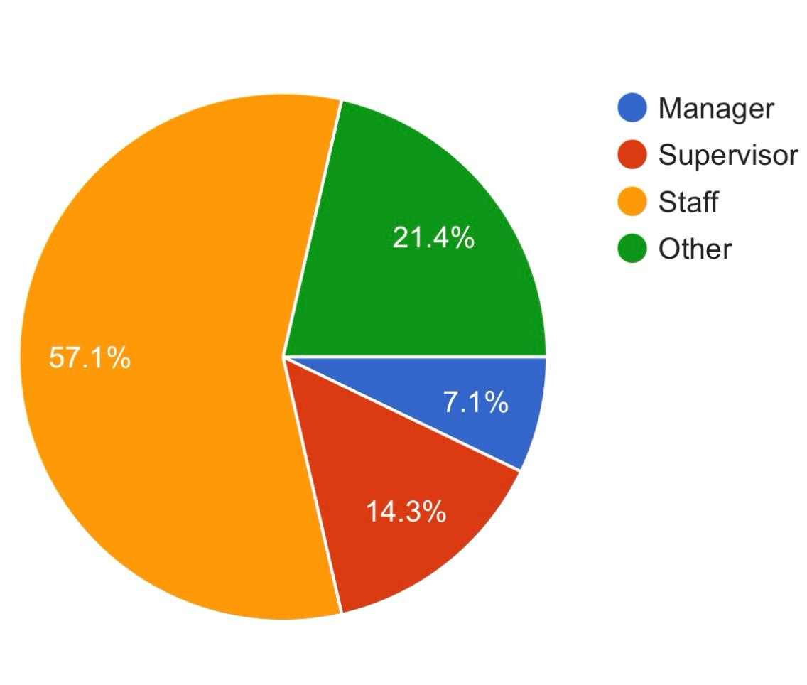

INTERPRETATION: This pie chart shows the result of a survey in which 7.1% are manager working in a company and
14.3% are supervisor and 57.1% are working as staff and 21.4% are others like interns etc.

TABLE NO. 02
TITLE OF THE TABLE: How familiar are you with the import and export processes within your company

 | FREQUENCY | PERCENTAGE
FAMILIAR | 12 | 42.9%
NOT FAMILIAR | 1 | 7.1%
VERY FAMILIAR | 8 | 28.6%
OTHER | 5 | 21.4%

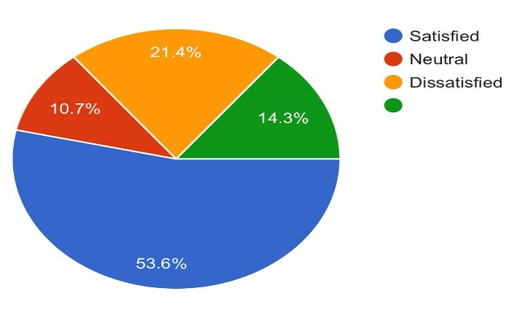

INTERPRETATION: This pie chart shows the result of a survey in which 53.6% people are stasified with the current
Import and export procedures within the company and 10.7% are netural about the satisfaction and 21.4% are
Dissatisfied and 14.3% not at all satisfied

TABLE NO. 03
TITLE OF THE TABLE: How satisfied are you with the current import and export procedures within the company

 | FREQUENCY | PERCENTAGE
SATISIFIED | 16 | 53.6%
NEUTRAL | 5 | 10.7%
DISSATISFIED | 7 | 21.4%
OTHER | 6 | 14.3%

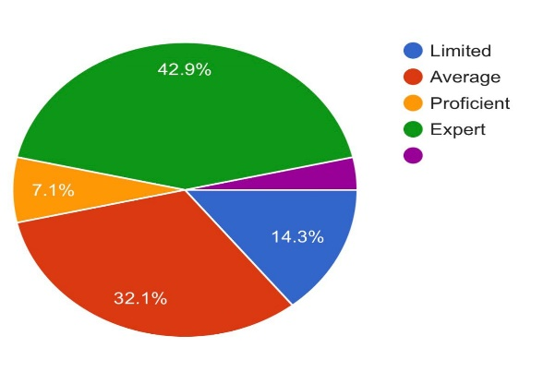

INTERPRETATION: This pie chart shows the result of how familiar are you with the import and export processes in
This survey 14.3% are limited with the processes and 32.1% are average and 42.9% are expert with their process and
7.1% are proficient.

TABLE NO. 05
TITLE OF THE TABLE: Have you observed any changes in the import and export after Covid-19 pandemic

 | FREQUENCY | PERCENTAGE
YES | 18 | 64.3%
NO | 7 | 35.7%
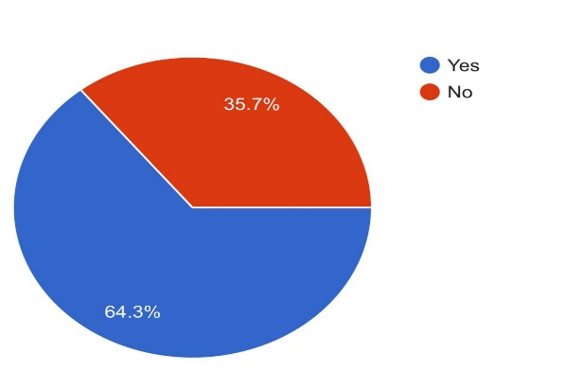

INTERPRETATION: This pie chart shows the result of any changes in the import and export after Covid-19
Pandemic wheras 64.3% are yes and 35.7% are saying NO

TABLE NO. 05
TITLE OF THE TABLE: Which department are you associated with

 | FREQUENCY | PERCENTAGE
SALES | 4 | 14.3%
LOGISTICS | 6 | 25%
FINANCE | 8 | 28.6%
OTHER | 10 | 32.1%

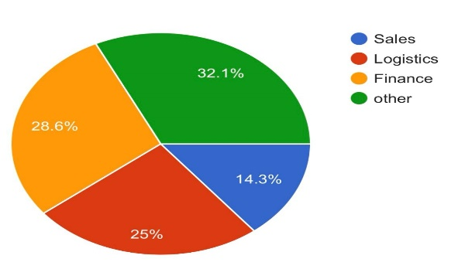

INTERPRETATION: This pie chart shows the result that in which department are you associated with where
28.6% are working under finance department and 14.3% are working under sales department and 25% are
Working under logistics department

TABLE NO. 07
TITLE OF THE TABLE: What type of international trade activities does your company engage in?

 | FREQUENCY | PERCENTAGE
IMPORTING GOODS | 15 | 57.1%
EXPORTING GOODS | -
LICENSING AGREEMENTS | 01 | 2.4%
OTHER | 9 | 39.3%

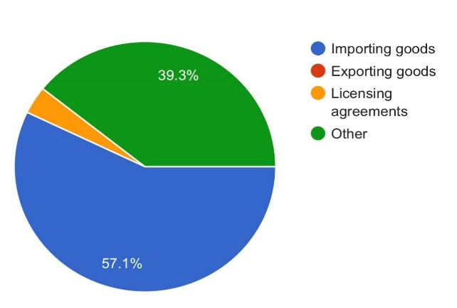

INTERPRETATION: This pie chart shows the result of international trade activities that a company engage with
57.1% results are importing the goods and 39.3% are others.

TABLE NO. 09
TITLE OF THE TABLE: What are the primary benefits your company gains from engaging in international trade

 | FREQUENCY | PERCENTAGE
INCREASED MARKET RESEARCH | 3 | 10.7%
COST SAVINGS | 12 | 39.3%
ACCESS NEW TECHNOLOGIES | 5 | 10.7%
OTHER | 8 | 39.3%

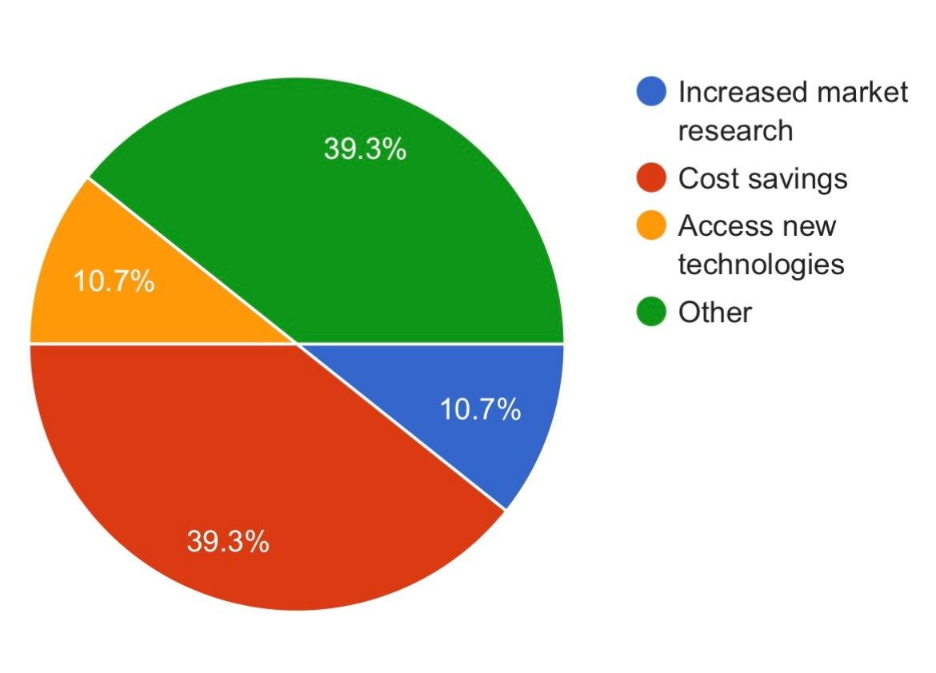

INTERPRETATION: This pie chart shows the result of to what extent does import contribute to the company
that 10.7% is increased market research and 10.7% are access new technologies and 39.3% are cost savings

TABLE NO. 08
TITLE OF THE TABLE: What are the main challenges faced in the import process

 | FREQUENCY | PERCENTAGE
TARRIFFS AND DUTIES | 10 | 39.3%
CUSTOM CLEARANCE DELAYS | 8 | 17.9%
DOCUMENTATION
CURRENCY FLUCTUTAION | 9 | 42.9%

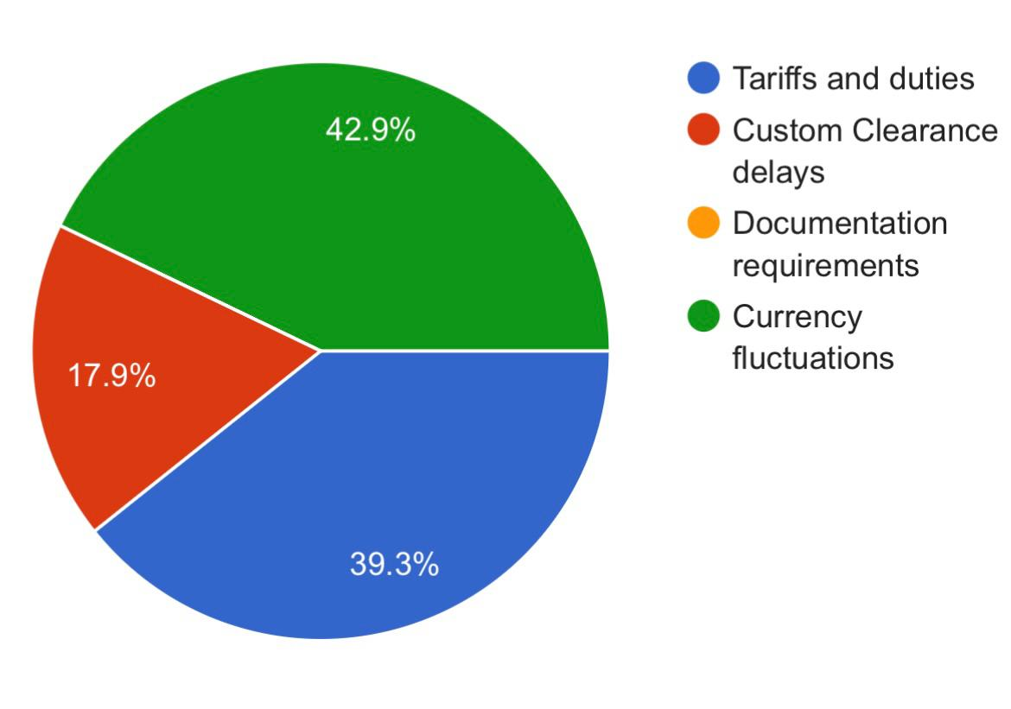

INTERPRETATION: This pie chart shows the result of primary benefits that company gains from engaging in
International trade where 42.9% are from currency fluctuations and 39.3% are tariffs and duties and 17.9%
are custom clearance delays

TABLE NO. 09
TITLE OF THE TABLE: In your opinion to what extent does import contribute to your company

 | FREQUENCY | PERCENTAGE
SLIGHTLY | 5 | 21.4%
SIGNIFICANTLY | 2 | 10.7%
EXTREMELY | 13 | 39.3%
NOT AT ALL

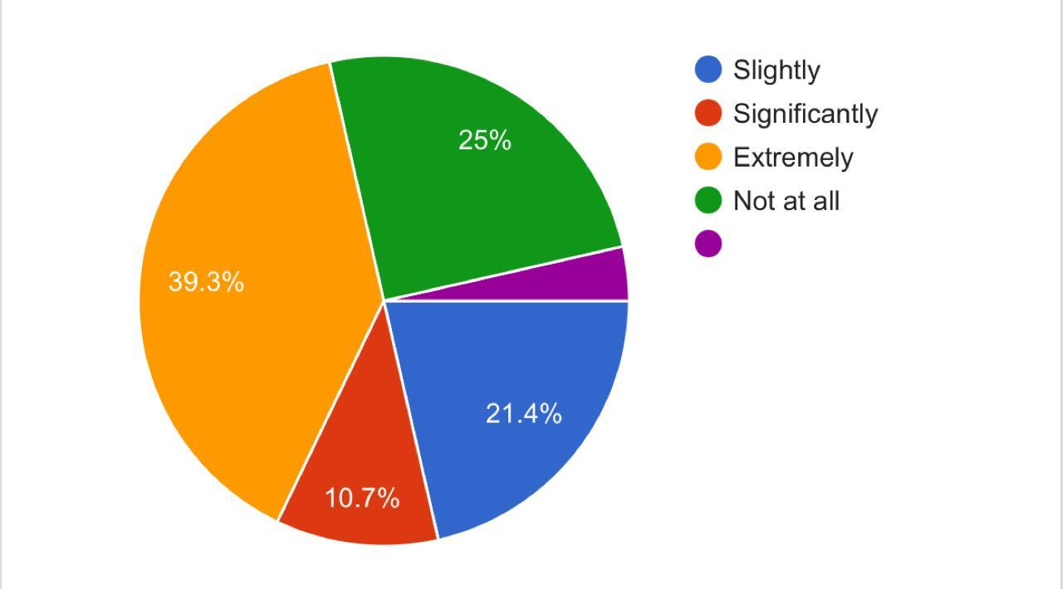

INTERPRETATION: This pie chart shows the result of how import contribute to the company in which 25% results
Are not at all contributing and 39.3% are extrememly contributing and 10.7% are significantly contributing and
21.4% are slightly contributing.

CHAPTER-07
SUGGESTIONS AND
CONCLUSSION

The review surveys the connection between global exchange and Gross domestic product development.
It dissects what changes in import and commodity levels mean for by and large monetary result and efficiency.
• An assessment of exchange obstructions, including levies and non-duty boundaries, is led to figure out their effect on import and product execution.
• The review investigates the job of worldwide stock chains in global exchange. It explores how imports and commodities are coordinated into complex inventory organizations and analyzes the ramifications for exchange proficiency and flexibility.
• This examination paper gives significant experiences into the elements of worldwide exchange and its effect on monetary execution, revealing insight into the multifaceted interaction between imports, sends out, and different macroeconomic factors.

Various investigations have shown a positive relationship between's global exchange and firm efficiency. Taking part in global exchange opens firms to bigger business sectors, expanded contest, and amazing open doors for specialization, prompting proficiency gains and efficiency enhancements.
Sending out and Firm Execution: Exploration demonstrates that organizations that participate in trading will quite often perform better compared to those that emphasis exclusively on homegrown business sectors. Trading firms frequently benefit from economies of scale, learning impacts, and admittance to new advancements and administrative practices.
Import Contest and Firm Elements: Import rivalry can significantly affect firm execution. While it can prompt expanded productivity and advancement as firms adjust to rivalry, it can likewise bring about market exits and employment misfortunes for less cutthroat firms.
Exchange and Gross domestic product Development: Worldwide exchange assumes a pivotal part driving monetary development and impacting Gross domestic product. Nations with open and serious exchange arrangements will generally encounter more significant levels of financial development contrasted with those with more protectionist strategies. Exchange adds to Gross domestic product development by growing business sector access, encouraging specialization, and advancing the effective designation of assets.
Worldwide Worth Chains (GVCs): The ascent of worldwide worth chains has changed the scene of global exchange. Numerous items are currently made through complex organizations of creation across various nations. Research on GVCs features the significance of understanding conventional exchange streams as well as the elements of halfway labor and products exchange.
Exchange Strategy and Firm Way of behaving: Changes in exchange strategy, like taxes, standards, and economic accords, can fundamentally affect firm way of behaving and execution. Research in this space investigates how firms change their systems in light of changes in exchange strategy and the ramifications for efficiency, development, and seriousness.

CONCLUSION:

•The review highlights the essential job of global exchange forming the monetary presentation of countries. It explains how import and commodity exercises fundamentally impact financial development, business rates, and in general success.
• The discoveries feature the two difficulties and potential open doors intrinsic in worldwide exchange. While obstructions, for example, duties and exchange awkward nature present impediments, drives like economic accords and mechanical progressions offer roads for upgraded exchange effectiveness and seriousness.
• State run administrations ought to focus on approach changes pointed toward lessening exchange hindrances and improving business sector access. This incorporates smoothing out customs systems, lessening levies, and blending administrative principles to work with smoother exchange streams.
Upgrading the limit of neighborhood organizations to participate in global exchange is vital. This includes offering designated help, for example, exchange finance help, send out preparing projects, and market knowledge, to engage little and medium-sized endeavors (SMEs) to partake all the more actually in worldwide exchange.

he mind boggling connection between worldwide exchange and firm execution, especially concerning the elements of import-trade exercises and efficiency, significantly impacts a country's Gross domestic product. The end drawn from broad exploration in this domain highlights the urgent job that worldwide exchange plays molding monetary results.

Import-trade elements act as an impetus for firms, working with admittance to different business sectors, assets, and innovations, consequently upgrading efficiency levels. Firms participating in worldwide exchange frequently experience uplifted seriousness, prodded by openness to worldwide business sectors and the basic to improve and advance effectiveness to stay applicable. This cutthroat strain drives firms to put resources into innovative work, embrace best practices, and smooth out tasks, all of which add to increased efficiency levels.

Thusly, the efficiency gains gathered by firms through global exchange resonate all through the economy, applying a positive effect on Gross domestic product development. As firms become more productive and cutthroat, they add to generally speaking monetary extension, creating business open doors, cultivating development, and drawing in unfamiliar venture. Besides, the combination of worldwide worth chains empowers firms to have practical experience in areas of relative benefit, further reinforcing efficiency and Gross domestic product.

Nonetheless, it is fundamental to recognize that the advantages of worldwide exchange are not consistently disseminated across firms or areas. While certain organizations flourish in the cutthroat worldwide commercial center, others might confront difficulties, especially those wrestling with expanded rivalry or disturbances in customary business sectors. Also, the macroeconomic ramifications of exchange elements stretch out past efficiency gains, enveloping contemplations like pay circulation, natural maintainability, and international elements, which can affect Gross domestic product development in complex ways.

All in all, the advantageous connection between worldwide exchange, firm execution, and Gross domestic product highlights the vital job of exchange driving monetary success. By encouraging efficiency gains, upgrading seriousness, and invigorating financial movement, worldwide exchange arises as a key part of monetary development and improvement, with broad ramifications for the two firms and countries the same. Thusly, policymakers and partners should focus on strategies that advance open, fair, and comprehensive exchange systems to tackle the maximum capacity of worldwide exchange as a driver of practical monetary advancement.

CHAPTER-08
BIBLIOGRAPHY

BIBLIOGRAPHY:

Andrew B. Bernard, J. B. (2007). Firms in International Trade. : Journal of Economic Perspectives—Volume 21, Number 3.

Castelline, :. D. (: 2008). Firms in International trade- Importers and Exporters heterogeneity in the Italian manufacturing industries . World Economy, 2010 .

Chandan Sharmaa, ,. R. (2015). International trade and performance of firms: Unraveling export, import and productivity. The Quarterly Review of Economics and Finance.

Chandan Sharmaa, ,. R. (2015). International trade and performance of firms: Unraveling export, import and productivity. The Quarterly Review of Economics and Finance.

Claudia, P. s. (2019). The Impact of Trade Liberalization on Firm Productivity and Innovation. Innovation Policy and the Economy, 2019 - journals.uchicago.edu.

Criscuolo, H. B. (2010). INTERNATIONAL TRADE IN SERVICES: A PORTRAIT OF IMPORTERS AND EXPORTERS. Journal of International Economics, 2011 .

Criscuolo, H. B. (2011). : INTERNATIONAL TRADE IN SERVICES: A PORTRAIT OF IMPORTERS AND EXPORTERS. Journal of International Economics, 2011 .

Imbs, J., & Scott, A. (2006). The dynamics of trade and competition. : NBB Working Paper, No. 91.
International trade and performance of firms: Unraveling export, i. a. (n.d.).

Lawless, M. (2007). Firm Export Dynamics and the Geography of Trade. Journal of International Economics, 2009 .

Li, R. H. (September 2005). The Role of International Trade and Investment in Business Growth and Development.

Melitz, :. M. (2007). : International Trade and Heterogeneous Firms. Journal of Economic …, 2007.
Morgan, R. E. (1997). Theories of international trade, foreign direct . Management Decision.

Topalova, P. (2004). Trade Liberalization and Firm Productivity: The Case of India.

Yeaple, W. K. (2003). MULTINATIONAL ENTERPRISES, INTERNATIONAL TRADE, AND PRODUCTIVITY GROWTH: FIRM LEVEL EVIDENCE FROM THE UNITED STATES.

