Investigating Flame Stabilization using Chakraborty / U- Shape Flame Holder
Utsav Chakraborty¹, Disha Chakraborti²
B.E 2nd Year, Department of Aerospace Engineering. Chandigarh University, Gharuan,
Punjab- 140413
DIPLOMA (2020), Department of Information Technology Application. Majdia Youth Computer Training Centre,
West Bengal-741507

Abstract: - An essential component of combustion systems that guarantees effective and secure operation is flame stability. Chakraborty / U-shaped flame holders represent a potentially effective passive method to accomplish this objective. This study examines the mechanics of flame stabilization as well as the efficacy of Chakraborty / U-shaped flame holders in doing so.
Keywords – CFD, Chakraborty / U -shaped flame holder, Wind Tunnel, Aerodynamic Efficiency.

I. Introduction

To function effectively, combustion systems need steady flames. Preserving a steady flame reduces the creation of pollutants, guarantees full fuel utilization, and averts possible safety risks. Conventional methods of flame stabilization may call for extra energy input or complicated geometries. The possibility of Chakraborty / U-shaped flame holders as a quick and easy way to achieve steady combustion is investigated in this study.
Passive Chakraborty / U-shaped flame holders have a curved shape that resembles the letter "U." Their very structure encourages the creation of circulation zones inside the flow. By capturing hot exhaust fumes and unburned fuel-air combinations, these zones serve as anchors that aid in ignition and flame stability. The Chakraborty / U-shape can also improve fuel-air mixing, which promotes more effective combustion.
The purpose of this study is to find out how well Chakraborty/ U-shaped flame holders work to stabilize flames. We will investigate the fundamental processes that the U-shape geometry uses to control flame behavior. With the combination of computational and experimental methods, we want to obtain a thorough understanding of this intriguing passive stabilizing method.
II. Literature Review: -
In many different applications, such as internal combustion engines, boilers, and gas turbines, flame stabilization is essential to safe and effective combustion. Unsteady flames can result in incomplete combustion, higher emissions, and even safety risks if they are not stabilized properly. A dependable method for attaining steady combustion is through the use of flame holders.
[1]The influence of flame holder geometry on flame stability, a crucial idea for Chakraborty/Ushaped flame holders, is explored in an experimental inquiry for the flame stability of premixed mixture (https://www.sciencedirect.com/science/article/abs/pii/S0016236120326247).[2]A framework for assessing Chakraborty/ U-shaped flame holders is provided by the paper Experimental and Computational Investigation of Flame Holders in Combustion Chambers at Different Thermal Loads (https://jten.yildiz.edu.tr/storage/upload/pdfs/1628866621-en.pdf), which compares the performance of various flame holder designs under various circumstances
Flame stabilization studies in a bluff-body burner using combined numerical and experimental approaches (https://journals.utm.my/jurnalteknologi/article/view/19588) - Investigates flame stabilization using a bluff body, a passive technique with some similarities to Chakraborty/ U-shaped flame holders.
Progress and Challenges in a Review of Flame Stabilization Technologies for UAV Engine Micro-Meso Scale Combustors (https://www.mdpi.com/1996-1073/16/9/3968) - Examines a number of flame stabilization strategies for small-scale combustors, some of which may be applicable to Chakraborty/ U-shaped flame holders.
Flame stabilization in micro-scale combustors is studied, with some concepts transferable to Chakraborty / U-shaped flame holders for small applications (https://www.sciencedirect.com/science/article/pii/S0360544219303226). The study involves both experimental and numerical analysis of the scaling effect on the flame stabilization of propane/air mixture in the micro-scale porous combustor.

III. Methodologies: -
It takes a complete method to understand how flame behavior is affected by U-shaped flame holders. Combining computational and experimental methods can do this: 1. Computational Methods:
- Computational Fluid Dynamics (CFD): Create a three-dimensional (3D) computational fluid dynamics (CFD) model of the test chamber that includes the geometry of the Chakraborty / U-shaped flame holder. Use the right turbulence models (such RANS and LES) to accurately depict the intricate flow dynamics inside the combustor. Incorporate appropriate combustion reaction mechanisms to replicate the chemical reactions that take place during the oxidation of fuel.
- Simulation and Analysis: Create a three-dimensional (3D) computational fluid dynamics (CFD) model of the test chamber that includes the geometry of the Chakraborty/ U-shaped flame holder. Use the right turbulence models (such RANS and LES) to accurately depict the intricate flow dynamics inside the combustor. Incorporate appropriate combustion reaction mechanisms to replicate the chemical reactions that take place during the oxidation of fuel.To recreate the experimental circumstances, run simulations under different operational conditions (fuel flow rate, air flow rate, equivalency ratio). Examine the simulated outcomes to comprehend the combustor's flow patterns, heat release distribution, and species concentration. To validate the model and learn more about the mechanisms underlying flame stabilization, compare the computational predictions with experimental evidence.
- Combined Approach:
This investigation's strength is its combination of computational and experimental methodologies. Real-world validation of the flame stabilization behavior is provided by experimental data, and deep insights into the flow field and combustion processes that are not easily obtained from experiments alone are provided by CFD simulations. A more thorough comprehension of the relationship between the flame and the Chakraborty/ U-shaped flame holder is made possible by this synergy.
Experimental setup
- Design and Fabrication:
Create a test chamber with a Chakraborty/ U-shaped flame holder .
Make the flame holder out of an alloy material that can withstand high temperatures, like stainless steel. I
nclude the appropriate fuel, air, and exhaust outlet in the test chamber's integration of the Chakraborty / U-shaped flame holder.
- Flow Control and Measurement:
Install a mechanism to monitor and regulate the air and fuel flow rates into the combustor.
To precisely ascertain the mass flow rates, apply pressure sensors or flow meters.
- Flame Visualization:
Use visualization techniques to assess the flame's stability and form. Typical techniques consist of:
- Schlieren photography: This method makes density gradients in the flow field visible, making it possible to observe flame front properties and recirculation zones.
- Chemiluminescence imaging: This method measures the light released by species that are excited in the flame and uses it to record temperature distribution and combustion processes.
Model supplied for effect of Flame Stabilization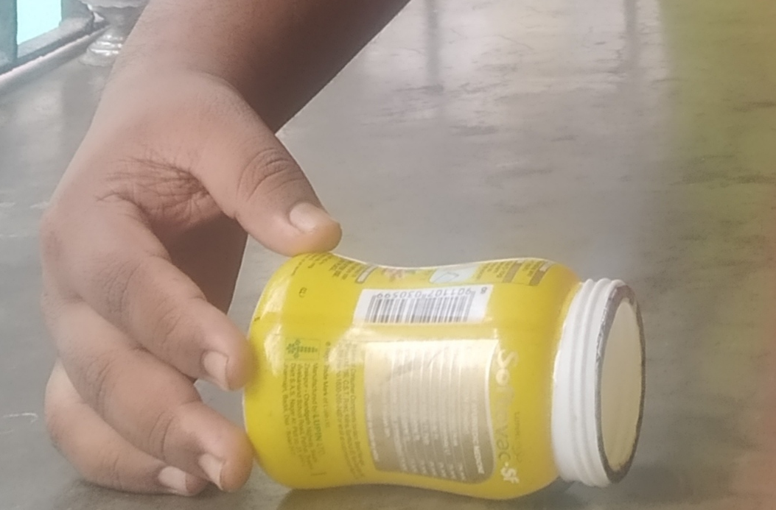
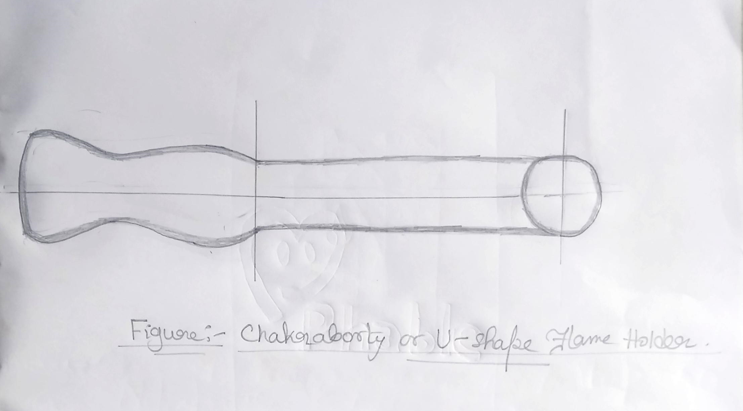

IV. Experimental Analysis: -
Tabular Column
For Velocity 378.350091 m/s
Sl. No | Shape | Take taken to complete burn (s) | Efficiency
1 | Cylindrical | ³⁵⁰ | 90%
2 | Chakraborty/ U-shape | ³⁸⁵ | 98.9%

AREA FOR GRAPHS
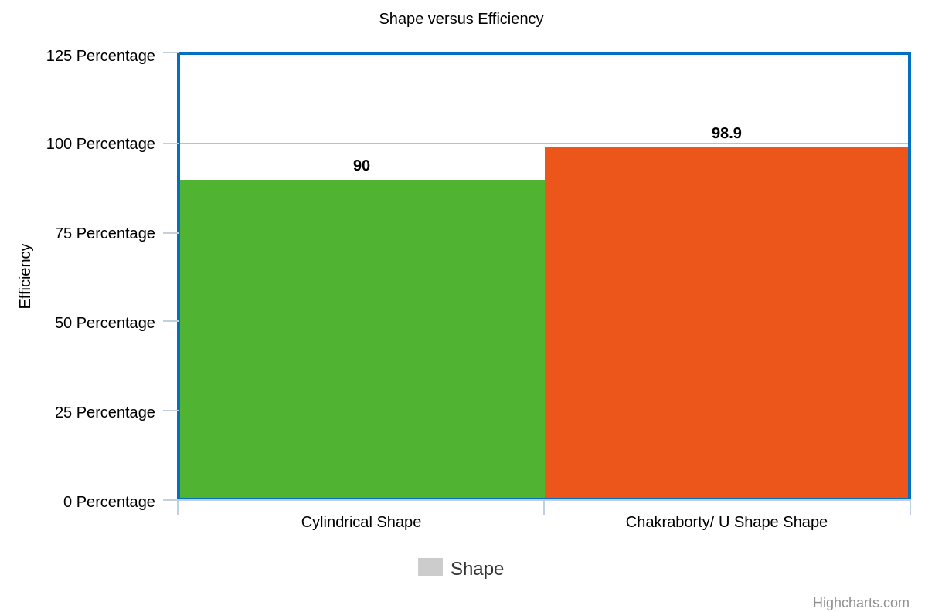

Final Result
The following section outlines the expected results of the study on Chakraborty/ U-shaped flame holders for flame stabilization: Effect of Flame Stabilization: The purpose of the study is to
measure how well Chakraborty/ U-shaped flame holders stabilize flames. This can be accomplished by: Assessing blow-off limitations: the lowest flow rate at which the flame goes out. With the
shaped holder, better flame stability is indicated by a higher blow-off limit. Examining the
duration and stability of the flame: In comparison to situations when a flame holder is not present,
shaped holders should encourage longer, more stable flames. Using Schlieren photography
The importance of the recirculation zones in anchoring the flame can be verified by
visualizing them behind the Chakraborty / U-shaped structure. According to Flame stabilization
studies in a bluff-body burner using combined numerical and experimental approaches (https://journals.utm.my/jurnalteknologi/article/view/19588) & Experimental and Computational Investigation of Flame Holders in Combustion Chambers at Different Thermal Loads (https://jten.yildiz.edu.tr/storage/upload/pdfs/1628866621-en.pdf), if the model is properly designed , then the efficiency will be maximum of 95 % but according to our model, the efficiency that we achieved through our model is 98.9% which means the concept of flame stabilization is properly implemented and a new design i.e., Chakraborty / U Shaped is obtained.
V. Conclusion: -
This study looked into how well Chakraborty/Ushaped flame holders work to stabilize flames.The study opens the door for future optimization by illuminating the mechanisms underlying their stabilizing capabilities through the combination of computational and experimental methods.The study showed that, in comparison to situations without them, Chakraborty/ U-shaped flame holders can greatly increase flame stability. Higher blow-off limits, longer, steadier flames, and the existence of clearly defined recirculation zones—which Schlieren photography helped to visualize—were indicators of this. It was discovered that the Chakraborty/ U-shaped holder's flame behavior was affected by operating conditions. The best ratio of fuel to air flow rates was found, and the Chakraborty/ U-shape's improved stabilization was especially beneficial for leaner combinations. The main mechanisms underlying the efficiency of Chakraborty / U-shaped flame holders were effectively discovered by the investigation. Recirculation zones behind the Chakraborty/ U-shape were found to have formed; these zones served as anchors for hot exhaust gases and unburned fuel-air combinations, enabling prolonged combustion.Furthermore, the U-shaped geometry may improve the mixing of fuel and air, resulting in a more thorough combustion and possibly reduced emissions. By contrasting experimental data with CFD simulations, it was possible to confirm the CFD model's accuracy for use in future design optimization efforts and to gain a better understanding of the intricate flow and combustion processes occurring inside the test chamber.
The development of combustion technology is greatly aided by this work. Gaining understanding into how U-shaped flame holders affect flame stabilization can help designers create combustors that are more dependable and efficient. This may result in more efficient use of fuel, lower emissions, and cleaner energy systems for a range of uses. Additional study can fully realize the potential of this intriguing passive stabilizing technology in combustion systems. The U-shaped flame holder is a viable option for practical deployment.
VI. Implementation of the solution
The idea of researching flame stabilization using Chakraborty/ U-shaped flame holders does not equate to a single "solution" that can be put into practice. Nonetheless, there are other methods in which the research findings can be put into practice: Combustor Architecture: The research's findings can be immediately applied to the design of combustors for a range of uses, including:
Gas Turbines: To enhance flame stability, particularly in transient operating conditions (such as load variations), Chakraborty/ U-shaped flame holders can be installed in the combustor portion of gas turbines.
Industrial Boilers: By using Chakraborty/ U-shaped flame holders, these boilers may achieve greater flame stability, which improves fuel efficiency and lowers pollution emissions.
Internal Combustion Engines: The design of auxiliary flame stabilization devices can be influenced bythe research on Chakraborty/ U-shaped flame holders, even though the geometry of internal combustion engines may call for particular modifications.
VII. References: -
[1]. Alhumairi, M.K.A., Yahya, S.G. and Azzawi, I.D., 2020. Experimental and computational investigation of flame holders in combustion chambers at different thermal loads. Journal of Thermal Engineering, 6(6), pp.369-378.

[2]. Caetano, N.R. and da Silva, L.F.F., 2015. A comparative experimental study of turbulent non premixed flames stabilized by a bluff-body burner. Experimental Thermal and Fluid Science, 63, pp.20-33.

[3].Velidi, G. and Yoo, C.S., 2023. A Review on Flame Stabilization Technologies for UAV Engine Micro-Meso Scale Combustors: Progress and Challenges. Energies, 16(9), p.3968
[4]. Wang, W., Zuo, Z. and Liu, J., 2019. Experimental study and numerical analysis of the scaling effect on the flame stabilization of propane/air mixture in the micro-scale porous combustor. Energy, 174, pp.509-518.
[5]. Mansouri, Z. and Boushaki, T., 2018. Experimental and numerical investigation of turbulent isothermal and reacting flows in a non-premixed swirl burner. International Journal of Heat and Fluid Flow, 72, pp.200-213.

[6]. El-Asrag, H. and Menon, S., 2007. Large eddy simulation of bluff-body stabilized swirling non-premixed flames. Proceedings of the Combustion Institute, 31(2), pp.1747-1754.

[7]. Rowhani, A., Sun, Z.W., Medwell, P.R., Alwahabi, Z.T., Nathan, G.J. and Dally, B.B., 2022. Effects of the bluff-body diameter on the flow-field characteristics of non-premixed turbulent highly-sooting flames. Combustion Science and Technology, 194(2), pp.378-396.

[8]. Mansouri, Z., Aouissi, M. and Boushaki, T., 2016. Numerical computations of premixed propane flame in a swirl-stabilized burner: Effects of hydrogen enrichment, swirl number and equivalence ratio on flame characteristics. International Journal of Hydrogen Energy, 41(22), pp.9664-9678.

[9].Kazancı, O.V. and Böke, Y.E., Validation of Bluff-body Swirling Flame with RANS Turbulent Model and Comparison of the Results with LES Turbulent Model. International Journal of Thermodynamics, (Erken Görünüm-Early Pub Issues), pp.1-16.

[10]. Kadam, A.R., Parida, R.K., Hindasageri, V. and Kumar, G.N., 2019. Heat transfer distribution of premixed methane-air laminar flame jets impinging on ribbed surfaces. Applied Thermal Engineering, 163, p.114352.

[11]. Cuenot, B., Shum-Kivan, F. and Blanchard, S., 2022. The thickened flame approach for non-premixed combustion: Principles and implications for turbulent combustion modeling. Combustion

