CHEST X-RAY CLASSIFICATION USING XCEPTION CNN MODEL FOR LUNG DISEASE PREDICTION

BANUPRIYA P*1, MENAKA S*2, SAVITHA M *3, SANGEETHA C*4, SUJITHA M*5

ABSTRACT: Air is a defining feature of a medical condition called pneumothorax, which affects the pleural cavity—the region of the chest that surrounds the lungs. The usual equilibrium between the pressures in the lung and the chest wall may be disturbed by this sickness, which can lead to a partial or full collapse of the lung. Trauma like rib fractures or penetrating chest injuries can cause traumatic pneumothorax, which allows air to enter the pleural space. On the other hand, spontaneous pneumothorax, which can occur for no apparent reason, is often linked to underlying lung diseases such chronic obstructive pulmonary disease (COPD) or lung micro spasms. This work classifies pneumonia infections using the Xception Convolutional Neural Network (CNN) model. Pneumonia is a dangerous respiratory illness that has to be diagnosed quickly in order to receive the right treatment. This work fully utilises the Xception architecture, which is an extension of the Inception model and is well-known for its efficacy in collecting complicated visual information utilising depth wise separable convolutions. The major objective is to develop a robust machine learning model that, using images from chest X-rays, can reliably classify individuals as having pneumonia or not. To optimise accuracy, a tagged dataset must be assembled and prepared, the Xception model must be adjusted, and it must then be fully trained and verified. The Xception CNN model, a deep learning technique, has the potential to enhance pneumonia diagnosis and support more precise and effective medical decision-making.

KEYWORDS: Pneumothorax, Deep learning, Convolutional neural network, Xception model, Medical imaging
1. INTRODUCTION
Pneumothorax is a medical disorder that is characterised by the presence of air in the pleural cavity, which is the space between the lung and the chest wall. This occurrence disturbs the normal pressure equilibrium required for proper lung expansion while breathing, which can lead to the partial or whole collapse of the affected lung. Traumatic pneumothorax can be brought on by physical trauma or injuries to the chest, such as rib fractures or puncture wounds, which let air to enter the pleural cavity. Conversely, spontaneous pneumothorax happens in the absence of external trauma and is often linked to underlying lung conditions. It can be classified as primary, emerging in individuals without a history of lung diseases, or secondary, associated with underlying respiratory illnesses such as chronic obstructive pulmonary disease. Acute chest pain, dyspnoea, and, in more severe cases, skin that is blue in colour due to insufficient oxygen intake are all signs of a pneumothorax. The diagnosis is often made by medical imaging. A number of therapies are advised, ranging from observation to more intrusive operations including the placement of a chest tube, depending on the severity and underlying reasons. Pneumothorax must be treated as quickly as possible to prevent complications and return normal lung function. Pneumonia can present with a range of symptoms, many of which suggest an inflammatory lung infection. Patients with pneumonia typically have a persistent cough that generates a lot of phlegm; the characteristics of this cough might provide information about the underlying illness. Fever is not unusual; the average high temperature is 100.4°F (38°C). Dyspnoea, which becomes worse with physical exertion, and chest discomfort that grows worse when you cough or breathe deeply are some of the symptoms. Weakness, broad weariness, and profuse sweating or shivering during fever episodes are other typical symptoms. Nausea, vomiting, diarrhoea, and, in rare instances, appetite reduction and unintentional weight loss may accompany the respiratory symptoms. Age-related changes in mental awareness or confusion are conceivable. Recognising these symptoms are essential if you want to seek medical attention as soon as possible since pneumonia can lead to life-threatening complications including respiratory failure. For pneumonia patients to fully recover, an early diagnosis and appropriate treatment are essential. The stage of pneumonia is seen in Fig. 1.
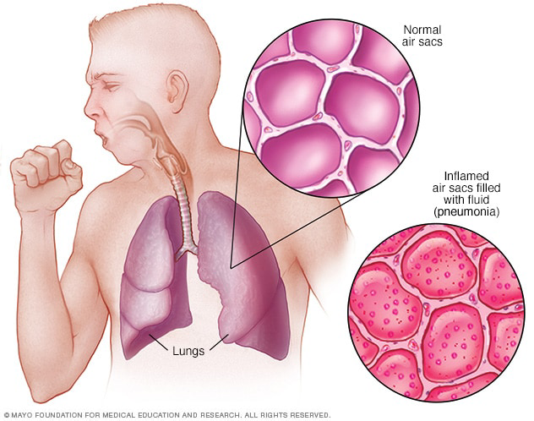
Fig 1: Pneumonia based causes details (https://www.mayoclinic.org/diseases-conditions/pneumonia/symptoms-causes/syc-20354204)
2. RELATED WORK
Cervantes,et.al,…[1] Convolutional neural networks (CNNs) have been shown to be incredibly successful at extracting small characteristics that are difficult for humans to notice. Due to two key considerations, a growing number of researchers have published studies employing CNNs to identify COVID-19 in CXR images: the accessibility of free machine learning (ML) tools and software, and the availability of CXR image datasets. The effective outcomes in several of these articles are also largely attributable to the transfer learning approach. With transfer learning, scientists may use a very small dataset to train only the last (top) layers of a highly deep CNN while keeping the prediction potential of the whole pre-trained network. Chowdhury et al. employed this method to fine-tune a number of previously trained ImageNet models to identify COVID-19 in CXR pictures. Apostolopoulos and Mpesiana used the similar idea to categorise COVID-19 in CXR pictures among a number of viral and bacterial pneumonia types as well as healthy individuals. Although the accuracy, sensitivity, and specificity of VGG16 and DenseNet201 were comparable, we were able to assess the models' potential generalizability thanks to the LIME explanations. Given that VGG16 relied on the CXR pictures' brightest white super pixels for its prediction, it might not perform well on datasets with differing dynamic range or pixel intensity characteristics.
Mohanapriya, et.al,…[2] suggests a DCNN-based architecture for lung tumour classification. The likelihood of cancer is reduced if the tumour is benign; cancer may be treatable in its early stages. The likelihood of developing cancer increases if the tumour turns malignant. Deep neural networks are made up of several hidden layers, including fully connected, pooling, and convolutional layers. Weight sharing and local connection define the convolutional layer. The nodes in this layer are organised into feature maps with shared weights; this technique, known as weight sharing, drastically lowers the amount of network parameters, boosts performance, and guards against overfitting. The pooling layer is used to subsample the preceding layer by aggregating tiny sub-sets of data. In order to lessen output susceptibility to small input changes, maximum or average pooling replaces input values with maximum or average values. A fully linked layer generates the categorization results. an effective algorithm that recognises and categorises tumours in CT scans. In order to improve the accuracy of lung tumour segmentation, the enhancement approach is first used using Wavelet-based Adaptive Histogram Equalisation (WAHE) to adjust the contrast. During the segmentation phase, the tumour area was effectively extracted from CT scans using Level set based Cellular Automata (LCA). A method based on neural networks was demonstrated to identify lung cancer from unprocessed chest photos. These retrieved highlights are thought to be the neural network's inputs.
Agrawal, et.al,…[3] Five distinct conventional NN classifiers were tested, and it was shown that the MLP Neural Network with fast propagation (QP) learning rule performed satisfactorily when compared to the other two for Data-base I and Data-base II. Thus, when a knowledge-based made up of histogram coefficients and image statistics parameters is utilised, it is concluded that the MLP neural network with QP learning algorithm should be the best neural network classifier for the diagnosis of lung tumours. It is observed that, in comparison to the other five traditional NN classifiers, the MLP Neural Network with fast propagation (QP) learning algorithm performs satisfactorily for Data-base I and Data-base II. Thus, when a knowledge-based made up of histogram coefficients and image statistics parameters is utilised, it is concluded that the MLP neural network with QP learning algorithm should be the best neural network classifier for the diagnosis of lung tumours. As seen in Fig. 4, the Receiver Operating Characteristics curve of the Best Classifier with respect to Data-base I is displayed, and 1.0 is observed as the Area under the ROC curve. Each configuration's many parameters are changed correctly. Following the creation of the smallest feasible MLP network, which consists of a single hidden layer with the fewest processing elements (PE), the number of PEs is progressively raised by 1 from 1 to 50, one at a time. Every training cycle, a network undergoes 1000 epochs of training. To guarantee impartial learning devoid of bias, the network is then retrained three times using various random initializations of connection weights and biases. The neural network is trained using the following various learning techniques.
Serener, et.al,…[4] seeks to accurately differentiate COVID-19 from other respiratory disorders that do have similar symptoms by using several deep learning architectures and medical pictures. This article specifically aims to distinguish COVID-19 from lung masses, pleural effusions, and pneumonia in sample radiographs of these conditions. We conducted COVID-19 detection tests using six distinct deep learning architectures, evaluated the data, and applied the results to achieve our aim. We think this might help reduce the possibility of false-positive COVID-19 diagnoses. Using chest radiographs, we applied deep learning techniques to distinguish COVID-19 from other lung infections, pleural illnesses, and lung tumours. In particular, we employed six techniques to differentiate COVID-19 from lung masses, pleural effusions, and pneumonia. The severe acute respiratory syndrome coronavirus 2 is the source of the extremely contagious respiratory illness COVID-19. It may result in fever, coughing, and in rare instances, serious pneumonia. Computed tomography scans and reverse-transcription polymerase chain reaction are the usual methods used to identify it. But because it affects the lungs, its symptoms are similar to those of other respiratory conditions. Its means that while diagnosing COVID19, we must carefully distinguish it from other illnesses of its kind. This paper attempts to do that using chest radiographs and many deep learning architectures. It focuses on distinguishing COVID-19 from lung masses, pleural effusions, and pneumonia. This investigation demonstrates that multiple deep learning architectures may be used to distinguish COVID19 from other respiratory disorders. It is further demonstrated that, across three experimental circumstances, the ResNet-18 design yields the highest overall performance.
Abdul, et.al,…[5] Analysed deep learning methods have shown that it is possible to manage interaction, even hierarchy, between the properties of a deep neural network and to automatically identify features from training photos. Additionally, feature computing, selection, and integration difficulties may be resolved by the new learning system without the need for laborious processing and pattern recognition procedures. In this study, every nodule recommended by the expert review will be taken into account. To reduce the impact of subjectivity on exams, this article considers just one instance per nodule. First, the features of each nodule estimated by the four specialists are summarised in a measurement, as demonstrated by Jabon et al. to determine if the nodule is benign or malignant. Thus, in this research, benign nodules exhibit high or moderate indicators of a benign tumour, while malignant nodules are those situations with semantic values of malignancy that are either highly suspicious or moderately suspicious. Regarding the contour, the value that has larger borders between the four markers during the annotation has been applied. A total of 1405 three-dimensional nodules (1011 normal and 394 malignant) were collected.

3. BACKGROUND OF THE WORK
Edge detection methods, such as the well-known Canny edge detector, are helpful in medical image analysis for detecting edges, particularly in chest X-ray images. These margins may serve as crucial indicators, helping to locate and identify abnormalities like pneumothorax. Thresholding methods, like the one Otsu utilised, help with the segmentation process by making it possible to discern between different intensities in chest X-ray images. This segmentation effectively highlights areas of interest inside the lung tissue by indicating air pockets, a sign of a pneumothorax.
Additionally, a Support Vector Machine (SVM) segmentation approach has been utilised to determine the pneumothorax class. SVMs are useful for binary classification tasks and have been applied successfully to medical image analysis to discriminate between healthy lung tissue and pneumothorax regions. Significant progress has also been made in volume-level pneumothorax grading and pixel-level classification for lung image segmentation defects. These advancements include sophisticated methods that enable accurate pixel-by-pixel detection of affected areas and a more comprehensive assessment of the pneumothorax's severity. These tools, which provide a more nuanced understanding of pneumothorax scenarios, considerably improve diagnostic capacities using advanced image processing and machine learning techniques.
4. PROPOSED METHODOLOGIES
The usage of an Xception Convolutional Neural Network (CNN) for deep learning-based pneumonia classification is a noteworthy advancement in medical image analysis. Distinguishing patterns associated with pneumonia in chest X-ray images is made easier by utilising the unique characteristics of the Xception architecture, which is well known for its efficiency in capturing minute details of photos via depth wise separable convolutions. Initially, a well-labeled dataset is put together, and images are categorised as either pneumonia-positive or pneumonia-negative. Data augmentation techniques like as rotation and scaling are used to the dataset to enhance the model's ability to generalise across a range of circumstances. Next, using this dataset, the Xception CNN model is tuned and trained to accurately distinguish between healthy and pneumonia-infected lungs by optimising its parameters. This cutting-edge deep learning method promises to enhance pneumonia diagnosis and facilitate more accurate and efficient medical decision-making in the field of respiratory healthcare through automated photo classification. Fig 2 shows the proposed framework

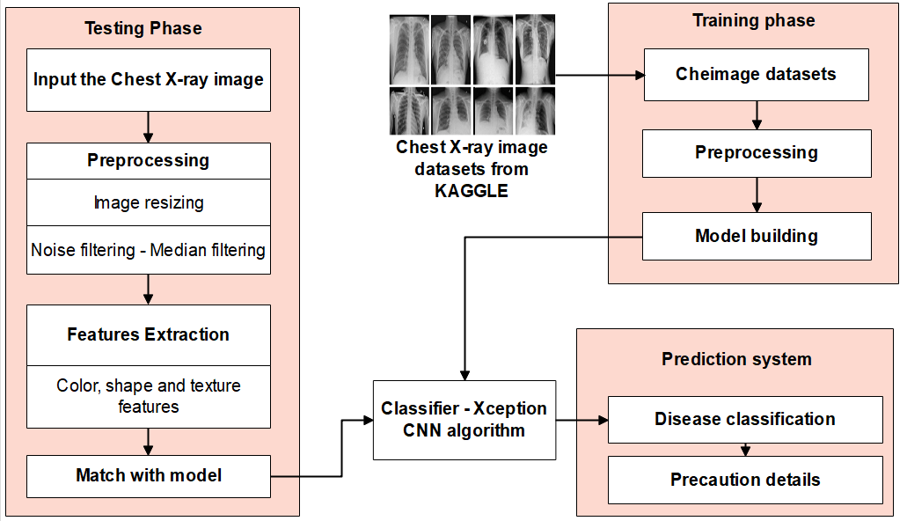
Fig 2: Proposed work
A deep learning convolutional neural network (CNN) architecture called Xception (pronounced "exception") is specifically made for image categorization applications. It was included in the Keras library, which is currently connected with Tensor Flow, and was first presented by François Chollet in 2017. "Extreme Inception," or "Xception," is an architecture that improves on the Inception design by making it more accurate and efficient. Here are some key characteristics of the Xception model:
- Depthwise Separable Convolutions: The application of depthwise separable convolutions is the primary innovation of the Xception architecture. This entails splitting the depthwise convolution and pointwise convolution components of the typical convolution procedure. Pointwise convolution aggregates the results by performing 1x1 convolutions, whereas depthwise convolution applies a single filter to each input channel. The model becomes more efficient as a result of this separation, which drastically lowers the number of parameters.
- High Efficiency: Xception's great efficiency is made possible by the use of depthwise separable convolutions, which lower computing costs without sacrificing accuracy. This is especially useful for apps on mobile devices or other devices with little processing power.
- Increased Depth: Inception models lack the substantial depth of the architecture found in Xception models. Its depth enables it to extract complex and hierarchical information from pictures, which makes it a good fit for a variety of computer vision applications.
- Fully Convolutional: Since Xception is completely convolutional, it can handle a range of input sizes. Because of its adaptability, it may be used for a variety of applications where the input dimensions may vary, such as object identification and picture segmentation.
- Transfer Learning: Xception is a transfer learning tool, much like other pre-trained models. Through the use of its pre-trained weights on a sizable dataset such as ImageNet, the model may be optimised for a particular job.
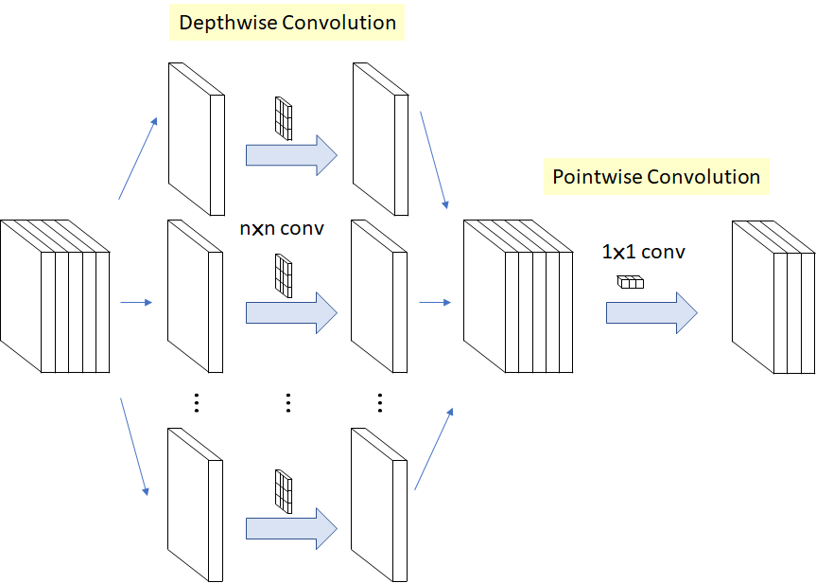
Fig 3: XCeption CNN model (refer: https://towardsdatascience.com/review-xception-with-depthwise-separable-convolution-better-than-inception-v3-image-dc967dd42568)
Fig 3 symbolises the model of the XCeption framework. Depthwise separable convolutions, a technology that drastically lowers the computing cost of conventional convolutional layers, are the foundation of Xception's design. Pointwise and depthwise convolutions are the two components of depthwise separable convolutions. Each input channel receives a single filter application via the depthwise convolution, which is succeeded by a pointwise convolution that uses 1x1 convolutions to aggregate the output. Because of this division of labour, the model has fewer parameters and is thus more effective, particularly in situations when resources are few, as in the case of mobile or edge devices. When the Xception model won the ImageNet Large Scale Visual Recognition Challenge and produced state-of-the-art results, it had a significant influence. Its superiority over other well-known designs shown its skill in picture classification challenges. Because of this accomplishment, the computer vision field has widely adopted it for a range of applications. Because Xception is completely convolutional, it can process inputs of different sizes, which makes it appropriate for tasks like object recognition and picture segmentation. This adaptability is quite useful, especially when working with pictures that have varying size and aspect ratios. With Xception, transfer learning entails honing the model on certain tasks by building upon its learnt properties. This decreases the requirement for a large amount of training data, speeds up the creation of new applications, and frequently enhances model performance.
5. RESULTS AND DISCUSSION
In order to build the XCeption CNN model, pneumonia picture datasets are gathered from the KAGGLE source. Next, assess the system's effectiveness in terms of training accuracy. The capacity of a model to correctly predict the labels of the training dataset is referred to as "training accuracy" in deep learning, including the Xception framework. It specifically represents the proportion of properly recognised instances within the training set.
The model is trained using labelled instances, and the difference between the model's predictions and the actual labels is decreased by iteratively fine-tuning its parameters. The number of successfully classified instances divided by the total number of training examples yields the training accuracy, which is often expressed as a percentage.
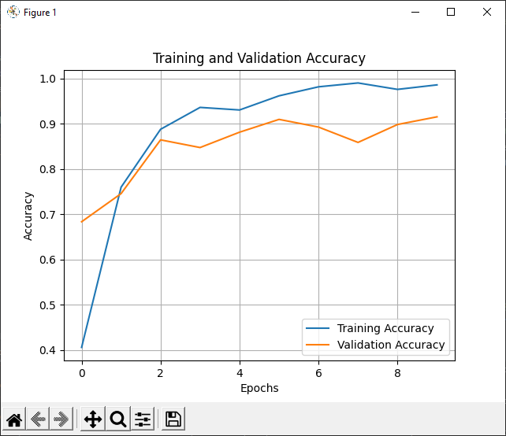
Fig 4: Training accuracy
The suggested model gives high-level accuracy (95%) in illness prediction based on training accuracy in Figure 4.
6. CONCLUSION
In conclusion, using deep learning to classify pneumonia using the Xception Convolutional Neural Network (CNN) is a promising and cutting edge technique in the field of medical visual analysis. Making the most of the depthwise separable convolutions in the Xception architecture facilitates the extraction of complicated pneumonia-related patterns from chest X-ray images. Careful data preparation, augmentation, and training on a labelled dataset are all part of the extensive process that results in a model that can accurately distinguish between lungs that are healthy and those that have pneumonia. This advanced deep learning model provides a more automated and efficient approach to categories pneumonia patients, which might lead to significant improvements in respiratory healthcare diagnostics. However, it is crucial to emphasize that evaluations of the model's performance should go beyond training accuracy. The model must be validated on several datasets, especially untested data, in order to assess its generalizability and viability.
REFERENCES
[1] Cervantes, Eduardo Gasca, and Wai-Yip Chan. "LIME-Enabled Investigation of Convolutional Neural Network Performances in COVID-19 Chest X-Ray Detection." 2021 IEEE Canadian Conference on Electrical and Computer Engineering (CCECE). IEEE, 2021.
[2] Mohanapriya, N., B. Kalaavathi, "Lung Tumor Classification and Detection from CT Scan Images using Deep Convolutional Neural Networks (DCNN)." 2019 International Conference on Computational Intelligence and Knowledge Economy (ICCIKE). IEEE, 2019.
[3] Agrawal, Vijay L., and Sanjay V. Dudul. "Conventional neural network approach for the diagnosis of lung tumor." 2020 International Conference on Computational Performance Evaluation (ComPE). IEEE, 2020.
[4] Serener, Ali, and Sertan Serte. "Deep learning to distinguish covid-19 from other lung infections, pleural diseases, and lung tumors." 2020 Medical Technologies Congress (TIPTEKNO). IEEE, 2020.
[5] Abdul, Wadood. "An Automatic Lung Cancer Detection and Classification (ALCDC) System Using Convolutional Neural Network." 2020 13th International Conference on Developments in eSystems Engineering (DeSE). IEEE, 2020.
[6] Bhat, Sachin, et al. "Convolutional neural network approach for the classification and recognition of lung nodules." 2020 4th International Conference on Electronics, Communication and Aerospace Technology (ICECA). IEEE, 2020.
[7] Lobo, Prenitha, and Sunitha Guruprasad. "Classification and segmentation techniques for detection of lung cancer from ct images." 2018 International Conference on Inventive Research in Computing Applications (ICIRCA). IEEE, 2018.
[8] Cengil, Emine, and Ahmet Cinar. "A deep learning based approach to lung cancer identification." 2018 International Conference on Artificial Intelligence and Data Processing (IDAP). IEEE, 2018.
[9] Anwar, Talha, and Seemab Zakir. "Deep learning based diagnosis of COVID-19 using chest CT-scan images." 2020 IEEE 23rd International Multitopic Conference (INMIC). IEEE, 2020.
[10] Tabrizchi, Hamed, et al. "Rapid covid-19 diagnosis using deep learning of the computerized tomography scans." 2020 IEEE 3rd International Conference and Workshop in Óbuda on Electrical and Power Engineering (CANDO-EPE). IEEE, 2020

