COST BENEFIT ANALYSIS
1. Author: M.VIJAYA LAKSHMI, Asst. Prof. Dept. of MBA, SANTHIRAM ENGINEERING COLLEGE, NANDYAL
2. Author: G.GIRIJA RANI, Student of MBA, SANTHIRAM ENGINEERING COLLEGE, NANDYAL
ABSTRACT:
The cost benefit analysis helps in finding out the relationship of costs and revenues to output. It enables the financial manager to study the general effect of the level of output upon income and expenses and therefore upon profits.
Cost-Benefit Analysis (CBA) estimates and totals up the equivalent money value of the benefits and costs to the community of projects to establish whether they are worthwhile.
Cost-Benefit Analysis (CBA) measures a project's societal value by quantifying the project's societal effects and making costs and benefits comparable in monetary terms.
INTRODUCTION:
A cost-benefit analysis is a systematic process that businesses use to analyse which decisions to make and which to forgo. The cost-benefit analyst sums the potential rewards expected from a situation or action and then subtracts the total costs associated with taking that action.
A cost-benefit analysis is the process of comparing the projected or estimated costs and benefits (or opportunities) associated with a project decision to determine whether it makes sense from a business perspective.
Generally speaking, cost-benefit analysis involves tallying up all costs of a project or decision and subtracting that amount from the total projected benefits of the project or decision. (Sometimes, this value is represented as a ratio.)
Cost benefit analysis may therefore be defined as a managerial tool showing the relationship between various ingredients of profit planning cost (both fixed and variables) selling price and volume of activity etc.
ADVANTAGES OF COST BENEFITS ANALYSIS:
Cost benefits analysis is an important tool of profit planning it provide information about the following matters.
1. The behaviour of cost in relation to volume
2. Volume of production or sales, where the businesses will break even.
3. Sensitivity of profits due to variation in output.
4. Amount of profit for a projected sales volume.
5. Quantity of production and sales for a target profit level.

Cost-benefit analysis is a term that refers both to:
•a formal discipline used to help appraise, or assess, the case for a projector proposal, which itself is a process known as project appraisal; and
•An informal approach to making decisions of any kind. Under both definitions the process involves, whether explicitly or implicitly, weighing the total expected costs against the total expected benefits of one or more actions in order to choose the best or most profitable option. The formal process is often referred to as either CBA (CostBenefit Analysis) or BCA (Benefit-Cost Analysis)

NEED FOR THE STUDY:
In the present world, each and every thing is marked by competition. Entry into the financial market or the management of portfolio dealings is very risky and challengeable. As a precaution the researcher aims at studying the nature of different financial assets in the money and capital markets. By the proper study of cost benefit analysis, the company as well as different investors can assess about different investments.

OBJECTIVES OF COST BENEFIT ANALYSIS:
The main aim of the present study is to accomplishing the following objectives.
1. To identify the investment allocation.
2. To know about how much per cent of returns and also analyse what they are giving as returns to the investors.
3. To find out the disparities between the actual and promised rate of returns.
4. To analyses the range of customers invested in UNIT LINKED INVESTMENT PLAN.
5. To analyses the risk and return pattern.

RESEARCH METHODOLOGY:
RESEARCH DESIGN:
Based on the objectives of the study, a descriptive research has been adopted.
Descriptive research is one, which largely used to draw interferences about the possible relationships between variables.
Primary Data: A primary source reflects the individual‘s viewpoint of a participant or observer. Data collected from the company guide.
Secondary Data: Companies existing investment portfolios, quarterly review report, available statistics, journals and magazines and Internet etc.

Methodology here is based on Unit Linked Investment plans using Growth Fund Investment Portfolio Techniques. First part contains the profile of investors including their gender, occupation, range of annual income etc. Second part contains questions related to their investment behaviour, choice of company, factors considered while investment etc.

DATA ANALYSIS & INTERPRETATIO:
GROWTH FUND INVESTMENT PORTFOLIO:
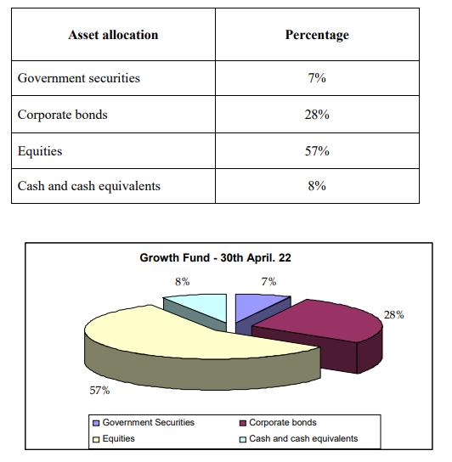

INTERPRETATION: From the period 31st December 2021 to 30th April 2022, the growth fund percentage of returns has increased from 47.1% to 49.9%. So there was a increase of 2.8% returns in Growth fund. This is because of the change in government securities allocation from 14% to 7% change in corporate bonds allocation from 16% to 28% and change in cash and cash equivalents allocation from 14 to 8%.

FINDINGS
• This unit is good at Cost of Production as compare to it other unit
• This unit has more expenditure and fewer Sales.
• It is observed that these units except cost of production, all the other majors‘ area are not satisfactory.
• The Management has control over the service management.
• Its sales are very high and expenditure is manageable low.
• Its cost of production is very low.
• A current liability of the company position is increased and then there is a positive growth.
SUGGESTIONS
1. In this analysis ULIPs generally have a lock-in period of up to 5 years, your money gets enough time to garner returns and grow in value.
2. Staying invested for longer than five years can further enhance the chance for growth; balanced funds are more evenly invested in equities and income securities.
3. Balanced and equity-income funds are suitable conservative investors who want high current t yield with some growth. If you seek to generate long-term capital appreciation and current income, an investment in the balanced fund would be ideal.

CONCLUSION
Life insurance is performing well and it acceptable for the investors for satisfying the return needs of the investors. More over the additional comparative benefits like service of investment professionals, ability to diversify price volatility risk, and ability to match with risk taking ability etc. are the some of high-lighted points of life insurance. And there is a roof for improvement in the forms of increasing the number of investors by undergoing changes in Unit Linked Investment Plan schemes. Max New York life shows only illustrative returns of 6% and 10% under the guidelines of IRDA but it pays the actual returns of 49.9% in growth fund and 29.3% in balanced fund respectively. And the returns will vary from period to period based on market fluctuations. As it is a market linked product, the stable returns cannot be expected by the customers. As Max New York Life has 160 years of experience in the insurance business, it invests in such a fortune company which will fetch more returns as well as safety of funds to the customers.

BIBLIOGRAPHY
BOOKS:
• M.Y. Khan & P. K. Jain , Financial Management Fourth edition, published by TATA McGraw HILL New Delhi: 2001.
• Prof. Satish Inamdar, Financial Management published by Symbiosis center for distance learning, Pune,2020
• M. Pandey, Financial Management Second edition published by TATA McGraw HILL publishing company. New Delhi: 2018.
• Sashi K Sharma, Gupta, Financial Management, 10th Edition, Cengage Publication, Hyderabad, 2020.
• Nirmal, Gupta, Financial Management, 12th Edition, Cengage Publication, Hyderabad, 2017.

WEBSITES:
• www.maxnewyorklife.com
• www.investopedia.com
• www.bamboo.com

