A STUDY ON YOUNG INVESTOR AWARENESS AND KNOWLEDGE ABOUT WEALTH MANAGEMENT IN GOSTOCKS, CHENNAI

James Gnana Selvaraj G
ABSTRACT

This study aims to evaluate and augment the awareness and knowledge of young investors regarding wealth management within the context of GoStocks, to empower them for informed financial decision-making. Through a descriptive research design utilizing a survey approach, data was collected using a structured questionnaire comprising 31 questions from a sample of 175 respondents in Chennai, specifically from the locality of GoStocks, Anna Nagar, Chennai, employing convenience sampling. The findings reveal a baseline level of awareness and knowledge about wealth management among young investors, even though with a limited understanding of investment options. Despite the availability of various channels for knowledge acquisition, the effectiveness of these channels is questioned due to a lack of interest and unequal access to education. Furthermore, there is evidence of fluctuating risk perceptions among young investors, indicating a need for guidance in aligning strategies with long-term financial objectives. However, the study also highlights positive outcomes, as young investors exhibited an increased understanding of wealth management, potentially leading to more informed financial decision-making and a clearer path towards achieving their financial goals. Recommendations include fostering a broader understanding of investment options and providing accessible financial education to all young individuals, ultimately guiding them toward a financially secure future.

INTRODUCTION

Welcome to the Young Investor Awareness and Wealth Management program. This in-depth, comprehensive study aims to equip the next generation of investors with the information and abilities needed to successfully navigate the complex world of finance. We will cover every detail as we dive into the nuances of wealth management in this comprehensive trip, giving you the knowledge and abilities to not only accumulate money but also make wise financial decisions.
We'll start by breaking down the basic ideas of money and simplifying difficult ideas to provide a strong basis for your financial literacy. You will get a comprehensive awareness of the financial environment, covering everything from the fundamentals of saving and budgeting to comprehending the economic factors influencing market dynamics.
The foundation of effective wealth management is a set of attainable financial objectives. We'll assist you in developing a financial plan by guiding you through the process of setting short- and long-term goals. Your investing approach will be shaped by your goals, which may include becoming financially independent, purchasing a home, or paying for school.
Explore the wide range of investing options in depth. We'll talk about conventional assets like stocks and bonds, investigate the possibilities of ETFs and mutual funds, and delve into the world of real estate and unconventional investments. Building a diverse and robust portfolio requires an understanding of the risk-return characteristics of different alternatives.
Discover the craft of creating a portfolio. Find out how to diversify your assets across a variety of asset types to achieve a risk-reward balance. Our professionals will assist you in creating a customized portfolio that is in line with your time horizon, financial objectives, and risk tolerance.
Investing involves not only statistics but also feelings and actions. Learn about behavioral finance and how mental health issues can affect financial judgment. Gain emotional intelligence to help you manage the market's highs and lows with resilience and confidence.

Markets are erratic and volatile. Examine risk management techniques and discover how to adjust to shifting market dynamics. We'll provide you with the tools you need to make wise choices when faced with uncertainty, so your investing plan will always be solid and adaptable.
We'll go over the fundamentals of budgeting and saving to highlight the significance of overall financial well-being. Your total financial performance may be greatly impacted by forming sound financial habits at a young age.
The goal of this program is to provide you with the knowledge and self-assurance to take charge of your financial future, not only to amass riches. Accompany us on this life-changing adventure as we decipher the intricacies of finance, furnishing you with the means to make wise choices and ensure a healthy financial future. The training for Young Investor Awareness and Wealth Management is your first step toward success and financial assurance. Together, let's go off on this adventure!

REVIEW OF LITERATURE

Amer Azlan Abdul Jamal, Wijaya Kamal Ramlan, MohdRahimie Abdul Karim, RosleMohidin, Zaiton Osman; (Nov 2015) The Effects of Social Influence and Financial Literacy on Savings Behavior: A Study on Students of Higher Learning Institutions in Kota Kinabalu, Sabah.
Mrs. Akanksha Sharma; (Jan 2022) Wealth Management and The Public A Study on The Awareness and Knowledge about Wealth Management in The Common Man.
Nor Hazanah Miskan, Nurulhayah Muhamad, Maryam Mohd Esa, Nurul Liyana Hussin, Farah Saniah Mohd Zabidi, Luqman Ahmad; (Nov 2023) The Relationship of Knowledge, Income & Lifestyle Factors to the Awareness of Asb Investment Among the Youth of Masjid Tanah.
Dr. Souvik Banerjee; (Aug 2023) Adoption of digital finance among youth:
Mykolas Navickas, Tadas Gudaitis, Emília Krajnakova; (Jan 2022) Influence of Financial Literacy on Management of Personal Finances in A Young Household.
Saxi Patel and Ms. Nisha Tolawala; (Mar 2022) A Study on Awareness and Knowledge about Wealth Management among Individuals.
Chen-Chen Yong, Siew-Yong Yew, Chu-Kok Wee; (Oct 2018) Financial Knowledge, Attitude and Behavior of Young Working Adults in Malaysia.
Robin Henager and Brenda J. Cude; (Mar 2016) Financial Literacy and Long- and Short-Term Financial Behavior in Different Age Groups.
Vera Intanie Dewi, Erie Febrian, Nury Effendi, and Mokhamad Anwar; (Apr 2016) Financial Literacy among the Millennial Generation: Relationships between Knowledge, Skills, Attitude, and Behavior
Alex Cheburet; (Apr 2016) Financial Management Skills and Utilization of Youth Enterprise Development Fund Among Youth Groups in Baringo South Constituency, Kenya.
Bożena Frączek, Monika Klimontowicz; (Jan 2015) Financial literacy and its influence on young customers’ decision factors
Divya Punj (Feb 2015) “A Study on The Awareness and Knowledge about Wealth Management in The Common Man”
Mrs. Akanksha Sharma; (Jan 2014) Wealth Management and The Public A Study on The Awareness and Knowledge about Wealth Management in The Common Man.
Jamal Mohammed Esmail Alekam, Madya Salniza Bt Md. Salleh, Sany Sanuri bin Mohd. Mokhtar; (July 2014) The Effect of Family, Peer, Behavior, Saving and Spending Behavior on Financial Literacy among Young Generations.

OBJECTIVES OF THE STUDY

PRIMARY OBJECTIVE
The study on young investor awareness and knowledge about wealth management in gostocks.

SECONDARY OBJECTIVE
Measure the baseline level of awareness and knowledge about wealth management among the target population.
Analyze the effectiveness of different awareness channels in conveying accurate and useful information.
Assess whether informed individuals are more likely to make sound financial decisions.
Identify areas where individuals may need guidance in aligning their strategies with long-term financial objectives.
Determine if there is a correlation between risk perception and knowledge levels.

RESEARCH METHODOLOGY

Depending on the study's objectives, research methodologies might be mixed, qualitative, or quantitative. Qualitative approaches center on comprehending behaviors, attitudes, and experiences, whereas quantitative methods prioritize statistical analysis and numerical data.

RESEARCH DESIGN:
Descriptive research design aims to describe the characteristics of a population or phenomenon. It focuses on answering "what," "who," "where," and "how" questions. This design involves observing and documenting behaviors, attitudes, or conditions without manipulating variables.

RESEARCH APPROACH
The survey approach is used during the research. A separate structured Questionnaire was used to collect data from individuals to achieve the objective of the study.

SAMPLE SIZE
A sample of 175 respondents was chosen for the study

SAMPLING AREA
The sample area chosen was Chennai (Gostocks, Anna Nagar).

SAMPLE DESIGN
Convenience sampling is a non-probability sampling method that is often employed for its ease and practicality. In convenience sampling, researchers select participants or data points based on their accessibility and proximity, rather than through random or systematic methods.

SOURCE OF DATA

PRIMARY DATA (QUESTIONNAIRE)
In this study, a questionnaire comprising 31 questions was framed for the study. The questionnaire was distributed among the people. The objective was to understand the people's perception of knowledge about wealth management. To meet the objectives of the study 175 samples were selected as sample units.

SECONDARY DATA
The research also makes use of the secondary data for the study. Secondary data are those which have been collected already by others. The main sources of secondary data are from published and unpublished sources. The secondary data used to prepare this project was obtained from Internet, Journals, Published record

PERIOD OF THE STUDY
The study was conducted during the period of 4 months from January to April 2024.

ANALYSIS TOOLS
Spearman Correlation, Mann-Whitney U-TEST, Kruskal-Wallis H test

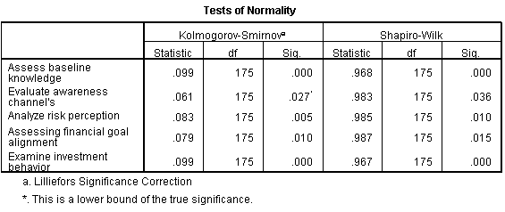
TEST OF NORMALITY

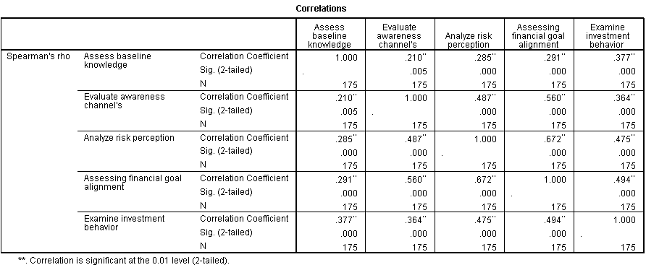
SPEARMAN NON-PARAMETRIC CORRELATIONS

MANN WHITNEY U TEST (GENDER)
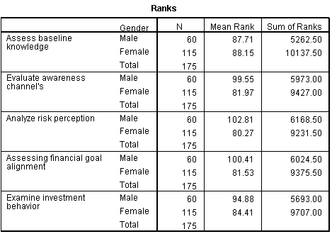

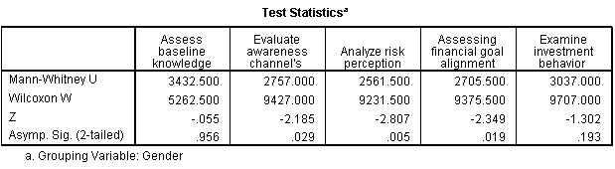

KRUSKAL WALLIS H TEST
AGE
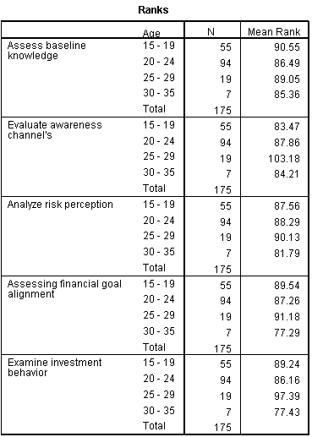
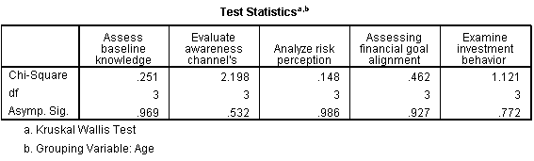

HOMEOWNERSHIP

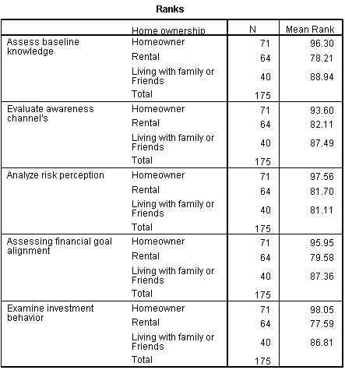
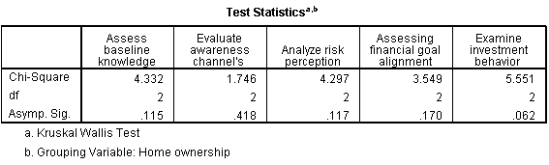

SUMMARY OF FINDINGS

DEMOGRAPHICS EVALUATION:
It is inferred from the above table that; Female constitute 65.7% of the total.
It is inferred from the above table that 53.71%, fall into the "20 - 24" age group.
It is inferred from the above table that 56%, have Bachelor’s degree.
It is inferred from the above table that 62.9%, are currently engaged in studying.
It is inferred from the above table that 60.6%, reported an annual income Below 2.5 lakhs.
It is inferred from the above table that 40.6%, have Homeowners.

SUBJECT EVALUATION:
It is inferred from the above table that 33.1%, “Agree”.
It is inferred from the above table that 30.3%, are Neutral.
It is inferred from the above table that 32%, have Agree.
It is inferred from the above table that 29.1%, have Agree.
It is inferred from the above table that 30.9%, have Agree.
It is inferred from the above table that 30.9%, are Rarely viewed online.
It is inferred from the above table that 31.4%, have A little from social media.
It is inferred from the above table that 29.1%, are Moderately aware.
It is inferred from the above table that, 31.4%, are Sometimes utilized by websites and apps.
It is inferred from the above table that 30.3% are Rarely and Occasionally conveyed about wealth management.
It is inferred from the above table that 46.9% are Neutral.
It is inferred from the above table that 33.1%, have a Neutral habit of taking risks.
It is inferred from the above table that 35.4% were Neutral.
It is inferred from the above table that 34.3% are Neutral.
It is inferred from the above table that 37.1% are Neutral.
It is inferred from the above table that 28%, are “Moderately matched” and “Slightly matched”.
It is inferred from the above table that 32.6%, are Moderately aware.
It is inferred from the above table that 44%, have Neutral.
It is inferred from the above table that 26.9%, are Moderately proactive.
It is inferred from the above table that 30.9%, have Moderate understanding.
It is inferred from the above table that 34.3%, are Neutral habits to long-term wealth goal.
It is inferred from the above table that 33.1%, are Neutral awareness in goal acquiring.
It is inferred from the above table that 30.3%, are Neutral in their self-rating financial decisions.
It is inferred from the above table that, 30.9%, are Neutral on their goal achievement.
It is inferred from the above table that 26.9%, are Strongly Agreed on their Knowledge of wealth options.

SUGGESTIONS

From the results of the study basic knowledge of young investors is known, but the investment options are not fully aware, so the investors need to know the investment options.

The results through the various channels of acquiring knowledge are not effective around young investors, even though they have different channels to provide knowledge there is no interest, and education is not provided to everyone. Because it has been separated and specialized study, instead it needs to teach everyone.

The level of risk taken by young investors is not stable, because they may not made any difficult decisions or not understand the risk value a lot, Why means this is the age of taking risks in their lives to obtain self-realization, new exposure, failure, pain, loss, understanding life and more.

Even though their understanding of wealth management is average, they all expect to achieve a financial goal, but for some reason, they are confused about their path. So young people need to decide on a proper financial goal for the short and long term, they can ask advice from their parents, teachers, and guides who are wise in this field.

As a Final Questions of my survey, I got a good result from young people Even though they didn't have a habit or interest in investment before. They all get some understanding of wealth management and this survey may lead these young investors to a good future in financial goals and risk-taking.

CONCLUSION

The study reveals that while young investors exhibit a foundational understanding of wealth management, their awareness of investment options remains inadequate. Despite the availability of various knowledge acquisition channels, conveying accurate information proves ineffective. Fluctuating risk perception underscores the need for guidance in aligning investment strategies with long-term financial objectives. Encouragingly, a positive trend indicates increased understanding among previously disinterested investors, potentially leading to more secure financial futures.

However, the study acknowledges potential biases such as sample representation and self-reported data. Moreover, it highlights the complexity of measuring awareness and financial decisions. However, this research serves as a crucial step towards equipping young investors with the necessary tools for reasonable financial decision-making, although with caution regarding its limitations.

BIBLIOGRAPHY

BOOKS REFERRED
1.Financial Management, I.M.Pandey, Vikas Publishing House Pvt. Ltd. New Delhi, 2004
2.Research Methodology & Technologies, C.R.Kothari, Wishwa Prakshan, New Delhi, 2002
3.Statistics for management, Levin R.I. and Rubin, Prentice Hall of India Pvt. Ltd, New Delhi, 2010
4.WEALTH MANAGEMENT, Dun & Bradstreet, McGraw Hill Education, India 2017

JOURNALS REFERRED
1.Banerjee, S. (2023). Adoption of digital finance among youth: A study. The Business & Management Review, 14(2), 36-41.
2.CHEBURET, A. (2023). FINANCIAL MANAGEMENT SKILLS AND UTILIZATION OF YOUTH ENTERPRISE DEVELOPMENT FUND AMONG YOUTH GROUPS IN BARINGO SOUTH CONSTITUENCY, KENYA.
3.Dewi, V., Febrian, E., Effendi, N., & Anwar, M. (2020). Financial literacy among the millennial generation: Relationships between knowledge, skills, attitude, and behavior. Australasian Accounting, Business and Finance Journal, 14(4), 24-37.
4.Fraczek, B., & Klimontowicz, M. (2015). Financial literacy and its influence on young customers’ decision factors. Journal of Innovation Management, 3(1), 62-84.
5.Henager, R., & Cude, B. J. (2016). Financial Literacy and Long-and Short-Term Financial Behavior in Different Age Groups. Journal of Financial Counseling and Planning, 27(1), 3-19.
6.Jamal, A. A. A., Ramlan, W. K., Karim, M. A., & Osman, Z. (2015). The effects of social influence and financial literacy on savings behavior: A study on students of higher learning institutions in Kota Kinabalu, Sabah. International Journal of Business and Social Science, 6(11), 110-119.
7.Miskan, N. H., Muhamad, N., Esa, M. M., Hussin, N. L., Zabidi, F. S. M., & Ahmad, L. (2023). THE RELATIONSHIP OF KNOWLEDGE, INCOME & LIFESTYLE FACTORS TO THE AWARENESS OF ASB INVESTMENT AMONG THE YOUTH OF MASJID TANAH. Journal of Business Innovation, 8(1), 88.
8.Mohammed Esmail Alekam, J., & Salniza Bt Md Salleh, M. (2018). The effect of family, peer, behavior, saving and spending behavior on financial literacy among young generations. International Journal of Organizational Leadership, 7(3), 309-323.
9.Navickas, M., Gudaitis, T., & Krajnakova, E. (2014). Influence of financial literacy on management of personal finances in a young household. Business: theory and practice, 15(1), 32-40.
10.PUNJ, D. (2018). A STUDY ON THE AWARENESS AND KNOWLEDGE ABOUT WEALTH MANAGEMENT IN THE COMMON MAN. Turkish Journal of Computer and Mathematics Education (TURCOMAT), 9(1), 303-329.
11.Sharma, M. A. (2022). WEALTH MANAGEMENT AND THE PUBLIC A STUDY ON THE AWARENESS AND KNOWLEDGE ABOUT WEALTH MANAGEMENT IN THE COMMON MAN. Open Access Repository, 8(1), 159-164.
12.Yadav, D. P., & Seth, A. (2022). Financial Literacy Among the Different Economic Classes in India. Amity Management Analyst, 9.
13.Yong, C. C., Yew, S. Y., & Wee, C. K. (2018). Financial knowledge, attitude and behaviour of young working adults in Malaysia. Institutions and Economies, 10(4).

WEBSITES
1. formpl.us
2. gostocks.in
3. scholar.google.com
4. zerodha.com

