A STUDY ON CHALLENGES RELATED TO CYBER LEGISLATIONS

AUTHOR:
Mangai.K
131901083
B.A.LLB(Hons),4th year
SAVEETHA SCHOOL OF LAW,
SAVEETHA INSTITUTE OF MEDICAL AND TECHNICAL SCIENCES.(SIMATS)
SAVEETHA UNIVERSITY
Chennai :77
e-mail: mangaikarnanlaw@gmail.com
Phone no:9150507364

CO- AUTHOR:
Mrs.Priyanka.P M.Sc., M.L..
Assistant Professor,
Saveetha School of Law, Saveetha Institute of Medical and Technical sciences (SIMATS)
Saveetha University,
Chennai :77
Email ID: priyankap.ssl@saveetha.com
Phone No : 9176254490

A STUDY ON CHALLENGES RELATED TO CYBER LEGISLATIONS

Mangai.K
Mrs. Bhuvaneshwari
ABSTRACT:
Now due to the technology development in the modern era, we are totally dependent on the technologies for day to day action.So now people started to use it for crime also. To examine the people’s knowledge about cybercrime and to ensure the importance of safety on the internet and to analyse cyber laws that are effective to control cybercrime.Cyber hacking became evident in the year of 1970,this type of crime is very difficult for enforcement of law because of the lack of legislation and shortage of skill in the technology. They suggested that an awareness campaign should be started in the rural areas to spread awareness . The empirical study of research is normally used in this research paper. A total of 202 samples have been taken out of which is taken through a convenient sampling method. The sample frame taken by the researcher is through the internet.The independent variable taken here is age, occupation, gender, educational qualification, locality and Marital status.The dependent variables the people’s knowledge about cybercrime , importance of safety on the internet ,laws that are effective to control cybercrime.The statistical tool used by the research is graphical representation.We don’t have universal law which governs cybercrime as we all know it is borderless, transnational and international crimes. If we have it then , So that wherever cybercrime is committed, the person can be trailed irrespective of where the person is situated.

KEYWORDS:Information , Cybercrime, Technology, Development, Virtual Space.

INTRODUCTION:
The Internet is considered as a web of interconnected computers which has a world-wide broadcasting capability, a mechanism for information dissemination, interaction between individuals and acts as a medium of collaboration in computers without regard for geographic location. It has been consider as the boon to the world.It led to the formation of (Advanced Research Projects Agency Network) ARPANET used packet switching to allow multiple computers to communicate on a single network. Our society demands a degree of connectivity at the same time it provides an environment for criminal activity. Cyber hacking became evident in the year of 1970,this type of crime is very difficult for enforcement of law because of the lack of legislation and shortage of skill in the technology. More incidents followed by this case led to the enactment of the first hacking-related legislation, the Federal Computer Fraud and Abuse Act, in 1986 , later Information technology Act , 2000 was enacted which got amended in 2008 . Central Government has taken steps to spread awareness about cyber crimes, issue of alerts/advisories, capacity building/training of law enforcement personnel/ prosecutors/ judicial officers, improving cyber forensics facilities etc. to prevent such crimes and to speed up investigation.The Central Government has rolled out a scheme for establishment of Indian Cyber Crime Coordination Centre to handle issues related to cybercrime in the country in a comprehensive and coordinated manner and the importance of the scheme is the government has launched a portal in the online which is cybercrime reporting portal is enable to reports pertaining to child pornography / sexual abuse or sexually explicit content .The Indian Computer Emergency Response Team (CERT), wherein works as the public organization for handling the nation's online protection, has helped in bringing down the pace of digital assaults on government organizations. The execution of hostile to phishing and online protection mindfulness preparing across India's administration offices has helped government workers in battling against cybercrimes. The Ministry of Electronics and Information Technology (MeitY) has dispatched Cyber Surakshit Bharat, there would be an ascent of mindfulness about cybercrime and building limits with respect to getting the CISOs and the cutting edge IT staff across all administration divisions. Several factors that cause the cybercrime to be more updated such as Lack of Awareness,People are using non-secure public wifi, Hacktivism- the act of hacking for a political or social reason,Spear Phishing,Data has Gone Digital. Nearly 62 percent of the cybercrime grievances stopped in 2020 were identified with monetary cheats, police said in an articulation here. 24 percent of the objections were identified with social media, primarily online harassment, and the remaining 14 percent were identified with violations, for example, hacking and data theft. Among the grumblings of different cybercrime, the dominating ones are online monetary fakes, representing around 62 percent of the aggregate, the assertion said.Most developed nations had embraced the web and electronic commerce was fairly well developed in countries just like the USA, France, Denmark, Sweden, etc. Corporate and even user consumers were buying from net enabled services, evaluating products on the web and making payment online. These countries had already tackled issues like encoding , authentication of identities, etc.If India didn't imitate , we were likely to lose bent countries like China, which were already taking steps to safeguard the interests of buyers and sellers on the web . The aim of the paper is to find measures to control cybercrime.

OBJECTIVES:
To identify whether the current legislation is able to control Cybercrimes.
To analyze the ideologies to be followed while formulating cyber legislations.
To examine the factors that are challenges for the enforcement of cyber legislations.
To find the solution to overcome the challenges of outdated cyber legislations.

REVIEW OF LITERATURE:
Peter Andreas, Richard Price (2001) This investigation closes with the compelling key discoveries of distributed and non‐published weaknesses and the approaches to keep from various security assaults to defeat cybercrimes. These wrongdoings can be perpetrated distantly and the lawbreakers don't stress over the laws, where they carry out the violations. The frameworks, which assist individuals with managing on the web exchanges and e‐commerce, are as of late being abused and assaulted by digital lawbreakers.Kshetri (2013) Developing countries like India face a major cyber risk due to increase in the economy and technology in the country. It discusses the system that outlines the connections of formal and casual organizations, different reasons for thriving and destitution and global relations related perspectives with cybercrime and online protection and apply it to dissect the cybercrime and network safety circumstances in India. The discoveries propose that formative, institutional and worldwide relations issues are important to cybercrime and network safety in developing countries.Oona A., et al.(2012) This journal examines how existing law could also be applied, adapted and amended to meet the distinctive challenge posed by cyber-attacks. It begins by clarifying what cyber-attacks are and the way they already are regulated by existing bodies of law, including the law of war, international treaties, and domestic legal code . This review makes clear that existing law effectively addresses only a little fraction of potential cyber-attacks and also concludes that a replacement , comprehensive legal framework at both the domestic and international levels is required to more effectively address cyber-attacks.Kshetri, N (2016) The journal development of a framework that delineates the relationships of formal and informal institutions, various causes of prosperity and poverty and diplomacy related aspects with cybercrime and cybersecurity and apply it to research the cybercrime and cybersecurity situations in India. The findings suggest that developmental, institutional and diplomacy issues are significant to cybercrime and cybersecurity in developing countries.Hathaway (2012) The paper reveals that this IT Act is weak on various fronts and within the absence of a sound legal framework e‐commerce cannot create a hit story in India. Indian Government must appreciate that for a safe and secure business environment in cyberspace, a sound legal framework is required . This paper suggests that there's a strong need to introduce separate laws for e‐commerce in India. Bechara, F.R. and Schuch, S.B. (2020) Cybersecurity as a worldwide and sophisticated issue also demands an honest governance within the deciding process, more integrated, accurate and precise. Also, the present debate about cybercrimes within the country is presented. The country has experienced technological innovation within the last 20 years , the utilization and misuse of the web also spread across the country.(Sai-Fu Fung. 2020)This journal discussed cybercrime prevention and it also compared the traditional form of crimes with cybercrime ,the crimes which are related to online are more relative to the youngsters. It decreases the self control over the person with the illegal and deviant behavior that’s the reason most of the studies highlighted the adverse effects of social networks on youngsters. This paper also provided data on a measure to identify the challenges in the cybercrime.Lilian Edwards (2018)The recent EU General Data Protection Regulation (GDPR), which strengthens data protection provisions and penalties, has been looked to internationally as how forward, particularly following high-profile coverage of the scandal around Facebook and Cambridge Analytica in early 2018. We conclude with a brief discussion about the utility of this approach, and reflections on what this set-up tells us about desirable directions for future law-making around fast-moving technological practices. Kethineni S. (2020) It explores a quick description of the Indian government structure, including the legislative and judicial branches, enforcement , legislations handling cybercrimes, and therefore the nature and extent of cybercrimes. It also concluded that due to the growing trends in the technologies our country has witnessed the huge number of cybercrimes in two decades.Sunita Kelkar (2019) Cybercrime may be a fast- growing area of crime. More and more criminals are exploiting the speed, convenience and anonymity of the web to commit a various range of criminal activities that know no borders, either physical or virtual, cause serious harm and pose very real threats to victims worldwide. Cybercrime could include any monetary offences as financial frauds also as non- monetary offences, like cyber bullying. F Cassim (2009) There is no precious explanation or definition for cybercrime or computer crimes.This paper gives suggestions that to affect cybercrime effectively, one must establish multi- dimensional public-private collaborations between enforcement agencies, the knowledge technology industry, and information security organizations. Unlike the important world, cyber criminals don't fight each other for supremacy or control. Instead, they work together to enhance their skills and even help one another with new opportunities.Neelesh Jain ,Vibhush Shrivastava (2014) Criminal behavior on the web , or cyber crime, presents together the main challenges of the longer term to India and law of nations enforcement. Digital evidence will become more commonplace, even in traditional crimes, and that we must be prepared to affect this new challenge.Law enforcement agencies round the world are working together to develop new partnerships, new forensic methodologies and new responses to cyber crime so as to make sure safety and security on the web .Jeffray, Calum (2015) The scoping paper examines the character of the identity crime problem in Australasia and examines various options and initiatives to stop and reduce such crime. It also examines the status of identity crimes under Australian law and describes international responses to the phenomenon, like legislative enactments, the formation of national ID theft clearinghouses and therefore the introduction of national identity cards.Ms. Shuchi Shukla (2015) The paper totally explains about the initiative taken by the Indian Government during this field to beat the matter , what steps should be taken by individuals in order that they're not being webbed within the cyber crime network. The decrease in cyber crime will help the young generation most because all the cyber crime that has been convicted thus far was found to be in the age of 16-25. Letter B. (2002) It is the initiative which the government of India takes so as to manage cyber crime. so that we are ready to identify the cyber risk and threats easily and after identifying them we are ready to affect it by avoiding it or taking some steps in order to scale back it and manage it. In several organizations we've crisis management department, during which cyber experts are there to manage and portfolio the danger .Seema M.Shinde (2013) The Government of India after careful consideration approved the Information Technology Act 2000. But, experts felt that the IT Act, 2000, is primarily meant to be a legislation to market e- commerce and it's not very effective in handling several emerging cyber crimes like cyber harassment, defamation, stalking then on.Bharuka, Devashish (2002) This paper is to specialise in provisions concerning criminal liability, analysing a couple of on-going cyber cases in India, and bridging the gap between cyber law and traditional Indian criminal laws. It's not intended to be an entire in-depth study of the world proposed, but merely a germander speedwell view of India's first cyber law and a proposal for its proper application to scale back cyber crimes and to market further information technology growth in India.Hathaway, Jayasekara, S.D. and Abeysekara, I. (2019) The aim of this paper is to debate the role of digital forensics in an evolving environment of cyber laws of (BIMSTEC) countries. It revealed that BIMSTEC countries are required to amend legislation to support the expansion of data technology. Most of the legislation are 10-15 years old and haven't been amended to resolve issues on cyber jurisdictions.Drew, J.M. (2020) The study seeks to raise understanding how previous victimisation, perception of cybercrime prevalence and perception of harm caused by cybercrime are associated with the utilization of online crime prevention strategies. It seeks to contribute to a body of labor that has found that crime prevention education focused on increasing knowledge is restricted in its effectiveness in reducing victimisation.Junaid Akram, Luo Ping (2020) Cybercrimes are turning into a genuine danger nowadays yet it is very unique in relation to old wrongdoings, including ransacking, robbing or taking. In contrast to these sorts of violations, cybercrimes don't need the actual presence of programmers (lawbreakers).

METHODOLOGY:
The research method followed here is an empirical research. A total of 202 samples have been taken out of which is taken through a convenient sampling method. The sample frame taken by the researcher is through the internet.The independent variable taken here is age, occupation, gender, educational qualification, locality and Marital status.The dependant variables are laws essentially can handle cybercrime ,belief systems to be kept during the definition of law on cybercrime, Challenges in regards to the methods of Cybercrime, measures to beat the difficulties looked by the obsolete digital laws .The statistical tool used by the research is graphical representation.

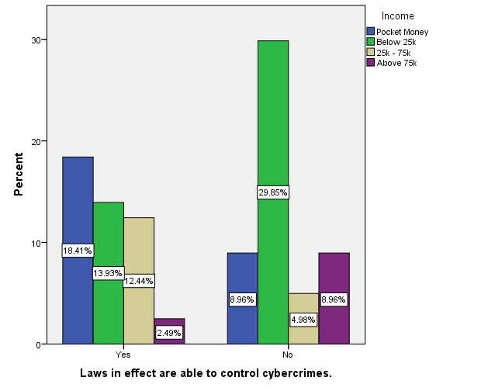

ANALYSIS:
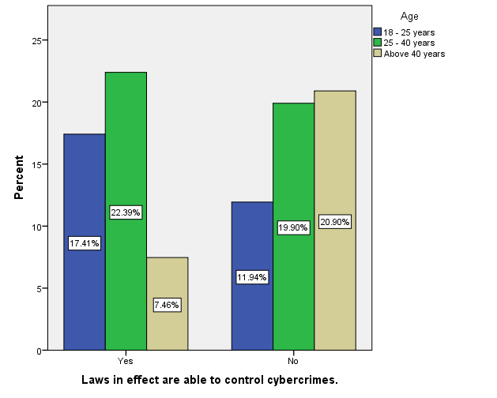
(FIG.1)
LEGEND: Figure 1 shows the people’s opinion towards On a scale,how the laws in effect are able to control cyber crimes in accordance with the age and occupation of the respondents.

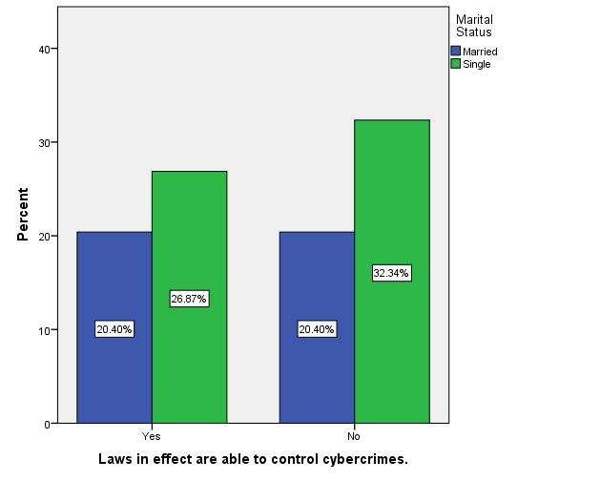
(FIG.2)
LEGEND: Figure 2 shows the people’s opinion towards On a scale,how the laws in effect are able to control cyber crimes in accordance with the gender and locality of the respondents.

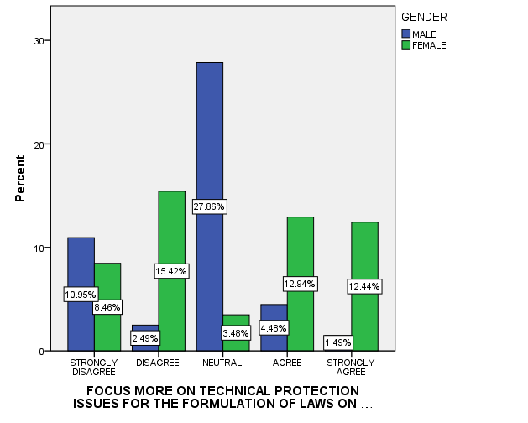
(FIG.3)
LEGEND: Figure 3 shows the people’s opinion towards Focus more on technical protection issues for the formulation of laws on cybercrime in accordance with the gender of the respondents.

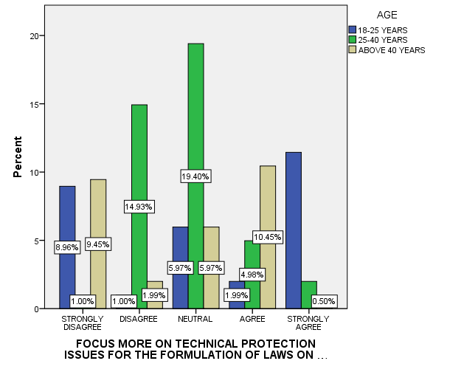
(FIG.4)
LEGEND: Figure 4 shows the people’s opinion towards Focus more on technical protection issues for the formulation of laws on cybercrime in accordance with the age of the respondents.

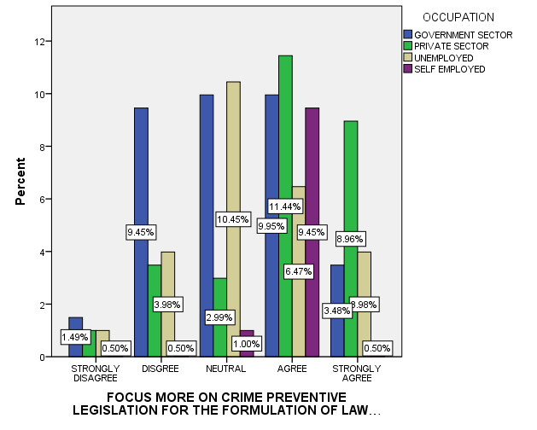
(FIG.5)
LEGEND: Figure 5 shows the people’s opinion towards Focus more on crime preventive legislation for the formulation of laws on cybercrime in accordance with the occupation of the respondents.

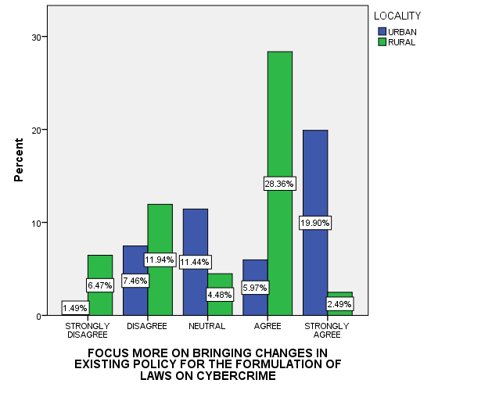
(FIG.6)
LEGEND: Figure 6 shows the people’s opinion towards Focus more on bringing changes in existing policy for the formulation of laws on cybercrime in accordance with the locality of the respondents.
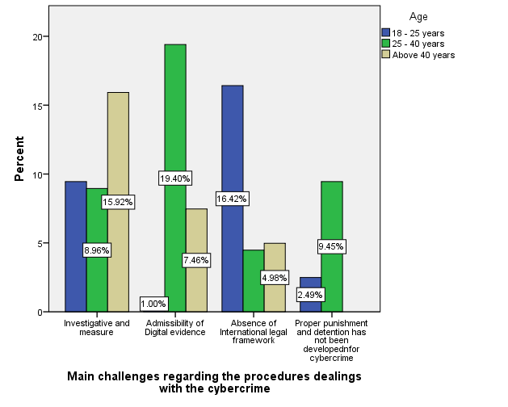
(FIG.7)
LEGEND: Figure 7 shows the people’s opinion towards investigate and measures as a challenge regarding the procedures dealing with the cybercrime in accordance with the gender of the respondents.

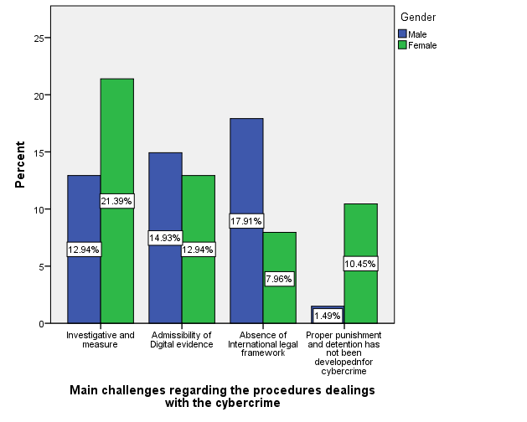
(FIG.8)
LEGEND: Figure 8 shows the people’s opinion towards admissibility of digital evidence as a challenge regarding the procedures dealing with the cybercrime in accordance with the age of the respondents.

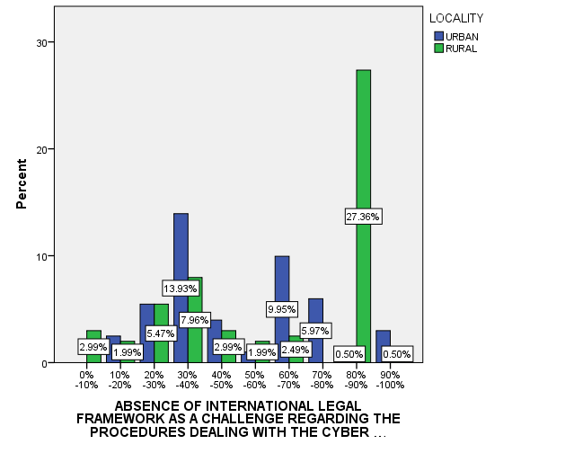
(FIG.9)
LEGEND: Figure 9 shows the people’s opinion towards absence of international legal framework as a challenge regarding the procedures dealing with the cybercrime in accordance with the locality of the respondents.
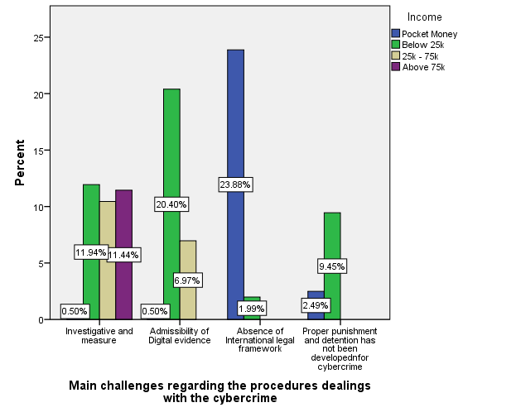
(FIG.10)
LEGEND: Figure 10 shows the people’s opinion towards proper punishment and detention has not been developed for cybercrime as a challenge regarding the procedures dealing with the cybercrime in accordance with the gender of the respondents.

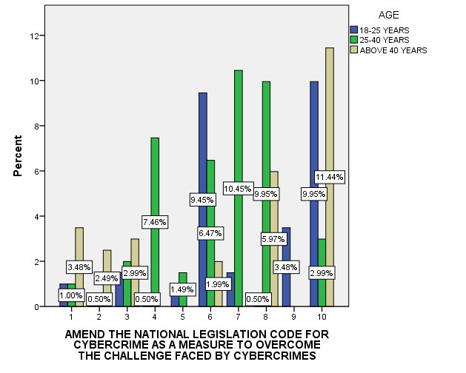
(FIG.11)
LEGEND: Figure 11 shows the people’s opinion towards amend the national legislation code for cybercrime as a measure to overcome the challenge faces by cybercrimes in accordance with the age of the respondents.

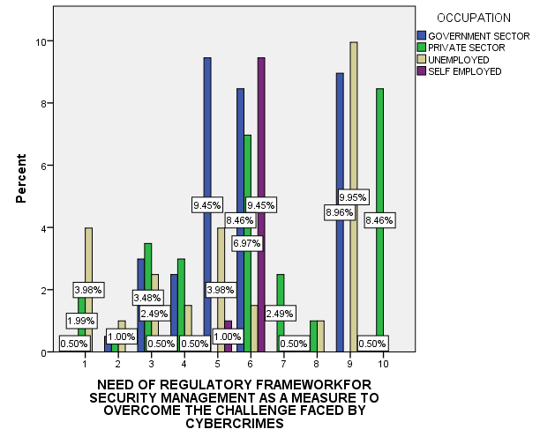
(FIG.12)
LEGEND: Figure 12 shows the people’s opinion towards need of regulatory framework for security management as a measure to overcome the challenge faced by cybercrimes in accordance with the occupation of the respondents.
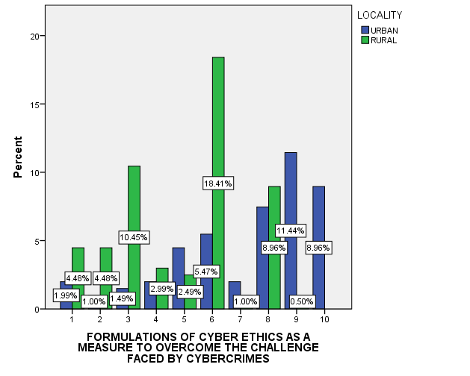
(FIG.13)
LEGEND: Figure 13 shows the people’s opinion towards formulations of cyber ethics as a measure to overcome the challenge faced by cybercrimes in accordance with the locality of the respondents.

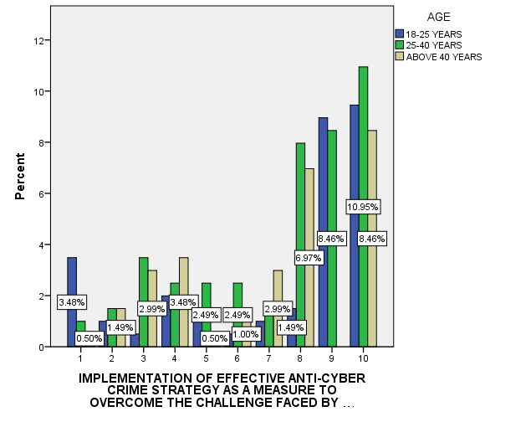
(FIG.14)
LEGEND: Figure 14 shows the people’s opinion towards implementation of effective anti-cyber crime strategy as a measure to overcome the challenge faced by cybercrimes in accordance with the age of the respondents.

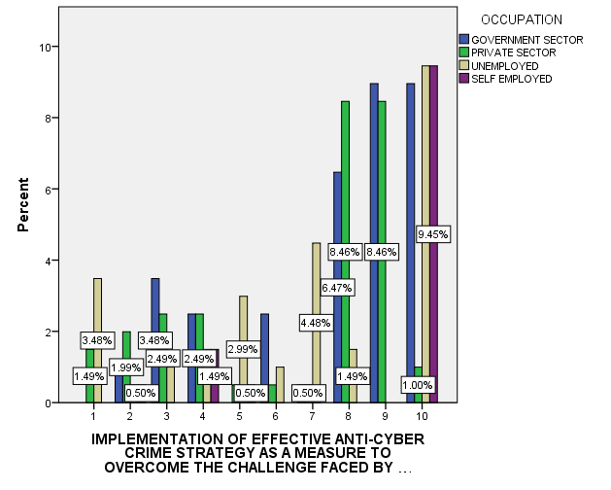
(FIG.15)
LEGEND: Figure 15 shows the people’s opinion implementation of effective anti-cyber crime strategy as a measure to overcome the challenge faced by cybercrimes in accordance with the occupation of the respondents.
RESULTS :
In fig.1, the graph explains that, the laws in effect are able to control cybercrimes and it has been responded to by all age group people in the society and compared with age and Occupation.In fig.2, the graph explains that, the laws in effect are able to control cybercrimes and it has been responded to by all people in the society and compared with gender and Locality.In fig.3, both the gender group people responded equally and says about the Focus more on the technical protection issues for the formulation of laws on the cybercrimes in the society.In fig.4, all the age group people responded equally when compared to the age group people of below 18 - 25 years towards the opinion of Focus more on the technical protection issues for the formulation of laws on the cybercrimes.In fig.5, the graphical representation is about that, the Focus more on the crime preventive legislation for the formulation of laws on the cybercrimes and it has been answered by all the sector people in the occupational field.In fig.6, the graphical representation is about the Focus more on the crime preventive legislation for the formulation of laws on the cybercrimes and it has been answered by both the group of people in the society.In fig.7, the graphical representation is about the Focus more on the crime preventive legislation for the formulation of laws on the cybercrimes and it has been answered by both the gender of people in the society.In fig.8, the graph explains that the admissibility of digital evidence as a challenge regarding in the procedures dealing with the cyber crimes and it has been responded to by all age group people in the society.In fig.9, the graphical representation is about the Absence of international legal framework as a challenge regarding the procedures dealing with the cybercrimes and it has been answered by both the both group of people in the society.In fig.10, the graphical representation is about the proper punishment and detention has not been developed for cybercrime as a challenge regarding in the procedures dealing with the cyber crimes and it has been answered by both the gender of people in the society. In fig.11, the graph explains that the amend the National legislation code for cybercrime as a measure to overcome the challenge regarding in the procedures dealing with the cyber crimes and it has been responded to by all age group people in the society.In fig.12,the graphical representation is about the need for regulatory framework for security management faced by the cyber crimes and it has been answered by all the sector people who are working in the occupational field.In fig.13, the graphical representation is about the formulation of cyber ethics as a measure to overcome the challenge faced by the cybercrimes and it has been answered by both the group of people in the society.In fig.14, all the age group people responded equally when compared to the age group people of below 18 - 25 years towards the opinion regarding the cybercrime. In fig.15, the graphical representation is about the implementation of effective anti-cyber crime strategy as a measure to overcome the challenges faced by the cybercrime and it has been answered by all the sector of the people working in the occupational field.

DISCUSSION:
From the survey,It is observed from fig.1,that, in the age of 25-40 years people have responded more when compared to other age group people saying that the people are less aware about that, the laws in effect are able to control cybercrimes and below 18 years have responded less to the survey. From the survey, in fig.2 it is observed that, both the gender of the people in the survey has given equal responses and it has been accepted that some people accept the opinion of that, the laws in effect are able to control cybercrimes in the society and male has accepted towards the opinion more in the society. The fig.3 depicts that, it is examined that, both the gender of the people have responded and the people is Focusing more on the technical protection issues for the formulation of laws on the cybercrimes in the society and female has responded more when compared to male in the society.From the survey,It is observed from fig.4 that, in the age of 25-40 years have responded more when compared to other age group people saying that opinion of Focus more on the technical protection issues for the formulation of laws on the cybercrimes and below 18 years have responded less to the survey.From the survey, in fig.5 it is examined that, all the people in the occupational field have responded equally and it has been responded towards the opinion that, Focus more on the crime preventive legislation for the formulation of laws on the cybercrimes and the people in the government sector have agreed towards the opinion in the society. The fig.6 depicts that, the responses given by the all group people are considered that, opinion focus more on bringing changes in the existing policy for the formulation of laws on cybercrime and their opinion is there should be more changes if there is a change the formulation of those laws can be prevented and it has been answered by all people in the society.From the survey, in fig.7 it is observed that, both the gender of the people in the survey has given equal responses and it has been accepted that some people accepts towards the opinion of that, investigate and measures as a challenge regarding the procedures dealing with the cybercrimes in the society.In fig.8, the graph represents that all age groups have responded but, above 40 years has responded less when compared to other age group people and below 18 years age group people are not aware of the fact that admissibility of digital evidence as a challenge regarding the procedures dealing with the cybercrimes in the society where the survey has been taken by the researcher. From the survey, in fig.9 it is examined that, all the people in the locality has responded equally and it has been answered towards the opinion of absence of international legal framework as a challenge regarding the procedures dealing with the cybercrimes and they think that, the people in urban has answered to around 80% that, the international legal framework as a challenge in the society.The fig.10 depicts that, it is examined that, both the gender of the people have responded and the proper punishment and detention has not been developed for cybercrime as a challenge regarding the procedure dealing with the cybercrimes and has responded more by female as they feel the punishment given to them is not enough and it should be amended when compared to males opinion in the society.The fig.11 depicts that, the responses given by the all age group people are considered that, opinion amend the national legislation code for cybercrime as a measure to overcome the challenge faced by the cybercrime and it has been answered by all people in the society as they think that, if there is amendments then the crime can be reduced in the society.From the survey, in fig.12 it is examined that, all the people in the occupational field has responded equally and it has been answered towards the opinion of need of regulatory framework security management as a measure to overcome the challenges faced by the cybercrime as they think there should be a need for laws in the society.From the survey, in fig.13 it is found that the formulation of cyber ethics a s a measure to overcome the challenges faced by the cybercrimes and it has been answered by all the sector people in the society.From the survey,It is observed from fig.14 that, in the age of 25-40 years have responded more when compared to other age group people saying that the people are less aware about that, implementation of effective anti-cyber crime strategy as a measure to overcome the challenges faced by the cybercrime and below 18 years have responded less to the survey.From the survey, in fig.15 it is examined that, all the people in the occupational field has responded equally and it has been responded towards the opinion of implementation of effective anti-cyber crime strategy as a measure to overcome the challenges faced by the cybercrime and it has been responded by all people in the society

LIMITATIONS:
The major limitation of my study is the sample frame. The sample frame is through offline mode.The people in the area where the survey has been taken are provoking us and they are unwilling to give pose for the photo.The restriction area of sample size is another major drawback.

SUGGESTIONS:
My suggestions towards the research topic is, there is a need to amend the national legislation for cybercrime as it threatens the unity, integrity, security sovereignty of India or to strike terror in the people.The IT (Amendment) Act, 2008, reduced the quantum of punishment for a majority of cyber crimes. This needs to be rectified.The majority of cyber crimes need to be made non-bailable offences.There is a need to implement the Anti-cybercrime strategies which are very flexible and promote cyber security in the information society.There should be one law which is applicable globally and universally accepted one which has one jurisdiction that would menace cybercrime.

CONCLUSION:
Now due to the technology development in the modern era, we are totally dependent on the technologies for day to day action.So now people started to use it for crime also. As our reliance on the internet grows,so does the need for revised measures. The Nations law making body will be wise to monitor the growth of the cybercrime, and the laws should designed to the extent of curbing such crimes to the greatest extent possible. As a result it the government’s and legislators’ responsibility to ensure that all aspects and challenges of cybercrime are addressed in cyber laws, allowing for the laws continued and active development. If we have it then , So that wherever cybercrime is committed, he can be trailed irrespective of where he is situated.

REFERENCES :
- Akram, Junaid, and Luo Ping. 2020. “How to Build a Vulnerability Benchmark to Overcome Cyber Security Attacks.” IET Information Security. https://doi.org/10.1049/iet-ifs.2018.5647.
- Alazab, Mamoun, and Roderic Broadhurst. 2015. “The Role of Spam in Cybercrime: Data from the Australian Cybercrime Pilot Observatory.” Cybercrime Risks and Responses. https://doi.org/10.1057/9781137474162_7.
- Andreas, Peter, and Ethan Avram Nadelmann. 2008. Policing the Globe: Criminalization and Crime Control in International Relations. Oxford University Press.
- Basu, Subhajit, and Richard Jones. 2005. “Indian Information and Technology Act 2000: Review of the Regulatory Powers under the Act.” International Review of Law, Computers & Technology. https://doi.org/10.1080/13600860500133495.
- Bechara, Fabio Ramazzini, and Samara Bueno Schuch. 2020. “Cybersecurity and Global Regulatory Challenges.” Journal of Financial Crime. https://doi.org/10.1108/jfc-07-2020-0149.
- Carpentier, Deborah A., and Brian E. Finch. 2012. “Tort Immunity for Cyber Attacks through SAFETY Act.” Natural Gas & Electricity. https://doi.org/10.1002/gas.21642.
- Cassim, F. 2010. “Formulating Specialised Legislation to Address the Growing Spectre of Cybercrime: A Comparative Study.” Potchefstroom Electronic Law Journal/Potchefstroomse Elektroniese Regsblad. https://doi.org/10.4314/pelj.v12i4.50049.
- Drew, Jacqueline M. 2020. “A Study of Cybercrime Victimisation and Prevention: Exploring the Use of Online Crime Prevention Behaviours and Strategies.” Journal of Criminological Research, Policy and Practice. https://doi.org/10.1108/jcrpp-12-2019-0070.
- “Emerging Issue in Cyber Crime: Case Study Cyber Crime in Indonesia.” 2016. International Journal of Science and Research (IJSR). https://doi.org/10.21275/art20162818.
- Huey, Laura J. 2002. “Policing the Abstract: Some Observations on Policing Cyberspace.” Canadian Journal of Criminology. https://doi.org/10.3138/cjcrim.44.3.243.
- Jayasekara, Sisira Dharmasri, and Iroshini Abeysekara. 2019. “Digital Forensics and Evolving Cyber Law: Case of BIMSTEC Countries.” Journal of Money Laundering Control. https://doi.org/10.1108/jmlc-02-2019-0019.
- Kethineni, Sesha. 2020. “Cybercrime in India: Laws, Regulations, and Enforcement Mechanisms.” The Palgrave Handbook of International Cybercrime and Cyberdeviance. https://doi.org/10.1007/978-3-319-78440-3_7.
- Kshetri, Nir. 2016. “Cybercrime and Cybersecurity in India: Causes, Consequences and Implications for the Future.” Crime, Law and Social Change. https://doi.org/10.1007/s10611-016-9629-3.
- “Public Awareness on Cyber Crime with Special Reference to Chennai.” 2019. International Journal of Innovative Technology and Exploring Engineering. https://doi.org/10.35940/ijitee.a9187.119119.
- Reynolds, Michael. 2015. “The Enemy Within: The Challenge for Business from Cyber-Attack.” Communications in Computer and Information Science. https://doi.org/10.1007/978-3-319-23276-8_11.
- Sahu, B., N. Sahu, S. K. Sahu, and P. Sahu. 2013. “Identify Uncertainty of Cyber Crime and Cyber Laws.” 2013 International Conference on Communication Systems and Network Technologies. https://doi.org/10.1109/csnt.2013.100.
- Sumanjeet, and Sumanjeet. 2010. “The State of E‐commerce Laws in India: A Review of Information Technology Act.” International Journal of Law and Management. https://doi.org/10.1108/17542431011059322.
- Veale, Michael, Reuben Binns, and Lilian Edwards. n.d. “Algorithms That Remember: Model Inversion Attacks and Data Protection Law.” https://doi.org/10.31228/osf.io/4bmfv.
- “Website.” n.d. Accessed March 22, 2021a. .Dennis Sing-Wing, and Sai-Fu Fung. 2020. “Development of the Cybercrime Rapid Identification Tool for Adolescents.” International Journal of Environmental Research and Public Health 17 (13).https://doi.org/10.3390/ijerph17134691.https://doi.org/10.3390/ijerph17134691.
- Wong, Dennis Sing-Wing, and Sai-Fu Fung. 2020. “Development of the Cybercrime Rapid Identification Tool for Adolescents.” International Journal of Environmental Research and Public Health. https://doi.org/10.3390/ijerph17134691.

PLAGIARISM:

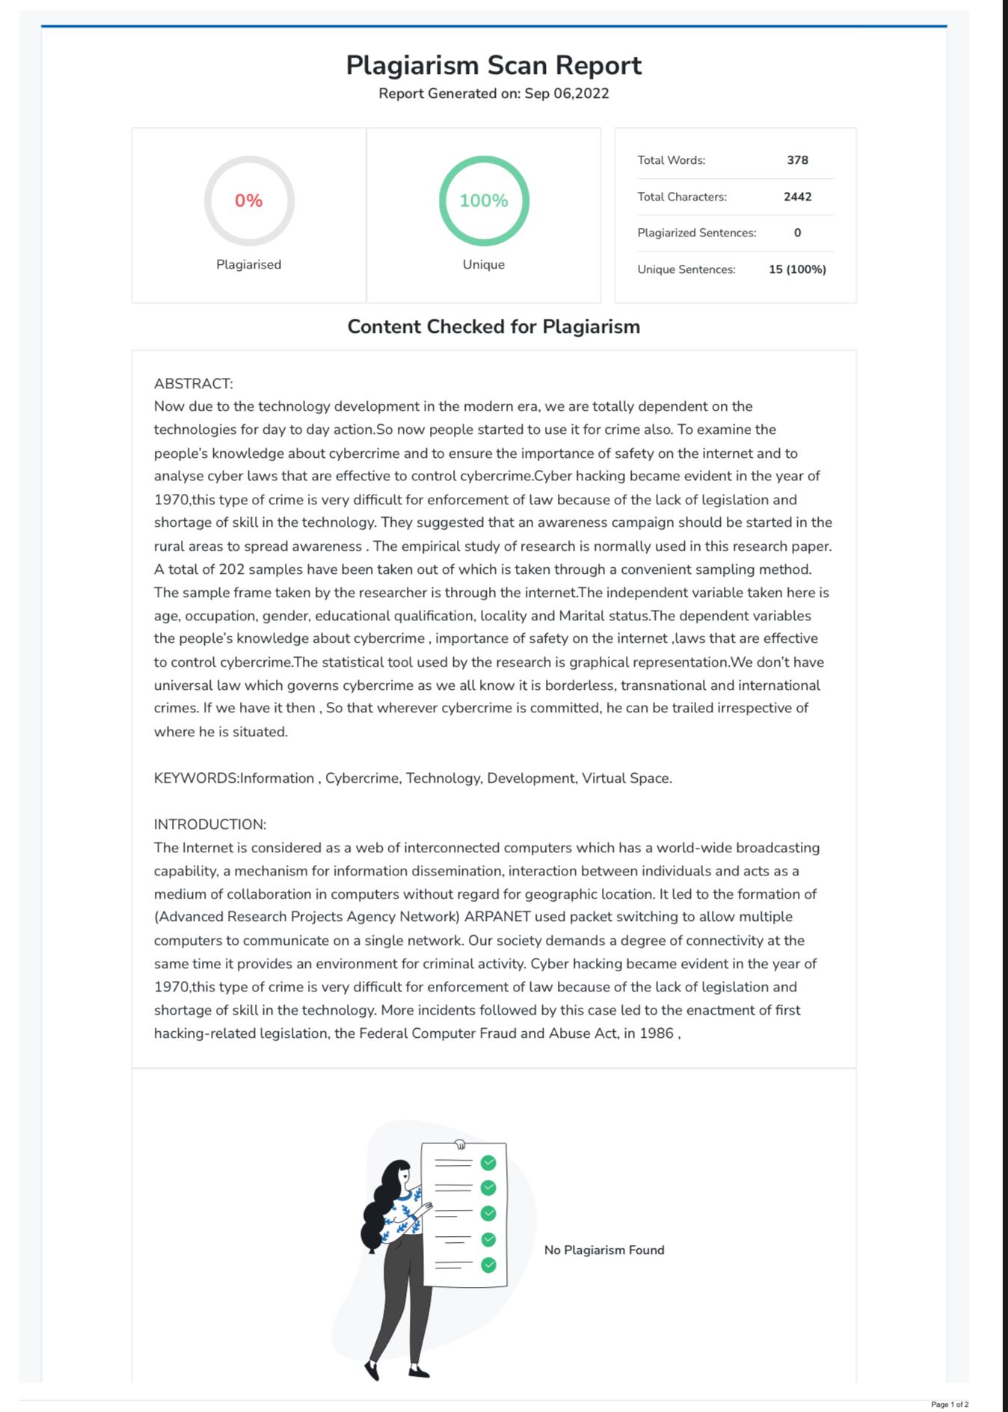

Mangai.K,131901083, B.A.LLB(Hons),4th year,Saveetha School of Law, Saveetha Institute of Medical and Technical Sciences (SIMATS),Saveetha University,Chennai :77,e-mail: mangaikarnanlaw@gmail.com,Phone no:9150507364.
Mrs.Priyanka.P M.Sc., M.L., Assistant Professor,Saveetha School of Law, Saveetha Institute of Medical and Technical sciences (SIMATS),Saveetha University,Chennai :77,Email ID: priyankap.ssl@saveetha.com,Phone No : 9176254490

