“The Use of Machine Learning (ML)/ Deep Learning (DL) approaches for a Comprehensive study of Blood & Bone Cancer that base on transmutation change in DNA/Genes in human bodies”


Younas Masih PhD.Cs.
Roll No phcs-F20-014
Superior University Gold Campus
Raiwind Road Lahore, Pakistan
Computer Science
(Machine Learning/Deep Learning)
Instructor Doctor Arfan Jaffar
1st Author Younas Masih
2nd Author Dr Danish Irfan
3rd Author Dr Arfan Jaffar
March 15, 2024

Abstract
In this article I have tried to study the Leukemia (Blood Cancer) in humen. The blood cancer is genetically disease that moves from generation after generation. This disease has no mercy on human being. It has no distinction among male, female, older, young or even in child. It shows its gravity in the form of death, if proper treatment did not start on time. It proves very fatal. Leukemia is a disease that starts from the uncontrollable and abnormal growth of the white blood cells WBCs. These white blood cells are the fighting soldiers of the human body called as immune system. When they become abnormal they did perform their function properly then disease virus increase in number and spread in the whole body through the circulatory system or by lymphatic system. If the diagnose of the cancer did not start at time then it prove very risky in the loss of a life.
Machine Learning/Deep learning is techniques that is very useful for the detection of such type of dangerous diseases particularly cancer of all types and the sever heart diseases. It is also work on statistical algorithms that are study from data and simplify to the undetected data and complete the given job without and open guidelines. Similarly Deep learning is also uses many layers to gradually sketch out higher-level features from the fresh input. For example, in image processing, lower layers may detect ends, while higher layers may isolate the ideas related to a human such as numbers or letters or faces. So machine learning and deep learning is best techniques for the detection, identification, classification and determination of stages of leukemia (Blood Cancer). This method is lower cost and high throughput and consider as the good solution for the detection of the leukemia and other dangerous diseases.
I have tried to use this method for the detection of leukemia because my sister is also suffering from this type of ailment. She has aplastic anemia and has passed through the trial of treatment of chemotherapy and also transplation of the bone marrow. So for this I am come forward for the research in leukemia (Blood cancer), bone cancer. First I work on the leukemia and then similar method I will apply on the bone marrow cancer.
Key Words

Leukemia; Machine learning; Deep learning; DNA; Gene; Benign; Malignant; genetic syndromes ; lymphoma; Carcinoma; Sarcoma; Lymphoma; Hepatitis B Virus and C Virus; white blood cells WBCs; red blood cells RBCs

Introduction
As per title “The Use of Machine Learning (ML)/ Deep Learning (DL) approaches for a Comprehensive study of Blood & Bone Cancer base on transmutation change in DNA/Genes in human bodies”. In this project I have tried to explore the cause of leukaemia in human. This is mainly an effort to know the cause of leukaemia in human and try to know that leukaemia a genetically disease and how it start or reach in the genes? Who one ordered DNA/Genes to create leukaemia. The cause factors of leukaemia its properties, treatment, and management, different types of leukaemia and its management. Various methods of the sequence of DNA/ genes, and to find out the mutant or cancer gene in humans DNA through DNA sequence technique.
By the use of Machine Learning/Deep learning technique it is easy to find the cause of Leukemia (Blood Cancer in human) Machine learning is the method that is used for the study of algorithms, research models which formed by the computer for a particular task.[1].Similarly Deep Learning (DL) is the core branch of machine learning (ML) and also the Artificial Intelligence (AI).In the present era It become the core technology because of its working ability on data. It is hot topic in computing and also used in the many fields such as healthcare, virus identification, text analysis, cyber security etc.[2]
Cancer is a dangerous disease but all time it is not so because there is two main types of cancer like benign, and malignant type. Benign cancer is a type in which a massive mass of the unwanted cells are formed. It does not move in the entire body through body serum or other means. It can be easily removed from the body through surgery. But on the other hand the malignant disease is a dangerous type of cancer. In this type the infected cancer cell can move in the whole body through the blood stream and lymphatic process. The infected cell enter in the blood vessels through the process of penetration and the circulation of blood it reach from one part of the body to other part. It reach in the DNA and become the congenital disease and it transfer from generation after generation. Some genes that cause produce cancer. Table1-Cancer cause genes
S.No | Types of Cancer | Name of Genes Involved
1 | Breast cancer in women | ATM, BARD1, BRCA1, BRCA2, CHEK2, CDH1,  NF1, PALB2, PTEN, RAD51C, RAD51D, STK11, TP53
2 | Breast cancer in men | BRCA1, BRCA2, CHEK2, PALB2
3 | Colorectal cancer | APC, BMPR1A, EPCAM, MLH1, MSH2, MSH6, PMS2, CHEK2,  POLE, PTEN, SMAD4, STK11, TP53, MUTYH
4 | Endometrial cancer | BRCA1*, EPCAM, MLH1, MSH2, MSH6, PMS2, PTEN, STK11
5 | Fallopian tube, ovarian, primary peritoneal cancer | ATM, BRCA1, BRCA2, BRIP1, EPCAM, MLH1,  MSH2, MSH6, PALB2, PMS2, RAD51C, RAD51D
6 | Gastric cancer | APC, CDH1, STK11, EPCAM, MLH1, MSH2, MSH6, PMS2
7 | Melanoma | BAP1(particularly uveal melanoma), BRCA2 CDK4, CDKN2A, PTEN, TP53
8 | Pancreatic cancer | ATM, BRCA1, BRCA2, CDKN2A, EPCAM, MLH1, MSH2, MSH6, PALB2, STK11, TP53
9 | Prostate cancer | ATM, BRCA1, BRCA2, CHEK2, HOXB13, EPCAM, MLH1, MSH2, MSH6, PMS2

Note: BRCA1 changes have been connected to a very unusual but violent kind of cancer called as serous endometrial cancer. The life risk for endometrial cancer is not enlarged in women with BRCA1 changes, but there is a minor rise in danger for this infrequent subtype. [3] There are different type of viruses that causes cancer in human of all ages and groups.

1-Epstein - Barr virus- Burkitt’s lymphoma, Hodgkin’s disease, and Nasopharyngeal Carcinoma

2-Papillomaviruses 16 and 18- Cervical Carcinoma, Anal Carcinoma, Oropharyngeal Carcinoma, Penile Carcinoma

3-Kaposi’s Sarcoma-Associated Herpesvirus- Kaposi’s sarcoma, Primary Effusion Lymphoma, Multicentric Castleman’s Disease

4-Hepatitis B Virus and Hepatitis C Virus- Hepatocellular Carcinoma

5-Human Adult T-cell Leukemia Virus Type 1 (HTLV-1) - T-cell Leukemia

6-Merkel Cell Polyomavirus- Merkel Cell Carcinoma[4]
By the use of (ML)/ (DL) techniques it is possible to find the particular DNA/ genes that cause cancer in human.Leukaemia is type of malignant cancer that is originate in the bone marrow substances of the long bones of the human body. Only few percent of blood formation take place in other parts like liver, and spleen etc. Leukemia is type of blood cancer and is start because of the distortion of any elements in the blood and bonemarrow.There are productions of odd white blood cells that are not fully developed are called as blast or leukemia cells. The leukemia cells row very rapidly than the normal cells and they replace the formation of normal WBCs and RBCs and dispersed to lymph nodes and other organs.[5] Leukemia happens due to the lack of any disposing factor, it may be germ line mutation which raises the threat of beginning of hematoietic malignancies in childhood. This character factor can be divided as that guide to bone marrow failure, and that involving tumor suppressor’s gene. DNA repair faults immunodeficiency or other genetic syndromes are connected with myeloid cancer. Leukemia is established as minor effect of that syndrome. There are many syndromes that closely clue to the growth of leukemia as their main phenotype.
Literature Review
Leukemia (Blood cancer) is disease that is start in human due to the production of large number of abnormal white blood cell that is called as leukemia cells. These leukemia cells are entered into the blood stream through the process of penetration and spread into the whole body via blood circulation or lymphatic system. This process of spreading of leukemia cell in the other parts of the body is called as metastasis. The making of the blood occurs in the bone marrow that is a substance present in the long bones of the body like legs, arms, shoulders, and hips etc. Here is the difference between leukemia and normal white blood cells.
Note: Smooth rounded Pink ball indicate normal Blood cells, while wrinkles black outline ball represent as leukemia cells.
Fig 1 Difference between Leukemia and normal white blood cells.

Leukemia Cells
Normal White blood cells

Material and Methods
For the study of leukemia (Blood Cancer) I have used different types of software, application, libraries and algorithms for this project such as Python3.10.1 environment with Anaconda 3.10.1, Jupyter Notebook, Pandas, other different types of libraries like Numpy, matplotlib .pyplot as plt, Sklearn, Seaborn, OS (Operating System), PIL (Python Image Library).I also used many classifiers in this article for the result and accuracy of the building Machine learning / Deep learning models. These classifiers are, Lab encoder, train _ test_split method, Standard- Scaler for features scaling, confusion_matrix, SVC (Support Vector Machine) LogisticRegression , KNeighborsClassifier, GaussianNB (Gaussian Naïve Bayes Classifier), DecisionTreeClassifier, RandomForestClassifier, AdaBoostClassifier, xgboost Classifier, XGBoost Parameter, Tuning Randomized Search, Randomized Search CV(Computer Vision) ,GridSearchCV, Classification Report of Model, Cross-validation of the Machine Learning Model, Save XGBoost Classifier Model By using Pickel, Bio-edit, snap gene, and many more helping adds like internet, You-Tube, Research paper and research article ,scholarly articles, and Books. The purposes of mention this material is to deep study for the leukemia (Blood Cancer).
First of all I have down load the data of Leukemia blood cells from the kaggle then I call it in the Jupyter Notebook with python environment to see any change in the shape of the blood cells.[6].In the figure below the leukemia virus entered in the blood the white blood cell make a circle around it to stop from further spreading. But the virus remain continue to control over the blood cell and destroyed the white blood cell. In this way the spread in the whole blood and reach all part of the body through the blood circulation or lymphatic system. Fig 1-Leukemia and Normal blood cell
Leukemia Cells
Normal White Blood Cells
Secondly I have Import the Essential Libraries for Leukemia (Blood Cancer) detection these libraries are as follow. This stage is consists of the number headings and sub headings.

import pandas as pd # for datamanupolation

import numpy as np # for numeric calculation

import matplotlib.pyplot as plt # for data visualiation

import sklearn # for statistical modeling, implement machine/deep learning models for regression, classification etc

import seaborn as sns # for data visualiation

i- Load the Data
import pandas as pd
df = pd.read_csv(r'C:\Users\Administrator\Downloads\archive\data.csv') # load blood cancer dataset
Fig 1-Leukemia and Normal blood cell
Leukemia Cells
Normal White Blood Cells

ii-Manipulate the Data
df # view the data as below
This data is consisting of 569 rows × 33 columns that is very huge in number and cannot visualize in single pane. So I have select only 5 rows and 10 columns. Table 2 Manipulation of data
id | diagnosis | radius_mean | texture_mean | perimeter_mean | area_mean | smoothness_mean | compactness_mean | concavity_mean | concave points_mean
0 | 842302 | M | 17.99 | 10.38 | 122.80 | 1001.0 | 0.11840 | 0.27760 | 0.30010
1 | 842517 | M | 20.57 | 17.77 | 132.90 | 1326.0 | 0.08474 | 0.07864 | 0.08690
2 | 84300903 | M | 19.69 | 21.25 | 130.00 | 1203.0 | 0.10960 | 0.15990 | 0.19740
3 | 84348301 | M | 11.42 | 20.38 | 77.58 | 386.1 | 0.14250 | 0.28390 | 0.24140
4 | 84358402 | M | 20.29 | 14.34 | 135.10 | 1297.0 | 0.10030 | 0.13280 | 0.19800

This graph is the illustration of the above data. The value are so small, for the more clearance I have multiply the given value with 10 time or more to chive this value as given in the graph.
Fig 3 Graph 1 and 1A

Then I have change the data into zero (0) and one (1) form by label encounter application and find the following data form
array([1, 1, 1, 1, 1, 1, 1, 1, 1, 1, 1, 1, 1, 1, 1, 1, 1, 1, 1, 0, 0, 0,
1, 1, 1, 1, 1, 1, 1, 1, 1, 1, 1, 1, 1, 1, 1, 0, 1, 1, 1, 1, 1, 1,
1, 1, 0, 1, 0, 0, 0, 0, 0, 1, 1, 0, 1, 1, 0, 0, 0, 0, 1, 0, 1, 1,
0, 0, 0, 0, 1, 0, 1, 1, 0, 1, 0, 1, 1, 0, 0, 0, 1, 1, 0, 1, 1, 1,
0, 0, 0, 1, 0, 0, 1, 1, 0, 0, 0, 1, 1, 0, 0, 0, 0, 1, 0, 0, 1, 0,
0, 0, 0, 0, 0, 0, 0, 1, 1, 1, 0, 1, 1, 0, 0, 0, 1, 1, 0, 1, 0, 1,
1, 0, 1, 1, 0, 0, 1, 0, 0, 1, 0, 0, 0, 0, 1, 0, 0, 0, 0, 0, 0, 0,
0, 0, 1, 0, 0, 0, 0, 1, 1, 0, 1, 0, 0, 1, 1, 0, 0, 1, 1, 0, 0, 0,
0, 1, 0, 0, 1, 1, 1, 0, 1, 0, 1, 0, 0, 0, 1, 0, 0, 1, 1, 0, 1, 1,
1, 1, 0, 1, 1, 1, 0, 1, 0, 1, 0, 0, 1, 0, 1, 1, 1, 1, 0, 0, 1, 1,
0, 0, 0, 1, 0, 0, 0, 0, 0, 1, 1, 0, 0, 1, 0, 0, 1, 1, 0, 1, 0, 0,
0, 0, 1, 0, 0, 0, 0, 0, 1, 0, 1, 1, 1, 1, 1, 1, 1, 1, 1, 1, 1, 1,
1, 1, 0, 0, 0, 0, 0, 0, 1, 0, 1, 0, 0, 1, 0, 0, 1, 0, 1, 1, 0, 0,
0, 0, 0, 0, 0, 0, 0, 0, 0, 0, 0, 1, 0, 0, 1, 0, 1, 0, 0, 0, 0, 0,
0, 0, 0, 0, 0, 0, 0, 0, 0, 1, 0, 0, 0, 1, 0, 1, 0, 0, 0, 0, 1, 1,
1, 0, 0, 0, 0, 1, 0, 1, 0, 1, 0, 0, 0, 1, 0, 0, 0, 0, 0, 0, 0, 1,
1, 1, 0, 0, 0, 0, 0, 0, 0, 0, 0, 0, 0, 1, 1, 0, 1, 1, 1, 0, 1, 1,
0, 0, 0, 0, 0, 1, 0, 0, 0, 0, 0, 1, 0, 0, 0, 1, 0, 0, 1, 1, 0, 0,
0, 0, 0, 0, 1, 0, 0, 0, 0, 0, 0, 0, 1, 0, 0, 0, 0, 0, 1, 0, 0, 1,
0, 0, 0, 0, 0, 0, 0, 0, 0, 0, 0, 0, 1, 0, 1, 1, 0, 1, 0, 0, 0, 0,
0, 1, 0, 0, 1, 0, 1, 0, 0, 1, 0, 1, 0, 0, 0, 0, 0, 0, 0, 0, 1, 1,
0, 0, 0, 0, 0, 0, 1, 0, 0, 0, 0, 0, 0, 0, 0, 0, 0, 1, 0, 0, 0, 0,
0, 0, 0, 1, 0, 1, 0, 0, 1, 0, 0, 0, 0, 0, 1, 1, 0, 1, 0, 1, 0, 0,
0, 0, 0, 1, 0, 0, 1, 0, 1, 0, 1, 1, 0, 0, 0, 1, 0, 0, 0, 0, 0, 0,
0, 0, 0, 0, 0, 1, 0, 1, 1, 0, 0, 0, 0, 0, 0, 0, 0, 0, 0, 0, 0, 0,
0, 0, 0, 0, 0, 0, 0, 0, 0, 0, 0, 0, 1, 1, 1, 1, 1, 1, 0],
dtype=int32)

iii-Creating the Data Frame

df.to_csv('data.csv') # store data innto csv file for further process

iv-Data Visualization

sns.pairplot (df.iloc [:,1:10], hue = "diagnosis") # visualize the data
<Seaborn.axisgrid.PairGrid at 0x8974658> Fig 2 Data Visualiation

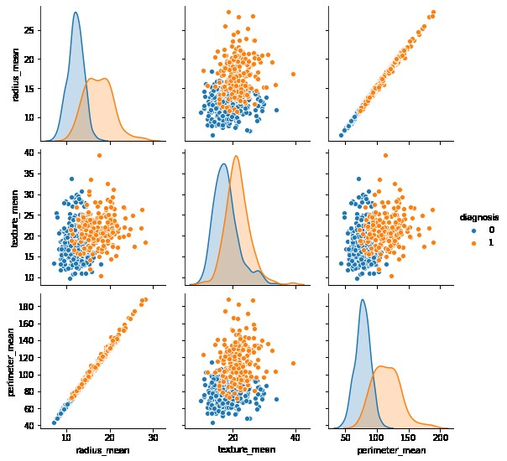

In this fig there are two colors are seen, the blue represent the Leukemia and the orange color for benign or no cancer disease. Similarly there are two no’s are also seen here zero (0) for malignant cells while one (1) for benign or no cancer cells.
v-Diagnosis of the Leukemia (Blood Cancer)
Suppose we have a total count of blood is 1000 cells in which Leukemia cells are 350 cells, benign cells are 200 cells and normal white blood cells are 450 cells the graphical representation is as under. Table
Cells Name | Series 1 | Series 2 | Series 3
Leukemia cell | 600 | 400 | 350
Benign cell | 400 | 300 | 300
Normal cell | 450 | 300 | 250
Blood Plasma | 350 | 300 | 350

vi-Heatmap of correlated Matrix

df.corr () #co-relate the data Fig 3- Heat map of Correlated matrix

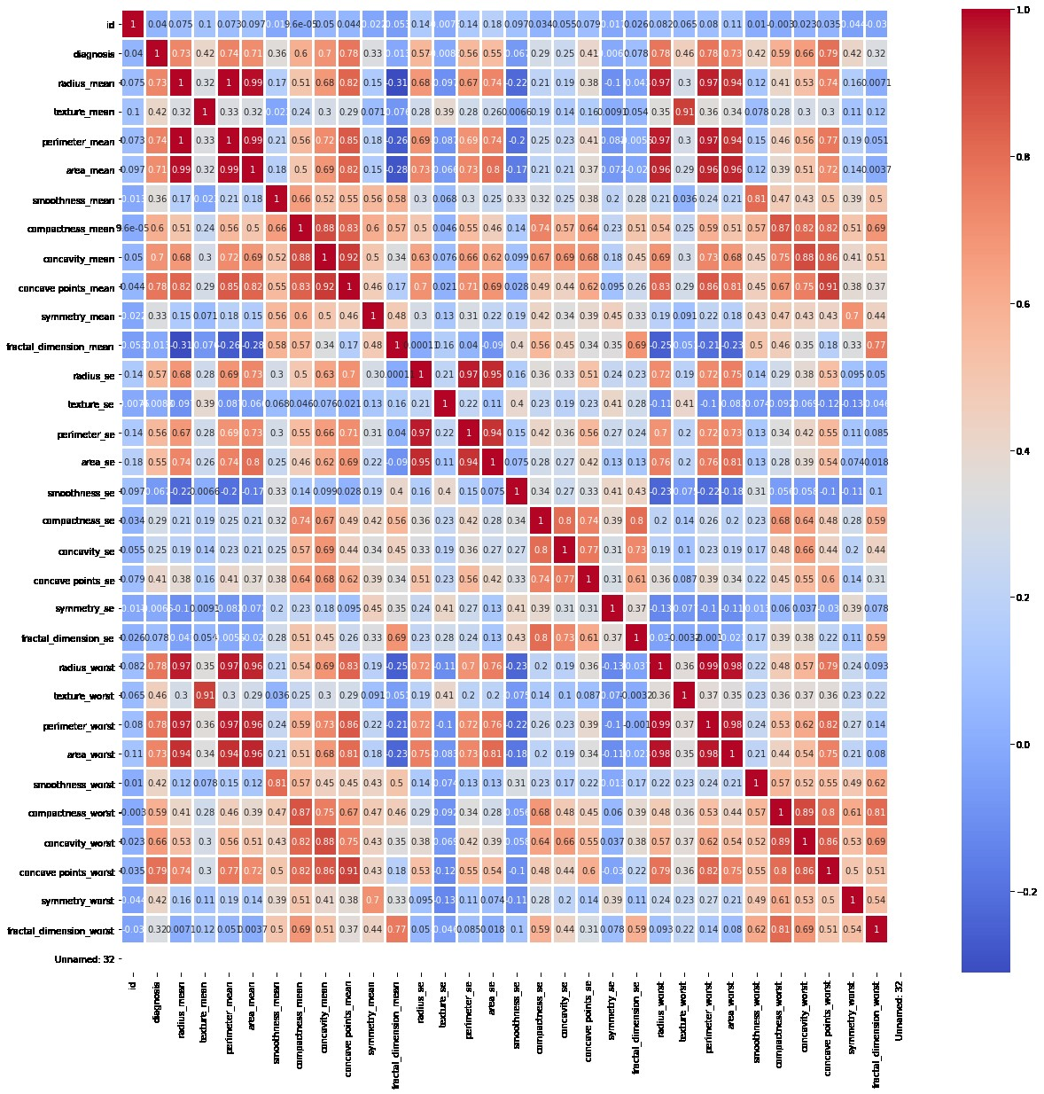

vii-Split Data Frame into Train and Test

from sklearn.model_selection import train_test_split
x_train,x_test,y_train,y_test = train_test_split(x, y,test_size = 0.3,random_state = 10)
x_train
(398, 32)
y_train
(398,)

vii-Feature Scaling
from sklearn.preprocessing import StandardScaler # for features study
x_train
(398, 32)
y_train
(398,)

ix-Machine/Deep Learning Model Building

ix.i-Support Vector Machine
from sklearn.svm import SVC
svc_classifier = SVC()
from sklearn.model_selection import train_test_split
x = df.iloc[:,2:32].values
y = df.iloc[:,1]
x_train,x_test,y_train,y_test = train_test_split(x,y,test_size = 0.3, random_state = 10)
svc_classifier.fit(x_train, y_train)
y_pred_scv = svc_classifier.predict(x_test)
accuracy_score(y_test,y_pred_scv)
0.935672514619883

ix.ii-Logistic Regression
from sklearn.linear_model import LogisticRegression
lr_classifier = LogisticRegression()
from sklearn.model_selection import train_test_split
import pandas as pd
df = pd.read_csv(r'C:\Users\Administrator\Downloads\archive\data.csv')
x = df.iloc[:,2:32].values
y = df.iloc[:,1]
x_train,x_test,y_train,y_test = train_test_split(x,y,test_size = 0.3, random_state = 10)
from sklearn.linear_model import LogisticRegression
lr_classifier = LogisticRegression()
lr_classifier.fit(x_train,y_train)
y_pred_lr = lr_classifier.predict(x_test)
accuracy_score(y_test,y_pred_lr)
0.9473684210526315

ix.iii-K-Nearest Neighbors Classifier
from sklearn.neighbors import KNeighborsClassifier
knn_classifier = KNeighborsClassifier()
from sklearn.metrics atrix, classification_report, accuracy_score
from sklearn.model_selection import train_test_split
x = df.iloc[:,2:32].values
y = df.iloc[:,1]
x_train,x_test,y_train,y_test = train_test_split(x,y,test_size = 0.3, random_state = 10)
from sklearn.neighbors import KNeighborsClassifier
knn_classifier = KNeighborsClassifier()
knn_classifier.fit(x_train,y_train)
y_pred_knn = knn_classifier.predict(x_test)
accuracy_score(y_test,y_pred_knn)
0.9415204678362573

ix.iv-Naive Bayes Classifier
from sklearn.naive_bayes import GaussianNB
nb_classifier = GaussianNB()
nb_classifier.fit(x_train,y_train)
y_pred_nb = nb_classifier.predict(x_test)
accuracy_score(y_test,y_pred_nb)
0.9590643274853801

ix.v-Decision Tree Classifier
from sklearn.tree import DecisionTreeClassifier
dt_classifier = DecisionTreeClassifier ()
dt_classifier.fit(x_train,y_train)
y_pred_dt = dt_classifier.predict(x_test)
accuracy_score(y_test,y_pred_dt)
0.9181286549707602

ix.vi-Random Forest Classifier
from sklearn.ensemble import RandomForestClassifier
rf_classifier = RandomForestClassifier ()
from sklearn.metrics import confusion_matrix, classification_report, accuracy_score
import pandas as pd
df = pd.read_csv(r'C:\Users\Administrator\Downloads\archive\data.csv')
x = df.iloc[:,2:32].values
y = df.iloc[:,1]
from sklearn.model_selection import train_test_split
x_train,x_test,y_train,y_test = train_test_split(x,y,test_size = 0.3, random_state = 10)
rf_classifier.fit(x_train,y_train)
y_pred_rf = rf_classifier.predict(x_test)
accuracy_score(y_test,y_pred_rf)
0.9824561403508771

ix.vii-AdaBoost Classifier
Adamodel = AdaBoostClassifier (n_estimators = 100, Learning_rate = 1)
model = Adamodel.fit (x_train,y_train)
y_pred = model.predict (x_test)
print("accuracy:", metrics.accuracy_score(y_test, y_pred))
accuracy: 0.9649122807017544

ix.viii-XGBoost Classifier
From xgboost import XGBClassifier
xgb_classifier = XGBClassifier ()
xgb_classifier.fit (x_train, y_train)
y_pred_xgb = xgb_classifier.predict (x_test)
accuracy_score (y_test, y_pred_xgb)
0.9824561403508771
Table 3- comparison of classifiers
No | Name of Classifiers | Accuracy Rate | Remarks
1 | Support Vector Machine | 0.935672514619883 | Intermediate
2 | Logistic Regression | 0.9473684210526315 | Fine
3 | K-Nearest Neighbors Classifier | 0.9415204678362573 | Fine
4 | Naive Bayes Classifier | 0.9590643274853801 | Normal
5 | Decision Tree Classifier | 0.9181286549707602 | Poor
6 | Random Forest Classifier | 0.9824561403508771 | Good
7 | AdaBoost Classifier | 0.9649122807017544 | Fair
8 | XGBoost Classifier | 0.9824561403508771 | Good

According to the above result it is come to know that an ordinary doctor or physician only examine the external feature and appearance of the cancer patient but he does not sure about the exact condition of the cancer patient. Only complete blood test and biopsy test and MRI and CT scan and X-rays show that the patient is suffering from cancer. But what is kind and what is present stage of the cancer is only detect by the use of the machine learning or Deep learning methodology.

Table 3- comparison of classifiers
Classifiers | Accuracy Rate | Remarks
Support Vector Machine | 0.935672514619883 | Ok
Logistic Regression | 0.9473684210526315 | Fine
K-Nearest Neighbors Classifier | 0.9415204678362573 | Fine
Naive Bayes Classifier | 0.9590643274853801 | Normal
Decision Tree Classifier | 0.9181286549707602 | Poor
Random Forest Classifier | 0.9824561403508771 | Good
AdaBoost Classifier | 0.9649122807017544 | Fair
XGBoost Classifier | 0.9824561403508771 | Good

According to the above result it is come to know that an ordinary doctor or physician only examine the external feature and appearance of the cancer patient but he does not sure about the exact condition of the cancer patient. Only complete blood test and biopsy test and MRI and CT scan and X-rays show that the patient is suffering from cancer. But what is kind and what is present stage of the cancer is only detect by the use of the machine learning or Deep learning methodology. The results of the above comparison of the different types of classifiers are multiply with 10 times to get the graphical demonstration as below.

DNA sequencing
DNA sequencing is the process of determining the nucleic acid sequence the order of nucleotides in DNA. It includes any method or technology that is used to determine the order of the four bases: adenine, guanine, cytosine, and thymine for double strands DNA, and adenine, guanine, cytosine, and Uracil in place of thymine in RNA. DNA sequences have become indispensable for basic biological research. DNA Genographic Projects are numerous applied fields such as medical diagnosis, biotechnology, biology, virology biological systematics, serious disease detection and cancer etc. There are many sequence methods used for the sequence of DNA, RNA, Genes Ribosomes, Protein, Nucleotide etc but I have discussed only most popular sequence method that Sanger sequence method.
Sanger Sequencing method is used to study genomes that allow the identification of genetic mutations, and their associations with diseases. Sanger sequencing has applications in the areas of medicine, forensics, and evolutionary biology and also for the detection of dangerous diseases like cancer. Sanger sequencing differs from PCR in two important ways:
i-Sanger sequencing uses dideoxynucleotides in addition to deoxynucleotides, whereas PCR uses only deoxynucleotides.
ii-In Sanger sequencing, only one primer, either forward or reverse, is used, whereas PCR uses both the primers.
The major technique involved in the Sanger sequencing method is polymerase chain reaction, or PCR. Like PCR, in vitro DNA replication takes place in the Sanger sequencing method, utilizing the reagents that are used in a PCR reaction.
Steps involve in Sanger DNA sequencing method
i-DNA template/get DNA sample
ii-Denature of DNA sample into smallest fragments by spinning
iii-Addition of primer of known sequence for the replication of DNA (To make more copies of single strand DNA)
iv- Take four test tubes to start the process and add the following material in each test tube. (SSDNA), DNA polymerase (enzyme), (DNTP, A normal DNA) and (DDNTP deoxynucleotides.
v-Add (DDATP), (DDCTP), (DDGTP), (DDTTP) in each test tube
vi-In first test tube TA* is result then the reaction will stop because A* is come from dideoxydized nucleotides. If A is come from normal DNA then the reaction will continue.
vii-In second test tube if TC* and TCC*
viii- In test tube three the following result is received TACG* and TACGG*
ix-In test tube four T* and TT*
In this process the smallest molecule/piece of nucleotide move faster and penetrate in the gel electrophoresis and show the result on the chromatogram as under. But the larger molecules or nucleotide move slowly in the gel electrophoresis apparatus and show the different result. After obtain the result the result is compared with the standard sequence and find out the mutant gene in the DNA strands.
Sanger Sequence of Human DNA/Chain Termination Method
Fig 4 Sanger sequence of DNA
ddATP
ddCTP
ddGTP
ddGTP

ddGTP
ddATP
T
C
G
G
C
A
T
A
G
C
C
G
T
A
ddCTP
ddTTP
3^{p}
5^{p}
3^{p}
5^{p}

Findings
i-Machine learning method is used for the low amount of data, while deep learning method can also handle the large amount of data and give a good result without the interfere of human efforts.
ii-The leukemia cell move from one part of the body to through the process of circulation of the blood and lymphatic material.
iii-The leukemia cell when entered in the new host it remain inactive for some time and then start control over the host and make it destroyed not able to work properly. In this way the leukemia cell increase in number and the patients have the signs of the disease.
iv-The chromosomes of the human contains 23 pairs of DNA and billions of genes located on it.Every chromsome have a cancer cause genes on it but 17p53 (17 mean chromsome number and p53 mean gene located on the short arm p of the chromsome and 53 is the location of the cancerous gene on it)
v-At the result of interchange of some part of the one chromosome and the few part of the other chromsome may result the double form of cancer
v-The leukemia cell or cancer causing agent reach to DNA by the process of mistake and then become the genetic disease for that patient.
vii-Mistake process is the process in which the protein is made by the body under the instruction of gene this protein may or may not need for the body.
Conclusion and Discussion
In this research article I tried to search the cause of leukemia (blood cancer) due to the cause of DNA/Gene contamination or mutation under the techniques of machine learning and deep learning .Leukemia is dangerous disease its only treatment is transfusion of blood time to time and the transplantation of germ cell of bone marrow in the bone. This disease is originate by the uncontrollable production of white blood cells .These cells are not die on time and hence increase the number of abnormal or leukemia cells in the blood. These cells then hold the control of the nutrition for their growth and also get control over the genes for their production. Due to this they become large and large in number and cause the leukemia (blood cancer).This disease have different signs and symptoms that are varies from patients to patients. It reaches into different parts of the body and damages the organs. Then the organs did not work properly and then the patients go in arrest position. Like other types of cancer leukemia has a chain of stages that indicates the severity of the disease.
Future Work
At the end of this research article I have decided that there is a hard need of a universal medicine which stop and then cure the not only blood cancer but all types of cancer that occurs in human bodies, either it is benign type or malignant type cancer. According to me this medicine is vaccines like a polio vaccine. I have an idea in my mind and after the completion of my PhD degree I will work on the discovery of vaccine or all types of cancer.

References
[1] B. Mahesh, Machine Learning Algorithms -A Review. 2019. doi: 10.21275/ART20203995.
[2] I. H. Sarker, “Deep Learning: A Comprehensive Overview on Techniques, Taxonomy, Applications and Research Directions,” SN Comput. Sci., vol. 2, no. 6, p. 420, Aug. 2021, doi: 10.1007/s42979-021-00815-1.
[3] “Table of different genes and the hereditary cancers that they cause,” Table of different genes and the hereditary cancers that they cause. Accessed: Mar. 19, 2024. [Online]. Available: https://www.facingourrisk.org/info/hereditary-cancer-and-genetic-testing/genes-by-cancer-types
[4] “The 7 Viruses That Cause Human Cancers,” ASM.org. Accessed: Mar. 19, 2024. [Online]. Available: https://asm.org:443/Articles/2019/January/The-Seven-Viruses-that-Cause-Human-Cancers
[5] “(PDF) LEUKEMIA – BRIEF REVIEW ON RECENT ADVANCEMENTS IN THERAPY AND MANAGEMENT.” Accessed: Mar. 19, 2024. [Online]. Available: https://www.researchgate.net/publication/281278674_LEUKEMIA_-_BRIEF_REVIEW_ON_RECENT_ADVANCEMENTS_IN_THERAPY_AND_MANAGEMENT
[6] “Leukemia (Blood Cancer) - Symptoms & Causes | Gleneagles Hospital.” Accessed: Mar. 20, 2024. [Online]. Available: https://www.gleneagles.com.sg/conditions-diseases/leukemia/symptoms-causes

