OPTIVISION: ENHANCING DIABETIC RETINOPATHY DETECTION USING DEEP LEARNING

Dr.P.D.R.Vijayakumar,M.E.,Ph.D., Dr.D.Loganathan,M.E., R.Gowtham Raj,G.K.Guru Prasath,

A.Pravin.
Dr.P.D.R.Vijayakumar HOD-CSE & INFO INSTITUTE OF ENGINEERING, COIMBATORE Dr.D.Loganathan AP- IT & INFO INSTITUTE OF ENGINEERING, COIMBATORE R.Gowtham Raj BE CSE & INFO INSTITUTE OF ENGINEERING, COIMBATORE G.K.Guru Prasath BE CSE & INFO INSTITUTE OF ENGINEERING, COIMBATORE A.Pravin BE CSE & INFO INSTITUTE OF ENGINEERING, COIMBATORE
---------------------------------------------------------------------***---------------------------------------------------------------------
Abstract -
The diabetic retinopathy is an eye disease associated with chronic diabetes. It is the leading cause of blindness in people. Diabetic Retinopathy is complication of diabetes that targets the eyes by damaging the retinal blood vessels. Primarily occurs when the blood sugar level is unmanageable. Therefore the person with diabetes mellitus is always at a high risk of acquiring this disease. The present work considers a deep learning methodology specifically a convolution neural network which is applied for the early detection of diabetic retinopathy is detected on time. It classifies the fundus images based n its severity levels as N0 DR, and Yes DR. The main objective of this work is t build a stable and noise compatible system for detection of diabetic retinopathy. This work employs the deep learning methodology for detecting the diabetic retinopathy based on severity level. Many processes were carried out before feeding the images to the network.

Key Words: Diabetic retinopathy detection, Deep learning, CNN, Real time classification.

INTRODUCTION

Diabetic retinopathy (DR) is a common complication of diabetes and a leading cause of vision loss worldwide. Early detection and timely intervention are crucial for preventing vision impairment and improving patient outcomes. In recent years, deep learning, a subset of artificial intelligence (AI), has emerged as a powerful tool for automated medical image analysis, offering the potential to revolutionize DR screening and diagnosis. Deep learning algorithms, particularly convolutional neural networks (CNNs), have demonstrated remarkable performance in accurately detecting signs of diabetic retinopathy from retinal images, rivaling or surpassing human experts in some cases In this context, this paper aims to provide an overview of recent advancements in diabetic retinopathy detection using deep learning, discuss challenges and opportunities in the field, and propose future directions for research and clinical implementation.

BODY OF PAPER

The project aims to develop a deep learning model for diabetic retinopathy detection, utilizing convolutional neural networks (CNNs) to analyze retinal images By leveraging deep learning techniques, the model will automatically identify signs of diabetic retinopathy, enabling early diagnosis and intervention. Key components include data preprocessing, model training, and validation using labeled datasets The model's accuracy and efficiency will be evaluated to ensure reliable detection. Ultimately, the project seeks to contribute to the advancement of medical technology for the early detection and management of diabetic retinopathy, potentially improving patient outcomes and reducing healthcare costs.
Diabetic retinopathy detection using deep learning involves training neural networks to identify signs of the condition in retinal images. By analyzing features like microaneurysms, hemorrhages, and exudates, these models can assist in early diagnosis and treatment, crucial for preventing vision loss in diabetic patients Leveraging large datasets annotated by experts, the networks learn to distinguish between healthy and affected retinas, offering a non-invasive and scalable solution for screening.

PROPOSED SYSTEM

The goal of the proposed system is to increase screening ability for disease. We are proposing model based on a CNN which mechanically traces patient’s fundus image collected from technician and helps to guess the severity. The image is taken in the form of an array of pixels. The images are labeled with their class names (No_DR, Mild, Moderate, Proliferate,Severe).The preprocessing stage includes rescaling,grey_scale,horizontal_flip, vertical_flip, shear_angle etc. performing data augmentation and shuffling the dataset and splitting it into train and test. Creating a data generator for training, testing and validation datasets The CNN block followed by Compiling and training the model.

SYSTEM OVERVIEW
The motivation behind the project on diabetic retinopathy detection using deep learning stems from the urgent need to address the growing prevalence of diabetes- related vision complications worldwide. By harnessing the power of deep learning algorithms, the project seeks to provide a scalable and accessible solution for early detection and intervention, aiming to mitigate the devastating impact of diabetic retinopathy on individuals' quality of life. Furthermore, by leveraging advancements in artificial intelligence and medical imaging technology, the project endeavors to streamline the diagnostic process, facilitate timely treatment, and ultimately contribute to reducing the global burden of preventable blindness caused by diabetic retinopathy. The project aims to develop a deep learning model for diabetic retinopathy detection, utilizing convolutional neural networks networks (CNNs) to analyze retinal images.
By leveraging deep learning techniques, the model will automatically identify signs of diabetic retinopathy, enabling early diagnosis and intervention. Key components include data preprocessing, model training, and validation using labeled datasets. The model's accuracy and efficiency will be evaluated to ensure reliable detection. Ultimately, the project seeks to contribute to the advancement of medical technology for the early detection and management of diabetic retinopathy, potentially improving patient outcomes and reducing healthcare costs.

Diabetic retinopathy detection using deep learning involves training neural networks to identify signs of the condition in retinal images. By analyzing features like microaneurysms, hemorrhages, and exudates, these models can assist in early diagnosis and treatment, crucial for preventing vision loss in diabetic patients. Leveraging large datasets annotated by experts, the networks learn to distinguish between healthy and affected retinas, offering a non-invasive and scalable solution for screening..

REQUIREMENTS ANALYSIS

- Pandas:It is a popular Python library for data analysis. It is not directly related to Machine Learning. As the dataset must be prepared before training. In this case, Pandas comes handy as it was developed specifically for data extraction and preparation.
- Matplotlib: It is a very popular Python library for data visualization. It is a 2D plotting library used for creating 2D graphs and plots. A module named pyplot makes it easy for programmers for plotting as it provides features to control line styles, font properties, formatting axes, etc.
- Librosa : It is valuable Python music and sound investigation library that helps programming designers to fabricate applications for working with sound and music document designs utilizing Python. Librosa is basically used when we work with audio data like in music generation (using LSTM's), Automatic Speech Recognition..
- Seaborn: It is a Python data visualization library based on matplotlib. It provides a high- level interface for drawing attractive and informative statistical graphics. Seaborn helps to explore and understand the data.
- Flask: A lightweight web framework, powers the user interface of the fatigue detection system. It enables the development of a responsive web application where users can interact with the system, configure settings, and monitor fatigue alerts in real-time, enhancing user accessibility and control over the system.

.

7

PROJECT OUTPUT

Fig-2 Front End Web Application

Fig-3 Input Data

Fig-4 Output

CONCLUSION
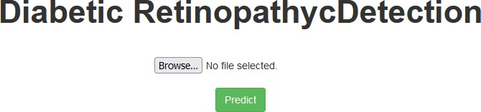
Traditional method for detection of DR is prolonged, challenging and costly, thus many researches were brought up to automate the detection process by using machine learning and deep learning approaches. In this work, we presented a comprehensive study of various methodologies for detecting diabetic retinopathy automatically and attempted to propose our own deep learning approach for the early diagnosis of retinopathy by using a new CNN architecture, having many deep layers.
.
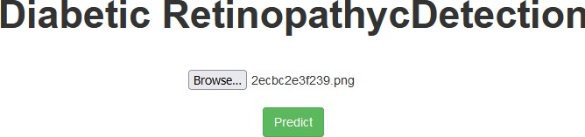

ACKNOWLEDGEMENT

  - We wish to express our gratitude to Dr.N.KOTTISWARAN,M.E.,Ph.D., Principal, Info Institute of Engineering, Coimbatore, who always helped us whenever we approached him during the course of our project.

  - We would also like to express gratitude to Dr.P.D.R.VIJAYAKUMAR,M.E.,Ph.D., Professor, Head of the Department, Department of Computer Science and Engineering, for his constant encouragement, valuable guidance and constructive criticism in making this project a successful one.

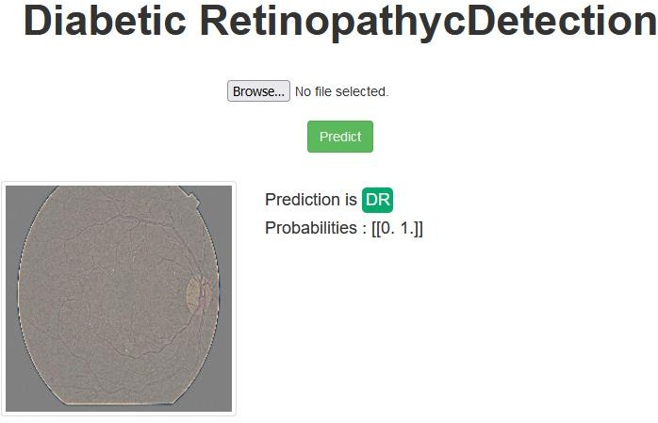
  - We pay our respects and kindly thank our project guide DR.D.LOGANATHAN Ph,D.,Associate Professor, Department of Information Technology, for his valuable guidance and timely suggestion in bringing out this project.

REFERENCES

    - Abramoff, M.D., Lavin, P.T., Birch, M., Shah, N., & Folk, J.C. (2013). Pivotal trial of an autonomous AI-based diagnostic system for detection of diabetic retinopathy in primary care offices. NPJ Digital Medicine, 1(1),
[2] Ramachandran, N., & Kavitha, V. (2020). A deep learning approach for the detection of diabetic retinopathy using retinal fundus images. Journal of Healthcare Engineering, 2020, 1-11.
[3] LeCun, Y., Bengio, Y., & Hinton, G. (2015). Deep learning. Nature, 521(7553), 436-444.

