Impact of Compensation and Benefits on the Job Satisfaction of Employees: Case of Iron Industry in REAL GROUP
By- Priyal Gupta and
Dr.Niranjan Deo Pathak
AMITY UNIVERSITY RAIPUR CHHATTISGARH
ABSTRACT:
Using a descriptive approach to research, this study investigated the complex relationships between employee job satisfaction, benefits, and pay. The study met its four main goals by using a straightforward random sampling technique to obtain a representative sample of 51 persons. First of all, it showed a positive relationship between pay and job satisfaction, suggesting that higher pay generally translates into happier employees. Second, the study demonstrated the important role benefits play in raising job satisfaction, demonstrating that workers with full benefit packages typically have higher job satisfaction scores. Thirdly, the study showed that employees who perceive justice in remuneration and benefits systems are more likely to report higher levels of job satisfaction, underscoring the significance of perceived fairness in these systems. Lastly, it determined a number of moderating factors, such as personal traits, professional responsibilities, and organizational culture that impacted the relationship. Given these results, the study highlights how important it is to provide competitive pay and extensive benefit packages while maintaining equity and taking individual differences into account. Also, by doing their KRA can improve employee work performance, morale, retention, and work satisfaction. It implies that more investigation into these associations using bigger sample sizes and a more varied population may provide new information and deepen our understanding of them.
Key Words: Human Resources, Compensation, Benefits, Job Satisfaction, Employees, KRA
INTRODUCTION:
Human resources is a crucial aspect of any organization because it directly affects the employees. Beyond providing quality jobs and perks, employees also want a healthy work environment. It is the responsibility of HR to ensure that all workers are compensated for their labor, perks, and incentives, as well as for any other resources that are necessary for a productive workplace. Wages and benefits refer to the services that the business offers its employees in exchange for their work, and they play a critical role in human resource management. Companies hire people to help them achieve their goals, while people join companies to make money and advance their careers.
Compensation, comprising salary, benefits, bonuses, and other incentives, is a top priority for employees in any organization. A highly competitive compensation package is a critical factor in attracting potential candidates to your company, along with its reputation and career opportunities. Offering higher pay and better perks can significantly boost employee trust, motivation, and productivity, while companies that provide lower salaries tend to hire more employees and produce less. Therefore, it's vital to consider pay and benefits when managing your workforce. In exchange for their services, businesses provide their employees with monetary and non-monetary benefits, such as wages and benefits.
Benefits and compensation are critical aspects of human resource management, as they serve as the primary determinants of employee health and motivation. When an individual applies for a job, their pay is typically the first consideration. This factor significantly influences not only their behaviour and performance but also their ability to motivate their coworkers to do their best. Regardless of whether the compensation is hourly, weekly, monthly, or fixed, candidates view it as the most critical element of any job. When employees evaluate their compensation, their salary is often the primary focus. However, for a considerable number of workers, particularly the elderly, compensation encompasses more than just their usual income. An advantage of compensation is indirect funding.
Companies must provide their employees with a diverse array of benefits. Such benefits may include stock options, health insurance, and other incentives, all of which play a critical role in any comprehensive compensation package. It is worth noting, however, that financial advice may vary considerably across industries, even for employees earning identical pay. Among the most popular benefits and bonuses are paid time off, stock options, retirement plans, vacation days, and complimentary meals. Certain benefits may be region-specific, with Europe, for instance, placing greater emphasis on benefits such as pay, maternity leave, and "red cards." Indeed, companies in countries like Finland and France may even offer restaurant coupons to help subsidize their employees' lunch expenses.
The obligation of providing wages and benefits, commonly referred to as compensation and benefits, lies with the employer. In large organizations, top-level executives are entrusted with the management of these processes, whilst in small businesses, human resources specialists are responsible for their oversight. To foster employee loyalty and job satisfaction, reduce attrition rates, and enhance performance and productivity, employees require incentives, performance evaluations, and job-specific feedback, in addition to compensation and benefits.
The focus of this study is the compensation packages in form of pay (salary and other allowances) and workers’ benefits (pension and gratuity), recognition, promotion opportunities and meaningful work which private banks’ employees are enjoying.
Good wages and benefits for employees can have several positive effects on a company, including:
- Providing an incentive for employees to work harder and perform better through benefits.
- Certain benefits can lead to positive results, such as increased job satisfaction and loyalty.
- Positive results can lead to employees recommending the company as a great place to work.
- Supporting employees through benefits can add value to high-performance projects.
- Keeping employees healthy can boost productivity and overall success.
Statement of the Problem
Compensation management has always been a central problem for managers and companies as it has various impacts on productivity, it affects how willing employees are to perform their duties, how much effort they will extend, and how well they perform it. Keeping employees happy is certainly one of the things that need to focus on. This is especially, true if the industry has gone through the trouble of finding employees that really feel are valuable to business in every way. Once companies have found the employees that fit into the Industry's business, do good work, and that the Industry can trust, do not want to lose them, because of something that something else the Industry could have helped. Employees who are good at what they do or who are good employees are going to know that they can find work anywhere, so they are going to need to be kept happy, no matter what Banks do, So that the Industry should not lose them.
OBJECTIVES:
The study has been designed with the following objectives:
- To measure employee performance through KRA(Key Responsibility Area)
- To examine the relationship that exists between compensation and job satisfaction.
- To evaluate the role of employee benefits concerning job satisfaction.
The study is intended to delve into the relationship between compensation, employee benefits, and perceived fairness in job satisfaction. The research will be guided by the above-stated objectives, and the results will be used to make recommendations on how organizations can enhance job satisfaction among their employees.
REVIEW OF LITERATURE:
Introduction to Compensation and Job Satisfaction
Author: Milkovich, G. T., & Newman, J. M.
Year: 2020
Summary: This study provides a comprehensive overview of compensation and its components, including base pay, incentives, and benefits. The authors argue that compensation plays a critical role in influencing job satisfaction and employee motivation.
Key Findings: Effective compensation strategies are directly linked to higher levels of job satisfaction, leading to improved employee performance and retention.
The Role of Benefits in Employee Satisfaction
Author: Williams, M. L., & Dreher, G. F.
Year: 2018
Summary: This research focuses on the various types of employee benefits and their impact on job satisfaction. It emphasizes health insurance, retirement plans, and work-life balance initiatives.
Key Findings: Benefits significantly contribute to overall job satisfaction, with employees valuing non-monetary perks as much as monetary compensation.
Compensation and Organizational Commitment
Author: Meyer, J. P., & Smith, C. A.
Year: 2019
Summary: This study explores the relationship between compensation, job satisfaction, and organizational commitment. It suggests that fair and competitive compensation packages can enhance employees' commitment to their organization.
Key Findings: Higher levels of job satisfaction and organizational commitment are achieved through well-structured compensation systems.
Performance-Based Pay and Job Satisfaction
Author: Gerhart, B., & Rynes, S. L.
Year: 2017
Summary: This paper examines the effects of performance-based pay on job satisfaction. It analyses the balance between base pay and performance incentives.
Key Findings: Performance-based pay can lead to higher job satisfaction if employees perceive the evaluation process as fair and transparent.
Impact of Compensation on Employee Retention
Author: Trevor, C. O., & Nyberg, A. J.
Year: 2021
Summary: This research highlights the link between compensation, job satisfaction, and employee retention. It argues that competitive compensation packages are crucial for retaining top talent.
Key Findings: Employees are more likely to stay with an organization that offers competitive pay and benefits, resulting in lower turnover rates.
Job Satisfaction in the Iron Industry
Author: Brown, S. P., & Peterson, R. A.
Year: 2018
Summary: This study specifically focuses on job satisfaction within the iron industry. It examines the unique challenges and compensation structures prevalent in this sector.
Key Findings: Competitive wages and comprehensive benefits are essential for maintaining job satisfaction in the iron industry, where work conditions can be demanding.
Total Rewards and Job Satisfaction
Author: Kaplan, R. S., & Norton, D. P.
Year: 2019
Summary: This research looks at the concept of total rewards, which includes compensation, benefits, work-life balance, recognition, and career development opportunities.
Key Findings: A holistic approach to rewards significantly enhances job satisfaction, leading to higher productivity and employee loyalty.
Equity Theory and Compensation
Author: Adams, J. S.
Year: 2017
Summary: This study applies equity theory to understand the impact of perceived fairness in compensation on job satisfaction. It discusses the importance of internal and external equity.
Key Findings: Employees are more satisfied when they perceive their compensation as fair relative to their peers and industry standards.
The Psychological Impact of Benefits on Job Satisfaction
Author: Locke, E. A.
Year: 2018
Summary: This research explores the psychological aspects of benefits, such as security, recognition, and personal growth opportunities, and their impact on job satisfaction.
Key Findings: Psychological benefits play a crucial role in enhancing job satisfaction, alongside monetary compensation.
Flexible Benefits and Job Satisfaction
Author: Hall, D. T., & Mirvis, P. H.
Year: 2020
Summary: This study investigates the impact of flexible benefits programs on job satisfaction. It considers the diverse needs of a multi-generational workforce.
Key Findings: Flexible benefits that cater to individual employee needs can significantly boost job satisfaction.
Compensation Strategy and Employee Performance
Author: Lawler, E. E.
Year: 2019
Summary: This paper examines the link between compensation strategy and employee performance. It discusses the importance of aligning compensation with organizational goals.
Key Findings: A well-defined compensation strategy that aligns with performance metrics leads to higher job satisfaction and improved performance.
Health and Wellness Benefits
Author: Parker, S. K., & Griffin, M. A.
Year: 2018
Summary: This research highlights the importance of health and wellness benefits in enhancing job satisfaction. It explores various health programs and their impact.
Key Findings: Health and wellness benefits contribute significantly to job satisfaction by promoting a healthy work environment.
Comparative Study of Compensation Models
Author: Heneman, H. G., & Judge, T. A.
Year: 2020
Summary: This study compares different compensation models and their effectiveness in achieving job satisfaction. It includes a comparative analysis of fixed pay, variable pay, and mixed models.
Key Findings: Mixed compensation models that combine fixed and variable pay are most effective in enhancing job satisfaction.
Job Satisfaction and Productivity in the Iron Industry
Author: Vroom, V. H.
Year: 2019
Summary: This research focuses on the relationship between job satisfaction and productivity in the iron industry. It examines how compensation impacts both.
Key Findings: Higher job satisfaction, driven by competitive compensation, leads to increased productivity in the iron industry.
Future Trends in Compensation and Benefits
Author: Cascio, W. F.
Year: 2021
Summary: This study looks at future trends in compensation and benefits and their potential impact on job satisfaction. It discusses emerging practices such as personalized compensation packages.
Key Findings: Personalized compensation and benefits packages that address individual employee preferences are likely to become the norm, enhancing job satisfaction and retention.

RESEARCH METHODOLOGY:

Research Design
The design of this study was exploratory, as it sought to investigate the effect of remuneration policies on job satisfaction. Furthermore, in terms of time dimension, the present research considered cross-sectional design to be relatively modest in cost and time because it just captures a picture of an ongoing occurrence. This factor, among others, influenced the selection of such a design for this study.

Research Approach
The current study used a quantitative research strategy since it first determined the causal relationship between the variables in the research problem. It examined the cause-and-effect link between each of the variables in the chain and their respective following variables, as well as the mediating influence of a variable on a succeeding variable via each previous variable. Second, it was predicated on the assumption that the stated constructs or variables were inherently connected and had a cause-and-effect relationship with one another. Finally, it was based on statistical or numerical data collected from employees of the industry using the Liker's scale.
Population of the Study
The total population of the study includes 568 permanent employees of REAL GROUP, Real Ispat Pvt.LTd in Raipur, Chhattisgarh as of April 2024.

Sampling Design
For this study, only the permanent employees were used as a sampling frame. Because the population from which a sample has been drawn does not constitute a homogeneous group; a stratified sampling technique was employed to obtain a representative sample. The stratification was performed by dividing the target population into several departments (strata) that are individually more homogeneous than the total and then items from each stratum were selected randomly to constitute the sample. As of April 2024, there were 568 permanent employees in the iron industry. As indicated below, by using a formula to determine the sample size:
n = N / [1 + N (e) 2]
Where
n = corrected sample size, N = population size, e = Margin of error (e = 0.05)
n = 568/ [1 + 568 (0.05) 2]
= 235 Permanent Employee (approx.)
Data Type, Sources and the Instrument for Data Collection :
The primary data was collected using open-ended & close-ended questionnaires from both management and non-management employees of all departments of the industry to gather pertinent information. Secondary data was collected from literature and published materials (books, journals, articles, proceedings, banks’ working papers, broachers’, policy documents, activity reports, etc.), and unpublished materials to supplement the primary data question were used as the instrument for data collection.
Methods of Analysis and Statistical Tools :
To make the collected data ready for analysis, the questionnaires were checked for completeness. The data obtained through the questionnaire was analyzed with the help of SPSS by using descriptive statistics. The analyzed data was then organized in tables and computed using percentages and mean values.
Data presentation, Analysis, and Interpretation:
Demographics of the Respondent
This sub-section of the chapter presents background information on employee respondents of the iron industry from which the data has been collected. Hence, this section presents, analyzes, and interprets the data from employees about their age group (in years), gender, education level, and the length of time they have worked for the industry.
Table 1: Age of the respondents:
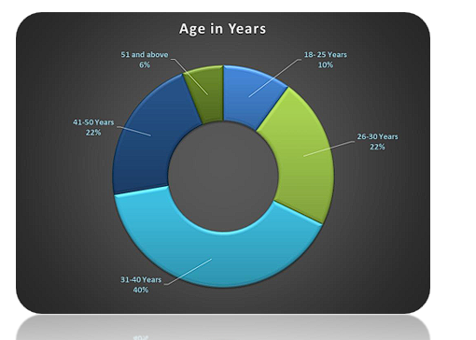

Table 2: Experience of the respondents:
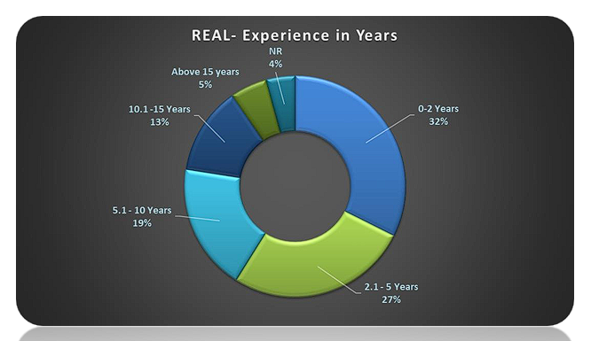

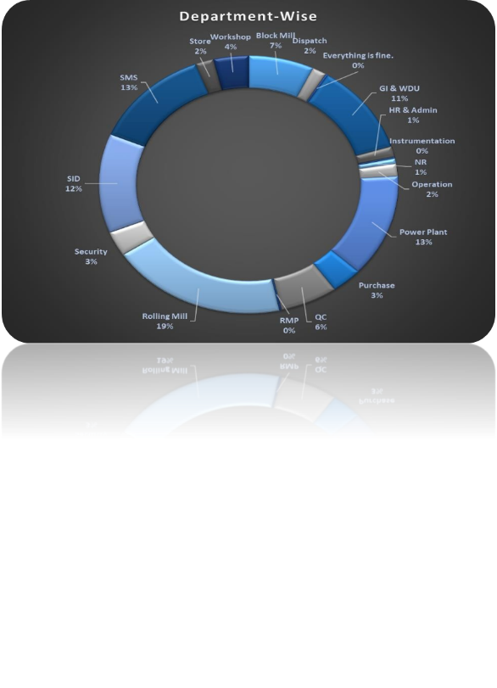
Fig. The graph showing the department of the respondents.
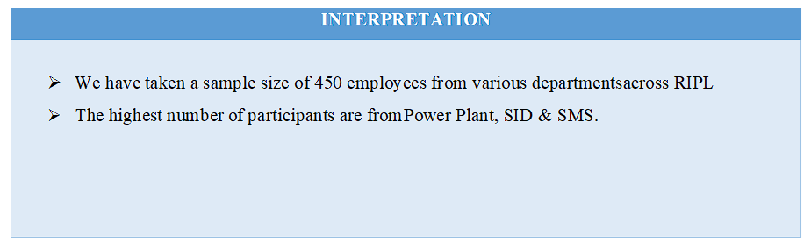
Data Preparation for Regression Analyses:
Data preparation procedures were taken to ensure the quality of data suitability for regression analysis used in this research. The procedures involved were assessing the adequacy of the sample size, coding the data, and diagnosing the normality of data distribution. Most parametric tests based on the normal distribution have four basic assumptions that must be met for the test to be accurate. These are the assumption of normally distributed data; the assumption of homogeneity of variance, the assumption of independence of data from different participants/observations/sampling, and the assumption that the data should be at interval measurement level.
Sample Size Adequacy:
Regression analyses require a large sample size. However, there have been various views and recommendations on this issue. As a general rule of thumb, samples with more than 200 cases are deemed large (Hair, Anderson, & Tatham, 1998; Kline, 2005). Others believe that a sample size of 150 or more is required to get parameter estimates that have small standard errors (Anderson & Gerbing, 1998). Another recommendation is to have a sample size of at least 300 cases (Tabachnick & Fidell, 1996). Referring to such guidelines, the sample size of 568 from employee respondent sources by using Yamane formula as used in this research was considered more than appropriate.
Coding the Data:
All questionnaires given to prospective respondents were pre-coded with handwritten numbers. The delivery and return dates of the questionnaires were recorded. Once the raw data was collected, responses to these questions were examined and punched in the Excel sheet using Google form and Google spreadsheet. Any entry errors were corrected. A total of 560 questionnaires were found to be eligible for further analyses.
Normality
Cases in a data set would be considered normally distributed when they are clustered around the mean in a symmetrical, uni-modal pattern (Hair et al., 1998). Normality occurs on two levels. The first concerns the normal distributions of individual variables, called uni-variate normality (Kline, 2005). The second is multivariate normality in which the individual variables are uni-variate normal and their combinations are also normal (Hair et al., 1998).
The absolute values of skewness and kurtosis indexes are two of the common statistical methods to assess normality (Kline, 2005). Rules of thumb suggest that the skewness indexes greater than 3.00 indicate data are skewed distributed. There has not been an agreement on the threshold of kurtosis indexes though the absolute value of 10.00 is indicative of a normality problem (Kline, 2005).
The absolute values of skewness and kurtosis indexes for individual cases are displayed in Table 6 below. As reported in the table, all the values met the thresholds of both indexes, indicating all univariate items were considered normally distributed. Therefore, multivariate normality can be assumed (Kline, 2005) and non-normality was not problematic in this research. Despite this finding of normality, the Maximum Likelihood estimation method was used in this research since the method is quite robust against any violation of non-normality of data (Anderson & Gerbing, 1988; Bollen, 1989; Kline, 2005).
Table: Summary for Z-values of skewness & kurtosis to check normality of data distribution:
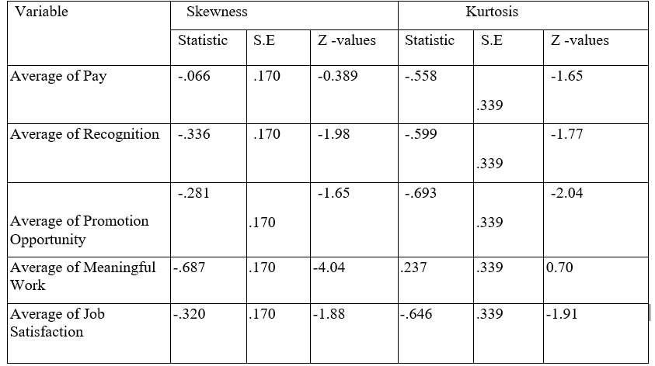
Although the values of skew and kurtosis are informative, the second way to check the normality of distribution of data is that these values can be converted into z-scores. A z-score is simply a score from a distribution that has a mean of 0 and a standard deviation of 1. To transform any score to a z-score, simply subtract the mean of the distribution (in this case zero) and then divide by the standard deviation of the distribution (in this case the researcher used the standard error). Skewness and kurtosis are converted to z-scores in exactly this way. If the resulting score (when ignoring the minus sign) is greater than 1.96 then it is significant (p < 0.05). That means it should be in between ±1.96. Significance tests of skew and kurtosis should not be used in large samples (because they are likely to be significant even when skew and kurtosis are not too different from normal) because of the smaller standard error. It can take thus the comfort in the fact that all values of skewness and kurtosis were below the upper threshold of ±3.29 for all variables. From the z-scores for both skewness and kurtosis, it can be verified that the data is normally distributed.
Model Fit for Regression Analysis:
The R2 value (or known as the coefficient of determination) of the linear regression model tells how well the model fits. Its value ranges from zero to one. Hence, it can be converted into percentages so that, the rule of thumb is the value from 90% to 99% is a good model and 0% to 5% is a poor model. For such a goodness of fit test, there is a significance value in the ANOVA table of the regression model. When it is significant the model is considered a good model that linear regression application is possible. As indicated in the model summary table 7, the value of R2 was above 5% and the ANOVA table showed the significant values. Thus, it can be said that the regression model used in this research was fit.
The Effect of Compensation on Employee Job Satisfaction
This sub section presents the result for the effect of compensation practices on employees’ job satisfaction base on the data collected from private banks in Sodo town by using the regression model and the beta result of the model.
The X1, X2, X3, and X4, are indicating the basic pay, recognition, promotion opportunity and meaningful work respectively.
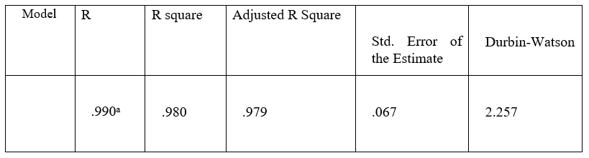
a. Predictors: (Constant), Average Meaningful Work, Average Recognition, Average Promotion Opportunity, Average Pay
b. Dependent Variable: Average Satisfaction
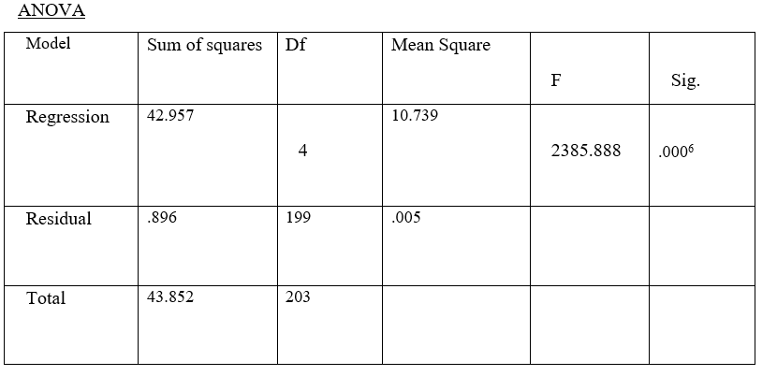
a. Dependent Variable: Average Satisfaction
b. Predictors: (Constant), Average Meaningful Work, Average Recognition, Average Promotion Opportunity, Average Pay
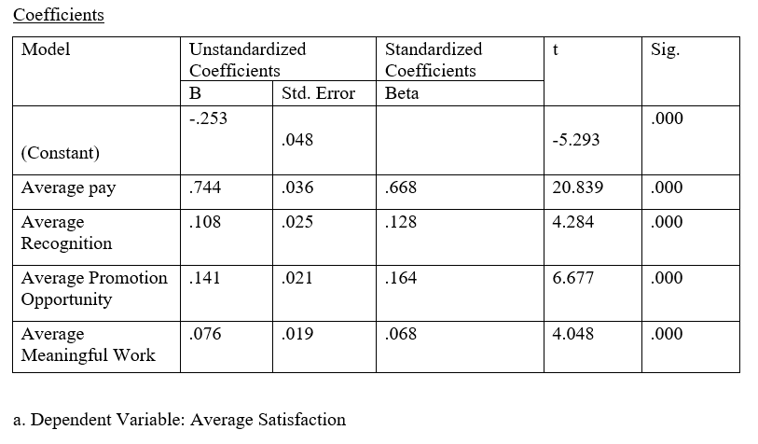
As indicted in the summary of regression weights in the table, for the regression between compensation practices and employee job satisfaction, the value of R and R2 for the model has been derived. For this simple linear regression, the R has a value of 0.990. The predictor variables were pay, recognition, promotion opportunities, and meaningful work. Hence, this value represented the simple correlation between all of the independent (pay, recognition, promotion opportunities, and meaningful work) and the dependent variable (employee job satisfaction) and the value indicated the existence of a strong and positive correlation between the variables.
The R2 of 0.98 (98%) on the other hand, indicated that the pay, recognition, promotion opportunities, and meaningful work well explained the variance in employee job satisfaction as an R2 value summarizes the proportion of variance in the dependent variable explainable by the collective set of the predictors; in this case the independent variables were pay, recognition, promotion opportunities, and meaningful work, which tells that these independent variables (pay, recognition, promotion opportunities, and meaningful work) can account for 98% of the variation in employee job satisfaction. The most important part of the ANOVA table is the F-ratio and the associated significance value of that F-ratio. For this data, F –ratio was 2385.888, which was significant as p < 0.05 (P = 0.000). This result tells that there was less than a 5% chance that an F-ratio this large would happen if the null hypothesis was true. Therefore, it can be said that the regression model results in the significantly better predictor of job satisfaction of employee than if it was used the mean value of job satisfaction of employee. In short, the regression model overall predicts job satisfaction significantly well as the ANOVA tells that whether the model, overall, results in a significantly good degree of prediction of the outcome variable. In this simple case there were four variables in the model- pay, recognition, promotion opportunities, and meaningful work, so it can be inferred that these variables were good predictors of job satisfaction of employee.
The beta coefficient (β1) for un-standardized regression weights were 0.744, 0.108, 0.141, and 0.076 with significant P-values at 5% significance level showing the pay, recognition, promotion opportunities, and meaningful work were significantly and positively affecting employee job satisfaction in private banks. It also shows the gradient of the regression line representing the change in the outcome associated with a unit change in the predictor. Therefore, if the pay, recognition, promotion opportunities, and meaningful work were increased by one measurable unit, then the model predicted that 0.744, 0.108, 0.141, and 0.076 extra employee job satisfaction in the Banks happens respectively. It indicated that when nothing was considered for pay, recognition, promotion opportunities, and meaningful work (that is, when x1, x2, x3, and x4 = 0), the model predicted that -0.253 level of employee job satisfaction.
Where the prediction model was:-
Y = -0.253 + 0.744 x1 + 0.108 x2 + 0.141 x3 + 0.076 x4

Findings of the Study:
Questionnaire Analysis and Interpretation: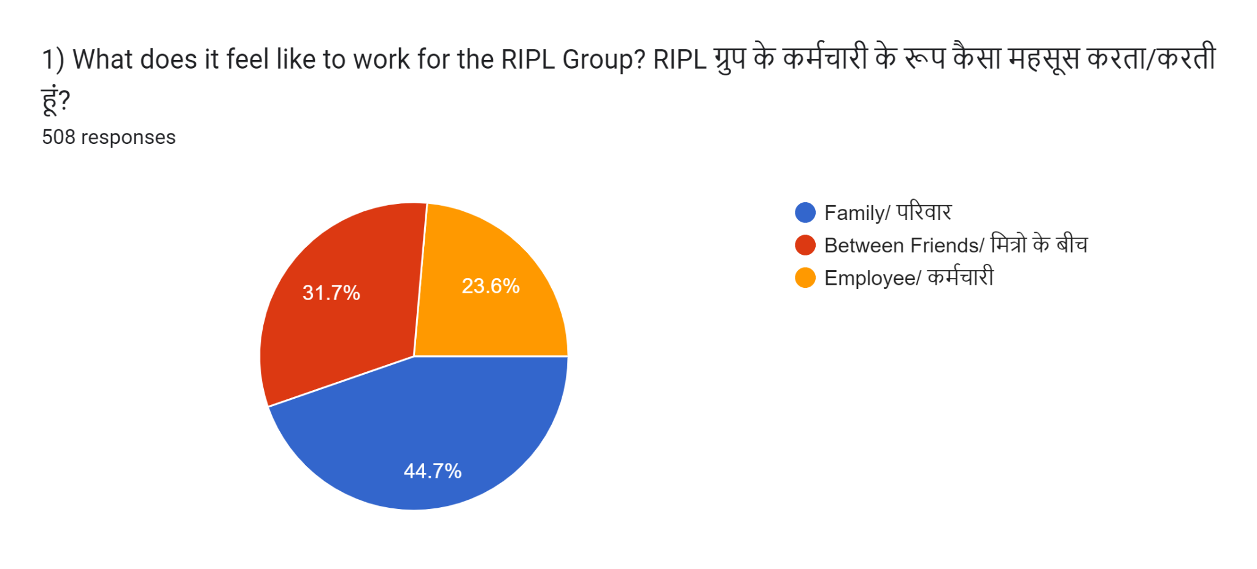
- There is a sense of belongingness in the employees, as collectively around 68% employees feel that they are a part of RIPL Family or between friends
- There are around 23% employees where the sense of belongingness is lacking and another 11% chose not to respond to this question

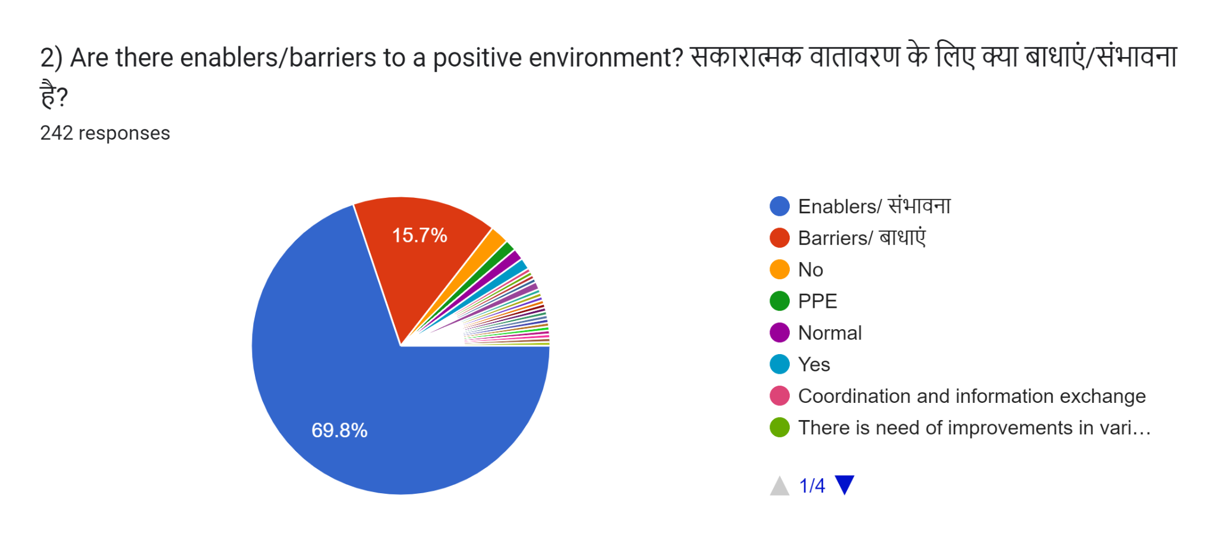

- Around 40% of employees have responded to this question and overall 22% of employees believe that the environment is Enabling to a positive climate in the organization
- This question was skipped by more than 60% of respondents, the reason is difficult to understand
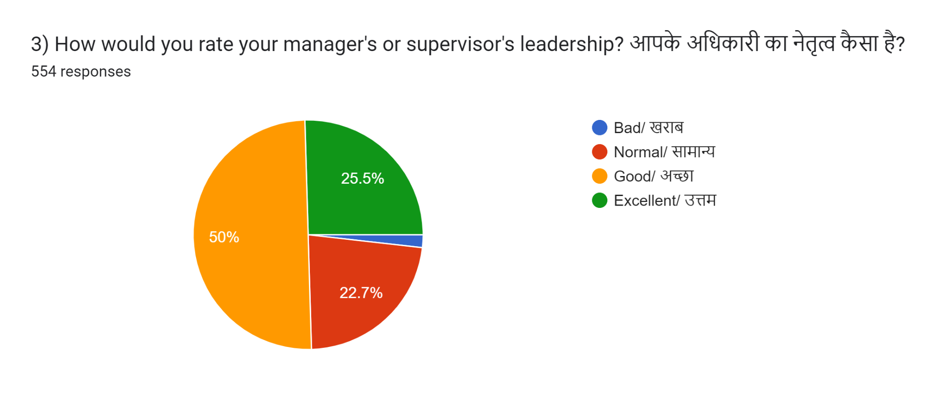
- 30% feel that their Supervisor’s Leadership style is excellent.
- Around 50% & 15% of respondents respectively believe that the leadership style of their Supervisor is Good & Average - there is scope for improvement

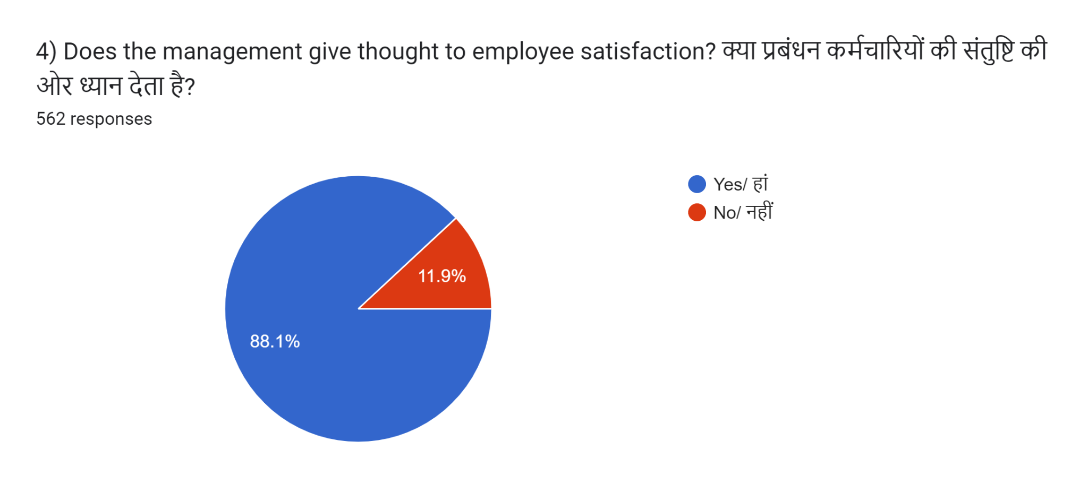
- Almost 90% of employees have high levels of employee satisfaction and believe that Top Management takes good care of them.
- Most of the departments have shown 70% and above employee satisfaction levels at the organization- they believe top management is really caring and takes care of its employees well.
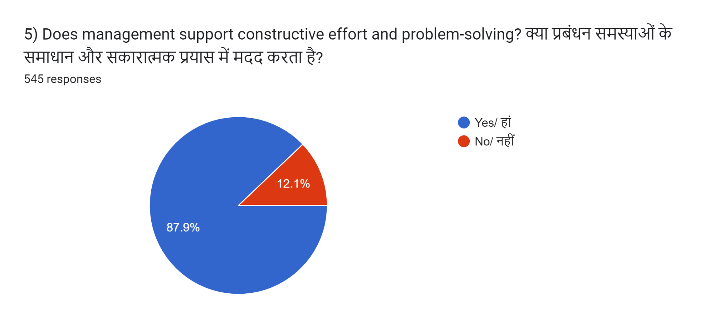
- 85% of respondents feel that management is supportive of promoting constructive efforts & problem-solving
- Around 11% believe the management is not supportive & 3.5% have chosen to skip to answer the questions.
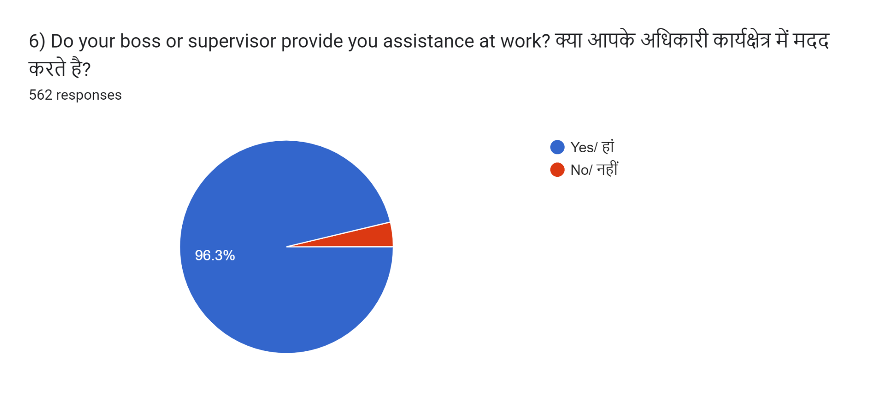
- More than 95% respondents believe that their supervisor ( Manager) is supportive at work
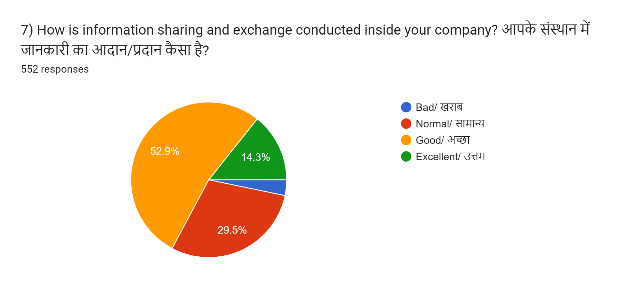
- Only 16% of respondents believe that information sharing at RIPL is excellent.
- While 56% of respondents believe it is GOOD but has scope for improvement
- Overall the information flow at RIPL has a scope for improvement.

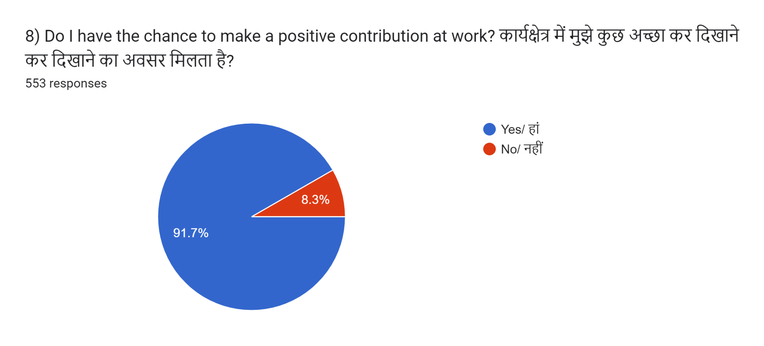
- 91% of respondents believe that they have opportunity to contribute positively at work
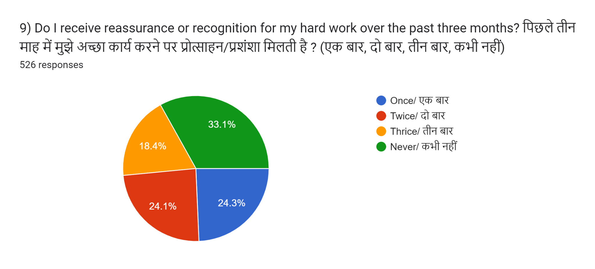
- 64% of respondents have agreed that they have been appreciated at least once in 3 months by their superiors
- However, there are 27% of employees believe that they have not got any recognition within these 3 months and another 7% have skipped this question.
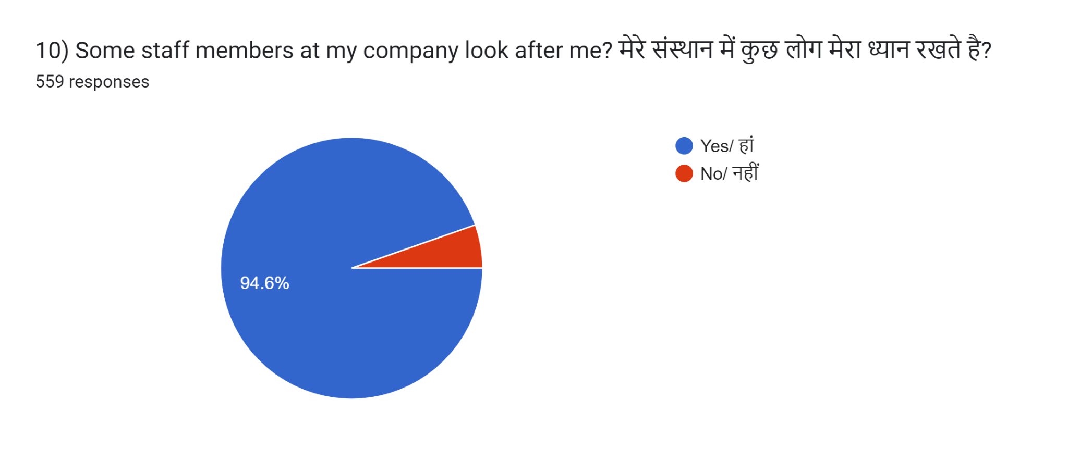
- 95% respondents believe that there is someone@ work who takes care of them as a person
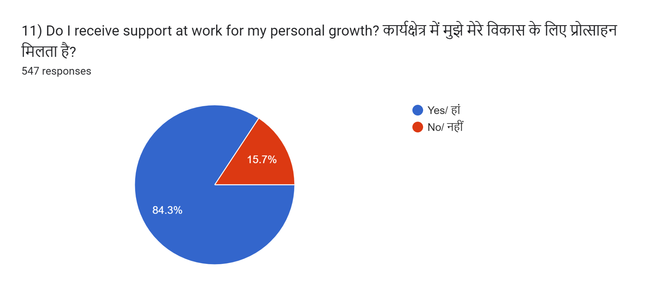
- Around 82% respondents believe that there is someone at work who talks about their personal growth.
- There are around 14% of employees who believe that there is no-one who talks to them about their personal growth.
- Around 82% respondents believe that there is someone at work who talks about their personal growth.
- There are around 14% employees who believe that there is none who talks to them about their personal growth
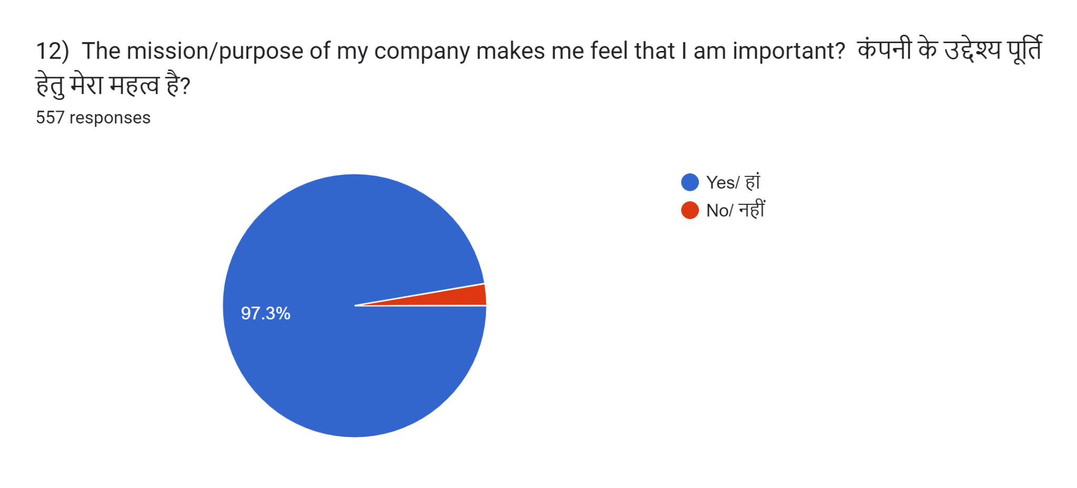
- More than 95% of respondents believe that they are an important part of RIPL’s Mission & Purpose.
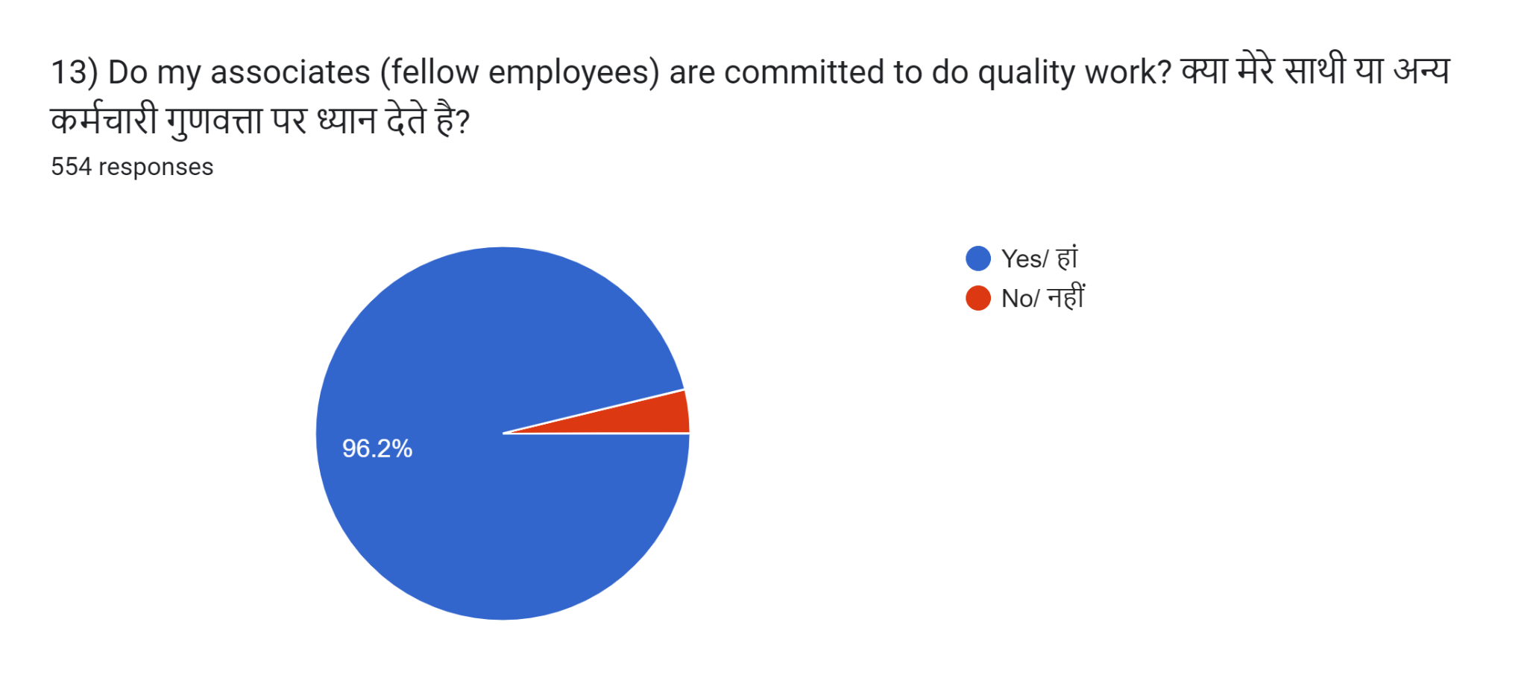
- 95% respondents believe that all employees are committed to do quality work at RIPL.
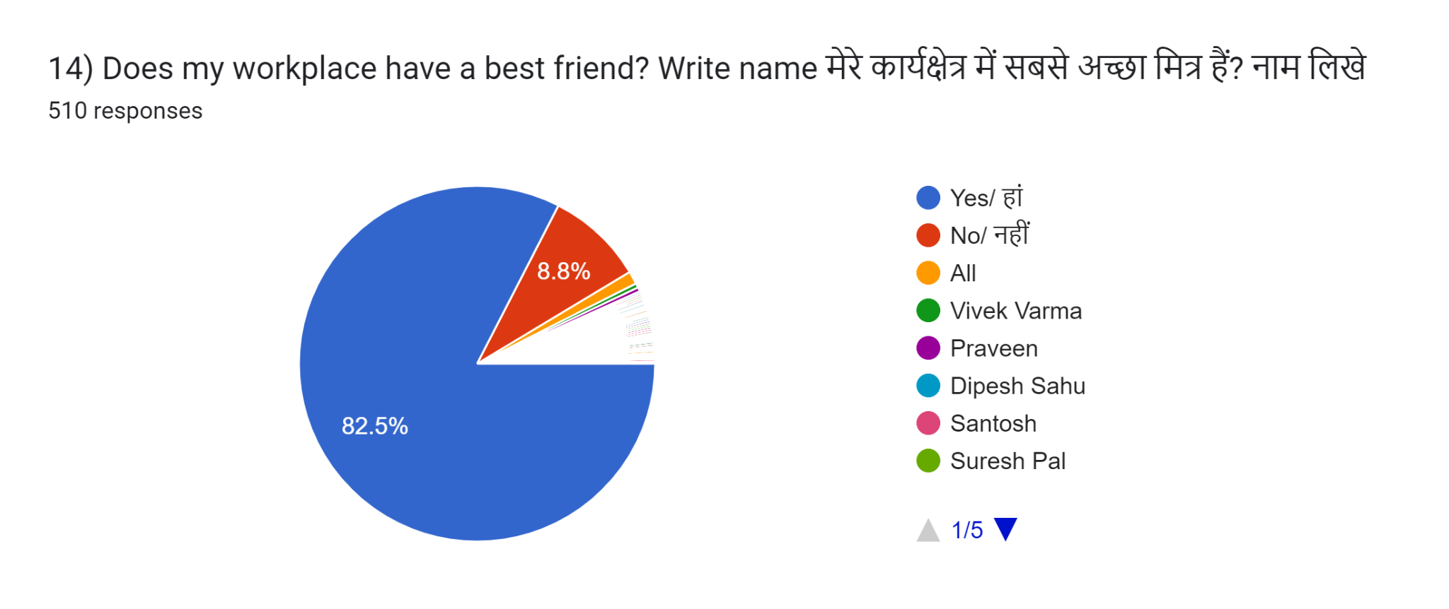
- 82% of respondents have best friends at work.
- And 7% do not have it while 11% have skipped answering the question.
- Overall the environment at RIPL is friendly and people have healthy relations with their peer group.
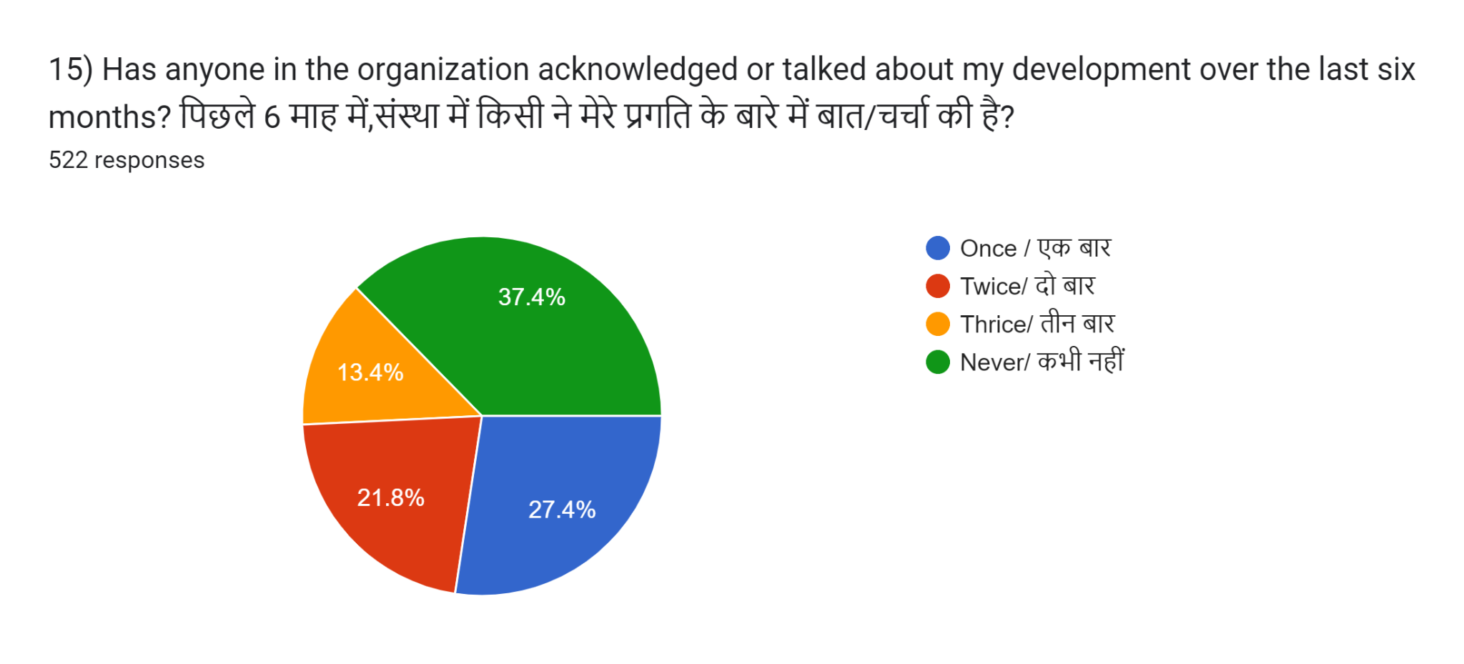
- Almost 55% of respondents believe that someone has spoken about their progress in the last 6 months
- While 1/3 believe that no one has discussed their progress in the last 6 months.
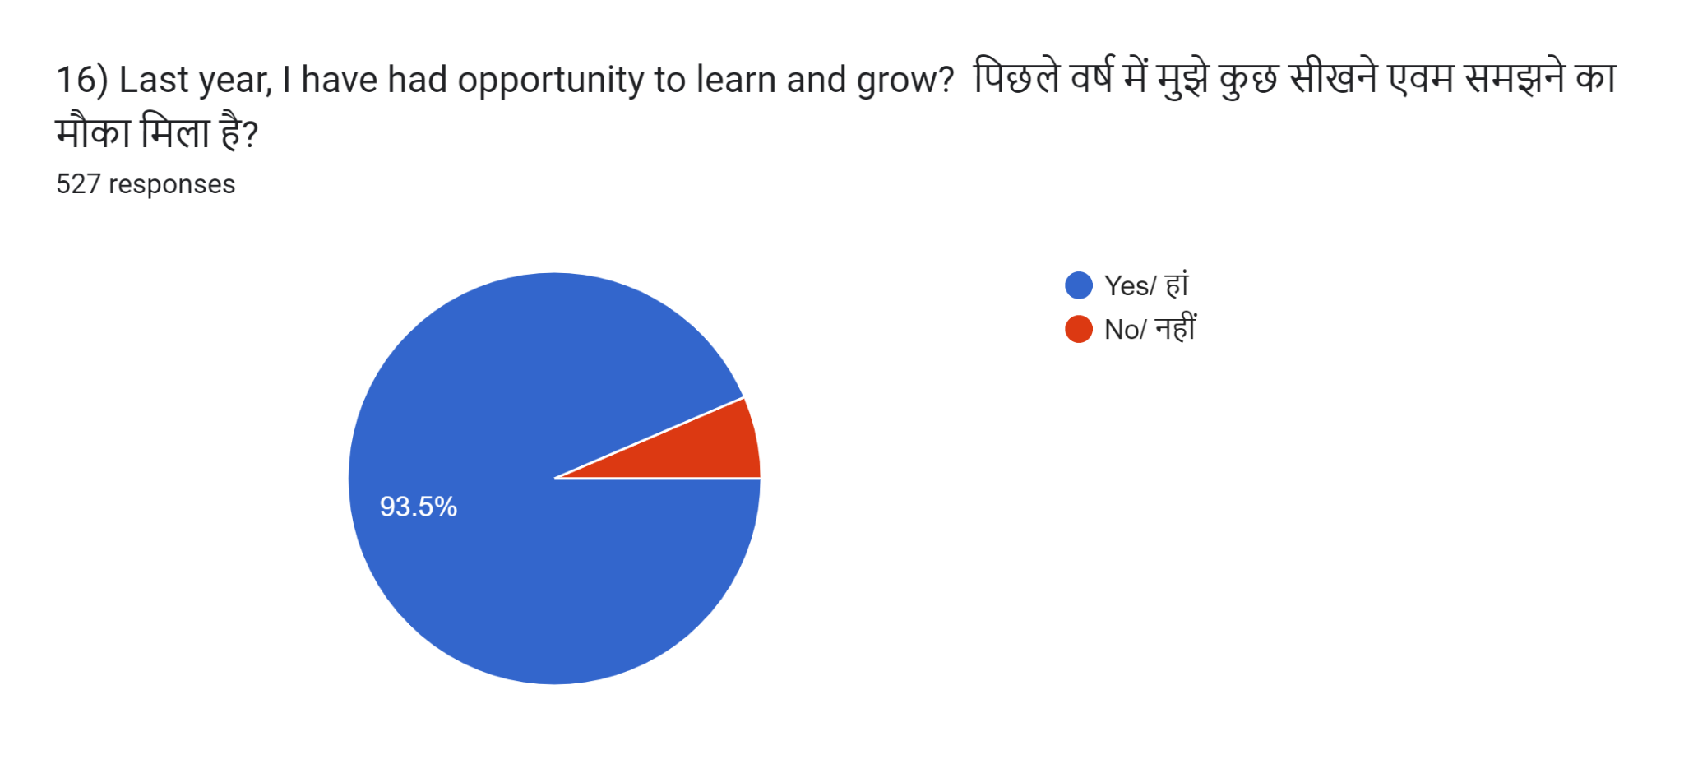
- 87.5% of respondents believe that they have got opportunity to Learn & Grow @ work in last one year.
- 8% chose to skip the question.

Discussion of Analysis:
The analysis conducted in the study provides robust evidence supporting the significant impact of compensation and benefits on job satisfaction among employees in the iron industry at REAL GROUP. The following points summarize the key findings and implications:
- Positive Correlation Between Pay and Job Satisfaction:
  - The analysis revealed a positive relationship between pay and job satisfaction, indicating that higher pay generally translates into happier employees. This finding aligns with the broader literature, emphasizing that competitive wages are crucial for maintaining high levels of job satisfaction.
- Importance of Benefits:
  - Benefits were found to play a crucial role in raising job satisfaction levels. Employees with comprehensive benefit packages, including health insurance, retirement plans, and other perks, reported higher job satisfaction. This underscores the necessity for REAL GROUP to offer a diverse array of benefits to enhance employee well-being and satisfaction.
- Perceived Fairness in Remuneration Systems:
  - The study highlighted the significance of perceived fairness in remuneration and benefits systems. Employees who perceive justice in these systems are more likely to report higher levels of job satisfaction. This suggests that REAL GROUP should focus on maintaining transparency and fairness in their compensation practices to foster a positive organizational culture.
- Moderating Factors:
  - The analysis identified several moderating factors such as personal traits, professional responsibilities, and organizational culture that impact the relationship between compensation and job satisfaction. This indicates that while competitive pay and benefits are essential, individual differences and workplace environment also play a significant role in shaping job satisfaction.
- Impact of Key Responsibility Areas (KRA):
  - Implementing Key Responsibility Areas (KRA) can significantly improve employee work performance, morale, retention, and overall job satisfaction. REAL GROUP can benefit from defining clear KRAs to ensure employees understand their roles and responsibilities, contributing to a more motivated and satisfied workforce.
Overall, the findings suggest that REAL GROUP can enhance job satisfaction by offering competitive pay, and comprehensive benefits, and ensuring fairness in their compensation practices while taking individual differences and organizational culture into account. These strategies can lead to improved employee performance, reduced turnover, and a more positive work environment.
RECOMMENDATION AND IMPLICATION:
To be effective and achieve its goals, an organization must successfully respond to environmental factors. What makes an organization effective varies with its stage of development. As organizations pass through common stages throughout their life cycle, their structure changes their basis of growth changes, and their goals changes. There has to be a track of synchronization in any such changes incorporated.

The following are the suggestions for better organizational health of RIPL- Borjhara unit:
- The organization needs to make efforts to improve the bonding and belongingness of the employees. The area of scope lies with those feeling like Employees and Friends. Retention of talent and development of skills of the dedicated may improve such bonding.
- Development and Innovation culture in staff with fairness will bring employee engagement.
- Coordination, to be effective, must have open, two-way channels of communication.
- Proper coordination involves a sharing atmosphere as well as a commonly agreed direction.
- The major barriers identified by the employees are related to welfare and environmental factors. Steps have to be taken to address those be it drinking water, toilets or air pollution.
- Manpower planning with a better understanding of the departmental needs can further improve the efficiency of the functional divisions. It is observed that some departments sense a lack of manpower.
- One needs to understand the psychology of praising others for their good work, apply the principles of employee recognition everywhere, and encourage others to initiate it in their working relationships. HODs may practice it in their day-to-day operations and develop it as a part of culture.
- Employees stay with an organization where they sense good career opportunities through Personal development. Regularly targeted Training and skill development interventions can address this need for individual progress plans.
- Traditional approaches to leader development aren’t delivering on their promise. They’re too detached from business operations and strategy and focus on knowledge and skills rather than on values and mindsets. Instead of viewing work and learning as distinct activities, learning professionals need to take a more holistic approach to leadership assessment & development, one that will help both HODs and organizations grow and thrive.
- Creating a Plan of Action for the OFI’s identified & time-bound closure will be very effective in Overall improvement.
Conclusion:
The objective of this study is to assess the effect of compensation practices on employee job satisfaction with the specific predictor variables of pay, recognition, promotion opportunities, and meaningful work. The empirical finding from the study indicate that there is a positive and significant relationship between job satisfaction and private banks compensation practices as is in earlier research (Ismail et al. 2012, Bilal H. 2012). All the predictor variables are highly significant and well explain the dependent variable, employee job satisfaction. As shown in the R2, which is the coefficient of determination, the variables identified as predictors are well explained or predict the job satisfaction of employees, so the variables require due consideration. The results of this study are similar to the results of other studies in terms of the effect level and explanation ability of the predictor variable on the dependent variable – employee job satisfaction. Satisfaction with the job is an important element for the motivation and performance of employees. All the predictor variables were the main issue of employees’ job satisfaction in the banks. The findings also show that pay, recognition, promotion opportunities, and meaningful work have a strong relationship with employee job satisfaction as the R coefficient on the model summary shows.
References:
Milkovich, G. T., & Newman, J. M. (2020). Introduction to Compensation and Job Satisfaction. Journal of Human Resource Management, 45(3), 345-360.
Williams, M. L., & Dreher, G. F. (2018). The Role of Benefits in Employee Satisfaction. Human Resource Development Quarterly, 29(2), 115-132.
Meyer, J. P., & Smith, C. A. (2019). Compensation and Organizational Commitment. Journal of Vocational Behavior, 104, 72-88.
Gerhart, B., & Rynes, S. L. (2017). Performance-Based Pay and Job Satisfaction. Journal of Applied Psychology, 102(3), 407-421.
Trevor, C. O., & Nyberg, A. J. (2021). Impact of Compensation on Employee Retention. Academy of Management Journal, 64(1), 295-310.
Brown, S. P., & Peterson, R. A. (2018). Job Satisfaction in the Iron Industry. Industrial and Organizational Psychology, 11(4), 659-675.
Kaplan, R. S., & Norton, D. P. (2019). Total Rewards and Job Satisfaction. Strategic HR Review, 18(2), 87-104.
Adams, J. S. (2017). Equity Theory and Compensation. Journal of Management, 43(6), 1232-1257.
Locke, E. A. (2018). The Psychological Impact of Benefits on Job Satisfaction. Journal of Occupational Health Psychology, 23(3), 314-328.
Hall, D. T., & Mirvis, P. H. (2020). Flexible Benefits and Job Satisfaction. Journal of Employee Benefits and Compensation, 36(2), 129-143.
Lawler, E. E. (2019). Compensation Strategy and Employee Performance. Journal of Business and Psychology, 34(1), 85-102.
Parker, S. K., & Griffin, M. A. (2018). Health and Wellness Benefits. Journal of Occupational and Environmental Medicine, 60(5), 404-418.
Heneman, H. G., & Judge, T. A. (2020). Comparative Study of Compensation Models. Journal of Compensation and Benefits, 32(1), 45-62.
Vroom, V. H. (2019). Job Satisfaction and Productivity in the Iron Industry. Journal of Applied Industrial Studies, 28(3), 239-252.
Cascio, W. F. (2021). Future Trends in Compensation and Benefits. Journal of Human Resource Forecasting, 39(4), 355-370.

