A STUDY ON ROLE OF AUTOMOBILE INDUSTRY IN INDIA AND
ITS CUSTOMERS SATISFACTION

- PRANJAL RATHORE
AMITY BUSINESS SCHOOL
AMITY UNIVERSITY, CHHATTISGARH
Pranjal.rathore9661@gmail.com

- Ms. SHWETA PATEL
ASSISTANT PROFESSOR
AMITY BUSINESS SCHOOL
AMITY UNIVERSITY, CHHATTISGARH
spatel@rpr.amity.edu

Abstract

Client satisfaction is defined by ISO 9000 as the opinion of druggies regarding how well a product satisfies its requirements. A veritably particular evaluation is that of client satisfaction. The main factor propelling the expansion of the Indian machine assiduity is the rise in demand for buses and other vehicles, which is fueled by rising inflows. The development of accessible prepayment plans and customized backing options has also backed in the expansion of the bus assiduity. Encyclopedically, the automotive sector is a significant artificial and profitable force. It produces 60 million motorcars and exchanges annually, which regard for about half of the oil painting consumed worldwide. There are 4 million direct jobs in this assiduity, and numerous further circular jobs are created. Indeed if a lot of big businesses struggle with overcapacity

INTRODUCTION

One of the biggest bus diligence in the world is located in India. The assiduity contributes7.1 of the GDP( Gross Domestic Product) of the nation. roughly 31 of small motorcars vended worldwide as of FY 2014 – 15 are made in India. Due to a youthful population and a growing middle class, the Two Wheelers sector leads the Indian machine request with an 81 per cent request share. likewise, the adding curiosity of the businesses to probe the pastoral requests contributed to the sector's expansion. The request share of the passenger vehicle( PV) order as a total is 13. India is a significant exporter of motorcars and has high development prospects for its exports in the near future. India's Automobile Products( API).

Rootes Group, a British pot, was latterly acquired byM.A. Chidambaram of the MAC Group from Madras, which is now Chennai. The communication. likewise, the adding curiosity of the businesses to probe the pastoral requests contributed to the sector's expansion. The request share of the passenger vehicle( PV) order as a total is 13. India is a significant exporter of motorcars and has high development prospects for its exports in the near future. Automobile Products of India( API) was established in 1949 in Bombay, which is now Mumbai. The company produced machine ancillaries, similar as Lambretta scooters and API Three Wheelers, which were made under license from Innocenti of Italy.

Clutch and Braking systems. API's registered services were before in Mumbai, latterly shifted to Chennai, in Tamil Nadu. The manufacturing installations were located in Mumbai and Aurangabad in Maharashtra and in Ambattur, Chennai. The company has not been functional since 2002. In April- January 2016, exports of Commercial Vehicles registered a growth of18.36 per cent over April- January 2015. In addition, several enterprise by the Government of India and the major machine players in the Indian request are anticipated to make India a leader in the Two Wheeler( 2W) and Four Wheeler( 4W) request in the world by 2020. The motorcars sector is compartmented in four different sectors which are as follows

vehicles, which include passenger buses , mileage vehicles, and multipurpose vehicles; • Two- wheelers, which include mopeds, scooters, motorcycles, and electric two- wheelers;

• Light and medium-heavy marketable motorcars

• Three- wheelers that can transport both passengers and weight

OBJECTIVES OF THE STUDY

The present study grounded on following objects

1. To know about the Indian Automobile Industry.
2. To study the part of Indian Automobile Industry in the country’s growth.
3. To know the enterprise of the Government towards and the achievement by the Indian Automobile diligence.
4. To know the confines of client satisfaction towards Indian Automobile diligence.

Operational Definitions

Machine is “ a tone- propelled passenger vehicle that generally has four bus and an internal- combustion machine, used for land transport. It also called as machine ”.
It also defined as “ a motor vehicle with four bus; generally propelled by an internal combustion machine ”.
A client “ is the philanthropist of a Good or a service, or a product, or an idea, attained from a dealer, seller, or supplier via a fiscal sale or exchange for plutocrat or some other precious consideration ”.
A client “ is an individual or business that purchases the goods or services produced by a business. Attracting guests is the primary thing of utmost public- facing businesses, because it's the client who creates demand for goods and services ”.

Review of the Literature

SaraswathiS.( 2010) According to a study named" client Satisfaction onPost-Sales Service with Reference to Four- Wheeler Automobile Industry," the capability to give guests the kind of service they want is just as important to the automotive assiduity's success as having high- quality products. Due to heightened competition in the Indian bus business, nearly all automakers have allocated significant coffers towards client satisfaction as a means of comprehending the conditions and expectations of their clientele. There's an adding demand for service architectures to be located near to the homes or workplaces of guests due to the increased frequence of four- wheeler vehicles across the nation.
Work done by Parasuraman et.al. between 1985 and 1988 provides the base for the dimension of client satisfaction with a service by using the gap between the client's anticipation of performance and their perceived experience of performance. This provides the measurer with a satisfaction" gap" which is objective and quantitative in nature. Work done by Cronin and Taylor propose the" evidence/ disconfirmation" proposition of combining the" gap" described by Parasuraman, Zeithaml and Berry as two different measures( perception and anticipation of performance) into a single dimension of performance according to anticipation.

Automobile Industry of India

One of India's main sectors is the automotive sector, along with the bus element sector. India isn't an exception to the rule that an frugality's capability to develop depends critically on its transportation structure. One of the biggest sectors of the worldwide request is the machine assiduity. due to its close ties both forward and backward with a number of important profitable sectors. A significant part that the machine sector plays in the Indian frugality. In the manufacturing sector, the automotive assiduity leads in both product and process technology. It's conceded as one of the factors causing profitable expansion.

The machine assiduity, together with the bus element assiduity, is one of India's primary diligence. India isn't an exception to the general rule that a country's transportation structure plays a pivotal part in its capability to grow economically. The automotive assiduity is one of the largest parts of the global request because of its strong links to several other significant profitable sectors, both directly and laterally. The auto assiduity contributes significantly to the Indian frugality. The machine assiduity is at the van of manufacturing technology, both in terms of products and processes. It's honored as one of the rudiments driving profitable growth.

One of India's main sectors is the automotive sector, along with the bus element sector. India isn't an exception to the general rule that a nation's capacity for profitable growth is greatly told by the quality of its transportation structure. Due to its strong direct and circular ties to a number of other important profitable sectors, the machine assiduity is one of the biggest divisions of the global request. The Indian frugality greatly benefits from the machine assiduity. In terms of both procedures and products, the automotive assiduity is at the van of manufacturing technology. It's conceded as one of the factors promoting profitable expansion.

The machine assiduity, together with the bus element assiduity, is one of India's primary diligence. The conventional notion that a country's capability to thrive economically is heavily told by the quality of its transportation structure doesn't apply to India. The automotive assiduity is one of the largest parts of the worldwide request because of its close connections, both direct and circular, to several other significant profitable sectors. The auto sector contributes significantly to the Indian frugality. The machine assiduity is at the van of manufacturing technology, both in terms of processes and products. It's honored as one of the rudiments fostering profitable growth.

The expansion of the automotive sector is critical to the expansion of the frugality, especially because this sector has a significant multiplier effect. It has the implicit to propel profitable expansion. The automotive assiduity is prognosticated to have a high direct to circular employment rate of roughly 110 because it has the capacity to produce jobs for roughly 10 further people for every worker directly employed in the automotive manufacturing sector. These circular jobs include those in the automotive service station assiduity, as well as jobs loading and drawing marketable vehicles, as well as jobs in affiliated and element sectors.
institutions financing purchase of vehicles and people who drive marketable vehicles and hired vehicles. There's a symbiotic relationship between the growth of frugality and the demand for vehicles.

Table 1: The Global Majors in Automobile Industry in India

Global Majors
Company | Foreign Partners | Year of Establishments
Maruti | Suzuki | 1983
Hyundai | Hyundai (Korea) | 1998
Tata | Daimaler Chrysler | 1998
Hindustan Motors | Mitsubishi | 1942
Fiat | Fiat | 1996
Honda Siel | Honda | 1997
Ford | Ford | 1996
GM | GM | 1996
Mercedes Benz | Daimler Chrysler | 1995
Skoda | Volkswagen | 2002
Toyota | Kirloskar | 1997
Daewoo | Daewoo (Korea) | 1995

Table 2: SWOT Analysis of the Indian Automotive Industry

 | Strengths |  | Weakness
•  •  •  •  •  •  • | Investments by foreign car manufacturers  Increase in the export levels  Low cost and cheap labour  Rise in the working and middle class income  Increasing demand for European quality  Expert skills in producing small cars  good for environment Large pool of engineers | •  •  •  •  •  • | Low quality compared to other automotive countries  Low labour productivity  High interest rate and overhead level  Production costs are generally higher than some other Asian states, such as China  Low investment in R&D area  Local demand is still towards low cost vehicles, due to low income levels
 | Opportunities |  | Threats
•  •  •  •  •  •  •  • | Growing population in the country  Focus from the government in  improving the road infrastructure  Rising living standards  Increase in income level  Better car technology is demanded  Rising rural demand  The car is a status symbol  Women drivers have increased | •  •  •  •  •  • | Less skilled labour  Lack of technologies for Indian companies  Increase in the import tariff and technology Cost  Imports of two wheelers from the Chinese market in India  Smaller players that do not fulfill international standards  Increased congestion in the urban area

Role of Indian Automobile Industry in the Country Growth

The Indian Automobile Industry's Role GDP has come a marvels. One of the diligence in India that's expanding the fastest is the machine sector. The main factor propelling the expansion of the Indian machine assiduity is the rise in demand for buses and other vehicles, which is fueled by rising inflows. The development of accessible prepayment plans and customized backing options has also backed in the expansion of the bus assiduity. Prior to independence, the Indian request was perceived as a request for imported motorcars, with General Motors and other brands' buses being assembled as the norm. The primary focus of the Indian machine assiduity was vehicle conservation, dealership operations, finance, and servicing. Manufacturing did not begin after independence for ten times.

Indian Railroads played a significant part in meeting India's transportation needs up until the 1950s. Since gaining independence, the Indian auto assiduity has endured a number of difficulties and obstacles, similar as the licensing demand that limited its manufacturing capacity and averted it from growing, but it has persisted to reach its current position of success and expansion. Two- wheelers, exchanges, buses , motorcars, and three- wheelers are all part of the Indian machine sector, which is vital to the country's profitable expansion. India is now the fourth- largest vehicle exporter in Asia, after Thailand, South Korea, and Japan.

By 2050, there will be nearly 611 million buses on the nation's roads, making the nation the leader in the world in automotivevolume.The volume of goods and services generated in this business, which enable transportation and increase machine deals, is a solid index of its profitable success. As a result of the massive rise in vehicle product, there's an circular increase in demand for several raw accoutrements , including sword, rubber, plastics, glass, makeup, electronics, and services.

Role of Automobile Industry in India GDP-Facts

• The Indian Automobile Industry produced2.06 million four- wheelers and 9 million two- and three- wheelers in 2006 – 07; the four- wheelers included passenger buses , light, medium, and heavy marketable vehicles, sports mileage vehicles, and more. • India has surfaced as one of the major global players in the machine request.

• India is the fourth- largest global request for marketable vehicles; it ranks 11th in the world's passenger auto request; it ranks 5th in terms of the volume of motorcars and exchanges vended worldwide; and it's anticipated that the country's machine assiduity will rank seventh by the time 2016. Three- wheelers include mopeds, motorbikes, scooters, and other

part of Automobile Industry in India GDP- Sales Trends

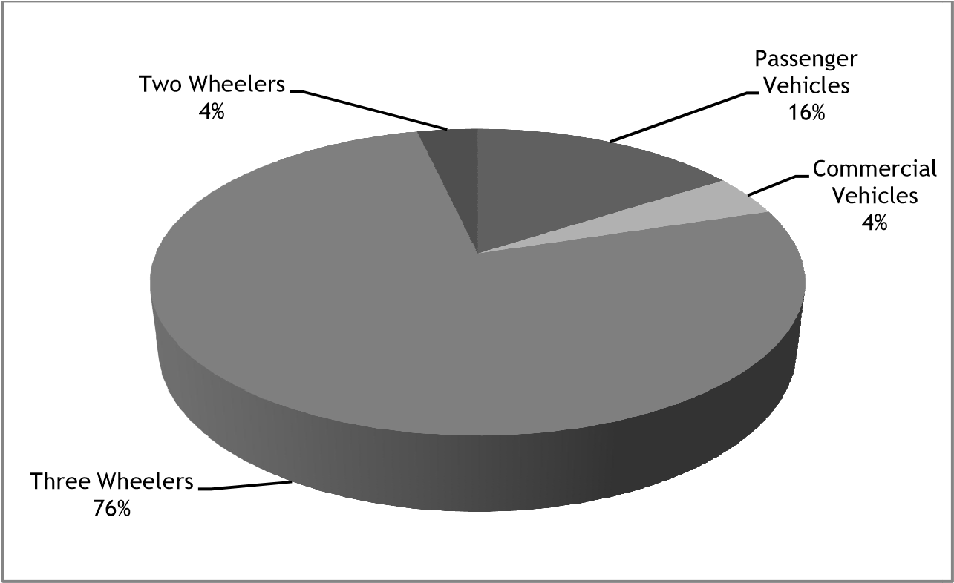
MARKET SHARE
• In the time 2006- 07 the number of Passenger Auto vended were
• In the time 2006- 07 the number of Passenger Vehicles vended were
• In the time 2006- 07 the number of Commercial Vehicles vended were
• In the time 2006- 07 the number of Three Wheelers vended were
• In the time 2006- 07 the number of Two Wheelers vended were
• In the time 2006- 07 the number of machine vended were

part of Automobile Industry in India GDP- Growth
• The growth rate of the Passenger buses in the time 2007 is13.50
• The growth rate of the Utility Vehicles in the time 2007 is10.10
• The growth rate of the Multi Purpose Vehicles in the time 2007 is24.40
• The growth rate of the Light Commercial Vehicles in the time 2007 is16.05
• The growth rate of the Commercial Vehicles in the time 2007 is3.43
• The Maruti Udyog Ltd is the largest auto manufacturer in the country and the rate of growth in the time 2007 was20.7
• The Mahindra & Mahindra Ltd’s accretive deals for the time 2007 was units and the rate of growth was35.8
• The Honda Siel buses India Ltd, the leaders in India pertaining to the manufacturing of ultraexpensive buses , registered a growth of16.1 during the time 2007 and vended 41,638 units •The General Motors India, registered a 114% increase in the national sales in the August of 2007

• The Hero Honda vended further than 2 million units in the Jan- Aug period of the time 2007
• The import pertaining to the motorbikes was units in the time 2007
• It's estimated that in the time 2007- 08 the motorcycle deals would be 7 million, the auto deals would be1.55 million, and the two- wheelers deals would be8.3 million

Role of Automobile Industry in India GDP-Foreign Investments

• Presently, the Indian machine sector is involved in global combinations and accessions.
• A mileage assembly installation in Manuas, North Brazil, will be established by Mahindra & Mahindr in cooperation with Bramont, a original company; the Indian machine assiduity's overseas sector is valued atUS$ 515 million.

• The Mahindra and Mahindra pot has established assembly
confines of client Satisfaction towards Indian Automobile diligence Regarding the client satisfaction five confines are bandied below figure
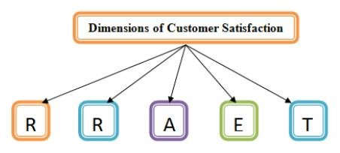

The capacity to execute service responsibility precisely and reliably is known as trustability. The customer anticipates that the service will be handed on schedule, constantly, and error-free — that is, rightly each and every time, for an extended length of time.

Response The capacity to help and serve guests instantly; rigidity in handling colorful circumstances; and professionalism in handling poor service.

Assurance People's capacity to inspire trust, specialized proficiency, tone- assurance, and civility. The client's stylish interest is always at the van when it comes to effective communication, graciousness, respect for the client, and good station.

Empathy is the capability to watch for others, give them with personalized attention, be approachable, give them a sense of security, and make an trouble to comprehend their requirements.

Tangibles The outside look of factual structures, goods, and workers.
Global business understands that the client is king. Understanding consumer geste
and why and how effects are consumed aids marketers in understanding how to make their products more, what kinds of particulars are necessary in the request, and how to draw in guests. The study of consumer geste
focuses on how people choose which consumption- related products to buy with the plutocrat they've available. This covers the following what, why, when, where, how constantly they buy it, how they rate it subsequently, and how that evaluation affects their decision to buy it again.

• Tata Motors has introduced the Tata Indigo, Tata Indica, and Tata Indigo Marina, marking its entry into the Saudi Arabian passenger auto request.
• In Karawang, Indonesia, the TVS Motor Company has opened a two- wheeler manufacturing installation.

Maruti UdyogLtd. now controls nearly 60 of the Indonesian small auto request. Tata MotorsLtd. bought the Nissan Motor South Africa installation to produce Tata vehicles for the European and South African requests. Ford Motor Company's Jaguar and Land Rover businesses were bought by Tata MotorsLtd. for an estimatedUS$1.5 billion.

Initiatives taken by Government of India towards Automobile Industries

- The Indian government has designated the automobile sector as a focal industry for Foreign Direct Investment (FDI) due to its significance in creating jobs. The "Automotive Mission Plan (AMP): 2006-2016" has been developed to establish India as a worldwide automotive hub in order to hasten and maintain growth in the automotive industry. By 2016, the Plan hopes to create jobs for 25 million people and double the automotive sector's GDP contribution to USD 145 billion (with a focus on exporting compact cars, MUVs, two- and three-wheelers, and auto components).

2. The automobile industry allows 100% of foreign direct investment (FDI) through an automated procedure.
3. Starting in 2015, the government will implement new fuel economy regulations and labeling for new automobiles, allowing manufacturers time to invest in and develop innovative technologies.
Achievements by the Automobile diligence in India

Without admitting the pioneering work of Mr.J.R.D. Tata in establishing the Tata group with an excellent Engineering Research Centre( ERC) in 1965 to promote technological growth, the development story of the Indian machine assiduity can not be completely told. introducing the indigenization of specialized information for exchanges in cooperation with Mercedes- Benze and introducing the Maruti 800 in 1983, which unnaturally altered the Indian passenger auto request. It was appertained to as the people's auto as well.
Tata Motors controls 60 of the Indian marketable vehicle request.
1. In 1897, Bombay saw the preface of the first vehicle in India.
2. India is getting seen as a possible developing machine request.
3. The sector totals the investments made by foreign parties.

4. Motorcycles and two- wheelers regard for 80 of the member's size.
5. In discrepancy to the USA, vehicles regard for 79 of the passenger vehicle request in India.
6. The world's largest request for two- and three- wheelers is set up in India. It's the world's fifth- largest patron of marketable vehicles and the alternate largest patron of tractors.

Conclusion

The Indian frugality is unnaturally woven by the machine sector. In India, this assiduity has grown snappily and steadily, especially after the 1990s thanks to delicensing, probative programs, government backing wholeheartedly, opening up the machine sector to 100 FDI, middle- class consumers' increased purchasing power, and simple, affordable bus backing options. The current analysis has determined that the most pivotal factor in any assiduity is client happiness.
thus, it's the primary duty of the service sectors to raise client happiness and service quality, both of which help to increase the number of new guests. When service diligence deliver best- in- class services, there is no need to spend further plutocrat on announcements and elevations because happy guests spread the word about a product's brand, which is the most effective form of word- of- mouth advertising for that service assiduity. The study will punctuate the need of upholding quality in order to satisfy auto possessors and druggies while their vehicles are being used laboriously.
The vehicle form and conservation sectors will be more able of making the applicable fiscal opinions to raise service quality and, eventually, client satisfaction. The findings of this study will be profitable to society as a whole since they will give a database that supplements the body of information formerly available on consumer geste
in the bus services assiduity.

References

- India: A future automotive centre. Hyderabad's ICFAI Business School Case Development Center.

- The Indian Economy in a Worldwide Perspective. In: Chinoy, S. and Krueger, A.O. (Eds.) The Indian Economy and Economic Policy Reforms. New Delhi: Oxford University Press, pp. 9–46.

- Indian Automotive Component Industry, ACMA, 2006. The Indian manufacturing sector is being driven by an engine of growth.
4. Goodbye. "Marketing Management," Walker & others, Tata Mcgraw Hill, New Delhi.
5. Armstrong and Philip Kotler. G, Prentice Hall of India, "Marketing," 12th Ed., New Delhi, 2015.
6.Press Information Bureau, Govt. Indian Automobile Industry on a High Growth Trajectory. India, 19 December 2011.

7. Industry of automobiles, ISSN: 2278-621X
8. Department of Industrial Policy and Promotion (DIPP) Press releases, media reports.
9. "Profiling the Young Indian Consumer," Aayush Chowdhury and Abhishek Kapoor, Advertising Express, Vol. V, Issue 9, September 2005.
10. Statistical Profile of the Indian Automobile Industry, SIAM, 2007.

