Promoting Rural Growth: Empowering Country Women and Youth through Agriculture & Human Resource Management
Koyel Mukherjee¹ Anweshan Jana² Souvik Das³ Sukumar Gorai⁴
1 Assistant Professor & Head- Rural Development and Management & Social Work; Seacom Skills University
2 Master in Business Administration; Maulana Abul Kalam Azad University of Technology (WBUT)
3 M.Sc in Agriculture Extension and Communication; Sam Higginbottom University Of Agriculture , Technology And Sciences
4 M.Sc in Agronomy, Lovely Professional University
Corresponding Author: Koyel Mukherjee, Email Id: send2koyel@yahoo.com

ABSTRACT-

This topic focuses on the transformative potential of agricultural initiatives in rural areas. Rural women and youth have pivotal role in agricultural development. So an overall socio-economic upliftment is possible through their optimal empowerment. Some targeted interventions such as access to education, training and capacity building may break the vicious cycle of poverty, gender inequality and youth unemployment. Awareness generation on resource utilization and modern technology adoption is also essential too. Sustainable livelihood development of rural women and youth is only possible through fostering rural entrepreneurship, leadership and innovation. Collaboration among Government, NGOs and rural communities is truly needed for promotion of optimal potential of agriculture as a key catalyst for rural women and youth empowerment. Multiple strategies of human resource management may bring the best performance of rural youth and women by employing them in the main course of farm economy. It would bring the optimal socio-economic prosperity of rural community as well as whole country.

Keywords: Transformative Potential, Agricultural Initiatives, Rural Women, Youth, Socio Economic Upliftment, Empowerment, Sustainable Livelihood Development, Entrepreneurship, Collaboration

“Each time a women stands up for herself without knowing it possibly, without claiming it, she stands up for all women”

Maya Angelou

“Girls we love for what they are; young men for what they promise to be”

Johann Wolfgang Von Goethe

“It is the malady of our age that the young are so busy teaching us that they have no time left to learn”
- Eric Hoffer

1. Introduction- If we look at the factors behind rural economic growth, we would find that agriculture has a prime role to make a
GENDER EQUALITY & WOMEN EMPOWERMENT
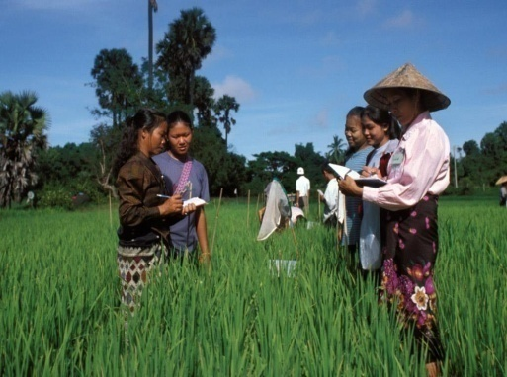
Figure Source- Food and
Agriculture Organization of the United Nations
remarkable evolution in recent years for transitioning rural community from conventional farming practice to the era of stable socio-economic progress. This is to be recognized that rural women and youth play a pivotal role in agricultural production, food security in the way of prolonged sustainable development. This article is a compelling narrative intersecting rural development through rural women and youth empowerment via precision agriculture.
Though rural women are considered historically marginalized and undeserved, they have noteworthy contributions to farm labor, agril food production and household livelihoods. But they've to face several formidable challenges such as constrained access to land, resources, markets etc. One thing to be specifically mentioned that they have been neglected in decision-making process in spite of having such major contributions. But the potential of rural women and youth must be unlocked for optimal promotion of agricultural productivity, poverty eradication. It would bring a new dawn of gender equality.
Rural youth also have the key of the future of agriculture and rural communities. They often encounter numerous constraints such as poor access to quality education, lack of employment opportunities and land tenure. Financial issue is also a critical hindrance for their development. But rejuvenation of rural economies require empowerment of rural youth. Innovation, cultivation of resilient agricultural systems would be automatically accomplished if their farming expertise could be well strengthened. It would help in confronting the challenges on the way of food security.
Promoting gender equality and youth empowerment in agriculture are highly prioritized through multiple initiatives. Important policy reforms, institutional interventions at grass root level are emphasized for fostering inclusive and sustainable rural development.
Rural youth and women empowerment initiatives include multifarious interventions such as vocational training and capacity building, financial supports, access to land and resources, market linkages etc. Exclusive assistance is employed for entrepreneurship and agribusiness development specifically for rural women and youth.
So it's clear to us that efforts for empowering rural women and youth through agriculture have been continuing for several decades. Such initiatives reflect the evolution of development paradigms, policy frameworks and different institutional mechanisms. These encompass the importance of gender equality and youth empowerment in achieving sustainable community development.
United Nations Conferences of 1990s focused on it. So such initiatives have the noble agenda of empowering rural youth and women to encourage them for becoming pioneers of social change through the wand of resilient agricultural practice. One thing can't be denied that appropriate utilization of Human Resource Management tools could promote rural women and youth participation in agricultural sectors that would give us a surprising economic growth along with a glorious dawn of rural women and youth empowerment. The appropriate integration of human resource management and farming sector development would initiate golden era of sustainable rural welfare.

2. Methodology- Collected data and information from different secondary sources have been analyzed.

3. Discussion and Analysis-

The pioneering role of rural women and youth in enhancing country's economic prosperity can't be denied. Some major aspects should be discussed from this perspective to narrate the exact essence of this specific topic as follows-
3.1 Promoting Gender Responsive Climate Smart Agriculture Approach:
Agriculture is the backbone of Indian economy. Climate smart agriculture aims at sustainable growth of agricultural productivity and enhancement of the food security. It increases farm resilience and adaptation to climate change. Besides, it could address the critical challenges faced by the rural women farm practitioners.
According to FAO approximately 205 billion people are engaged in agricultural production system either fully or part-time farming or in the farming household. Agricultural system is solely based on small farm holding i.e. of 2 ha or less (Wiggins and Keates 2013).
Recent research says that women farmers are more affected by climate change than male farmers because of their excessive dependence on natural resources for earning livelihood.
Small women farmers have less adaptability as they have poor access to resources, and other modern technologies. They are insisted to have lower decision-making capacity too.
GENDER SPECIFIC ASPECTS AND ADOPTION OF CLIMATE SMART AGRICULTURE PRACTICES
IMPROVED LAND AND WATER MANAGEMENT PRACTICE |  | IMPROVED SOIL FERTILITY AND CROP MANAGEMENT PRACTICE
- Agro-forestry  - Terrace and Bunds  - Improved agriculture, Water Management  - Crop residue management |  | - Composting  - Effective use of fertilizers  - Improved high yielding varieties
IMPROVED LIVESTOCK MANAGEMENT PRACTICE
- Improved feed management
- Livestock management
- Pasture management
- Rearing livestock species that are more adapted to water scarcity and resistance diseases
Gender Responsive Climate Smart Agricultural Approaches

3.2 Strengthening Women & Youth Farmers’ Capacity and Participation for Efficient and Sustainable Production:
Farmer capacity building is a continuous process that allows access to information facilitation and empowerment and fosters technical advancement too. Capacity building is mainly conducted through extensional services.

Benefits Of Capacity Building Toward Agriculture Success |  | 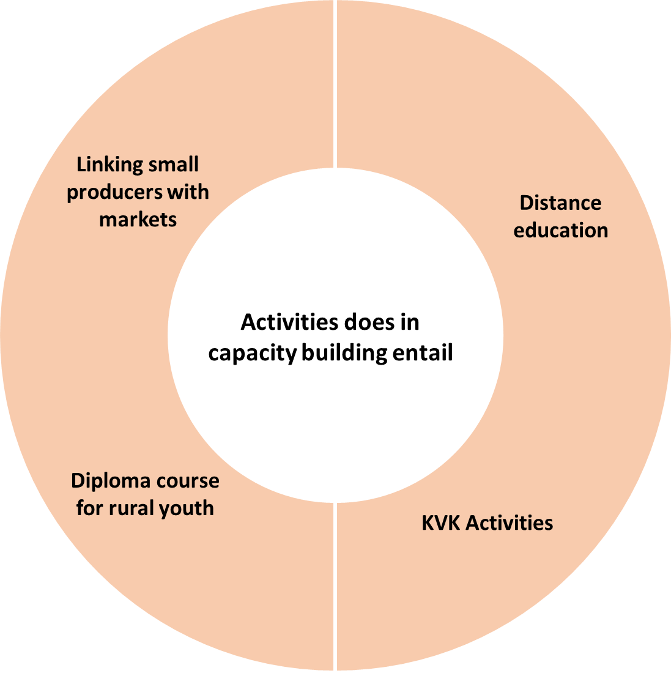  Agriculture has the potential to be a key driver of growth and the eradication of poverty. But the sector is underperforming in many nations in part because of barriers that prevent women, who are frequently a vital resource in agriculture and the rural economy, from working as productively as they could.
Improved Food Safety | Agri training teaches farmers safe food handling, storage, and processing of the farm products. This is helpful for preventing the food contamination and ensures that the consumers are provided with safe foods.
Diversified Income Source And Resilience To Climate Change | Farmer with diversified skills can explore alternative income source such as bee keeping, goat farming, fisheries, handcraft industries etc. are also aware of climate smart agricultural practices, land cropping techniques, changing weather patterns, such as biotic and abiotic stress resistant crop varieties.
Migration Mitigation And Women Empowerment | By providing opportunities for sustainable income and higher quality of life in rural areas, basic education in agriculture reduces the occupational migration of rural people. Agricultural training empowers rural women’s by providing them with knowledge and skills which results in equitable gender participation in agriculture and promotes access to multiple resources such as accessing credit and land and opportunities for women to engage in income generating activities.
Capacities and Participations for Efficient and Sustainable Productions: Women Youth Farmers

“If a society is to preserve stability and a degree of continuity, it must know how to keep its adolescents from imposing their tastes, attitudes, values and fantasies on everyday life”
- Eric Hoffer

3.3 Trained Farm Women Empowered & Disempowered In Different Domains

DOMAINS OF EMPOWERMENT IN THE WOMEN’S EMPOWERMENT  DATA SOURCE- Alkire et al (2013) |  | TRAINED AND OUTREACH HELPING TO EMPOWER FEMALE FARMERS
DOMAIN | INDICATOR | 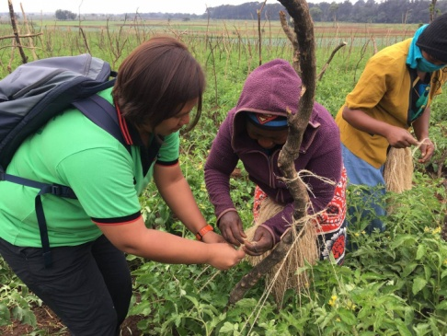  Figure Source- East West Seed Knowledge Transfer Team
EMPOWERMENT | WOMEN’S EMPOWERMENT
Production | Input in Productive Decisions
Production | Autonomy in Production
Resources | Ownership of Assets
Resources | Purchase, Sale, Transfer of Assets
Resources | Access to and Decisions on Credit
Income Leadership | Control over Use of Income
Income Leadership | Group Members
Income Leadership | Speaking in Public
Time | Work Load
Time | Leisure
CONTRIBUTION OF EACH INDICATOR TO WOMENS’ DISEMPOWERMENT
INDICATOR |  |  | WOMEN
Input in Productive Decision |  |  | 41%
Ownership of Assets |  |  | 5%
Access to & Decisions on Credit |  |  | 12%
Control Over Use of Income |  |  | 2%
Group Member |  |  | 7%
Work Load |  |  | 33%
PERCENTAGES
4. Facilitating Women Access to Labor Saving Technologies to Overcome Production Constraints-
In recent years, research reported that women are more involved in agriculture overtime. Women are not only engaged in domestic household work and also spent time in agricultural sector across all the season. Agriculture operations are time consuming, physically draining along with their burden women face several constraints.

STRATEGIES LABOR SAVING TECHNOLOGIES TO OVERCOME THE PRODUCTION CONSTRAINTS
WOMEN AND MEN’S DIFFERENCE ACCESS TO INFORMATION AN EXTENSION SERVICE AFFECT ADOPTION
Crucial Factors Influencing Adoption of New Technology were Found to be | Features of Conservation Agriculture
- The effectiveness of field demonstration  - Hands on training an extension agent availability  - Preference for women extension agents | a) Maintain of permanent soil cover for mulch  b) Crop residue management and weed management to stimulate soil formation, improved soil fertility  c) Crop rotation, disease control base Integrated Pest Management (IPM)
Features of conservation tillage | Livelihood resilience strengthening and livelihood diversification
a)Reduce tillage  b) Zero tillage  c) Ridge tillage  Production Constraints  OVERCOME | a) Represent a move towards a more sustainable farming system with increased yield quality of environment improved and previous degradation result  b) More time available to undertake of farm work and hire out services e.g. Drought animals, there is the opportunity to move into the organic produce.  FACILITATING WOMEN ACCESS TO LABOUR SAVING TECHNOLOGIES

Contribution of each indicator to empower trained & untrained rural farm women & youth | ROLE OF INDICATOR | Empowerment Pathways
 | ROLE OF INDICATOR | Livelihood Diversification
 | ROLE OF INDICATOR | Capacity Building
 | ROLE OF INDICATOR | Gender Mainstreaming
 | ROLE OF INDICATOR | Social Capital
 | ROLE OF INDICATOR | Value Chain development
 | ROLE OF INDICATOR | Resilience Building
 | ROLE OF INDICATOR | Rights Based Approach
 | ROLE OF INDICATOR | Participatory Decision Making
 | ROLE OF INDICATOR | Inclusive Development
 | ROLE OF INDICATOR | Intersectional Collaboration
 | ROLE OF INDICATOR | Cultural Sensitivity

DIFFERENT ROLES PLAYED BY RURAL WOMEN AND THE NEED OF WOMEN EMPOWERMENT
Female Foeticide

fffFeticides
Rape Cases
Sexual Harassment
NEED OF WOMEN EMPOWERMENT
About 55 % Rural Population are Farmers

5. Stages-

There are five steps indentified in the process of empowerment. The first two stages

powerlessness and initiation are more or less passive. Here, women are not aware of their injustice and do not speak up for their rights and needs. During these stages women are just getting to know that they can achieve a better life for themselves and their families. The remaining three stages i.e. participation, adoption, and leadership are considered active stage of development. Here women are deeply involved and seek interaction with organizational intervention, local agents and other active women in the community. During these stages of development, women are interested in learning how to bring an improved life to themselves and their families.

6. Schemes-

WOMEN EMPOWERMENT

The Govt. of India Implements Several Schemes for Women Empowerment

BETI BANCHAO BETI PADHAO
DESCRIPTION |  | In 2015, the Indian government introduced the Beti Bachao, Beti Padhao (BBBP) scheme to address concerns of gender discrimination and women empowerment in the country. The name Beti Bachao, Beti Padhao translates to ‘Save the girl child, educate the girl child’. The scheme aims to educate citizens against gender bias and improve efficacy of welfare services for girls. It was launched with an initial funding of Rs. 100 crore.
OBJECTIVES |  | 1. Improve the child sex ratio.  2. Ensure gender equality and women empowerment.  3. Ensure survival and protection of girl child.  4. Encourage education and participation of the girl child.

ICDS
DESCRIPTION |  |  | This scheme was launched in 1975 by Govt. of India.
OBJECTIVES |  |  | 1. To improve the nutritional health status of children below the age of 6yrs. and pregnant lasting others.  2. To reduce the incidence of mortality, morbidity, malnutrition and school dropout.  3. To achieve an effective coordination of policy and implementation among various dept. to promote child development.  4. To enhance the capacity of the mother to look after the nutritional needs of child through proper health and nutrition education.

MAHILA SAMRIDHI YOJANA
DESCRIPTION | While empowering minorities, maximum emphasis is required to be given on empowerment of women because they are the weakest link among the minorities. Its launched on 2nd oct.1993.
OBJECTIVES | 1. To provide economic security to the rural women through training and credit.  2. To encourage the women from rural regions, underprivileged classes, and minority groups to adopt an entrepreneurial attitude.

NIRBHAYA FUND: The Indian government established the ‘Nirbhaya Fund’ to improve the safety and security of women.

Under this plan the rural women aged above 18 yrs. can open their saving account in the rural post office of their own area with a minimum 4 rupees or its multiplier. On the amount not withdrawn for 1 year. Govt. will deposit 25 of the bonus in the form of encouragement amount with a maximum selling of Rs. 300 every year.

WOMEN EMPOWERMENT: AGRICULTURE

MAHILA KISAN SASHAKTIKARAN PARIYOJANA ( MKSP)
DESCRIPTION |  | It is subcomponent of DAY NRLM ( Deendayal Antyodaya yojana ) National Rural Livelihoods Mission. This scheme is implemented since 2011. To empower women by making systematic investment to enhance their participation and productivity as also create sustainable livelihoods of rural women. Its objective is to strengthen small holder agri. through promotion of sustainable agriculture practice such as community managed sustainable agriculture ( CMSA) non pesticide management (NPM) zero budget natural farming ( ZBNF) pashu sakti model for doorstep animal care services

MISSION FOR INTEGRATED DEVELOPMENT OF HORTICULTURE (MIDH)
DESCRIPTION |  |  | Specific coverage schedule caste, schedule tribe, and women beneficiaries for programmatic interventions. Assistance for horticulture mechanization also available grower association farmers groups / self help groups / women farmers having at least 10 members , who are engaged in cultivation of horticultural crops provide the balanced 60% of the cost of machine and tools is borne by such group.

NATIONAL MISSION FOR SUSTAINABLE AGRICULTURE ( NMSA)
DESCRIPTION | Soil and Water conservation, water use efficiency, soil health management and rainfed area development. At least 50% of the allocation is to be utilized for small marginal farmers at which 30% are women beneficiaries / farmers.

NATIONAL FOOD SECURITY MISSION
DESCRIPTION |  |  |  | Scheme launched in 2007 based on recommendation of Agriculture subcommittee of National Development Council (NDC)
BENEFIT |  |  |  | 1. Sustainable increase in the production of targeted crops through area expansion and productivity enhancement and also rise in farm level net income.  2. Restoration of soil fertility and productivity at the individual farm level.

PRADHAN MANTRI MUDRA YOJANA ( PMMY)
DESCRIPTION |  |  |  |  | Provides financial support to women entrepreneurs.
OBJECTIVES |  |  |  |  | To fund the unfunded with the twin of 349 crore enterprises supported during 2015- 2016, nearly 36% (1.25 crore accounts) were for first time borrowers (new entrepreneurs) 79% (2.76 crore women) were funded under PMMY

Motivating and Attracting Youth in Agriculture:

To be job creator not job seeker.

Youth as Entrepreneurs.

Youth (including women) as extension agents in paid extension.

Youth as input provider.

7. Social Protection-

Multiple Factors Regarding Social Protection For Women And Youth In The Rural Economy
SOCIAL PROTECTION
KEY FACTORS
Large number of women and youth are engaged in agriculture as subsistent farmers, small scale producers in plantation and agro industries. Youth in rural area are also employed in other sector such as educational tourism and domestic work. Here some activities those are also looked after by rural youth for the development of rural economy. Agricultural programs, health programs for humen and livestocks, community development programs, vocational and training programs etc. Social protection can support rural population by-
- Increasing their access to health care and maternity leaves and ensuring they receive adequate dietary aligning them to enjoy at least minimum intake
- Pro development and pro gender equality by reducing unpaid work burdens and also promoting equal wages for men and women
8. Constraints of Rural Women & Youth in Farm Activities-
- Lack of technical skill support from resource person.
- Lack of proper market facilities.
- Lack of information about latest scheme and service in agriculture.
- Inadequate irrigation facility.
- Difficulty in accessing financial resource.
- Poor Govt. commitment and also lack of awareness about important practices.

HINDRANCES

Hindrances and Their Causes Faced by Human Resource Management in Agriculture Sector for Managing Youth & Women

9. Programme for Skill Development-

Skill Training of Rural Youth ( STRY)
The component aims at training rural youths, rural artisans (black smiths, carpenters are designing /manufacturing farm implements) including farm women across the country. The training under this component focuses on specific vocational area in agri. and allied sector. Both public and private/non govt. institution including vocational training organization. Youth organizations like nehru yuva kendra are actively involved in the implementation of this programme.
Diploma in Agricultural Extension Services For Input Dealers (DAESI)
Agri.input dealers in the country are a prime source of farm information to the farming community besides the supply of inputs and credit, however majority of these dealers do not have formal agricultural education. In order to build their technical competency in agriculture and to facilitate them to serve the farmer as for their better growth.
Establishment of Agri. Clinics and Agri. Business Centre (AC AND ABC)
- To supplement efforts of public extension by providing extension and other services
- To farmers either on payments basis or free basis as per business model of agri. preneur, local needs or affordability of target group of farmers.
- To create gainful self employment opportunities to unemployed agri. graduate, agri. diploma holders.
Attracting and Retaining Youth in Agriculture ( ARYA)
- Attract and empower the rural youth in involving them in agri. development.
- Generate employment and regular flow of income stream for rural youth.
- Encourage the rural rural youth to purpose farming as a profession.
- It can reduce migration of youth from rural area.
- It can solve the food security problem associated with small holding and rising population in country
Rashtriya Yuva Sashaktikaran Karyakram (RYSK)
The scheme aim to develop the personality and leadership qualities of the youth. It also aim to make the youth engage in national building activities. The scheme beneficiaries are youth in the age group 15-29 yrs. in line with the definition youth in the national youth policy 2014.
National Service Scheme and National Youth Crops
The national services scheme is a public programme implemented by the ministry of youth affairs and sports. The scheme was launched in1969, marketing the birth centenary year of Mahatma Gandhi. It is a voluntary association of young people in colleges and universities. The scheme aims at developing a student’s personality through community services.
The motto of NSS is ‘NOT ME, BUT YOU’. Each educational institution covered under the scheme has at least one NSS unit comprising around 100 students volunteers by teachers designated as programme office. Each NSS unit adopts a village or slum for taking up its activities. Each NSS volunteer must put in a maximum of 120 hrs. of services per year for two year , a total of 240hrs. of besides , each volunteer must participate in a special camp of 7 days duration , organized by the NSS unit in the adopted village or urban slum. In National Youth Crops youth in the age group of 18 to 25 yrs. are engaged as volunteers to serve up to a maximum of two yrs, in nation building activities.

10. Participation of Rural Youth in Agriculture -

Participation or engagement of rural women and youth could upscale the overall agricultural economy in Such a way that it may bring a socio economic revolution. There are multiple precious contributions of rural women and youth in restructuring the dimension of agro based rural economy as follows:

HRM TOOLS | Need Assessment
HRM TOOLS | Skill Development Programs
HRM TOOLS | Flexible Work Policies
HRM TOOLS | Gender Inclusive Requirement
HRM TOOLS | Leadership Development
HRM TOOLS | Networking & Support Groups
HRM TOOLS | Performance Management
HRM TOOLS | Advocacy & Policy Support
HRM TOOLS | Evaluation & Feedback
HRM TOOLS | Sustainability Planning
HRM TOOLS | Conflict Resolution Mechanisms
HRM TOOLS | Mentorship Programs
HRM TOOLS | Strategic Resource Allocation
HRM TOOLS | Community Engagement Initiatives
HRM TOOLS | Cultural Sensitivity Training
Utilization of different tools of Human Resource Management (HRM) for strengthening women’s participation and leadership in Rural Organizations
- Improved decision making processes could be fostered by greater gender equity along with proper resource allocation within farming households.
- Engagement of rural women and youth in agriculture and allied sectors strengthens social cohesion within rural communities.
- Transfer of traditional wisdom is ensured alongside modern farming techniques through the collaboration between youth and older generations.
- Both women and youth play pivotal roles in integrating small scale farming activities into broader value chains
- Sustainable farming practices can be promoted through their active participation. It would promote environmental conservation too.
- They leverage information and communication tools which increasing scope of accessibility to modern digital techniques.
- They contribute a lot in eradication of poverty and inequality by promoting inclusive agricultural development.
- Preservation of cultural heritage could be fostered through their engagement in agricultural practices.
- They leads to a more diversified and resilient agricultural sector.
- Enthusiastic, energetic youth would inject new charm in to environmental farming communities.
- Greater gender equity could be fostered through engagement of rural women with farming community.

11. Recommendation for Youth and Women Empowerment through Agriculture-

RECOMMENDATION | Promoting access to education & training
RECOMMENDATION | Policy advocacy & institutional support
RECOMMENDATION | Enhanced access to resources
RECOMMENDATION | Timely monitoring & education
RECOMMENDATION | Fostering gender equality
RECOMMENDATION | Capacity building and skill development
RECOMMENDATION | Access to markets and value addition
RECOMMENDATION | Utilization of technology & innovation
RECOMMENDATION | Financial inclusion & support
RECOMMENDATION | Community engagement & empowerment
RECOMMENDATION | Promotion of entrepreneurship & innovation
RECOMMENDATION | Environmental sustainability through youth & women engagement in agriculture
 | Inadequate irrigation facility
 | Poor Govt. commitment and also lack of awareness about important practices
 | Lack of information about latest scheme and service in agriculture
IMPACT OF EMPLOYMENT ON WOMEN EMPOWERMENT: SWOT ANALYSIS
STRENGTHS | WEAKNESSES
- More Confident b) Financial Independence  c) More Innovative and Techno-friendly  d) Gain Respect  e) Job Providers  f) Awareness Increase g) Regular Income  h) More Adaptability i) More Assets  j) Institutional Support k) Work Life Balance  l) Creditability/ Loaning/ Lending Capacity Increase | - Less Quality Tome for Family Members  - Social Relations  - d) Less Awareness  - Guilt  - Lack of Legal Awareness  f) Less Mobility  g) Low Risk Taking Capacity
OPPORTUNITIES | THREATS
- Awareness about Govt. Schemes  - Training  - More Saving  - Industrial Linkage  - e) More Exposure | - Lack of Family Support  - Conflicts  - Easy Accessibility of Loans

12. Authors Statement-
Koyel Mukherjee¹ - Conceptualization; Data Collection & Analysis; Theoretical Discussion; Writing; Reviewing & Editing
Anweshan Jana² - Conceptualization; Data Collection & Analysis; Designing; Theoretical Discussion; Writing; Reviewing & Editing
Souvik Das³ – Writing; Reviewing & Editing
Sukumar Gorai⁴ - Writing; Reviewing & Editing

13. Conclusion-

Women and youth empowerment are most vital aspects of a country’s socio-economic development. They’ve great contribution in integrated social development. They could be much more strengthened through multifarious interventions of several segments of agricultural sector. But it is high time to manage their talent and expertise with the help of different tools or strategies of Human Resource Management. Rural women and youth are facing multiple challenges in this field of agricultural practice. It happens due to lack of expertise in human resource management. They suffer a lot instead of having ample capabilities. This is not a little issue. Because there are lacuna in the way of optimum resource allocation for them in this particular sector. HRM may bring a new dawn of revolution by altering such weaknesses into prospective strengths. An extensive awareness along with serious initiatives may change the scenario. Rural women should be inspired in such a way that they would prioritize agriculture as their sole occupation other than unproductive household works. Active participation of both strong forces can't be ignored to uplift the overall rural economy. A stable sustainable growth is expected by engaging them in the main course of economic activities. Agriculture has the potential to restructure this whole process with evolving a fruitful outcome. So they should be well empowered through the proper utilization of agriculture and human resource management in integrated way. It would facilitate prolonged socio-economic development.

References-

BOOKS & ARTICLES

- Brooke Shannan west (2006), “‘Does employment Empower Women- An Analysis of Employment and Women’s Empowerment in India”
- Afrin Sultana, S.K.Sharafat Hossen (2013), “Role of Employment and Women Empowerment: Evidence from Khulana City of Bangladesh” Published in IJSSIR Vol.2 (7), July 2013.
- Haque M.S. Yamao, M. (2008): ‘Can Micro Credit Alleviate Rural Poverty: A case study of Bangladesh’, World Academy of Science Engineering and Technology, Vol. 46.
- Patra, S. (2008): ‘Micro Credit, Self Help Group and Empowerment of Women’ in Das, S.K. Nanda, B.P. and Rocth, J. Leds.), Micro Finance and Rural Development in India, New Century Publications, New Delhi, P.P. 76-83.
- Sure, here are 25 article references on promoting rural growth through empowering country women and youth in agriculture and human resource management:
- Smith, L., Ramakrishnan, U., Ndiaye, A., Haddad, L., & Martorell, R. (2003). The importance of women's status for child nutrition in developing countries. Research Report 131, IFPRI.
- Quisumbing, A., Rubin, D., Manfre, C., Waithanji, E., van den Bold, M., Olney, D., & Meinzen-Dick, R. (2015). Closing the gender asset gap: Learning from value chain development in Africa and Asia. IFPRI Discussion Paper 1483.
- Kabeer, N. (2005). Gender equality and women's empowerment: A critical analysis of the third Millennium Development Goal. Gender & Development, 13(1), 13-24.
- Alkire, S., Meinzen-Dick, R., Peterman, A., Quisumbing, A., Seymour, G., & Vaz, A. (2013). The women's empowerment in agriculture index. World Development, 52, 71-91.
- FAO. (2011). The State of Food and Agriculture 2010-2011: Women in Agriculture—Closing the Gender Gap for Development. Food and Agriculture Organization of the United Nations.
- Doss, C. (2013). Intrahousehold bargaining and resource allocation in developing countries. World Bank Research Observer, 28(1), 52-78.
- Haddad, L., & Quisumbing, A. (2003). Gender and agricultural development: A primer. Food Policy, 28(4), 1-17.
- Agarwal, B. (1997). "Bargaining" and gender relations: Within and beyond the household. Feminist Economics, 3(1), 1-51.
- World Bank. (2007). World Development Report 2008: Agriculture for Development. World Bank.
- Peterman, A., Behrman, J., & Quisumbing, A. (2011). A review of empirical evidence on gender differences in nonland agricultural inputs, technology, and services in developing countries. IFPRI Discussion Paper 01251.
- Quisumbing, A. (2003). Household decisions, gender, and development: A synthesis of recent research. IFPRI Discussion Paper 143.
- Blackden, C. M., & Wodon, Q. (2006). Gender, time use, and poverty in sub-Saharan Africa. World Bank Working Paper 73.
- Gammage, S., & Hinton, R. (2005). Labouring to learn: towards a political economy of plantations, people and education in Sri Lanka. Journal of Education and Work, 18(1), 23-45.
- FAO. (2017). The future of food and agriculture: Trends and challenges. Food and Agriculture Organization of the United Nations.
- Agarwal, B. (2010). Does women's proportional strength affect their land rights? World Development, 38(1), 59-66.
- FAO. (2019). Women in agriculture: Closing the gender gap for development. Food and Agriculture Organization of the United Nations.
- Meinzen-Dick, R., Johnson, N., Quisumbing, A., Njuki, J., Behrman, J., Rubin, D., & Peterman, A. (2011). Gender, assets, and agricultural development programs: A conceptual framework. CAPRi Working Paper 101.
- Quisumbing, A., & Pandolfelli, L. (2010). Promising approaches to address the needs of poor female farmers: Resources, constraints, and interventions. World Development, 38(4), 581-592.
- FAO. (2008). Gender dimensions of agricultural and rural employment: Differentiated pathways out of poverty. Food and Agriculture Organization of the United Nations.
- Duflo, E. (2012). Women's empowerment and economic development. Journal of Economic Literature, 50(4), 1051-1079.
- Hoddinott, J., & Haddad, L. (1995). Does female income share influence household expenditures? Evidence from Cote d'Ivoire. Oxford Bulletin of Economics and Statistics, 57(1), 77-96.
- Quisumbing, A., & Pandolfelli, L. (2010). Promising approaches to address the needs of poor female farmers: Resources, constraints, and interventions. World Development, 38(4), 581-592.
- World Bank. (2012). Gender in agriculture sourcebook. World Bank.
- Quisumbing, A., & Pandolfelli, L. (2010). Promising approaches to address the needs of poor female farmers: Resources, constraints, and interventions. World Development, 38(4), 581-592.
- Deere, C. D., & Doss, C. R. (2006). The gender asset gap: What do we know and why does it matter? Feminist Economics, 12(1-2), 1-50.
- "Women's Empowerment and Global Health: A Twenty-First-Century Agenda" edited by Shari L. Dworkin, Monica Gandhi, Paige Passano (Published in 2016)
- "Gender, Work, and Population in Sub-Saharan Africa" by Josephine Beoku-Betts (Published in 2013)
- "Rural Women and State Policy: Feminist Perspectives on Latin American Agricultural Development" by Carmen Diana Deere (Published in 1985)
- "Empowering Women: Land and Property Rights in Latin America" edited by Carmen Diana Deere and Magdalena León (Published in 2001)
- "Agriculture, Diversification, and Gender in Rural Africa: Longitudinal Perspectives From Six Countries" edited by Agnes Andersson Djurfeldt et al. (Published in 2018)
- "Gender, Agriculture and Rural Development in Angola" by Margarida Paulo and João Pontífice (Published in 2020)
- "Agricultural Governance: Globalization and the New Politics of Regulation" edited by Vaughan Higgins and Geoffrey Lawrence (Published in 2016)
- "Gender and Development: Concepts and Definitions" by Caroline Sweetman (Editor) (Published in 2013)
- "Empowering Women in Rural Africa: The Role of Traditional Institutions in Sustainable Development" by John Mukum Mbaku and Julius O. Ihonvbere (Published in 2006)
- "Women, Agriculture, and Rural Development in Latin America" by Carmen Diana Deere (Published in 2003)
- "Youth, Education and Rural Development: Addressing Rural Youth Migration and Unemployment" edited by Maja Miskovic and Valerie Carkovic (Published in 2019)
- "Youth in Rural Development: Achieving the Goals of the Rural Development Policy" by John P. Davis (Published in 1985)
- "Empowering Women: Land and Property Rights in Latin America" edited by Carmen Diana Deere and Magdalena León (Published in 2001)
- "Women in African Agriculture: From Plot to Plate" edited by Mary Nzomo, Hale Tufan, and Adebisi Araba (Published in 2020)
- "Agricultural Extension and Rural Development: Breaking Out of Knowledge Transfer Traditions" by Jamie Newth and Sean Dougherty (Published in 2019)

WEBSITES

- "Empowering Women in Agriculture" - World Bank: https://www.worldbank.org/en/topic/agriculture/brief/empowering-women-in-agriculture
- "Women’s Empowerment in Agriculture Index" - IFPRI: https://www.ifpri.org/publication/womens-empowerment-agriculture-index
- "Promoting Rural Women’s Economic Empowerment" - UN Women: https://www.unwomen.org/en/news/in-focus/rural-women
- "Youth Employment in Agriculture" - FAO: http://www.fao.org/youth-employment/en/
- "Empowering Youth in Agriculture" - USAID: https://www.usaid.gov/what-we-do/agriculture-and-food-security/empowering-youth-agriculture
- "Rural Women and Empowerment" - International Labour Organization: https://www.ilo.org/global/topics/rural-employment/WCMS_310342/lang--en/index.htm
- "Gender and Rural Development" - FAO: http://www.fao.org/gender/gender-home/gender-issues/gender-and-rural-development/en/
- "Empowering Rural Youth" - European Commission: https://ec.europa.eu/agriculture/rural-development-2014-2020/policy-in-action/guide-young-farmers/empowering-rural-youth_en
- "Women in Agriculture: Closing the Gender Gap for Development" - FAO: http://www.fao.org/3/I9553EN/i9553en.pdf
- "Youth and Agriculture" - United Nations: https://www.un.org/en/chronicle/article/youth-and-agriculture
- "Rural Youth Empowerment" - IFAD: https://www.ifad.org/en/web/knowledge/topic/youth
- "Women’s Empowerment in Agriculture" - Oxfam: https://www.oxfamamerica.org/explore/stories/womens-empowerment-in-agriculture/
- "Youth in Agriculture" - CGIAR: https://www.cgiar.org/news-events/news/youth-in-agriculture/
- "Rural Women's Empowerment" - WFP: https://www.wfp.org/publications/rural-womens-empowerment-how-food-and-nutrition-programmes-can-help
- "Empowering Rural Youth" - United Nations: https://www.un.org/development/desa/youth/news/2021/02/rural-youth-empowerment/
- "Women in Agriculture: Key to Food Security" - UN Women: https://www.unwomen.org/en/news/stories/2019/10/feature-women-in-agriculture-key-to-food-security
- "Youth and Rural Development" - United Nations: https://www.un.org/development/desa/youth/
- "Empowering Women in Rural Areas" - European Parliament: https://www.europarl.europa.eu/RegData/etudes/BRIE/2021/660313/EPRS_BRI(2021)660313_EN.pdf
- "The Role of Women in Agriculture" - World Food Prize Foundation: https://www.worldfoodprize.org/en/youth_programs/global_youth_institute/the_role_of_women_in_agriculture/
- "Youth and Agriculture: Key Challenges and Solutions" - Brookings Institution: https://www.brookings.edu/research/youth-and-agriculture-key-challenges-and-solutions/
- "Gender and Rural Development" - United Nations: https://www.un.org/development/desa/dpad/publication/gender-and-rural-development/
- "Youth Employment in Agriculture" - International Labour Organization: https://www.ilo.org/global/topics/employment-youth/areas/youth-employment-in-agriculture/lang--en/index.htm
- "Rural Women: The Backbone of Sustainable Agriculture" - Food Tank: https://foodtank.com/news/2021/05/rural-women-the-backbone-of-sustainable-agriculture/
- "Youth in Agriculture: Opportunities and Challenges" - OECD: https://www.oecd.org/site/agrindi/country-policy-reviews/Youth_in_Agriculture_Fact_Sheet_2020.pdf
- "Empowering Women in Agriculture" - The Guardian: https://www.theguardian.com/global-development/2020/feb/10/empowering-women-in-agriculture-from-laboratories-to-farms-and-markets
- "Empowering Rural Women through Agriculture" - International Fund for Agricultural Development (IFAD): https://www.ifad.org/en/web/knowledge/publication/asset/42170363
- "Youth Employment in Agriculture: Policies and Programmes" - Food and Agriculture Organization (FAO): http://www.fao.org/3/a-i3144e.pdf
- "Rural Women's Economic Empowerment" - United Nations Development Programme (UNDP): https://www.undp.org/content/undp/en/home/librarypage/womens-empowerment/rural-womens-economic-empowerment.html
- "Youth and Agriculture: Key Challenges and Solutions" - Food Tank: https://foodtank.com/news/2019/04/youth-and-agriculture-key-challenges-and-solutions/
- "Empowering Women in Agriculture: What Works?" - World Bank Blogs: https://blogs.worldbank.org/voices/empowering-women-agriculture-what-works
- "Youth in Agriculture: Opportunities and Challenges" - European Commission: https://ec.europa.eu/eip/agriculture/en/content/youth-agriculture-opportunities-and-challenges
- "Rural Women and Youth Empowerment" - United Nations Economic Commission for Africa (UNECA): https://www.uneca.org/sites/default/files/PublicationFiles/rural_women_and_youth.pdf
- "Youth in Agriculture: The Future of Farming" - AgriCultures Network: https://agriculturesnetwork.org/magazines/global/youth-in-agriculture/
- "Empowering Women in Agriculture: Lessons from the Field" - ONE: https://www.one.org/africa/blog/empowering-women-in-agriculture-lessons-from-the-field/
- "Youth and Agriculture: Key Challenges and Solutions" - Food and Agriculture Organization (FAO): http://www.fao.org/in-action/rural-youth-innovation-challenge/youth-in-agriculture/en/
- "Rural Women's Empowerment: Pathways to Gender Equality" - International Labour Organization (ILO): https://www.ilo.org/global/about-the-ilo/newsroom/news/WCMS_738292/lang--en/index.htm
- "Youth and Agriculture: Challenges and Opportunities" - United Nations Development Programme (UNDP): https://www.undp.org/content/undp/en/home/librarypage/poverty-reduction/youth-and-agriculture--challenges-and-opportunities.html
- "Empowering Rural Women through Access to Land" - Landesa: https://www.landesa.org/our-work/womens-land-rights/empowering-rural-women-through-access-to-land/
- "Youth in Agriculture: Strategies for Engagement" - World Economic Forum: https://www.weforum.org/agenda/2019/10/youth-in-agriculture-strategies-for-engagement/
- "Rural Women's Empowerment: A Pathway to Sustainable Development" - UN Women: https://www.unwomen.org/en/news/stories/2015/10/feature-rural-women-s-empowerment-a-pathway-to-sustainable-development

