Analyzing the Impact of Incubator cum Accelerator in Fostering Innovation and Entrepreneurship Scene in Chhattisgarh.

Prerna Sahu*, Dr. Niranjan Dev Pathak**
*MBA, Amity Business School, Amity University, Raipur (C.G.)
** Assistant Professor, Amity Business School, Amity University, Raipur (C.G.)

Abstract:

The entrepreneurial ecosystem plays a pivotal role in driving economic growth and fostering innovation within a region. In recent years, incubators and accelerators have emerged as key facilitators in nurturing startups and promoting entrepreneurship. The study explores how these programs contribute to the growth of startups, and foster a culture of innovation. By leveraging a mixed-methods approach, we analyze incubators' performance metrics and qualitative insights from interviews with entrepreneurs, incubator managers, and policymakers. Our findings reveal that incubators and accelerators significantly enhance startup survival rates, access to funding, and market reach. Through a comprehensive analysis of the effectiveness of these programs, this research sheds light on the specific mechanisms through which incubators and accelerators facilitate the growth and success of startups in Chhattisgarh. Additionally, we identify key success factors including mentorship quality, networking opportunities, and government support. The research underscores the importance of tailored incubation programs to address the unique challenges faced by startups in emerging economies. Our study contributes to the understanding of how regional incubator and accelerator models can be optimized to boost local innovation ecosystems, offering policy recommendations to enhance the entrepreneurial landscape in Chhattisgarh and see the support services provided by incubators and accelerators, and the perceived value and effectiveness of these programs.

Keywords:

Incubators, Incubation, Accelerators, Chhattisgarh, Entrepreneurship, Start-up, Innovation, Investment, Support, Funding, Eco-system, Business, Industry, Policy, Scheme, Employment, Mentorship, AIC

The objective and scope of the study:

- To analyze how incubators are helping startups and entrepreneurs (services amongst other things)
- To Shed light on the Incubator-startup relationship
- To understand the working process of incubators and incubation process

Introduction:

An overview of incubators:

Along the lines of “An Idea can change the world” Incubators and other similar units serve as a springboard for new ideas and innovation and thus help society to face future challenges and meet the rising aspirations of the growing population. Grassroots innovation and entrepreneurship are seen as an objective of, and a way to contribute to, achieving Sustainable Development Goals (SDGs). Incubators act as oxygen – all that is needed for survival and growth. Incubators are the organizations that play a very major role in the nurturing and growth of an entrepreneur or say an innovative idea.

A business incubator and accelerator help start-ups and existing companies to expand and develop by providing them with services like co-working space, management, mentorship, fund support, technological assistance or any support that is involved for a business to grow.
An incubator welcomes any start-up aspiring to develop their ideas and turn them into reality or desire to scale an existing business. Any start-up idea can be groomed and made into a working business model by access to extensive mentorship on all things relating to technology and product development and every other aspect related to business.

Modern incubators work towards bridging the gaps between entrepreneurs, industry mentors, and eminent academicians by offering full-fledged support. They provide space to nurture startups on reasonable and favourable terms. The incubation centres aspire to be a pulsating hub for promising ideas, and emerging technological and knowledge-based innovative ventures. These are essential focal points of innovation making it into real life businesses; thus transforming 'ideas' into 'products'.

Stages of startups in incubation: Startups in incubators undergo stages of Ideation, Validation, EarlyTraction, and Scaling

Ideation: Founders brainstorm and develop a concept for a product/service.
Validation: The concept is validated through market research, prototyping, and testing with potential customers.
Early Traction: If validation is successful, the startup gains initial customers and generates revenue.
Scaling: With seed funding, the startup focuses on rapid growth, hiring, expansion, and new product/service development.
They may run incubation programs ranging from 6 months upwards to offer support.

Key components of the incubation process:

Development of a standard procedure for sourcing of start-ups as well as screening is an imperative to weed out unsustainable entrepreneurs that will save the time, resources and man hour of the person responsible for sourcing and screening of start-ups for incubation.

Finding worthwhile start ups would enable the incubators to add value to start-ups through institutionalised mentoring, organising knowledge sessions on different subjects under the aegis of Capacity Building Initiatives and connecting them to investors, thereby improving the incubator-incubatee relationship.
The selection process for startup incubation typically involves:
- Application: Startups submit a detailed application including their business plan, team, product, market analysis, and funding requirements.
- Evaluation: The incubator team evaluates the applications and selects promising startups for the program, which may involve interviews and product assessments.
- Mentorship and Support: Selected startups receive guidance from experienced entrepreneurs, industry experts, and mentors on business strategy, product development, marketing, and fundraising.
- Funding: Incubators provide access to funding opportunities through their investor networks.
- Networking: Startups can build connections with other entrepreneurs, investors, and industry leaders.
- Resources: Incubators offer legal, accounting, administrative services, and operational support.
- Education and Training: Training programs cover topics like marketing, sales, finance, and product development to equip startups with necessary skills.
Incubators and Entrepreneurship in Chhattisgarh and role of government:
Entrepreneurship and start-ups are a key driver to the country’s growth and economy. Homegrown start-ups like Ola, Flipkart, Big Basket have grown in just a few years to valuations in excess of USD 1 Billion (Unicorns). India now, has a mature investment community of VC’s, Angels and seed funders. Besides the Central government and states have significant funds allocated to support early stage start-ups and innovative and creative businesses.
Chhattisgarh is an emerging State with unmatched potential and limitless opportunities. Incubators in Chhattisgarh have been launched to encourage the growth of entrepreneurship by promoting start-up opportunities to cater to the employment needs of the youth and encourage local youth in innovation. Both government-established and academic institution incubators have been working to attract large incubators and accelerators to nurture the startup ecosystem in the state. Incubators like THINK-B have generated commercial and social entrepreneurship ventures in the region, along with an environment of innovation. THINK-B is empowering the locals to work for locals by utilizing local resources.
The Government heralds supportive Industrial Policy and removing regulatory barriers to create atmosphere of innovation and entrepreneurship in the State. State supports entrepreneurs and start ups in all stages of innovation starting from ideation stage to commercialization of products, aiming to develop Chhattisgarh as a global innovation hub.
In the past 15 years, the government of Chhattisgarh has been relentlessly working towards creating an eco-system aids and encourages the growth of entrepreneurship. With initiatives like 36inc and Start-up Chhattisgarh, the state is helping nurture the spirit of innovation and entrepreneurship within not just the state but also across the country.
Chhattisgarh is among the few Indian states to have its own Innovation and Entrepreneurship Policy. The Government of Chhattisgarh recognises this new wave where Start-ups will be the dominant job creator of the future and the engine for social innovation. While standing on the foundation of innovation and entrepreneurship, the State is now focusing on developing sunrise sectors as new engines of state growth. With massive increase in mobile usage and a huge shift in mind-set among Indian consumers willing to experiment with new services from start-ups, the new entrepreneurship ecosystem today is getting fuelled by a vibrant Indian market which has attained a critical mass of online users. Business-friendly policies and a proactive administration make Chhattisgarh a preferred investment destination. Even the faster growing large companies look for an innovation and entrepreneurial milieu to invest, which encourages them to 'soft land' with Incubator-cum-Accelerators.

- The State introduced a new startup policy and action plan for the year 2019 to 2024 to keep up with the ever-changing needs of the startups.
- The Chhattisgarh startup policy includes the creation of an Innovation Fund to support the core Incubator-cum-Accelerator for at least three years, which will help in setting up infrastructure, covering operating expenses, and organizing events
- Launch of Ease of Doing Business Cell
- A promised set-up of innovation hub which is projected to create 6 lakh jobs
- Leap of Fath Revolving (LoFR) Fund will provide upto Rs. 50 lakh of interest free loan to Startups selected in the State Incubator. The loan will be recovered within a period of 3 years.
- Initiatives like the "Startup Chhattisgarh" program aim to support entrepreneurs in line with the national vision.
- The Government of Chhattisgarh and Wadhwani Foundation, California have signed MoU to make Entrepreneurship ubiquitous in Chhattisgarh by supporting aspiring entrepreneurship through training. It will also focus to develop city based startup and SME Ecosystem by leveraging mentors, inventors and incubators through National Entrepreneurship Network (NEN) by WOF.
- The startup policy outlines tax benefits and subsidies available to startups in the State. The policy also includes incentives for new incubators being set up in the State. Through the key pillars of the startup policy i.e., the collaboration between startups and industries, and incentives for startups and incubators, the State has propelled from ideation to implementation.

Collaborative ecosystem for startups:
Government: State government agencies, policies and schemes.

Industry: Domain & Technology Partners, Knowledge Partners, Industry Associations.

Academia: Academic, Mentoring, Training Partners.

Investors: Investment Funding Agencies, Venture Capitalists, Angel Investors.

Incubators in Chhattisgarh:
Government-Backed Incubators
- B.Incube: Government-backed incubation center in Bilaspur, Chhattisgarh. Established in 2021. B.Incube Institute has been started under the Public Private Partnership between Smart City Bilaspur and AIILSG.
- Think-B - Technological Hub for Innovation Network and Knowledge-Bastar: Government initiative by the Bastar district administration. TISS Incubation Centre is the knowledge partner of THINK-B.
- I2K Startup Incubator Center: Being established by District Administration Kondagaon to provide assistance to entrepreneurs at the district and divisional level.
- RKVY-RAFTAAR AGRI-BUSINESS INCUBATOR (IGKV R-ABI), RAIPUR: Biotech and Agri-Business incubation center providing infrastructure and assistance to agricultural startups.
- AIC@36 Inc: Business incubator-cum-accelerator supported by Government of Chhattisgarh and Atal Innonation Mission, NITI Aayog. It is the nodal agency for entrepreneurship development in the state and manages the Chhattisgarh State Venture Fund.
University-Affiliated Incubators
- BrainTech@BIT Incubation Centre: In collaboration with Brainstation India Foundation
- RUBI (Rungta Buisness Incubator): A joint venture of NEN (WADHWANI FDN) & Rungta Group Of Inst R1, Bhilai.
- KALINGA UNIVERSITY INCUBATION AND INNOVATION CENTRE (KUIIC)
- Amity Innovation Incubator Raipur: Part of Amity University Chhattisgarh
- Shri Shankaracharya Technical Campus Business Incubator: The first Business Incubator of Chhattisgarh State under the Ministry of Micro, Small & Medium Enterprises (MSME).
- NIT Raipur Foundation for Innovation & Entrepreneurship (NITRRFIE)
- IIIT-NR FOUNDATION FOR TECHNOLOGY BUSINESS INCUBATION & ENTREPRENEURSHIP
- NIDHI i-TBI: Incubator for nurturing technology-driven ideas at CSVTU Campus, Newai, Bhilai (CG), under the National Initiative for Developing and Harnessing Innovations (NIDHI).
- IIT BHILAI INNOVATION AND TECHNOLOGY FOUNDATION (IBITF): IIT Bhilai is a Host Institute/Business Incubator for providing entrepreneurial support through the Ministry of Micro, Small and Medium Enterprises (MSMEs).
Specialized Incubators
- Subhash Chandra Bose Biotechnology Incubation Centre: Phase I of Chhattisgarh Biotechnology Park Project, established in collaboration with the Department of Biotechnology and Department of Agriculture.
Other Incubators
- Bhilai Incubation Service: STPI provides Incubation Services to start-ups and SME companies in the IT/ITeS sector.
AIC@36Inc Spoke Model Incubators
- AIC@36Inc is developing Incubators across Chhattisgarh to reach local entrepreneurs at different regions.
Partnerships and Collaborations
- AIC@36Inc has partnered with educational institutes, independent bodies like Headstart Foundation & state government departments like CSIDC, CHiPS, Dept. of E&IT (CG).
Services provided by different incubators:

- Market research and Linkage (backward and forward), marketing and branding - helps to Connect with top corporates, testing of new products, and scale up ideas. Collection and analysis of data, market trends, and customer feedback to gain a deeper understanding of a business's operations, market position, and potential growth opportunities.
- Security Measures: Implementing robust security measures, including firewalls, antivirus software, and data encryption, helps safeguard sensitive information and protect against cyber threats.
- Co-working space provides a sense of community, culture, opportunities, and office amenities, meeting and board rooms.
- Funding - provide a platform and connect startups with opportunities to tap into the funding available with private players and government grants. They may introduce promising ideas to angel investors for seed funding and established startups to VCs for subsequent rounds of funding.
- Mentorship and networking to let them build on each other's unique skill sets along with support from domain and startup experts who can help review business plan. These connections can help startups find new customers, partners, and suppliers, and can also provide opportunities for collaboration and growth.
- This expert advice can help startups refine their business plans, build better products, and develop more effective strategies for growth.
- Specialized mentors may be made available, based on demand, to the startups to assist with strategic areas or to provide project-oriented consultation.
- Workshops and Training Seminars
- Value-added services to start-ups like Legal, IPR, accounting, HR, Secretarial and other registrations support.
- MOUs with technical and non-technical universities and educational institutes of Chhattisgarh and India for tech resources and labs - IIIT Raipur provides technical information to the startups while institutes like IIM Raipur to teach management skills, TISS for information like the market value of the business and feasibility of the startup idea while experts of HNLU will provide legal assistance to the startups.
Literature Review:
The concept of incubators in India has gained significant attention in recent years. Bulsara et al. (2013) present a case study of Nature Technocrats, a small business firm supported by GIAN, a Technology Business Incubator for Grassroots Innovations in India. This highlights the role of incubators in fostering techno-entrepreneurship at the grassroots level. Singh et al. (2015) discuss the relevance of Technology Business Incubators (TBIs) in India and emphasize the need for a structured approach, such as the Six Sigma DMAIC method, to drive growth in the incubator ecosystem. This suggests a shift towards more efficient support mechanisms for small enterprises in the competitive business environment. Nahar et al. (2018) shed light on the impact of startup incubators in India, emphasizing their role in promoting the growth and success of startups, MSMEs, and early-stage companies. This underscores the importance of incubators in nurturing entrepreneurial ventures in the country. On the institutional front, Narayanan et al. (2019) introduce the concept of academic incubators in India, highlighting their role in facilitating entrepreneurship within the educational context. This adds a new dimension to the understanding of incubators as organizational forms that support entrepreneurial activities. Rathore et al. (2021) focus on performance indicators for TBIs in Indian higher educational institutes, proposing new indicators to assess the effectiveness of incubation activities. This underscores the need for measuring the impact and success of incubators in the educational setting. Overall, the literature on incubators in India covers a wide range of topics, from grassroots innovations to academic incubation, highlighting the diverse roles and impacts of these entities in fostering entrepreneurship and supporting small businesses in the country. Further research in this area can provide valuable insights for policymakers and incubator managers to enhance the effectiveness of these support mechanisms.
Concerning Chhattisgarh, According to Bakshi and Bagchi (2020), to promote equitable and sustainable socio-economic growth, the state has built co-working spaces in the incubator-cum-accelerator for engineers, social entrepreneurs, government, technology firms, and impact investors. Through the key pillars of the startup policy i.e., the collaboration between startups and industries, and incentives for startups and incubators, the State has propelled from ideation to implementation (Kumar & Aquil, 2024).

Research design:

The research design adopted for this study is an exploratory research design. It aims to provide a comprehensive overview of the role of incubators and accelerators in promoting innovation and entrepreneurship in Chhattisgarh by examining existing literature and incorporating primary and secondary data collection. The exploratory design facilitates the identification of key variables, trends, and relationships within the context of the incubator ecosystem.
This study was conducted on the basis of data collected from various periodicals, government reports, project reports and data published on government websites and magazines. During conduction of study investigators visited various incubation centers located in Raipur, Chhattisgarh and collected data by direct interview methods and continuous observation in the period of study.

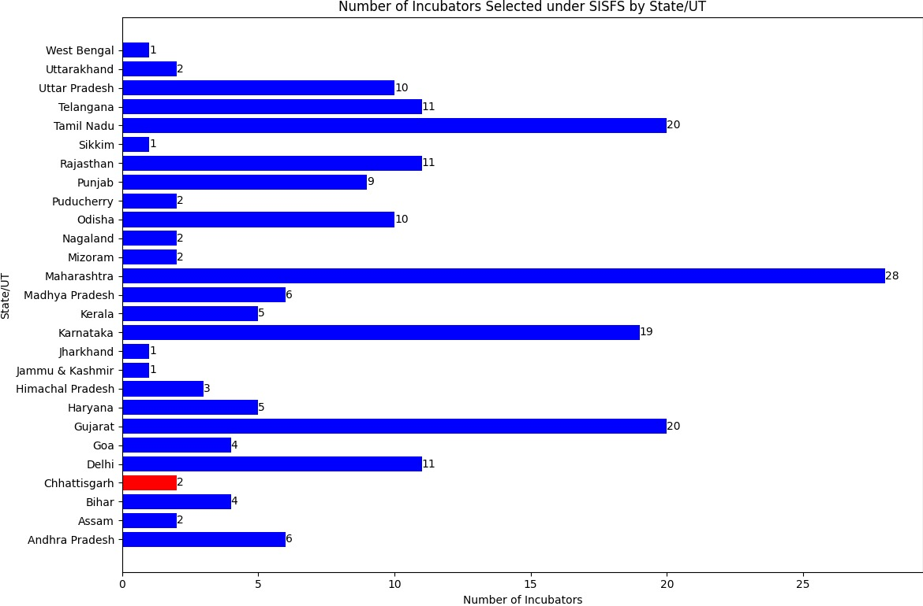

The Startup India Seed Fund Scheme (SISFS) provides financial assistance to startups for proof of concept, prototype development, product trials, market entry and commercialization through eligible incubators.
As per provisions under the SISFS, the Experts Advisory Committee (EAC) evaluates and selects incubators for allocation off undsunder the Scheme. The approved incubators shortlist the startups in accordance with the guidelines of the Scheme. The Scheme has been operationalized from 1 April 2021.

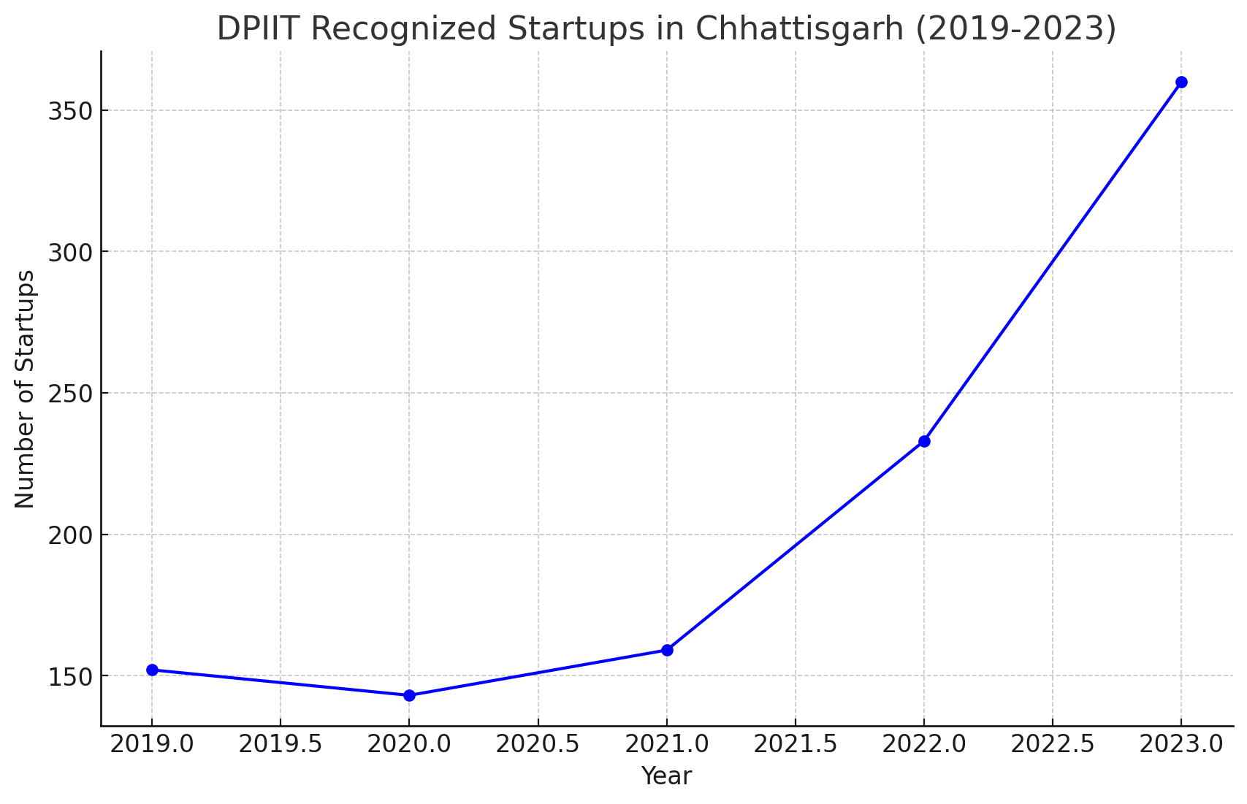

There's been substantial growth in the number of DPIIT-recognized startups in Chhattisgarh between 2019 and 2023, indicating a thriving and expanding startup ecosystem in the state.
The upward trend suggests a positive outlook for the startup ecosystem in Chhattisgarh. Continued support from the government and other stakeholders could further accelerate this growth.

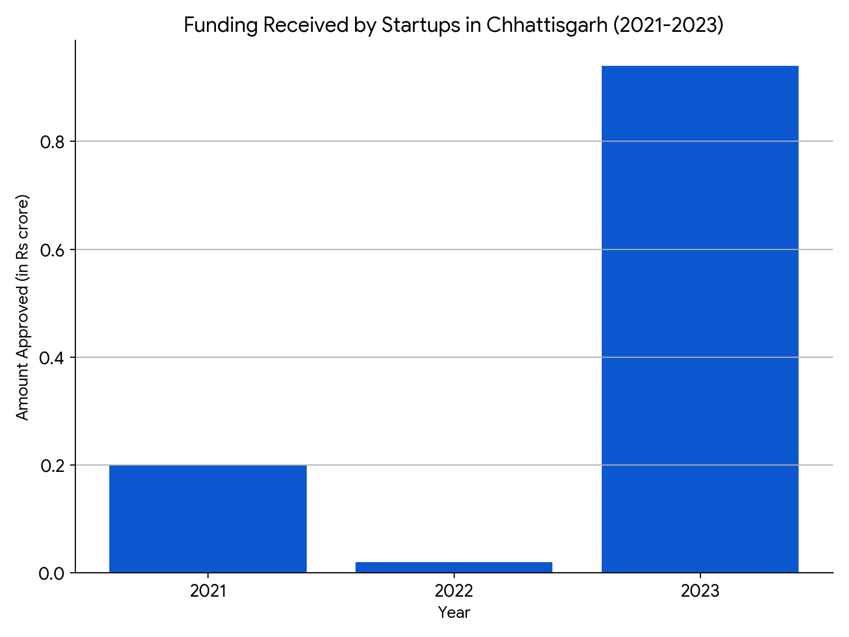

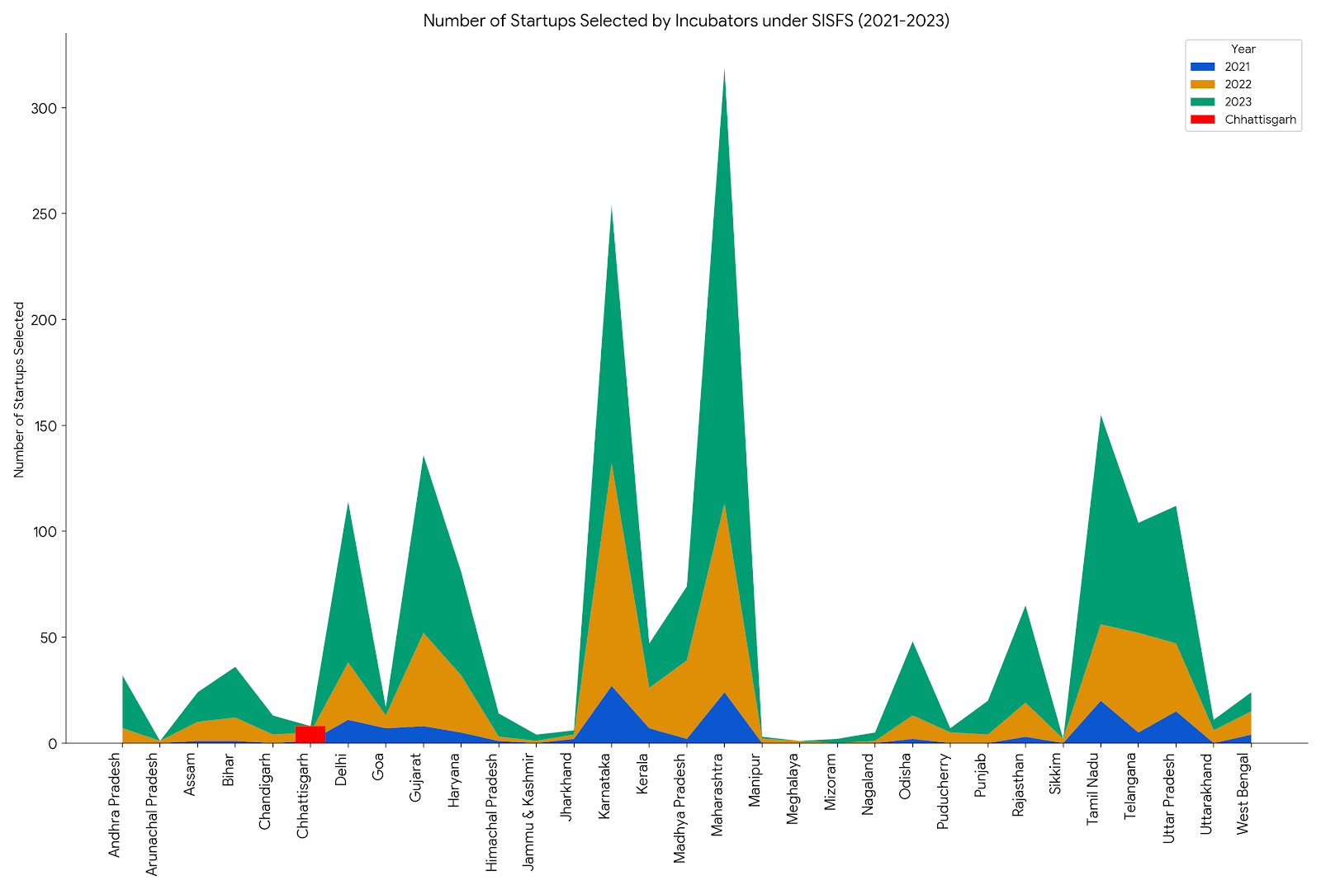

Chhattisgarh, while having a relatively lower number of startups compared to other states, experienced a sharp increase in 2023, suggesting a promising trajectory for its startup ecosystem.

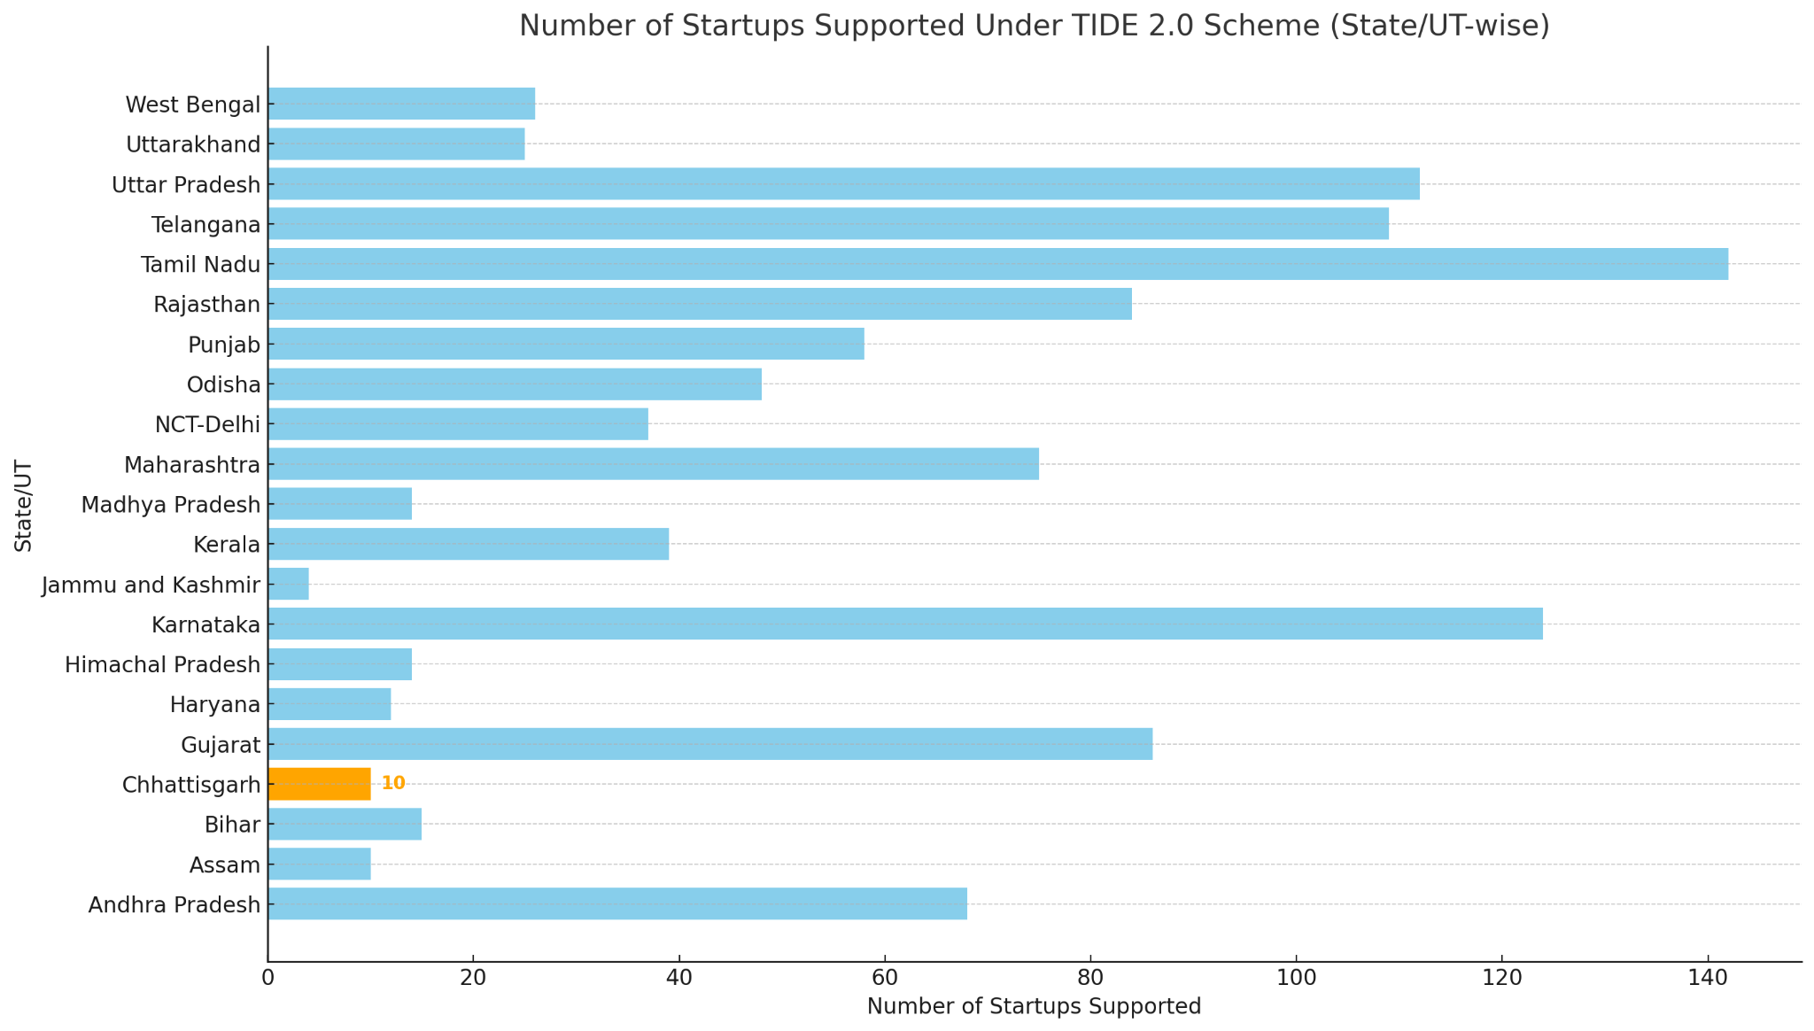

Ministry of Electronics & Information Technology (MeitY) has initiated Technology Incubation and Development of Entrepreneurs (TIDE 2.0)” Scheme in the year 2019 with an aim to promote technology-based entrepreneurship through financial and technical support to incubators.

Findings:

- The Chhattisgarh government's new Industrial Policy 2019-24 has been a catalyst for the startup boom, with the creation of an Innovation Fund to support incubators and startups.
- The Department of Promotion of Industry and Internal Trade, Government of India, has recognized a total of 1012 startup units in Chhattisgarh, with 838 of these registered in the last four and a half years, showcasing a rapid growth in the startup sector.
- Validation and credibility - Being associated with an incubator can provide startups with validation and credibility in the eyes of investors, customers, and partners. This can make it easier for startups to raise capital, attract customers, and form partnerships.
- Significant market opportunity exists to develop sustainable solutions to social and economic difficulties facing low-income communities at the Bottom of the Pyramid (BoP). Yet, providing relevant products and services to BoP markets is often complex. There is a serious shortage of social venture incubators to provide the capacity building and incubation support needed at idea/pilot/test stage, both in India as a whole and particularly in the low-income state like Chhattisgarh.
- The startups under the incubators have been very focused on primary industries and traditional sectors.

Though Chhattisgarh has been lagging in terms of funding received and startups selected when compared to other states, it is still evolving and achieving an attractive business ecosystem, given its recent formation as a state and a new culture of incubators and startups. The state must continue to formulate new and appealing business areas to develop and nurture local talent and avoid the issue of brain drain. Overall, the presence of various incubators and accelerators in Chhattisgarh signifies a growing interest in supporting and nurturing entrepreneurial ventures in the state.

Challenges:
Pressure for Short-Term Results:

- Incubators may push startups towards achieving quick wins instead of focusing on building a sustainable long-term business model.
There is a tendency for incubators to focus predominantly on technology startups, potentially neglecting other sectors such as social enterprises or those targeting the rural economy
Unclear Exit Strategies:

- For startups to deliver returns to their investors, they need clear exit opportunities. Many incubators in the state lack a defined exit strategy, which can be a barrier to attracting investment
Talent Retention:
- Retaining skilled mentors and professionals within the incubator ecosystem may be a challenge, affecting the quality of support provided to startups.
Conclusion:

Incubators are an integral part of the innovation, self-employment, entrepreneurship, job creation, research and development ecosystem. A business incubator and accelerator help start-ups and already existing companies to develop their products and services. They work with industry leaders, organisations and agencies to create a thriving community for networking and collaboration.
Incubators in Chhattisgarh are producing tangible results, with a growing number of startups, national recognition, and successful ventures that contribute to the local economy. The combined efforts of the government, incubators, and the entrepreneurial community are transforming Chhattisgarh into a dynamic landscape for innovation and business growth.

Recommendations:

- Incubators and accelerators should consider providing ventures with multiple mentors to cover every aspect of their business.
- They should be open to the community at large to enable them to solve problems.
- Incubators should also provide virtual incubation support and a platform should be developed for it to reach remote areas.
- A separate plan should be developed to establish Rural business Incubators in far-flung areas to cater to the development and innovation needs.
- A platform can be establish to increase inter-connectivity among different incubators present in the state, nearby regions, other organizations for sharing of knowledge and best practices.
- Customized incubation programme to support women-led startups

References:

- [1] Dr. Hemantkumar P. Bulsara; Dr. Shailesh Gandhi; Dr. P. D. Porey; "Grassroots Innovations to Techno-Entrepreneurship Through GIAN – Technology Business Incubator in India: A Case Study of Nature Technocrats", INTERNATIONAL JOURNAL OF INNOVATION, 2013.
- [2] Sahib Sartaj Singh; Bikram Singh; Dinesh Khanduja; "Synthesising TBI-relevance in India Through Six Sigma Approach", INTERNATIONAL JOURNAL OF ENTREPRENEURSHIP AND INNOVATION ..., 2015.
- [3] Bhavana Nahar; Snigdha Bhatt; "Impact of Startup Incubators in India", JOURNAL OF COMMERCE AND TRADE, 2018.
- [4] V. K. Narayanan; Jungyoun (Natalie) Shin; "The Institutional Context of Incubation: The Case of Academic Incubators in India", MANAGEMENT AND ORGANIZATION REVIEW, 2019. (IF: 3)
- [5] M. H. Bala Subrahmanya; H S Krishna; "Chapter 6 Technology Business Incubators in India: An Assessment of Performance", 2021.
- [6] M. H. Bala Subrahmanya; H S Krishna; "Chapter 4 Technology Business Incubators in India: Structure and Characteristics", 2021.
- [7] Rahul Singh Rathore; Rajat Agrawal; "Performance Indicators for Technology Business Incubators in Indian Higher Educational Institutes", MANAGEMENT RESEARCH REVIEW, 2021.
- [8] Kshitija Joshi; Krishna H S; Muralidharan Loganathan; "Resources or Capabilities: A Study of Startup Emergence Within Applied Research Universities in India", 2021.
- [9] M H Bala Subrahmanya; H. S. Krishna; "Technology Business Incubators in India", 2021.
- [10] M. H. Bala Subrahmanya; H S Krishna; "Chapter 5 Role of Technology Business Incubators in India: Incubatee Selection, Incubation and Start-up Graduation", 2021.
- Bakshi, S., & Bagchi, S. AN EMPIRICAL STUDY ON ENTREPRENEURIAL ECOSYSTEM IN CHHATTISGARH DURING COVID-19. Multidisciplinary Approaches in the Current Times, 131.
- Kumar, C., & Aquil, S. S. (2024). Problems and challenges of startup units in India. International Journal of Science Academic Research, 5(2), 7019-7021.
- Tusharkushwaha., Mishra, A., Pandey, A., Vedikamusle., and Ravikantsoni. (2022). Development of Virtual Incubation Platform for Start-Ups and College Students. i-manager’s Journal on Software Engineering, 16(3), 54-59. https://doi.org/10.26634/jse.16.3.18508
- https://industries.cg.gov.in/startupcg/Home/StartUp_Incubator_list
- https://www.startupindia.gov.in/
- https://www.investindia.gov.in/state/chhattisgarh
- https://government.economictimes.indiatimes.com/news/governance/bastar-admin-launches-think-b-to-encourage-local-youth-in-innovation-self-employment-and-entrepreneurship/87900983
- https://indianexpress.com/article/india/this-start-up-incubator-in-bastar-district-means-serious-business-8432925/

