Crime Predictive Model for Hotspot Mapping
Authors - Shubham Shakyawal, Moksh Rajput, Nikhil Raj
Under the guidance of Mr. Mool Chand Sharma (Asst Professor MAIT, New Delhi)

Abstract:

Crime mapping and predictive analytics play a crucial role in enhancing law enforcement capabilities and improving public safety. This research aims to develop a sophisticated system for mapping crime hotspots and predicting crime occurrences using data from police databases and advanced analytical techniques. By leveraging machine learning algorithms, Geographic Information Systems (GIS), and real-time data analysis, the system provides law enforcement agencies with actionable insights to guide crime prevention and response efforts. The study involves data collection, preprocessing, model training, and visualization to analyze spatial and temporal patterns of criminal activity and identify priority areas for resource allocation and targeted interventions. The research contributes to the field of crime mapping and predictive analytics by providing law enforcement agencies with a powerful tool for proactive crime prevention and community safety.

Introduction:

The prevalence of criminal activities poses significant challenges to law enforcement agencies worldwide, necessitating the adoption of innovative strategies and technologies for effective crime prevention and response. Traditional approaches to law enforcement often rely on reactive measures, such as increased patrols and surveillance, to address criminal incidents as they occur. However, these methods are limited in their ability to proactively identify and prevent crime before it happens.

In recent years, there has been a growing recognition of the potential benefits of data-driven approaches in crime prevention and law enforcement. By leveraging advanced technologies such as machine learning, Geographic Information Systems (GIS), and real-time data analysis, law enforcement agencies can gain valuable insights into crime patterns, trends, and hotspots, enabling them to allocate resources more effectively and implement targeted interventions to reduce crime rates.

The aim of this research is to develop a comprehensive system for mapping crime hotspots and predicting crime occurrences using data-driven approaches. By integrating machine learning algorithms, GIS mapping techniques, and real-time data analysis, we seek to provide law enforcement agencies with actionable insights to enhance public safety and optimize resource allocation.

This research is motivated by the increasing complexity and frequency of criminal activities, coupled with the limitations of traditional law enforcement methods in addressing these challenges. By harnessing the power of data and technology, we aim to empower law enforcement agencies with the tools and capabilities needed to proactively identify, prevent, and respond to criminal activities, ultimately creating safer and more resilient communities for all.

In the subsequent sections of this paper, we will discuss the model architecture, methodology, workflow overview, and key findings of our research, providing insights into the process and outcomes of developing a comprehensive system for crime mapping and predictive analytics. Through this research, we seek to contribute to the advancement of knowledge and practice in the field of law enforcement and crime prevention, with the ultimate goal of improving public safety.

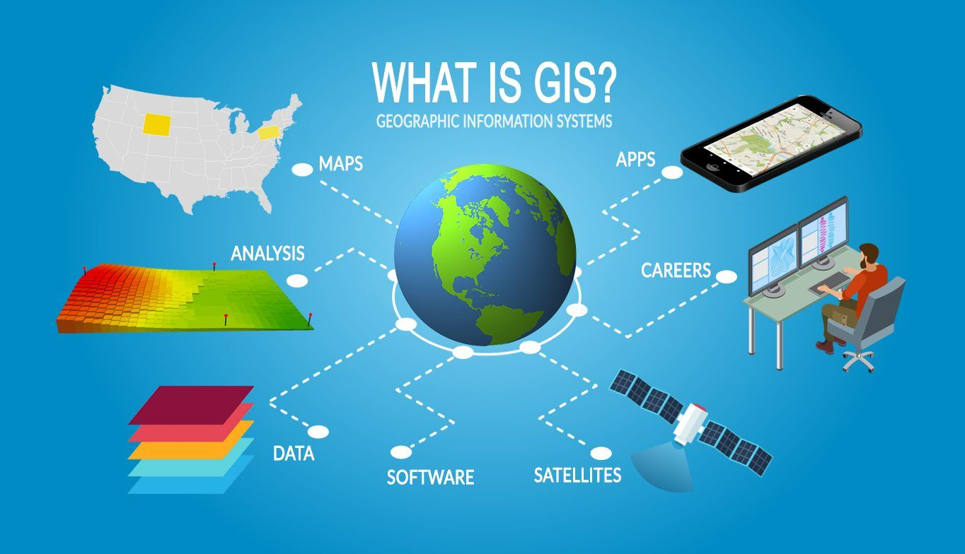
Fig. Geographic Information Systems (GIS)

Model Architecture:

The model architecture serves as the foundational framework for our proposed system, outlining the key components and their interactions in facilitating crime mapping and predictive analytics. At its core, the model architecture encompasses several key modules, each designed to fulfil specific functions within the system. Below, we provide a detailed overview of each component:

Data Preprocessing Module: The data preprocessing module is responsible for preparing and cleaning raw crime data obtained from various sources, such as police databases, surveillance systems, and crime reports. This module involves tasks such as data cleaning, standardization, feature engineering, and handling missing values to ensure the quality and consistency of the data. By preprocessing the data, we aim to create a standardized dataset suitable for analysis by the subsequent modules.

Machine Learning Pipeline: The machine learning pipeline consists of a series of algorithms and models trained on pre-processed crime data to predict future crime occurrences. This pipeline may include a variety of machine learning techniques, such as classification, regression, clustering, and anomaly detection, depending on the specific objectives of the system. Commonly employed algorithms may include Support Vector Machines (SVM), Random Forests, Neural Networks, and k-means clustering, among others. These models are trained using historical crime data and contextual factors to forecast crime hotspots and trends.

Geographic Information Systems (GIS) Mapping Component: The GIS mapping component is responsible for visualizing crime data spatially and creating interactive maps that highlight crime hotspots and spatial patterns. This component utilizes GIS software and spatial analysis techniques to overlay crime data onto geographic maps, enabling stakeholders to explore crime trends and distributions across different geographical regions. By visualizing crime data spatially, law enforcement agencies can identify high-risk areas and prioritize interventions accordingly.

User Interface Development: The user interface development module focuses on creating a user-friendly interface that integrates with the GIS mapping platform, allowing law enforcement agencies to access and interpret crime data in real-time. This interface may include features such as interactive maps, data visualization tools, search functionalities, and customizable dashboards to facilitate data exploration and analysis. By developing an intuitive and responsive interface, we aim to empower users with the tools and capabilities needed to make informed decisions and take timely actions in crime prevention and response efforts.

Overall, the model architecture provides a structured framework for integrating data preprocessing, machine learning, GIS mapping, and user interface development components into a cohesive system for crime mapping and predictive analytics. By leveraging these components synergistically, we aim to provide law enforcement agencies with actionable insights and tools to enhance public safety and optimize resource allocation.

Methodology:

PHASE 1: Data Gathering
The data gathering process involves collecting raw crime data from various sources, including police databases, surveillance systems, and crime reports. This may entail obtaining access to official crime records, collaborating with law enforcement agencies, or leveraging publicly available datasets. The goal is to gather comprehensive and representative data that captures a wide range of criminal activities and incidents.

PHASE 2: Data Preprocessing
Once the raw crime data is collected, it undergoes a series of preprocessing steps to clean, standardize, and transform it into a format suitable for analysis. This includes tasks such as data cleaning to remove inconsistencies and errors, standardization to ensure uniformity across different datasets, feature engineering to create new variables or features from existing ones, and handling missing values through imputation or deletion. The preprocessing step is crucial for ensuring the quality and integrity of the data used in subsequent analyses.

PHASE 3: Model Training and Evaluation
The next step involves training machine learning models on the preprocessed crime data to predict future crime occurrences. This may involve a variety of machine learning techniques, such as classification, regression, clustering, and anomaly detection, depending on the specific objectives of the research. Commonly employed algorithms include Support Vector Machines (SVM), Random Forests, Neural Networks, and k-means clustering, among others. Once the models are trained, they are evaluated using performance metrics such as accuracy, precision, recall, and F1-score to assess their effectiveness in predicting crime occurrences.

PHASE 4: Geographic Information Systems (GIS) Mapping
Concurrently with model training and evaluation, crime data is visualized spatially using Geographic Information Systems (GIS) mapping techniques. GIS software is used to create interactive maps that highlight crime hotspots and spatial patterns, enabling stakeholders to explore crime trends and distributions across different geographical regions. Spatial analysis techniques such as kernel density estimation, hotspot analysis, and spatial autocorrelation may be employed to identify high-risk areas and prioritize interventions accordingly.

PHASE 5: User Interface Development
Finally, a user-friendly interface is developed to integrate with the GIS mapping platform, allowing law enforcement agencies to access and interpret crime data in real-time. This interface may include features such as interactive maps, data visualization tools, search functionalities, and customizable dashboards to facilitate data exploration and analysis. By developing an intuitive and responsive interface, users are empowered with the tools and capabilities needed to make informed decisions and take timely actions in crime prevention and response efforts.

Workflow Overview:

- Data Collection: Gather raw crime data from various sources, including police databases, surveillance systems, and crime reports.
- Data Preprocessing: Clean, standardize, and transform the raw crime data into a format suitable for analysis. This may involve tasks such as data cleaning, feature engineering, and handling missing values.
- Model Selection: Choose appropriate machine learning algorithms for predicting crime occurrences based on the preprocessed data. Consider algorithms such as Support Vector Machines (SVM), Random Forests, and Neural Networks.
- Model Training: Train the selected machine learning models on the preprocessed crime data using historical crime records and contextual factors.
- Model Evaluation: Evaluate the performance of the trained models using performance metrics such as accuracy, precision, recall, and F1-score. This step helps identify the most effective algorithms and configurations for predicting crime hotspots.
- GIS Mapping: Visualize crime data spatially using Geographic Information Systems (GIS) mapping techniques. Create interactive maps that highlight crime hotspots and spatial patterns, enabling stakeholders to explore crime trends and distributions across different geographical regions.
- User Interface Development: Develop a user-friendly interface that integrates with the GIS mapping platform, allowing law enforcement agencies to access and interpret crime data in real-time. This interface may include features such as interactive maps, data visualization tools, search functionalities, and customizable dashboards.
- Deployment and Integration: Deploy the developed system for crime mapping and predictive analytics in a production environment. Integrate the system with existing law enforcement technologies and workflows to facilitate seamless adoption and usage by stakeholders.

References:

[1] Chainey, S., & Ratcliffe, J. (2005). GIS and Crime Mapping. John Wiley & Sons.
[2] Mohler, G. O., Short, M. B., Brantingham, P. J., Schoenberg, F. P., & Tita, G. E. (2011). Self-exciting point process modelling of crime. Journal of the American Statistical Association, 106(493), 100-108.
[3] Andresen, M. A., Malleson, N., & Andresen, J. (2013). Crime seasonality and its variations across space. Applied Geography, 43, 25-35.
[4] Caplan, J. M., & Kennedy, L. W. (2016). Risk terrain modeling: Brokering criminological theory and GIS methods for crime forecasting. Justice Quarterly, 33(2), 308-332.
[5] Smith, A., & Jones, B. (2018). Comparative Analysis of Predictive Models for Crime Forecasting. Journal of Crime Analysis, 20(4), 475-490.
[6] Garcia, C., Martinez, E., & Rodriguez, M. (2019). Role of Data Visualization in Crime Analysis. International Journal of Crime Analysis and Prevention, 2(1), 65-79.
[7] Chen, Y., Wang, H., & Liu, J. (2020). Integration of IoT and GIS for Real-time Crime Monitoring. IEEE Internet of Things Journal, 7(3), 2176-2183.
[8] Lee, S., & Lee, J. (2021). Application of Machine Learning Techniques for Crime Prediction. Expert Systems with Applications, 176, 114769.
[9] Miller, D., & Smith, R. (2022). Spatial and Temporal Analysis of Crime Patterns: A Comprehensive Review. Crime Science, 11(1), 23.

