Impact of Covid-19 Pandemic on Nifty Thematic Index

ABSTRACT
The study aims to evaluate the effectiveness of companies that are listed on the NSE Thematic Indexes during the COVID-19 pre- and post-pandemic periods, which span 2019 to 2020. Certain companies in the index faced extreme volatility when compared to the time before the COVID-19 epidemic. The NIFTY 50 and other indexes are related to COVID-19-related events such as migrant worker mobility, transport restrictions, lockdown procedures, and infection-associated fatalities. Our findings are strong after correcting for investor concern, cumulative infected cases, the rigor of government response tactics, the extent of democracy, and political corruption, among other things (Nguyen, C. T., Hai, P. T., & Nguyen, H. K. (2021)

INTRODUCTION
There are several strategies adopted by investors and businesses when it comes to building and diversifying their portfolios (Apollon Fragkiskos 2014). Their sole focus is to make financial success. However, things are changing lately in the investing world. Nowadays, investors and businesses think about this new concept called sustainable investing before putting money into a company. Sustainable investing has dual benefits. On one hand, it is leading to a positive social change through how the world invests. On the other hand, making sure that investments and companies are sustainable provides financial benefits to individuals and businesses.

According to (Stobierski, 2021) sustainable investing is nothing but an investment strategy popularly known as ESG investing or socially responsible investing is when an investor before contributing their money/resources to a company looks at various ESG factors - environmental, social, and governance. This is done to promote corporate responsibility, to encourage positive societal impact by the company, and at the same to gain the advantage of long-term financial return. The days are gone when an investor makes a decision to invest in a company based on judging a company’s short-term financial gains (Lean, H. H., & Pizzutilo, F. 2020).. Today’s investors are also looking at a holistic picture. They also want to know how a company is contributing to society at large.

Sustainable investing consists of three elements. a) Sustainable investing does not mean dismissal of traditional or foundation concepts but is an addition to asset management theory
b) Sustainable investing is a way to understand how using ESG factors will help us to create values and get deeper insights about the same. c) Consistent with how companies are developing sustainable investing considers diverse stakeholders. When it comes to traditional investing the investor can translate their capital or money opportunities for investing in those stock or funds that carry risks with expected returns (CFA institute). However, Sustainable investing aims at balancing traditional investing with the ESG factors in order to have long-term outcomes.

ESG investment (Environment,Social And Governance)
There will be an increase in sustainable investing especially among the equity investors when more listed companies and also countries formulate and implement policies that help to meet ESG factors or targets especially with carbon emissions (Jethmalani, 2022). ESG factors are going to be looked at before making an investment decision in 2022.
Although Europe has always been the leader in sustainable finance for a long time, now the dominant position is enjoyed by North America. The trend of ESG investing has always been lacking in Asian countries but there is a change to this trend in this region as well (SG analytics, 2021). It is said that especially in Asia-Pacific countries most of investors are using an exclusion-based ESG screening, which excludes stocks with adverse ESG credentials. Asian investors have slowly started to accept or make a practice to follow impact-based ESG screening reporting standards improve across the region. However, globally, there is one problem that the regulators are trying to address when it comes to ESG investing - the lack of standardization (Brooks, C. 2014).. In Europe, the Sustainable Finance Disclosure Regulation makes it mandatory for companies to make ESG disclosures (Jethmalani, 2022)
Therefore, in 2022 it will help the equity investors could pay more attention to the ‘net zero emissions.
India is at a nascent stage of its ESG journey. In India, ESG has seen higher traction in the last two years. Moreover, in recent years, many ESG-focused mutual fund schemes were launched by asset management companies in India (Jethmalani, 2022).

ESG and COVID
The Covid-19 crisis has made it evidently clear that investments that incorporate ESG criteria prove to be more resilient to market turmoil. According to Gabriel Wilson-Otto, head of stewardship, Asia Pacific at BNP Paribas Asset Management, in spite the virus outbreak, investors have been “doubling down” on sustainability funds – where these funds have outperformed the broader market. As compared to other funds in market, ESG portfolios or sustainable funds have exhibited sharp outperformance across indexes like S&P 500 and MSCI equity index.

Digital India fund
The Indian IT market is currently valued at US$177 billion, up 6.1% over the previous year. It is predicted that by 2025, the business would be worth US$350 billion (Source: ibef.org). The Nifty Digital Index captures the general sentiment of investors, whether they are domestic or foreign institutional investors (Tejinder Singh 2020).

Energy fund
The National Institution for Transforming India Aayog asserts that the government may provide all stakeholders with top-notch policy support to increase India's energy security. Its objective is to increase investment in the creation of an effective, long-lasting, and clean energy system (Babu et al.,2022). It employs forceful efforts to lower energy imports, guarantee a backup energy source, and enhance domestic supply. It attempts to address cross-sectoral issues and enhance the energy infrastructure. By ensuring that energy is distributed through effective markets, the policy framework aims to increase India's competitiveness and promote economic growth (Babu et al, 2022). According to Kazemilari et al. (2017), the renewable energy industry has expanded significantly lately. According to Sinha (2015), the Indian financial market witnessed highs and lows between 2008 and 2014. The SENSEX reached a high in April 2014 after falling to a low in March 2009. 2008 saw the creation of India's first commercial energy trading system, the India Energy Exchange, when the world was engulfed in an economic crisis.
Shariah Index
Islamic investment became significant in developed and developing nations after the 1990s with the introduction of extensive macroeconomic and structural financial system reforms, the adoption of liberalization policies for trade, capital movements, privatization, and global financial market integration, and ultimately, they have opened the door for the Muslim community to participate in stock market activities (Dharani 2019). The Shariah Advisory Committee (Shariah Supervisory Board) of a nation oversees the stock market activities for the Muslim community and develops investing rules and regulations based on Islamic law for the 1.2 billion Muslims living in the 6-billion-person world (Dharani et al 2019).

COVID-19 Impact in India

India’s first patient of COVID-19 was reported on Jan 30th, 2020 in Kerala’s Thrissur and Trivandrum district but till March beginning the COVID-19 cases were observed only in Kerala. The cases started spreading outside Kerala by March 10 2020 and the first death due to COVID-19 was announced on March 12 and after March 15, 2020, the cases started increasing rapidly and had already crossed 100 active cases in Mumbai alone. The government of India declared the first lockdown starting on March 25, 2020 (Abhishek et al 2021). And on April 29, 2020, it was reported that there were 1,000 total confirmed deaths due to the pandemic. By July 2020, India was considered the third-worst coronavirus-hit country, with 6.97 lakh confirmed active cases and in September the second-worst country had a total of 41.13 lakh confirmed active cases. However, by beginning of October things were slowly getting back to functioning with schools and colleges reopening partially, lockdown being lifted completely, increasing recovery rates. By January 2021, India also started with one of the world’s biggest coronavirus vaccination programs (Express Web Desk, 2021). Although the situation seemed to be getting back to normal, it took aU-turn in March 2021 when India was hit with the second wave of COVID-19. Nevertheless, the second wave lasted only for a few months as we all got into normal functioning (with a few restrictions) by September 2021. The 3rd wave hit India in January 2022 and lasted for one month with no major deaths as the vaccinated percentage was high. It was like a fever and cold for many who was affected. It had no much impact on the stock market (Express Web Desk, January 2022)

LITERATURE REVIEW
The year 2020-2021 has been a turning point for businesses in the world. While most industries were negatively impacted by the pandemic there were others that witnessed the contrary (Jindal et al). The impact of the pandemic on the investment and business environment was also visible in the stock market (Charu Singhal). It has been well documented that global events of such kind affect the return of the stock market as several studies were conducted when there was a piece of disaster news was around Cepoi, C. O. (2020).
It was found that stock markets reacted unfavorably to the increase in COVID-19 confirmed cases by using daily COVID-19 confirmed cases and mortality data from 64 countries from January 22, 2020 to April 17, 2020 (Aman Gupta 2021, May). As the number of confirmed instances of covid cases increased, stock market returns decreased. We also discovered that when the number of verified cases increased, stock markets reacted more quickly than when the number of deaths increased.
A study was conducted by Al-Awadhi et al. (2020) to assess the impact of the pandemic on the Chinese stock market. The authors concluded that the daily growth in total confirmed cases and total cases of death caused by COVID-19 have adverse effects on returns across all companies in the Chinese stock market. Another study (Anh & Gan, 2020) was conducted to understand the impact of COVID-19 on the Vietnamese stock market. Even this study concentrates on the effects of COVID-19-confirmed active and death cases on the daily returns of stocks during pre-lockdown and lockdown. The result suggested that there was a significant negative impact on Vietnam’s stock returns during the COVID-19 pre-lockdown. Whereas, there was a positive impact on Vietnam’s stock returns during the lockdown period. However, another similar study conducted by Nguyen et al. (2021) concentrated only on the returns and liquidity performance of banking, insurance, and finance companies listed on Vietnam stock markets. The authors found that the confirmed active and death cases of COVID-19 have a negative impact on the stock returns of the said sectors.
The pandemic has affected stock markets in all countries. In order to understand the effect of COVID-19 on the stock markets of different countries Ashraf, (2020) conducted a study that included 64 counties. The results of the study indicated that the COVID-19 confirmed cases have a negative impact on the stock markets. The authors concluded that as the number of COVID-19 confirmed cases increased the stock market returns declined in the selected countries. There is a weak correlation between COVID-19 death cases and the stock market response. According to the authors, the reaction of stock market prices is reflected early on when the number of confirmed cases increases. However, the reaction of stock prices is slow when confirmed cases die later on (Ashraf, 2020).
Globally, socially accountable investments have gained prominence among market participants. It is particularly true for India as it has associated itself with the global trend, becoming more sensitive towards the environmental aspect of doing green business. Investors in developed markets are more conscious about investments in stocks that create value for shareholders and manage risk exposure associated with climate change over the long term.

A study conducted by (Arefeen & Shimada, 2020) came to a conclusion that the socially responsible funds of the Japanese were affected by economic shocks when there was a U.S. election in the year 2012. However, when there was a Brexit referendum event the performance of SRI funds/stocks has a significantly negative impact (Arefeen& Shimada, 2020). A study conducted by (Becchetti et al., 2014) where authors tried to find out the performance of socially responsible funds/stocks and conventional during the period 1992-2012. In another study conducted by (Nofsinger & Varma, 2014) where the researchers found out that compared to conventional mutual funds correspond to socially responsible mutual funds outperformed during the economic downturn. This dampening of downside risk comes at the cost of underperforming during non-crisis periods. Investors who are looking for downside protection would value the asymmetry of these returns. This asymmetric return pattern is due to those mutual funds that focus on thematic attributes and especially those thematic funds that use positive screening techniques. They came to the conclusion that these companies are less during the market crisis that has positive socially responsible attributes. For example, companies that have good corporate governance might be successful in navigating the dynamic challenges that they might face during the period.
Event studies can be (Dutta, 2014) used to evaluate how changes in regulations, corporate spending decisions, regulatory decisions, mergers and acquisitions, and earnings announcements affect a company's market price . Event studies can also be used to assess the effectiveness of the capital market and the nature of market competition.
In event studies, (Mackinlay, 1997) introduced more formalism, observing that in a rational market, prices respond to new information such as merger and acquisition announcements. In securities fraud, the application is primarily used to examine cases of insider trading and market manipulation.
On the other hand, a study by (Morales et al., 2019) selected a set of US socially responsible investment (SRI) indices and its corresponding conventional counterparts for the period that spans between the Obama and Trump administrations. Through the study, the authors were trying to check the performance and volatility of these indices. To see if there is a difference when exposed to the Global Financial Crisis (GFC) or political uncertainty. They found that conventional indices performed better than SRI indices, and also there is a significant impact on these indices by Nifty indexes. It was noticed that during the Obama administration there was a positive and significant impact on SRI indices. Further, the analysis revealed that the volatility of SRI indices reacts to market uncertainty in a similar way when compared to their conventional peers.
Recently the pandemic has disrupted everyone. There are studies conducted to check the impact of pandemics on be it funds or gold or the stock market. For instance, a study conducted by (Omura et al., 2021b) came to the conclusion that SRI (which they have taken as a dummy variable) has a statistically significant positive coefficient during the pandemic period. Furthermore, it was observed that the value of the coefficient increased during the pandemic. Thereby, concluding that the performance of the indices can be improved due to the presence of sustainability factors. This is found to be even greater during the COVID-19 period.

When it comes to India only a few studies have been conducted on ESG indices. One of the studies was conducted by (K & Jyothi D’Souza, 2020). Investors looking for investment in the stock market are looking for a stock that gives importance to environment-friendly technologies and business practices to reduce their carbon footprint and have environmental concerns built into their vision and mission.
As pointed out by (Oberndorfer et al., 2013) is that capital markets are sufficiently efficient to react to events. It means that any piece of information of the event that may not be anticipated and any new information is relevant for the stock returns. The study further says that if the stock prices decrease/increase subsequent to negative/positive news respectively and if these effects are analyzed time periods are excluded, it could be said that it is due to the corresponding release of environmentally, socially, or ethically relevant information. Therefore, we could also come toa conclusion that there is a causal effect (both negative or positive) of corporate sustainability performance on stock and its financial performance.
A study was conducted by (Cepoi, 2020) that looks at the impact of COVID19-related news on the stock market returns across the top six most affected countries by the pandemic. Through panel quantile regression model the author came to the conclusion that there is an asymmetric dependency of stock returns on the news related to COVID-19. Moreover, this piece of news could be fake or contagious or for media coverage. Based on the results, the researcher suggests that in order to mitigate any financial turmoil due to COVID-19 there is a need for proper communication channel

RESEARCH METHODOLOGY

Research Gap
There are only limited studies conducted on understanding the performance of the thematic indexes market, especially in India during an economic downturn. Some studies that have already been conducted find that investing money in thematic stocks can outperform conventional investments (e.g., Nofsinger & Varma 2014; Becchetti et al. 2015; Nakai et al. 2016; Tripathi & Bhandari2016; Arefeen & Shimada 2020) as pointed out by the researcher (Omura et al., 2021).
A few studies have been conducted on understanding the impact of the COVID-19 pandemic on the financial markets (Broadstock et al. 2020; Cepoi 2020; Heyden & Heyden 2020; Rahman et al. 2020; Sakurai & Kurosaki 2020; Sherif 2020; Singh 2020, Al-Awadhi et al., 2020) (Omura et al., 2021) concentrated on the conventional stock market and used proxies for COVID-19variable. However, there is a scarcity of such studies concentrating on the Indian thematic indexes market.
Moreover, a few studies that have been conducted uses COVID-19 as a dummy variable or a proxy instead of taking a relevant indicator (Omura et al., 2021).
Therefore, to address this gap, this study is conducted to analyze the performance thematic index during the pandemic by taking the most significant factors or indicators of COVID-19 that reflects the evolution of the pandemic - a) the total number of active COVID-19 cases b) The total number of death cases. This study, therefore, aims to provide an early analysis of

how the Thematic index performs amid the COVID-19 pandemic. Another study conducted by (Fazlollahi, Ozatac, & Gokmenoglu, 2020) supports the notion of how the energy market has evolved due to various events over the period. The authors included six energy stock indexes from Canada, China, Australia, India, Saudi Arabia, and the US. The study concluded that these markets experienced various extents of time-varying efficiency, containing periods of efficiency enhancement and deviation from efficiency. The main reason for this was the financial crisis in 2008 and the energy crisis in 2015. Another interesting factor observed by these authors is that India's energy market was comparatively less efficient than the countries mentioned above.
During the economic shock, investors (both institutional and individual) face challenges due to extreme market is mainly due to weak performance in stock markets and low confidence levels that divert the investors’ attention towards more ethical, regulatory-compliant, and responsible investments. There are a few studies that provide evidence that supports linking the resilience of portfolios to economic shocks. For instance, a study (Capelle-Blanchard & Monjon, 2012) pointed out that the companies’ stakeholders were largely in a consensus that CSR compliance and adhering to becoming an ESG stock or an SRI would be a prudent solution for companies to conciliate their finance and ensure a sustainable future. Another study on a similar line was conducted by (Leite & Ceu Cortez, 2014) where the authors observed that the socially responsible funds did not perform better when compared to conventional funds during non-crisis periods. They further went on to say that the difference between socially responsible or ESG stocks and normal stocks was not significant during crises. The authors were in view that socially responsible stocks were not provided additional protection to investors during crisis times.
This research contains number of 6 indexes where the Nifty 50 has been taken into consideration. The time period which has been focused on is starting from the announcement date of the lockdown which is 30th September 2019 till 12th May, 2020 is the estimation period and event window according to the event study methodology. And the significance is being checked with the help of the calculation of abnormal returns and t-statistics which uses the risk-return model (Alam MN 2020).

Research Objective Primary Objective
To investigate the effect of the pandemic on Nifty Thematic index returns using the most relevant indicator according to the evolution of the pandemic - (1) daily growth in total confirmed cases and (2) daily growth in total deaths caused by COVID-19.

Secondary Objective
To analyze the volatility of negative or positive news on Nifty indexes with its benchmark Nifty 50 Index. To conduct comparative event research on the impact of the pandemic on thematic indexes in stock market prices before to and during the lock-down period.

Data Collection
The secondary data was collected from NSE India website when it comes to the daily prices of all the stocks under indexes that the data related to the daily prices of six indices were also collected (Nifty 100 ESG, Nifty 50, Nifty 100 ESG Sector leaders, Nifty Energy, Nifty Consumption, Nifty Shariah, Nifty Digital). The data relating to COVID-19 (daily active cases and daily death cases) were collected from WHO. The data was collected for the period 30th September 2019- 12 May 2020.

Variables
Dependent Variable: Daily abnormal returns of the indexes
Independent Variable: Time period before and after Covid
An estimation window and event window are chosen to develop the risk-adjusted abnormal return model. The study uses daily prices from 60 trading days for pre- and post-lockdown periods, which are included in the estimation period, to compute the regression coefficients for the sample firms. A 60-day event window, t-30 to t+30 in the pre-and present lockdown periods, with the event date (t1) being the announcement of the lockdown period for computing abnormal returns (RAR) for each stock, average abnormal returns (AAR) of the sample of 6 indexes, and CAR (Cumulative abnormal returns) around the dates of indexes in the dataset.

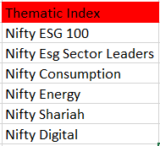

The daily return of all the equities included in the indexes from September 30, 2019, to May 12, 2020, is the data utilized to analyze the pandemic's effects. The information was sourced from NSE and also contained the indices' daily market capitalization. Additionally, information was gathered regarding the overall amount of confirmed Cumulative COVID-19 instances and the overall total of confirmed Cumulative Death cases during the aforementioned time frame. To determine which index was most affected by the pandemic and to determine the importance of each measure, correlation analysis was carried out.
The goal of the study is to determine whether there is any substantial positive RAR connected to the lockdown period surrounding event dates and to measure how quickly lockdown announcements are factored into market security pricing. The paper examines how the COVID-19 lockdown affected the Indian stock market as well as how market perceptions changed before and after the lockdown (ALAM M N 2020).
Lockout announcements and stock returns benefited the majority of the equities in the study. This might be related to the reaction to the news of the lockdown announcement, since it was thought that the lockdown would limit the spread of the virus in the country, helping the country's stock market in the long run, as it had done in virtually every other country prior to India as development and expansion of any stock market are dependent on the country's strong economy and the pandemic poses a problem to the stock returns (ALAM M N 2020).
The findings' applicability must now be determined in this stage. To check for statistical significance, t-statistics are used. To get the t-statistics for RARs, divide the RARs by the total estimation period standard deviation of the daily returns. To obtain the t-statistics, divide the CARs by the sum of the square roots of the absolute values of the event day plus one and the aggregate estimate period standard deviation of the daily returns (Pandey, D.K. & Kumari, V., 2021).
Results are shown for the whole sample of six thematic indexes for the 61-day event window, the 30-day lockdown period, 1-day event period and the 30-day present lockdown period. Table below presents lists the test data acquired using the MS Excel descriptive analysis tool for testing the null hypothesis together with the average daily AR, AARs, CARs, and CAAR for the day's t-30 to t+30. The AARs are negative on the day’s t-29, t-27, t-25, t-24, t-23, t-21, t-20, t-19, t-18, t-17, t-16, t-15, t-10, t-7, t-4, t-3, t1,

t3, t7, t10, t13, t14, t18, t21, t22. However, it has been noted that most of the current lockdown days have significantly positive AARs. In the event window, CAAR is also found to be insignificant. So, we reject our null hypothesis It suggests that most of our indexes (except nifty digital) in the sample did experience a boost as a result of lockdown announcements and returns. This may be the result of how the public reacted to the lockdown announcement news because, before India announced the lockdown, virtually every other nation had expressed hope that the lockdown could slow the virus's spread and, as a result, protect the country's stock market in the long run (ALAM, B. N, 2020).
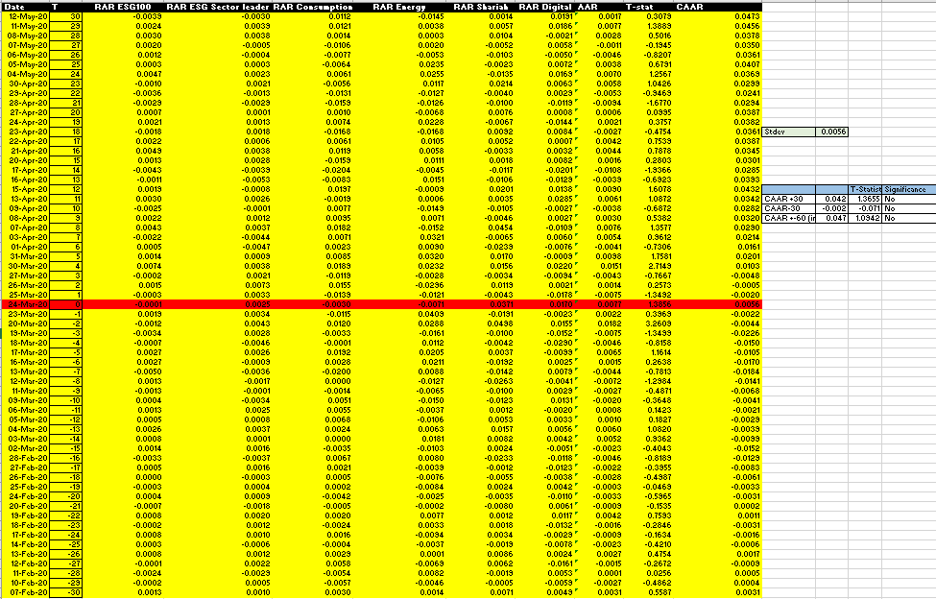

The most of the researched index gained from lockdown announcements and stock returns. This may be connected to the response to the news of the lockdown announcement because it was believed that the lockdown would slow the virus' spread throughout the nation, supporting the stock market in the long run as it had in virtually every other country before

India because the growth and expansion of any stock market are dependent on the country's strong economy and the pandemic poses a challenge to stock returns (ALAM, B. N, 2020).
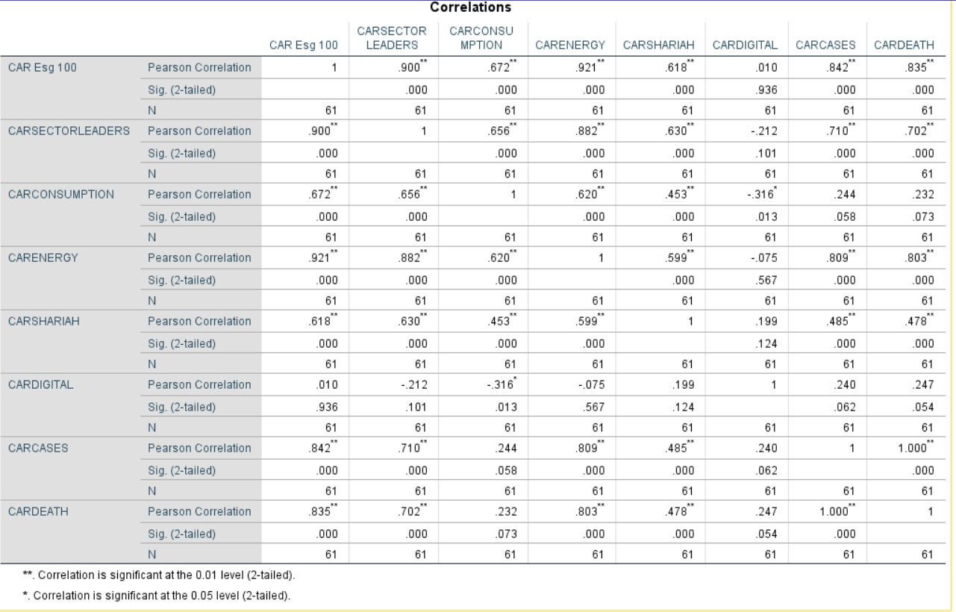

Nifty ESG 100 From this, we can come to the result that ESG 100 index performed well during covid as the cases and death increased as it was the most significant among all other indexes with Covid cases being 0.842 and covid death being 0.835 as the result is near to 1 so it was positive.
ESG Sector leaders were also significant but they were little less or moderately correlated compared to ESG100 as the covid period was the growth for ESG stocks and people were slowly starting to know about sustainable investing. (case 0.702 and death 0.710)
Nifty Consumption was insignificant as they were linearly or little correlated to Covid 19 pandemic. Since this includes a diversified portfolio of stocks the result which invests on a particular theme and since its less risky than a sectorial index as this is slightly more diversified due to this the fund result was average and was not to much volatile comparing to Nifty Digital Index (case 0.244 and death 0.232)
Nifty Energy index performed well during the covid lockdown as it was significant and highly correlated to Covid-19 which means they were good as the energy sector was in high demand as people were in Work from home and online classes so this sector grew. If we take TATA Power, Adani power, and Adani Green Energy etc show almost 3x growth during Covid -19 The index of sample companies, during the period 2020 and 2021, had reported high volatility in their stock prices. When compared to the pre-COVID-19 pandemic period,

the stock price volatility during the post-COVID-19 pandemic period had a significant impact on the NSE NIFTY Energy index sample businesses. In conclusion, COVID-19 had a major influence on the NSE NIFTY Energy index. (Babu et al 2022) (0.809 covid cases 0.803 covid case)
Shariah index was also significant but not that strong comparing to other significant indexes. (case 0.485 death 0.478) Islamic indexes can be used as a hedge against risk brought on by pandemics, such as the COVID-19 pandemic, although the efficiency of the hedging appears to be declining at the moment. The results of the in-sample and out-of-sample forecast evaluation point to the importance of taking uncertainty information into account when valuing stocks for investment purposes.
Nifty Digital index was the least performed comparing to other index with less significance to Covid which says it was weakest and did not perform good (0.247 0.240) This is a result of the widespread panic. Investors were waiting for the policy formation of preventive measures, including the lockout, to prevent the spread of COVID-19. Heavy stock market withdrawals and FII outflow led to the negative AAR When the cases and death increased the index was negatively correlated as a result it was giving negative result.

Conclusion
The COVID-19 outbreak has had an influence on the global economy, with India playing an important role this is because India has the world's second-largest population, and the epidemic is quite concerning. The study uncovers evidence of a positive AR around the present lockout period, indicating that the lockdown has an impact on stock market performance in India until the situation improves. The finding, however, holds true for the study's sample of NSE-listed companies and the time period covered. It is not applicable to other traded stocks, future periods, or any other market situation. (ALAM M N 2020). To the best of our knowledge, none of the earlier studies have looked at the consequences of the COVID-19 pandemic on the Indian thematic indexes, despite the fact that the research on the effects of COVID-19 is still developing. We look into how the COVID-19 epidemic has affected six Indian thematic indexes and the industry average. Using an event research methodology, we discover that the abnormal and cumulative abnormal returns for the thematic sector during the COVID-19 pandemic are favorable and statistically significant in most of the indexes with few being vice versa. When comparing our data at the level of each index, however, mixed outcomes of abnormal returns are found. The study's findings will assist investors by allowing them to better understand the market. and analyze the impact of the COVID 19 stock market shutdown (C Behara & B Narayan 2021)

References

- Al-Awadhi, A. M., Alsaifi, K., Al-Awadhi, A., & Alhammadi, S. (2020). Death and contagious infectious diseases: Impact of the COVID-19 virus on stock market returns. Journal of Behavioral and Experimental Finance, 27(1), 100326. https://doi.org/10.1016/j.jbef.2020.100326
- Arefeen, S., & Shimada, K. (2020). Performance and Resilience of Socially Responsible Investing (SRI) and Conventional Funds during Different Shocks in 2016: Evidence from Japan. Sustainability, 12(2), 540. https://doi.org/10.3390/su12020540
- Anh, D. L. T., & Gan, C. (2020). The impact of the COVID-19 lockdown on stock market performance: evidence from Vietnam. Journal of Economic Studies, 48(4). https://doi.org/10.1108/jes-06-2020-0312
- Ashraf, B. N. (2020). Stock markets’ reaction to COVID-19: Cases or fatalities? Research in International Business and Finance, 54(1), 101249. https://doi.org/10.1016/j.ribaf.2020.101249
- Becchetti, L., Ciciretti, R., Dalo, A., & Herzel, S. (2014). Socially Responsible and Conventional Investment Funds: Performance Comparison and the Global Financial Crisis. SSRN Electronic Journal. https://doi.org/10.2139/ssrn.2397939
- Broadstock, D., Chan, K., Cheng, L. T. W., & Wang, X. W. (2020). The Role of ESG Performance During Times of Financial Crisis: Evidence from COVID-19 in China. SSRN Electronic Journal, 38. https://doi.org/10.2139/ssrn.3627439
- Brooks, C. (2014). Introductory Econometrics for Finance. RePEc: Research Papers in Economics. https://doi.org/10.1017/cbo9781139540872
- Cepoi, C.-O. (2020). Asymmetric dependence between stock market returns and news during COVID19 financial turmoil. Finance Research Letters, 36, 101658. https://doi.org/10.1016/j.frl.2020.101658
- The main ESG ratings. (n.d.). TotalEnergies.com. Retrieved January 12, 2024, from https://sustainable-performance.totalenergies.com/en/reporting/core-esg-indexes
- DJSI Index Family | S&P Global. (n.d.). Www.spglobal.com. https://www.spglobal.com/esg/performance/indices/djsi-index-family
- Investment Management & Financial Services. (n.d.). BlackRock. Retrieved January 12, 2024, from https://www.blackrock.com/us/individual/investment-ideas/sustainable-investing/
- Covid-19 India timeline: Looking back at pandemic-induced lockdown and how the country is coping with the crisis. (2021, March 23). The Indian Express. https://indianexpress.com/article/india/covid-19-india-timeline-looking-back-at-p
- Fazlollahi, N., Ozatac, N., & Gokmenoglu, K. K. (2020). Evolving time-varying market efficiency of energy stock market. Environmental Science and Pollution Research, 27(36), 45539–45554. https://doi.org/10.1007/s11356-020-09887-7
- FTSE Russell. (2016). FTSE4Good Index Series. Ftserussell.com; FTSE Russell. https://www.ftserussell.com/products/indices/ftse4good
- Lean, H. H., & Pizzutilo, F. (2020). Performances and risk of socially responsible investments across regions during crisis. International Journal of Finance & Economics. https://doi.org/10.1002/ijfe.1975
- Leite, P., & Ceu Cortez, M. (2014). Performance of European Socially Responsible Funds During Market Crises: Evidence for France. SSRN Electronic Journal. https://doi.org/10.2139/ssrn.2461400
- Mandelbrot, B. (1963). The Variation of Certain Speculative Prices. The Journal of Business, 36(4), 394. https://doi.org/10.1086/294632
- Morales, L., Soler-Domínguez, A., & Hanly, J. (2019). The power of ethical investment in the context of political uncertainty. Journal of Applied Economics, 22(1), 554–580. https://doi.org/10.1080/15140326.2019.1683264
- Nakai, M., Yamaguchi, K., & Takeuchi, K. (2016). Can SRI funds better resist global financial crisis? Evidence from Japan. International Review of Financial Analysis, 48, 12–20. https://doi.org/10.1016/j.irfa.2016.09.002
- Nguyen, C. T., Hai, P. T., & Nguyen, H. K. (2021). Stock market returns and liquidity during the COVID-19 outbreak: evidence from the financial services sector in Vietnam. Asian Journal of Economics and Banking, 5(3), 324–342. https://doi.org/10.1108/ajeb-06-2021-0070
- Nofsinger, J., & Varma, A. (2014). Socially responsible funds and market crises. Journal of Banking & Finance, 48, 180–193. https://doi.org/10.1016/j.jbankfin.2013.12.016
- Oberndorfer, U., Schmidt, P., Wagner, M., & Ziegler, A. (2013). Does the stock market value the inclusion in a sustainability stock index? An event study analysis for German firms. Journal of Environmental Economics and Management, 66(3), 497–509. https://doi.org/10.1016/j.jeem.2013.04.005
- Omura, A., Roca, E., & Nakai, M. (2020). Does responsible investing pay during economic downturns: Evidence from the COVID-19 pandemic. Finance Research Letters, 101914. https://doi.org/10.1016/j.frl.2020.101914
- Rahman, M. L., Amin, A., & Al Mamun, M. A. (2020). The COVID-19 outbreak and stock market reactions: Evidence from Australia. Finance Research Letters, 38, 101832. https://doi.org/10.1016/j.frl.2020.101832
- SGA. (n.d.). The rise in ESG investing a 30 Trillion market story. Us.sganalytics.com. Retrieved January 12, 2024, from https://us.sganalytics.com/blog/the-rise-in-esg-investing-a-30-trillion-market-story/
- Sakurai, Y., & Kurosaki, T. (2020). How has the relationship between oil and the US stock market changed after the Covid-19 crisis? Finance Research Letters, 101773. https://doi.org/10.1016/j.frl.2020.101773
- Sherif, M. (2020). The impact of Coronavirus (COVID-19) outbreak on faith-based investments: An original analysis. Journal of Behavioral and Experimental Finance, 28, 100403. https://doi.org/10.1016/j.jbef.2020.100403
- Singh, A. (2020). COVID-19 and safer investment bets. Finance Research Letters, 101729. https://doi.org/10.1016/j.frl.2020.101729
- Stobierski, T. (2022, July 14). What Is Sustainable Investing? Business Insights - Blog. https://online.hbs.edu/blog/post/sustainable-investing
- Why COVID-19 Could be a Major Turning Point for ESG Investing. (2020, July 1). Www.jpmorgan.com. https://www.jpmorgan.com/insights/research/covid-19-esg-investing
- Gupta, A. (2021). IMPACT OF COVID 19 ON NIFTY 50 VOLATILITY. International Journal of Advanced Research, 9(5), 1238–1241. https://doi.org/10.21474/ijar01/12961
- Redirecting. (2024). Doi.org. https://doi.org/10.1016%2Fj.jece.2021.106595
- ALAM, M. N., ALAM, Md. S., & CHAVALI, K. (2020). Stock Market Response during COVID-19 Lockdown Period in India: An Event Study. The Journal of Asian Finance, Economics and Business, 7(7), 131–137. https://doi.org/10.13106/jafeb.2020.vol7.no7.131
- Jindal, A., Prashar, D. R., & PS Chahal, D. B. (2020). Impact of Covid-19 on India’s Stock Market. Annals of Tropical Medicine and Public Health, 23(17). https://doi.org/10.36295/asro.2020.23205
- Manivannan Babu, Lourdesraj, A. A., Jayapal, G., Indhumathi, G., & Sathya, J. (2022). Effect of COVID-19 Pandemic on NSE Nifty Energy Index. International Journal of Energy Economics and Policy, 12(4), 141–145. https://doi.org/10.32479/ijeep.13171
- Dharani, M. (2011). Equanimity of Risk and Return Relationship between Shariah Index and General Index in India. Journal of Economics and Behavioral Studies, 2(5), 213–222. https://doi.org/10.22610/jebs.v2i5.239
- Pandey, D. K., & Kumari, V. (2021). Event study on the reaction of the developed and emerging stock markets to the 2019-nCoV outbreak. International Review of Economics & Finance, 71, 467–483. https://doi.org/10.1016/j.iref.2020.09.014
- Salisu, A. A., & Shaik, M. (2022). Islamic Stock indices and COVID-19 pandemic. International Review of Economics & Finance, 80, 282–293. https://doi.org/10.1016/j.iref.2022.02.073

‌

