Developing the Value Added Product (Panitenga) an Indigenous Traditional Food Dish of Assam
Kamal Gauli¹, Swapna Dutta ²
Department of Home science
Lakhimpur Telahi Kamalabaria College, Assam
Corresponding author email:gaulikamal@gmail.com
SL No | Author Name | E-mail ID
1 | Mr. Kamal Gauli | gaulikamal@gmail.com
2 | Dr. Swapna Dutta | swapnadutta544@gmail.com

Abstract
Strong in taste Panitenga or mostly known as Kahudi is a very unique fermented recipe from Assam which is mostly served with an Assamese meal as a side dish Panitenga is one of the traditional food products mainly consumed by the people of Assam..Our study was done to develop a new method to increase the shelf life of the panitenga an indigenous dish made in Assam so that a new product may develop and can be brought to market .These panitenga indigenous dish is indeed very rich in phytonutrients, minerals, vitamins, and anti-oxidants.
Keywords: Panitenga, Kahudi, Indigenous, Traditional, Shelf-life.

Introduction
Developing new products is a complex process requiring knowledge of ingredients, processing techniques packaging materials, legislation and consumer demands and preferences. Product development is the process of creating new or modified food products. The aim of food product development is to increase sales. The process of product development involves a complex series of stages, requiring the combined talents of many specialists to make it successful. Manufacture of products is controlled throughout to ensure that the original specification is met. The products should fill a gap in the market. In addition, consumers must be tempted to buy the new products in preference to similar products.The food processing sector has the potential to grow at a rapid pace with the demand for processed food increasingly every day. Considerations such as improving food safety, shelf life, and reducing wastage, to demands for increasingly sophisticated foods having special characteristics in terms of nutritional value, palatability, and convenience. The actual product development process is determined by the interaction between consumer expectations and demand.
Material and methods
Panitenga is one of the traditional food products mainly consumed by the people of Assam. In this study we are developing a new idea to increase the shelf life of this dishes by using different a methods. Here the panitenga is prepared from the extract of mustard seeds which is obtained during the preparation of mastered oil. Different spices like chili, salt, garlic, ginger are mixed and panitenga dough is prepared. Now this dough’s are kept submerged for 3-4 days in the lemon juice or vinegar solution and are then taken out and sundried for a day and blended into a paste. The paste is then transferred into a vessel and can be stored and consumed for up to 6 months.
Steps for preparation of panitenga dish:
Washing the mustard seed

Sun dry the seed

Grinding and sieving

Mixing salt and Chili powder

Mixing the lemon juice and make a dough

7. Wrapped in banana leaves

Steps for preparation of panitenga dish using new method
Washing the extract of mustard seed

Sundry the extract of mustard seed.

Sieving the extract seeds

Mixing with different spices.

Dough is prepared.

Submerged the dough into the vinegar solution for 2-3 days.

7. Taken out the dough and sundried

Results and discussion

Results shows that the panitenga dough wrapped by banana leaves had develop the fungus very fast within a very short period of time on the other hand the panitenga dough which was dried and deep into the vinegar solution had not affect by any fungus and long storage life was observed in this dough. This may be due to the following reasons: Foods are preserved in vinegar in an attempt to lower the pH, which can prevent the growth of food-spoiling microbes. Microorganisms responsible to destroy food cannot live in an acetic acid environment. Vinegar is most commonly used preservatives in food product. The acetic acid in vinegar kills microbes and stalls food spoilage. Vinegar delays the Listeria monocytogenes growth in the food products. Thereby it increases the shelf life of the panitenga (kahudi) dish. Strong in taste Panitenga or mostly known as Kahudi is a very unique fermented recipe from Assam which is mostly served with an Assamese meal as a side dish. This product is only made in Assam. It is very easy to make and taste of the products is very good. We can use this product for income generation. When value is added to this product like packaging than its look good and it is also safe and hygienic.

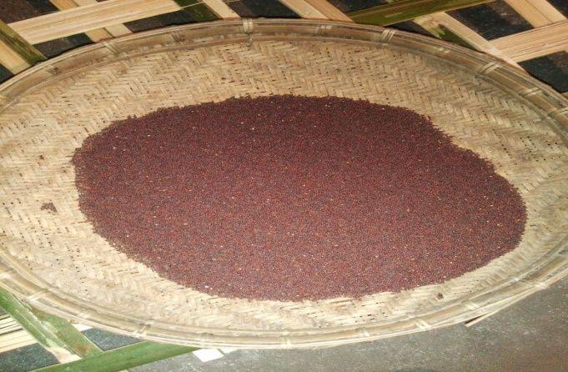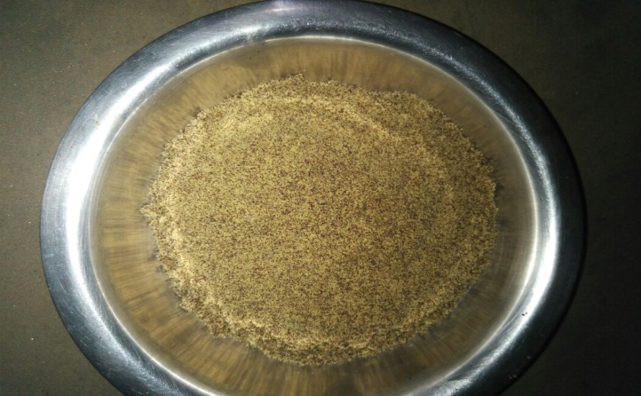
1.Pic :Mustard seed 2.Powdered mustard seed

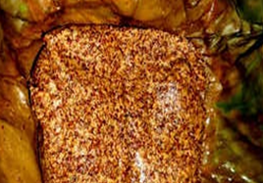
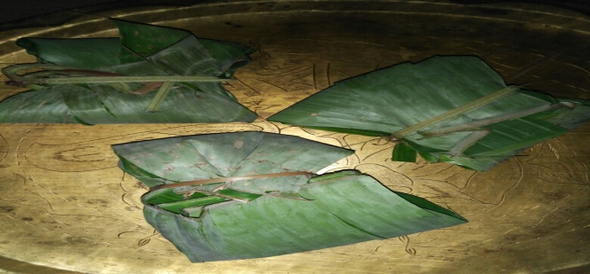
3. Panitega dough 4.Panitenga wrapped in banana leaves

Conclusion

Results shows that this product is only made in Assam. It is very easy to make and taste of the products is very good. As the mustard seeds becomes a waste product after extracting oil so this mustard seed can be use to develop a new product like panitenga which is made in Assam. We can use this product for income generation. It can be new product in the market as it is not available in the market. When value is added to this product like packaging than its look good and it is also safe and hygienically made. This product is also nutritious and good for health. These panitenga samples are indeed very rich in phytonutrients, minerals, vitamins, and anti-oxidants. Prepared sample indigenous dish may contain B-complex vitamins such as foliates, niacin, thiamin, riboflavin, pyridoxine (vitaminB-6), pantothenic acid. These B-complex groups of vitamins help in enzyme synthesis, nervous system function and regulating body metabolism. Thus a vast study is a very much important.

Acknowledgement
I would like to acknowledge and give my warmest thanks to Dr. Swapna Dutta, Assistant Professor, Home Science Dept, L.T.K.College, North Lakhimpur, who helped with her advice and guidance to carry out the all possible work. I would also like to give thanks to all the staffs of L.T.K.College, North Lakhimpur, for their support and guidance in carrying out this work the completion of this work could not have been possible without all of them.

Reference

1. Deak T. Yeasts in specific types of foods, Chapter 7. In: Handbook of food spoilage Yeasts. 2nd ed. Boca Raton (Florida): CRC Press; 2007. p. 117e201
2. A study on indigenous fermented foods and beverages of Kokrajhar, Assam, India: Yutika Narzary, Jahnovi Brahma, Chandan Brahma, Sandeep Das
3. Singh RK, Singh A and Sureja AK. Traditional foods of Monpa tribe of West Kameng. Indian J Tradit Know 2007; 6:25e36.
4. Devi, P. B., & Shetty, P. H. (2020). Traditional preserved and fermented foods and their nutritional aspects. Nutritional and Health Aspects of Food in South Asian Countries, 61–73. https://doi.org/10.1016/B978-0-12-820011-7.00006-X

