"Enhancing Stock Price Prediction Accuracy through Advanced Machine Learning Models and Technical Indicators: A Comprehensive Analysis on Reliance Industry Data"
Research project submitted to CHRIST (Deemed to be University)
as partial requirement for the award of the Degree of

BACHELOR

IN
COMMERCE
by

KIRUTHIK PRANAV SR
And
AMIT KUMAR SAHOO

Under the Supervision of
PROF. KV THOMAS
Assistant Professor

Name and Signature of Student Name and Signature of Supervisor(s)



DEPARTMENT OF COMMERCE
CHRIST (Deemed to be University) PUNE LAVASA CAMPUS
APRIL 2024

DEPARTMENT OF COMMERCE

Approval of Research Project

Name of Student | KIRUTHIK PRANAV, AMIT KUMAR SAHOO
Discipline | Commerce
Name of Research Guide | Prof. KV THOMAS
Date of Department Level Presentation of Viva | 25.04.2024
Title of the Research Project: | Enhancing Stock Price Prediction Accuracy through Advanced Machine Learning Models and Technical Indicators: A Comprehensive Analysis on Reliance Industry Data
Approved by:

- Name of Research Guide: Signature:

- Name of Research Co-Ordinator Signature:

Head of Department

Seal of Department of Commerce
ii

ABSTRACT
The stock market can be described as a complicated and unpredictable system where prices of stocks and other securities can change quickly as a result of a wide range of factors, creating a very volatile environment. Advances in artificial intelligence and powerful computers have increased efficiency in this area, making it more important than ever to predict stock prices accurately and precisely. In recent years, the theoretical and speculative aspects of the stock market have been examined, with an emphasis on identifying and making use of recurring patterns to enhance forecasts. Various models, including Logistic Regression (LR), Long Short-Term Memory (LSTM), and Support Vector Regression (SVR), were utilized in this study to predict stock prices. The financial data used in the study includes important factors such as Date, Volume, Open, High, Low, Close, and Adjusted Close prices. Additionally, the study incorporates technical indicators such as Relative Strength Index (RSI), Exponential Moving Average, and Moving Average Convergence-Divergence to improve the accuracy of the predictions. The analysis includes 22 years of data for the Reliance industry. The models are evaluated using standard strategic indicators RMSE, MAPE for LSTM & SVR model, and accuracy for LR. Making accurate stock price predictions can provide investors with workable solutions to the problems they encounter in real-world situations. Accurate forecasts help investors make wise decisions that minimize risks and maximize returns.

KEYWORDS: LSTM, SVR, Logistic Regression, RMSE, MAE, MACD, RSI, MACD, high price, low price, volume, close price, open price.

TABLE OF CONTENTS
SN0: | Content
1. | Abstract And Keyword
2. | Introduction
3. | Problem Identification
4. | Company Profile
5. | Objective
6. | Literature Review
7. | Research Methodology
8. | Long Short-Term Memory
9. | Support Victor Regression
10. | Logistic Regression
11. | Data Collection
12. | Algorithm For LSTM
13. | Algorithm For SVR
14. | Algorithm For LR
15. | Results And Interpretation
16. | Conclusion
17. | Reference

CHAPTER 1

1. INTRODUCTION
With the development of artificial intelligence, new methods like deep learning and machine learning have emerged. These advancements have paved the way for the development of analytics and data science solutions for a variety of business issues. Stock trading is one of the most important uses of these methods in the financial industry. A share represents the unit of firm ownership. The shareholder of a corporation earns any profits that the corporation earns as a dividend. They are the bearers of losses as well if that company incurs any losses. A shareholder or investor exchanges capital for the shares. Shares are a way for a corporation to generate capital for growth in exchange for sharing the profit and loss in the proportion to the shareholder as a dividend. On the other hand, a stock market is the number of venues where shares of any corporation can be sold and bought. These activities can be conducted through formal exchanges in electronic or physical form and via OTC marketplaces and these venues operate by a set of regulations that are regulated by some local regulatory bodies.
Stock market prediction is the practice of speculating on the future values of stocks or other financial instruments traded on stock exchanges. Profitable trades can be made by correctly predicting a stock's future price. Machine learning techniques have been widely used by traders recently across many industries. Understanding financial data and the stock market from a machine learning perspective offers a distinctive viewpoint. Algorithms for machine learning can spot unusual patterns of behavior by looking at previous behavior. The stock market is incredibly volatile and produces a tonne of data. Political developments, economic conditions, and traders' expectations are just a few of the variables that affect the stock market. The main goal is to lessen uncertainty by accurately forecasting future stock market values and identifying their fluctuations in advance to reduce risks.

  - PROBLEM IDENTIFICATION
Stock market prediction involves estimating the worth of particular stock and making efforts to comprehend and anticipate fluctuations in the macro and micro economic environment. Consequently, relying on a single dataset for the prediction is insufficient and may produce inaccurate results. As a result, we are focusing on the implications of ML with different dataset integrations to forecast market trends.
The challenge of predicting stock prices will persist unless a more advanced algorithm for stock market prediction is developed. Estimating the movement of the stock market is a complex and challenging task. Being able to anticipate how investors react to current events is a skill that is valuable in stock market trading. A political leader's statement, a scam-related news item, etc. are examples of political events that might fall under this category. Predicting stock prices is very challenging due to these types of factors. Once the appropriate data is gathered, it can be used to train a computer and produce a prognostic outcome.
1.2 COMPANY PROFILE
Reliance Industries (RIL) is a Mumbai-based multinational conglomerate with a market capitalization of 1,563,887 crores, making it the most valuable Indian company. RIL operates businesses in a range of industries, including petrochemicals, textiles, telecommunications, and retail. The business is well known for emphasizing technology and innovation, and it has made sizeable investments in R&D to support its growth and sustainability efforts. RIL has received various accolades and recognition for its corporate conduct and contributions to the Indian economy.

1.3 OBJECTIVE
- To predict the stock price of the Reliance Industry with a high level of accuracy and precision.
- To find the indicator and the data which has a high impact on the prediction of the price using LSTM and SVR algorithms by comparing the RMSE and MAE values for different input combinations.
- To predict the stock price movement of the next day using Logistic Regression.

CHAPTER 2
2. LITERATURE REVIEW
Manish Agrawal et al. [20] developed an optimal Long Short-Term Memory (O-LSTM) deep learning approach, coupled with adaptive Stock Technical Indicators, to improve the predictability of daily stock price trends. To optimize the deep learning process, a correlation tensor is constructed using appropriate technical indicators. The tensor, along with adaptive indicators, is passed to the model to enhance the accuracy of the prediction. The mean prediction accuracy obtained using the proposed model is 59.25%, which is significantly higher than traditional benchmark approaches, for a variety of stocks.
On yahoo finance datasets, Ishita et al. and associates used regression and long short-term memory (LSTM) networks to forecast stock prices. For this specific issue, they discovered that LSTM-based models performed better than other approaches.
Achyut Ghosh et al. [23] has been observed from the result that for different sectors (IT, Pharma, Bank, Aviation, FMCG) the error level comes down drastically with the test data for longer periods. Therefore, this model that uses LSTM to predict share prices is designed to work with historical data over long periods. Guangyu Ding et al. [22] introduced the Associated Net, a multi-value associated network model based on an LSTM-based deep recurrent neural network, to predict various stock prices. The experiments' findings demonstrated that the Associated Net model's average accuracy is greater than that of the other two models. Furthermore, the Associated Net model forecasts multiple values simultaneously with an average accuracy of over 95% for each value predicted.
Zhen Sun et al. [16] conducted a study to compare the forecasting performance of three machine learning algorithms, namely Multiple Linear Regression, Random Forest, and LSTM. The study found that Multiple Linear Regression is more suitable for predicting future stock prices, while Random Forest had the best prediction accuracy for in-sample data. However, Random Forest did not perform as well as Multiple Linear Regression for out-of-sample data, indicating a higher risk of overfitting. The LSTM network had the worst forecasting performance for both in-sample and out-of-sample data, with higher values of RMSE and MAPE. The study also found that using the closing price of NASDAQ ETF yielded better forecast results compared to using statistical factors, although the difference was not significant.
Using a Convolutional Neural Network (CNN) for financial news and a Long Short-Term Memory (LSTM) for technical indicators, Manuel R. Vargas et al. [13] developed a hybrid model known as SI-RCNN. Additionally, they proposed the I-RNN LSTM network for technical indicators. A trading agent that chooses when to buy or sell stocks uses the output of each model as its input. While the sets of technical indicators used did not show appreciable improvements, the results demonstrate that financial news is crucial in stabilizing predictions.
Srinath Ravikumar et al. [14] created a system that forecasts stock prices using regression and classification algorithms. The system employs two methods: regression to forecast the closing price of a company's stock and classification to predict whether the stock's closing price will increase or decrease the following day.
Phayung Meesad et al. [24] used different windowing techniques in SVR to predict the stock price. The study is conducted using the 4 years time series data of the ACI group of companies from the Dhaka stock exchange. The results show that the de-flatten windows provide precise value compared to rectangular and flattened window operators, but they are good enough to predict the price.
The technical indicators and the average of 5 days' stock information such as open, close, high, low, and volume are used to predict the next five days' stock price. Additionally, we make use of technical analysis indicators to decide whether to buy, hold, or sell stocks. To test the effectiveness of the Neural Network Long Short-Term Memory, the authors utilized data from the Taiwan Stock Exchange of Foxconn Company [25].
Hum Nath Bhandari et al. [3] compared the single and multilayer LSTM, and the experimental results demonstrate that a single-layer LSTM model with approximately 150 hidden neurons can provide a better fit and higher prediction precision. If data in other broad market indices show a similar pattern, the proposed model can be easily modified to apply there. The proposed model can help interested parties make better-informed investment decisions by providing them with more accurate market information.
Israt Jahan et al. [26] anticipated the stock price is extremely close to the actual price. In his study, stock prices from five different companies were sampled. According to this model, the mean absolute percentage error is less than 2%. The model efficiency is measured using the metrics such as the absolute percentage of error, the coefficient of determination (r²), Pearson's correlation coefficient, the Spearman's rank correlation coefficient, and the explained variance error. Based on the results, there is a notable connection between the projected and real stock prices. The Wilcoxon signed rank test and the chi-square goodness of fit tests were carried out to verify the statistical hypothesis.
According to Ugur Demirel et al. [19], both MLP and LSTM models are effective in time series analysis for predicting stock prices. The study found that the MLP model performed better than SVM and LSTM models in predicting the opening stock prices, while the LSTM model outperformed MLP and SVM models in predicting the closing stock prices. The SVM model had the poorest forecasting performance among the three models for both opening and closing stock prices.
Srilakshmi et al. [27] analyzed an increase in the number of epochs, CNN LSTM, Single-Layer, and Three-Layer LSTM performance have steadily improved. Hyperparameter tuning, which involves altering the neural network's activation function, number of neurons, or number of layers, can improve the accuracy of stock price predictions. To produce more reliable results, the suggested models could also be combined. To make a more reliable prediction of future stock prices, external factors like news headlines can be taken into account in addition to the stock prices. Any company's stock price can be forecast using the suggested DL approach.
The increase in epochs increases the prediction accuracy of the LSTM model [21]. For daily prices and fixed training models, the Gaussian kernel is more effective in predicting stock prices compared to the radial and polynomial kernels, and it outperformed the random model for some stocks in the three countries under consideration that were categorized as blue chips and small caps. The model's ability to predict prices using a fixed training period was however diminished when the price frequency was increased to minutes. About almost all stocks studied in real-time prices, SVR's predictive performance was worse than a random walk model regardless of the kernel function used [2].
Yash Mehta et al. and colleagues [15] employed three different models and conducted sentiment analysis on tweets related to the company or stock. The classification results provided valuable insights into the market's unpredictable fluctuations and a new investment approach for investors. The study concluded that the ARIMA model demonstrated the best accuracy for predicting stock prices among the three models.
Binary logistic regression has been used by Mrinalini Smita et al. [27] to analyze the relationship between financial ratios and the stock performance of the companies. She demonstrated the application of the Logistic Regression method to forecast the likelihood of stock performance. The classification and misclassification are analyzed for both good and poor companies. The results show that good companies have a correct classification rate of 86.7%, and poor companies have a rate of 93.3%. The performance of the model was 90%.
Utilizing data from various stock indexes, including the S&P 500, NYSE, NSE, BSE, NASDAQ, and Dow Jones Industrial Average, Gourav Bathla et al. [18] used LSTM to predict stock price movements and compared its performance with that of SVR. According to the analysis, LSTM outperformed SVR in terms of accuracy. Ranjeet Kaur et al. and Yogesh Kumar Sharma et al. [17] decided on the technique that would produce the highest level of accuracy. Three supervised learning methods were put to the test using various variations, and they were trained on training sets that were 70:30, 50:50, and 30:70 in size, respectively. The 70:30 training size for the KNN variant was discovered to be the best.
CHAPTER 3

3. RESEARCH METHODOLOGY
For a better understanding of the structure of LSTM, SVR and Logistic Regression are discussed. Accuracy is not sufficient for the prediction of stock price. In this paper, the accuracy, RMSE, and MAE are compared for different input combinations for both LSTM and SVR. The Logistic Regression is used to predict the direction of stock price movement depending on the input data and indicators for Reliance Industry. The platform and language used to predict the price is Jupiter notebook and python respectively. The necessary libraries are imported for the processing of the data.

3.1 LONG-SHORT TERM MEMORY
LSTM (Long Short-Term Memory) is a type of Recurrent Neural Network (RNN) that is designed to store long-term temporal dependencies by incorporating memory cells within the network architecture. Each LSTM neuron functions as a memory cell that is capable of retaining specific contextual information over a prolonged period. This is because the memory cell can maintain and manipulate its internal state, which allows it to keep track of relevant data. An LSTM neuron considers both the old cell state and new cell state in output, as opposed to normal RNN neurons, which only take in their current input and previous hidden state to produce a new hidden state.

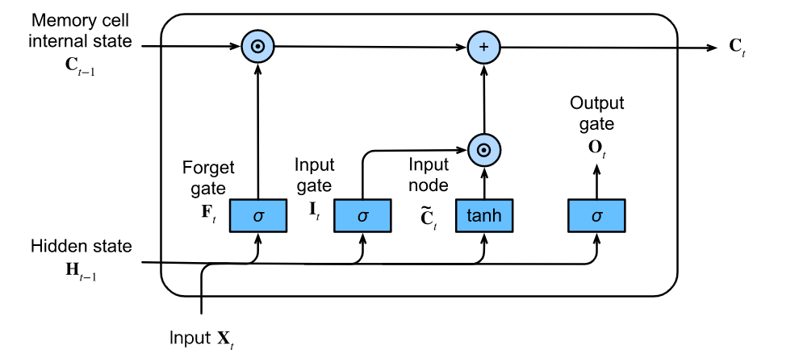

Fig 3.1: LSTM Architecture

The cell state has the accessibility to add or remove information. Numbers between 0 and 1 are generated by the sigmoid layer, indicating how much of each component should be allowed to pass. The new vector is generated by the layer tanh.

The gates that make up an LSTM memory cell are
- Forget gate: It chooses when to replace particular sections of the cell state with the most recent data. The generated value close to 1 is added to the cell state as components and the values nearer to 0 are eliminated.
- Input gate: Using the input, the gate validates the information to get stored in the cell state.
- Output gate: This part determines what data is forwarded to the network's next node, depending on the input and cell state. Therefore, we can conclude that the LSTM model is suitable for identifying the fluctuations in the price of the stock over time can impact the prices of multiple other stocks.
The LSTM network can selectively choose which information to retain as it enters the network. Any information that does not align with the algorithm can be eliminated through the forgetting gate, allowing only relevant data to be stored. By saving states in the cell state, it overcomes one of the drawbacks. Additionally, the LSTM has a Forget gate that determines whether or not previous state data is pertinent. Cell state saves the information when the Forget gate output is 1, and ignores it when the output is 0. Additionally used in LSTM are input and output gates. Input gates filter data from earlier layers, and output gates filter data that will be sent to the next layer.

3.2 SUPPORT VECTOR REGRESSION
The primary goal of SVR is to determine the optimal function-to-data point fit. A hyperplane situated in a high-dimensional space serves as the function's representation. The fundamental goal of SVR is to identify a hyperplane that minimizes error while still providing the best fit to the data points in the feature space. Support vectors, a subset of the data points that are the nearest to the hyperplane and define the hyperplane, are the subset of data points that make up the entire dataset. SVR aims to maximize margin, i.e., defined as the distance between hyperplane and support vectors. SVR uses a loss function that penalizes errors and a regularisation term that regulates the model's complexity to accomplish this. The epsilon-insensitive loss, which penalizes errors outside of a given range (epsilon), is the most frequently used loss function in SVR. Typically, the regularisation term is a quadratic penalty on the weights' magnitude.
The linear kernel, polynomial kernel, and Radial Basis function kernel provide non-linear relationships between the input and output variables. The kernel changes the dataset from lower dimensional to higher dimensional. The computation cost is reduced by assisting the hyperplane in the higher dimension. Moving to a higher dimension becomes necessary when it is impossible to find a way to separate the hyperplane in the current dimension. In SVR, the objective is to find a hyperplane that best fits the training data such that the support vectors—the distances between the hyperplane and the nearest data points—are maximized. The linear kernel is a particular kind of kernel function that calculates the dot product of two data points to determine similarity.

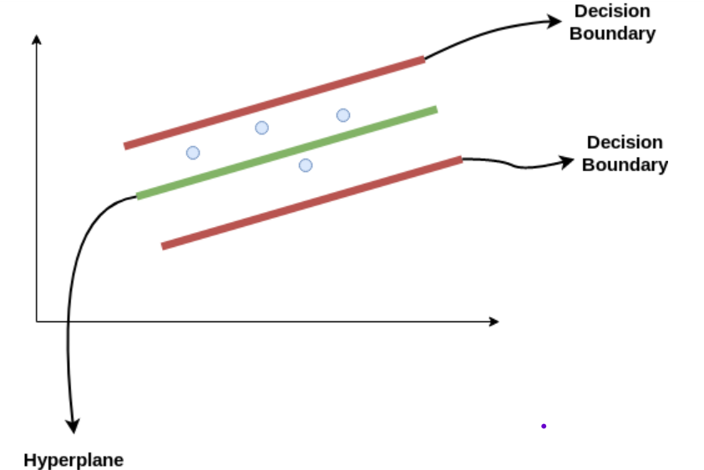
Fig 3.2 SVR planes

The line separating the data classes in the SVR is a hyperplane. It helps to predict the value with high accuracy. Besides the hyperplane, the algorithm creates two boundary lines, which are categorized as positive or negative. The points are within the boundary lines. The line which has a maximum number of points could be considered a best-fit line.
The equation of the hyperplane
y = wx + b
The equations of the boundary lines are
wx + b = +a
wx + b = -a
So, the points should be lies between -a < y-wx+b < +a

3.3 LOGISTIC REGRESSION
Logistic regression is a statistical analysis technique that uses prior observations of a dataset to predict a binary outcome, such as whether a result will be 1 or 0. A linear classifier called logistic regression learns or modifies the weights for each attribute in the input vector using training data. In Logistic Regression (LR), we predict the Probability of Y occurring given known values of X’s rather than the value of the variable Y from a predictor variable X or several predictor variable X’s. As a result, the logistic regression model is a kind of Generalised Linear Model (GLM) that enhances the linear regression model by standardizing the real numbers to the 0–1 range. Regression employs binomial probability theory, as opposed to OLS (ordinary least squares) regression, which uses normal probability theory. The actual value of the outcome variable Y could not be predicted based on the predictor variable X, rather, the probability of Y is predicted from a set of known X values.
Regression problems are not modeled using this statistical approach.
The "log odds" are referred to by the term "logistic". Based on odds ratios, logit regression models the relationship between the binary dependent variables. The odds ratio is the comparison between the likelihood that something will occur and the likelihood that it won't. It implies that as the chances and probabilities rise, so do they. The range of probability is from 0 to 1, while odds are measured from 0 to infinity. Logistic regression uses the natural algorithm of odds, also known as logit, as the dependent variable. It illustrates how the odds change for a given variable in a logistic regression while keeping all other variables constant.

3.4 DATA COLLECTION
The daily data are gathered for Reliance Industry from the Yahoo/Finance website. The data collection spans a full 22-year period, beginning in January 2000 and ending in December 2022. The dataset contains 5755 data, 4604 are considered training datasets, and 1151 are considered testing data. The parameters are the stock's price at the start of the day ("open price"), its highest point during the day ("high price"), its lowest point during the day ("low price"), last price ("close price"), and the number of shares traded on that day (volume). are the parameters used as indicators The stock's closing price the following day is used as the output.
In addition to the parameters, there are other technical indicators used in financial analysis. These include the 12-period EMA (Exponential Moving Average), the 26-period EMA, MACD (Moving Average Convergence/Divergence), and RSI (Relative Strength Index). To calculate the EMA, the mean price of an asset over a specific duration is computed. The EMA calculation assigns greater importance to more recent prices in the time series compared to earlier prices.
EMA = (Price – EMA (previous day)) * (2/(n+1)) + EMA (previous day)
The difference between the rapidly fluctuating stock price or index and the slowly fluctuating exponential moving average (EMA) at the close is what determines the MACD indicator's curves and graphs. As opposed to "Slow," which refers to EMA over a longer period, "Fast" denotes EMA over a shorter period. 12-day and 26-day EMAs are the most frequently used.
MACD = EMA_{(Close,12)} - EMA_{(Close,26)}
With the help of a technical analysis tool RSI, price intensity can be expressed by comparing price movements.
RSI = 100-(100/(1+RS))
Where RS = Average Gain /Average Loss
Traders employ RSI to spot trend reversals or to validate trends. They spot potential trend reversals by observing divergences between the RSI and the price. It may be a sign that the asset needs a price correction when the RSI is in overbought or oversold territory.

3.5 ALGORITHM
3.5.1 ALGORITHM FOR LSTM
Input: History data of Reliance Industry.
Output: The predicted price of the history data, MAPE, MAE, and RMSE value.
Step 1: Begin and import the required libraries. The libraries are Sequential, MinMaxScaler, LSTM, Dense, Dropout, math, NumPy, and pandas.
Step 2: Import the data and eliminate the NA values and outliers during pre-processing.
Step 3: Different combinations of inputs are given to the algorithm to predict which combinations provide the minimum error.
Step 4: Split the dataset into training and testing data (80:20) for model performance.
Step 5: The data undergoes feature scaling operation using MinMaxScaler so that the values of the input range from 0 to 1.
x* = (x – x_{min}) / (x_{max} – x_{min})
Step 6: Assembling a data structure with 1 output and 60 timestamps.
Step 7: After assembling it for the dataset, initialize the recurrent neural network using the sequential repressor for LSTM.
Step 8: After inserting the first layer of the Long Short-Term Memory model, eliminate the undesirable values by incorporating the Dropout regularisation. After eliminating the undesirable values, the output layer is added in LSTM.
Step 9: The performance could be found by testing the 1151 testing data.
Step 10: The model used to predict the results of new data once it has been trained and tested.
Step 11: Evaluate the model performance on the predicted data using MAPE, MAE, and RMSE metrics.

3.5.2 ALGORITHM FOR SVR
Step 1: Begin and import the required libraries. The libraries are Sequential, MinMaxScaler, train_test_split, SVR, Dropout, math, NumPy, and pandas.
Step 2: Import the data and eliminate the NA values and outliers during pre-processing.
Step 3: Different combinations of inputs are given to the algorithm to predict which combinations provide the minimum error.
Step 4: Split the dataset into training and testing data (80:20) for model performance and perform feature scaling operation using MinMaxScaler so that the values of the input range from 0 to 1.
Step 6: The linear kernel function is chosen and tune the hyperparameters such as C and epsilon are. Hyperparameters determine the balance between model complexity and accuracy. Epsilon determines the diameter of the tube around the regression line, and C determines how the slack variables and the margin are traded off.
Step 7: By minimizing the regularised objective function, the SVR model is trained using the training data. Using methods like quadratic programming or gradient descent, a convex optimization problem is solved in this situation.
Step 8: Evaluate the model performance on the predicted data using MAPE, MAE, and RMSE metrics.
Step 9: The model used to predict the results of new data once it has been trained and tested.

3.5.2 ALGORITHM FOR LR
Step 1: Begin and import the required libraries. The libraries are LogisticRegression, MinMaxScaler, train_test_split, NumPy, and pandas.
Step 2: A binary response variable and predictor variables should be collected in a dataset (continuous or categorical). The binary response variable is calculated from the closing price of the stock. The increase in stock prices should be indicated by the value and 1 and the decrease in stock in stock price is indicated by -1.
Step 3: To process the data for analysis, the dataset is split into training and testing sets. Then the variables are standardized using MinMaxScaler to convert all the values between 0 to 1.
Step 4: The model is evaluated on the testing set using performance metrics such as accuracy and precision.
Step 5: The process is iterated when the performance of the model is not satisfactory by adding a new predictor variable.
Step 6: The probability of the binary response variable for new observations can be predicted using the trained logistic regression model.

CHAPTER 4
4. RESULTS AND INTERPRETATION
To assess the models' efficacy, LSTM and SVR models for different input combinations of the Reliance company are compared. To evaluate the accuracy of the predicted price, metrics such as Root Mean Square Error (RMSE), Mean Absolute Percentage Error (MAPE), Mean Absolute Error (MAE), and R-Squared (R²) are used. Regardless of their direction, the MAE calculates the average size of errors between the predicted and actual values. A lower MAE indicates a more effective model because it indicates how well the model predicts actual values.
MAE = $\frac{\sum_{i=0 }^{n}{{{(y}_{i}-\hat{y_{i }})}^{2}}}{n}$

where y is the actual value, $\hat{y_{i }}$ is the predicted value, n = no. of observation
MAPE, which stands for "Mean Absolute Percentage Error," is a frequently employed metric for assessing the precision of predictions. It calculates the typical percentage difference between the predicted and actual values.

MAPE = $\frac{\sum_{i=0 }^{n}{(Actual price-Predicted price)}}{Actual Price}*100$

It has limitations, such as its sensitivity to extreme values and the fact that it cannot be defined when the actual values are zero. As a result, it should be used and evaluated with other metrics to provide a better model performance. A statistical measure used to evaluate the goodness of fit of a regression model to the data is called R-squared (r²) or the coefficient of determination. The r² value ranges from 0 to 1, where 0 denotes that the model doesn’t fit the dataset.

R² = $1- \frac{{SS}_{RES}}{{SS}_{TOT}}$

The value of R² could be affected by some predictor variables, so it is necessary to analyze the model with other metrics. RMSE is the residuals' standard deviation (prediction errors).

RMSE = $\sqrt{\frac{\sum_{i=0 }^{n}{{(Actual price-Predicted price)}^{2}}}{n}}$

To assess the accuracy of models in regression analysis, RMSE is frequently used. Because it is simple to interpret and comprehend. While MAE and RMSE are similar, the latter gives larger errors more weight. As a result, it is helpful when large errors are not desired. It can be vulnerable to extreme values and does not indicate the direction of the errors (whether the model is overpredicting or underpredicting). Therefore, it is recommended to use additional evaluation metrics in combination with RMSE to get a comprehensive understanding of model performance.

TABLE 4.1 Results of LSTM
Inputs | MAE | MAPE | RMSE | R²
Open | 0.4529 | 0.2383 | 0.2268 | 0.3897
Close | 0.4435 | 0.2354 | 0.2188 | 0.4320
Open, Close | 0.4607 | 0.2463 | 0.2348 | 0.3460
Adj Close, Close | 0.4979 | 0.2642 | 0.2831 | 0.0494
High, Close | 0.4229 | 0.2284 | 0.2029 | 0.5114
Low, Close | 0.4287 | 0.2261 | 0.2075 | 0.4891
Volume, Close | 0.6871 | 0.4453 | 0.5561 | -2.6697
Close, RSI, Open | 0.6125 | 0.3403 | 0.4664 | -1.5811
Close, RSI | 0.6250 | 0.3543 | 0.4849 | -1.7901
Close, 12EMA | 0.4387 | 0.2346 | 0.2167 | 0.4429
Close, 26EMA | 0.4450 | 0.2386 | 0.2212 | 0.4193
Close, MACD | 0.4379 | 0.2357 | 0.2159 | 0.4467
Close, Adj Close, High | 0.4474 | 0.2406 | 0.2237 | 0.4061
Close, Adj Close, Low | 0.4472 | 0.2433 | 0.2234 | 0.4077
Close, Adj Close, Volume | 0.4541 | 0.2440 | 0.2298 | 0.3734
Close, Adj Close, RSI | 0.4396 | 0.2295 | 0.2149 | 0.4518
Close, Adj Close,12EMA | 0.4422 | 0.2381 | 0.2192 | 0.4298
Close, Adj Close, 26EMA | 0.4517 | 0.2442 | 0.2275 | 0.3860
Close, Adj Close, MACD | 0.4218 | 0.2267 | 0.2019 | 0.5163
Open, Close, Adj Close, High, Low, RSI | 0.4337 | 0.2348 | 0.2121 | 0.4662
Open, Close, Adj Close, High, Low, 12EMA | 0.4411 | 0.2369 | 0.2179 | 0.4366
Open, Close, Adj Close, High, Low, 26EMA | 0.4408 | 0.2365 | 0.2167 | 0.4428
Open, Close, Adj Close, High, Low, MACD | 0.4238 | 0.2284 | 0.2037 | 0.5075
Open, Close, Adj Close, High, Low, RSI, 12EMA | 0.4728 | 0.2598 | 0.2477 | 0.2722
Open, Close, Adj Close, High, Low, RSI, 26EMA | 0.4200 | 0.2199 | 0.1994 | 0.5282
Open, Close, Adj Close, High, Low, RSI, MACD | 0.4180 | 0.2233 | 0.1983 | 0.5334
Open, Close, Adj Close, High, Low, RSI,12EMA, MACD | 0.4217 | 0.2257 | 0.2015 | 0.5180
Open, Close, Adj Close, High, Low, RSI,12EMA, MACD, 26EMA | 0.4326 | 0.2339 | 0.2115 | 0.4694
Open, Close, Adj Close, High, Low, RSI,12EMA, MACD, 26EMA, Volume | 0.4355 | 0.2365 | 0.2139 | 0.4573

Python is used to implement the LSTM model with epochs as 10, which uses historical data on the stock prices of the company to forecast future stock prices for Reliance shares. From table 1, it is evident that the best input combination for the LSTM model is open price, close price, Adjacent close price, high price, low price, RSI, and MACD. The observed performance metric for the input combinations is MAE is 0.41, MAPE is 22.3%, RMSE is 0.19, and R-squared is 53.3%. The MAE and RMSE values are small compared to all the input combinations. In addition, the higher value of r² shows that the data will fit the model for this combination. The next input combination that fit the model was the open price, close price, Adjacent close price, high price, low price, RSI, 26EMA with small variation in the metrics. The values of the metrics are is MAE is 0.41, MAPE is 21.98%, RMSE is 0.19, and R-squared is 52.8%. From this, it is evident that open price, close price, Adjacent close price, high price, low price, and RSI indicators has a high impact on the model performance in the LSTM algorithm.
FIG 4.1 Predicted Stock Price using LSTM
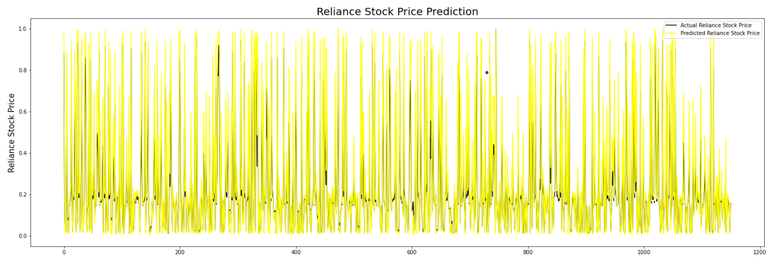

Fig 4.1 compares the actual and predicted stock price of the Reliance Industry with the input combination (i.e., open price, close price, Adjacent close price, high price, low price, RSI and MACD as the predictor variable, and close price as response variable) which has low error rate compared to another combo of input.

TABLE 4.2 Results of SVR
Inputs | MAE | MAPE | RMSE | R²
Open | 0.2625 | 4.1530 | 0.0731 | 0.9016
Close | 0.2607 | 4.0111 | 0.0720 | 0.9044
Open, Close | 0.2616 | 4.0759 | 0.0725 | 0.9059
Adj Close, Close | 0.2549 | 3.9668 | 0.0693 | 0.9139
High, Close | 0.2607 | 4.0219 | 0.0721 | 0.9069
Low, Close | 0.2615 | 4.0707 | 0.0724 | 0.9062
Volume, Close | 0.2605 | 4.0121 | 0.0721 | 0.9070
Close, RSI, Open | 0.2640 | 4.0920 | 0.0738 | 0.9025
Close, RSI | 0.2627 | 4.0268 | 0.0732 | 0.9041
Close, 12EMA | 0.1599 | 3.4404 | 0.0297 | 0.9842
Close, 26EMA | 0.1437 | 3.3656 | 0.0261 | 0.9878
Close, MACD | 0.2635 | 4.0189 | 0.0738 | 0.9024
Close, Adj Close, High | 0.2568 | 3.9833 | 0.0703 | 0.9116
Close, Adj Close, Low | 0.2569 | 4.0059 | 0.0702 | 0.9118
Close, Adj Close, Volume | 0.2557 | 3.9728 | 0.0698 | 0.9127
Close, Adj Close, RSI | 0.2580 | 3.9883 | 0.0710 | 0.9098
Close, Adj Close,12EMA | 0.1966 | 3.6116 | 0.0424 | 0.9679
Close, Adj Close, 26EMA | 0.1873 | 3.5596 | 0.0389 | 0.9728
Close, Adj Close, MACD | 0.2576 | 3.9722 | 0.0710 | 0.9097
Open, Close, Adj Close, High, Low, RSI | 0.2613 | 4.0495 | 0.0725 | 0.9060
Open, Close, Adj Close, High, Low, 12EMA | 0.2576 | 3.8426 | 0.0710 | 0.9097
Open, Close, Adj Close, High, Low, 26EMA | 0.2271 | 3.8157 | 0.0551 | 0.9456
Open, Close, Adj Close, High, Low, MACD | 0.2608 | 4.0440 | 0.0722 | 0.9066
Open, Close, Adj Close, High, Low, RSI, 12EMA | 0.2500 | 3.9639 | 0.0665 | 0.9208
Open, Close, Adj Close, High, Low, RSI, 26EMA | 0.2477 | 3.9465 | 0.0653 | 0.9236
Open, Close, Adj Close, High, Low, RSI, MACD | 0.2626 | 4.0587 | 0.0733 | 0.9039
Open, Close, Adj Close, High, Low, RSI,12EMA, MACD | 0.2532 | 3.9893 | 0.0682 | 0.9166
Open, Close, Adj Close, High, Low, RSI,12EMA, MACD, 26EMA | 0.2427 | 3.9143 | 0.0630 | 0.9290
Open, Close, Adj Close, High, Low, RSI,12EMA, MACD, 26EMA, Volume | 0.2436 | 3.9201 | 0.0635 | 0.9278

SVR with the linear kernel is implemented using python in Jupiter notebook, which uses historical data to forecast future stock prices for Reliance shares. Table 2, it is evidence that the best input combination for the SVR model is close price and 26EMA. The observed performance metric for the input combinations is MAE is 0.14, MAPE is 3.36%, RMSE is 0.26, and R-squared is 98%. The MAE and RMSE values are small compared to all the input combinations. In addition, the higher value of r² shows that the data will fit the model for this combination. The next input combination that fit the model was close price and 12EMA with small variation in the metrics. The values of the metrics are is MAE is 0.41, MAPE is 21.98%, RMSE is 0.19, and R-squared is 52.8%. From this, it is evident that close price, 12EMA, and 26EMA indicators have a high impact on the model performance in the SVR algorithm.

FIG 4.2 Predicted Stock Price using SVR
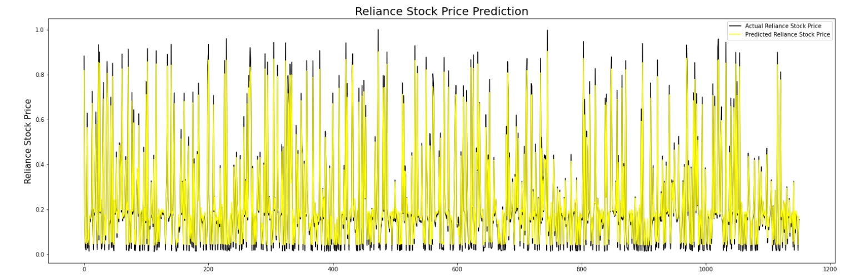

Fig 4.2 compares the actual and predicted stock price of the Reliance Industry with the input combination (i.e., close price and 26EMA as the predictor variable and close price as response variable) which has a low error rate compared to another combo of input.

TABLE 4.3 Results of Logistic Regression
Inputs | Accuracy
Open | 47.35
Close | 47.78
Open, Close | 47.95
Adj Close, Close | 47.95
High, Close | 47.95
Low, Close | 47.95
Volume, Close | 47.96
Close, RSI, Open | 48.56
Close, RSI | 49.34
Close, 12EMA | 49.69
Close, 26EMA | 49.78
Close, MACD | 49.78
Close, Adj Close, High | 49.95
Close, Adj Close, Low | 50.04
Close, Adj Close, Volume | 50.04
Close, Adj Close, RSI | 50.3
Close, Adj Close,12EMA | 50.65
Close, Adj Close, 26EMA | 50.65
Close, Adj Close, MACD | 50.82
Open, Close, Adj Close, High, Low, RSI | 51.6
Open, Close, Adj Close, High, Low, 12EMA | 51.95
Open, Close, Adj Close, High, Low, 26EMA | 52.04
Open, Close, Adj Close, High, Low, MACD | 52.04
Open, Close, Adj Close, High, Low, RSI, 12EMA | 52.04
Open, Close, Adj Close, High, Low, RSI, 26EMA | 52.04
Open, Close, Adj Close, High, Low, RSI, MACD | 52.04
Open, Close, Adj Close, High, Low, RSI,12EMA, MACD | 52.04
Open, Close, Adj Close, High, Low, RSI,12EMA, MACD, 26EMA | 52.12
Open, Close, Adj Close, High, Low, RSI,12EMA, MACD, 26EMA, Volume | 52.3

LR is implemented using python in Jupiter notebook, which uses historical data to predict the direction of movement of stock prices. From table 3, it is evident that the best input combination for the LR model is the high price, close price, open price, low price, volume, Adjacent close, RSI, 12EMA, 26EMA, and MACD. The observed performance metric for the input combinations is accuracy is 52.3%. The next input combination that fit the model was the high price, close price, open price, low price, Adjacent close, RSI, 12EMA, 26EMA, and MACD with small variations in the metrics. The accuracy value is 52.12%. From this, it is evident that volume does not impact the accuracy of the model in logistic regression. The technical indicators influence the direction of movement.
CHAPTER 5

5. CONCLUSION
For equity traders, investors, and portfolio managers, stock price forecasting is of great interest. The noisy and nonlinear nature of stock price behavior makes it challenging to predict prices with accuracy and consistency. Many factors may influence the prediction, such as fundamental market data, macroeconomic data, technical indicators, and other variables.
The main objective of this study is to create a model based on the LSTM algorithm to predict the closing price of Reliance stock by extracting different combinations of input variables focused on multiple aspects of the market. The experimental findings of LSTM demonstrate that, when compared to other inputs open price, close price, Adjacent close price, high price, and low price, RSI and MACD provides can offer a better fit and higher prediction accuracy The values of the metrics such as RMSE (0.19), MAPE (0.223), R-squared (53.3%) and MAE (0.41). The technical indicator RSI plays a major role in predicting the stock price using the LSTM algorithm.
The findings of SVR demonstrate that when compared to other inputs close price and 26EMA provides can offer a better fit and higher prediction accuracy. The values of the metrics such as RMSE (0.26), MAPE (0.33), R-squared (98%), and MAE (0.14). The technical indicator RSI plays a major role in predicting the stock price using the LSTM algorithm. The exponential moving average (EMA) contributes the major implication in predicting the stock price using SVR.
The implications of Logistic Regression are to predict the direction of stock price movement. The performance is evaluated using accuracy score metrics. The high accuracy is 53% obtained by using the
high price, close price, open price, low price, volume, Adjacent close, RSI, 12EMA, 26EMA, and MACD. The value of 1 indicates the rise in stock price and the value of -1 represents the fall in stock price.
The volume of stock price traded in the day has minimal impact on the prediction.
The model proposed in the study can be applied to other market indices that exhibit similar behavior. This model can assist companies in gaining a better understanding of the market before making investment decisions. In the future, the authors plan to explore the possibility of integrating unstructured textual data, such as investor sentiment from social media, earnings reports, policy news, and research reports from market analysts, into the model.

Reference:

- Kumbure, M. M., Lohrmann, C., Luukka, P., & Porras, J. (2022). Machine learning techniques and data for stock market forecasting: A literature review. Expert Systems with Applications, 197, 116659.

- Choudhry, R., & Garg, K. (2008). A hybrid machine learning system for stock market forecasting. International Journal of Computer and Information Engineering, 2(3), 689-692.

- Awad, A. L., Elkaffas, S. M., & Fakhr, M. W. (2023). Stock Market Prediction Using Deep Reinforcement Learning. Applied System Innovation, 6(6), 106.

- Nandi, B., Jana, S., & Das, K. P. (2023). Machine learning-based approaches for financial market prediction: A comprehensive review. Journal of Applied Math, 1(2).

- Jafar, S. H., Akhtar, S., El-Chaarani, H., Khan, P. A., & Binsaddig, R. (2023). Forecasting of NIFTY 50 Index Price by Using Backward Elimination with an LSTM Model. Journal of Risk and Financial Management, 16(10), 423.

- Kirkpatrick II, C. D., & Dahlquist, J. R. (2010). Technical analysis: the complete resource for financial market technicians. FT press.

- GÜR, Y. E. Comparative Analysis of Deep Learning Models for Silver Price Prediction: CNN, LSTM, GRU and Hybrid Approach. Akdeniz İİBF Dergisi, 24(1), 1-13.

- Elavarasan, D., Vincent, D. R., Sharma, V., Zomaya, A. Y., & Srinivasan, K. (2018). Forecasting yield by integrating agrarian factors and machine learning models: A survey. Computers and electronics in agriculture, 155, 257-282.

- Boukherouaa, E. B., Shabsigh, M. G., AlAjmi, K., Deodoro, J., Farias, A., Iskender, E. S., ... & Ravikumar, R. (2021). Powering the digital economy: opportunities and risks of artificial intelligence in finance. International Monetary Fund.

- Shehadeh, M. Exploring Cutting-Edge Algorithms in Islamic Banking: Machine Learning and Deep Learning for Enhanced Decision-Making and Risk Management.

