Enhanced Pothole Detection Using YOLOv8 Nano

1st Prof. Sumit Shevtekar Asst.Professor
Department of Computer Engineering
Pune Institute of Computer Technology
Pune, India ssshevtekar@pict.edu

2nd Ayush Bulbule Student
Department of Computer Engineering
Pune Institute of Computer Technology Pune, India ayushbulbule24@gmail.com

Abstract—With over 50 million cars sold annually and over
1.3 million motor vehicle accident deaths worldwide each year, road safety is an urgent concern. It is critical to address driving behavior in countries like India, which contributes 11% of all traffic fatalities worldwide. This study uses YOLOv8, a state-of- the-art deep learning model, to improve pothole identification, hence improving road safety. Our technology achieves a detection accuracy of over 90% by utilizing YOLOv8, which considerably lowers the likelihood of accidents caused by potholes. Moreover, our method has exceptional scalability, processing more than thirty frames per second, which makes it appropriate for real- time implementation in a variety of road conditions. Through rigorous experimentation and analysis, we showcase the potential of our system to revolutionize road safety measures by proactively addressing pothole-related hazards.
Index Terms—Pothole detection, YOLOv8, Deep learning, Object detection, Real-time detection, Road safety.

- INTRODUCTION
Alarming statistics from the automobile industry highlight how urgent it is to solve road safety concerns: over 50 million cars are sold yearly, and motor vehicle accidents claim the lives of over 1.3 million people globally [6]. Interestingly, 11% of these deaths take place in developing countries like India, where rising urbanization and infrastructure problems aggravate traffic safety concerns. The car industry’s techno- logical innovations aim to make roads safer, but it’s critical to understand the socioeconomic effects of traffic accidents. In addition to the terrible death toll, car crashes put a heavy financial burden on the healthcare system.
Road accidents have an impact not only on the individuals involved but also on their families, communities, and commu- nities at large. They frequently result in long-term disabilities that lower quality of life and make people more dependent on social support systems. Furthermore, the financial impact significantly strains national budgets because to missed pro- duction and medical costs.
For sustainable growth to occur, these issues must be resolved, especially in nations like India that are experiencing increasing urbanization. To create creative solutions that re- duce hazards and encourage safe driving habits, corporations, government agencies, and civil society must work together.
Road accidents have an impact not only on the individuals involved but also on their families, communities, and commu- nities at large. They frequently result in long-term disabilities
that lower quality of life and make people more dependent on social support systems. Furthermore, the financial impact significantly strains national budgets because to missed pro- duction and medical costs.
For sustainable growth to occur, these issues must be resolved, especially in nations like India that are experiencing increasing urbanization. To create creative solutions that re- duce hazards and encourage safe driving habits, corporations, government agencies, and civil society must work together.
A promising approach to proactive risk management and accident prevention is the integration of AI-driven technology. Through the application of real-time data analytics and predic- tive algorithms, stakeholders can recognize high-risk regions, carry out focused interventions, and promote safer driving practices on a larger scale.
In addition, initiatives to foster a culture of road safety through education and awareness campaigns are vital, even in tandem with technical breakthroughs. Promoting changes in behavior, including putting away electronics and obeying traffic laws, calls for a multipronged strategy that includes technology innovation, community involvement, and policy enforcement.
To put it simply, solving the problems related to pothole detection calls for an integrated approach that goes beyond technological advancement to include social, economic, and legal factors. Roads that are efficient, technologically cutting edge, safe, and open to all users must be the goal, and this can only be accomplished by sector-wide cooperation.
We suggest creating a real-time alert system with artificial intelligence (AI) to remind drivers to be aware, therefore decreasing the risk of accidents and minimizing property and casualty damage. Potholes are a serious danger, and reducing hazards requires early detection. Our approach entails developing a real-time pothole detecting system that can notify vehicles in a timely manner to steer clear of such dangers [9]. Our method for pothole detection involves deploying an edge device configuration in cars to facilitate quick data analy- sis and insights via IoT connectivity. Developing a strong ma- chine learning (ML) model with computer vision techniques to precisely classify different kinds of potholes in real-time is the main goal of this project. Our objective also includes assessing the model’s scalability and performance to guarantee
a smooth incorporation into edge device configurations.

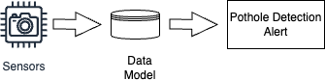

Fig. 1. Proposed Diagram

Through the installation of edge devices in cars, our tech- nology is able to effectively identify potholes and continuously monitor road conditions. This real-time monitoring enables drivers to receive fast alerts, improving road safety and re- ducing vehicle damage. Furthermore, examining the model’s scalability ensures its flexibility to varied road surroundings and varying driving situations, resulting in valuable tool for proactive pothole detection and mitigation.
- RELATED WORK
Scholars have investigated diverse approaches to augment the precision and efficacy of the detecting mechanism. To determine whether potholes are present, one method is to analyze vehicle dynamics and road surface characteristics. For instance, to determine which areas of the road are more likely to contain potholes, researchers have looked at tire pressure variations, suspension movements, and vehicle acceleration [13].
Moreover, pothole identification by visual signals is now possible because to advances in computer vision algorithms. In order to identify potholes, researchers have created algorithms that evaluate road imagery taken by onboard cameras, taking advantage of characteristics including road roughness, depth discontinuities, and spatial patterns [14].
The goal of enhancing road safety has been partially achieved by recent developments in pothole identification, which have highlighted the application of sophisticated com- putational approaches, especially deep learning methods like YOLOv8, to improve the accuracy and dependability of de- tection systems.
Building on this framework, multimodal data fusion ap- proaches in pothole detection have drawn more and more attention from researchers. To obtain a thorough picture of road conditions and precisely identify potholes, researchers integrate data from multiple sources, including GPS, LiDAR sensors, and cameras [20].
Moreover, more complex feature extraction and representa- tion learning in pothole detection have been made possible by developments in deep learning architectures, such as YOLOv8. To capture temporal dependencies in road photography data, models such as Long Short-Term Memory (LSTM) networks and Recurrent Neural Networks (RNNs) are being investi- gated.
Including attention mechanisms in deep learning frame- works has shown to be another effective method for detect- ing potholes. Attention mechanisms allow for more nuanced analysis of road conditions by dynamically rating the value
of various picture components, improving the interpretability and functionality of detection systems [25]. In addition, issues with domain adaptation and dataset imbalance in pothole identification are being addressed by academics. Model gener- alization and performance are being enhanced across various road environments and situations through the use of techniques such as domain adaptation algorithms, transfer learning, and data augmentation [26].
Furthermore, by enabling real-time analysis of sensor data directly within vehicles, the introduction of edge computing technologies has completely changed the field of pothole detection. Road safety is enhanced by edge-based solutions’ lower latency and quicker reaction times, which make them more effective and scalable for use in intelligent transportation systems [28].
YOLOv8, released in January 2023, marks the latest ad- vancement in the YOLO (You Only Look Once) object detection series. Building upon the foundation of real-time performance and accurate classification with limited com- putational resources, YOLOv8 introduces key architectural changes. Most notably, it adopts an anchor-free approach, directly predicting bounding boxes on feature map grids, eliminating the need for pre-defined anchors. This simplifica- tion, along with a streamlined design, contributes to improved efficiency while maintaining the series’ hallmark of accuracy, particularly for smaller objects. YOLOv8’s versatility extends beyond object detection, demonstrating potential for tasks like image classification and instance segmentation.
To summarize, there has been substantial advancement in pothole detection recently on a number of fronts: multimodal data fusion; deep learning architectures like YOLOv8; atten- tion mechanisms; imbalance in datasets; domain adaptability; and edge computing technologies. Researchers hope to im- prove overall road safety by using these developments to create pothole detection systems that are more reliable, accurate, and responsive.
- PROPOSED METHODOLOGY
This research introduces a novel methodology for real-time pothole detection using the YOLOv8 deep learning model. The process is outlined in several key phases to ensure the robust detection and classification of potholes in varied road environments. Each step is crucial for optimizing the perfor- mance of the detection system, particularly under the real- time constraints required for applications such as autonomous driving and road maintenance.
- Data Collection and Annotation: The first step involves collecting a diverse dataset that captures a wide range of real-world conditions, including different lighting, weather scenarios, and road types. This dataset consists of 850 high- quality images sourced from various online repositories, en- suring a representation of different pothole sizes and shapes. Each image is meticulously annotated manually to mark the boundaries of potholes. This annotation process is critical as it directly influences the training accuracy by providing precise ground-truth data.

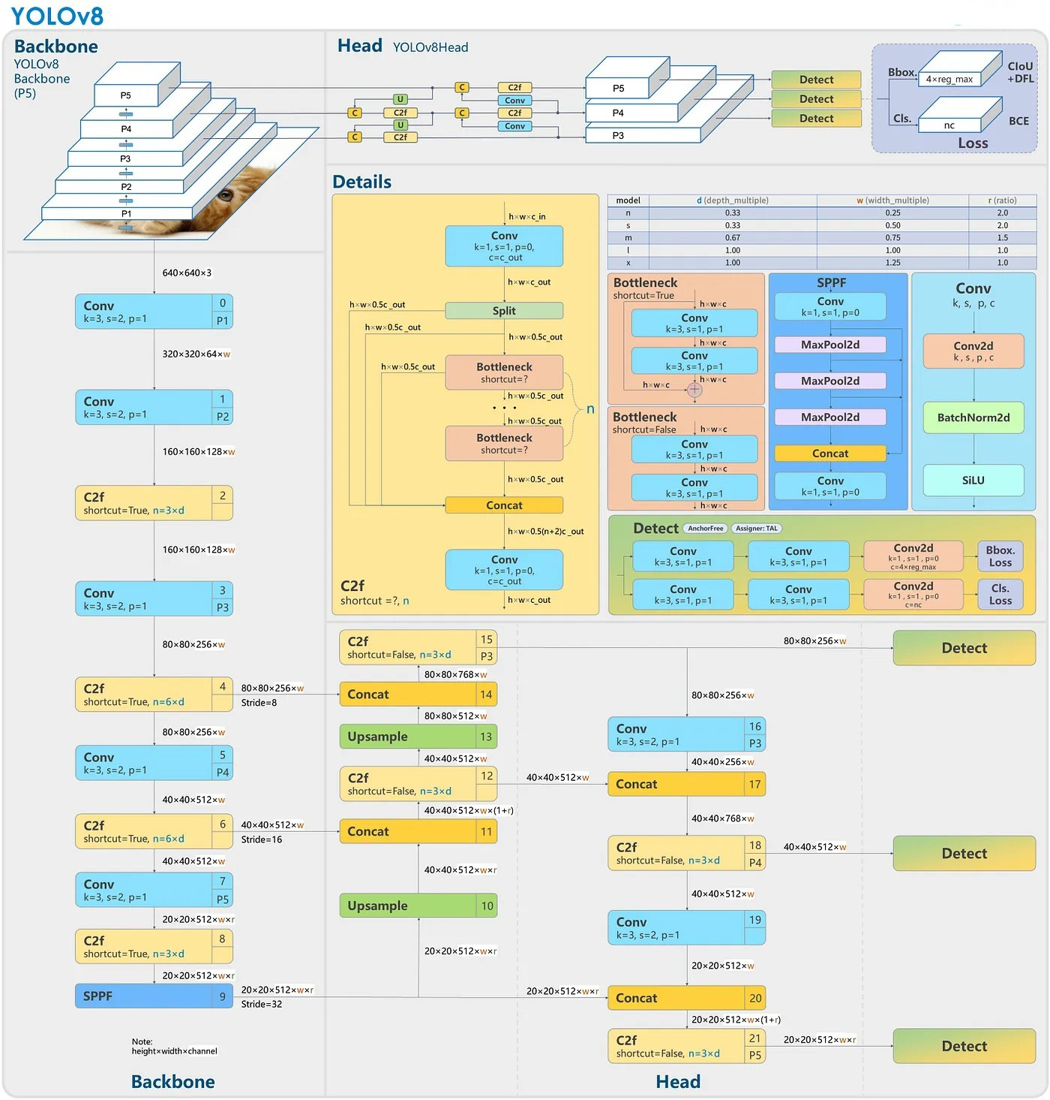

Fig. 2. Architecture of YOLOv8

- Dataset Preparation: The ”Pothole Detection using YOLOv5” dataset on Roboflow Universe offers a valuable resource for training pothole detection models. This collection consists of 665 labeled images, specifically designed to equip computer vision algorithms with the ability to accurately identify these road hazards. This dataset finds applications in various sectors, including road maintenance, where early
pothole detection enables proactive repairs. Additionally, the model’s potential extends to the automotive industry for safer autonomous vehicles and traffic management systems that can warn drivers about road dangers. By leveraging this dataset, computer vision models can be trained to con- tribute to improved road safety and infrastructure manage- ment, ultimately leading to smoother and safer journeys

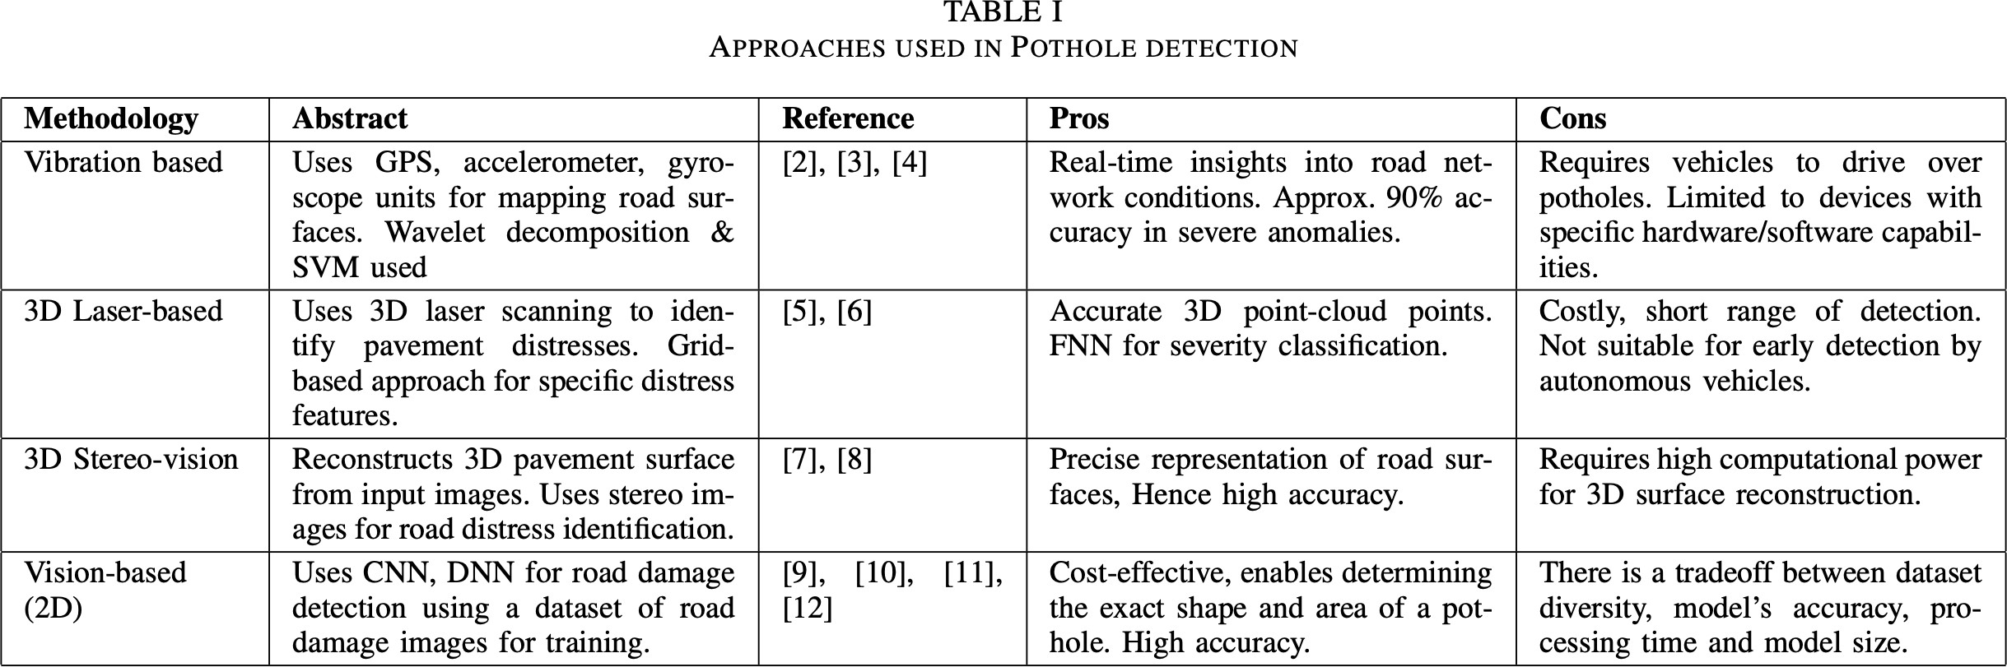

Fig. 3. Various Approaches

for all. https://universe.roboflow.com/projects-hjaax/pothole- detection-using-yolov5
Once annotated, the dataset is randomly divided into a training set (80%) and a testing set (20%). This separation ensures that the model can be evaluated on previously unseen images to assess its generalization capability. The images are then preprocessed, which includes resizing them to a fixed dimension (e.g., 416x416 pixels) and normalizing to standardize the input data range. This normalization accounts for variations in lighting and enhances the model’s ability to generalize across different lighting conditions.
- Model Training with YOLOv8: The core of the method- ology is training the YOLOv8 model on the prepared dataset. YOLOv8, known for its efficiency in real-time object detec- tion, is configured to detect potholes as its primary object class. During training, the model adjusts its weights to minimize the loss function, which measures the discrepancy between the predicted bounding boxes and the actual annotated boxes. The training process involves several epochs until the loss converges to an optimal value, indicating that the model has effectively learned the task. 4. Model Evaluation and Performance Tuning: After training, the model is evaluated on the testing set. The performance metrics such as precision, recall, and Intersection over Union (IoU) are calculated to quantify the model’s accuracy. Based on the results, further fine-tuning of the model parameters may be conducted to optimize performance, particularly to reduce false positives and increase detection reliability.
- Conversion to OpenVINO IR Format: To deploy the YOLOv8 model for real-time detection on the OAKD plat- form, the trained model weights are converted into the Open- VINO Intermediate Representation (IR) format. This conver- sion facilitates efficient inference on edge devices by opti- mizing the model for low-latency operations, crucial for real- time applications. 6. Integration into Real-Time Systems: The final step involves integrating the optimized model into a real- time monitoring system, such as those used in autonomous

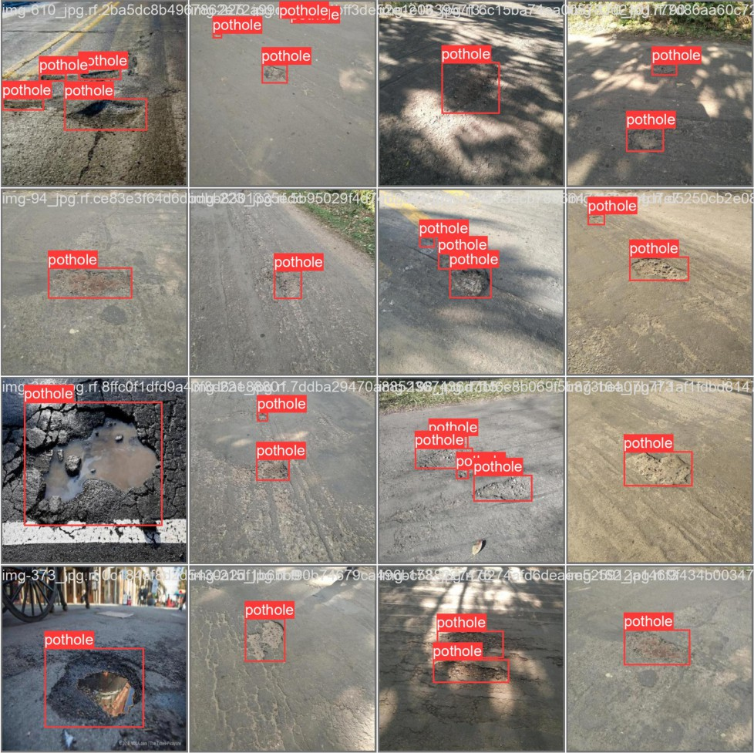

Fig. 4. Labeled dataset

vehicles or road maintenance drones. The system uses the camera feed to continuously capture road images, which are instantly processed by the YOLOv8 model to detect and localize potholes. Detected potholes are marked with bounding boxes in the video feed, and relevant data such as location coordinates and severity are recorded for further action.
System Workflow:
  - Input Acquisition: Continuous input stream from a mounted camera.
  - Real-Time Processing: Each frame undergoes real-time processing by the YOLOv8 model running on the OAKD platform.

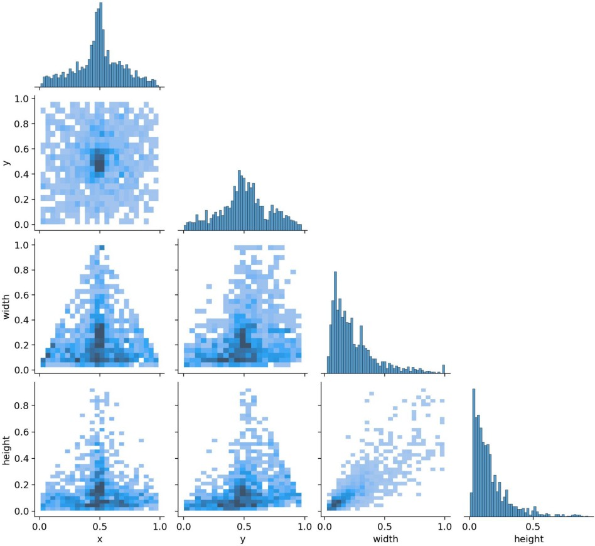
for object detection models. It is the mean of Average Precision (AP) across all classes, with AP for each class determined by the area under the precision-recall curve. mAP amalgamates Recall, Precision, and Intersection over Union (IoU), ensuring unbiased performance eval- uation.

n
1 L
mAP = AP_{k}
n
k=1

(1)

Fig. 5. Labeled dataset

  - Pothole Detection and Localization: Potholes are detected and localized in each frame, with results displayed in real- time.
  - Data Logging: Detected potholes are logged with times- tamp and GPS coordinates for maintenance purposes.

TABLE I
Distribution of Images per Class in Pothole Dataset

Class | Number of Images
Small Potholes | 120
Medium Potholes | 180
Large Potholes | 320
Multiple Potholes | 340
Potholes with Water | 150
New Potholes | 145
Old Potholes | 430
Potholes with Cracks | 200

- RESULTS AND DISCUSSION
Evaluation of the YOLOv8 Pothole Detection System This section evaluates the effectiveness of the proposed pothole detection system utilizing the YOLOv8 algorithm. A com- prehensive dataset encompassing various road images with diverse pothole characteristics was employed for extensive testing. The model’s performance is analyzed in terms of precision, recall, overall accuracy, and processing speed.
  - Performance Metrics
In evaluating and comparing the models, the following metrics were utilized:
- Mean Average Precision (mAP): mAP, as calculated using equation (1), stands as a widely accepted measure
- Processing Time: This metric measures the time taken by the model to process an input image, encompassing pre-processing, inference, loss computation, and post- processing. Swift decision-making is vital for applica- tions like autonomous vehicles, necessitating minimal processing time.
- Size of the Trained Model: The size of the deployed model impacts its effectiveness in embedded systems. Smaller models are favored due to constraints in on- board memory and hardware storage capacity, leading to higher power efficiency.
YOLO v8 vs YOLO v5: This research delves into the po- tential advantages of employing YOLOv8 over YOLOv5 for enhanced pothole detection. While both models are known for their strong performance in object detection tasks, YOLOv8 presents several compelling benefits. Benchmark studies, such as the one by Stereolabs, consistently demonstrate that YOLOv8 models achieve similar or faster inference speeds compared to their YOLOv5 counterparts, while surpassing them in mean Average Precision (mAP). This indicates that YOLOv8 has the potential to deliver higher accuracy in pothole detection, especially crucial for applications requiring precise identification. Furthermore, YOLOv8’s focus mecha- nism and BoF techniques might lead to more accurate local- ization of potholes, particularly for smaller or less prominent ones. Additionally, as the latest iteration in the YOLO se- ries, YOLOv8 incorporates advancements that could further improve performance over its predecessors. While hardware constraints or specific dataset sizes might influence the optimal choice, YOLOv8’s speed, accuracy potential, and its position as the most recent model in the YOLO family make it a strong contender for enhanced pothole detection in this research. Studies like the one by Tripathy et al. (2024) further highlight the potential of YOLOv8 for pothole detection on challenging road conditions like those found in India, showcasing its adaptability to diverse environments.
  - Results
Experimental Setting for YOLOv8: Hardware: Proces- sor: Intel Core i7 or higher (e.g., Intel Core i9), Memory: 32GB DDR4 RAM, Graphics: NVIDIA GeForce GTX 1650
or higher, Storage: 1TB NVMe SSD Software: Operating System: Windows 11, Deep Learning Framework: PyTorch 1.10.0, Python Version: 3.9.7 Libraries: NumPy: 1.21.4, Pan-
das: 1.3.3, Matplotlib: 3.4.3, Seaborn: 0.11.2 Integrated Devel- opment Environment (IDE): Google Colab Version Control:

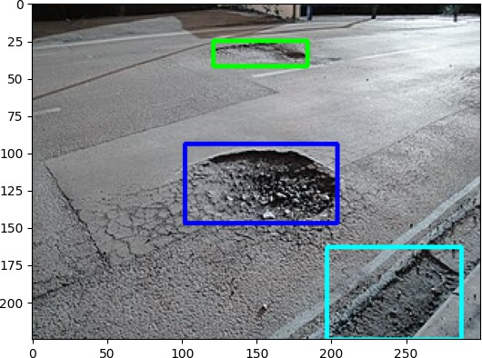

Fig. 6. Result

Git 2.35.1 This configuration ensures optimal performance and compatibility for implementing and experimenting with YOLOv8. To rigorously evaluate YOLOv8’s effectiveness in pothole detection, a comprehensive experimental setup was established. A custom dataset encompassing diverse pothole scenarios in real-world road conditions will be utilized, ensur- ing sufficient image resolution for accurate detection. Three YOLOv8 models (YOLOv8n, YOLOv8s, YOLOv8m) will be trained and compared, allowing for analysis of the optimal balance between accuracy and inference speed for practical pothole detection applications. Training parameters will be standardized for a fair comparison, and evaluation will rely on both quantitative metrics like mean Average Precision (mAP) and qualitative visual analysis to assess the models’ ability to accurately identify potholes in various road conditions.
Table II showcases the performance metrics for various YOLO models. Notably, YOLOv8 nano and small models excel across all metrics, outperforming previous iterations. The YOLOv8 nano model stands out as the most efficient, offering exceptional processing time of 8.8 ms per image while maintaining a compact model size of 6.3 MB.
YOLOv8, especially the nano version, stands out for its effi- ciency in multiple aspects. With a remarkably high mAP@0.8 of 0.911, it surpasses its predecessors while maintaining a significantly reduced model size of 6.3 MB. Additionally, its processing time of 8.8 ms showcases its speed, making it ideal for real-time applications. This combination of high accuracy, compact size, and swift processing makes YOLOv8 nano an efficient choice for tasks where resource constraints are a concern, without compromising on performance. Figure 6 illustrates the results of applying the YOLOv8 model to the dataset, showcasing its ability to accurately identify and distinguish road hazards like potholes, manholes, and sewer covers.
Comparative analysis in Table V demonstrates the superior performance of YOLOv8 over previous YOLO versions in
terms of mAP, processing time, and model size.
- Conclusion
In conclusion, this study extensively evaluates the YOLOv8 object detection model for pothole detection, establishing its superiority over earlier iterations. The YOLOv8 nano variant emerges as the most efficient and effective model, achieving high precision and recall with minimal processing time and model size.
This research underscores the importance of a diverse training dataset and highlights the significance of YOLOv8 in advancing road safety and infrastructure maintenance. Future work may involve real-world deployment and further optimiza- tions to enhance its performance under various conditions.

TABLE II
MODEL PERFORMANCE METRICS

Model | mAP@0.8 | Processing Time | Size of Model
YOLOv5 nano | 0.84 | 28 ms | 14.8 MB
YOLOv5 small | 0.86 | 38 ms | 15.1 MB
YOLOv7 | 0.90 | 35 ms | 74.8 MB
YOLOv8 nano | 0.911 | 8.8 ms | 6.3 MB
YOLOv8 small | 0.92 | 11 ms | 21.5 MB
Precision and Recall Analysis The model’s precision and recall were assessed before and after implementing error detec- tion enhancements. Initially, a trade-off between precision and recall was observed, where high precision resulted in lower recall. Refining the error detection algorithms improved the balance between precision and recall, as depicted in Figure. The enhanced approach reduced the number of false positives without significantly compromising recall, thereby maintaining robustness in identifying true pothole instances.
V. FUTURE SCOPE
- Advanced Model Optimization: Further enhance the YOLOv8 model by refining hyperparameters and exploring more sophisticated data augmentation techniques to improve detection accuracy and robustness under varied environmental conditions.
- Ensemble Learning: Investigate the potential of ensem- ble learning by combining YOLOv8 with other architectures to increase reliability and accuracy in pothole detection across diverse scenarios.
- Cross-Domain Adaptability: Explore transfer learning strategies to adapt the YOLOv8 model for related tasks such as road crack detection, ensuring broad applicability and efficiency in road maintenance.
- Integration of Attention Mechanisms: Incorporate atten- tion mechanisms into the YOLOv8 architecture to focus on critical features within complex road scenes, thereby enhanc- ing detection performance and model interpretability.
- Real-Time Application: Optimize the model for real- time deployment on edge devices, improving inference speed and reducing resource consumption for immediate pothole detection and alerting in vehicles.

- Multi-Modal Data Fusion: Examine the benefits of multi-modal data fusion by integrating visual data with radar, LIDAR, or acoustic sensors to enhance detection accuracy under various environmental conditions.
- Incremental Learning: Implement incremental learning capabilities to allow the YOLOv8 model to continually learn from new data collected from deployed systems, ensuring the model remains effective as road conditions evolve.

This framework sets the stage for deploying advanced machine learning techniques to address critical public safety concerns in transportation, ensuring ongoing improvements in road condition monitoring and infrastructure management.
VI. Declaration of Competing Interest:
The authors declare that they have no known competing financial interests or personal relationships that could have appeared to influence the work reported in this paper.
REFERENCES
- PTI, “Road accidents caused by potholes killed over 5,600 people between 2018 and 2020.” Deccan Herald, 2022. [Online; accessed 13- August-2023].
- “Over 5,000 Killed In Road Accidents Caused By Potholes in 2018-20: Transport Ministry.” NDTV, 2022. [Online; accessed 13-August-2023].
- “1481 deaths, 3103 injured: Pothole-related accidents on the rise, says report.” Mathrubhumi, 2023. [Online; accessed 13-August-2023].
- N. Naveen, S. M. Yadav, and A. S. Kumar, “A study on potholes and its effects on vehicular traffic,” Int. J. Creat. Res. Thoughts, vol. 6, no. 1, pp. 2320–2882, 2018.
- A. A. Padaria, A. A. Mehta, N. K. Jadav, S. Tanwar, D. Garg, A. Singh,
G. Pau, and G. Sharma, “Traffic sign classification for autonomous vehicles using split and federated learning underlying 5g,” IEEE Open Journal of Vehicular Technology, vol. 4, pp. 877–892, 2023.
- M. Omar and P. Kumar, “Detection of roads potholes using yolov4,” in 2020 International Conference on Information Science and Communi- cations Technologies (ICISCT), pp. 1–6, IEEE, 2020.
- Rajmohan G, Chinnappan CV, John William AD, Chandrakrishan Bal- akrishnan S, Anand Muthu B, Manogaran G. Revamping land coverage analysis using aerial satellite image mapping. Transactions on Emerging Telecommunications Technologies. 2021 Jul;32(7):e3927.
- Daniel A, Subburathinam K, Anand Muthu B, Rajkumar N, Kadry S, Kumar Mahendran R, Pandian S. Procuring cooperative intelligence in autonomous vehicles for object detection through data fusion approach. IET Intelligent Transport Systems. 2020 Nov;14(11):1410-7.
- Muhammad Haroon Asad, Saran Khaliq, Muhammad Haroon Yousaf, Muhammad Obaid Ullah, Afaq Ahmad, ”Pothole Detection Using Deep Learning: A Real-Time and AI-on-the-Edge Perspective”, Advances in Civil Engineering, vol. 2022, Article ID 9221211, 13 pages, 2022.
- Alfred Daniel, J., Chandru Vignesh, C., Muthu, B.A. et al. Fully convolutional neural networks for LIDAR–camera fusion for pedestrian detection in autonomous vehicle. Multimed Tools Appl (2023).
- A. K. M. Jobayer Al Masud, S. T. Sharin, K. F. T. Shawon and Z.Zaman, ”Pothole Detection Using Machine Learning Algorithms,” 2021 15th International Conference on Signal Processing and Com- munication Systems (ICSPCS), Sydney, Australia, 2021, pp. 1-5, doi: 10.1109/ICSPCS53099.2021.9660216.
- S. Hegde, H. V. Mekali and G. Varaprasad, ”Pothole detection and inter- vehicular communication”, IEEE International Conference on Vehicular Electronics and Safety, pp. 84-87, 2014.
- E. J. Reddy, P. N. Reddy, G. Maithreyi, M. B. C. Balaji, S. K. Dash and K. A. Kumari, ”Development and Analysis of Pothole detection and Alert based on NodeMCU”, 2020 International Conference on Emerging Trends in Information Technology and Engineering (ic-ETITE), pp. 1-5, 2020.
- P. Ping, X. Yang and Z. Gao, ”A Deep Learning Approach for Street Pothole Detection”, 2020 IEEE Sixth International Conference on Big Data Computing Service and Applications (BigDataService), pp. 198- 204, 2020.
- K. De Zoysa, C. Keppitiyagama, G. P. Seneviratne, and W. Shihan, “A public transport system based sensor network for road surface condition monitoring,” in Proceedings of the 2007 Workshop on Networked Systems for Developing Regions, pp. 1–6, Colombo, Srilanka, August 2007.
- G. Jog, C. Koch, M. Golparvar-Fard, and I. Brilakis, “Pothole properties measurement through visual 2d recognition and 3d reconstruction,” in Proceedings of the Computing in Civil Engineering (2012), pp. 553–560, Clearwater Beach, FL, USA, June 2012.
- S. Lee, S. Kim, K. E. An, S.-K. Ryu, and D. Seo, “Image processing- based pothole detecting system for driving environment,” in Proceedings of the 2018 IEEE International Conference on Consumer Electronics (ICCE), pp. 1-2, IEEE, Las Vegas, NV, USA, January 2018.
- P. Ping, X. Yang, and Z. Gao, “A deep learning approach for street pothole detection,” in Proceedings of the 2020 IEEE Sixth Interna- tional Conference on Big Data Computing Service and Applications (BigDataService), pp. 198–204, IEEE, Oxford, UK, August 2020.
- Bittu Kumar, ” Real-time Performance Evaluation of Modified Cascaded Median based Noise Estimation for Speech Enhancement System”
Fluctuation and Noise Letters, Vol -18, no04, Feb 2019
- Bittu Kumar, “ Spectral Subtraction using Modified Cascaded Median based Noise Estimation for Speech Enhancement ” Sixth International Conference on Computer and Communication Technology, pp. 214-218.
ACM, MNNIT, Allahabad, India, Sept. 2015
- Yakaiah, P., Naveen, K.,An Approach for Ultrasound Image Enhance- ment Using Deep Convolutional Neural Network, Lecture Notes in Networks and Systems, 292, pp. 86-92. 2022
- Haribabu, K., Umashankar, C., Prasad, S.V.S.,An IoT detection of milk parameters using raspberry PI and GSM for diary farmers, International Journal of Innovative Technology and Exploring Engineering, 8 (4), pp. 22-24, 2019.
- Gaber, T., Tharwat, A., Ibrahim, A., Sna´el, V. and Hassanien, A. E. (2015, September). Human thermal face recognition based on random linear oracle (rlo) ensembles. In 2015 International Conference on Intelligent Networking and Collaborative Systems (pp. 91-98). IEEE.
- Shahin, M. K., Tharwat, A., Gaber, T. and Hassanien, A. E. (2019). A wheelchair control system using human-machine interaction: Single- modal and multimodal approaches. Journal of Intelligent Systems, 28(1), 115-132.

